Re-pointing the VA CPRS Demo Shortcut
(As of 5/18/2015)

After installing the VA CPRS Demo.msi file from the CPRS Demo web site (http://www.ehealth.va.gov/CPRS_Demo.asp) you will have an icon on your desktop that looks like this:

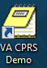

To re-point this shortcut to a different server so that it will work until there are changes made to the VA CPRS Demo.msi file, right click on the icon (above) and click on Properties which will be on the bottom of the list. This will bring up this window where you will see CPRSDemo.va.gov on the target line.

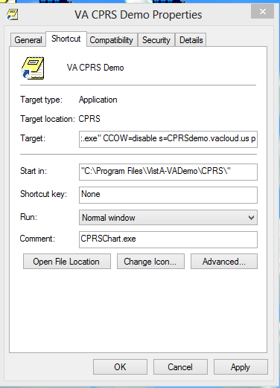

Edit the target line so I looks like the screen shot below.

Change
s=CPRSDemo.va.gov
to
s=cprsdemo.vacloud.us

Click Apply and then Click OK.

Double Click on the ICON to launch the CPRS Demo.

