

INTEGRATED BILLING

TECHNICAL MANUAL /
SECURITY GUIDE

IB Version 2.0
Patch IB*2.0*436

December 2010

Department of Veterans Affairs
Office of Information and Technology (OI&T)
Office of Enterprise Development (OED)

(This page included for two-sided copying.)

Revision History
Date | Revision | Description of Change | Author Information
12/15/10 | Patch IB*2.0*436 | Initial Version | Berry Anderson/ Darlene White Steve Tjernagel/ Rodger Null

(This page included for two-sided copying.)

PREFACE
This is the Technical Manual for Integrated Billing (IB) patch IB*2.0*436. It is designed to assist IRM personnel in the operation and maintenance of this patch.

For information regarding use of the software, please refer to the EDI User Guide.

For information on the installation of this interface, please refer to the Release Notes and Installation Guide for patch IB*2.0*436.

Note to Users with Qume Terminals
It is very important that you set up your Qume terminal properly. After entering your access and verify codes, you will see

Select TERMINAL TYPE NAME: {type} //

Please make sure that <C-QUME> is entered here. This entry will become the default. You can then press <RET> at this prompt for all subsequent logins. If any other terminal type configuration is set, options using the List Manager utility will neither display nor function properly on your terminal. The reports and error messaging system in the interface makes extensive use of the List Manager functions.

Who Should Read this Manual?
This manual is intended for technical IRM personnel who may be called upon to install and support this software.

(This page included for two-sided copying.)
Table of Contents

PREFACE v
Note to Users with Qume Terminals v
Who Should Read this Manual? v
Introduction 1
Implementation and Maintenance 1
General Notes Regarding Changes to this Software 1
Platform Requirements 1
Pre-Requisite Patch Requirements 2
Revenue Process 2
EDI Process Flow 3
Files 4
Namespace 4
File List 4
Input Templates 4
Routines 5
Exported Options 5
Archiving 5
Callable Routines/Entry Points/Application Program Interfaces 5
Callable Routine 5
Entry Points 6
External Relationships 6
Internal Relationships 6
Global Variables 6
SECURITY 6
File Protection 6
Security Keys 7
Options Locked by Security Keys 7
Glossary 8

(This page included for two-sided copying.)

Introduction
The U.S. Department of Health and Human Services (HHS) adopted the National Provider Identifier (NPI) as the standard health identifier for health care providers. Veterans Health Administration (VHA) implemented Veterans Health Integrated Systems Technology Architecture (VistA) software system changes to facilitate compliance with Health Insurance Portability and Accountability Act (HIPAA) NPI regulations in May 2007. Since then, Chief Business Office (CBO) Business Development Department through the Office of Enterprise Development (OED) has released a number of software patches to the original VistA NPI design to meet business needs. The VistA system utilizes the NPI in the Integrated Billing (IB), e-Claims Management Engine (ECME), and Fee Basis software applications as the primary identifier for providers and facilities for billing via the Electronic Data Interchange (EDI) process.

Changes to VistA were requested by the VHA CBO Business Development Department to comply with HIPAA standards and meet payer requirements in support of VHA revenue collection initiatives. Some of these changes were requested in an effort to improve the integrity of data stored in VistA files and remove HIPAA rules built into VistA that are negatively impacting non-HIPAA covered transactions.

Additionally, changes to VistA Integrated Billing (IB) and Accounts Receivable (AR) applications were requested by the Veterans Health Administration (VHA) Chief Business Office (CBO) Business Development Department to improve financial integrity and relieve the excessive staff burden inadvertently created by the implementation of electronic Medicare Remittance Advice (MRA) in 2005.
.

Implementation and Maintenance
There are no new or modified Site Parameters as a result of patch IB*2.0*436. Nor does this patch modify the current process flow at the sites.

General Notes Regarding Changes to this Software

- Integrated Billing files may only be updated through distributed options.
- Per VHA Directive 10-93-142 regarding security of software that affects financial systems, most of the IB routines and files may not be modified. Routines that may not be modified will be indicated by a comment on the third line. Files that may not be modified will have a note in the file description.
- According to the same directive, most of the IB Data Dictionaries may not be modified.

Platform Requirements

VistA System:
A fully patched and complete VistA system is required, running Integrated Billing (IB) Version 2.0. In particular, the pre-requisite patches listed below must be installed prior to the installation of the EDI patch IB*2.0*436.

In addition, the VistA system must have a properly installed and functioning HL7 module.

Pre-Requisite Patch Requirements

VistA Package and Version | Associated Patch Designation(s) | Brief Patch Description
Integrated Billing (2.0) | IB*2.0*323 | This patch addresses several bugs related to e-MRA. These bugs are included in the patch description with their respective remedy tickets.
Integrated Billing (2.0) | IB*2.0*349 | UB-04 claim form
Integrated Billing (2.0) | IB*2.0*400 | eClaims additional claim form and transmission data

Revenue Process
The overall patient billing revenue process for the VHA is summarized in the table below:

Revenue Cycle
Intake | UR | Billing | Collection | UR
Patient Registration  Insurance  Identification  Insurance Verification | Pre-certification & Certification  Continued Stay | Documentation  EDI Bill Generation  MRA  Claim status messages | Establish Receivables  A/R Follow-up  Lockbox  Collection Correspondence | Appeals

During the Intake phase, the patient is registered. Insurance information is identified and/or verified.

In the Utilization Review phase, the patient is pre-certified and certified, and continued stay reviews are performed.

In the Billing phase, the patient encounter is documented and coded. An electronic data interchange (EDI) bill and/or Medicare Remittance Advice (MRA) request is generated and sent to the payer. Claim status messages include information that appears on the Claims Status Awaiting Resolution (CSA) report.

During the Collections phase, establishment of receivables, accounts receivables follow-up, lockbox, and any collection correspondence take place.

Another Utilization Review can take place if there are any appeals.

EDI Billing provides the VHA with the capability to submit electronic Institutional & Professional claims, rather than printing and mailing claims from each facility.

No changes are being made to the Revenue process with the introduction of IB*2.0*436 except that users will now have access to a new ‘TYPE OF PLAN’ for an insurance policy. This plan type, “MediGap (Suppl – Coins, Ded, Part B Exc)”, is to address the new balance due calculations that were introduced with the new MediGap Plans F and G.

EDI Process Flow

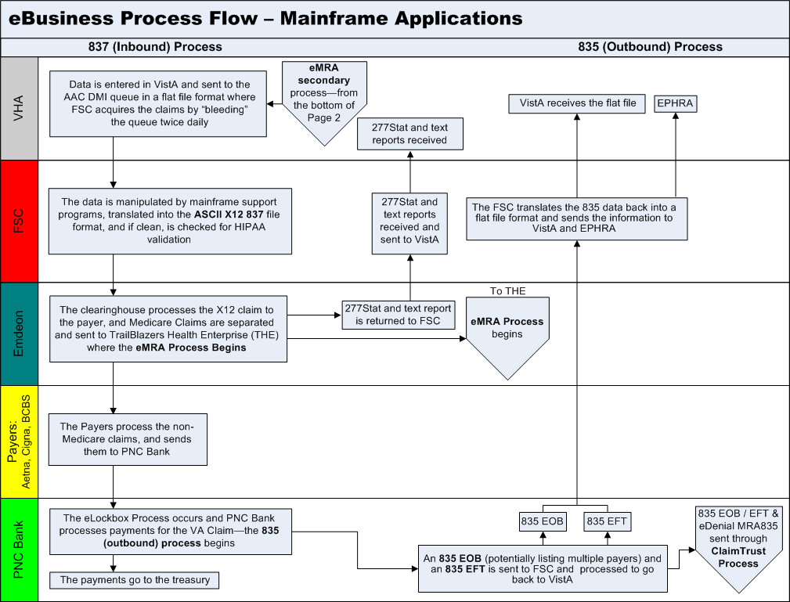

The above flowchart represents the path electronic claims follow. The objective of electronic billing is to submit completely correct claims. Claims sent electronically reach the payer faster, are processed faster, and are paid faster than claims submitted on paper via the mail.

From the user’s desktop, the claim goes to the FSC in Austin, TX as a VistA MailMan message. The FSC translates the claim into the HIPAA 837 format and forwards it to the clearinghouse.

The clearinghouse processes the claims. Medicare claims are separated and sent to TrailBlazers Health Enterprise. Other claims are sent to the Payer. If the clearinghouse does not have an electronic connection with a payer or if specific claims must be submitted on paper, the claim is printed at Express Bill and mailed to the payers.

The payer adjudicates the claim and determines payment. The payment may be sent electronically to PNC Bank as an EFT or the payer may mail a paper check.
PNC Bank will send: EFT dollars directly to the U.S. Treasury, .EFT 835 transactions, containing daily total deposit information by payer to the FSC, and ERA 835 transactions, containing electronic EOBs (EEOBs) to the FSC.
The FSC will pass EFT and ERA information on to each VAMC in flat file format via VistA MailMan messages. Additionally, the FSC will transmit the EFT and ERA flat file information to the EPHRA database, maintained by the Austin Information Technology Center (AITC), but managed by the FSC 224-Unit staff. The FSC will also transmit unroutable EEOB data to EPHRA. Unroutable EEOB data does not contain the appropriate Tax ID information to allow the FSC to route it to the proper VistA AR system. FSC 224-Unit staff will monitor EPHRA for unroutable EEOB data and use other data identifiers, such as the bill number, to determine appropriate routing and transmit to the correct VistA AR system.

Different electronic edits are in place at each transmission point that may initiate the sending of a claims status message. Claim status messages returned by the clearinghouse and/or payer will provide information on a specific claim. There is no standard content for messages. The information contained within a claim status message varies from payer to payer.

No changes were introduced to the EDI Process flow with patch IB*2.0*436.

Files

Namespace
All routines that are modified as a result of patch IB*2.0*436 are in the “IBC” namespace.

File List
WARNING: It is not recommended that you use VA FileManager to edit any of the files directly! Furthermore, editing any of the new files without direction from the interface programmers may cause the interface to become non-functional!

File # | File Name | Data Dictionary | Patch
355.93 | IB NON/OTHER VA BILLING PROVIDER | This file contains data for non-VA facilities that provide services for VA patients who have reimbursable insurance for these services. VA pays for these services and in turn submits the charges to the insurance co for reimbursement. | IB*2.0*436
399 | BILL/CLAIMS | This file contains all of the information necessary to complete a Third Party billing form. | IB*2.0*436

Input Templates
There are no VA FileMan Input templates exported with IB*2.0*436.

Input Template | File | Patch
n/a

Routines
Routine Name | Description | Patch
IBCCCB | Coordination of Benefits | IB*2.0*436
IBCEMU2 | IB MRA Utility | IB*2.0*436
IB20P436 | Post install routine synchronizes the provider names between file #200 and file #355.93 where the records share the same NPI, sends a report via MailMan identifying which records were modified during the synchronization process, and adds a new record to the TYPE OF PLAN file (355.1) to accommodate MediGap Plans F and G. | IB*2.0*436
IBCEP6 | Functions for NON-VA PROVIDER | IB*2.0*436
IBCEP8 | Functions for NON-VA PROVIDER | IB*2.0*436
IBCBB11 | Continuation of edit check routine | IB*2.0*436
IB20A436 | Pre install routine to delete triggers that will no longer be used. | IB*2.0*436

Exported Options
There are no exported options with IB*2.0*436.
Option Name | Menu Text | Patch
N/A

Archiving
Patch IB*2.0*436 did not have anything to do with archiving.

Callable Routines/Entry Points/Application Program Interfaces

Callable Routine
Routine Name | Called by | Description | Patch
MRACALC2^IBCEMU2 | SKIP^IBCCCB | This function will add all EOB’s for a given claim number to calculate the total Medicare contractual obligation amount. | IB*2.0*436

Entry Points
Routine Name | Entry Point/ Required Variables | Description | Patch
N/A

External Relationships

IA # | Between IB and | Related to | FORUM  Status | Patch
IRC #4964 | KERNEL | Pulling Pay to Provider information from file #350.9. | Approved | IB*2.0*436

Internal Relationships
No new routines or options were introduced with patch IB*2.0*436 and therefore, this is not applicable.

Global Variables
No non-standard variables were introduced with patch IB*2.0*436.

SECURITY

File Protection

The Electronic Data Interface contains files that are standardized. They carry a higher level of file protection with regard to Delete, Read, Write, and LAYGO access, and should not be edited locally unless otherwise directed. The data dictionaries for all files should NOT be altered.

The following is a list of recommended VA FileMan access codes associated with each file contained in the KIDS build for the EDI interface.

File # | File Name | DD | RD | WR | DEL | LAYGO | AUDIT | Patch
355.93 | IB NON/OTHER VA BILLING PROVIDER | @ |  |  |  |  | @ | Not modified with IB*2.0*436
399 | BILL/CLAIMS | @ | @ | @ | @ | @ |  | Not modified with IB*2.0*436

Security Keys

Security Key Name | Description | Patch
N/A |  | IB*2*436

Options Locked by Security Keys

Options/Programs locked by a Security Key | Security Key | Patch
N/A |  | IB*2*436

Glossary
Term | Description
Accounts Receivable (AR) | The financial computer system used by the Department of Veterans Affairs Medical Centers.
AITC | Austin Information Technology Center (formerly AAC); located in Austin, Texas; responsible for maintaining the hardware that supports the Lockbox system, including FSC servers, the MailMan routing system, and EPHRA database
CBO | Chief Business Office
Claim Status Message | Electronic messages returned to the VAMC providing status information on a claim from the Financial Service Center (FSC) in Austin, Texas. These messages can originate at FSC, at the payer or at the clearinghouse.
Clearinghouse | A company that provides batch and real time transaction processing services and connectivity to a payer or provider. Transactions include insurance eligibility verification, claims submission processing, electronic remittance processing and payment posting for electronic claims.
Data Dictionary | The structure of a file, table or any group of related information as defined for and by VA FileMan.
eClaim | A claim that is transmitted to FSC electronically.
ECME | e-Claims Management Engine
EDI | Electronic Data Interchange (EDI) is the process of transacting business electronically. It includes submitting claims electronically (paperless claims processing), as well as electronic funds transfer and electronic inquiry for claim status and patient eligibility.
EEOB | Electronic Explanation of Benefits; one line item within an ERA
Electronic Remittance Advice | An electronic record transmitted to the sites with EEOB detail information included. An Electronic Remittance Advice can consist of one or more EEOBs from one payer.
Emdeon | The clearinghouse used by VA.
EOB | An Explanation of Benefits (EOB) is a document from a payer that details the amount of payment on a claim and if not paid in full, the reasons for it.
EPHRA | EEOB and Payment Healthcare Resolution Application; Web-based archival repository and research tool; allows user to search for missing EEOBs that are not received due to incorrect routing information; allows Austin FSC 224-unit staff to route unroutable EEOB data
ERA | Electronic Remittance Advice; the equivalent to a stack of paper Explanation of Benefits (EOB) statements for many patients from one payer
Express Bill | An Emdeon (clearinghouse) printing service that prints and mails claims to payers who do not have the capability to accept electronic claims or in specific circumstances when a paper claim is required.
FSC | The Financial Service Center (Austin, Texas) receives 837 claims transmissions from VistA and transmits this data to a clearinghouse. FSC also receives error/informational messages and 835 data from the clearinghouse and transmits this data to VistA.
Health Level Seven (HL7) | Health Level Seven, a standardized application level communications protocol that enables systems to exchange information and to affect requests and responses. Basically, HL7 is an agreement between two HL7-compliant systems that specifies where to expect certain data in a stream of characters.
HHS | The U.S. Department of Health and Human Services
HIPAA | In 1996 Congress passed into law the Health Insurance Portability and Accountability Act (HIPAA). This Act is comprised of two major legislative actions: Health Insurance Reform and Administrative Simplification. The Administrative Simplification provisions of HIPAA direct the federal government to adopt national electronic standards for automated transfer of certain health care data between health care payers, plans, and providers. This will enable the entire health care industry to communicate electronic data using a single set of standards thus eliminating all non standard formats currently in use. Once these standards are in place, a health care provider will be able to submit a standard transaction for eligibility, authorization, referrals, claims, or attachments containing the same standard data content to any health plan. This will "simplify" many clinical, billing, and other financial applications and reduce costs.
IB | Integrated Billing
Integration Agreement (same as IRC) | Programming agreements made between two VISTA packages enabling the sharing/management of data and or functions.
MailMan Message | The messaging system used to communicate between the users of the VISTA software. MailMan messages will be used to process automatic payments and to communicate between the Accounts Receivable software and the users.
NPI | National Provider Identifier
OED | Office of Enterprise Development
Option | A unique method defined in the Option file (^DIC(19,). Options are usually defined as part of a user driven menu system but may be invoked as extensions of other options or VA MailMan messages.
Required Variable | An attribute of a package interface. It is a variable that must exist in order for the interface's entry point to be called.
Routines | A unique identifiable containment of software pertinent to a computer system function. The routines contain the programming logic to implement the functionality for the EDI Lockbox Project.
Security Key | Used in conjunction with locked options or functions. Only holders of this key may perform these options/functions. Security Keys are used for options, which perform a sensitive task.
VistA | Veterans Health Integrated Systems Technology Architecture
VHA | Veterans Health Administration
835 | The HIPAA adopted standard for electronic remittance advice to report the processing of all claim types (including retail pharmacy). The term “835” represents the data set that is sent from health plans to health care providers and contains detailed information about the processing of the claim. This includes payment information and reduction or rejection reasons. All health plans are required to use the same explanation of benefit codes (adjustment reason codes) and adhere to very specific reporting requirements. The term “835” is used interchangeably with electronic remittance advice (ERA) and Medicare remittance advice (MRA).
837 | The HIPAA adopted standard for electronic submission of hospital, outpatient and dental claims. The term “837” represents the data set that is sent from health care providers to insurance companies (payers). The 837 standard includes the data required for coordination of benefits and is used for primary and secondary payer claims submission. The term “837” is used interchangeably with electronic claim.

