

Clinical Reminders

CPRS32B IMMUNIZATION DIALOGS

Install Guide

**October 2022**

Product Development

Office of Information Technology

Department of Veterans Affairs

Table of Contents

Introduction 1

Pre-install 13

Install Details 17

Install Example 17

Post Installation 69

# Introduction

This install guide contains the instructions for installing the national immunization reminders after a site has installed the CPRS 32B patch bundle. The format of the dialogs has changed requiring all sites to reinstall the national immunization reminder dialogs.

CPRS 32B CONTENT contains 1 Reminder Exchange entry:

**CPRSV32B IMMUNIZATION REMINDER DIALOGS**

**The exchange file contains the following components:**

**REMINDER GENERAL FINDINGS**

VIEW PROGRESS NOTE TEXT

**TIU TEMPLATE FIELD**

IM PHARMACY PHONE NUMBERS

IM VIS MPOX URL

IM VIS MPOX DT

IM MPX ADMIN INFO

MPX JYNNEOS PATIENT HTML

MPX JYNNEOS PROVIDER HTML

IM SCRIBE

IM SARS COV-2 ADMIN BOOSTER INFO PRE TEXT

IM SARS COV-2 BOOSTER PFIZER EUA VHA VACCINE INFO URL

IM SARS COV-2 ADMIN BOOSTER INFO POST TEXT PFIZER #1

IM SARS COV-2 ADMIN BOOSTER INFO POST TEXT C2 #1

IM SARS COV-2 ADMIN C2 INFO PRE TEXT

IM SARS COV-2 BOOSTER MODERNA EUA VHA VACCINE INFO URL

VA-VANOD BLANK

IM SARS COV-2 CDC VACCINE UNDERLYING CONDITIONS

IM SARS COV-2 CDC VACCINE INFO URL

IM SARS COV-2 VA PRE SCREEN FORM

IM SARS COV-2 VA SIDE EFFECTS AE REPORTING

COVID-19 BOOSTER PFIZER RECIPIENT

COVID-19 BOOSTER MODERNA RECIPIENT

BLANK TEXT FIELD FOR DIALOGS

IM SARS COV-2 OUTSIDE INSTR 2

IM SARS COV-2 OUTSIDE INSTR 1

IM SARS COV-2 OUTSIDE WARNING

IM SARS COV-2 VIS/EUA INFO URL D2

IM SARS COV-2 ADMIN D2 INFO PRE TEXT

IM SARS COV-2 ADMIN INFO POST TEXT D2 #2

IM SARS COV-2 DOSE #2 WARNING

IM SARS COV-2 DOSE D2 #B WARNING

IM SARS COV-2 D2 DOSE #3 BOOSTER

IM SARS COV-2 DOSE SERIES BOOSTER WARNING

IM SARS COV-2 DOSE D2 #3 WARNING

IM SARS COV-2 D2 DOSE #3

IM SARS COV-2 ADMIN INFO POST TEXT D2 #1 LONG INTERVAL

IM SARS COV-2 ADMIN INFO POST TEXT D2 #1

IM SARS COV-2 VIS/EUA INFO URL E2

IM SARS COV-2 ADMIN E2 INFO PRE TEXT

IM SARS COV-2 ADMIN INFO POST TEXT E2 #2

IM SARS COV-2 E2 DOSE

IM SARS COV-2 DOSE E2 #3 WARNING

IM SARS COV-2 E2 DOSE #3

IM SARS COV-2 ADMIN INFO POST TEXT E2 #1

IM SARS COV-2 VIS/EUA INFO URL B1

IM SARS COV-2 ADMIN B1 INFO PRE TEXT

IM SARS COV-2 ADMIN INFO POST TEXT B1 #2

IM SARS COV-2 DOSE B1 #3 WARNING

IM SARS COV-2 B1 DOSE #3

IM SARS COV-2 ADMIN INFO POST TEXT B1 #1

IM SARS COV-2 VIS/EUA INFO URL A1

IM SARS COV-2 ADMIN A1 INFO TTS COUNSELING

IM SARS COV-2 ADMIN A1 INFO PRE TEXT

IM SARS COV-2 ADMIN INFO POST TEXT A1 #B

IM SARS COV-2 DOSE A1 #3 WARNING

IM SARS COV-2 A1 DOSE #3

IM SARS COV-2 DOSE A1 #2 WARNING

IM SARS COV-2 A1 DOSE #2

IM SARS COV-2 ADMIN INFO POST TEXT A1

IM SARS COV-2 VIS/EUA INFO URL C2

IM SARS COV-2 ADMIN INFO POST TEXT C2 #2

IM SARS COV-2 DOSE C2 #B WARNING

IM SARS COV-2 C2 DOSE #3 BOOSTER

IM SARS COV-2 DOSE C2 #3 WARNING

IM SARS COV-2 C2 DOSE #3

IM SARS COV-2 ADMIN INFO POST TEXT C2 #1 LONG INTERVAL

IM SARS COV-2 ADMIN INFO POST TEXT C2 #1

IM COVID-19 BOOSTER INFO

VA-COVID-19 VACCINE SCHEDULE AT A GLANCE

IM SARS COV-2 PROVIDER EUA FACT URL A1

IM SARS COV-2 PROVIDER EUA FACT URL B1

IM SARS COV-2 PROVIDER EUA FACT URL D2

IM SARS COV-2 PROVIDER EUA FACT URL C2

IM SARS COV-2 CDC VACCINE CLINICAL CONSIDERATIONS BOOSTERURL

IM SARS COV-2 CDC VACCINE ANAPHYLAXIS INFO URL

IM SARS COV-2 CDC VACCINE CLINICAL CONSIDERATIONS URL

IM SARS COV-2 VHA VACCINE INFO URL

VA-CLC ADL SCORE INSTRUCTIONS

VA-THS SLEEP EPWORTH GUIDANCE

IM VIS PPSV23 URL

IM PNEUMOCOCCAL VACCINE NCP GUIDANCE

IM PNEUMOCOCCAL VACCINE SCHEDULE

IM PNEUMOC PCV INFO

VA-LOCATIONS

IM VIS PCV URL

VA-INFLUENZA RECOMMEND

VA-INFLUENZA SUMMARY

IM INFLUENZA VACCINE POST SEASON MESSAGE

IM INFLUENZA VACCINE REMINDER DIALOG HEADER

IM INFLUENZA COUNSELING

NCP INFLUENZA IMMUNIZATION GUIDANCE

NCP HAV IMMUNIZATION GUIDANCE

IM VIS HBV URL

IM VIS HAV URL

IM VIS HBV ADJ URL

IM VIS MENING B URL

IM MENINGOCOCCAL VACCINE NCP GUIDANCE

IM MENING B WARNING

IM VIS MENING ACWY URL

IM MENING ACWY WARNING

IM MENING ACWY HEADER

BLANK SPACE1

VIS HPV GARDASIL-9

CDC HPV VACCINE RECOMMENDATIONS

NCP HPV GUIDANCE

IM ZOSTER SHINGRIX INFO URL

CDC ZOSTER VACCINE RECOMMENDATIONS

NCP HERPES ZOSTER GUIDANCE

NCP TD/TDAP GUIDANCE STATEMENT

IM VIS TDAP URL

IM VIS TD URL

**HEALTH FACTORS**

VA-MONKEYPOX[C]

VA-MONKEYPOX LAB PCR OUTSIDE - INDETERMINATE

VA-MONKEYPOX LAB PCR OUTSIDE - PENDING

VA-MONKEYPOX LAB PCR OUTSIDE - NEGATIVE

VA-MONKEYPOX LAB PCR OUTSIDE - POSITIVE

VA-MONKEYPOX LAB PCR OUTSIDE - MONKEYPOX CONFIRMED

VA-MONKEYPOX LAB PCR OUTSIDE – ORTHOPOX PRESUMPTIVE

IMMUNIZATION [C]

VA-MONKEYPOX (JYNNEOS) VACCINE SUBCUTANEOUS DOSE VOLUME 0.5ML

VA-MONKEYPOX (JYNNEOS) VACCINE INTRADERMAL DOSE VOLUME 0.1ML

VA-COVID-19 BOOSTER VACCINE DEFER PERMANENT

VA-COVID-19 BOOSTER VACCINE DEFER 1Y

VA-COVID-19 BOOSTER VACCINE DEFER 6M

VA-COVID-19 BOOSTER VACCINE DEFER 3M

VA-SARS-COV-2 IMMUN EDUC VVC/TELE VST

VA-COVID-19 [C]

VA-SARS-COV-2 IMM CLIN REV NO ADDL DOSE

COVID-19 VACCINE DEFER PERMANENT

COVID-19 VACCINE DEFER 1Y

COVID-19 VACCINE DEFER 6M

COVID-19 VACCINE DEFER 3M

VA-COVID-19 VACCINE DEFER PERMANENT

VA-COVID-19 VACCINE DEFER 1Y

VA-COVID-19 VACCINE DEFER 6M

VA-COVID-19 VACCINE DEFER 3M

VA-SARS-COV-2 IMM REFUSAL - BOOSTER/ADDL DOSE

VA-SARS-COV-2 VACCINE REFUSAL

VA-SARS-COV-2 VACCINE DEFERRED

VA-SARS-COV-2 VACCINE CONTRAIND B1

VA-SARS-COV-2 VACCINE CONTRAIND A1

VA-SARS-COV-2 VACCINE CONTRAIND E2

VA-SARS-COV-2 VACCINE CONTRAIND C2

VA-SARS-COV-2 VACCINE CONTRAIND D2

VA-SARS-COV-2 IMM REFUSAL - NVX CVX 211

VA-SARS-COV-2 IMM REFUSAL - AZN CVX 210

VA-SARS-COV-2 IMM REFUSAL - JSN CVX 212

VA-SARS-COV-2 IMM REFUSAL - UNS CVX 213

VA-SARS-COV-2 IMM REFUSAL - PFR CVX 208

VA-SARS-COV-2 IMM REFUSAL - MOD CVX 207

COVID-19 VERBAL REPORT COVID VACCINE

VA-CLC PREADMISSION SCREEN [C]

VA-CLC ADL CARE LEVEL 6-13

VA-CLC ADL CARE LEVEL 0-5

VA-CAREGIVER PROGRAM [C]

VA-CSP COACH SESSION DURATION IN MINUTES

REMINDER FACTORS [C]

VA-HEMOGLOBIN A1C OUTSIDE LAB

VA-RAI FRAILTY TOOL [C]

VA-RAI FRAILTY SCORE WITHOUT CANCER

VA-RAI FRAILTY SCORE

TS SLEEP/PAP/CPAP [C]

VA-SLEEP EPWORTH SCORE

HYPERTENSION [C]

VA-HTN SELF-RECORDED DIASTOLIC BLOOD PRESSURE

VA-HTN SELF-RECORDED SYSTOLIC BLOOD PRESSURE

VA-REMINDER UPDATES [C]

VA-UPDATE_32B

VA-SARS-COV-2 VACCINE BOOSTER CONTRAINDICATED

VA-SARS-COV-2 IMM REFUSAL BOOSTER

VA-COVID-19 PRIMARY SERIES VACCINE DEFER 1Y

VA-COVID-19 PRIMARY SERIES VACCINE DEFER 6M

VA-SARS-COV-2 PRIMARY SERIES VACCINE REFUSAL

VA-COVID-19 PRIMARY SERIES VACCINE DEFER 3M

PNEUMOCOCCAL CONJUGATE VACCINE CONTRAIND

IMMUNIZATION

PNEUMOCOCCAL PPSV23 DX INCORRECT

PNEUMOCOCCAL PPSV23 VACCINE PRECAUTION

REFUSED PNEUMOC VACCINE PPSV23

PNEUMOCOCCAL PPSV23 VACCINE CONTRAIND

VA-PCV EDUCATION VVC/TELEHEALTH VST

PNEUMOCOCCAL PCV13 VACCINE CONTRAIND

REFUSED PNEUMOC CONJUGATE VACCINE PCV

PNEUMOCOCCAL CONJUGATE VACCINE PRECAUTION

PNEUMOCOCCAL CONJUGATE VACCINE DX INCORRECT

VA-INFLUENZA IMM CONTRAINDICATION

VA-INFLUENZA IMM NONE CURRENT SEASON

VA-FLU EDUCATION VIRTUAL/TELEHEALTH VST

VA-INFLUENZA IMM PERM CONTRAINDICATION

VA-INFLUENZA IMM SEASON CONTRAINDICATION

VA-INFLUENZA IMM REFUSED

OUTSIDE SEROLOGY [C]

OUTSIDE HEPATITIS A SEROPOSITIVE

OUTSIDE HEPATITIS B SURFACE AB POSITIVE

OUTSIDE HEPATITIS B S ANTIBODY NEGATIVE

OUTSIDE HEPATITIS B SURFACE AB NEGATIVE

OUTSIDE HEPATITIS B SURFACE AG POSITIVE

OUTSIDE HEPATITIS B SURFACE AG NEGATIVE

OUTSIDE HEPATITIS B IMMUNITY

OUTSIDE HEPATITIS B CORE AB POSITIVE

OUTSIDE HEPATITIS B CORE AB NEGATIVE

VA-HEP B EDUCATION VVC/TELEHEALTH VST

HEPATITIS C [C]

HEPATITIS B VACCINATION NOT INDICATED

HEPATITIS B [C]

HEPATITIS B SEROLOGY NOT INDICATED

HEPATITIS B VACCINATION DEFER TEMPORARY

REFUSED HEPATITIS B VACCINE

REFUSED HEPATITIS B SEROLOGY

LIFE EXPECTANCY < 6 MONTHS

INCORRECT DIAGNOSES [C]

VA-INCORRECT DIABETES DIAGNOSIS

VA-MEN B EDUCATION VVC/TELEHEALTH VST

MENINGOCOCCAL B DISEASE RISK

MENINGOCOCCAL B DISEASE - NOT AT RISK

MENINGOCOCCAL B DEFERRAL PERMANENT

MENINGOCOCCAL B DEFERRAL TEMPORARY

REFUSED MENINGOCOCCAL B VACCINE

VA-MEN ACWY EDUCATION VVC/TELEHEALTH VST

MENINGOCOCCAL ACWY DISEASE RISK

MENINGOCOCCAL ACWY DISEASE - NOT AT RISK

MENINGOCOCCAL ACWY DEFERRAL PERMANENT

MENINGOCOCCAL ACWY DEFERRAL TEMPORARY

REFUSED MENINGOCOCCAL ACWY VACCINE

VA-HPV

VA-HPV PRECAUTION

VA-HPV DECLINED

VA-HPV CONTRAINDICATED

VA-HPV DECLINED PERMANENTLY

VA-ZOSTER EDUCATION VVC/TELEHEALTH VST

ZOSTER IMMUNIZATION [C]

HERPES ZOSTER IMMUN CONTRAINDICATION

DECLINES HERPES ZOSTER IMMUNIZATION

HERPES ZOSTER VACCINE UNAVAILABLE

HERPES ZOSTER IMMUN PRECAUTION

VA-TD/TDAP EDUCATION VVC/TELEHEALTH VST

TDAP PRECAUTION

CURRENT FEBRILE ILLNESS

REFUSED TDAP VACCINE

TDAP CONTRAINDICATION

REFUSED TD VACCINE

TETANUS/DIPHTHERIA CONTRAINDICATION

**REMINDER SPONSOR**

VA NATIONAL CENTER FOR HEALTH PROMOTION AND DISEASE PREVENTION (NCP)

NATIONAL CENTER FOR HEALTH PROMOTION AND DISEASE PREVENTION (NCP)

POPULATION HEALTH

OFFICE OF GERIATRIC EXTENDED CARE

OFFICE OF QUALITY & PERFORMANCE

VHA ONCOLOGY

VHA CARDIOLOGY SERVICES

OFFICE OF PATIENT CARE SERVICES

OFFICE OF PUBLIC HEALTH AND ENVIRONMENTAL HAZARDS

VHA NATIONAL CENTER FOR HEALTH PROMOTION AND DISEASE PREVENTION (NCP) AND VHA OFFICE OF WOMEN'S HEALTH

WOMEN VETERANS HEALTH PROGRAM

VHA Office of Mental Health and Suicide Prevention

**REMINDER TAXONOMY**

VA-IMMUNIZATION INJECTION 90471

VA-IMMUNIZATION ICD10 CODE

VAL-SARS-COV-2 PFIZER BIVALENT BOOSTER

VAL-SARS-COV-2 IMM MODERNA BIVALENT BOOSTER

VA-IMMUNOCOMPROMISED FOR COVID-19 ADDL DOSE

VA-HIV INFECTION

LONG TERM SYSTEMIC STEROID

VA-PNEUMOC DZ RISK - CHEMOTHERAPY

VA-PNEUMOC DZ RISK - IMMUNOCOMPROMISED

VA-PNEUMOC DZ RISK - HIGHEST/NOT IMMUNO COMP

VA-PNEUMOC DZ RISK - HIGH

VA-TERMINAL CANCER PATIENTS

VA-DIABETES

VA-CIRRHOSIS

VA-CHRONIC LIVER DISEASE (NON-HBV/HCV)

VA-GASTRIC VARICES

VA-HEPATIC FIBROSIS

VA-HEPATITIS B RISK DRUG USE

VA-ESOPHAGEAL VARICES

VA-END STAGE RENAL DISEASE

VA-HEPATITIS B RISK SEXUAL TRANSMISSION

VA-HEPATITIS C INFECTION

VA-COMPLEMENT DEFICIENCY

VA-ASPLENIA

VA-IMMUNOCOMPROMISED FOR ZOSTER VACCINE

**REMINDER TERM**

VA-IM NO DOSES AVAIL MONKEYPOX 206

VA-CURRENT INPATIENT

VA-IM NO DOSES AVAIL PFZ 300

VA-IM NO DOSES AVAIL MOD 229

VA-SARS-COV-2 VACCINE WHO APPROVED ALL (INCL US)

VA-SARS-COV-2 VACCINE WHO PFIZER

VA-SARS-COV-2 VACCINE WHO MODERNA

VA-SARS-COV-2 VACCINE WHO JANSSEN

VA-SARS-COV-2 VACCINE WHO APPROVED ALL (INCL US) BOOSTER

VA-SARS-COV-2 VACCINE WHO NOVAVAX

VA-COVID-19 IM DEFER INDEFINITE

VA-SARS-COV-2 VACCINE REFUSAL

VA-SARS-COV-2 VACCINE DEFERRAL

VA-SARS-COV-2 VACCINE CONTRAINDICATION

VA-COVID-19 VACCINATION CLINIC FUTURE APPT

VA-CD4 COUNT

VA-STEROID PREDN EQUIV 5-6.6MG

VA-STEROID PREDN EQUIV 6.6-9MG

VA-STEROID PREDN EQUIV 10-19MG

VA-STEROID PREDN EQUIV >=20MG

VA-CHEMO/IMMUNOSUPPRESSIVE DRUGS

VA-SARS-COV-2 VACCINE INDICATION ADDL DOSE NEEDED

VA-SARS-COV-2 VACCINE FOR BL

VA-SARS-COV-2 VACCINE DOSE C IN STD SERIES

VA-IM NO DOSES AVAIL PFZ TS 217

VA-SARS-COV-2 VACCINE D2 2 DOSE

VA-SARS-COV-2 VACCINE D2 1 DOSE

VA-SARS-COV-2 IM DOSE NOT PFIZER

VA-SARS-COV-2 VACCINE A1 1 DOSE

VA-AGE >64

VA-SARS-COV-2 VACCINE E2 2 DOSE

VA-SARS-COV-2 IM DOSE NOT ASTRAZENECA

VA-SARS-COV-2 IM DOSE NOT MODERNA

VA-SARS-COV-2 VACCINE E2 1 DOSE

VA-IM NO DOSES AVAIL NOV 211

VA-SARS-COV-2 VACCINE B1 2 DOSE

VA-SARS-COV-2 VACCINE B1 1 DOSE

VA-SARS-COV-2 IM DOSE NOT NOVAVAX

VA-IM NO DOSES AVAIL JSN 212

VA-SARS-COV-2 VACCINE C2 2 DOSE

VA-SARS-COV-2 VACCINE C2 1 DOSE

VA-IM NO DOSES AVAIL PFZ 208

VA-SARS-COV-2 VACCINE D2 3 DOSE

VA-IM NO DOSES AVAIL MOD 207

VA-SARS-COV-2 VACCINE C2 3 DOSE

VA-COVID-19 CONTRAINDICATION

VA-SARS-COV-2 VACCINE BIVALENT

VA-SARS-COV-2 ALL CDC VACCINES

VA-SARS-COV-2 VACCINE PRIMARY SERIES REFUSAL

VA-SARS-COV-2 VACCINE PRIMARY SERIES DEFERRAL

STEROIDS - PNEUMOCOCCAL DZ RISK

VA-PNEUMOC DZ RISK - LONG TERM STEROIDS

VA-PNEUMOC DZ RISK - CHEMO/IMMUNOSUPP DRUGS

VA-BL PNEUMOC RECENT CHEMO/IMMUNOSUPPRESSION

VA-BL PNEUMOC RECENT CHEMOTHERAPY (ICD ONLY)

VA-PNEUMOC PCV IMMUNIZATION (ALL CONJUGATE)

VA-PNEUMOC PPSV23 IMMUNIZATION

VA-PNEUMOC DZ RISK - IMMUNOCOMPROMISED

VA-PNEUMOC DZ RISK - HIGHEST/NOT IMMUNO COMP

VA-PNEUMOC DZ RISK - HIGH

VA-IM NO DOSES AVAIL PPSV23 33

VA-PNEUMOC PPSV23 ORDER SUPPRESSION

VA-ZOSTER IMMUNIZATION 1Y

VA-PNEUMOC PCV CONTRAINDICATION

VA-PNEUMOC PPSV23 INCORRECT DIAGNOSIS

VA-PNEUMOC PCV20 IMMUNIZATION

VA-PNEUMOC PCV15 IMMUNIZATION

VA-PNEUMOC PCV13 IMMUNIZATION

VA-PNEUMOC PPSV23 CONTRAINDICATIONS

VA-PNEUMOC PPSV23 ORDERS

VA-PNEUMOC DZ RISK - IMMUNOCOMPROMISED RX

VA-IM NO DOSES AVAIL PCV13 133

VA-IM NO DOSES AVAIL PCV20 216

VA-IM NO DOSES AVAIL PCV15 215

VA-PNEUMOC PCV ORDER SUPPRESSION

VA-PNEUMOC PCV DEFERRALS

VA-MENING VACCINES DIPHTHERIA CONJUGATE

VA-PNEUMOC PCV ORDERS

VA-PNEUMOC PCV DX INCORRECT

VA-INFLUENZA CONTRAINDICATION

VA-INFLUENZA IMM SEASON STOP DATE

VA-INFLUENZA ADMIN SUPPRESSION

VA-IM NO DOSES AVAIL FLU 185

VA-INFLUENZA HIGH DOSE SUPPRESS OPTION

VA-IM NO DOSES AVAIL FLU 186

VA-IM NO DOSES AVAIL FLU 171

VA-IM NO DOSES AVAIL FLU 197

VA-IM NO DOSES AVAIL FLU 205

VA-IM NO DOSES AVAIL FLU 158

VA-IM NO DOSES AVAIL FLU 150

VA-INFLUENZA ORDER SUPPRESSION

VA-INFLUENZA IMM NOT DONE THIS SEASON

VA-INFLUENZA IMM CONTRAINDICATION

VA-INFLUENZA IMM SEASON START DATE

VA-INFLUENZA IMM SEASONAL VACCINE FORMULATIONS

VA-HEPATITIS A VACCINATION INDICATED

VA-HEPATITIS A IMMUNE/SEROPOS

VA-HEPATITIS A SEROLOGY IGG/TOTAL

VA-OUTSIDE HEPATITIS B SURFACE AB POSITIVE

VA-OUTSIDE HEPATITIS B SURFACE AB NEGATIVE

VA-OUTSIDE HEPATITIS B SURFACE AG POSITIVE

VA-OUTSIDE HEPATITIS B SURFACE AG NEGATIVE

VA-OUTSIDE HEPATITIS B CORE AB POSITIVE

VA-OUTSIDE HEPATITIS B CORE AB NEGATIVE

VA-HEPATITIS B SURFACE ANTIBODY

VA-HEPATITIS B SURFACE ANTIGEN

VA-HEPATITIS B CORE ANTIBODY (IGG/TOTAL)

VA-BL HBV SEROLOGY SECTION SUPPRESS

VA-LAST SERVICE SEPARATION >1/1/2001

VA-HBV ADMINISTRATION SUPPRESSION

VA-IM NO DOSES AVAIL HBV DIAL 44

VA-IM NO DOSES AVAIL HBV/HAV 104

VA-IM NO DOSES AVAIL HBV-CPG 189

VA-IM NO DOSES AVAIL HBV ADULT 43

VA-HEPATITIS B IMMUNIZATION STD ONLY

VA-HEPATITIS B IMMUNIZATION NOT INDICATED

VA-HEPATITIS B SEROLOGY NOT INDICATED

VA-HEPATITIS B IMMUNIZATION REFUSED/DEFERRED

VA-HEPATITIS B SEROLOGY REFUSED/DEFERRED

VA-HEPATITIS B IMMUNIZATION ADJUVANT

VA-HEPATITIS B IMMUNIZATION 3/4 DOSE SERIES

VA-LIFE EXPECTANCY < 6 MONTHS

VA-DIABETES DX INCORRECT

VA-DIABETES DX

VA-HEPATITIS B RISK

VA-IM NO DOSES AVAIL MEN B OMV 163

VA-MENING B ADMIN SUPPRESSION

VA-MENING B ORDER SUPPRESSION

VA-MENINGOCOCCAL B NOT AT RISK

VA-MENINGOCOCCAL B RISK OTHER

VA-MENINGOCOCCAL B VACCINE DEFERRED PERMANENT

VA-MENINGOCOCCAL B VACCINE DEFERRED TEMPORARY

VA-MENINGOCOCCAL B VACCINE MENB-FHBP TRUMENBA

VA-MENINGOCOCCAL B VACCINE MENB-4C BEXSERO

VA-MENINGOCOCCAL B RISK IMMUNOCOMPROMISED

VA-IM NO DOSES AVAIL MEN ACWY OMV 136

VA-MENING ACWY ADMIN SUPPRESSION

VA-MENING ACWY ORDER SUPPRESSION

VA-MENINGOCOCCAL ACWY VACCINE DEFERRED PERMANENT

VA-MENINGOCOCCAL ACWY VACCINE DEFERRED TEMPORARY

VA-MENINGOCOCCAL ACWY VACCINE (MPSV4 OR UNSPECIFIED)

VA-MENINGOCOCCAL ACWY VACCINE CONJUGATE

VA-MENINGOCOCCAL ACWY NOT AT RISK

VA-MENINGOCOCCAL ACWY DISEASE RISK

VA-MENINGOCOCCAL ACWY RISK IMMUNOCOMPROMISED

VA-HPV VACCINES

VA-IM NO DOSES AVAIL HPV9 165

VA-HPV ADMINISTRATION SUPPRESSION

VA-HPV ORDER SUPPRESSION

VA-HPV VACCINE PRECAUTION

VA-HPV VACCINE ORDERED

VA-HPV VACCINE DECLINED

VA-HPV VACCINE CONTRAINDICATED

VA-HPV VACCINE DECLINED PERMANENTLY

VA-HPV VACCINES SERIES 2

VA-HPV VACCINES SERIES COMPLETE

VA-HERPES ZOSTER NEOMYCIN BL

VA-IM NO DOSES AVAIL HERPES ZOSTER 187

VA-ZOSTER ADMINISTRATION SUPPRESSION

VA-ZOSTER ORDER SUPPRESSION

VA-AGE >18

VA-IMMUNOCOMPROMISED FOR ZOSTER VACCINE - DX

VA-IMMUNOCOMPROMISED FOR ZOSTER VACCINE - RX

VA-ZOSTER IMMUNIZATION LIVE VIRUS

VA-ZOSTER CONTRAINDICATIONS

VA-ZOSTER ORDERS

VA-ZOSTER DEFERRALS

VA-ZOSTER IMMUNIZATION RECOMBINANT VACCINE

VA-TETANUS/DIPHTHERIA IMMUNIZATION

VA-IM NO DOSES AVAIL TDAP

VA-TD/TDAP ORDER SUPPRESSION

VA-PREGNANCY FOR TDAP

VA-TDAP ORDERS

VA-TDAP DEFERRALS

VA-TDAP CONTRAINDICATION

VA-TDAP IMMUNIZATION

VA-IM NO DOSES AVAIL TD 09 & 113

VA-TETANUS/DIPHTHERIA ORDERS

VA-TETANUS/DIPHTHERIA DEFERRALS

VA-TETANUS/DIPHTHERIA CONTRAINDICATION

**REMINDER DEFINITION**

VA-SARS COV-2 IMMUNIZATION COUNT OVER EIGHT

VA-SARS COV-2 IMMUNIZATION COUNT EIGHT

VA-SARS COV-2 IMMUNIZATION COUNT SEVEN

VA-SARS COV-2 IMMUNIZATION COUNT SIX

VA-SARS COV-2 IMMUNIZATION COUNT FIVE

VA-SARS COV-2 IMMUNIZATION COUNT FOUR

VA-SARS COV-2 IMMUNIZATION COUNT THREE

VA-SARS COV-2 IMMUNIZATION COUNT TWO

VA-SARS COV-2 IMMUNIZATION COUNT ONE

VA-SARS COV-2 IMMUNIZATION COUNT ZERO

VAL-IMMUNOCOMPROMISING DRUGS/LABS/DX FOR COVID-19

VA-SARS COV-2 IMMUNIZATION

VAL-BL COVID-19 CONTRAINDICATION

VA-SARS COV-2 IMMUNIZATION PRIMARY SERIES

VA-SARS COV-2 IMMUNIZATION BOOSTER SERIES

LONG TERM STEROID USE

VA-BL PNEUMOC RECENT CHEMO/IMMUNOSUPPRESSION

VA-OB PNEUMOCOCCAL PRIOR VACCINATIONS

VA-OB PNEUMOCOCCAL PPSV23 INDICATIONS

VAL-IMMUNOCOMPROMISING DRUGS FOR PNEUMOCOCCAL DZ

VA-PNEUMOCOCCAL IMMUNIZATION PPSV23

VA-OB PNEUMOCOCCAL PCV INDICATIONS

VA-PNEUMOCOCCAL IMMUNIZATION PCV13

VAL-BL INFLUENZA CONTRAINDICATION

VA-INFLUENZA SEASONAL IMMUNIZATION

VA-BL HBV SEROLOGY SECTION SUPPRESS

VA-HEPATITIS B IMMUNIZATION

VA-MENINGOCOCCAL B IMMUNIZATION

VA-MENINGOCOCCAL ACWY IMMUNIZATION

VA-HPV PRIOR IMMUNIZATIONS (OBJECT)

VA-HUMAN PAPILLOMAVIRUS (HPV) IMMUNIZATION

VAL-IMMUNOCOMPROMISING DRUGS FOR ZOSTER

VA-HERPES ZOSTER (SHINGLES) IMMUNIZATION

VA-OB TD/TDAP PRIOR VACCINATIONS

VA-TETANUS/DIPHTHERIA/PERTUSSIS (TDAP)

IMMUNIZATION

VA-TETANUS/DIPHTHERIA (TD) IMMUNIZATION

VA-HEPATITIS B SEROLOGY/IMMUNIZATION

**HEALTH SUMMARY TYPE**

SARS-COV-2 IMMUNIZATION

VA-COVID CONTRA

OB PNEUMOC IMMUNIZATIONS

OB PPSV23 INDICATIONS

OB PCV INDICATIONS

VA-INFLUENZA CONTRA

OB HAV HBV SEROLOGY OUTSIDE

OB HAV HBV SEROLOGY

HPV IMMUNIZATIONS

RZV IMMUNIZATIONS

OB TD/TDAP IMMUNIZATIONS

**HEALTH SUMMARY OBJECTS**

SARS-COV-2 IMMUNIZATION (TIU)

VA-COVID CONTRA (TIU)

PNEUMOCOCCAL IMMUNIZATIONS (TIU)

PPSV23 INDICATIONS (TIU)

PNEUMOCOCCAL CONJUGATE INDICATIONS (TIU)

VA-INFLUENZA CONTRA (TIU)

HAV HBV SEROLOGY OUTSIDE (TIU)

HAV HBV SEROLOGY

HPV IMMUNIZATIONS (TIU)

RECOMBINANT ZOSTER IMM (TIU)

TD/TDAP IMMUNIZATIONS (TIU)

**TIU DOCUMENT DEFINITION**

SARS-COV-2 IMMUNIZATION

VA-COVID CONTRA

PNEUMOCOCCAL IMMUNIZATIONS

PPSV23 INDICATIONS

PNEUMOCOCCAL CONJUGATE INDICATIONS

VA-INFLUENZA CONTRA

HAV HBV SEROLOGY OUTSIDE

HAV HBV SEROLOGY

HPV IMMUNIZATIONS

RECOMBINANT ZOSTER IMM

TD/TDAP IMMUNIZATIONS

**REMINDER DIALOG**

VA-MONKEYPOX

VA-SARS-COV-2 IMMUNIZATION TEMPLATE

VAL-GP 32B CONTENT UPDATE

VA-SARS-COV-2 BOOSTER IMMUNIZATION

VA-SARS-COV-2 IMMUNIZATION

VA-PNEUMOCOCCAL IMMUNIZATION PPSV23 PNEUMOVAX

VA-PNEUMOCOCCAL IMMUNIZATION PCV13 PREVNAR

VA-INFLUENZA IMMUNIZATION

VA-HEPATITIS B IMMUNIZATION

VA-MENINGOCOCCAL B IMMUNIZATION

VA-MENINGOCOCCAL ACWY IMMUNIZATION

VA-HUMAN PAPILLOMAVIRUS (HPV) VACCINE

VA-HERPES ZOSTER VACCINE

VA-TETANUS/DIPHTHERIA/PERTUSSIS (TDAP) IMMUNIZATION

VA-TETANUS/DIPHTHERIA (TD) IMMUNIZATION

VA-HEPATITIS B SEROLOGY/IMMUNIZATION

# Pre-install

**Back Up National Reminder Immunization Dialogs Immunization Entries**

You will need to review the orders and menus that are linked to the dialog elements or groups in national dialogs so that they can be replaced after the dialogs have been installed.

Sites should back up dialog elements/groups that contains orders so that they will not need to recreate the orders mapping in the post-install. The instructions below give an example of how to back up the known national dialog elements/groups that may contains local ordering mappings.  
  
These instructions show you how to create a reminder exchange file entry with the order options from the national immunization reminder dialogs:

1. On the Clinical Reminders Exchange screen, at the “Select Action” prompt, enter “CFE” for Create Exchange File Entry.

**Example – Create Exchange File Entry Action**

**Clinical Reminder Exchange** May 11, 2021@10:10:07 Page: 1 of 61_

Exchange File Entries.

Item Entry Source Date Packed _

1 BDI II RESULT GROUP CPRSCRM20@REDACTED 04/13/2004@15:53

2 DEPRESSION/PTSD REMINDER TERM CPRSCRM21@REDACTED02/26/2010@12:07

UPDATES - PATCH 17

3 ECOE REMINDER DIALOGS CPRSCRM22@REDACTED 08/28/2013@09:38

4 GMTS FOR HRMH CPRSCRM23@REDACTED 12/01/2011@11:10

5 GMTS SKIN RISK HS OBJECTS CPRSCRM20@REDACTED 07/09/2007@13:21

6 GMTS SKIN RISK HS TYPES CPRSCRM20@REDACTED 07/09/2007@13:20

7 GMTSMHV CPRSCRM20@REDACTED 07/06/2004@15:06

8 NATIONAL BLOOD PRESSURE CPRSCRM24@REDACTED 04/05/2011@13:20

CHANGES

+ + Next Screen - Prev Screen ?? More Actions >>>

CFE Create Exchange File Entry LHF Load Host File

CHF Create Host File LMM Load MailMan Message

CMM Create MailMan Message LR List Reminder Definitions

DFE Delete Exchange File Entry LWH Load Web Host File

IFE Install Exchange File Entry RI Reminder Definition Inquiry

IH Installation History RP Repack

Select Action: Next Screen// CFE Create Exchange File Entry

1. Add the following reminder dialogs:

* VA-HBV OI IMMUNIZATION
* VA-HERPES ZOSTER ORDER
* VAL-HPV ORDER OPTIONS
* OI MENING ACWY OUTPT
* OI MENING B OUTPT
* OI PNEUMOC PCV OUTPT SHORT
* OI PNEUMOC PPSV23 OUTPT
* OI TD OUTPT
* OI TDAP OUTPT
* VA-HBV OI SEROLOGIC PANEL
* VAL-OI IM INFLUENZA OUTPT
* VAL-SARS-COV-2 VACCINE ORDERING GP
* VAL-COVID-19 BOOSTER ACTIONS ORDER
  1. At the Select a File prompt, type “4” for REMINDER DIALOG.
  2. At the Select REMINDER DIALOG NAME prompt, enter the name of the dialog from the list above.
  3. At the …OK? prompt, press the Enter key.
  4. Repeat steps b and c for the remaining dialogs in the list above.
  5. At the Select REMINDER DIALOG NAME prompt, press the Enter key.

**Example – Adding a Reminder Dialog**

Select from the following reminder files:

1 REMINDER COMPUTED FINDINGS

2 REMINDER COUNTING GROUP

3 REMINDER DEFINITION

4 REMINDER DIALOG

5 REMINDER EXTRACT COUNTING RULE

6 REMINDER EXTRACT DEFINITION

7 REMINDER LIST RULE

8 REMINDER LOCATION LIST

9 REMINDER SPONSOR

10 REMINDER TAXONOMY

11 REMINDER TERM

12 REMINDER ORDER CHECK ITEMS GROUP

13 REMINDER ORDER CHECK RULES

Select a file: (1-13): 4

Select REMINDER DIALOG NAME: VA-HBV OI IMMUNIZATION dialog element

NATIONAL

...OK? Yes// (Yes)

Enter another one or just press enter to go back to file selection.

Select REMINDER DIALOG NAME: VA-HERPES ZOSTER ORDER

1. After you have added all of the listed reminder dialogs, press the Enter key when prompted with “Select REMINDER DIALOG NAME”.
2. At the Press ENTER to continue or '^' to exit prompt, press the Enter key.
3. At the Enter the Exchange File entry name prompt, type “CPRS V32 PRE INSTALL IM DIALOG ELEMENTS”.
4. You will now see the Text Editor. A description for the exchange entry is auto generated and appears in the editor. You are not required to edit this description. Press the keyboard key that is mapped to PF1 (either the NUM LOCK key on the keypad or the F1 key) and then, immediately press the E key to exit the text editor.

**Example – Adding a Description**

Enter a description of the Exchange File entry you are packing..................

...................

==[ WRAP ]==[INSERT ]===================< >=========[Press <PF1>H for help]====

The following Clinical Reminder items were selected for packing:

REMINDER DIALOG

VA-HBV OI IMMUNIZATION  
 VA-HERPES ZOSTER ORDER  
 VAL-HPV ORDER OPTIONS

OI MENING ACWY OUTPUT  
 OI MENING B OUTPUT  
 OI PNEUMOC PVC13 OUTPUT SHORT…

1. You will now see the Text Editor a second time. You are not required to enter any keywords or phrases. Press the keyboard key that is mapped to PF1 (either the NUM LOCK key on the keypad or the F1 key) and then, immediately press the E key to exit the text editor.

**Example – Adding Keywords**

Enter keywords or phrases to help index the entry you are packing.

Separate the keywords or phrases on each line with commas.

==[ WRAP ]==[INSERT ]===================< >=========[Press <PF1>H for help]====

<=======T=======T=======T=======T=======T=======T=======T=======T=======T>======

1. The exchange entry is now packed.
2. You are returned to the Clinical Reminders Exchange screen. Note at the top of the screen that the entry you created was saved.
3. At the Select Action prompt, type “Q” to exit Reminder Exchange.

**Example – Exiting Reminder Exchange**

**Clinical Reminder Exchange** May 11, 2021@10:14:57 Page: 1 of 61_

CPRS V32 PRE INSTALL IM DIALOG ELEMENTS was saved in the Exchange File.

Item Entry Source Date Packed _

1 BDI II RESULT GROUP CPRSCRM20@REDACTED 04/13/2004@15:53

2 DEPRESSION/PTSD REMINDER TERM CPRSCRM21@REDACTED02/26/2010@12:07

UPDATES - PATCH 17

3 ECOE REMINDER DIALOGS CPRSCRM22@REDACTED 08/28/2013@09:38

4 GMTS FOR HRMH CPRSCRM23@REDACTED 12/01/2011@11:10

5 GMTS SKIN RISK HS OBJECTS CPRSCRM20@REDACTED 07/09/2007@13:21

6 GMTS SKIN RISK HS TYPES CPRSCRM20@REDACTED 07/09/2007@13:20

7 GMTSMHV CPRSCRM20@REDACTED 07/06/2004@15:06

8 HI RISK MEDICATIONS CONTENT CPRSCRM25@REDACTED 05/11/2021@10:10

BACKUP

+ + Next Screen - Prev Screen ?? More Actions >>>

CFE Create Exchange File Entry LHF Load Host File

CHF Create Host File LMM Load MailMan Message

CMM Create MailMan Message LR List Reminder Definitions

DFE Delete Exchange File Entry LWH Load Web Host File

IFE Install Exchange File Entry RI Reminder Definition Inquiry

IH Installation History RP Repack

Select Action: Next Screen// Q

# Install Details

This update is being distributed as a web host file. The address for the host file is: **https://REDACTED/CPRSV32B.PRD**

The file will be installed using Reminder Exchange, programmer access is not required.

Installation:

=============

This update can be loaded with users on the system. Installation will take less than 5 minutes.

**You should not install until the CPRS32B Patches have been installed in your account.**

# Install Example

To Load the Web Host File. Navigate to Reminder exchange in Vista

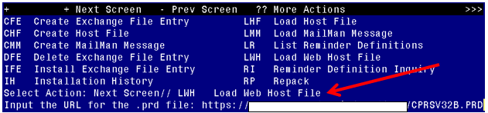

At the **Select Action:** prompt, enter **LWH** for Load Web Host File

At the **Input the url for the .prd file:** prompt, type the following web address:

Terminal window screen shot of the message displaying the URL of the file that was successfully loaded.  Part of the URL has been redacted as it is a VA only internal web site URL.

You should see a message at the top of your screen that the file successfully loaded.

Search and locate an entry titled CPRSV32B IMMUNIZATION REMINDES in reminder exchange

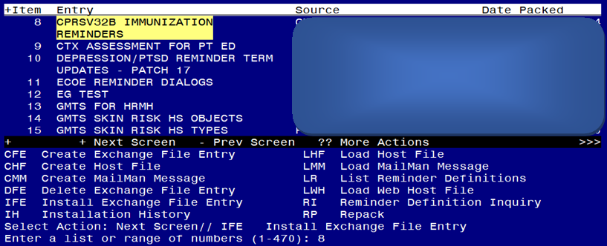

At the **Select Action** prompt, enter **IFE** for Install Exchange File Entry

Enter the number that corresponds with your entry titled CPRSV32B IMMUNIZATION REMINDERS *(in this example it is entry 8, it will vary by site, the date should be 10/14/2022)*

**Do not INSTALL ALL. Follow the screen shots below to only install selected items.**

At the **Select Action** prompt, type **SL** to search for, then at the search for prompt, type **IM PH** after hitting enter, you will see this prompt, Find Next 'IM PH'? Yes// say **No** to stop the search.

Type **IS** to install select item 3, the TIU template field named IM PHARMACY PHONE NUMBERS:

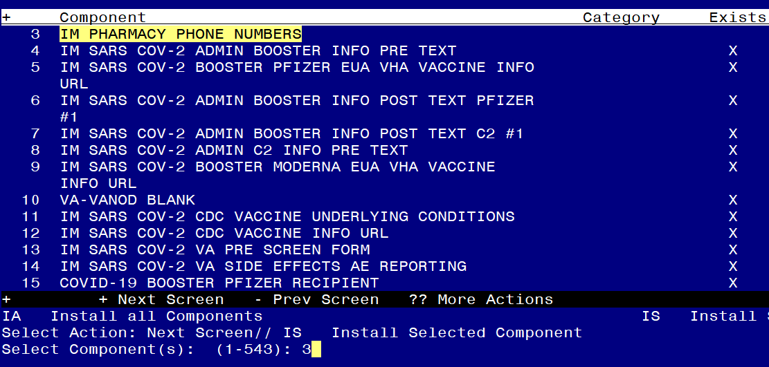

Select Action: Next Screen// **IS**  Install Selected Component

Select Component(s): (1-543): **3**

TIU TEMPLATE FIELD entry IM PHARMACY PHONE NUMBERS is NEW,

what do you want to do?

Select one of the following:

C Create a new entry by copying to a new name

I Install

Q Quit the install

S Skip, do not install this entry

Enter response: I// nstall

++ NOTE: if you have previously installed this file and are prompted to overwrite, choose SKIP. ++

At the **Select Action** prompt, type **SL** to search for, then at the search for prompt, type **80**, after hitting enter, you will see this prompt, Find Next '80'? Yes// say **No** to stop the search.

Type **IS** to install select item **80,85,86**, the TIU TEMPLATE fields named **IM PNEUMOCOCCAL VACCINE SCHEDULE**, **VA-INFLUENZA RECOMMEND** and **VA-INFLUENZA SUMMARY**

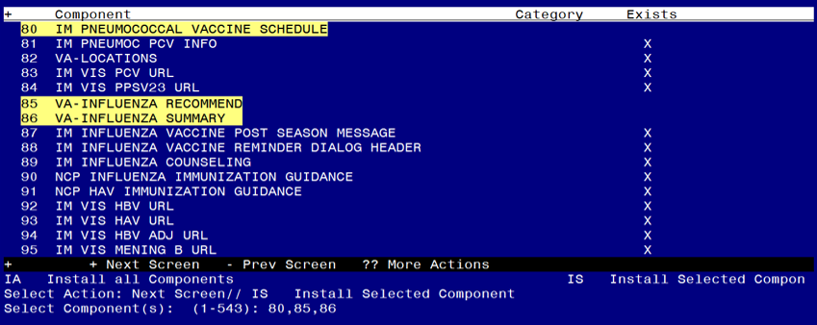

Select Action: Next Screen// **IS** Install Selected Component

Select Component(s): (1-543): **80,85,86**

TIU TEMPLATE FIELD entry IM PNEUMOCOCCAL VACCINE SCHEDULE is NEW,

what do you want to do?

Select one of the following:

C Create a new entry by copying to a new name

I Install

Q Quit the install

S Skip, do not install this entry

Enter response: I// nstall

TIU TEMPLATE FIELD entry VA-INFLUENZA RECOMMEND is NEW,

what do you want to do?

Select one of the following:

C Create a new entry by copying to a new name

I Install

Q Quit the install

S Skip, do not install this entry

Enter response: I// nstall

TIU TEMPLATE FIELD entry VA-INFLUENZA SUMMARY is NEW,

what do you want to do?

Select one of the following:

C Create a new entry by copying to a new name

I Install

Q Quit the install

S Skip, do not install this entry

Enter response: I// nstall

At the **Select Action** prompt, type **SL** to search for, then at the search for prompt, type **119**, after hitting enter, you will see this prompt, Find Next 119? Yes// say **No** to stop the search. Type **IS** to install select item **119,120,121,122** the health factors named COVID-19 VACCINE DEFER PERMANENT, COVID-19 VACCINE DEFER 1Y, COVID-19 VACCINE DEFER 6M, COVID-19 VACCINE DEFER 3M.

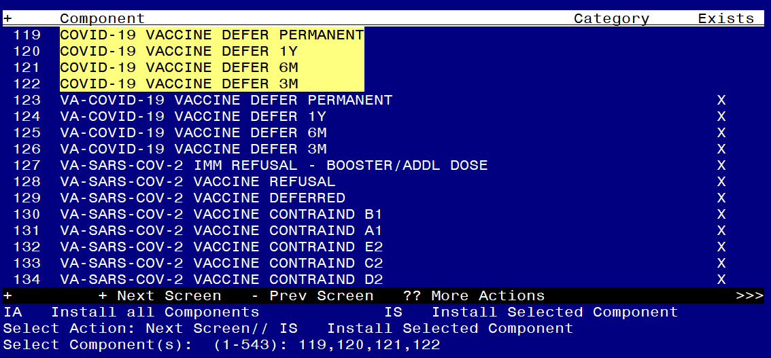

IA Install all Components IS Install Selected Component

Select Action: Next Screen// **IS** Install Selected Component

HEALTH FACTORS entry COVID-19 VACCINE DEFER PERMANENT is NEW,

what do you want to do?

Select one of the following:

C Create a new entry by copying to a new name

I Install

Q Quit the install

S Skip, do not install this entry

Enter response: **I// nstall**

HEALTH FACTORS entry COVID-19 VACCINE DEFER 1Y is NEW,

what do you want to do?

Select one of the following:

C Create a new entry by copying to a new name

I Install

Q Quit the install

S Skip, do not install this entry

Enter response: **I// nstall**

HEALTH FACTORS entry COVID-19 VACCINE DEFER 6M is NEW,

what do you want to do?

Select one of the following:

C Create a new entry by copying to a new name

I Install

Q Quit the install

S Skip, do not install this entry

Enter response: **I// nstall**

HEALTH FACTORS entry COVID-19 VACCINE DEFER 3M is NEW,

what do you want to do?

Select one of the following:

C Create a new entry by copying to a new name

I Install

Q Quit the install

S Skip, do not install this entry

Enter response: **I// nstall**

At the **Select Action** prompt, type **SL** to search for, then at the search for prompt, type **152**, after hitting enter, you will see this prompt, Find Next 152? Yes// say **No** to stop the search.

Type **IS** to install select item **152,153,155,157,159,160,162,164,165,167** the health factors named VA-CLC ADL CARE LEVEL 6-13 , VA-CLC ADL CARE LEVEL 0-5 , VA-CSP COACH SESSION DURATION IN MINUTES , VA-HEMOGLOBIN A1C OUTSIDE LAB , VA-RAI FRAILTY SCORE WITHOUT CANCER, VA-RAI FRAILTY SCORE, VA-SLEEP EPWORTH SCORE, VA-HTN SELF-RECORDED DIASTOLIC BLOOD PRESSURE, VA-HTN SELF-RECORDED SYSTOLIC BLOOD PRESSURE and VA-UPDATE 32B.

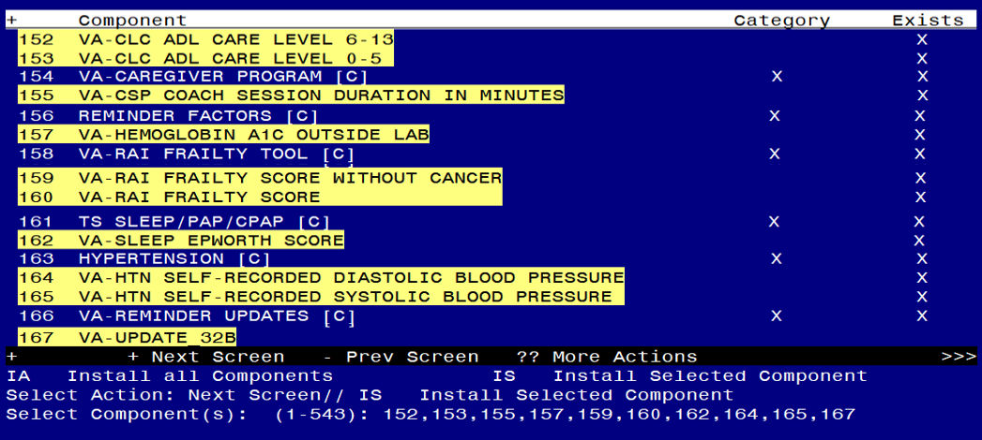

IA Install all Components IS Install Selected Component

Select Action: Next Screen// **IS** Install Selected Component

Select Component(s): (1-543): **152,153,155,157,159,160,162,164,165,167**

HEALTH FACTORS entry named VA-CLC ADL CARE LEVEL 6-13 already exists but the packed component is different, what

do you want to do?

Select one of the following:

C Create a new entry by copying to a new name

O Overwrite the current entry

U Update

Q Quit the install

S Skip, do not install this entry

Enter response: **O// Overwrite the current entry**

Are you sure you want to overwrite? N// **Y**

HEALTH FACTORS entry named VA-CLC ADL CARE LEVEL 0-5 already exists but the packed component is different, what do you want to do?

Select one of the following:

C Create a new entry by copying to a new name

O Overwrite the current entry

U Update

Q Quit the install

S Skip, do not install this entry

Enter response: **O// Overwrite the current entry**

Are you sure you want to overwrite? N// **Y**

HEALTH FACTORS entry named VA-CSP COACH SESSION DURATION IN MINUTES already exists but the packed component is different, what do you want to do?

Select one of the following:

C Create a new entry by copying to a new name

O Overwrite the current entry

U Update

Q Quit the install

S Skip, do not install this entry

Enter response: **O// Overwrite the current entry**

Are you sure you want to overwrite? N// **Y**

HEALTH FACTORS entry named VA-HEMOGLOBIN A1C OUTSIDE LAB already exists but the packed component is different, what do you want to do?

Select one of the following:

C Create a new entry by copying to a new name

O Overwrite the current entry

U Update

Q Quit the install

S Skip, do not install this entry

Enter response: **O// Overwrite the current entry**

Are you sure you want to overwrite? N// **Y**

HEALTH FACTORS entry named VA-RAI FRAILTY SCORE WITHOUT CANCER already exists but the packed component is different, what

do you want to do?

Select one of the following:

C Create a new entry by copying to a new name

O Overwrite the current entry

U Update

Q Quit the install

S Skip, do not install this entry

Enter response: **O// Overwrite the current entry**

Are you sure you want to overwrite? N// **Y**

HEALTH FACTORS entry named VA-RAI FRAILTY SCORE already exists but the packed component is different, what do you want to do?

Select one of the following:

C Create a new entry by copying to a new name

O Overwrite the current entry

U Update

Q Quit the install

S Skip, do not install this entry

Enter response: **O// Overwrite the current entry**

Are you sure you want to overwrite? N// **Y**

HEALTH FACTORS entry named VA-SLEEP EPWORTH SCORE already exists but the packed component is different, what do you want to do?

Select one of the following:

C Create a new entry by copying to a new name

O Overwrite the current entry

U Update

Q Quit the install

S Skip, do not install this entry

Enter response: **O// Overwrite the current entry**

Are you sure you want to overwrite? N// **Y**

HEALTH FACTORS entry named VA-HTN SELF-RECORDED DIASTOLIC BLOOD

PRESSURE already exists but the packed component is different, what do you want to do?

Select one of the following:

C Create a new entry by copying to a new name

O Overwrite the current entry

U Update

Q Quit the install

S Skip, do not install this entry

Enter response: **O// Overwrite the current entry**

Are you sure you want to overwrite? N// **Y**

HEALTH FACTORS entry named VA-HTN SELF-RECORDED SYSTOLIC BLOOD

PRESSURE already exists but the packed component is different, what do you want to do?

Select one of the following:

C Create a new entry by copying to a new name

O Overwrite the current entry

U Update

Q Quit the install

S Skip, do not install this entry

Enter response: **O// Overwrite the current entry**

Are you sure you want to overwrite? N// **Y**

HEALTH FACTORS entry VA-UPDATE_32B is NEW,

what do you want to do?

Select one of the following:

C Create a new entry by copying to a new name

I Install

Q Quit the install

S Skip, do not install this entry

Enter response: **I// nstall**

At the **Select Action** prompt, type **SL** to search for, then at the search for prompt, type **188**, after hitting enter, you will see this prompt, Find Next '188'? Yes// say **No** to stop the search.

Type **IS** to install select items **188,189,198,**  the health factors named VA-INFLUENZA IMM PERM CONTRAINDICATION, VA-INFLUENZA IMM SEASON CONTRAINDICATION and OUTSIDE HEPATITIS B IMMUNITY

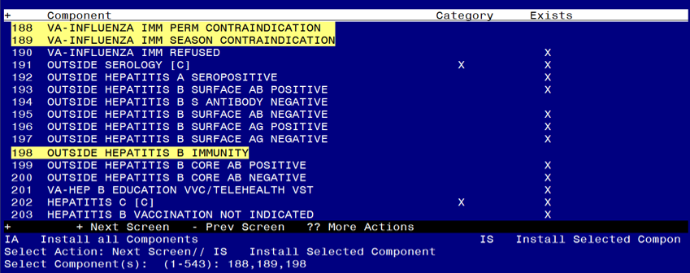

IA Install all Components IS Install Selected Component

Select Action: Next Screen// **IS** Install Selected Component

Select Component(s): (1-543): **188,189,198**

HEALTH FACTORS entry VA-INFLUENZA IMM PERM CONTRAINDICATION is NEW,

what do you want to do?

Select one of the following:

C Create a new entry by copying to a new name

I Install

Q Quit the install

S Skip, do not install this entry

Enter response: **I// nstall**

HEALTH FACTORS entry VA-INFLUENZA IMM SEASON CONTRAINDICATION is NEW, what do you want to do?

Select one of the following:

C Create a new entry by copying to a new name

I Install

Q Quit the install

S Skip, do not install this entry

Enter response: **I// nstall**

HEALTH FACTORS entry OUTSIDE HEPATITIS B IMMUNITY is NEW,

what do you want to do?

Select one of the following:

C Create a new entry by copying to a new name

I Install

Q Quit the install

S Skip, do not install this entry

Enter response: **I// nstall**

At the **Select Action** prompt, type **SL** to search for, then at the search for prompt, type **252**, after hitting enter, you will see this prompt, Find Next '252'? Yes// say **No** to stop the search.

Type **IS** to install select item **252,** the reminder sponsor named VHA Office of Mental Health and Suicide Prevention

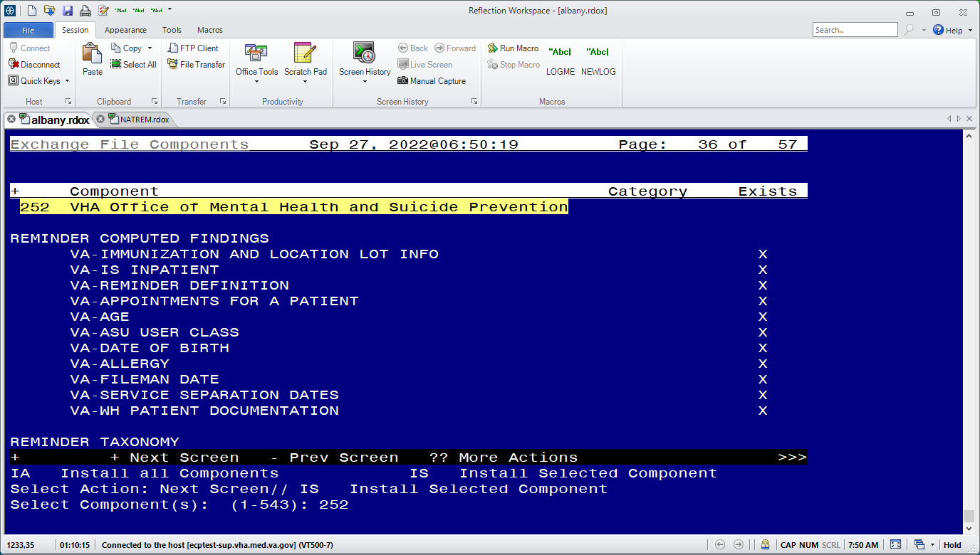

IA Install all Components IS Install Selected Component

Select Action: Next Screen// **IS** Install Selected Component

Select Component(s): (1-543): **252**

REMINDER SPONSOR entry VHA Office of Mental Health and Suicide Prevention is NEW, what do you want to do?

Select one of the following:

C Create a new entry by copying to a new name

I Install

Q Quit the install

S Skip, do not install this entry

Enter response: I// nstall

At the **Select Action** prompt, type **SL** to search for, then at the search for prompt, type **279**, after hitting enter, you will see this prompt, Find Next '279'? Yes// say **No** to stop the search.

Type **IS** to install select item **279,280,** the reminder terms named VA-IM NO DOSES AVAIL PFZ 300, VA-IM NO DOSES AVAIL MOD 229.

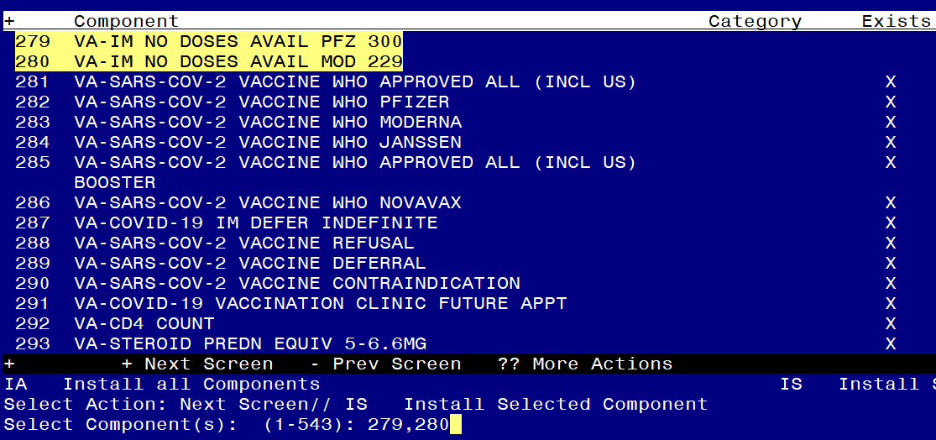

IA Install all Components IS Install Selected Component

Select Action: Next Screen// **IS** Install Selected Component

Select Component(s): (1-543): **279,280**

REMINDER TERM entry VA-IM NO DOSES AVAIL PFZ 300 is NEW,

what do you want to do?

Select one of the following:

C Create a new entry by copying to a new name

I Install

Q Quit the install

S Skip, do not install this entry

Enter response: I// nstall

REMINDER TERM entry VA-IM NO DOSES AVAIL mod 229 is NEW,

what do you want to do?

Select one of the following:

C Create a new entry by copying to a new name

I Install

Q Quit the install

S Skip, do not install this entry

Enter response: I// nstall

At the **Select Action** prompt, type enter to go to the next page.

Type **IS** to install select item **301**, the REMINDER TERM named VA-IM NO DOSES AVAIL PFZ TS 217

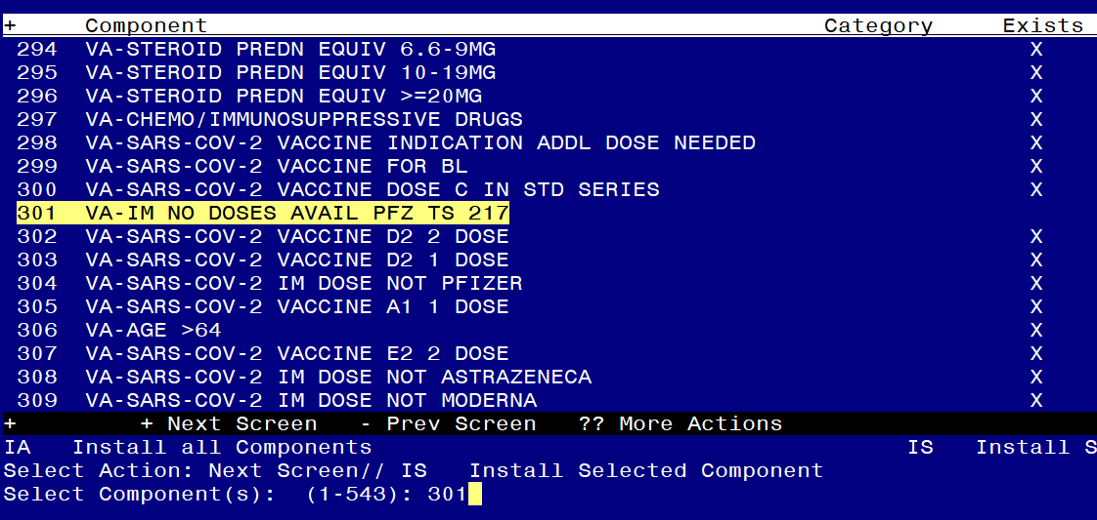

Select Action: Next Screen// **IS** Install Selected Component

Select Component(s): (1-543): **301**

REMINDER TERM entry VA-IM NO DOSES AVAIL PFZ TS 217 is NEW,

what do you want to do?

Select one of the following:

C Create a new entry by copying to a new name

I Install

Q Quit the install

S Skip, do not install this entry

Enter response: I// nstall

At the **Select Action** prompt, type enter to go to the next page.

Type IS to install select items **311,315,318,320,322,323** the REMINDER TERMS named VA-IM NO DOSES AVAIL NOV 211, VA-IM NO DOSES AVAIL JSN 212, VA-IM NO DOSES AVAIL PFZ 208, VA-IM NO DOSES AVAIL MOD 207, VA-COVID-19 CONTRAINDICATION and VA-IM NO DOSES AVAIL MONKEYPOX 206.

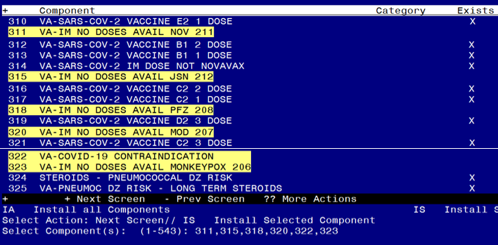

Select Action: Next Screen// **IS** Install Selected Component

Select Component(s): (1-543): **311,315,318,320,322,323**

REMINDER TERM entry VA-IM NO DOSES AVAIL NOV 211 is NEW,

what do you want to do?

Select one of the following:

C Create a new entry by copying to a new name

I Install

Q Quit the install

S Skip, do not install this entry

Enter response: I// nstall

REMINDER TERM entry VA-IM NO DOSES AVAIL JSN 212 is NEW,

what do you want to do?

Select one of the following:

C Create a new entry by copying to a new name

I Install

Q Quit the install

S Skip, do not install this entry

Enter response: I// nstall

REMINDER TERM entry VA-IM NO DOSES AVAIL PFZ 208 is NEW,

what do you want to do?

Select one of the following:

C Create a new entry by copying to a new name

I Install

Q Quit the install

S Skip, do not install this entry

Enter response: I// nstall

REMINDER TERM entry VA-IM NO DOSES AVAIL MOD 207 is NEW,

what do you want to do?

Select one of the following:

C Create a new entry by copying to a new name

I Install

Q Quit the install

S Skip, do not install this entry

Enter response: I// nstall

REMINDER TERM entry VA-COVID-19 CONTRAINDICATION is NEW,

what do you want to do?

Select one of the following:

C Create a new entry by copying to a new name

I Install

Q Quit the install

S Skip, do not install this entry

Enter response: I// nstall

REMINDER TERM entry VA-IM NO DOSES AVAIL MONKEYPOX 206 is NEW,

what do you want to do?

Select one of the following:

C Create a new entry by copying to a new name

I Install

Q Quit the install

S Skip, do not install this entry

Enter response: I// nstall

At the **Select Action** prompt, hit enter to go to the next page.

Type **IS** to install select items **334,335,336** the REMINDER TERMS named.

VA-IM NO DOSES AVAIL PCV13 133, VA-IM NO DOSES AVAIL PCV20 216 and VA-IM NO DOSES AVAIL PCV15 215.

Screen shot showing when the components 326-341  are displayed, the "Select Action:" prompt has the entry "IS", and the Selected Component(s) entry is  334,335,336   corresponding to the REMINDER TERMS named.
VA-IM NO DOSES AVAIL PCV13 133, VA-IM NO DOSES AVAIL PCV20 216 and VA-IM NO DOSES AVAIL PCV15 215 as described in the text.

Select Action: Next Screen// **IS** Install Selected Component

Select Component(s): (1-543): **334,335,336**

REMINDER TERM VA-IM NO DOSES AVAIL PCV13 133 is NEW, what do you want to do?

Select one of the following:

C Create a new entry by copying to a new name

I Install

Q Quit the install

S Skip, do not install this entry

Enter response: I// nstall

REMINDER TERM VA-IM NO DOSES AVAIL PCV20 216 is NEW, what do you want to do?

Select one of the following:

C Create a new entry by copying to a new name

I Install

Q Quit the install

S Skip, do not install this entry

Enter response: I// nstall

REMINDER TERM VA-IM NO DOSES AVAIL PCV15 215 is NEW, what do you want to do?

Select one of the following:

C Create a new entry by copying to a new name

I Install

Q Quit the install

S Skip, do not install this entry

Enter response: I// nstall

At the **Select Action** prompt, hit enter to go to the next page.

Type **IS** to install select items **347,357** the REMINDER TERMS named VA-IM NO DOSES AVAIL PPSV23 33 and VA-INFLUENZA CONTRAINDICATION.

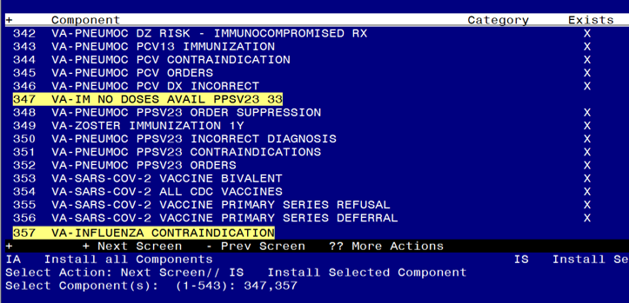

Select Action: Next Screen// **IS** Install Selected Component

Select Component(s): (1-543): **347,357**

REMINDER TERM entry VA-IM NO DOSES AVAIL PPSV23 33 is NEW,

what do you want to do?

Select one of the following:

C Create a new entry by copying to a new name

I Install

Q Quit the install

S Skip, do not install this entry

Enter response: I// nstall

REMINDER TERM entry VA-INFLUENZA CONTRAINDICATION is NEW,

what do you want to do?

Select one of the following:

C Create a new entry by copying to a new name

I Install

Q Quit the install

S Skip, do not install this entry

Enter response: I// nstall

At the **Select Action** prompt, hit enter to go to the next page.

Type **IS** to install select items **360,361,362,363,365,366,367,370**

the REMINDER TERMS named, VA-IM NO DOSES AVAIL FLU 185, VA-IM NO DOSES AVAIL FLU 186, VA-IM NO DOSES AVAIL FLU 171, VA-IM NO DOSES AVAIL FLU 197, VA-IM NO DOSES AVAIL FLU 205, VA-IM NO DOSES AVAIL FLU 158, VA-IM NO DOSES AVAIL FLU 150 and VA-INFLUENZA IMM CONTRAINDICATION.

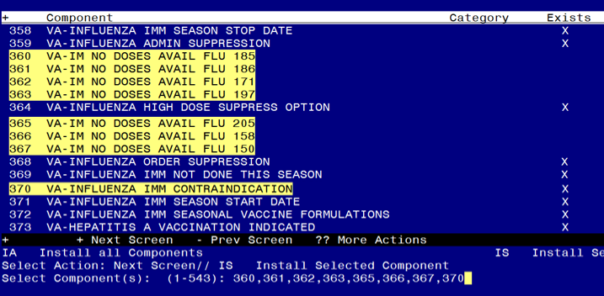

Select Action: Next Screen// **IS**  Install Selected Component

Select Component(s): (1-543): **360,361,362,363,365,366,367,370**

REMINDER TERM entry VA-IM NO DOSES AVAIL FLU 185 is NEW, what do you want to do?

Select one of the following:

C Create a new entry by copying to a new name

I Install

Q Quit the install

S Skip, do not install this entry

Enter response: I// nstall

REMINDER TERM entry VA-IM NO DOSES AVAIL FLU 186 is NEW, what do you want to do?

Select one of the following:

C Create a new entry by copying to a new name

I Install

Q Quit the install

S Skip, do not install this entry

Enter response: I// nstall

REMINDER TERM entry VA-IM NO DOSES AVAIL FLU 171 is NEW, what do you want to do?

Select one of the following:

C Create a new entry by copying to a new name

I Install

Q Quit the install

S Skip, do not install this entry

Enter response: I// nstall

REMINDER TERM entry VA-IM NO DOSES AVAIL FLU 197 is NEW, what do you want to do?

Select one of the following:

C Create a new entry by copying to a new name

I Install

Q Quit the install

S Skip, do not install this entry

Enter response: I// nstall

REMINDER TERM entry VA-IM NO DOSES AVAIL FLU 205 is NEW, what do you want to do?

Select one of the following:

C Create a new entry by copying to a new name

I Install

Q Quit the install

S Skip, do not install this entry

Enter response: I// nstall

REMINDER TERM entry VA-IM NO DOSES AVAIL FLU 158 is NEW, what do you want to do?

Select one of the following:

C Create a new entry by copying to a new name

I Install

Q Quit the install

S Skip, do not install this entry

Enter response: I// nstall

REMINDER TERM entry VA-IM NO DOSES AVAIL FLU 150 is NEW, what do you want to do?

Select one of the following:

C Create a new entry by copying to a new name

I Install

Q Quit the install

S Skip, do not install this entry

Enter response: I// nstall

REMINDER TERM entry named VA-INFLUENZA IMM CONTRAINDICATION already

exists but the packed component is different, what do you want to do?

Select one of the following:

C Create a new entry by copying to a new name

M Merge findings

O Overwrite the current entry

U Update

Q Quit the install

S Skip, do not install this entry

Enter response: O// verwrite the current entry

Are you sure you want to overwrite? N// YES

At the **Select Action** prompt, type enter to go to the next page.

Type IS to install select items **388,389** the REMINDER TERMS named VA-IM NO DOSES AVAIL HBV DIAL 44 and VA-IM NO DOSES AVAIL HBV/HAV 104,.

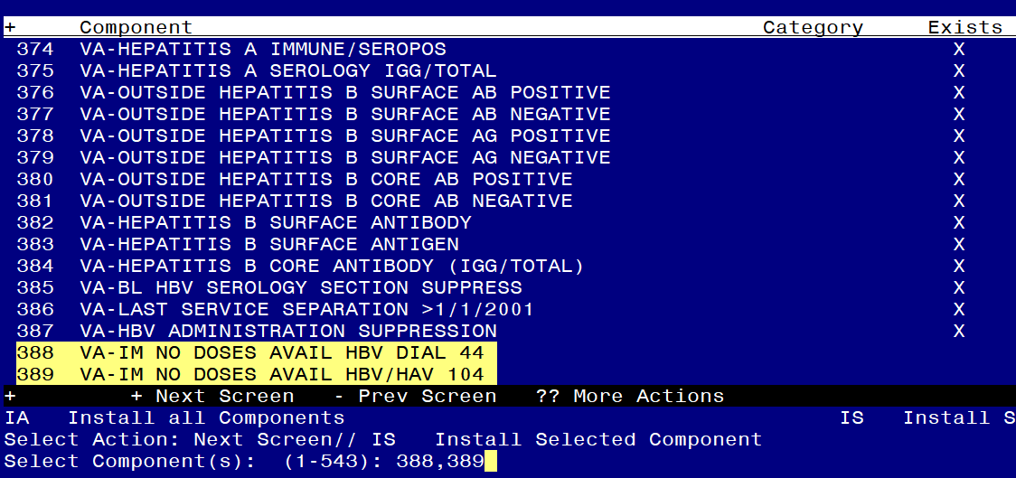

Select Action: Next Screen// **IS** Install Selected Component

Select Component(s): (1-543): **388,389**

REMINDER TERM entry named VA-IM NO DOSES AVAIL HBV DIAL 44 is NEW, what do you want to do?

Select one of the following:

C Create a new entry by copying to a new name

I Install

Q Quit the install

S Skip, do not install this entry

Enter response: I// nstall

REMINDER TERM VA-IM NO DOSES AVAIL HBV/HAV 104 is NEW, what do you want to do?

Select one of the following:

C Create a new entry by copying to a new name

I Install

Q Quit the install

S Skip, do not install this entry

Enter response: I// nstall

At the **Select Action** prompt, hit enter to go to the next page.

Type **IS** to install select items **390,391,403** reminder terms VA-IM NO DOSES AVAIL HBV-CPG 189 , VA-IM NO DOSES AVAIL HBV ADULT 43 and VA-IM NO DOSES AVAIL MEN B OMV 163.

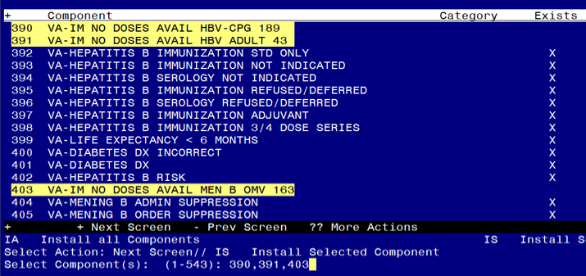

Select Action: Next Screen// **IS Install Selected Component**

Select Component(s): (1-543): **390,391,403**

REMINDER TERM entry VA-IM NO DOSES AVAIL HBV-CPG 189 is NEW,

what do you want to do?

Select one of the following:

C Create a new entry by copying to a new name

I Install

Q Quit the install

S Skip, do not install this entry

Enter response: I// nstall

REMINDER TERM VA-IM NO DOSES AVAIL HBV ADULT 43 is NEW, what do you want to do?

Select one of the following:

C Create a new entry by copying to a new name

I Install

Q Quit the install

S Skip, do not install this entry

Enter response: I// nstall

REMINDER TERM VA-IM NO DOSES AVAIL MEN B OMV 163 is NEW, what do you want to do?

Select one of the following:

C Create a new entry by copying to a new name

I Install

Q Quit the install

S Skip, do not install this entry

Enter response: I// nstall

At the **Select Action** prompt, hit enter to go to the next page.

Type **IS** to install select items **413** reminder term VA-IM NO DOSES AVAIL MEN ACWY OMV 136.

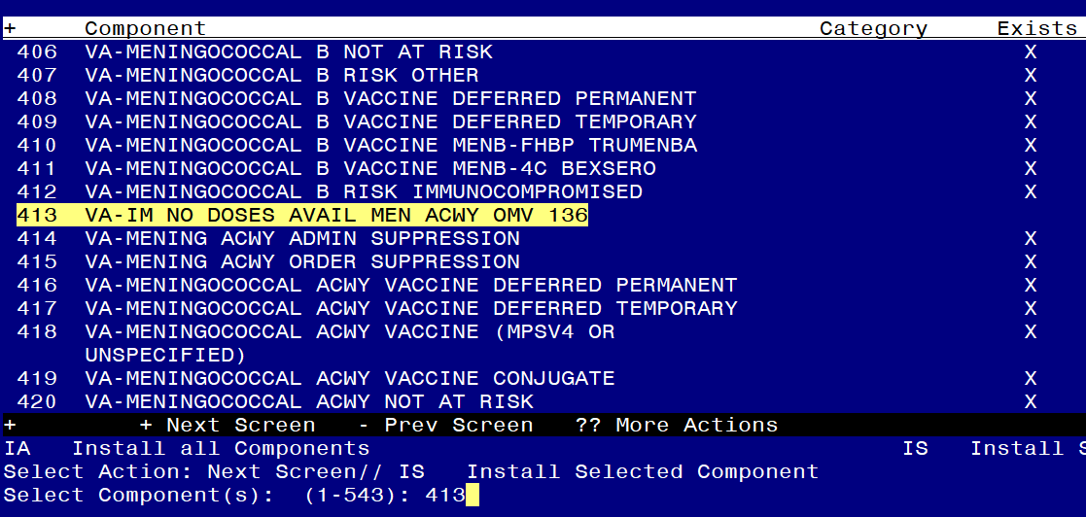

Select Action: Next Screen// **IS Install Selected Component**

Select Component(s): (1-543): **413**

VA-IM NO DOSES AVAIL MEN ACWY OMV 136 is NEW, what do you want to do?

Select one of the following:

C Create a new entry by copying to a new name

I Install

Q Quit the install

S Skip, do not install this entry

Enter response: I// nstall

At the **Select Action** prompt, hit enter to go to the next page. Type **IS** to install select items **424,435** reminder terms VA-IM NO DOSES AVAIL HPV9 165 and VA-IM NO DOSES AVAIL HERPES ZOSTER 187.

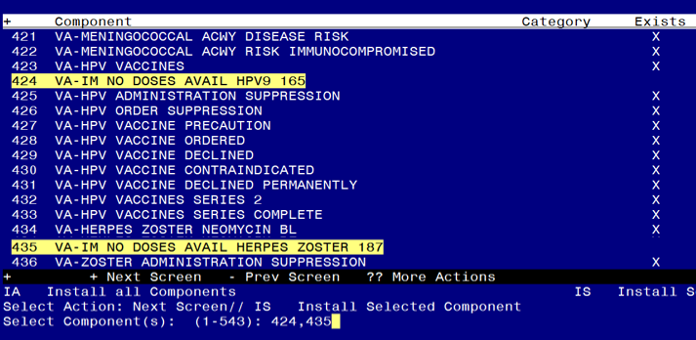

Select Action: Next Screen// **IS Install Selected Component**

Select Component(s): (1-543): **424,435**

REMINDER TERM VA-IM NO DOSES AVAIL HPV9 165 is NEW, what do you want to do?

Select one of the following:

C Create a new entry by copying to a new name

I Install

Q Quit the install

S Skip, do not install this entry

Enter response: I// nstall

REMINDER TERM entry VA-IM NO DOSES AVAIL HERPES ZOSTER 187 is NEW,

what do you want to do?

Select one of the following:

C Create a new entry by copying to a new name

I Install

Q Quit the install

S Skip, do not install this entry

Enter response: I// nstall

At the **Select Action** prompt, hit enter to go to the next page.

Type **IS** to install select items **447** reminder term VA-IM NO DOSES AVAIL TDAP.

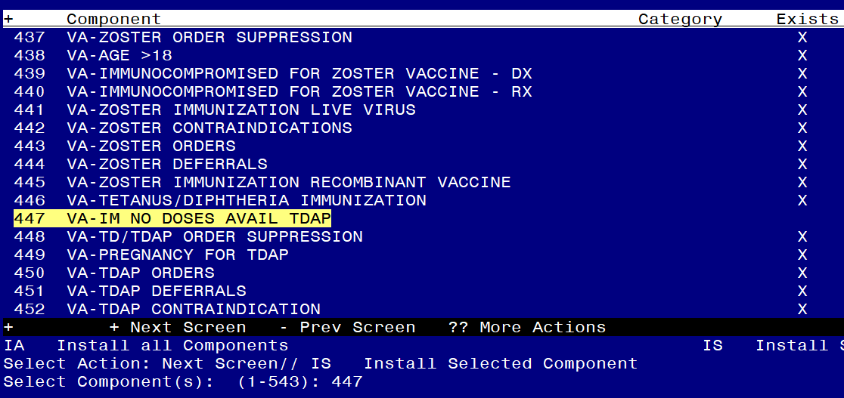

Select Action: Next Screen// **IS Install Selected Component**

Select Component(s): (1-543): **447**

VA-IM NO DOSES AVAIL TDAP is NEW, what do you want to do?

Select one of the following:

C Create a new entry by copying to a new name

I Install

Q Quit the install

S Skip, do not install this entry

Enter response: I// nstall

At the **Select Action** prompt, hit enter to go to the next page.

Type **IS** to install select item 454, reminder term VA-IM NO DOSES AVAIL TD 09 & 113.

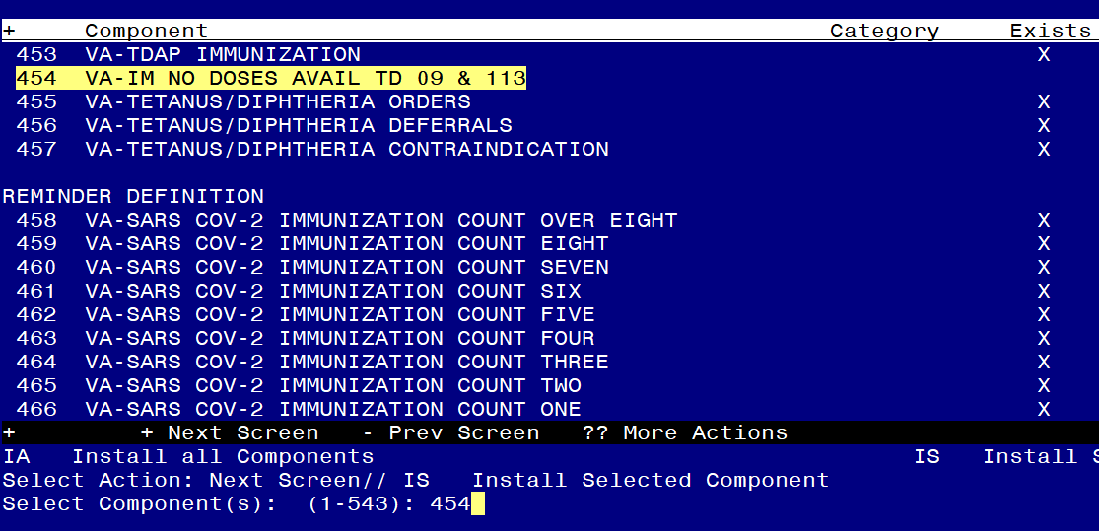

Select Action: Next Screen// **IS Install Selected Component**

Select Component(s): (1-543): **454**

REMINDER TERM VA-IM NO DOSES AVAIL TD 09 & 113 is NEW, what do you want to do?

Select one of the following:

C Create a new entry by copying to a new name

I Install

Q Quit the install

S Skip, do not install this entry

Enter response: I// nstall

At the **Select Action** prompt, hit enter to go to the next page.

Type **IS** to install select item **470,476,478,479,480,481,482,** the reminder definitionsVAL-BL COVID-19 CONTRAINDICATION, VA-PNEUMOCOCCAL IMMUNIZATION PCV13, VA-PNEUMOCOCCAL IMMUNIZATION PPSV23, VA-SARS COV-2 IMMUNIZATION PRIMARY SERIES , VA-SARS COV-2 IMMUNIZATION BOOSTER SERIES, VAL-BL INFLUENZA CONTRAINDICATION and VA-INFLUENZA SEASONAL IMMUNIZATION.

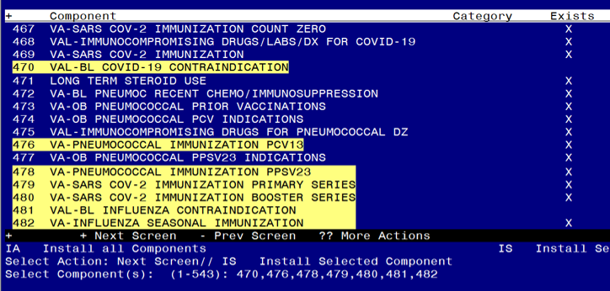

Select Action: Next Screen// **IS Install Selected Component**

Select Component(s): (1-543): **470,476,478,479,480,481,482**

REMINDER DEFINITION entry named VAL-BL COVID-19 CONTRAINDICATION is NEW, what do you want to do?

Select one of the following:

C Create a new entry by copying to a new name

O Overwrite the current entry

U Update

Q Quit the install

S Skip, do not install this entry

Enter response: I// nstall

REMINDER DEFINITION entry named VA-PNEUMOCOCCAL IMMUNIZATION PCV13 already exists but the packed component is different, what do you want to do?

Select one of the following:

C Create a new entry by copying to a new name

O Overwrite the current entry

U Update

Q Quit the install

S Skip, do not install this entry

Enter response: **O// Overwrite the current entry**

Are you sure you want to overwrite? N// **Y**

REMINDER DEFINITION entry named VA-PNEUMOCOCCAL IMMUNIZATION PPSV23 already exists but the packed component is different, what do you want to do?

Select one of the following:

C Create a new entry by copying to a new name

O Overwrite the current entry

U Update

Q Quit the install

S Skip, do not install this entry

Enter response: **O// Overwrite the current entry**

Are you sure you want to overwrite? N// **Y**

REMINDER DEFINITION entry named VA-SARS COV-2 IMMUNIZATION PRIMARY SERIES already exists but the packed component is different, what do you want to do?

Select one of the following:

C Create a new entry by copying to a new name

O Overwrite the current entry

U Update

Q Quit the install

S Skip, do not install this entry

Enter response: **O// Overwrite the current entry**

Are you sure you want to overwrite? N// **Y**

REMINDER DEFINITION entry named VA-SARS COV-2 IMMUNIZATION BOOSTER SERIES already exists but the packed component is different, what do you want to do?

Select one of the following:

C Create a new entry by copying to a new name

O Overwrite the current entry

U Update

Q Quit the install

S Skip, do not install this entry

Enter response: **O// Overwrite the current entry**

Are you sure you want to overwrite? N// **Y**

REMINDER DEFINITION entry named VAL-BL INFLUENZA CONTRAINDICATION is NEW, what do you want to do?

Select one of the following:

C Create a new entry by copying to a new name

O Overwrite the current entry

U Update

Q Quit the install

S Skip, do not install this entry

Enter response: I// nstall

REMINDER DEFINITION entry named VA-INFLUENZA SEASONAL IMMUNIZATION already exists but the packed component is different, what do you want to do?

Select one of the following:

C Create a new entry by copying to a new name

O Overwrite the current entry

U Update

Q Quit the install

S Skip, do not install this entry

Enter response: **O// Overwrite the current entry**

Are you sure you want to overwrite? N// **Y**

At the **Select Action** prompt, hit enter to go to the next page. Type **IS** to install select items **484,485,486,487,489,491,493,494** reminder definitions VA-HEPATITIS B IMMUNIZATION, VA-HEPATITIS B SEROLOGY/IMMUNIZATION , VA-MENINGOCOCCAL B IMMUNIZATION, VA-MENINGOCOCCAL ACWY IMMUNIZATION, VA-HUMAN PAPILLOMAVIRUS (HPV) IMMUNIZATION, VA-HERPES ZOSTER (SHINGLES) IMMUNIZATION, VA-TETANUS/DIPHTHERIA/PERTUSSIS (TDAP) IMMUNIZATION, VA-TETANUS/DIPHTHERIA (TD) IMMUNIZATION,.

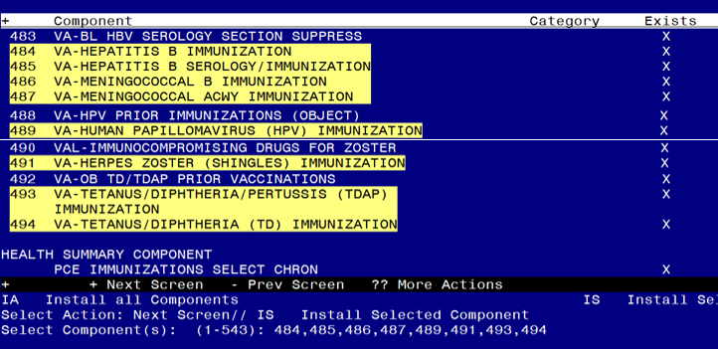

Select Action: Next Screen// **IS Install Selected Component**

Select Component(s): (1-543): **484,485,486,487,489,491,493,494**

REMINDER DEFINITION entry named VA-HEPATITIS B IMMUNIZATION already exists but the packed component is different, what do you want to do?

Select one of the following:

C Create a new entry by copying to a new name

O Overwrite the current entry

U Update

Q Quit the install

S Skip, do not install this entry

Enter response: **O// Overwrite the current entry**

Are you sure you want to overwrite? N// **Y**

REMINDER DEFINITION entry named VA-HEPATITIS B SEROLOGY/IMMUNIZATION

already exists but the packed component is different, what do you want to do?

Select one of the following:

C Create a new entry by copying to a new name

O Overwrite the current entry

U Update

Q Quit the install

S Skip, do not install this entry

Enter response: **O// Overwrite the current entry**

Are you sure you want to overwrite? N// **Y**

REMINDER DEFINITION entry named VA-MENINGOCOCCAL B IMMUNIZATION already exists but the packed component is different, what do you

want to do?

Select one of the following:

C Create a new entry by copying to a new name

O Overwrite the current entry

U Update

Q Quit the install

S Skip, do not install this entry

Enter response: **O// Overwrite the current entry**

Are you sure you want to overwrite? N// **Y**

REMINDER DEFINITION entry named VA-MENINGOCOCCAL ACWY IMMUNIZATION already exists but the packed component is different, what do you

want to do?

Select one of the following:

C Create a new entry by copying to a new name

O Overwrite the current entry

U Update

Q Quit the install

S Skip, do not install this entry

Enter response: **O// Overwrite the current entry**

Are you sure you want to overwrite? N// **Y**

REMINDER DEFINITION entry named VA-HUMAN PAPILLOMAVIRUS (HPV) IMMUNIZATION already exists but the packed component is different, what do you

want to do?

Select one of the following:

C Create a new entry by copying to a new name

O Overwrite the current entry

U Update

Q Quit the install

S Skip, do not install this entry

Enter response: **O// Overwrite the current entry**

Are you sure you want to overwrite? N// **Y**

REMINDER DEFINITION entry named VA-HERPES ZOSTER (SHINGLES) IMMUNIZATION already exists but the packed component is different, what do you

want to do?

Select one of the following:

C Create a new entry by copying to a new name

O Overwrite the current entry

U Update

Q Quit the install

S Skip, do not install this entry

Enter response: **O// Overwrite the current entry**

Are you sure you want to overwrite? N// **Y**

REMINDER DEFINITION entry named VA-TETANUS/DIPHTHERIA/PERTUSSIS (TDAP) IMMUNIZATION already exists but the packed component is different, what do you want to do?

Select one of the following:

C Create a new entry by copying to a new name

O Overwrite the current entry

U Update

Q Quit the install

S Skip, do not install this entry

Enter response: **O// Overwrite the current entry**

Are you sure you want to overwrite? N// **Y**

REMINDER DEFINITION entry named VA-TETANUS/DIPHTHERIA (TD) IMMUNIZATION already exists but the packed component is different, what do you

want to do?

Select one of the following:

C Create a new entry by copying to a new name

O Overwrite the current entry

U Update

Q Quit the install

S Skip, do not install this entry

Enter response: **O// Overwrite the current entry**

Are you sure you want to overwrite? N// **Y**

At the **Select Action** prompt, hit enter to go to the next page.

Type **IS** to install select items **496,500,** the health summary types VA-COVID CONTRA and VA-INFLUENZA CONTRA

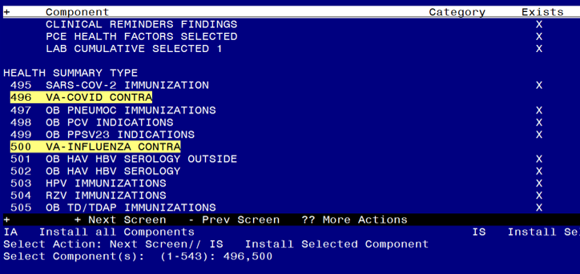

Select Action: Next Screen// **IS Install Selected Component**

Select Component(s): (1-543): **496,500**

HEALTH SUMMARY TYPE entry named VA-COVID CONTRA is NEW, what do you want to do?

Select one of the following:

C Create a new entry by copying to a new name

I Install

Q Quit the install

S Skip, do not install this entry

Enter response: **I// nstall**

HEALTH SUMMARY TYPE entry named VA-INFLUENZA CONTRA is NEW, what do you want to do?

Select one of the following:

C Create a new entry by copying to a new name

I Install

Q Quit the install

S Skip, do not install this entry

Enter response: **I// nstall**

At the **Select Action** prompt, hit enter to go to the next page.

Type **IS** to install select items **507,511,** the health summary objects VA-COVID CONTRA (TIU) and VA-INFLUENZA CONTRA (TIU).

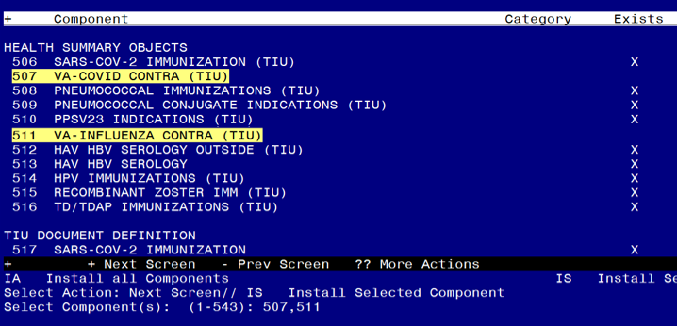

Select Action: Next Screen// **IS Install Selected Component**

Select Component(s): (1-543): **507,511**

HEALTH SUMMARY OBJECT entry named VA-COVID CONTRA (TIU) is NEW, what do you want to do?

Select one of the following:

C Create a new entry by copying to a new name

I Install

Q Quit the install

S Skip, do not install this entry

Enter response: **I// nstall**

HEALTH SUMMARY OBJECT entry named VA-INFLUENZA CONTRA (TIU) is NEW, what do you want to do?

Select one of the following:

C Create a new entry by copying to a new name

I Install

Q Quit the install

S Skip, do not install this entry

Enter response: **I// nstall**

At the **Select Action** prompt, hit enter to go to the next page.

Type **IS** to install select items **518,522,** the TIU document definitions VA-COVID CONTRA and VA-INFLUENZA CONTRA

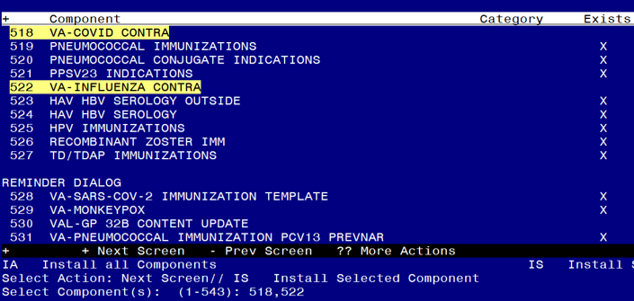

Select Action: Next Screen// **IS Install Selected Component**

Select Component(s): (1-543): **518,522**

TIU DOCUMENT DEFINITION entry named VA-COVID CONTRA is NEW, what do you want to do?

Select one of the following:

C Create a new entry by copying to a new name

I Install

Q Quit the install

S Skip, do not install this entry

Enter response: **I// nstall**

TIU DOCUMENT DEFINITION entry named VA-INFLUENZA CONTRA is NEW, what do you want to do?

Select one of the following:

C Create a new entry by copying to a new name

I Install

Q Quit the install

S Skip, do not install this entry

Enter response: **I// nstall**

You should see the first of the reminder dialog components displaying on your screen, you will Type **IS** to install select ALL REMAINING ITEMS IN THE FILE (including the items you cannot see on the screen), **528-543** :

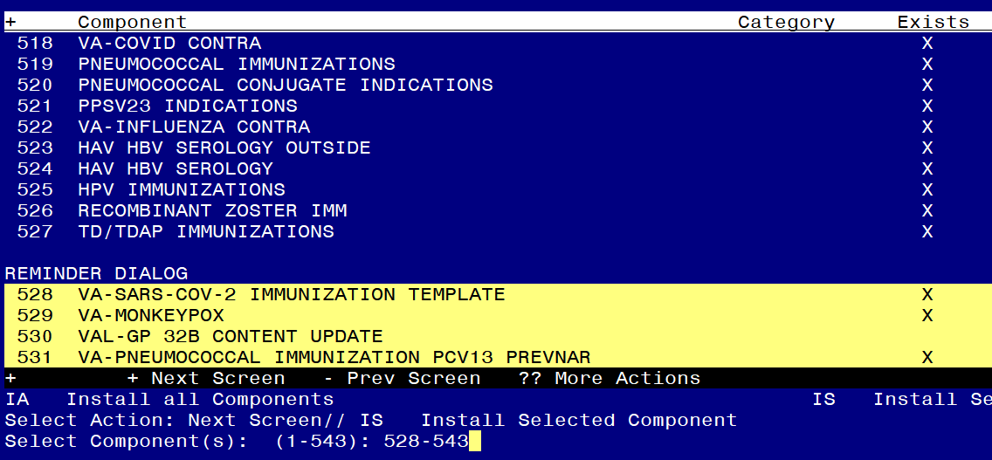

At the **Select Action** prompt, type **IS** to install selected component, then at the Select Component(s) prompt, type **528-543** to install selected ONLY the reminder dialogs.

Select Action: Next Screen// **IS Install Selected Component**

Select Component(s): (1-543): **528-543**

**You will be promped to install the FIRST dialog component, VA-SARS-COV-2 IMMUNIZATION TEMPLATE:**

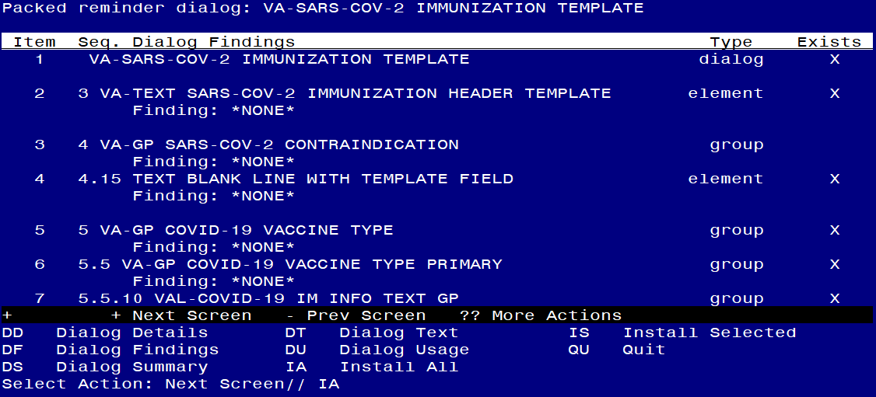

At the **Select Action** prompt, type **IA** to install the dialog – **VA-SARS-COV-2 IMMUNIZATION TEMPLATE**

**Select Action: Next Screen// IA Install All**

Install reminder dialog and all components with no further changes: Y// ES

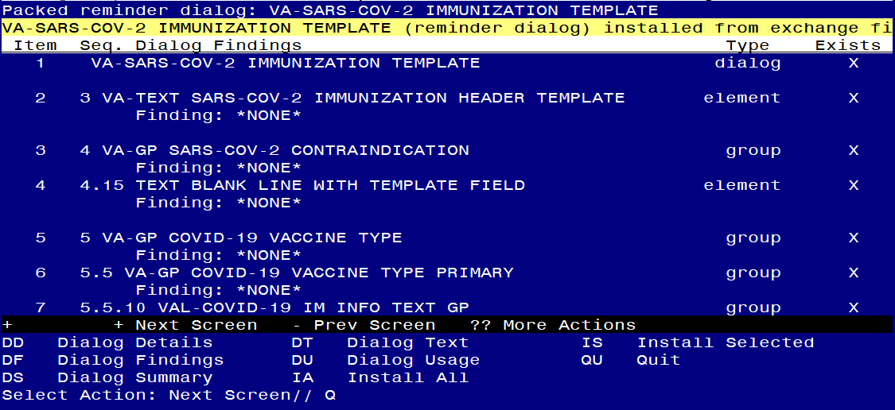

When the dialog has completed installation, you will then be returned to this screen. At the **Select Action** prompt, type **Q.**

**You will be promped to install the NEXT dialog component, VA-MONKEYPOX:**

Regarding the VA Reminder Dialog: VA MONKEYPOX:
Screen shot of the terminal window showing a list of elements, groups and dialogs with the text with IA for "Install All" entered at the "Select Action:" Prompt.  The correct entry is described in the text.

At the **Select Action** prompt, type **IA** to install the dialog – **VA-MONKEYPOX**

**Select Action: Next Screen// IA Install All**

Install reminder dialog and all components with no further changes: Y// ES

Regarding the VA Reminder Dialog: VA MONKEYPOX:
Screen shot of the last of the list of elements, groups and dialogs that needed to be installed with a Q for quit entered at the "Select Action:" prompt because they now all exist.  

When the dialog has completed installation, you will then be returned to this screen. At the **Select Action** prompt, type **Q.**

**You will be promped to install the NEXT dialog component, VAL-GP 32B CONTENT UPDATE:**

Regarding the reminder dialog: VAL GP 32B CONTENT UPDATE:
Screen shot of the terminal window showing a list of elements, groups and dialogs with the text with IA for "Install All" entered at the "Select Action:" Prompt.  The correct entry is described in the text.

At the **Select Action** prompt, type **IA** to install the dialog – **VAL-GP 32B CONTENT UPDATE**

**Select Action: Next Screen// IA Install All**

Install reminder dialog and all components with no further changes: Y// ES

Regarding the reminder dialog: VAL GP 32B CONTENT UPDATE:
Screen shot of the last of the list of elements, groups and dialogs that needed to be installed with a Q for quit entered at the "Select Action:" prompt because they now all exist.  

When the dialog has completed installation, you will then be returned to this screen. At the **Select Action** prompt, type **Q.**

**You will be promped to install the NEXT dialog component, VA-PNEUMOCOCCAL IMMUNIZATION PCV13 PREVNAR:**

Regarding the Reminder Dialog:VA-PNEUMOCOCCAL IMMUNIZATON PCV13 PREVNAR: 
Screen shot of the terminal window showing a list of elements, groups and dialogs with the text with IA for "Install All" entered at the "Select Action:" Prompt.  The correct entry is described in the text.

At the **Select Action** prompt, type **IA** to install the dialog – **VA-PNEUMOCOCCAL IMMUNIZATION PCV13 PREVNAR**

**Select Action: Next Screen// IA Install All**

Install reminder dialog and all components with no further changes: Y// ES

Regarding the Reminder Dialog:VA-PNEUMOCOCCAL IMMUNIZATON PCV13 PREVNAR: 
Screen shot of the last of the list of elements, groups and dialogs that needed to be installed with a Q for quit entered at the "Select Action:" prompt because they now all exist.  

When the dialog has completed installation, you will then be returned to this screen. At the **Select Action** prompt, type **Q.**

**You will be promped to install the NEXT dialog component, VA-PNEUMOCOCCAL IMMUNIZATION PPSV23 PNEUMOVAX:**

Regarding the Reminder Dialog , VA-PNEUMOCOCCAL IMMUNIZATION PPSV23 PNEUMOVAX:
Screen shot of the terminal window showing a list of elements, groups and dialogs with the text with IA for "Install All" entered at the "Select Action:" Prompt.  The correct entry is described in the text

At the **Select Action** prompt, type **IA** to install the dialog – **VA-PNEUMOCOCCAL IMMUNIZATION PPSV23 PNEUMOVAX**

**Select Action: Next Screen// IA Install All**

Install reminder dialog and all components with no further changes: Y// ES

Regarding the Reminder Dialog , VA-PNEUMOCOCCAL IMMUNIZATION PPSV23 PNEUMOVAX:
Screen shot of the last of the list of elements, groups and dialogs that needed to be installed with a Q for quit entered at the "Select Action:" prompt because they now all exist.  

When the dialog has completed installation, you will then be returned to this screen. At the **Select Action** prompt, type **Q.**

**You will be promped to install the next dialog component, VA-SARS-COV-2 BOOSTER IMMUNIZATION:**

Regarding the Reminder Dialog VA-SARS-COV-2 BOOSTER IMMUNIZATION:
Screen shot of the terminal window showing a list of elements, groups and dialogs with the text with IA for "Install All" entered at the "Select Action:" Prompt.  The correct entry is described in the text.

At the **Select Action** prompt, type **IA** to install the dialog – **VA-SARS-COV-2 BOOSTER IMMUNIZATION**

**Select Action: Next Screen// IA Install All**

Install reminder dialog and all components with no further changes: Y// ES

Regarding the Reminder Dialog VA-SARS-COV-2 BOOSTER IMMUNIZATION:
Screen shot of the last of the list of elements, groups and dialogs that needed to be installed with a Q for quit entered at the "Select Action:" prompt because they now all exist.  

When the dialog has completed installation, you will then be returned to this screen. At the **Select Action** prompt, type **Q.**

**You will be promped to install the next dialog component, VA-SARS-COV-2 IMMUNIZATION:**

Regarding the reminder dialog VA SARS COV 2 IMMUNIZATION: 
Screen shot of the terminal window showing a list of elements, groups and dialogs with the text with IA for "Install All" entered at the "Select Action:" Prompt.  The correct entry is described in the text

At the **Select Action** prompt, type **IA** to install the dialog – **VA-SARS-COV-2 IMMUNIZATION**

**Select Action: Next Screen// IA Install All**

Install reminder dialog and all components with no further changes: Y// ES

Regarding the reminder dialog VA SARS COV 2 IMMUNIZATION: 
Screen shot of the last of the list of elements, groups and dialogs that needed to be installed with a Q for quit entered at the "Select Action:" prompt because they now all exist.  

When the dialog has completed installation, you will then be returned to this screen. At the **Select Action** prompt, type **Q.**

**You will be promped to install the NEXT dialog component, VA-INFLUENZA IMMUNIZATION:**

Regarding the VA-INFLUENZA IMMUNIZATION:
Screen shot of the terminal window showing a list of elements, groups and dialogs with the text with IA for "Install All" entered at the "Select Action:" Prompt.  The correct entry is described in the text

At the **Select Action** prompt, type **IA** to install the dialog – **VA-INFLUENZA IMMUNIZATION**

**Select Action: Next Screen// IA Install All**

Install reminder dialog and all components with no further changes: Y// ES

 Regarding the VA-INFLUENZA IMMUNIZATION:
Screen shot of the last of the list of elements, groups and dialogs that needed to be installed with a Q for quit entered at the "Select Action:" prompt because they now all exist. 

When the dialog has completed installation, you will then be returned to this screen. At the **Select Action** prompt, type **Q.**

**You will be promped to install the NEXT dialog component, VA-HEPATITIS B IMMUNIZATION:**

Regarding the Reminder Dialog VA-HEPATITIS B IMMUNIZATION:
Screen shot of the terminal window showing a list of elements, groups and dialogs with the text with IA for "Install All" entered at the "Select Action:" Prompt.  The correct entry is described in the text

At the **Select Action** prompt, type **IA** to install the dialog – **VA-HEPATITIS B IMMUNIZATION**

**Select Action: Next Screen// IA Install All**

Install reminder dialog and all components with no further changes: Y// ES

Regarding the Reminder Dialog VA-HEPATITIS B IMMUNIZATION:
Screen shot of the last of the list of elements, groups and dialogs that needed to be installed with a Q for quit entered at the "Select Action:" prompt because they now all exist. 

When the dialog has completed installation, you will then be returned to this screen. At the **Select Action** prompt, type **Q.**

**You will be promped to install the NEXT dialog component, VA-HEPATITIS B SEROLOGY/IMMUNIZATION:**

Regarding the reminder dialog VA-HEPATITIS B SEROLOGY/IMMUNIZATION:
Screen shot of the terminal window showing a list of elements, groups and dialogs with the text with IA for "Install All" entered at the "Select Action:" Prompt.  The correct entry is described in the text

At the **Select Action** prompt, type **IA** to install the dialog – **VA-HEPATITIS B SEROLOGY/IMMUNIZATION:**

**Select Action: Next Screen// IA Install All**

Install reminder dialog and all components with no further changes: Y// ES

Regarding the reminder dialog VA-HEPATITIS B SEROLOGY/IMMUNIZATION:
Screen shot of the last of the list of elements, groups and dialogs that needed to be installed with a Q for quit entered at the "Select Action:" prompt because they now all exist. 

When the dialog has completed installation, you will then be returned to this screen. At the **Select Action** prompt, type **Q.**

**You will be promped to install the NEXT dialog component, VA-MENINGOCOCCAL B IMMUNIZATION:**

Regarding the Reminder Dialog component, VA-MENINGOCOCCAL B IMMUNIZATION:
Screen shot of the terminal window showing a list of elements, groups and dialogs with the text with IA for "Install All" entered at the "Select Action:" Prompt.  The correct entry is described in the text

At the **Select Action** prompt, type **IA** to install the dialog – **VA-MENINGOCOCCAL B IMMUNIZATION**

**Select Action: Next Screen// IA Install All**

Install reminder dialog and all components with no further changes: Y// ES

Regarding the Reminder Dialog component, VA-MENINGOCOCCAL B IMMUNIZATION:
Screen shot of the
Screen shot of the last of the list of elements, groups and dialogs that needed to be installed with a Q for quit entered at the "Select Action:" prompt because they now all exist. 

When the dialog has completed installation, you will then be returned to this screen. At the **Select Action** prompt, type **Q.**

**You will be promped to install the NEXT dialog component, VA-MENINGOCOCCAL ACWY IMMUNIZATION:**

Regarding the VA Reminder Dialog Component, VA-MENINGOCOCCAL ACWY IMMUNIZATION: 
Screen shot of the terminal window showing a list of elements, groups and dialogs with the text with IA for "Install All" entered at the "Select Action:" Prompt.  The correct entry is described in the text

At the **Select Action** prompt, type **IA** to install the dialog – **VA-MENINGOCOCCAL ACWY IMMUNIZATION**

**Select Action: Next Screen// IA Install All**

Install reminder dialog and all components with no further changes: Y// ES

Regarding the VA Reminder Dialog Component, VA-MENINGOCOCCAL ACWY IMMUNIZATION: 
Screen shot of the last of the list of elements, groups and dialogs that needed to be installed with a Q for quit entered at the "Select Action:" prompt because they now all exist. 

When the dialog has completed installation, you will then be returned to this screen. At the **Select Action** prompt, type **Q.**

**You will be promped to install the NEXT dialog component, VA-HUMAN PAPILLOMAVIRUS (HPV) VACCINE:**

Regarding the VA Reminder Dialog Component  VA-HUMAN PAPILLOMAVIRUS (HPV) VACCINE:
Screen shot of the terminal window showing a list of elements, groups and dialogs with the text with IA for "Install All" entered at the "Select Action:" Prompt.  The correct entry is described in the text

At the **Select Action** prompt, type **IA** to install the dialog – **VA-HUMAN PAPILLOMAVIRUS (HPV) VACCINE**

**Select Action: Next Screen// IA Install All**

Install reminder dialog and all components with no further changes: Y// ES

Regarding the VA Reminder Dialog Component  VA-HUMAN PAPILLOMAVIRUS (HPV) VACCINE:
Screen shot of the last of the list of elements, groups and dialogs that needed to be installed with a Q for quit entered at the "Select Action:" prompt because they now all exist. 

When the dialog has completed installation, you will then be returned to this screen. At the **Select Action** prompt, type **Q.**

**You will be promped to install the NEXT dialog component, VA-HERPES ZOSTER IMMUNIZATION:**

Regarding the VA Reminder Dialog Component VA-HERPES ZOSTER VACCINE:
Screen shot of the terminal window showing a list of elements, groups and dialogs with the text with IA for "Install All" entered at the "Select Action:" Prompt.  The correct entry is described in the text

At the **Select Action** prompt, type **IA** to install the dialog – **VA-HERPES ZOSTER IMMUNIZATION**

**Select Action: Next Screen// IA Install All**

Install reminder dialog and all components with no further changes: Y// ES

Regarding the VA Reminder Dialog Component VA-HERPES ZOSTER VACCINE:
Screen shot of the last of the list of elements, groups and dialogs that needed to be installed with a Q for quit entered at the "Select Action:" prompt because they now all exist. 

When the dialog has completed installation, you will then be returned to this screen. At the **Select Action** prompt, type **Q.**

**You will be promped to install the NEXT dialog component, VA- TETANUS/DIPHTHERIA/PERTUSSIS (TDAP) IMMUNIZATION:**

Regarding the VA Reminder Dialog Component VA- TETANUS/DIPHTHERIA/PERTUSSIS (TDAP) IMMUNIZATION:  
Screen shot of the terminal window showing a list of elements, groups and dialogs with the text with IA for "Install All" entered at the "Select Action:" Prompt.  The correct entry is described in the text

At the **Select Action** prompt, type **IA** to install the dialog – **VA- TETANUS/DIPHTHERIA/PERTUSSIS (TDAP) IMMUNIZATION**

**Select Action: Next Screen// IA Install All**

Install reminder dialog and all components with no further changes: Y// ES

Regarding the VA Reminder Dialog Component VA- TETANUS/DIPHTHERIA/PERTUSSIS (TDAP) IMMUNIZATION: 
Screen shot of the last of the list of elements, groups and dialogs that needed to be installed with a Q for quit entered at the "Select Action:" prompt because they now all exist. 

When the dialog has completed installation, you will then be returned to this screen. At the **Select Action** prompt, type **Q.**

**You will be promped to install the NEXT dialog component, VA-TETANUS/DIPHTHERIA (TD) IMMUNIZATION:**

Regarding the VA Reminder Dialog Component VA-TETANUS/DIPHTHERIA (TD) IMMUNIZATION:  
Screen shot of the terminal window showing a list of elements, groups and dialogs with the text with IA for "Install All" entered at the "Select Action:" Prompt.  The correct entry is described in the text

At the **Select Action** prompt, type **IA** to install the dialog – **VA- TETANUS/DIPHTHERIA (TD) IMMUNIZATION**

**Select Action: Next Screen// IA Install All**

Install reminder dialog and all components with no further changes: Y// ES

Regarding the VA Reminder Dialog Component VA-TETANUS/DIPHTHERIA (TD) IMMUNIZATION:  
Screen shot of the last of the list of elements, groups and dialogs that needed to be installed with a Q for quit entered at the "Select Action:" prompt because they now all exist. 

When the dialog has completed installation, you will then be returned to this screen. At the **Select Action** prompt, type **Q.**

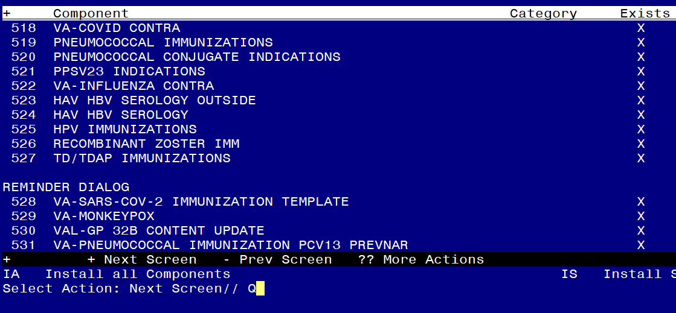At the Select Action prompt, type Q to quit.

Install Completed

# Post Installation

**Reinstall Backup Reminder Exchange File from the Pre-Install Step**

1. Reinstall all dialog elements after the Immunization Reminder dialogs have been updated in order to restore all the local orders and menus to the dialogs. An example of reinstalling the dialog elements packed up in pre-install steps is listed below.  
   1. On the Exchange File Components screen, at the “Select Action” prompt, enter “IS” for Install Selected Component.
   2. At the “Select Component(s)” prompt, enter the appropriate component numbers in the Reminder Dialog section. You will ONLY install the reminder dialogs. In the example below, the component numbers are 10-18, yours may differ.   
        
      **Example – Exchange File Components screen**

**Exchange File Components** May 14, 2020@10:24:28 Page: 62735of 62735

+ Component Category Exists

6 VA-MENING B ORDER SUPPRESSION X

7 VA-MENING ACWY ORDER SUPPRESSION X

8 VA-HPV ORDER SUPPRESSION X

9 VA-ZOSTER ORDER SUPPRESSION X

REMINDER DIALOG

10 OI TDAP OUTPT X

11 OI TD OUTPT X

12 OI PNEUMOC PPSV23 OUTPT X

13 OI PNEUMOC PCV13 OUTPT SHORT X

14 OI MENING B OUTPT X

15 OI MENING ACWY OUTPT X

16 VAL-HPV ORDER OPTIONS X

17 VA-HERPES ZOSTER ORDER X

18 VA-HBV OI IMMUNIZATION X

+ Next Screen - Prev Screen ?? More Actions >>>

IA Install all Components IS Install Selected Component

Select Action: Quit// IS Install Selected Component

Select Component(s): (1-18): 10-18

1. Review the COVID-19 dialogs to make sure only the vaccine options that your site administers show as available to administer.
   1. Disable any dialog groups for vaccine types not in use at your site – E.g. if you are exclusively a Moderna & Janssen site, then disable the reminder dialog groups for Pfizer. Possible groups are listed below:

VAL-SARS-COV-2 VACCINE ADMIN C2 GP 🡪this is MODERNA Monovalent

VAL-SARS-COV-2 VACCINE ADMIN D2 TS GP 🡪this is PFIZER Monovalent Tris Sucrose

VAL-SARS-COV-2 VACCINE ADMIN A1 GP 🡪this is Janssen

VAL-SARS-COV-2 VACCINE ADMIN B1 GP 🡪this is NOVAVAX

VAL-COVID-19 BOOSTER ACTIONS ADMIN TODAY MODERNA BIVALENT

VAL-COVID-19 BOOSTER ACTIONS ADMIN TODAY PFIZER BIVALENT

1. Enable reminder dialog VA-MONKEYPOX.

This dialog will install disabled. You will need to edit the dialog and remove the disable.

Using the Vista menu, DM Reminder Dialog Management, DI Reminder Dialogs, search for and find/open the reminder dialog VA-MONKEYPOX. Edit and remove DISABLE AND SEND MESSAGE from the DISABLE prompt:

Select Item: Next Screen// ED Edit/Delete Dialog

NAME: VA-MONKEYPOX//

DISABLE: DISABLE AND SEND MESSAGE// @

SURE YOU WANT TO DELETE? Y (Yes)

CLASS: LOCAL// ^

Checking reminder dialog for errors..

NO ERRORS FOUND

1. There is a reminder dialog element used in the national clinical reminders for immunizations to display a message when no lot numbers are available for a vaccine. That reminder dialog element can be edited to include local information on what to do if your facility does not have lot numbers available. This message is in addition to the setting for the VIMM form that you may have set earlier.

The reminder dialog element name is VAL-GP IM NO LOT #S AVAILABLE and it includes the template field IM PHARMACY PHONE NUMBERS. You can edit the template field or the reminder dialog element to include site specific information.