How to Delete The Identifying Information for Autor and Last Edited

Open the document and on the top menu bar, choose **File**

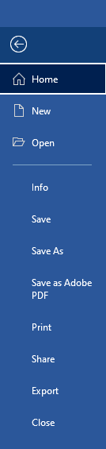

Then Click on **Info**

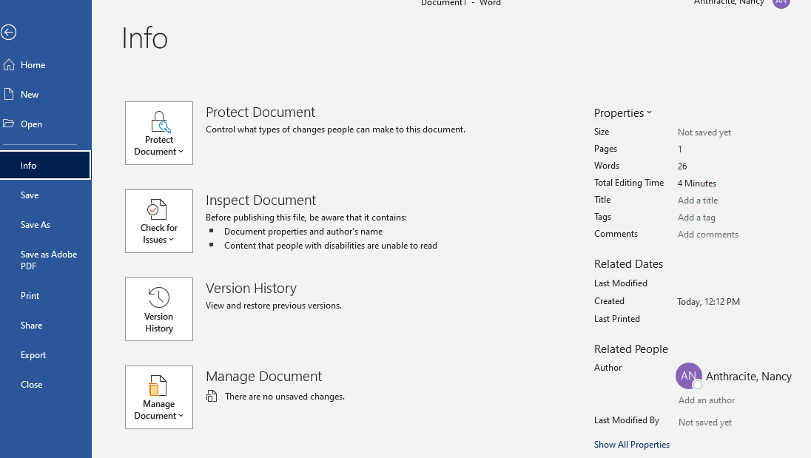

Then Click on **Inspect Document and choose Inspect Document**

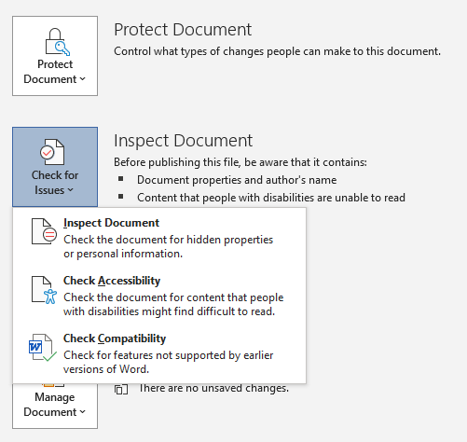

Click the **Inspect Button**.

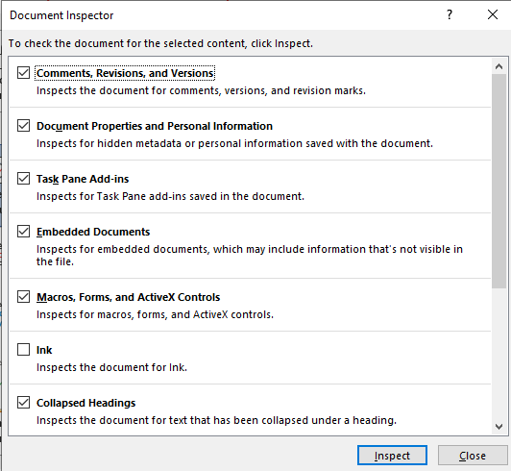

Click the **Remove All Button. After you click the Remove All button and Click on** Close, the names on the right under **Related People** will disappear.

