### IFC CVT-TeleOncology CONSULT SETUP TECHNICAL GUIDE

Department of Veterans Affairs,

Veterans Health Administration,

National Oncology Program

**V 1.0 December 2023**

# 1.0 Document Purpose

In support of the National TeleOncology service (NTO), this clinical Inter-Facility Consult (IFC), IFC CVT-TELEONCOLOGY CONSULT TO REDACTED was developed to route referrals for cancer patients enrolled in the VHA requesting to participate in TeleOncology services.

Providers and clinical staff throughout VHA may submit referrals to the NTO hub site located in Durham, NC to address any questions regarding hematology/oncology, breast/gynecologic cancers, clinical cancer genetics, clinical pharmacy review, clinical trials, national tumor board review or may need a second opinion. Certain services require a Telehealth Service Agreement (TSA) and will be initiated with the requesting site, if needed.

For any technical questions, please contact **REDACTED**

# 2.0 Overview of the Process

**One consult service will need to be created for this release.**

The recommended steps for this process are:

**Step 1:** Create new IFC CVT-TELEONCOLOGY CONSULT TO REDACTED consult.

**Step 2:** Associate the Stop Codes 308, 316, 353, and 340 with the IFC CVT-TELEONCOLOGY CONSULT TO REDACTED consult.

**Step 3:** Add IFC CVT-TELEONCOLOGY CONSULT TO REDACTED to the Consult Hierarchy.

**Step 4:** Associate appropriate TXML template to the IFC CVT-TELEONCOLOGY CONSULT TO REDACTED consult.

**Step 5:** Create quick order, map quick order, and test IFC.

# 3.0 Vista Access Requirements

The CAC/HIS will need the following access in VistA/CPRS for making the updates required in this Technical Guide:

* VistA secondary menu options:
  + [OR GPRS GUI CHART] - for access to CPRS GUI
  + [GMRC MGR] Consult Management - for consult and hierarchy set up
  + [SD ASSOCIATED STOP CODE] CONSULT ASSOCIATED STOP CODE -   
     for reviewing and entering the Consult Associated Stop Code
  + [ORCM MENU] - for editing and adding quick orders, menus, etc.
  + [ORLP TEAM MENU] Team List Mgmt. Menu - for creating & editing consult  
     teams
  + [GMRC REPORTS] Consult Tracking Reports
* Access to “Cor” Tabs in CPRS
* Restrict Patient Selection: set to NO
* User classes (for unlocking CAC options in the CPRS GUI allowing the ability to Edit/create shared TIU templates, link Consult Services to templates, and create   
  new TIU field, respectively):
  + CLINICAL COORDINATOR
  + Locally Created User Classes (as needed)
* VistA Key* (*one* of the following CPRS keys will be needed for testing the consult ordering process on Test Patients):
  + ORES
  + ORELSE

* Note: only one of the keys above can be issued and used at one time.   
 If the CAC needs to test the capabilities of each one, the previous key   
 must be deleted before issuing another.

# 4.0 Create Consult Service

Items requiring input in the steps below will be in **Red**.

Select Consult Management Option: **SS** Set up Consult Services

Service/Specialty: **IFC CVT-TELEONCOLOGY CONSULT TO REDACTED**

Are you adding ‘IFC CVT-TELEONCOLOGY CONSULT TO REDACTED’ as a new REQUEST SERVICES (the 144TH)? No// **YES**

ABBREVIATED PRINT NAME (Optional):

INTERNAL NAME:

Select SYNONYM:

SERVICE USAGE:

SERVICE PRINTER:

SECONDARY PRINTER:

NOTIFY SERVICE ON DC:

REPRINT 513 ON DC:

PREREQUISITE:

  Edit? NO//

PROVISIONAL DX PROMPT: **REQUIRE**

PROVISIONAL DX INPUT: **LEXICON**

DEFAULT REASON FOR REQUEST:

 Edit? NO//

RESTRICT DEFAULT REASON EDIT:

Inter-facility information

IFC ROUTING SITE: **REDACTED**

IFC REMOTE NAME: **IFC CVT-TELEONCOLOGY CONSULT TO REDACTED**

Select IFC SENDING FACILITY:

**The section below is used for notifications and permissions to complete and/or update the consult. Local naming convention for consult teams can be used.**

SERVICE INDIVIDUAL TO NOTIFY:

Select SERVICE TEAM TO NOTIFY:

Select NOTIFICATION BY PT LOCATION:

PROCESS PARENTS FOR NOTIFS:

Select UPDATE USERS W/O NOTIFICATIONS:

Select UPDATE TEAMS W/O NOTIFICATIONS:

Select UPDATE USER CLASS W/O NOTIFS:

Select ADMINISTRATIVE UPDATE USER:

Select ADMINISTRATIVE UPDATE TEAM:

PROCESS PARENTS FOR UPDATES:

SPECIAL UPDATES INDIVIDUAL:

RESULT MGMT USER CLASS:

UNRESTRICTED ACCESS:

Select SUBSERVICE/SPECIALTY:

ADMINISTRATIVE:

# 5.0 Consult Associated Stop Code

The option and process in VistA to add the Stop Codes to the newly created consult service is described below. Add 308, 316, 353, and 340 stop codes.

**Step 1:** At any prompt in VistA, type **^CONSULT** and choose the option:

CONSULT ASSOCIATED STOP CODE [SD ASSOCIATED STOP CODE]

**Step 2:** At the REQUEST SERVICES SERVICE NAME, type the name of the consult service created.

Select REQUEST SERVICES SERVICE NAME:

**IFC CVT-TELEONCOLOGY CONSULT TO REDACTED**

**Step 3:** Add **REDACTED** as the first Associated Stop Code

ASSOCIATED STOP CODE: REDACTED HEMATOLOGY REDACTED

Are you adding ' HEMATOLOGY ' as a new ASSOCIATED STOP CODE? No// **YES**

**Step 4:** Continue to add **REDACTED** and **REDACTED** as the second, third and fourth Associated Stop Codes.

# 6.0 Add Consult Service to Consult Hierarchy

Add the IFC CVT-TELEONCOLOGY CONSULT TO REDACTED consult to the appropriate Grouper according to your facility’s set-up (i.e., ALL SERVICES or ONCOLOGY). For the example below, the consult is being added to the ALL SERVICES Grouper.

**In VistA, go to the Consult Management Menu and select “SS” for Set up Consult Services to edit the Grouper.**

Select Consult Management Option: **SS Setup Consult Services**

Select Service/Specialty: **ALL SERVICES**

SERVICE NAME: ALL SERVICES//

ABBREVIATED PRINT NAME (Optional):

INTERNAL NAME:

Select SYNONYM:

SERVICE USAGE: GROUPER

**(Several Input fields are not being shown for this section to save space)**

Select ADMINISTRATIVE UPDATE USER:

Select ADMINISTRATIVE UPDATE TEAM:

PROCESS PARENTS FOR UPDATES:

SPECIAL UPDATES INDIVIDUAL:

RESULT MGMT USER CLASS:

UNRESTRICTED ACCESS:

Select SUB-SERVICE/SPECIALTY: **IFC CVT-TELEONCOLOGY CONSULT TO REDACTED**

Are you adding 'IFC CVT-TELEONCOLOGY CONSULT TO REDACTED' as a new SUB-SERVICE (the 30TH for this REQUEST SERVICES)? No// **YES**

MNEMONIC:

Select SUB-SERVICE/SPECIALTY:

ADMINISTRATIVE:

Add/Edit Another Service? NO

# 7.0 Consult Template Linkage

Step 1: Save the TXML file that was sent via Update_2_0_392 to a location that you can find to import the template into CPRS. For example, save the TXML file to your desktop. Then import the TXML file as listed below in the template editor so that all fields are imported.

Screen shot of consult template with IFC TeleOncology Consult at the top, a text area for Reason for the Consult, two check boxes for Is the patient aware of diagnosis  Yes No
Are all records available in teh VA Electronic Health Record for Review Yes No
Service(s) requested (check all that apply)
National TeleOncology Hem/Onc Consult and Management
2nd Opinion
Breast (including high-risk) and Gynecologic Oncolgy System of Excellence (BGSOE)
Clinical Pharmacy Reveiw
Clinical Cancer Genetics Service (CCGS)
Clinical Trials
National Tumor Board Review
Other

Type of consult preferred: *
Asynchronous (E-Consult)
Synchronous (Video TeleHealth)

Did the patient consent verbally to telehealth services? *Yes No N/A (E-Consult) 

**Step 2:** Select “Edit Shared Templates”.

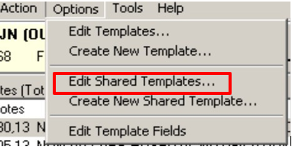

**Step 3:** In CPRS template editor, go to the Consult Reasons for Request folder.

Click on the Consult Reasons for Request to highlight it and expand this folder by double clicking on the name or clicking on the ‘triangle’ to left of the folder name.

In the CPRS Template Editor, 
under Shared Templates, Consult Reason for Request folder is selected

**Step 4:** Select the folder you wish to add the consult to. Each VA is set up differently, so determine the appropriate location to add the new consult reason for requests. Place the cursor under the folder or location where the Consult Reason for Request needs to be placed.

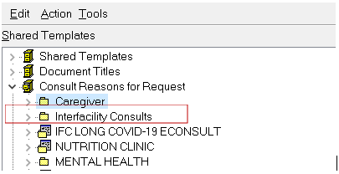

**Step 5:** After clicking on the folder, go to Tools and select Import Template.

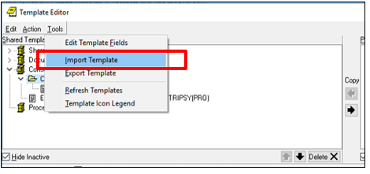

Select the location where you saved the template and click OPEN to import the template.

**Step 6:** The TXML now appears under the folder selected.

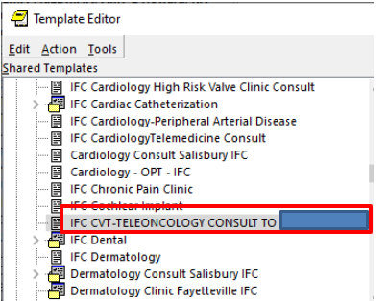

**Step 7:** Link the Consult to the template.

Select the template by clicking on it.

In the Associated Consult Service box, type: **IFC CVT-TELEONCOLOGY CONSULT TO REDACTED**

Click Apply to save and link the template to the consult service.

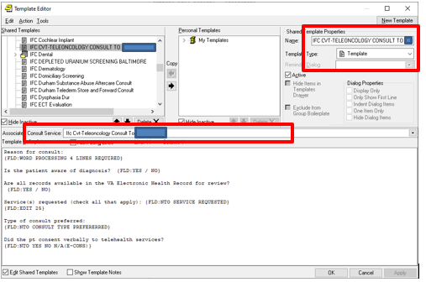

# 8.0 Create and Link Consult Quick Order

**\*Note:** Must use exact display text “**IFC TELEONCOLOGY CONSULT TO DURHAM**”

**Step 1:** Create a consult quick order

From the Order Menu Management menu, select the “**Set Enter/edit quick orders**” menu option by typing “**QO**” at the main prompt.

OI Manage orderable items ...   
PM Enter/edit prompts   
GO Enter/edit generic orders   
QO Enter/edit quick orders   
QU Edit personal quick orders by user   
ST Enter/edit order sets   
AC Enter/edit actions   
MN Enter/edit order menus   
AO Assign Primary Order Menu   
CP Convert protocols   
SR Search/replace components   
Go to the Order Menu Management option:

Select Order Menu Management <TEST ACCOUNT> Option: **QO** Enter/edit quick orders

Select QUICK ORDER NAME: **GMRCTZ IFC CVT-TELEONCOLOGY CONSULT TO REDACTED** – *if this is not your local naming convention, you may change it*

Are you adding GMRCTZ IFC CVT-TELEONCOLOGY CONSULT TO REDACTED’ as a new ORDER DIALOG? No// **Y** (Yes)

TYPE OF QUICK ORDER: **CONSULTS**

NAME: GMRCTZ IFC CVT-TELEONCOLOGY CONSULT TO REDACTED Replace

DISPLAY TEXT: **IFC TELEONCOLOGY CONSULT TO REDACTED** (*if this is not your local naming convention, you may change it,* ***do not use CVT in the display text***).

VERIFY ORDER:

DESCRIPTION:

Edit? NO//

ENTRY ACTION:

Consult to Service/Specialty: **IFC CVT-TELEONCOLOGY CONSULT TO REDACTED** //

Consult Type:

Reason for Request:

No existing text

Edit? No// (No)

Category:

Urgency: **ROUTINE**//

Clinically Indicated Date: **TODAY**//

Place of Consultation:

Attention:

Provisional Diagnosis:

-------------------------------------------------------------------------------

Consult to Service/Specialty: IFC CVT-TELEONCOLOGY CONSULT TO REDACTED

Category: OUTPATIENT

Urgency: ROUTINE

Clinically Indicated Date:

Provisional Diagnosis:

-------------------------------------------------------------------------------

(P)lace, (E)dit, or (C)ancel this quick order? PLACE//

Auto-accept this order? NO//

**Step 2: Link Quick Order**

From the Reminder Dialog Management menu, select the “Reminder Dialogs” menu option by typing “DI” at the main prompt.

Change view to Group view and locate the following reminder dialog group. You will add the quick order as an additional finding. Do not remove any existing findings.

1. Locate and edit the reminder dialog group:

**VA-GP NTO GENETIC POSTTEST FU CCGS CONSULT**

Map the quick order for the IFC consult:

**GMRCTZ IFC CVT-TELEONCOLOGY CONSULT TO REDACTED**

Change view to Element view and locate the following reminder dialog element. You will add the quick order as an additional finding. Do not remove any existing findings.

1. Locate and edit the reminder dialog elements:

**VA-NTO GENETIC PRETEST OPTION CONSULT CCGS**

**VA-ONC PRCA GENETIC PRETEST OPTION CONSULT CCGS**

Map the quick order for the IFC consult:

**GMRCTZ IFC CVT-TELEONCOLOGY CONSULT TO REDACTED**

**Step 3:** Test Inter-Facility Consult (IFC).

IFC Management Menu à Test IFC Implementation (TI) à Consult Service (C)

Contact the National Oncology CAC email group: **REDACTED EMAIL** so they can add your local site to the IFC Sending Facility list at **REDACTED**.

After you are added as an IFC Sending Facility, Test IFC Implementation:

Ex:

Screen shot showing
Select IFC Management Menu Option:
Select one of the following:  Test IFC Implementation
P   procedure
C   consult service
Would you like to test a procedure or consult service:  C Consult Service
Select the Consult service that you would like to test:  IFC CVT TELEONCOLGY CONSULT TO REDACTED        DISABLED
 attempting to connect to remote system ...
Congratulations:  You're configured correctly

Would you like to test another implementation?