**REMINDER UPDATE_2_0_205 VA-MISC UPDATE 14 CHANGES**

NOTE: All reminder dialog changes are included in Reminder Dialog Group:

VA-GP MISC UPDATE 14

* A number of items below are Elements or Groups that are set with a ‘national’ class. To confirm updates were made on any ‘national’ dialog element or group, choose the INQ (Inquiry/Print) option in the Reminder Dialog Management Menu.

1. Reminder Dialog GROUP: **VA-GP RH&S - PSYCHOLOGICAL – TECHNOLOGY**

Change Made:

A text change with one word. The word “identify” was changed be “identity”.

This group resides in reminder dialog: VA-RELATIONSHIP HEALTH AND SAFETY ASSESSMENT

**BEFORE**:

NAME: VA-GP RH&S - PSYCHOLOGICAL - TECHNOLOGY

GROUP HEADER DIALOG TEXT:

Psychological - Using technology (e.g., cyberstalking, harassment, identify theft/misuse)

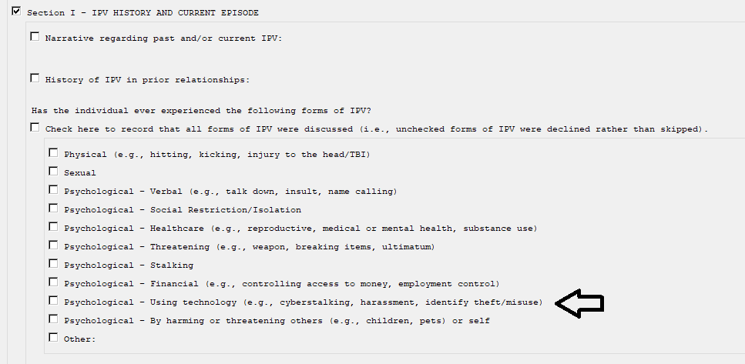

**AFTER**:

NAME: VA-GP RH&S - PSYCHOLOGICAL - TECHNOLOGY

GROUP HEADER DIALOG TEXT:

Psychological - Using technology (e.g., cyberstalking, harassment, identity theft/misuse)

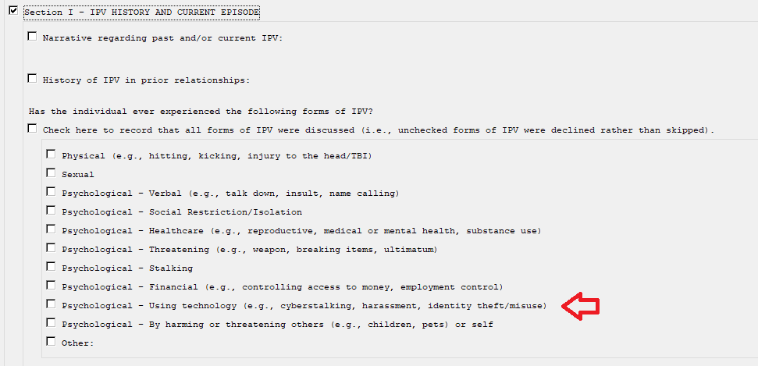

1. Reminder Dialog ELEMENT: **VA-HF HTN REFERRAL DIETICIAN**

Change Made:

The spelling of the word ‘dietician’ was changed to ‘dietitian’.

This element resides in reminder dialog: VA-HTN ELEVATED BP>140/90

**BEFORE**:

NAME: VA-HF HTN REFERRAL DIETICIAN

Refer to Dietician

Edit? NO//

ALTERNATE PROGRESS NOTE TEXT:

Patient referred to Dietician.

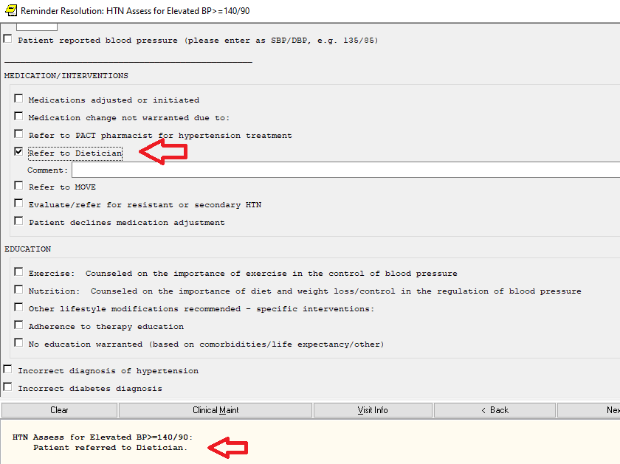

**AFTER**:

NAME: VA-HF HTN REFERRAL DIETICIAN

Refer to Dietitian

Edit? NO//

ALTERNATE PROGRESS NOTE TEXT:

Patient referred to Dietitian.

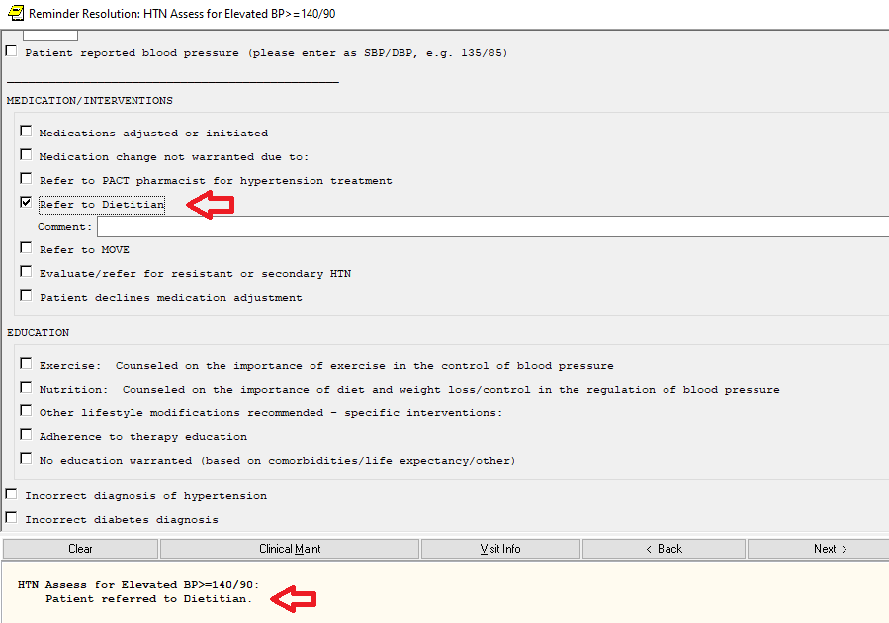

1. Reminder Dialog ELEMENT: **VA-PHP INTRODUCTION2**

Change Made:

This element contains a template field (web link) to a whole health library. The link to this library has changed and has been updated in the template field.

This element and template field resides in reminder dialog: VA-PHP PERSONAL HEALTH PLAN

**BEFORE**:

NAME: VA-PHP INTRODUCTION2 Replace

DIALOG/PROGRESS NOTE TEXT:. . .

. . .

health and well-being and is supported by self-care goals, professional

shared goals, and community support. The document will likely be filled

out by multiple members of the Veterans' care team, including providers,

educators, coaches, complementary and integrative health instructors,

etc, and therefore does not need to be completely filled out in one

setting. It is meant to be a record for Veterans to review and use to

help in their journey in whole health.

Access Whole Health Library: {FLD:VA-PHP WHOLE HEALTH LIBRARY URL}

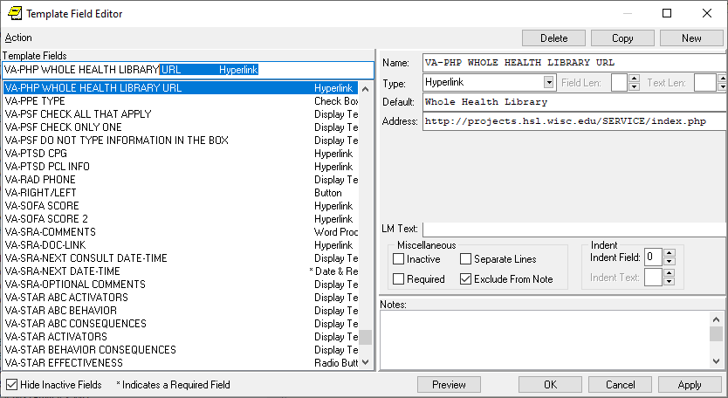

**AFTER**:

NAME: VA-PHP INTRODUCTION2 Replace

DIALOG/PROGRESS NOTE TEXT:. . .

. . .

health and well-being and is supported by self-care goals, professional

shared goals, and community support. The document will likely be filled

out by multiple members of the Veterans' care team, including providers,

educators, coaches, complementary and integrative health instructors,

etc, and therefore does not need to be completely filled out in one

setting. It is meant to be a record for Veterans to review and use to

help in their journey in whole health.

Access Whole Health Library: {FLD:VA-PHP WHOLE HEALTH LIBRARY URL}

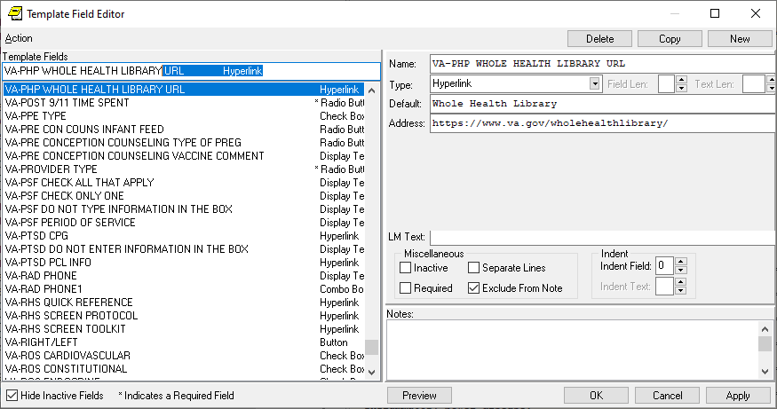

1. Reminder Dialog ELEMENTS: **VA-BFA TYPE OF TREATMENT BFA** and **VA-BFA TYPE OF TREATMENT BAA**

Change Made:

The two Health Factors, mapped as finding items, have changed. See before/after below.

These elements resides in reminder dialog: VA-BFA BATTLEFIELD ACUPUNCTURE NOTE

**BEFORE**:

ELEMENT NAME: VA-BFA TYPE OF TREATMENT BFA

Finding: VA-BFA PT AGREED BFA (HEALTH FACTOR)

ELEMENT NAME: VA-BFA TYPE OF TREATMENT BAA

Finding: VA-BFA PT AGREED BAA (HEALTH FACTOR)

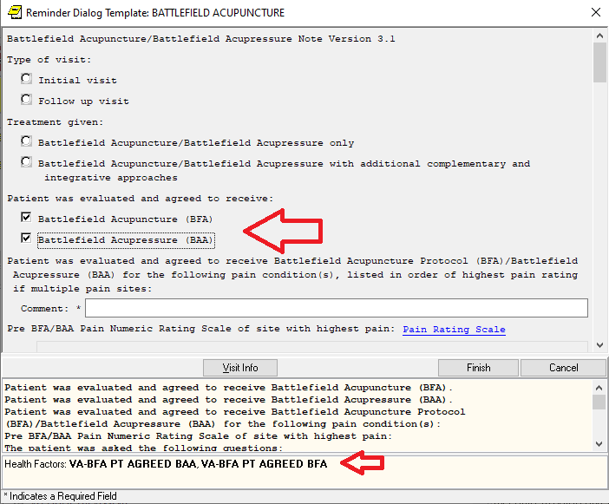

**AFTER**:

ELEMENT NAME: VA-BFA TYPE OF TREATMENT BFA

Finding: VA-WHS - BFA (HEALTH FACTOR)

ELEMENT NAME: VA-BFA TYPE OF TREATMENT BAA

Finding: VA-WHS - BAA (HEALTH FACTOR)

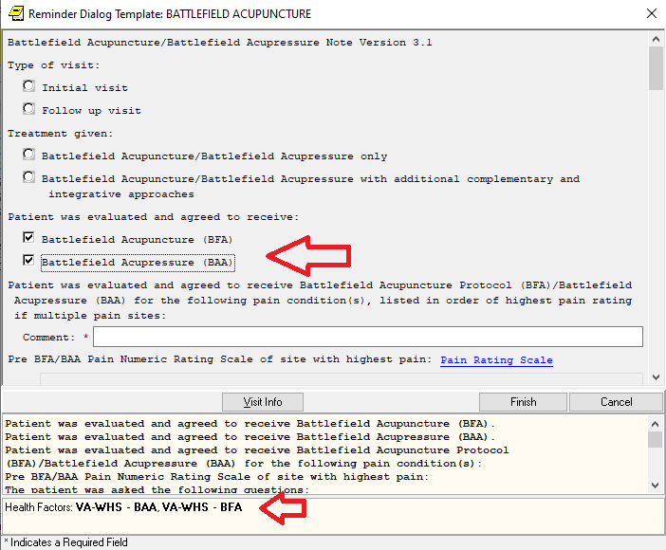

1. Reminder Dialog GROUP: **VA-GP CCC LUNG ECOG DEF**

Change Made:

An additional ELEMENT was added and some text changes made within some ELEMENTS.

See before/after below.

This group can be found in reminder dialog: VA-ONCOLOGY MDC THORACIC

**BEFORE**:

Group: VA-GP CCC LUNG ECOG DEF

5 Element: VA-EL CCC LUNG ECOG 1 DEF

Text: 0 = Fully active, able to carry on all pre-disease performance

without restriction.

10 Element: VA-EL CCC LUNG ECOG 2 DEF

Text: 1 = Restricted in physically strenuous activity but ambulatory

and able to carry out work of a light or sedentary nature.

e.g. light house work, office work

15 Element: VA-EL CCC LUNG ECOG 3 DEF

Text: 2 = Ambulatory and capable of all selfcare but unable to carry

out any work activities. Up and about more than 50% of waking

hours.

20 Element: VA-EL CCC LUNG ECOG 4 DEF

Text: 4 = Completely disabled. Cannot carry on any selfcare. Totally

confined to bed or chair.

25 Element: VA-EL CCC LUNG ECOG 5 DEF

Text: 5 = Dead

30 Element: VA-EL CCC LUNG ECOG DEF PERMISSION

Text: This information is copyrighted and used with permission from

the Eastern Cooperative Oncology Group, Robert Comis M.D., Grop

Chair.

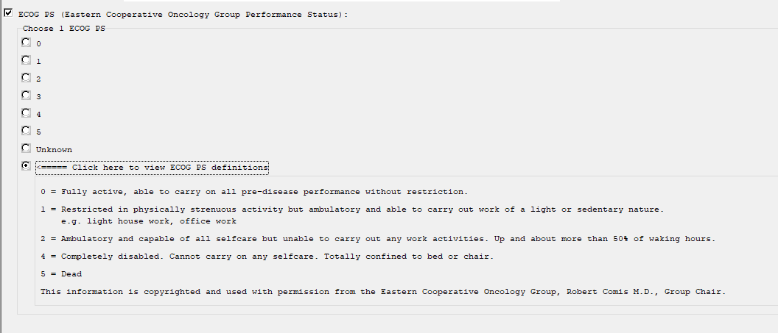

**AFTER**:

Group: VA-GP CCC LUNG ECOG DEF

3 Element: VA-EL CCC LUNG ECOG 0 DEF

Text: 0 = Fully active, able to carry on all pre-disease performance

without restriction.

5 Element: VA-EL CCC LUNG ECOG 1 DEF

Text: 1 = Restricted in physically strenuous activity but ambulatory

and able to carry out work of a light or sedentary nature, e.g,

light house work, office work

10 Element: VA-EL CCC LUNG ECOG 2 DEF

Text: 2 = Ambulatory and capable of all selfcare but unable to carry

out any work activities. Up and about more than 50% of waking

hours.

15 Element: VA-EL CCC LUNG ECOG 3 DEF

Text: 3 = Capable of only limited selfcare, confined to bed or chair

more than 50% of waking hours.

20 Element: VA-EL CCC LUNG ECOG 4 DEF

Text: 4 = Completely disabled. Cannot carry on any selfcare. Totally

confined to bed or chair.

25 Element: VA-EL CCC LUNG ECOG 5 DEF

Text: 5 = Dead

30 Element: VA-EL CCC LUNG ECOG DEF PERMISSION

Text: This information is copyrighted and used with permission from

the Eastern Cooperative Oncology Group, Robert Comis M.D., Grop

Chair.

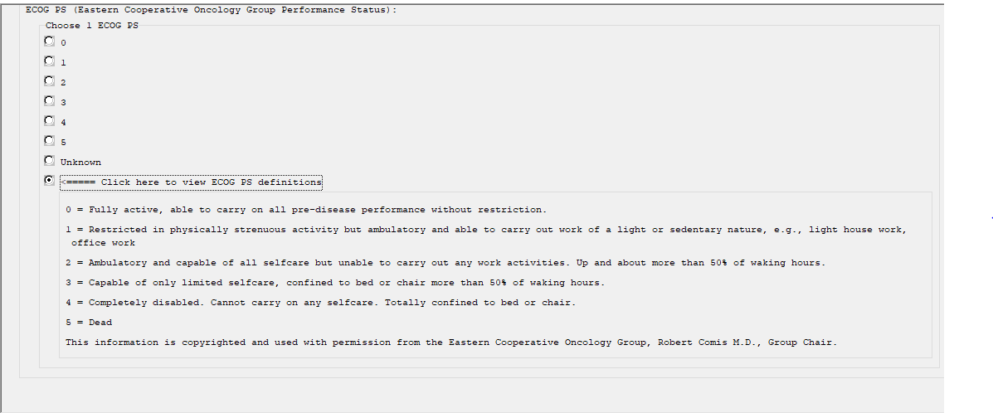

1. Reminder Dialog Group: **VA-GP SOC WORK ADVANCE CARE PLANNING (ACP) GROUP VISIT (GV)**

Change Made:

Has been updated with text changes and to include new selectable options within two sub-groups.

This group resides in reminder dialog: VA-SOC WORK ADVANCE CARE PLANNING GROUP VISIT (CRD)

**BEFORE**:

Group: VA-GP SOC WORK ADVANCE CARE PLANNING (ACP) GROUP VISIT (GV)

Text: ADVANCE CARE PLANNING GROUP VISIT

{FLD:ACP-GV INTRO}

GROUP VISIT OBJECTIVES: The Advance Care Planning - Group Visit (ACP-GV)

creates discussions about the importance of Advance Care Planning (ACP).

During the discussion, emphasis was placed on the following:

1) ACP terms and uses. 2) Healthcare preferences and identification of trusted others.

3) Communication with healthcare team and trusted others. 4) Documentation of

healthcare preferences using resources such as VHA Form 10-0137 (Advance Directive).

[NO BOX, SUPPRESS, SHOW, NO SELECTION]

Group: BLANK LINE

Text: {FLD:IC/BLANK LINE 74 CHARACTERS T DIALOG USE}

[NO BOX, SUPPRESS, SHOW, NO SELECTION]

Group: VA-GP SOC WORK ACP GV VISIT TYPE

Text: [BOX, SUPPRESS, SHOW, ONE ONLY]

Element: VA-SOC WORK ACP GV ATTEND IN PERSON

Text: {FLD:BLANK (1)SPACE}-In person

Element: VA-SOC WORK ACP GV ATTEND TELEHEALTH

Text: {FLD:BLANK (1)SPACE}-Via telehealth

Element: VA-SOC WORK ACP GV ATTEND VA VIRTUAL MEDICAL CENTER

Text: {FLD:BLANK (1)SPACE}-VA-Virtual Medical Center

Group: BLANK LINE

Text: {FLD:IC/BLANK LINE 74 CHARACTERS T DIALOG USE}

[NO BOX, SUPPRESS, SHOW, NO SELECTION]

Group: VA-GP SOC WORK ACP GV VISIT TYPE II

Text: [BOX, SUPPRESS, SHOW, ONE ONLY]

Element: VA-SOC WORK ACP GV ATTEND ESTABLISHED GROUP

Text: {FLD:BLANK (1)SPACE}-Established group (e.g. MOVE,

Element: VA-SOC WORK ACP GV ATTEND CREATED BY ACP-GV STAFF

Text: {FLD:BLANK (1)SPACE}-Created by ACP-GV Staff

Element: VA-SOC WORK ACP GV ATTEND INDIVIDUAL

Text: {FLD:BLANK (1)SPACE}-Individual Session with Veteran a

family member. {FLD:ACP-GV INDIVID}

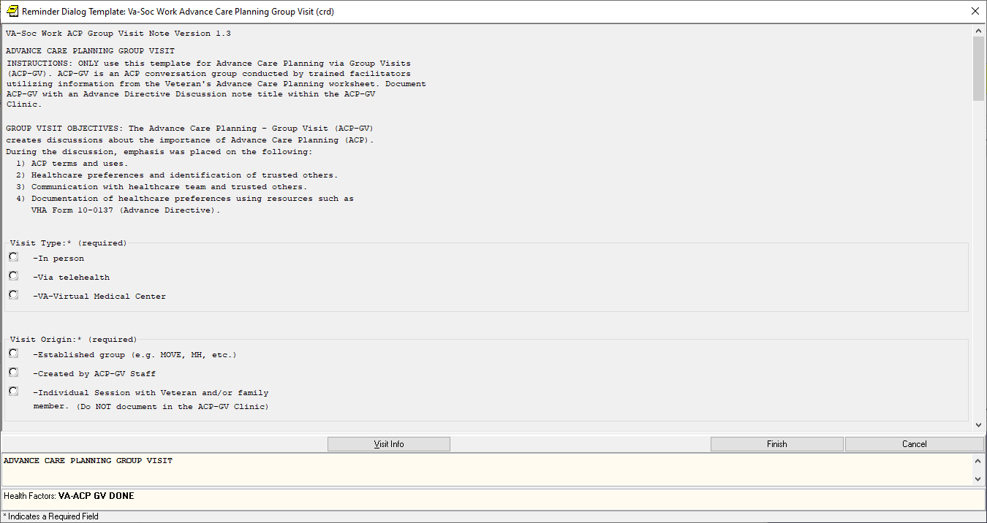

**AFTER**:

Group: VA-GP SOC WORK ADVANCE CARE PLANNING (ACP) GROUP VISIT (GV)

Text: ADVANCE CARE PLANNING GROUP VISIT

{FLD:ACP-GV INTRO}

GROUP VISIT OBJECTIVES: The Advance Care Planning - Group Visit (ACP-GV)

Facilitates discussions about the importance of Advance Care Planning (ACP).

During the discussion, emphasis was placed on the following:

1) ACP terms and uses. 2) Healthcare preferences and identification of trusted others.

3) Communication with healthcare team and trusted others. 4) Documentation of

healthcare preferences using resources such as VHA Form 10-0137 (Advance Directive).

[NO BOX, SUPPRESS, SHOW, NO SELECTION]

Group: VA-GP BLANK LINE

Text: {FLD:IC/BLANK LINE 74 CHARACTERS T DIALOG USE}

[NO BOX, SUPPRESS, SHOW, NO SELECTION]

Group: VA-GP SOC WORK ACP GV VISIT TYPE

Text: [BOX, SUPPRESS, SHOW, ONE ONLY]

Element: VA-SOC WORK ACP GV ATTEND IN PERSON

Text: {FLD:BLANK (1)SPACE}-In person

Element: VA-SOC WORK ACP GV ATTEND TELEHEALTH VA VIDEO

Text: {FLD:BLANK (1)SPACE}-Telehealth: VA Video Connect

Element: VA-SOC WORK ACP GV ATTEND TELEHEALTH CVT

Text: {FLD:BLANK (1)SPACE}-Telehealth: CVT

Add. Finding: ACP GV ATTEND TELEHEALTH CVT [20161] (HEALTH

FACTOR)

Element: VA-SOC WORK ACP GV ATTEND VIRTUAL MEDICAL CENTER

Text: {FLD:BLANK (1)SPACE}-Virtual Medical Center

Element: VA-SOC WORK ACP GV ATTEND TELEPHONIC GP

Text: {FLD:BLANK (1)SPACE}-Telephonic Group

Group: VA-GP BLANK LINE

Text: {FLD:IC/BLANK LINE 74 CHARACTERS T DIALOG USE}

[NO BOX, SUPPRESS, SHOW, NO SELECTION]

Group: VA-GP SOC WORK ACP GV VISIT TYPE II

Text: [BOX, SUPPRESS, SHOW, ONE ONLY]

Element: VA-SOC WORK ACP GV ATTEND ESTABLISHED GROUP

Text: {FLD:BLANK (1)SPACE}-Established group (e.g. MOVE, MH,

Element: VA-SOC WORK ACP GV ATTEND CREATED BY ACP-GV STAFF

Text: {FLD:BLANK (1)SPACE}-Created by ACP-GV Staff

Element: VA-SOC WORK ACP GV ATTEND INDIVIDUAL

Text: {FLD:BLANK (1)SPACE}-Individual Session with Veteran a

family member. {FLD:ACP-GV INDIVID}

Group: VA-GP SOC WORK ACP GV ATTEND COLLABORATION

Text: {FLD:BLANK (1)SPACE}-ACP-GV-In collaboration with another

program;

[BOX, NO SUPPRESS, HIDE, ONE ONLY]

Element: VA-SOC WORK ACP GV ATTEND COL CAREGIVER

Text: {FLD:BLANK (1)SPACE}-Caregiver Support

Element: VA-SOC WORK ACP GV ATTEND COL WHOLE HEALTH

Text: {FLD:BLANK (1)SPACE}-Whole Health

Element: VA-SOC WORK ACP GV ATTEND COL OTHER

Text: {FLD:BLANK (1)SPACE}-Other;

Prompts: Comment:

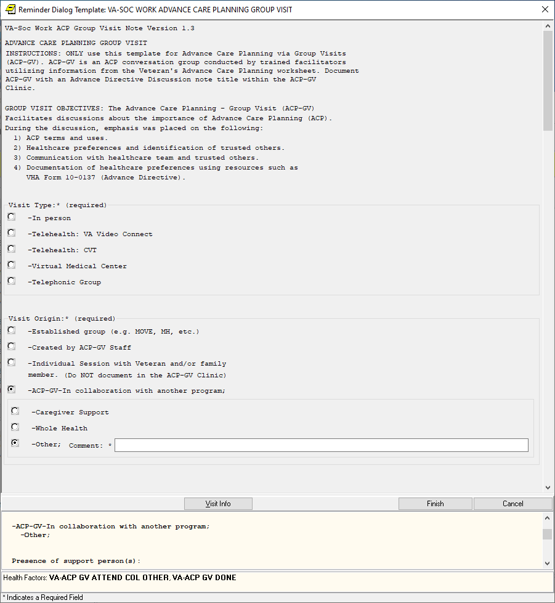

1. Reminder Dialog ELEMENT: **VA-EL ONC LUNG PATHWAY INSTRUCT**.

Change Made:

The template field was edited to reflect the correct SharePoint link.

This element resides in reminder dialog: VA-ONCOLOGY LUNG PATHWAY

**BEFORE**:

Element: VA-EL ONC LUNG PATHWAY INSTRUCT

Text: Reference for molecular testing methods: {FLD:VA-ONC PW SCRIPT}

**AFTER**:

Element: VA-EL ONC LUNG PATHWAY INSTRUCT

Text: Reference for molecular testing methods: {FLD:VA-ONC PW SCRIPT} < link to SharePoint was changed

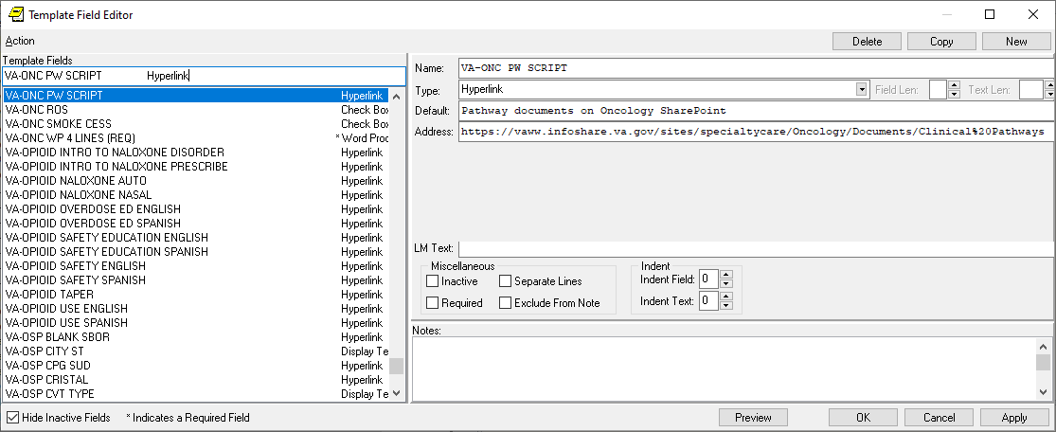

1. Reminder Dialog ELEMENT: **VA-DIALYSIS NUTR DIAG INCREASED**

Change Made:

The dialog text contained a misspelled word. The “n” was missing in the word ‘recommendation’ in the sentence “Limited adherence to nutrition recommendation”.

This element resides in reminder dialog: VA-DIALYSIS NUTRITION ASSESSMENT

**BEFORE**:

Element: VA-DIALYSIS NUTR DIAG INCREASED

DIALOG/PROGRESS NOTE TEXT:

Limited adherence to nutrition recommedation

**AFTER**:

Element: VA-DIALYSIS NUTR DIAG INCREASED

DIALOG/PROGRESS NOTE TEXT:

Limited adherence to nutrition recommendation

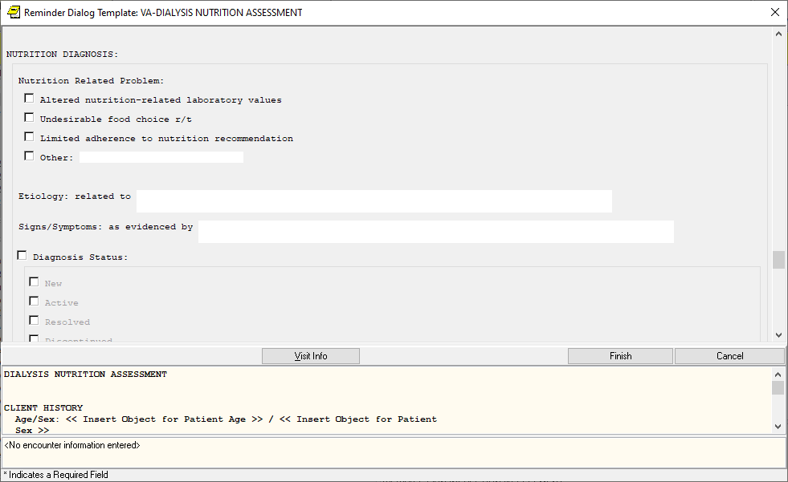

1. Reminder Dialog Group: **VA-GP TELE URGENT TRM CONSULT ORIGIN GP**

Change Made:

An additional element was added for CLC Referral.

This group resides in reminder dialog: VA-TELE URGENT CARE NOTE

**BEFORE**:

Group: VA-GP TELE URGENT TRM CONSULT ORIGIN GP

Text: Consult Origin

[NO BOX, SUPPRESS, SHOW, ONE ONLY]

Element: VA-TELE URGENT REFERRAL FROM CCC RN

Text: Clinical Contact Center/Call Center

Element: VA-TELE URGENT REFERRAL SELF REFERRAL

Text: Patient Self-Referral

Element: VA-TELE URGENT REFERRAL FROM OTHER

Text: Other

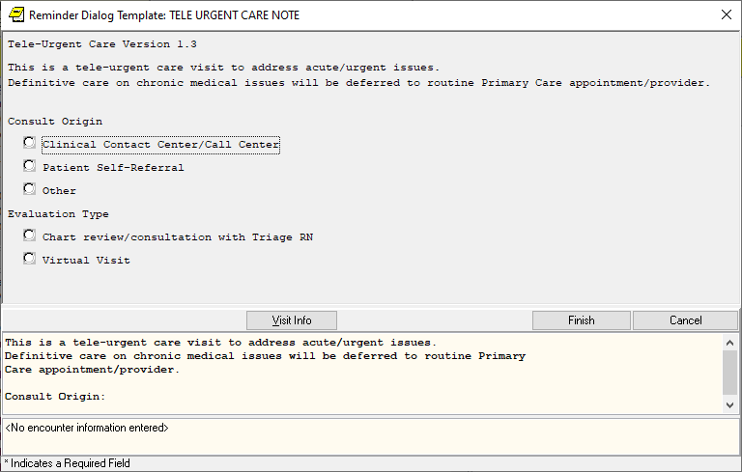

**AFTER**:

Group: VA-GP TELE URGENT TRM CONSULT ORIGIN GP

Text: Consult Origin

[NO BOX, SUPPRESS, SHOW, ONE ONLY]

Element: VA-TELE URGENT REFERRAL FROM CCC RN

Text: Clinical Contact Center/Call Center

Element: VA-TELE URGENT REFERRAL CLC

Text: Community Living Center/Nursing Facility

Element: VA-TELE URGENT REFERRAL SELF REFERRAL

Text: Patient Self-Referral

Element: VA-TELE URGENT REFERRAL FROM OTHER

Text: Other

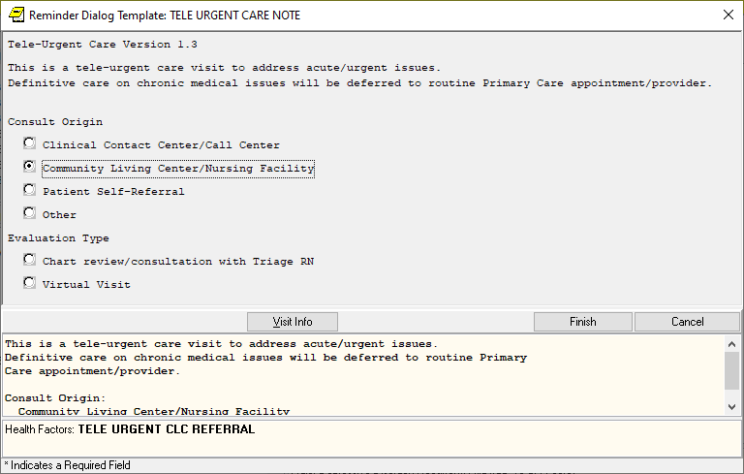

1. Reminder Dialog Elements: **VA-WH OR PAP SMEAR REPEAT – OUTPATIENT and VA-WH OR COLPOSCOPY - OUTPATIENT**

Change Made:

Alternate progress note text has been added to both elements and “YES” has been removed from the ‘Exclude from Progress Note’ field.

These elements reside in reminder dialog: VA-WH PAP SMEAR REVIEW RESULTS

**BEFORE**:

NAME: **VA-WH OR PAP SMEAR REPEAT - OUTPATIENT**

DISABLE:

CLASS: NATIONAL//

SPONSOR: WOMEN VETERANS HEALTH PROGRAM//

REVIEW DATE:

RESOLUTION TYPE:

ORDERABLE ITEM:

Finding item: HF WH ORDER REPEAT PAP HF

FINDING ITEM: WH ORDER REPEAT PAP HF//

Additional findings: none

Select ADDITIONAL FINDING:

DIALOG/PROGRESS NOTE TEXT:

Consult - repeat PAP smear

Edit? NO//

ALTERNATE PROGRESS NOTE TEXT:

Edit? NO//

EXCLUDE FROM PROGRESS NOTE: YES//

NAME: **VA-WH OR COLPOSCOPY - OUTPATIENT**

DISABLE:

CLASS: NATIONAL//

SPONSOR: WOMEN VETERANS HEALTH PROGRAM//

REVIEW DATE:

RESOLUTION TYPE:

ORDERABLE ITEM:

Finding item: HF WH ORDER COLPOSCOPY HF

FINDING ITEM: WH ORDER COLPOSCOPY HF//

Additional findings: none

Select ADDITIONAL FINDING:

DIALOG/PROGRESS NOTE TEXT:

Consult - colposcopy

Edit? NO//

ALTERNATE PROGRESS NOTE TEXT:

Edit? NO//

EXCLUDE FROM PROGRESS NOTE: YES//

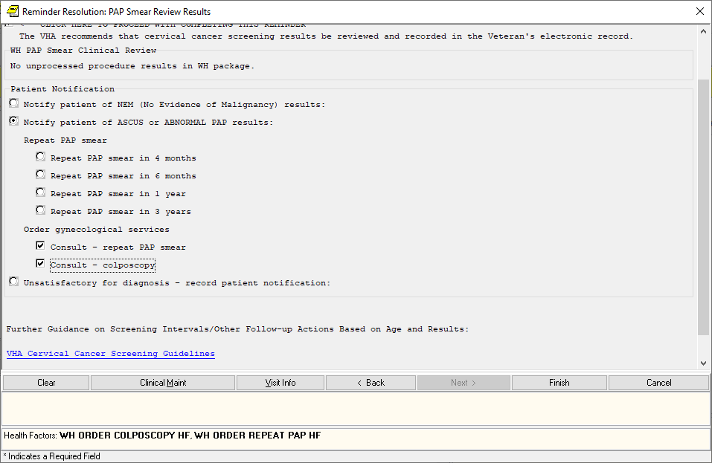

**AFTER**:

NAME: **VA-WH OR PAP SMEAR REPEAT - OUTPATIENT**

DISABLE:

CLASS: NATIONAL//

SPONSOR: Women Veterans Health Program//

REVIEW DATE:

RESOLUTION TYPE:

ORDERABLE ITEM:

Finding item: HF WH ORDER REPEAT PAP HF

FINDING ITEM: WH ORDER REPEAT PAP HF//

Additional findings: none

Select ADDITIONAL FINDING:

DIALOG/PROGRESS NOTE TEXT:

Consult - repeat PAP smear

Edit? NO//

ALTERNATE PROGRESS NOTE TEXT:

Order placed for pap smear. See orders tab for details.

Edit? NO//

EXCLUDE FROM PROGRESS NOTE:

NAME: **VA-WH OR COLPOSCOPY - OUTPATIENT**

DISABLE:

CLASS: NATIONAL//

SPONSOR: Women Veterans Health Program//

REVIEW DATE:

RESOLUTION TYPE:

ORDERABLE ITEM:

Finding item: HF WH ORDER COLPOSCOPY HF

FINDING ITEM: WH ORDER COLPOSCOPY HF//

Additional findings: none

Select ADDITIONAL FINDING:

DIALOG/PROGRESS NOTE TEXT:

Consult - colposcopy

Edit? NO//

ALTERNATE PROGRESS NOTE TEXT:

Order placed for colposcopy. See orders tab for details.

Edit? NO//

EXCLUDE FROM PROGRESS NOTE:

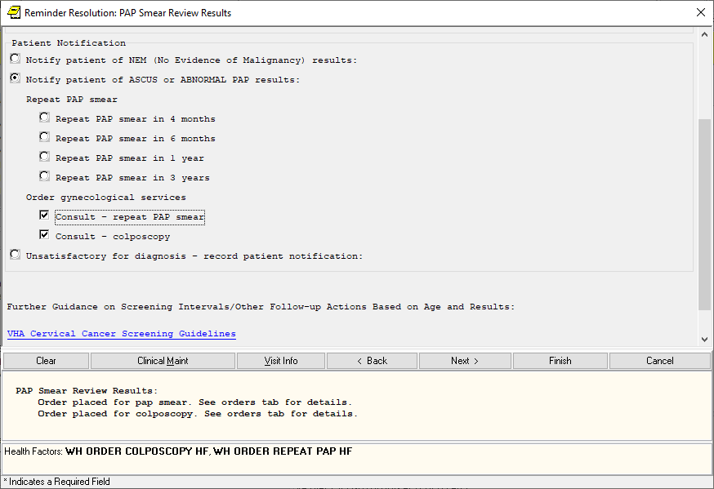

1. Reminder Dialog Element: **VA-MHRRTP PTSD TX VA** and Reminder Dialog Group: **VA-GP MHRRTP PTSD**

Change Made:

The element contains a misspelling in the alternate progress note text (i.e. “receiving” is misspelled) and the group dialog requires the word “Veterans” be changed to “Veteran”, removing the “s”.

This element and group both reside in reminder dialog: VA-MHRRTP DISCHARGE

**BEFORE**:

NAME: **VA-MHRRTP PTSD TX VA**

DISABLE:

CLASS: NATIONAL//

SPONSOR:

REVIEW DATE:

RESOLUTION TYPE:

ORDERABLE ITEM:

Finding item: HF VA-MH-RRTP PTSD CC VA

FINDING ITEM: VA-MH-RRTP PTSD CC VA//

Additional findings: none

Select ADDITIONAL FINDING:

DIALOG/PROGRESS NOTE TEXT:

VA (Includes inpatient, outpatient, RRTP, etc)

Edit? NO//

ALTERNATE PROGRESS NOTE TEXT:

Veteran plans to continue recieving PTSD care at the VA

NAME: **VA-GP MHRRTP PTSD TX VET RECEIVE CARE WHERE**

Text: Veterans plans to receive continuing Mental Health and/or PTSD care at any of the following:

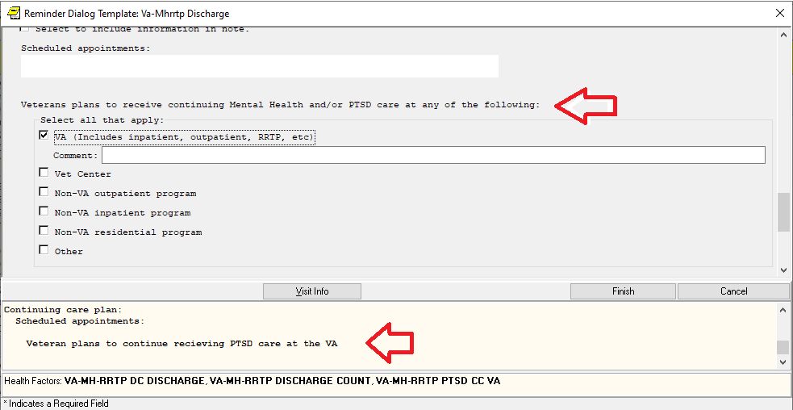

**AFTER**:

NAME: **VA-MHRRTP PTSD TX VA**

DISABLE:

CLASS: NATIONAL//

SPONSOR:

REVIEW DATE:

RESOLUTION TYPE:

ORDERABLE ITEM:

Finding item: HF VA-MH-RRTP PTSD CC VA

FINDING ITEM: VA-MH-RRTP PTSD CC VA//

Additional findings: none

Select ADDITIONAL FINDING:

DIALOG/PROGRESS NOTE TEXT:

VA (Includes inpatient, outpatient, RRTP, etc)

Edit? NO//

ALTERNATE PROGRESS NOTE TEXT:

Veteran plans to continue receiving PTSD care at the VA

NAME: **VA-GP MHRRTP PTSD TX VET RECEIVE CARE WHERE**

Text: Veteran plans to receive continuing Mental Health and/or PTSD care at any of the following:

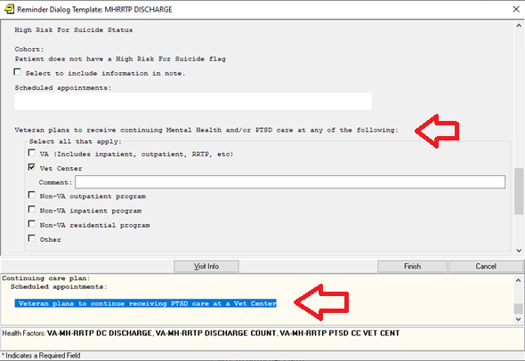

1. Reminder Dialog ELEMENTS: **VA-HBV OI IMMUNIZATION and VA-HBV OI SEROLOGIC PANEL**

Change Made:

Both elements have been changed to a ‘local’ class, to allow the Alternate Progress Note Text be edited by sites, if needed.

These elements reside in reminder dialog: VA-HEPATITIS B IMMUNIZATION and VA-HEPATITIS B SEROLOGY/IMMUNIZATION

**BEFORE**:

ELEMENT NAME: VA-HBV OI IMMUNIZATION

DISABLE:

CLASS: NATIONAL//

DIALOG/PROGRESS NOTE TEXT:

Order HBV vaccine

  Edit? NO//

ALTERNATE PROGRESS NOTE TEXT:

** see orders

ELEMENT NAME: VA-HBV OI SEROLOGIC PANEL

DISABLE:

CLASS: NATIONAL//

DIALOG/PROGRESS NOTE TEXT:

Order HBV serology

  Edit? NO//

ALTERNATE PROGRESS NOTE TEXT:

  ** see orders

**AFTER**:

ELEMENT NAME: VA-HBV OI IMMUNIZATION

DISABLE:

CLASS: LOCAL//

DIALOG/PROGRESS NOTE TEXT:

Order HBV vaccine

  Edit? NO//

ALTERNATE PROGRESS NOTE TEXT:

** see orders

ELEMENT NAME: VA-HBV OI SEROLOGIC PANEL

DISABLE:

CLASS: LOCAL//

DIALOG/PROGRESS NOTE TEXT:

Order HBV serology

  Edit? NO//

ALTERNATE PROGRESS NOTE TEXT:

  ** see orders

1. Reminder Dialog ELEMENT: **VA-OSTEO REMINDER INTRO** been edited to be ‘local’ class, to allow hyperlinks or text be added by sites, if needed.

Change Made:

Changed to a ‘local’ class, to allow hyperlinks or text be added by sites, if needed.

This element resides in reminder dialog: VA-WH OSTEOPOROSIS SCREENING

**BEFORE**:

NAME: VA-OSTEO REMINDER INTRO Replace

DISABLE:

CLASS: NATIONAL//

**AFTER**:

NAME: VA-OSTEO REMINDER INTRO Replace

DISABLE:

CLASS: LOCAL//

1. Reminder Dialog GROUP: **VA-GP TELE URGENT EVALUATION CHART REVIEW/CONSULT GP** and **VA-GP TELE URGENT EVALUATION VIRTUAL VISIT GP**

Change Made:

An additional element (VAL-TELE URGENT MED REC) has been added as a sequence. This element presents an option in the dialog for documenting completion of medication reconciliation.

These groups reside in reminder dialog: VA-TELE URGENT CARE NOTE

**BEFORE**:

GROUP NAME: **VA-GP TELE URGENT EVALUATION CHART REVIEW/CONSULT GP**

DISABLE:

CLASS: NATIONAL//

Select SEQUENCE:

10 VA-GP TELE URGENT SUBJECTIVE GP

15 VA-TEXT BLANK LINE WITH TEMPLATE FIELD

18 VAL-TELE URGENT PROBLEM LIST

20 VAL-TELE URGENT ALLERGIES

40 VAL-TELE URGENT ACTIVE MEDS

45 VA-TEXT BLANK LINE WITH TEMPLATE FIELD

50 VA-GP TELE URGENT OBJECTIVE GP

60 VA-GP TELE URGENT ASSESSMENT GP

65 VA-TEXT BLANK LINE WITH TEMPLATE FIELD

70 VA-GP TELE URGENT PLAN CONSULT GP

75 VA-TEXT BLANK LINE WITH TEMPLATE FIELD

80 VA-TEXT TELE URGENT TIME IN CONSULTATION

GROUP NAME: **VA-GP TELE URGENT EVALUATION VIRTUAL VISIT GP**

DISABLE:

CLASS: NATIONAL//

Select SEQUENCE:

10 VA-GP TELE URGENT TYPE

20 VA-TELE URGENT CARE HEADER

30 VA-GP TELE URGENT SUBJECTIVE GP

35 VA-TEXT BLANK LINE WITH TEMPLATE FIELD

38 VAL-TELE URGENT PROBLEM LIST

40 VAL-TELE URGENT ALLERGIES

60 VAL-TELE URGENT ACTIVE MEDS

65 VA-TEXT BLANK LINE WITH TEMPLATE FIELD

70 VA-GP TELE URGENT OBJECTIVE GP

80 VA-GP TELE URGENT ASSESSMENT GP

85 VA-TEXT BLANK LINE WITH TEMPLATE FIELD

90 VA-GP TELE URGENT PLAN

95 VA-TEXT BLANK LINE WITH TEMPLATE FIELD

100 VAL-GP TELE URGENT DISCHARGE INSTR CARE

105 VA-TEXT BLANK LINE WITH TEMPLATE FIELD

110 VA-TEXT TELE URGENT TIME IN TELE/VIDEO VISIT

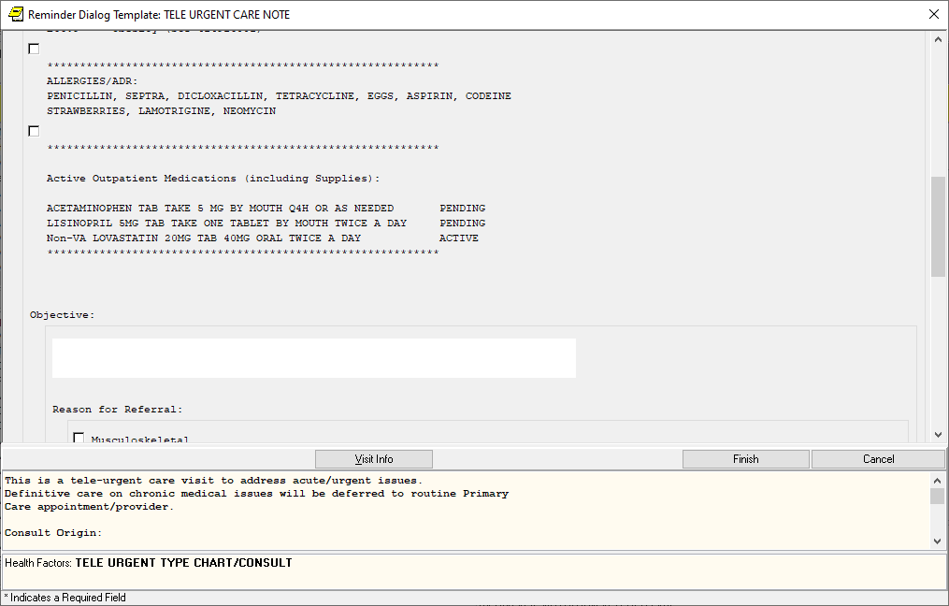

**AFTER**:

GROUP NAME: **VA-GP TELE URGENT EVALUATION CHART REVIEW/CONSULT GP**

DISABLE:

CLASS: NATIONAL//

Select SEQUENCE:

10 VA-GP TELE URGENT SUBJECTIVE GP

15 VA-TEXT BLANK LINE WITH TEMPLATE FIELD

18 VAL-TELE URGENT PROBLEM LIST

20 VAL-TELE URGENT ALLERGIES

40 VAL-TELE URGENT ACTIVE MEDS

43 VAL-TELE URGENT MED REC

45 VA-TEXT BLANK LINE WITH TEMPLATE FIELD

50 VA-GP TELE URGENT OBJECTIVE GP

60 VA-GP TELE URGENT ASSESSMENT GP

65 VA-TEXT BLANK LINE WITH TEMPLATE FIELD

70 VA-GP TELE URGENT PLAN CONSULT GP

75 VA-TEXT BLANK LINE WITH TEMPLATE FIELD

80 VA-TEXT TELE URGENT TIME IN CONSULTATION

GROUP NAME: **VA-GP TELE URGENT EVALUATION VIRTUAL VISIT GP**

DISABLE:

CLASS: NATIONAL//

Select SEQUENCE:

10 VA-GP TELE URGENT TYPE

20 VA-TELE URGENT CARE HEADER

30 VA-GP TELE URGENT SUBJECTIVE GP

35 VA-TEXT BLANK LINE WITH TEMPLATE FIELD

38 VAL-TELE URGENT PROBLEM LIST

40 VAL-TELE URGENT ALLERGIES

60 VAL-TELE URGENT ACTIVE MEDS

63 VAL-TELE URGENT MED REC

65 VA-TEXT BLANK LINE WITH TEMPLATE FIELD

70 VA-GP TELE URGENT OBJECTIVE GP

80 VA-GP TELE URGENT ASSESSMENT GP

85 VA-TEXT BLANK LINE WITH TEMPLATE FIELD

90 VA-GP TELE URGENT PLAN

95 VA-TEXT BLANK LINE WITH TEMPLATE FIELD

100 VAL-GP TELE URGENT DISCHARGE INSTR CARE

105 VA-TEXT BLANK LINE WITH TEMPLATE FIELD

110 VA-TEXT TELE URGENT TIME IN TELE/VIDEO VISIT

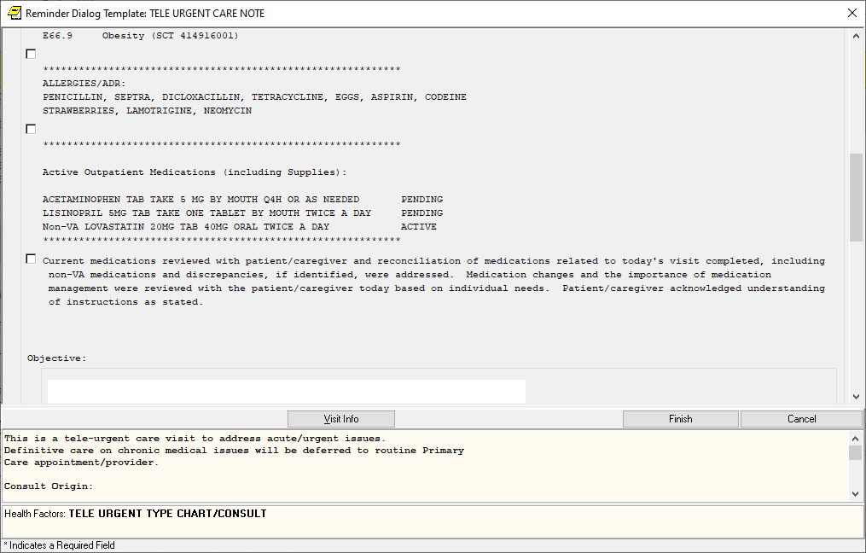

1. Reminder Dialog GROUP: **VA-GP TELE URGENT PLAN CONSULT GP**

Change Made:

An additional group (VA-GP TELE URGENT PLAN TRIAGE INTERVAL GP) has been added as a sequence. This group provides for selectable options to reference a triage interval.

This group resides in reminder dialog: VA-TELE URGENT CARE NOTE

**BEFORE**:

1 Group: VA-GP TELE URGENT PLAN CONSULT GP

2 5 Element: VA-GP TELE URGENT GENERIC WP

3 10 Group: VA-GP TELE URGENT PLAN CONSULT GROUPER GP

4 10.5 Element: VA-TELE URGENT PLAN TELE URGENT CONSULT

5 10.10 Group: VA-GP TELE URGENT PLAN PACT

6 10.10.10 Element: VA-TELE URGENT PLAN PACT LESS THAN 72

7 10.15 Element: VA-TELE URGENT PLAN URGENT CARE

8 10.20 Element: VA-TELE URGENT PLAN NEAREST ER

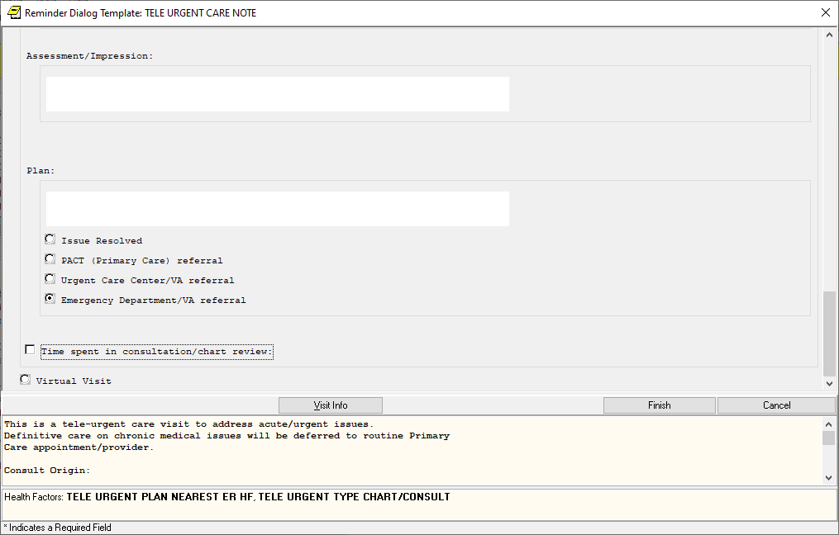

**AFTER**:

1 Group: VA-GP TELE URGENT PLAN CONSULT GP

2 5 Element: VA-GP TELE URGENT GENERIC WP

3 10 Group: VA-GP TELE URGENT PLAN CONSULT GROUPER GP

4 10.5 Element: VA-TELE URGENT PLAN TELE URGENT CONSULT

5 10.10 Group: VA-GP TELE URGENT PLAN PACT

6 10.10.10 Element: VA-TELE URGENT PLAN PACT LESS THAN 72

7 10.15 Element: VA-TELE URGENT PLAN URGENT CARE

8 10.20 Element: VA-TELE URGENT PLAN NEAREST ER

9 15 Element: VA-BLANK LINE DIALOG & NOTE

10 20 Group: VA-GP TELE URGENT PLAN TRIAGE INTERVAL GP

11 20.10 Element: VA-TELE URGENT PLAN TRIAGE INTERVAL DOWN

12 20.20 Element: VA-TELE URGENT PLAN TRIAGE INTERVAL UP

13 20.30 Element: VA-TELE URGENT PLAN TRIAGE INTERVAL VIRTUAL

14 20.40 Element: VA-TELE URGENT PLAN TRIAGE INTERVAL F2F

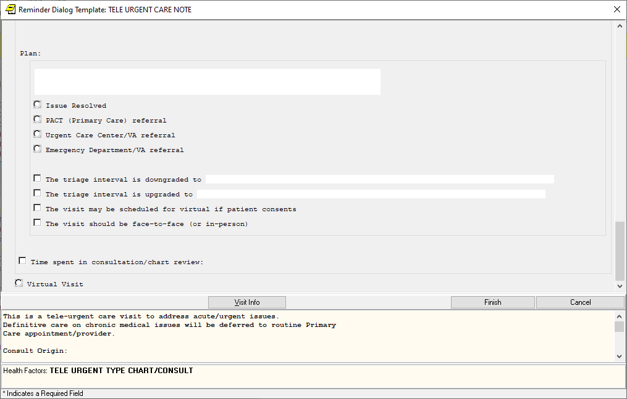

1. Reminder Dialog GROUP: **VA-PHI MOST RECENT HISTORICAL PHI RESPONSES**

Change Made:

The word “CWAD” was removed from the text of the object

This group resides in reminder dialog: VA-PERSONAL HEALTH INVENTORY (PHI) NOTE

**BEFORE**:

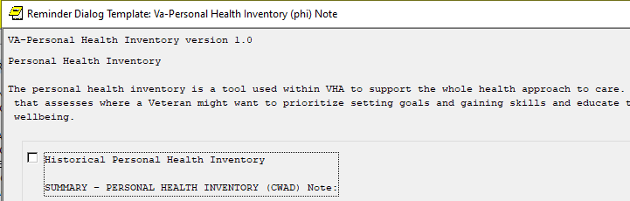

**AFTER**:

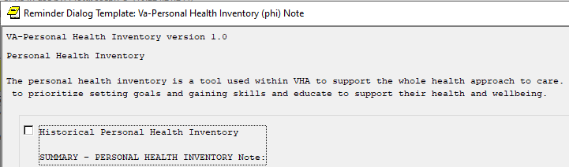

1. Reminder Dialog ELEMENTS: **VA-VM HTN BLOOD PRESSURE** and **VA-VM HTN BLOOD PRESSURE SELF RECORDED**

Change Made:

The dialog text was changed in both elements

These elements reside in reminder dialog: VA-HTN ELEVATED BP>140/90

**BEFORE**:

NAME: **VA-VM HTN BLOOD PRESSURE**

DISABLE:

CLASS: NATIONAL//

SPONSOR: OFFICE OF QUALITY & PERFORMANCE//

REVIEW DATE:

RESOLUTION TYPE: DONE AT ENCOUNTER//

ORDERABLE ITEM:

Finding item: VM BLOOD PRESSURE

FINDING ITEM: BLOOD PRESSURE//

Additional findings: none

Select ADDITIONAL FINDING:

VITALS PROMPT CAPTION:

DIALOG/PROGRESS NOTE TEXT:

Repeat blood pressure and record below if appropriate

NAME: **VA-VM HTN BLOOD PRESSURE SELF RECORDED**

DISABLE:

CLASS: NATIONAL//

SPONSOR:

REVIEW DATE:

RESOLUTION TYPE:

ORDERABLE ITEM:

Finding item: HF HTN SELF-RECORDED BP

FINDING ITEM: HTN SELF-RECORDED BP//

Additional findings: none

Select ADDITIONAL FINDING:

DIALOG/PROGRESS NOTE TEXT:

Patient reported blood pressure (please enter as SBP/DBP, e.g. 135/85)

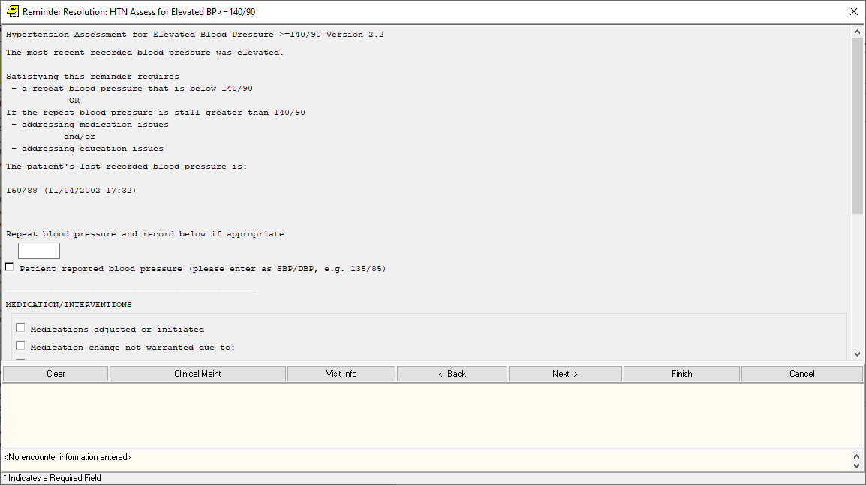

**AFTER**:

NAME: **VA-VM HTN BLOOD PRESSURE**

DISABLE:

CLASS: NATIONAL//

SPONSOR: OFFICE OF QUALITY & PERFORMANCE//

REVIEW DATE:

RESOLUTION TYPE: DONE AT ENCOUNTER//

ORDERABLE ITEM:

Finding item: VM BLOOD PRESSURE

FINDING ITEM: BLOOD PRESSURE//

Additional findings: none

Select ADDITIONAL FINDING:

VITALS PROMPT CAPTION:

DIALOG/PROGRESS NOTE TEXT:

Repeat Blood pressure if patient seen in person and record below. \\

Staff may enter a blood pressure measurement visualized over VVC or CVT.

\\

(Enter as SBP/DBP, e.g. 120/80).

NAME: **VA-VM HTN BLOOD PRESSURE SELF RECORDED**

DISABLE:

CLASS: NATIONAL//

SPONSOR:

REVIEW DATE:

RESOLUTION TYPE:

ORDERABLE ITEM:

Finding item: HF HTN SELF-RECORDED BP

FINDING ITEM: HTN SELF-RECORDED BP//

Additional findings: none

Select ADDITIONAL FINDING:

DIALOG/PROGRESS NOTE TEXT:

Enter patient reported blood pressure below.\\

(Enter as SBP/DBP, e.g. 120/80. NOTE: Only the first 7 digits will count

toward BP measures.)

