**REMINDER UPDATE_2_0_233 VA-MISC UPDATE 15 CHANGES**

Contents

1. Reminder Dialog ELEMENT: VA-COMM CARE CIH TEMPLATE FIELD 1

**2.** Reminder Dialog ELEMENT: VA-TELESTROKE PROVIDER TYPE FIELD 2

3. Reminder TERM: VA-AGE <40!>71 2

4. Reminder Dialog GROUP: VA-GP ACUTE STROKE NURSE TRIAGE SYMPTOMS-LVO 3

5. Reminder Dialog ELEMENT: VA-COVID-19 VACCINE REFUSAL 5

6. Reminder Dialog ELEMENT: VA-SCID EE TYPE OTHER 6

7. Reminder Dialog ELEMENT: UPDATE VIS DATES AUG-2021 8

8. Reminder Dialog ELEMENT: VA-MH PCL-5 WEEKLY 9

9. Reminder Dialog GROUP: VA-GP MHRRTP PTSD TX VET RECEIVE CARE WHERE 11

10. Reminder Dialog GROUP: VA-GP MHRRTP COVID-19 INFORMATION 13

11. Reminder Dialog ELEMENTS: 14

12. Reminder Dialog ELEMENT: VA-EL ONC MDC CRC INSTRUCTIONS 16

13. Reminder TERM: VA-HEALTH AND WELL BEING 16

14. Reminder ELEMENT: VA-NEWS PULSE SCORE 0 22

15. Reminder ELEMENT: VA-TXT PACT COVID-19 INVENTORY-FLU DONE (BL) 24

16. Reminder ELEMENT: VA-EL RH&S – ADVOCACY GROUP 25

17. Reminder GROUP: VA-CLC PREADMISSION SCREEN ADL SCORE 0-5 OPTIONS N/A 26

18. Reminder ELEMENT: VA-NSG SA GI LAST BM D/T 27

19. Reminder GROUP: VA-GP SUICIDE INTERVENTION ACTION EMERGENCY 28

20. Reminder ELEMENT: VA-NSG SA GI LAST BM DISPLAY 30

NOTE: All reminder dialog changes are included in Reminder Dialog Group:

VA-GP MISC UPDATE 15

*A number of the items below are Elements or Groups that are set with a class of ‘national’. To confirm updates made on any ‘national’ dialog element or group, choose the INQ (Inquiry/Print) option in the Reminder Dialog Management Menu.*

# Reminder Dialog ELEMENT: VA-COMM CARE CIH TEMPLATE FIELD

Change Made: Community Care edited a template field hyperlink that resides within their Community Care-CIH Acupuncture consult. The updated hyperlink now points to the correct SharePoint.

**BEFORE**:

This ELEMENT (**VA-COMM CARE CIH TEMPLATE FIELD**) is new, and was created specifically to include this updated template field for community care.

**AFTER**:

NAME: VA-COMM CARE CIH TEMPLATE FIELD Replace

DISABLE:

CLASS: LOCAL//

SPONSOR:

REVIEW DATE:

RESOLUTION TYPE:

ORDERABLE ITEM:

FINDING ITEM:

Additional findings: none

Select ADDITIONAL FINDING:

DIALOG/PROGRESS NOTE TEXT: {FLD:NON PHARM APPROACHES TO CLINICAL COND}

Link is:

<https://effectivehealthcare.ahrq.gov/sites/default/files/pdf/noninvasive-nonpharm-pain-update.pdf>

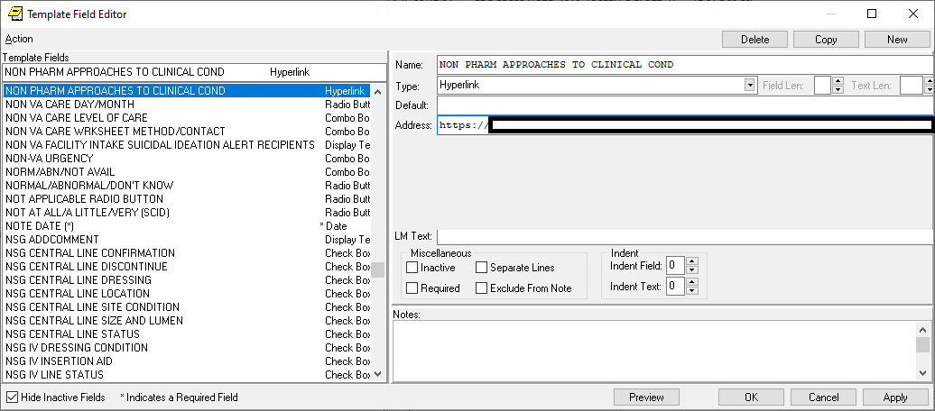

# Reminder Dialog ELEMENT: VA-TELESTROKE PROVIDER TYPE FIELD

Change Made: This Element was created to ensure the {VA-PROVIDER TYPE} field, used in the VA-TELESTROKE RN TRIAGE-ACUTE STROKE dialog, is installed. The template field failed to pack with the original installation even though it does reside in the dialog text. Installation of misc. update 15 will ensure the template field is installed and displays properly on the dialog.

**BEFORE**:

This ELEMENT (**VA-TELESTROKE PROVIDER TYPE FIELD**) is new, and was created specifically to include the {VA-PROVIDER TYPE} template field for Tele stroke.

**AFTER**:

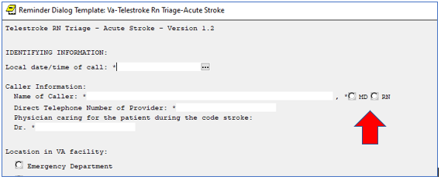

# Reminder TERM: VA-AGE <40!>71

Change Made: The ‘condition’ was edited from I V<40!(V>71) to I V<35!(V>71) to evaluate at age 35 vs. 40.

This term is used as branching logic in the VA-CRC SCREEN reminders.

**BEFORE**:

VA-AGE <40!>71

-----------------------------------------------------------------------------

Class:                  LOCAL

Sponsor:

Date Created:

Review Date:

Description:

  Used as branching logic in the VA-CRC Screen reminders. The term will be

  evaluated as true if the patient is <35 or >71 years old. This was updated

  in May 2021 with new CRC screening guidance. The original version was true

  if the patient was <40 or >71, hence the name.

Findings:

                  Finding Item: VA-AGE (FI(1)=CF(24))

                  Finding Type: REMINDER COMPUTED FINDING

                     Condition: I V<40!(V>71)

**AFTER**:

VA-AGE <40!>71

-----------------------------------------------------------------------------

Class:                  LOCAL

Sponsor:

Date Created:

Review Date:

Description:

  Used as branching logic in the VA-CRC Screen reminders. The term will be

  evaluated as true if the patient is <35 or >71 years old. This was updated

  in May 2021 with new CRC screening guidance. The original version was true

  if the patient was <40 or >71, hence the name.

Findings:

                  Finding Item: VA-AGE (FI(1)=CF(24))

                  Finding Type: REMINDER COMPUTED FINDING

                     Condition: I V<35!(V>71)

# Reminder Dialog GROUP: VA-GP ACUTE STROKE NURSE TRIAGE SYMPTOMS-LVO

Change Made: The misspelled word “occulsion” corrected to “occlusion” in the dialog text.

This group resides in reminder dialog: VA-TELESTROKE RN TRIAGE-ACUTE STROKE

**BEFORE**:

Group: VA-GP ACUTE STROKE NURSE TRIAGE SYMPTOMS-LVO

Text: LARGE VESSEL OCCULSION (LVO) SYMPTOMS:

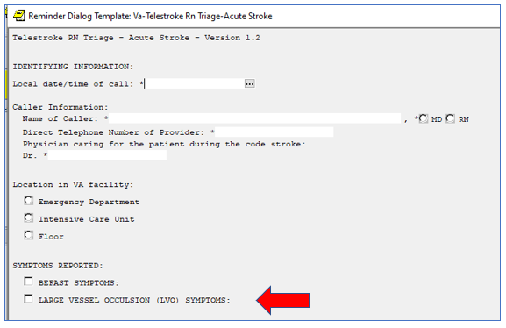

**AFTER**:

Group: VA-GP ACUTE STROKE NURSE TRIAGE SYMPTOMS-LVO

Text: LARGE VESSEL OCCLUSION (LVO) SYMPTOMS:

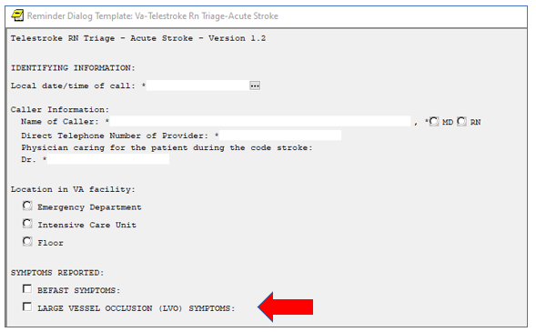

# Reminder Dialog ELEMENT: VA-COVID-19 VACCINE REFUSAL

Change Made: The misspelled word “recieve” corrected to “receive” in the alternate dialog text.

This element resides in reminder dialog: VA-COVID-19 PREVENTIVE HEALTH INVENTORY

**BEFORE**:

NAME: VA-COVID-19 VACCINE REFUSAL

DISABLE:

CLASS: NATIONAL//

SPONSOR:

REVIEW DATE:

RESOLUTION TYPE:

ORDERABLE ITEM:

Finding item: HF VA-SARS-COV-2 VACCINE REFUSAL

FINDING ITEM: VA-SARS-COV-2 VACCINE REFUSAL//

Additional findings: none

Select ADDITIONAL FINDING:

DIALOG/PROGRESS NOTE TEXT:

No:Refused {FLD:VA-COVID ACCEPT}

Edit? NO//

ALTERNATE PROGRESS NOTE TEXT:

Patient declines to recieve COVID-19 Immunization.

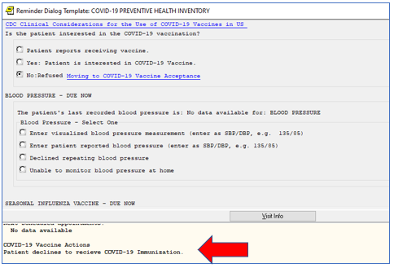

**AFTER**:

NAME: VA-COVID-19 VACCINE REFUSAL

DISABLE:

CLASS: NATIONAL//

SPONSOR:

REVIEW DATE:

RESOLUTION TYPE:

ORDERABLE ITEM:

Finding item: HF VA-SARS-COV-2 VACCINE REFUSAL

FINDING ITEM: VA-SARS-COV-2 VACCINE REFUSAL//

Additional findings: none

Select ADDITIONAL FINDING:

DIALOG/PROGRESS NOTE TEXT:

No:Refused {FLD:VA-COVID ACCEPT}

Edit? NO//

ALTERNATE PROGRESS NOTE TEXT:

Patient declines to receive COVID-19 Immunization.

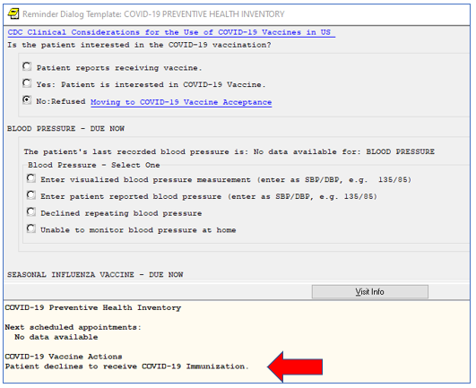

# Reminder Dialog ELEMENT: VA-SCID EE TYPE OTHER

Change Made: Two elements with PXRM COMMENT prompts shared the same health factor. The duplicate health factor, in the VA-SCID EE TYPE OTHER element has been replaced with a new health factor.

This element resides in reminder dialog: VA-SCI/D EMERGENCY EVENT

**BEFORE**:

NAME: VA-SCID EE TYPE OTHER

DISABLE:

CLASS: NATIONAL//

SPONSOR:

REVIEW DATE:

RESOLUTION TYPE:

ORDERABLE ITEM:

Finding item: HF VA-SCI/D EE OTHER ND

FINDING ITEM: VA-SCI/D EE OTHER ND//

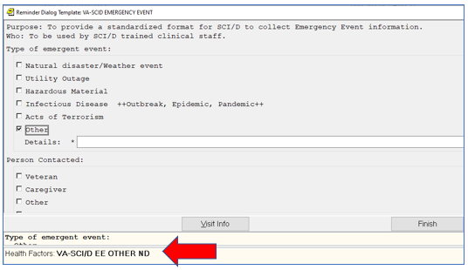

**AFTER**:

NAME: VA-SCID EE TYPE OTHER

DISABLE:

CLASS: NATIONAL//

SPONSOR:

REVIEW DATE:

RESOLUTION TYPE:

ORDERABLE ITEM:

Finding item: HF VA-SCI/D EE OTHER

FINDING ITEM: VA-SCI/D EE OTHER//

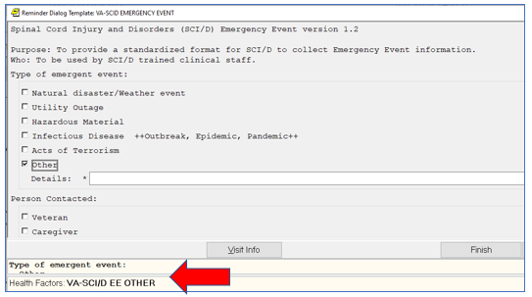

# Reminder Dialog ELEMENT: UPDATE VIS DATES AUG-2021

Change Made: **Vaccine Information Statement** (VIS) dates have been updated to be current. Installation of this element will update the VIS dates included in national reminders. The list of VIS date template fields updated are in the ‘after’ section below.

**BEFORE**:

THIS ELEMENT WAS CREATED TO INCLUDE THE UPDATED VIS DATES.

**AFTER**:

NAME: UPDATE VIS DATES AUG-2021 Replace

DISABLE:

CLASS: LOCAL//

SPONSOR:

REVIEW DATE:

RESOLUTION TYPE:

ORDERABLE ITEM:

FINDING ITEM:

Additional findings: none

Select ADDITIONAL FINDING:

DIALOG/PROGRESS NOTE TEXT:

{FLD:IM VIS HPV9 DT}

{FLD:IM VIS INFLUENZA DT}

{FLD:IM VIS MENING ACWY DT}

{FLD:IM VIS MENING B DT}

{FLD:IM VIS PCV13 DT}

{FLD:IM VIS TD DT}

{FLD:IM VIS TDAP DT}

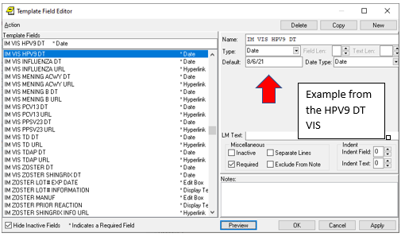

# Reminder Dialog ELEMENT: VA-MH PCL-5 WEEKLY

Change Made: PCL5 weekly scores were not populating correctly in the note. It should just be the total score populating versus all item scores.

This element resides in reminder dialog: VA-MH PEI 3RD SESSION and other dialogs

**BEFORE**:

Assessment:

  PCL-5 Weekly

    The score was 2.

     Interpretive Statement:

     PCL-5 weekly has a total score range of 0-80, with higher scores

     indicating greater PTSD symptom severity.

     0-10: no or minimal symptoms reported

     11-20: mild symptoms reported

     21-40: moderate symptoms reported

     41-60: severe symptoms reported

     61-80: very severe symptoms reported

    1. Repeated, disturbing, and unwanted memories of the stressful experience?

    Not at all

    2. Repeated, disturbing dreams of the stressful experience?

    Not at all

    3. Suddenly feeling or acting as if the stressful experience were actually

    happening again (as if you were actually back there reliving it)?

    Not at all

    4. Feeling very upset when something reminded you of the stressful

    experience?

    Not at all

    5. Having strong physical reactions when something reminded you of the

    stressful experience (for example, heart pounding, trouble breathing,

    sweating)?

    Not at all

    6. Avoiding memories, thoughts, or feelings related to the stressful

    experience?

    Not at all

    7. Avoiding external reminders of the stressful experience (for example,

    people, places, conversations, activities, objects, or situations)?

    Not at all

    8. Trouble remembering important parts of the stressful experience?

    Not at all

    9. Having strong negative beliefs about yourself, other people, or the

    world (for example, having thoughts such as: I am bad, there is something

    seriously wrong with me, no one can be trusted, the world is completely

    dangerous)?

    Moderately

    10. Blaming yourself or someone else for the stressful experience or what

    happened after it?

    Not at all

    11. Having strong negative feelings such as fear, horror, anger, guilt, or

    shame?

    Not at all

    12. Loss of interest in activities that you used to enjoy?

    Not at all

    13. Feeling distant or cut off from other people?

    Not at all

    14. Trouble experiencing positive feelings (for example, being unable to

    feel happiness or have loving feelings for people close to you)?

    Not at all

    15. Irritable behavior, angry outbursts, or acting aggressively?

    Not at all

    16. Taking too many risks or doing things that could cause you harm?

    Not at all

    17. Being "super alert" or watchful or on guard?

    Not at all

    18. Feeling jumpy or easily startled?

    Not at all

    19. Having difficulty concentrating?

    Not at all

    20. Trouble falling or staying asleep?

    Not at all

**AFTER**:

NAME: VA-MH PCL-5 WEEKLY//

DISABLE:

CLASS: NATIONAL//

SPONSOR:

REVIEW DATE:

RESOLUTION TYPE:

ORDERABLE ITEM:

Finding item: MH PCL-5 WEEKLY

FINDING ITEM: PCL-5 WEEKLY//

Additional findings: none

Select ADDITIONAL FINDING:

Select RESULT GROUP: PXRM PCL-5 WEEKLY RESULT GROUP

//

RESULT GROUP: PXRM PCL-5 WEEKLY RESULT GROUP//

Select RESULT GROUP:

EXCLUDE MH TEST FROM PN TEXT: YES//

MH TEST REQUIRED: Optional open and optional complete (partial complete possible)

//

DIALOG/PROGRESS NOTE TEXT:

PCL-5 Weekly

Edit? NO//

ALTERNATE PROGRESS NOTE TEXT:

Edit? NO//

EXCLUDE FROM PROGRESS NOTE:

SUPPRESS CHECKBOX: SUPPRESS//

Select SEQUENCE:

Select BRANCHING LOGIC SEQUENCE:

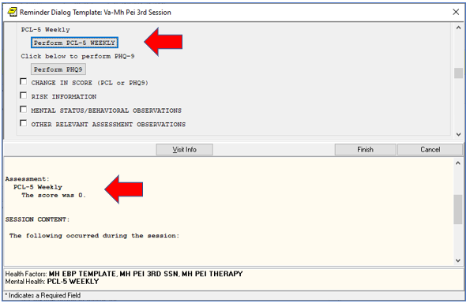

# Reminder Dialog GROUP: VA-GP MHRRTP PTSD TX VET RECEIVE CARE WHERE

Change Made: Alternate text was added to the options for documenting the veteran plans to receive continuing mental health and/or PTSD care in the VA-MHRRTP DISCHARGE reminder dialog.

This group resides in reminder dialog: VA-MHRRTP DISCHARGE

**BEFORE**:

Group: VA-GP MHRRTP PTSD TX VET RECEIVE CARE WHERE

Element: VA-MHRRTP PTSD TX VA

ALTERNATE PROGRESS NOTE TEXT:

Veteran plans to continue receiving PTSD care at the VA

Element: VA-MHRRTP PTSD TX VET CENTER

ALTERNATE PROGRESS NOTE TEXT:

Veteran plans to continue receiving PTSD care at a Vet Center

Element: VA-MHRRTP PTSD TX NON VA OUTPATIENT PROGRAM

ALTERNATE PROGRESS NOTE TEXT:

Veteran plans to continue receiving PTSD care at a non-VA outpatient program

Element: VA-MHRRTP PTSD TX NON VA INPATIENT PROGRAM

ALTERNATE PROGRESS NOTE TEXT:

Veteran plans to continue receiving PTSD care at a Non-VA inpatient program

Element: VA-MHRRTP PTSD TX NON VA RESIDENTIAL PROGRAM

ALTERNATE PROGRESS NOTE TEXT:

   Veteran plans to continue receiving PTSD care at a Non-VA residential program

**AFTER**:

Group: VA-GP MHRRTP PTSD TX VET RECEIVE CARE WHERE

Element: VA-MHRRTP PTSD TX VA

ALTERNATE PROGRESS NOTE TEXT:

Veteran plans to continue receiving continuing Mental Health and/or PTSD care at the VA

Element: VA-MHRRTP PTSD TX VET CENTER

ALTERNATE PROGRESS NOTE TEXT:

Veteran plans to continue receiving continuing Mental Health and/or PTSD care at a Vet Center

Element: VA-MHRRTP PTSD TX NON VA OUTPATIENT PROGRAM

ALTERNATE PROGRESS NOTE TEXT:

Veteran plans to continue receiving continuing Mental Health and/or PTSD care at a non-VA outpatient program

Element: VA-MHRRTP PTSD TX NON VA INPATIENT PROGRAM

ALTERNATE PROGRESS NOTE TEXT:

Veteran plans to continue receiving continuing Mental Health and/or PTSD care at a Non-VA inpatient program

Element: VA-MHRRTP PTSD TX NON VA RESIDENTIAL PROGRAM

ALTERNATE PROGRESS NOTE TEXT:

   Veteran plans to continue receiving continuing Mental Health and/or PTSD care at a Non-VA residential program

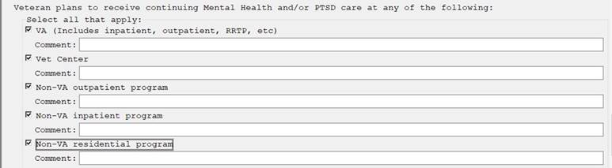

# Reminder Dialog GROUP: VA-GP MHRRTP COVID-19 INFORMATION

Change Made: The COVID-19 questions have been removed from the VA-MHRRTP SCREENING reminder dialog. The group with the questions (VA-GP MHRRTP COVID-19 INFORMATION) is disabled with this update.

This group resides in reminder dialog: VA-MHRRTP SCREENING

**BEFORE**:

Group: VA-GP MHRRTP COVID-19 INFORMATION

Element: VA-GP MHRRTP COVID-19 DELAYED RELATED

Element: VA-GP MHRRTP COVID-19 DELAYED DX

Element: VA-GP MHRRTP COVID-19 NO IMPACT

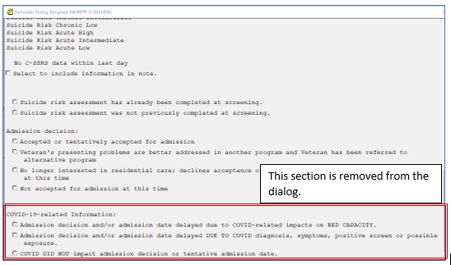

**AFTER**:

Group: VA-GP MHRRTP COVID-19 INFORMATION (Disabled)

Element: VA-GP MHRRTP COVID-19 DELAYED RELATED

Element: VA-GP MHRRTP COVID-19 DELAYED DX

Element: VA-GP MHRRTP COVID-19 NO IMPACT

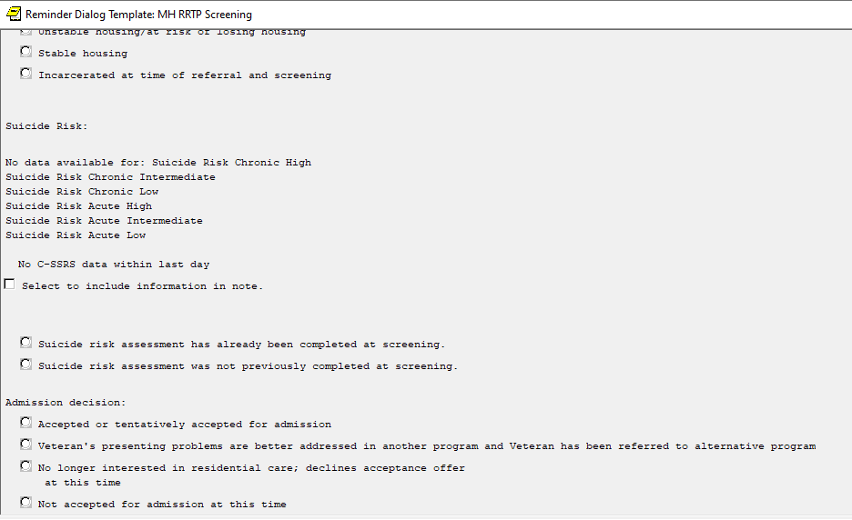

# Reminder Dialog ELEMENTS:

* VA-EL MHRRTP ADMIT ACC REQST LTR NO PRIORITY
* VA-EL MHRRTP ADMIT ACC LATER DATE NO PRIORITY
* VA-GP MHRRTP REMAINS CURRENTLY SCHEDULED LATER NO PRIOR and \
* VA-EL MHRRTP REQUIRE LATER DATE NO PRIORITY

Change Made: New comment fields added to a few of the options.

These elements reside in reminder dialogs: VA-MHRRTP SCREENING and VA-MHRRTP STATUS UPDATE.

**BEFORE**:

VA-EL MHRRTP ADMIT ACC REQST LTR NO PRIORITY

VA-EL MHRRTP ADMIT ACC LATER DATE NO PRIORITY

VA-GP MHRRTP REMAINS CURRENTLY SCHEDULED LATER NO PRIOR

VA-EL MHRRTP REQUIRE LATER DATE NO PRIORITY

**AFTER**:

Element: VA-EL MHRRTP ADMIT ACC REQST LTR NO PRIORITY

Text: Veteran requested later date

Prompts: Please explain:

Element: VA-EL MHRRTP ADMIT ACC LATER DATE NO PRIORITY

Text: Veteran requires a later date (e.g., incarcerated, completing

other program)

Prompts: Please explain:

Element: VA-GP MHRRTP REMAINS CURRENTLY SCHEDULED LATER NO PRIOR

Text: Veteran was offered next available date and is requesting a

later date.

Prompts: Please explain:

Element: VA-EL MHRRTP REQUIRE LATER DATE NO PRIORITY

Text: Veteran requires later date (e.g., incarcerated, completing

other program)

Prompts: Please explain:

VA-MHRRTP SCREENING

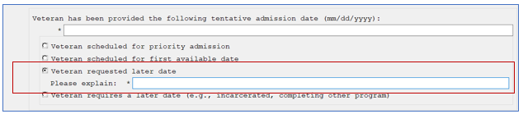

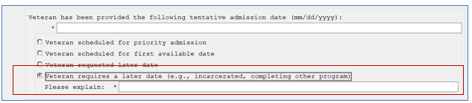

VA-MHRRTP STATUS UPDATE

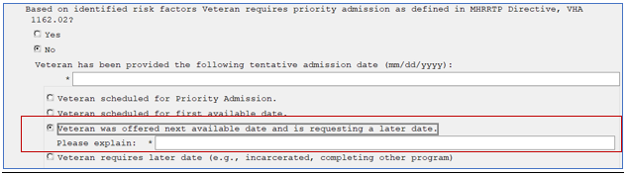

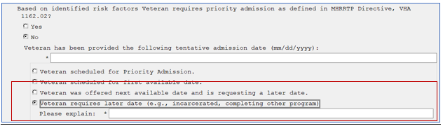

# Reminder Dialog ELEMENT: VA-EL ONC MDC CRC INSTRUCTIONS

Change Made: A misspelling has been corrected, from “Gastrointestional” to “Gastrointestinal.

This element resides in reminder dialog: VA-ONCOLOGY MDC COLORECTAL.

**BEFORE**:

Element: VA-EL ONC MDC CRC INSTRUCTIONS

Text: It is recommended that the Multidisciplinary Gastrointestional

Conference Template be initiated when colorectal cancer cases

are presented to the Tumor Board.

**AFTER**:

Element: VA-EL ONC MDC CRC INSTRUCTIONS

Text: It is recommended that the Multidisciplinary Gastrointestinal

Conference Template be initiated when colorectal cancer cases

are presented to the Tumor Board.

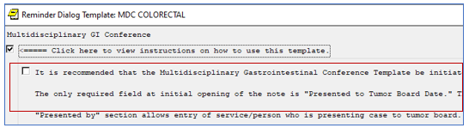

# Reminder TERM: VA-HEALTH AND WELL BEING

Change Made: Term has been updated to include the **VA-WHS NADA** health factor.

**BEFORE**:

Select REMINDER TERM: VA-HEALTH AND WELL BEING NATIONAL

-----------------------------------------------------------------------------

VA-HEALTH AND WELL BEING No. 1127

-----------------------------------------------------------------------------

Class: NATIONAL

Sponsor:

Date Created:

Review Date:

Description:

This term is being created to distribute the health factors that represent

health and well being treatments.

UPDATE_2_0_78: Added 2 new Health Factors to this term VA-WHS MAP TO THE

MAPP VA-WHS FUNCTIONAL NUTRITION

UPDATE_2_0_164 added 2 new health factors to this term: VA-WHS - NATIVE

AMERICAN HEALING VA-WHS - MY STORY

UPDATE_2_0_178 added 7 new health factors for age friendly whole health

VA-WHS-AGE-FRIENDLY-4M VA-WHS-AGE-FRIENDLY-WHAT MATTERS VA-WHS-AGE-FRIENDLY

MEDICATION VA-WHS-AGE-FRIENDLY-MENTATION VA-WHS-AGE-FRIENDLY-MOBILITY

VA-WHS-AFHS-IDENTIFY PATIENT PRIORITIES VA-WHS-AFHS-PATIENT PRIORITIES

FOLLOW-UP

Findings:

Finding Item: VA-WHS - AROMATHERAPY (FI(1)=HF(10045))

Finding Type: HEALTH FACTOR

Health Factor Category: VA-HEALTH AND WELL BEING [C]

Finding Item: VA-WHS - BFA (FI(2)=HF(10033))

Finding Type: HEALTH FACTOR

Health Factor Category: VA-HEALTH AND WELL BEING [C]

Finding Item: VA-WHS - CHANGING THE CONVERSATION (FI(3)=HF(10048))

Finding Type: HEALTH FACTOR

Health Factor Category: VA-HEALTH AND WELL BEING [C]

Finding Item: VA-WHS - EXPRESSIVE ARTS (FI(4)=HF(10029))

Finding Type: HEALTH FACTOR

Health Factor Category: VA-HEALTH AND WELL BEING [C]

Finding Item: VA-WHS - INTEGRATIVE HEALTH (FI(5)=HF(10034))

Finding Type: HEALTH FACTOR

Health Factor Category: VA-HEALTH AND WELL BEING [C]

Finding Item: VA-WHS - INTRODUCTION TO WHOLE HEALTH (FI(6)=HF(10049))

Finding Type: HEALTH FACTOR

Health Factor Category: VA-HEALTH AND WELL BEING [C]

Finding Item: VA-WHS - MEDITATION (FI(7)=HF(10036))

Finding Type: HEALTH FACTOR

Health Factor Category: VA-HEALTH AND WELL BEING [C]

Finding Item: VA-WHS - PERSONAL HEALTH INVENTORY (FI(8)=HF(10047))

Finding Type: HEALTH FACTOR

Health Factor Category: VA-HEALTH AND WELL BEING [C]

Finding Item: VA-WHS - PERSONAL HEALTH PLANNING (FI(9)=HF(10046))

Finding Type: HEALTH FACTOR

Health Factor Category: VA-HEALTH AND WELL BEING [C]

Finding Item: VA-WHS - QI GONG (FI(10)=HF(10030))

Finding Type: HEALTH FACTOR

Health Factor Category: VA-HEALTH AND WELL BEING [C]

Finding Item: VA-WHS - REIKI (FI(11)=HF(10038))

Finding Type: HEALTH FACTOR

Health Factor Category: VA-HEALTH AND WELL BEING [C]

Finding Item: VA-WHS - RELAXATION TECHNIQUES (FI(12)=HF(10039))

Finding Type: HEALTH FACTOR

Health Factor Category: VA-HEALTH AND WELL BEING [C]

Finding Item: VA-WHS - TAI CHI (FI(13)=HF(10040))

Finding Type: HEALTH FACTOR

Health Factor Category: VA-HEALTH AND WELL BEING [C]

Finding Item: VA-WHS - TAKING CHARGE LIFE AND HEALTH (FI(14)=HF(10032))

Finding Type: HEALTH FACTOR

Health Factor Category: VA-HEALTH AND WELL BEING [C]

Finding Item: VA-WHS - THERAPEUTIC OR HEALING TOUCH (FI(15)=HF(10041))

Finding Type: HEALTH FACTOR

Health Factor Category: VA-HEALTH AND WELL BEING [C]

Finding Item: VA-WHS - WHOLE HEALTH COACHING (FI(16)=HF(10042))

Finding Type: HEALTH FACTOR

Health Factor Category: VA-HEALTH AND WELL BEING [C]

Finding Item: VA-WHS - WHOLE HEALTH EDUCATION (FI(17)=HF(10044))

Finding Type: HEALTH FACTOR

Health Factor Category: VA-HEALTH AND WELL BEING [C]

Finding Item: VA-WHS - YOGA (FI(18)=HF(10043))

Finding Type: HEALTH FACTOR

Health Factor Category: VA-HEALTH AND WELL BEING [C]

Finding Item: VA-WHS - GUIDED IMAGERY (FI(19)=HF(10031))

Finding Type: HEALTH FACTOR

Health Factor Category: VA-HEALTH AND WELL BEING [C]

Finding Item: VA-WHS - MINDFULNESS BASED STRESS REDUCE (FI(20)=HF(10035))

Finding Type: HEALTH FACTOR

Health Factor Category: VA-HEALTH AND WELL BEING [C]

Finding Item: VA-WHS - MINDFULNESS OTHER THAN MBSR (FI(21)=HF(10037))

Finding Type: HEALTH FACTOR

Health Factor Category: VA-HEALTH AND WELL BEING [C]

Finding Item: VA-WHS - FUNCTIONAL NUTRITION (FI(22)=HF(12857))

Finding Type: HEALTH FACTOR

Health Factor Category: VA-HEALTH AND WELL BEING [C]

Finding Item: VA-WHS - MAP TO THE MAP (FI(23)=HF(12856))

Finding Type: HEALTH FACTOR

Health Factor Category: VA-HEALTH AND WELL BEING [C]

Finding Item: VA-WHS - NATIVE AMERICAN HEALING (FI(24)=HF(18527))

Finding Type: HEALTH FACTOR

Health Factor Category: VA-HEALTH AND WELL BEING [C]

Finding Item: VA-WHS - MY STORY (FI(25)=HF(19202))

Finding Type: HEALTH FACTOR

Health Factor Category: VA-HEALTH AND WELL BEING [C]

Finding Item: VA-WHS-AGE-FRIENDLY-4MS (FI(26)=HF(19295))

Finding Type: HEALTH FACTOR

Health Factor Category: VA-HEALTH AND WELL BEING [C]

Finding Item: VA-WHS-AGE-FRIENDLY-WHAT MATTERS (FI(27)=HF(19296))

Finding Type: HEALTH FACTOR

Health Factor Category: VA-HEALTH AND WELL BEING [C]

Finding Item: VA-WHS-AGE-FRIENDLY MEDICATION (FI(28)=HF(19297))

Finding Type: HEALTH FACTOR

Health Factor Category: VA-HEALTH AND WELL BEING [C]

Finding Item: VA-WHS-AGE-FRIENDLY-MENTATION (FI(29)=HF(19298))

Finding Type: HEALTH FACTOR

Health Factor Category: VA-HEALTH AND WELL BEING [C]

Finding Item: VA-WHS-AGE-FRIENDLY-MOBILITY (FI(30)=HF(19299))

Finding Type: HEALTH FACTOR

Health Factor Category: VA-HEALTH AND WELL BEING [C]

Finding Item: VA-WHS-AFHS-IDENTIFY PATIENT PRIORITIES (FI(31)=HF(19300))

Finding Type: HEALTH FACTOR

Health Factor Category: VA-HEALTH AND WELL BEING [C]

Finding Item: VA-WHS-AFHS-PATIENT PRIORITIES FOLLOW-UP (FI(32)=HF(19301))

Finding Type: HEALTH FACTOR

Health Factor Category: VA-HEALTH AND WELL BEING [C]

**AFTER**:

Select REMINDER TERM: VA-HEALTH AND WELL BEING NATIONAL

-----------------------------------------------------------------------------

VA-HEALTH AND WELL BEING No. 1127

-----------------------------------------------------------------------------

Class: NATIONAL

Sponsor:

Date Created:

Review Date:

Description:

This term is being created to distribute the health factors that represent

health and well being treatments.

UPDATE_2_0_78: Added 2 new Health Factors to this term VA-WHS MAP TO THE

MAPP VA-WHS FUNCTIONAL NUTRITION

UPDATE_2_0_164 added 2 new health factors to this term: VA-WHS - NATIVE

AMERICAN HEALING VA-WHS - MY STORY

UPDATE_2_0_178 added 7 new health factors for age friendly whole health

VA-WHS-AGE-FRIENDLY-4M VA-WHS-AGE-FRIENDLY-WHAT MATTERS VA-WHS-AGE-FRIENDLY

MEDICATION VA-WHS-AGE-FRIENDLY-MENTATION VA-WHS-AGE-FRIENDLY-MOBILITY

VA-WHS-AFHS-IDENTIFY PATIENT PRIORITIES VA-WHS-AFHS-PATIENT PRIORITIES

FOLLOW-UP

UPDATE_2_0_233 added 1 new health factor to this term: VA-WHS - NADA

Findings:

Finding Item: VA-WHS - AROMATHERAPY (FI(1)=HF(10045))

Finding Type: HEALTH FACTOR

Health Factor Category: VA-HEALTH AND WELL BEING [C]

Finding Item: VA-WHS - BFA (FI(2)=HF(10033))

Finding Type: HEALTH FACTOR

Health Factor Category: VA-HEALTH AND WELL BEING [C]

Finding Item: VA-WHS - CHANGING THE CONVERSATION (FI(3)=HF(10048))

Finding Type: HEALTH FACTOR

Health Factor Category: VA-HEALTH AND WELL BEING [C]

Finding Item: VA-WHS - EXPRESSIVE ARTS (FI(4)=HF(10029))

Finding Type: HEALTH FACTOR

Health Factor Category: VA-HEALTH AND WELL BEING [C]

Finding Item: VA-WHS - INTEGRATIVE HEALTH (FI(5)=HF(10034))

Finding Type: HEALTH FACTOR

Health Factor Category: VA-HEALTH AND WELL BEING [C]

Finding Item: VA-WHS - INTRODUCTION TO WHOLE HEALTH (FI(6)=HF(10049))

Finding Type: HEALTH FACTOR

Health Factor Category: VA-HEALTH AND WELL BEING [C]

Finding Item: VA-WHS - MEDITATION (FI(7)=HF(10036))

Finding Type: HEALTH FACTOR

Health Factor Category: VA-HEALTH AND WELL BEING [C]

Finding Item: VA-WHS - PERSONAL HEALTH INVENTORY (FI(8)=HF(10047))

Finding Type: HEALTH FACTOR

Health Factor Category: VA-HEALTH AND WELL BEING [C]

Finding Item: VA-WHS - PERSONAL HEALTH PLANNING (FI(9)=HF(10046))

Finding Type: HEALTH FACTOR

Health Factor Category: VA-HEALTH AND WELL BEING [C]

Finding Item: VA-WHS - QI GONG (FI(10)=HF(10030))

Finding Type: HEALTH FACTOR

Health Factor Category: VA-HEALTH AND WELL BEING [C]

Finding Item: VA-WHS - REIKI (FI(11)=HF(10038))

Finding Type: HEALTH FACTOR

Health Factor Category: VA-HEALTH AND WELL BEING [C]

Finding Item: VA-WHS - RELAXATION TECHNIQUES (FI(12)=HF(10039))

Finding Type: HEALTH FACTOR

Health Factor Category: VA-HEALTH AND WELL BEING [C]

Finding Item: VA-WHS - TAI CHI (FI(13)=HF(10040))

Finding Type: HEALTH FACTOR

Health Factor Category: VA-HEALTH AND WELL BEING [C]

Finding Item: VA-WHS - TAKING CHARGE LIFE AND HEALTH (FI(14)=HF(10032))

Finding Type: HEALTH FACTOR

Health Factor Category: VA-HEALTH AND WELL BEING [C]

Finding Item: VA-WHS - THERAPEUTIC OR HEALING TOUCH (FI(15)=HF(10041))

Finding Type: HEALTH FACTOR

Health Factor Category: VA-HEALTH AND WELL BEING [C]

Finding Item: VA-WHS - WHOLE HEALTH COACHING (FI(16)=HF(10042))

Finding Type: HEALTH FACTOR

Health Factor Category: VA-HEALTH AND WELL BEING [C]

Finding Item: VA-WHS - WHOLE HEALTH EDUCATION (FI(17)=HF(10044))

Finding Type: HEALTH FACTOR

Health Factor Category: VA-HEALTH AND WELL BEING [C]

Finding Item: VA-WHS - YOGA (FI(18)=HF(10043))

Finding Type: HEALTH FACTOR

Health Factor Category: VA-HEALTH AND WELL BEING [C]

Finding Item: VA-WHS - GUIDED IMAGERY (FI(19)=HF(10031))

Finding Type: HEALTH FACTOR

Health Factor Category: VA-HEALTH AND WELL BEING [C]

Finding Item: VA-WHS - MINDFULNESS BASED STRESS REDUCE (FI(20)=HF(10035))

Finding Type: HEALTH FACTOR

Health Factor Category: VA-HEALTH AND WELL BEING [C]

Finding Item: VA-WHS - MINDFULNESS OTHER THAN MBSR (FI(21)=HF(10037))

Finding Type: HEALTH FACTOR

Health Factor Category: VA-HEALTH AND WELL BEING [C]

Finding Item: VA-WHS - FUNCTIONAL NUTRITION (FI(22)=HF(12857))

Finding Type: HEALTH FACTOR

Health Factor Category: VA-HEALTH AND WELL BEING [C]

Finding Item: VA-WHS - MAP TO THE MAP (FI(23)=HF(12856))

Finding Type: HEALTH FACTOR

Health Factor Category: VA-HEALTH AND WELL BEING [C]

Finding Item: VA-WHS - NATIVE AMERICAN HEALING (FI(24)=HF(18527))

Finding Type: HEALTH FACTOR

Health Factor Category: VA-HEALTH AND WELL BEING [C]

Finding Item: VA-WHS - MY STORY (FI(25)=HF(19202))

Finding Type: HEALTH FACTOR

Health Factor Category: VA-HEALTH AND WELL BEING [C]

Finding Item: VA-WHS-AGE-FRIENDLY-4MS (FI(26)=HF(19295))

Finding Type: HEALTH FACTOR

Health Factor Category: VA-HEALTH AND WELL BEING [C]

Finding Item: VA-WHS-AGE-FRIENDLY-WHAT MATTERS (FI(27)=HF(19296))

Finding Type: HEALTH FACTOR

Health Factor Category: VA-HEALTH AND WELL BEING [C]

Finding Item: VA-WHS-AGE-FRIENDLY MEDICATION (FI(28)=HF(19297))

Finding Type: HEALTH FACTOR

Health Factor Category: VA-HEALTH AND WELL BEING [C]

Finding Item: VA-WHS-AGE-FRIENDLY-MENTATION (FI(29)=HF(19298))

Finding Type: HEALTH FACTOR

Health Factor Category: VA-HEALTH AND WELL BEING [C]

Finding Item: VA-WHS-AGE-FRIENDLY-MOBILITY (FI(30)=HF(19299))

Finding Type: HEALTH FACTOR

Health Factor Category: VA-HEALTH AND WELL BEING [C]

Finding Item: VA-WHS-AFHS-IDENTIFY PATIENT PRIORITIES (FI(31)=HF(19300))

Finding Type: HEALTH FACTOR

Health Factor Category: VA-HEALTH AND WELL BEING [C]

Finding Item: VA-WHS-AFHS-PATIENT PRIORITIES FOLLOW-UP (FI(32)=HF(19301))

Finding Type: HEALTH FACTOR

Health Factor Category: VA-HEALTH AND WELL BEING [C]

Finding Item: VA-WHS – NADA (FI(33)=HF(23470))

Finding Type: HEALTH FACTOR

Health Factor Category: VA-HEALTH AND WELL BEING [C]

# Reminder ELEMENT: VA-NEWS PULSE SCORE 0

Change Made: Element has been updated to include Pulse alternate progress note text.

This element resides in reminder dialog: VA-AES NSG FREQUENT DOCUMENTATION

**BEFORE**:

Dialog Name: VA-NEWS PULSE SCORE 0

DISABLE:

CLASS: NATIONAL//

SPONSOR:

REVIEW DATE:

RESOLUTION TYPE:

ORDERABLE ITEM:

FINDING ITEM:

Additional findings: none

Select ADDITIONAL FINDING:

DIALOG/PROGRESS NOTE TEXT:

Pulse: |PULSE| NEWS = 0

Edit? NO//

ALTERNATE PROGRESS NOTE TEXT:

Edit? NO//

EXCLUDE FROM PROGRESS NOTE:

SUPPRESS CHECKBOX: SUPPRESS//

Select SEQUENCE:

Select BRANCHING LOGIC SEQUENCE: 1//

BRANCHING LOGIC SEQUENCE: 1//

EVALUATION ITEM: VA-NEWS PULSE SCORE 0//

EVALUATION STATUS: FALSE//

ACTION: HIDE//

Select BRANCHING LOGIC SEQUENCE:

Checking reminder dialog for errors..

NO ERRORS FOUND

Input your edit comments.

Edit? NO//

**AFTER**:

Dialog Name: VA-NEWS PULSE SCORE 0

DISABLE:

CLASS: NATIONAL//

SPONSOR:

REVIEW DATE:

RESOLUTION TYPE: OTHER//

ORDERABLE ITEM:

Finding item: HF VA-VAAES NEWS PULSE SCORE 0

FINDING ITEM: VA-VAAES NEWS PULSE SCORE 0//

Additional findings: none

Select ADDITIONAL FINDING:

DIALOG/PROGRESS NOTE TEXT:

0 = |PULSE|

Edit? NO//

ALTERNATE PROGRESS NOTE TEXT:

0 = Pulse: |PULSE|

Edit? NO//

EXCLUDE FROM PROGRESS NOTE:

SUPPRESS CHECKBOX: SUPPRESS//

Select SEQUENCE:

Select BRANCHING LOGIC SEQUENCE: 1//

BRANCHING LOGIC SEQUENCE: 1//

EVALUATION ITEM: VA-NEWS PULSE SCORE 0//

EVALUATION STATUS: FALSE//

ACTION: HIDE//

Select BRANCHING LOGIC SEQUENCE:

Checking reminder dialog for errors..

NO ERRORS FOUND

Input your edit comments.

Edit? NO//

# Reminder ELEMENT: VA-TXT PACT COVID-19 INVENTORY-FLU DONE (BL)

Change Made: Element has been updated so when the influenza vaccine is refused the previous season it documents in the note as such or puts in a statement that vaccine is not needed.

This element resides in reminder dialog: VA-COVID-19 PREVENTIVE HEALTH INVENTORY

**BEFORE**:

Dialog Name: VA-TXT PACT COVID-19 INVENTORY-FLU DONE (BL)

DISABLE:

CLASS: NATIONAL//

SPONSOR: NATIONAL CENTER FOR HEALTH PROMOTION AND DISEASE PREVENTION (NCP)

//

REVIEW DATE:

RESOLUTION TYPE: OTHER//

ORDERABLE ITEM:

FINDING ITEM:

Additional findings: none

Select ADDITIONAL FINDING:

DIALOG/PROGRESS NOTE TEXT:

\\SEASONAL FLU VACCINE - NOT DUE\\

The patient has received the influenza vaccine this season.

|VA-FLU VACCINE DATE|

Edit? NO// ....

ALTERNATE PROGRESS NOTE TEXT:

\\Seasonal Flu Vaccine\\

The patient has received the influenza vaccine this season.

Edit? NO//

**AFTER**:

Dialog Name: VA-TXT PACT COVID-19 INVENTORY-FLU DONE (BL)

DISABLE:

CLASS: NATIONAL//

SPONSOR: NATIONAL CENTER FOR HEALTH PROMOTION AND DISEASE PREVENTION (NCP)

//

REVIEW DATE:

RESOLUTION TYPE: OTHER//

ORDERABLE ITEM:

FINDING ITEM:

Additional findings: none

Select ADDITIONAL FINDING:

DIALOG/PROGRESS NOTE TEXT:

\\SEASONAL FLU VACCINE - NOT DUE\\

The influenza vaccine reminder is not due.

|VA-FLU VACCINE DATE|

Edit? NO// ....

ALTERNATE PROGRESS NOTE TEXT:

\\Seasonal Flu Vaccine\\

The influenza vaccine clinical reminder is not due at this time.

Edit? NO//

# Reminder ELEMENT: VA-EL RH&S – ADVOCACY GROUP

Change Made: Misspelled word “coaltion” corrected to “coalition”

This element resides in reminder dialog: VA-RELATIONSHIP HEALTH AND SAFETY ASSESSEMENT

**BEFORE**:

Element: VA-EL RH&S - ADVOCACY GROUP

Text: Advocacy group or state/local coaltion (e.g., www.ncadv.org)

**AFTER**:

Element: VA-EL RH&S - ADVOCACY GROUP

Text: Advocacy group or state/local coalition (e.g., [www.ncadv.org](http://www.ncadv.org))

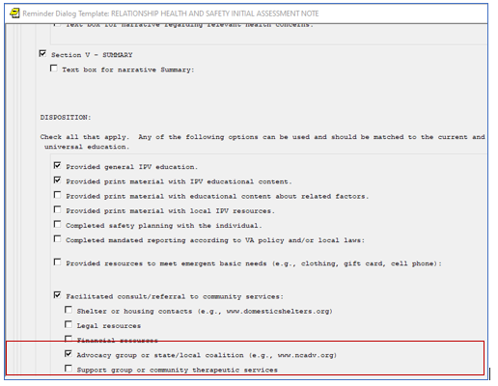

# Reminder GROUP: VA-CLC PREADMISSION SCREEN ADL SCORE 0-5 OPTIONS N/A

Change Made: The dialog text was edited.

This element resides in reminder dialog: VA-COMMUNITY LIVING CENTER PREADMISSION SCREEN

**BEFORE**:

Group: VA-CLC PREADMISSION SCREEN ADL SCORE 0-5 OPTIONS N/A

Text: Not applicable (needs CLC due to psychosocial factors)

Group: VA-CLC PREADMISSION SCREEN ADL SCORE 0-5 OPTIONS N/A FACTORS

Text: Psychosocial factors influencing the need for CLC setting:

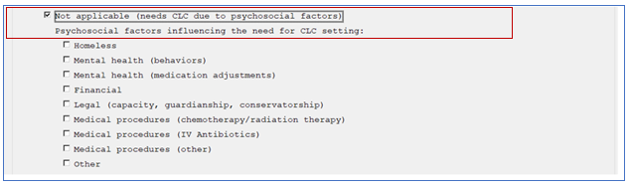

**AFTER**:

Group: VA-CLC PREADMISSION SCREEN ADL SCORE 0-5 OPTIONS N/A

Text: Not applicable (requesting CLC consideration due to psychosocial

or medical factors)

Group: VA-CLC PREADMISSION SCREEN ADL SCORE 0-5 OPTIONS N/A FACTORS

Text: Factors influencing the need for CLC setting:

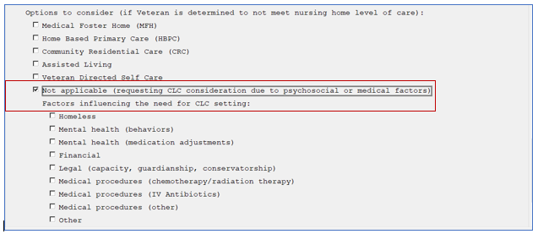

# Reminder ELEMENT: VA-NSG SA GI LAST BM D/T

Change Made: The dialog text was edited and the calendar field was changed to a comment prompt.

This element resides in reminder dialog: VA-AES ACUTE INPATIENT NSG SHIFT ASSESSMENT and VA-AES NSG FREQUENT DOCUMENTATION

**BEFORE**:

ELEMENT: VA-NSG SA GI LAST BM D/T

DIALOG/PROGRESS NOTE TEXT:

Last bowel movement: {FLD:VA-NSG DATE/TIME}

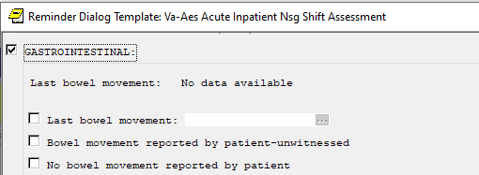

**AFTER**:

ELEMENT: VA-NSG SA GI LAST BM D/T

DIALOG/PROGRESS NOTE TEXT:

Last bowel movement (enter date as MM/DD/YYYY (e.g. 02/01/2021)):

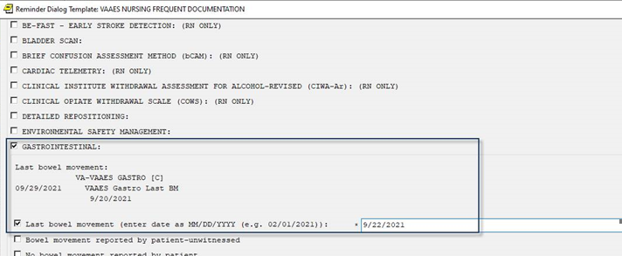

# Reminder GROUP: VA-GP SUICIDE INTERVENTION ACTION EMERGENCY

Change Made: Additional options were added to this group.

This group resides in reminder dialog: VA-OSP SUICIDE RISK ASSESSMENT

**BEFORE**:

Group: VA-GP SUICIDE INTERVENTION ACTION EMERGENCY

Text: Strategies for Managing Risk if the Veteran is Currently in the

EMERGENCY DEPARTMENT/URGENT CARE CENTER: (Select all that apply)

Element: VA-SUICIDE ACTION INVOLUNTARY HOSPITALIZATION

Text: Initiate involuntary hospitalization

Element: VA-SUICIDE ACTION VOLUNTARY HOSPITALIZATION

Text: Initiate voluntary hospitalization

Element: VA-SUICIDE ACTION INITIATE ONE ON ONE

Text: Initiate one-to-one observation

Element: VA-SUICIDE ACTION INCREASE OP CONTACTS

Text: Increase frequency of outpatient contacts

Prompts: Indicate frequency:

Element: VA-SUICIDE ACTION FOLLOW UP AP

Text: Schedule for follow-up appointments

Prompts: Comment/Date:

Element: VA-SUICIDE ACTION COMPLETE SAFETY PLAN

Text: Complete or update Veteran's safety plan

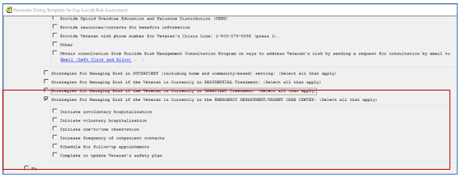

**AFTER**:

Group: VA-GP SUICIDE INTERVENTION ACTION EMERGENCY

Text: Strategies for Managing Risk if the Veteran is Currently in the

EMERGENCY DEPARTMENT/URGENT CARE CENTER: (Select all that apply)

Element: VA-SUICIDE ACTION COMPLETE SAFETY PLAN

Text: Complete or update Veteran's safety plan (REQUIRED for Veterans

discharging home who are at Intermediate or High Acute or Chronic Risk)

Element: VA-SUICIDE ACTION INFORM OF FOLLOWUP

Text: Inform Veteran that they will receive follow-up contacts until

engaged in mental health care (i.e., attendance at an outpatient

mental health appointment or admitted to an inpatient or

residential mental health program; REQUIRED for patients

discharging home who are at Intermediate or High Acute or

Chronic Risk)

Element: VA-SUICIDE ACTION VET DECLINES FOLLOWUP

Text: Veteran requested to not receive a follow-up phone call related

to the Safety Planning in the Emergency Department intervention

and they are not determined to be at high acute risk for

suicide. An outreach letter will be sent in the first week

post-ED/UC discharge in lieu of an outreach phone call

Element: VA-SUICIDE ACTION INVOLUNTARY HOSPITALIZATION

Text: Initiate involuntary hospitalization

Element: VA-SUICIDE ACTION VOLUNTARY HOSPITALIZATION

Text: Initiate voluntary hospitalization

Element: VA-SUICIDE ACTION INITIATE ONE ON ONE

Text: Initiate one-to-one observation

Element: VA-SUICIDE ACTION INCREASE OP CONTACTS

Text: Increase frequency of outpatient contacts

Prompts: Indicate frequency:

Element: VA-SUICIDE ACTION FOLLOW UP AP

Text: Schedule for follow-up appointments

Prompts: Comment/Date:

Element: VA-SUICIDE ACTION COMPLETE SAFETY PLAN

Text: Complete or update Veteran's safety plan

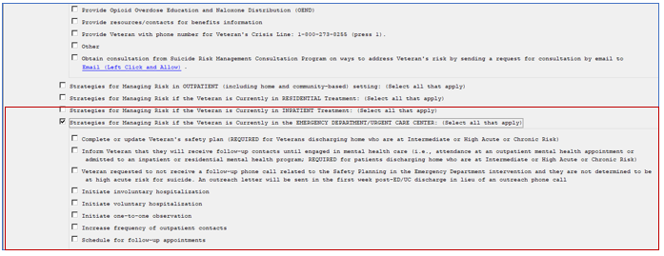

# Reminder ELEMENT: VA-NSG SA GI LAST BM DISPLAY

Change Made: Element contains a Health Summary Object for last bowel movement. The Health Summary Object is re-enabled so the Last Bowel Movement data will display in the dialog template.

This element resides in reminder dialog: VA-AES NSG FREQUENT DOCUMENTATION

**BEFORE**:

Screen shot showing Last bowel movement: No "historical" data available

**AFTER**:

NAME: VA-NSG SA GI LAST BM DISPLAY

DISABLE:

CLASS: NATIONAL//

Additional findings: none

Select ADDITIONAL FINDING:

DIALOG/PROGRESS NOTE TEXT:

Last bowel movement: |VA-NSG LAST BM|

