**REMINDER UPDATE_2_0_304 VA-MISC UPDATE 20 CHANGES**

NOTE: All reminder dialog changes are included in reminder dialog group:

VA-GP MISC UPDATE 20

Table of Contents

1. Reminder GROUP: **VA-WH TD PREGNANCY ENDED REASON MATERNAL MORTALITY** 2

2. Reminder GROUP: **VA-GP MCC COVERAGE OF NEWBORN CARE MAIN** 3

3. Reminder ELEMENT: **VA-MISC 20 HFS** 5

4. Reminder GROUPS: **VA-GP EYE CARE AT-RISK OUTSIDE EXAM-DIABETIC and VA-GP EYE CARE AT-RISK OUTSIDE EXAM-NON DIABETIC** 6

5. Reminder GROUPS: **VA-LST DMC GROUP QUERY (G) and VA-LST INFORMED CONSENT QUERY 2 (G)** 7

6. Reminder ELEMENT: **VA-RADIOLOGY SCHEDULE/CANCEL SUBMIT ORDER** 9

7. Reminder ELEMENT: **VA-HISTORY OF SUICIDE BEHAVIOR** 10

8. Reminder ELEMENTS: **VA-ADNS WHY NOTIFY (E) and VA-ADNS HOW NOTIFY (E)** 12

9. Reminder ORDER CHECK RULE: **VA-NALOXONE FOR OPIOID USE DISORDER** 14

10. Reminder TAXONOMY: **VA-ADVANCED LIVER DISEASE INPT DX** 14

11. Reminder ELEMENT: **VA-CRC RESULT LETTER CONTACT PCP** 15

12. Reminder TAXONOMY: **VA-DEMENTIA DIAGNOSIS** 16

13. Reminder DEFINITION: **VA-LIPID STATIN RX CVD/DM** 18

14. Reminder GROUP: **WH GP PAP SCREEN** 19

*Note: To confirm updates made on any ‘national’ dialog element or group listed below, choose the INQ (Inquiry/Print) option in the Reminder Dialog Management Menu.*

# Reminder GROUP: **VA-WH TD PREGNANCY ENDED REASON MATERNAL MORTALITY**

Change Made: The element for ‘Infant Loss’ was removed.

This group resides in the VA-WH UPDATE PREGNANCY STATUS reminder dialog.

**BEFORE**:

Group: VA-WH TD PREGNANCY ENDED REASON MATERNAL MORTALITY

Text: Maternal mortality

Element: VA-WH TD PREGNANCY ENDED INFANT MORTALITY

Text: Infant loss

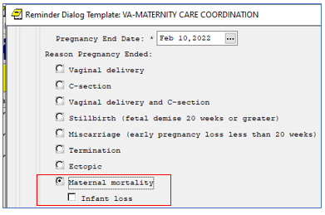

**AFTER**:

Group: VA-WH TD PREGNANCY ENDED REASON MATERNAL MORTALITY

Text: Maternal mortality

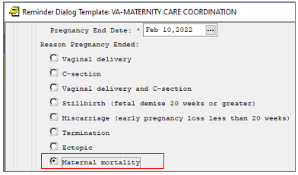

# Reminder GROUP: **VA-GP MCC COVERAGE OF NEWBORN CARE MAIN**

Change Made: Dialog text in four sub-elements has changed.

This group resides in the VA-MATERNITY CARE COORDINATION reminder dialog.

**BEFORE**:

Group: VA-GP MCC COVERAGE OF NEWBORN CARE MAIN

Text: VA Coverage of Maternity and Newborn Care

[BOX, NO SUPPRESS, HIDE, ONE OR MORE]

Element: VA-MCC COVERAGE OF NEWBORN CARE

Text: VA Newborn Care Coverage and obtaining Non-VA Newborn Health

Insurance Coverage.

Element: VA-MCC COVERAGE OF NEWBORN CARE PROVIDER

Text: VA Reimbursement for Pregnancy-Related Classes.

Element: VA-MCC COVERAGE OF NEWBORN CARE DATE

Text: VA Coverage of Nursing Bras, Breast Pumps and Supplies.

Element: VA-MCC COVERAGE OF EMERGENCY CARE

Text: VA Coverage of Emergency Care, including hospitalizations.

Process for after-hours authorization.

Element: VA-MCC COVERAGE OF MEDICATIONS

Text: VA Coverage of Medications. They are only to be filled at VA

pharmacies.

Element: VA-MCC COVERAGE OF NEWBORN CARE BENEFITS

Text: Patient Response to Receiving a Bill from an Approved Community

Care Provider.

Element: VA-MCC COVERAGE OF NEWBORN CARE COMMENTS

Text: Additional Comments: {FLD:TEXT NO LIMIT}

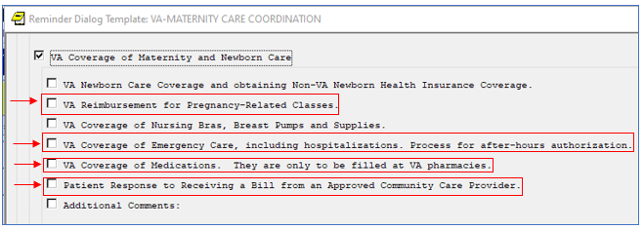

**AFTER**:

Group: VA-GP MCC COVERAGE OF NEWBORN CARE MAIN

Text: VA Coverage of Maternity and Newborn Care

Element: VA-MCC COVERAGE OF NEWBORN CARE

Text: VA Newborn Care Coverage and obtaining Non-VA Newborn Health

Insurance Coverage.

Element: VA-MCC COVERAGE OF NEWBORN CARE PROVIDER

Text: VA Coverage Policies for Pregnancy-related Education and

Lactation Support.

Element: VA-MCC COVERAGE OF NEWBORN CARE DATE

Text: VA Coverage of Nursing Bras, Breast Pumps and Supplies.

Element: VA-MCC COVERAGE OF EMERGENCY CARE

Text: VA Coverage of Hospitalizations, Emergency Care and the

Emergency Treatment Notification Process.

Element: VA-MCC COVERAGE OF MEDICATIONS

Text: VA Coverage and Process for Obtaining Medications Prescribed

by an approved Community Care Provider.

Element: VA-MCC COVERAGE OF NEWBORN CARE BENEFITS

Text: Guidance for Addressing Billing Inquiries from an approved

Community Care Provider.

Element: VA-MCC COVERAGE OF NEWBORN CARE COMMENTS

Text: Additional Comments: {FLD:TEXT NO LIMIT}

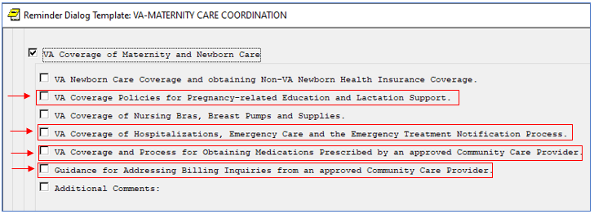

# Reminder ELEMENT: **VA-MISC 20 HFS**

Change Made: The element was created to house three Health Factors that have been updated to fall under different categories.

**BEFORE**:

VA-ONC PRCA RADIATION THERAPY RECURRENCE PATHWAY

-----------------------------------------------------------------------------

Print Name: Radiation Therapy Recurrence Clinical Pathway

Entry Type: FACTOR

Category: VA-ONC PRCA RADIATION THERAPY RECURRENCE PATHWAY [C]

VA-ONC PRCA MOLECULAR TESTING

-----------------------------------------------------------------------------

Print Name: Prostate Cancer Molecular Testing Pathway

Entry Type: FACTOR

Category: VA-ONC MOLECULAR TESTING [C]

VA-ONC PRCA CRPC M0 <=10M CLIN TRIAL

-----------------------------------------------------------------------------

Print Name: CRPC M0 PSA DT <=10M Clinical Trial

Entry Type: FACTOR

Category: VA-ONCOLOGY PATHWAYS [C]

**AFTER**:

ELEMENT: VA-MISC 20 HFS

Finding: VA-ONC PRCA RADIATION THERAPY RECURRENCE PATHWAY

Additional findings:

HF VA-ONC PRCA MOLECULAR TESTING

HF VA-ONC PRCA CRPC M0 <=10M CLIN TRIAL

VA-ONC PRCA RADIATION THERAPY RECURRENCE PATHWAY

-----------------------------------------------------------------------------

Print Name: Radiation Therapy Recurrence Clinical Pathway

Entry Type: FACTOR

Category: VA-ONCOLOGY PATHWAYS [C]

VA-ONC PRCA MOLECULAR TESTING

-----------------------------------------------------------------------------

Print Name: Prostate Cancer Molecular Testing Pathway

Entry Type: FACTOR

Category: VA-ONCOLOGY PATHWAYS [C]

VA-ONC PRCA CRPC M0 <=10M CLIN TRIAL

-----------------------------------------------------------------------------

Print Name: CRPC M0 PSA DT <=10M Clinical Trial

Entry Type: FACTOR

Category: VA-ONC PRCA CRPC M0 PATHWAY [C]

# Reminder GROUPS: **VA-GP EYE CARE AT-RISK OUTSIDE EXAM-DIABETIC and VA-GP EYE CARE AT-RISK OUTSIDE EXAM-NON DIABETIC**

Change Made: The alternate progress note text was edited to include ‘Optometrist or Ophthalmologist’.

These groups reside in the VA-EYE CARE AT-RISK SCREEN (NURSING) reminder dialog

**BEFORE**:

GROUP: VA-GP EYE CARE AT-RISK OUTSIDE EXAM-DIABETIC

GROUP HEADER ALTERNATE P/N TEXT:

No Referral Ordered:\\

Eye exam was performed elsewhere

GROUP: VA-GP EYE CARE AT-RISK OUTSIDE EXAM-NON DIABETIC

GROUP HEADER ALTERNATE P/N TEXT:

No Referral Ordered:\\

Eye exam was completed elsewhere

**AFTER**:

GROUP: VA-GP EYE CARE AT-RISK OUTSIDE EXAM-DIABETIC

GROUP HEADER ALTERNATE P/N TEXT:

No Referral Ordered:\\

Eye exam was performed elsewhere by an Optometrist or an Ophthalmologist

GROUP: VA-GP EYE CARE AT-RISK OUTSIDE EXAM-NON DIABETIC

GROUP HEADER ALTERNATE P/N TEXT:

No Referral Ordered:\\

Eye exam was completed elsewhere by an Optometrist or Ophthalmologist

Portion of the AFTER Eye Care At-Risk Screen reminder dialog with the entry Action 
No Referral Ordered
Eye exam was performed elsewhere by an Optometrist or and Ophthalmologist emphasized.

# Reminder GROUPS: **VA-LST DMC GROUP QUERY (G) and VA-LST INFORMED CONSENT QUERY 2 (G)**

Change Made: The multiple selection field was set to ONE SELECTION ONLY to ensure user is guided properly for missing required items in the dialog.

These groups reside in the VA-LIFE-SUSTAINING TREATMENT (D) reminder dialog.

**BEFORE**:

GROUP: VA-LST DMC GROUP QUERY (G)

DISABLE:

CLASS: NATIONAL//

GROUP CAPTION:

PUT A BOX AROUND THE GROUP:

SHARE COMMON PROMPTS:

MULTIPLE SELECTION:

HIDE/SHOW GROUP: SHOW//

GROUP HEADER DIALOG TEXT:

*1. Decision-Making Capacity to Make Decisions About

Life-Sustaining Treatments

GROUP: VA-LST INFORMED CONSENT QUERY 2 (G)

DISABLE:

CLASS: NATIONAL//

GROUP CAPTION:

PUT A BOX AROUND THE GROUP:NO

SHARE COMMON PROMPTS:

MULTIPLE SELECTION:

HIDE/SHOW GROUP: SHOW//

GROUP HEADER DIALOG TEXT:

*6. Informed Consent

**AFTER**:

GROUP: VA-LST DMC GROUP QUERY (G)

DISABLE:

CLASS: NATIONAL//

GROUP CAPTION:

PUT A BOX AROUND THE GROUP: YES

SHARE COMMON PROMPTS:

MULTIPLE SELECTION: ONE SELECTION ONLY

HIDE/SHOW GROUP: SHOW//

GROUP HEADER DIALOG TEXT:

*1. Decision-Making Capacity to Make Decisions About

Life-Sustaining Treatments

GROUP: VA-LST INFORMED CONSENT QUERY 2 (G)

DISABLE:

CLASS: NATIONAL//

GROUP CAPTION:

PUT A BOX AROUND THE GROUP: YES

SHARE COMMON PROMPTS:

MULTIPLE SELECTION: ONE SELECTION ONLY

HIDE/SHOW GROUP: SHOW//

GROUP HEADER DIALOG TEXT:

*6. Informed Consent

Screen shot of a section of the Reminder Dialog Template VA-Life Sustaining Treatment (d) with the Decision-Making Capacity to Make Decisions About Life-Sustaining Treatments  with check boxes for Patient has capacity to make decisions about LSTs., Patient does not have capacity to make decisions about LSTs: LST plan written based on discussion with surrogate and Patient does no have capacity to make decisions about LSTs and does not have a surrogate; LAT plan written based on valid state-authorized portable order of following review by Facility multidisciplinary committee are emphasized.  Also, a popup window had "Group *1 Decision-Making Capacity to Make Decisions About Life-Sustaining Treatments Treatment 
One selectin required" is emphasized.

Screen shot of the Reminder Dialog Template VA-Life Sustaining Treatment (d):
Number 6, Informed Consent with 4 possible selections
Patient gave oral informed consent for life-sustaining treatment plan
Patient's surrogate gave oral informed consent for life-sustaining treatment plan
Live -sustaining treatment plan written based on valid state-authorized portable orders
Life-sustaining treatment plan written following multidisciplinary committee review
And in  a pop-up window "Group 6 Informed Consent One selection required. "

# Reminder ELEMENT: **VA-RADIOLOGY SCHEDULE/CANCEL SUBMIT ORDER**

Change Made: “Yes” was removed from the ‘Exclude from Progress Note’ field to ensure the alternate progress note text populates into the progress note.

This element resides in the VA-RADIOLOGY SCHEDULING CANCELLATION DELAY reminder dialog.

**BEFORE**:

ELEMENT: VA-RADIOLOGY SCHEDULE/CANCEL SUBMIT ORDER

CLASS: NATIONAL//

DIALOG/PROGRESS NOTE TEXT:

\\

++ CLINICIAN NOTE: Please submit a new order if the exam is still

clinically indicated. ++\\

Edit? NO//

ALTERNATE PROGRESS NOTE TEXT:

\\

Please submit a new order if the exam is still clinically indicated.\\

\\

Edit? NO//

EXCLUDE FROM PROGRESS NOTE:YES

**AFTER**:

ELEMENT: VA-RADIOLOGY SCHEDULE/CANCEL SUBMIT ORDER

CLASS: NATIONAL//

DIALOG/PROGRESS NOTE TEXT:

\\

++ CLINICIAN NOTE: Please submit a new order if the exam is still

clinically indicated. ++\\

Edit? NO//

ALTERNATE PROGRESS NOTE TEXT:

\\

Please submit a new order if the exam is still clinically indicated.\\

\\

Edit? NO//

EXCLUDE FROM PROGRESS NOTE:

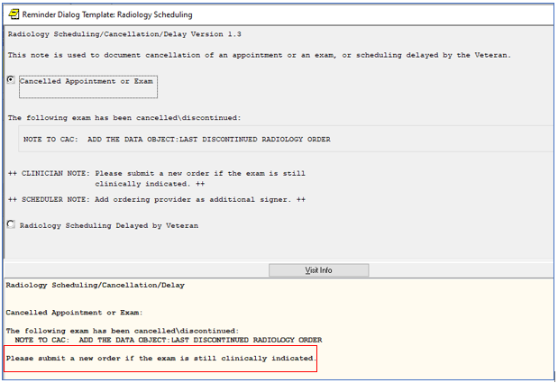

# Reminder ELEMENT: **VA-HISTORY OF SUICIDE BEHAVIOR**

Change Made: The link to the **C**APRI, **R**EACH VET, Risk **I**ndicators, **S**TORM **T**ool for **A**nalytic **L**ookup (CRISTAL) report has been updated.

This element resides in the VA-OSP SUICIDE RISK ASSESSMENT reminder dialog.

**BEFORE**:

ELEMENT: VA-HISTORY OF SUICIDE BEHAVIOR Replace

DISABLE:

CLASS: NATIONAL//

DIALOG/PROGRESS NOTE TEXT:

Previous suicide attempts documented in the Suicide Behavior and

Overdose Report (SBOR) or by previous CSREs.\\

|VA-SBOR EVENT DATE|\\

\\The CAPRI, REACH VET, Risk Indicators, STORM Tool for Analytic

Lookup (CRISTAL) dashboard is another resource to check the

patient record for details of prior suicide behaviors:

{FLD:VA-OSP CRISTAL}\\

\\Suicide Attempt: A non-fatal self-inflicted potentially injurious

behavior with any intent to die as a result of the behavior.

Link:

REDACTED LINK

**AFTER**:

ELEMENT: VA-HISTORY OF SUICIDE BEHAVIOR Replace

DISABLE:

CLASS: NATIONAL//

DIALOG/PROGRESS NOTE TEXT:

Previous suicide attempts documented in the Suicide Behavior and

Overdose Report (SBOR) or by previous CSREs.\\

|VA-SBOR EVENT DATE|\\

\\The CAPRI, REACH VET, Risk Indicators, STORM Tool for Analytic

Lookup (CRISTAL) dashboard is another resource to check the

patient record for details of prior suicide behaviors:

{FLD:VA-OSP CRISTAL}\\

\\Suicide Attempt: A non-fatal self-inflicted potentially injurious

behavior with any intent to die as a result of the behavior.

Link:

REDACTED LINK

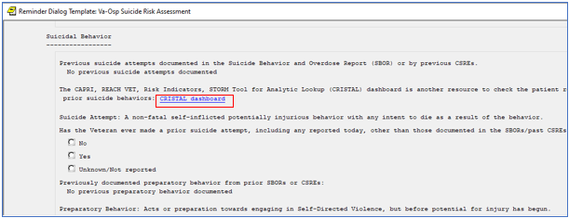

SCREEN SHOT REDACTED

# Reminder ELEMENTS: **VA-ADNS WHY NOTIFY (E) and VA-ADNS HOW NOTIFY (E)**

Change Made: The link to Form 10-0137A has changed and the link to Form 10-0137B has been removed (as it no longer exists)

These elements reside in the VA-ADVANCE DIRECTIVE NOTIFICATION AND SCREENING (D) reminder dialog.

**BEFORE**:

Element: VA-ADNS WHY NOTIFY (E)

Text: Per the Patient Self-Determination Act (PSDA) of 1990 and

{FLD:VA-ETHICS-LINK-HB-1004-02}, all patients must be given

written notification stating their right to accept or decline

medical treatment, to designate a Health Care Agent, and to

document their treatment preferences in an advance directive.

Patients must be informed that VA does not discriminate against

patients based on whether or not they have an advance directive.

NOTE: {FLD:VA-ETHICS-FORM 10-0137A} satisfies this notification

requirement. Consider also providing the patient with

{FLD:VA-ETHICS-FORM 10-0137B}.

Element: VA-ADNS HOW NOTIFY (E)

Text: NOTE: Giving the patient a copy of the {FLD:VA-ETHICS-FORM

10-0137A} satisfies this requirement. Consider also providing

the patient with {FLD:VA-ETHICS-FORM 10-0137B}.

Link: REDACTED LINK

**AFTER**:

Element: VA-ADNS WHY NOTIFY (E)

Text: Per the Patient Self-Determination Act (PSDA) of 1990 and

{FLD:VA-ETHICS-LINK-HB-1004-02}, all patients must be given

written notification stating their right to accept or decline

medical treatment, to designate a Health Care Agent, and to

document their treatment preferences in an advance directive.

Patients must be informed that VA does not discriminate against

patients based on whether or not they have an advance directive.

NOTE: {FLD:VA-ETHICS-FORM 10-0137A} satisfies this notification

requirement.

Element: VA-ADNS HOW NOTIFY (E)

Text: NOTE: Giving the patient a copy of the {FLD:VA-ETHICS-FORM

10-0137A} satisfies this requirement.

Link: REDACTED LINK

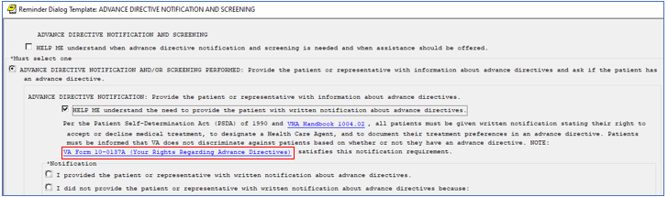

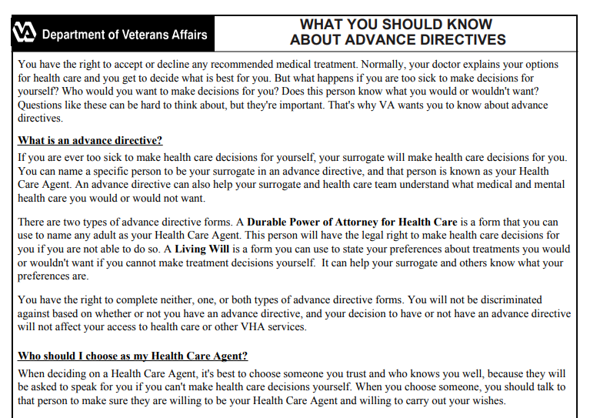

# Reminder ORDER CHECK RULE: **VA-NALOXONE FOR OPIOID USE DISORDER**

Change Made: The display name was edited (the length decreased to 64 characters). The display name is now “NALOXONE RECOMMENDED FOR OPIOID OR STIMULANT USE DISORDER”

**BEFORE**:

REMINDER ORDER CHECK RULE INQUIRY

------------------------------------------------------

VA-NALOXONE FOR OPIOID USE DISORDER

------------------------------------------------------

Display Name: NALOXONE RECOMMENDED FOR OPIOID USE DISORDER OR STIMULANT USE DISORDER

**AFTER**:

REMINDER ORDER CHECK RULE INQUIRY

------------------------------------------------------

VA-NALOXONE FOR OPIOID USE DISORDER

------------------------------------------------------

Display Name: NALOXONE RECOMMENDED FOR OPIOID OR STIMULANT USE DISORDER

# Reminder TAXONOMY: **VA-ADVANCED LIVER DISEASE INPT DX**

Change Made: The problem list was added as a data source.

**BEFORE**:

--------------------------------------------------------------------------------

VA-ADVANCED LIVER DISEASE INPT DX

--------------------------------------------------------------------------------

Class: NATIONAL

Sponsor: NATIONAL GASTROENTEROLOGY & HEPATOLOGY PROGRAM

Review Date: MAY 17,2022

Description:

List of codes used to indicate the patient has advanced liver disease.

Inactive Flag:

Patient Data Source: IN

Use Inactive Problems:

**AFTER**:

--------------------------------------------------------------------------------

VA-ADVANCED LIVER DISEASE INPT DX

--------------------------------------------------------------------------------

Class: NATIONAL

Sponsor: NATIONAL GASTROENTEROLOGY & HEPATOLOGY PROGRAM

Review Date: OCT 31,2022

Description:

List of codes used to indicate the patient has advanced liver disease.

Inactive Flag:

Patient Data Source: IN,PL

Use Inactive Problems:

# Reminder ELEMENT: **VA-CRC RESULT LETTER CONTACT PCP**

Change Made: The Dialog/Progress Note Text was changed from full text to a template field, to allow for local editing of the text, if needed.

This element resides in the VA-CRC COLON SCREENING DOCUMENTATION BEFORE reminder dialog.

**BEFORE**:

ELEMENT: VA-CRC RESULT LETTER CONTACT PCP

DISABLE:

CLASS: NATIONAL//

SPONSOR: VHA GI FIELD ADVISORY COMMITTEE//

REVIEW DATE:

RESOLUTION TYPE:

ORDERABLE ITEM:

FINDING ITEM:

Additional findings: none

Select ADDITIONAL FINDING:

DIALOG/PROGRESS NOTE TEXT:

Please contact your primary care team if it is time for your colonoscopy

and the test has not been scheduled.

**AFTER**:

ELEMENT: VA-CRC RESULT LETTER CONTACT PCP

DISABLE:

CLASS: NATIONAL//

SPONSOR: VHA GI FIELD ADVISORY COMMITTEE//

REVIEW DATE:

RESOLUTION TYPE:

ORDERABLE ITEM:

FINDING ITEM:

Additional findings: none

Select ADDITIONAL FINDING:

DIALOG/PROGRESS NOTE TEXT:

{FLD:VA-CRC COLONOSCOPY SCHEDULE INSTRUCTIONS}

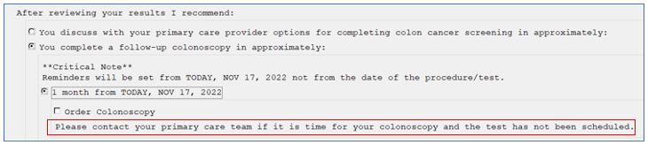

# Reminder TAXONOMY: **VA-DEMENTIA DIAGNOSIS**

Change Made: Additional ICD-10 codes have been included in the Taxonomy.

**BEFORE**:

TAXONOMY: VA-DEMENTIA DIAGNOSIS

This taxonomy includes the following numbers of codes:

ICD-10-CM: 32

ICD-9-CM: 30

Total number of codes: 62

**AFTER**:

TAXONOMY: VA-DEMENTIA DIAGNOSIS

This taxonomy includes the following numbers of codes:

ICD-10-CM: 101

ICD-9-CM: 30

Total number of codes: 131

ICD-10 Codes that were added:

|  |
| --- |
| F01.52 |
| F01.53 |
| F01.54 |
| F01.511 |
| F01.518 |
| F01.A0 |
| F01.A2 |
| F01.A3 |
| F01.A4 |
| F01.A11 |
| F01.A18 |
| F01.B0 |
| F01.B2 |
| F01.B3 |
| F01.B4 |
| F01.B11 |
| F01.B18 |
| F01.C0 |
| F01.C2 |
| F01.C3 |
| F01.C4 |
| F01.C11 |
| F01.C18 |
| F02.82 |
| F02.83 |
| F02.84 |
| F02.811 |
| F02.818 |
| F02.A0 |
| F02.A2 |
| F02.A3 |
| F02.A4 |
| F02.A11 |
| F02.A18 |
| F02.B0 |
| F02.B2 |
| F02.B3 |
| F02.B4 |
| F02.B11 |
| F02.B18 |
| F02.C0 |
| F02.C2 |
| F02.C3 |
| F02.C4 |
| F02.C11 |
| F02.C18 |
| F03.92 |
| F03.93 |
| F03.94 |
| F03.911 |
| F03.918 |
| F03.A0 |
| F03.A2 |
| F03.A3 |
| F03.A4 |
| F03.A11 |
| F03.A18 |
| F03.B0 |
| F03.B2 |
| F03.B3 |
| F03.B4 |
| F03.B11 |
| F03.B18 |
| F03.C0 |
| F03.C2 |
| F03.C3 |
| F03.C4 |
| F03.C11 |
| F03.C18 |

# Reminder DEFINITION: **VA-LIPID STATIN RX CVD/DM**

Change Made: Finding Item 3 (VA-DIABETES MEDICATIONS) was removed from the definition, from the cohort logic and from Function Finding 4.

**BEFORE**:

--------------------------------------------------------------------------------

VA-LIPID STATIN RX CVD/DM

--------------------------------------------------------------------------------

Print Name: Assess Statin Use - Lipids (CVD/DM)

**Customized PATIENT COHORT LOGIC** to see if the Reminder applies to a patient:

(((FI(1)&FF(1))!FI(2)!FI(3))&FF(4))!(FI(5)&FF(6))!(FI(15)&FF(15))&'

(FI(7)!FI(17)!FI(18)!FI(25))

**Expanded Patient Cohort Logic:**

(((FI(VA-DIABETES HEDIS)&FF(1))!FI(VA-DIABETES HEDIS PROB LIST)!

FI(VA-DIABETES MEDICATIONS))&FF(4))!(FI(VA-IHD AND ASVD)&FF(6))!

(FI(VA-STATIN REVASCULARIZATION CODES)&FF(15))&'

(FI(VA-STATIN LIFE EXPECTANCY < 2 YEARS)!FI(VA-STATIN CIRRHOSIS)!

FI(VA-STATIN MUSCULAR PAIN AND DISEASE)!FI(VA-STATIN-ESRD))

**Function Finding (4):**

---- Begin: FF(4)---------------------------------------------------------

               Function String: MRD(1,2,3)>MRD(4)

      Expanded Function String:

       MRD(VA-DIABETES HEDIS,VA-DIABETES HEDIS PROB LIST,

       VA-DIABETES MEDICATIONS)>MRD(VA-DIABETES DX INCORRECT)

  ---- End: FF(4) ----------------------------------------------------------

**AFTER**:

--------------------------------------------------------------------------------

VA-LIPID STATIN RX CVD/DM

--------------------------------------------------------------------------------

Print Name: Assess Statin Use - Lipids (CVD/DM)

**Customized PATIENT COHORT LOGIC** to see if the Reminder applies to a patient:

(((FI(1)&FF(1))!FI(2))&FF(4))!(FI(5)&FF(6))!(FI(15)&FF(15))&'(FI(7)!

FI(17)!FI(18)!FI(25))

**Expanded Patient Cohort Logic:**

(((FI(VA-DIABETES HEDIS)&FF(1))!FI(VA-DIABETES HEDIS PROB LIST))&FF(4))!

(FI(VA-IHD AND ASVD)&FF(6))!(FI(VA-STATIN REVASCULARIZATION CODES)&

FF(15))&'(FI(VA-STATIN LIFE EXPECTANCY < 2 YEARS)!

FI(VA-STATIN CIRRHOSIS)!FI(VA-STATIN MUSCULAR PAIN AND DISEASE)!

FI(VA-STATIN-ESRD))

**Function Finding (4):**

---- Begin: FF(4)---------------------------------------------------------

               Function String: MRD(1,2)>MRD(4)

      Expanded Function String:

       MRD(VA-DIABETES HEDIS,VA-DIABETES HEDIS PROB LIST)>MRD

(VA-DIABETES DX INCORRECT)

  ---- End: FF(4) ----------------------------------------------------------

# Reminder GROUP: **WH GP PAP SCREEN**

Changes Made: Two Health Factors have been added as Finding Items within two (2) sub-elements, a new sub-element was added (i.e., HPV test obtained at this encounter) and text “Pap smear was obtained” was changed to “Cervical cytology obtained”.

This element resides in the VA-WH PAP SMEAR SCREENING reminder dialog.

**BEFORE**:

Group: WH GP PAP SCREEN

Text: Screening

{FLD:VA-WH PAP INFORMATION}

Element: VA-WH PAP SMEAR OBTAINED

Text: Pap smear was obtained at this encounter

Element: VA-WH PAP HPV TESTING

Text: Order HPV testing

Group: VAL-WH ORDER PAP SMEAR

Text: Order pap smear

Group: VA-WH GP PAP OUTSIDE RESULTS

Text: Record prior or outside Pap and/or HPV results:

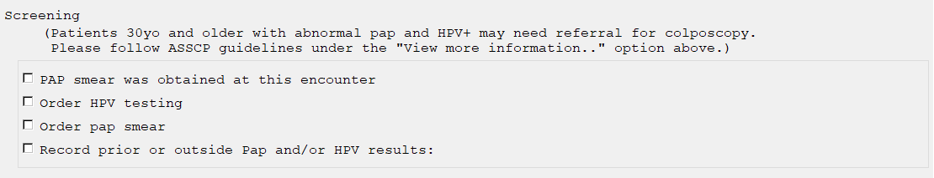

**AFTER**:

Group: WH GP PAP SCREEN

Text: Screening

{FLD:VA-WH PAP INFORMATION}

Element: VA-WH PAP SMEAR OBTAINED

Text: Cervical cytology obtained at this encounter

Add. Finding: VA-WH CERVICAL CYTOLOGY OBTAINED (HEALTH FACTOR)

Element: VA-WH PAP HPV OBTAINED

Text: HPV test obtained at this encounter.

Finding: VA-WH HPV OBTAINED (HEALTH FACTOR)

Element: VA-WH PAP HPV TESTING

Text: Order HPV testing

Group: VAL-WH ORDER PAP SMEAR

Text: Order pap smear

Group: VA-WH GP PAP OUTSIDE RESULTS

Text: Record prior or outside Pap and/or HPV results:

