**REMINDER UPDATE_2_0_385 VA-MISC UPDATE 24 CHANGES**

NOTE: All reminder dialog changes are included in reminder dialog group:

VA-GP MISC UPDATE 24

*Note: To confirm updates made on any ‘national’ dialog element or group listed below, choose the INQ (Inquiry/Print) option in the Reminder Dialog Management Menu.*

Table of Contents

1. Reminder ELEMENT: VAL-OPC 2 DAY FS DIETICIAN 2

2. Reminder GROUPS: VA-GP COMMUNITY CARE RFS INFORMATION and VA-GP COMMUNITY CARE RFS INFORMATION SCANNED 3

3. Reminder GROUP: VA-GEC PCS REVIEW VDC MONTH 1 4

4. Reminder ELEMENTS: VA-SCI/D PQD ETIOLOGY INFO VERIFIED, VA-SCI/D PQD INFO VERIFIED-MS and VA-SCI/D PQD INFO VERIFIED-MOTOR NEURON 5

5. Reminder ORDER CHECK RULES: VA-OPIOID DRUG CLASS (CN101) and VA-BENZODIAZEPINE DRUG CLASS (CN302) 6

6. Reminder ELEMENT: VA-ONC LUNG MT DETAILED INSTRUCTIONS 8

7. Reminder GROUP: VA-GP REACH VET PROV REACH OUT TO VETERAN COMBO 9

8. Reminder GROUP: VA-GP TECS TECH COMP EXAM-CATARACT/CC/VM/HANDOUTS 10

9. Reminder ELEMENT: VA-TXT TELESTROKE PROVIDER CONSULT-CANCEL 11

10. Reminder ELEMENT: VA-ONC KID PATHWAYS VIEW INSTRUCTIONS/SHAREPOINT 12

11. Reminder ELEMENT: VA-FLU IMM NCP URL 14

12. Reminder DEFINITION: VA-RELATIONSHIP HEALTH AND SAFETY SCREEN 15

13. Reminder ELEMENTS: VA-TXTZ RHS RESOURCE - HOTLINE and VA-TXTZ RHS RESOURCE - HOTLINE 2 17

14. Reminder ELEMENT: VA-TXTZ RHS SCREEN INFO BUTTON 18

15. Reminder GROUP: VA-GP RHS SESSION FORMAT 19

16. Reminder GROUP: VA-TXTZ RHS PRIMARY SCREEN NEGATIVE and VA-TXTZ RHS PRIMARY SCREEN NEGATIVE 2 20

17. Reminder GROUPS: VA-GP RHS RESOURCE and VA-GP RHS RESOURCE 2 22

18. Reminder ELEMENTS: VAL-TXTZ RHS FUTURE CONSULT PLACED PRIM NEG, VAL-TXTZ RHS FUTURE CONSULT PLACED PRIM NEG 2, VA-TXTZ RHS CONSULT BY IPV PROVIDER, VA-TXTZ RHS CONSULT BY IPV PROVIDER 2, VAL-TXT RHS CONSULT DECLINED and VAL-TXT RHS CONSULT DECLINED 2 23

# Reminder ELEMENT: VAL-OPC 2 DAY FS DIETICIAN

Change Made: The word “dietician” was changed to dietitian” in the dialog text.

The element resides in the VA-OPC 2 DAY POST DISCHARGE reminder dialog.

**BEFORE:**

Element: VAL-OPC 2 DAY FS DIETICIAN

DIALOG/PROGRESS NOTE TEXT:

Dietician/Nutrition Services

ALTERNATE PROGRESS NOTE TEXT:

Dietician/Nutrition Services

**AFTER:**

Element: VAL-OPC 2 DAY FS DIETICIAN

DIALOG/PROGRESS NOTE TEXT:

Dietitian/Nutrition Services

ALTERNATE PROGRESS NOTE TEXT:

Dietitian/Nutrition Services

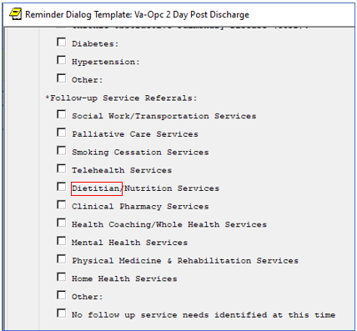

# Reminder GROUPS: VA-GP COMMUNITY CARE RFS INFORMATION and VA-GP COMMUNITY CARE RFS INFORMATION SCANNED

Change Made: Template field {FLD:TEXT (1-10 CHAR) REQ} was replaced with {FLD:TEXT (1-15 CHAR)REQ in both groups to allow for an increase in number-length when a consult number is entered.

The groups reside in the VA-COMMUNITY CARE RFS NOTE reminder dialog.

**BEFORE:**

Group: VA-GP COMMUNITY CARE RFS INFORMATION

Text: Community Care Consult: COMMUNITY CARE-{FLD:TEXT (1-30 CHAR) REQ}

Consult No: {FLD:TEXT (1-10 CHAR)REQ}

Date sent to scanning: {FLD:DATE (*)}

Group: VA-GP COMMUNITY CARE RFS INFORMATION SCANNED

Text: Community Care Consult: COMMUNITY CARE-{FLD:TEXT (1-30 CHAR) REQ}

Consult No: {FLD:TEXT (1-10 CHAR)REQ}

Date scanned: {FLD:DATE (*)}

**AFTER:**

Group: VA-GP COMMUNITY CARE RFS INFORMATION

Text: Community Care Consult: COMMUNITY CARE-{FLD:TEXT (1-30 CHAR) REQ}

Consult No: {FLD:TEXT (1-15 CHAR)REQ}

Date sent to scanning: {FLD:DATE (*)}

Group: VA-GP COMMUNITY CARE RFS INFORMATION SCANNED

Text: Community Care Consult: COMMUNITY CARE-{FLD:TEXT (1-30 CHAR) REQ}

Consult No: {FLD:TEXT (1-15 CHAR)REQ}

Date scanned: {FLD:DATE (*)}

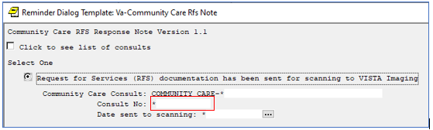

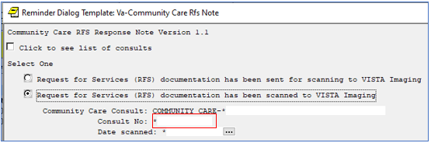

# Reminder GROUP: VA-GEC PCS REVIEW VDC MONTH 1

Change Made: Alternate progress note text was added and ‘yes’ was removed from the exclude from PN text field.

The group resides in the VA-GEC PERSONAL CARE SERVICES REVIEW reminder dialog.

**BEFORE:**

Group: VA-GEC PCS REVIEW VDC MONTH 1

Group Header Dialog Text:

Monthly VDC Provider contacts with Veteran:

Month 1 *

Group Header Alternate P/N Text:

Exclude from Progress Note: YES

**AFTER:**

Group: VA-GEC PCS REVIEW VDC MONTH 1

Group Header Dialog Text:

Monthly VDC Provider contacts with Veteran:

Month 1 *

Group Header Alternate P/N Text:

Monthly VDC Provider contacts with Veteran:

Exclude from Progress Note:


On the bottom after Care plan has been reviewed.  Veteran is enrolled in Veteran Directed Care (VDC) followed by Monthly VDC Provider contacted with Veteran.

# Reminder ELEMENTS: VA-SCI/D PQD ETIOLOGY INFO VERIFIED, VA-SCI/D PQD INFO VERIFIED-MS and VA-SCI/D PQD INFO VERIFIED-MOTOR NEURON

Change Made: The health factors were removed from the Finding Items in all three Elements.

The elements do not reside within any reminder dialog.

**BEFORE:**

Element: VA-SCI/D PQD ETIOLOGY INFO VERIFIED

FINDING ITEM: VA-SCI/D ETIOLOGY REVIEW DATE

Element: VA-SCI/D PQD INFO VERIFIED-MS

FINDING ITEM: VA-SCI/D KURTZKE SCALE REVIEW DATE

Element: VA-SCI/D PQD INFO VERIFIED-MOTOR NEURON

FINDING ITEM: VA-SCI/D MOTOR NEURON REVIEW DATE

**AFTER:**

Element: VA-SCI/D PQD ETIOLOGY INFO VERIFIED

FINDING ITEM: < the health factor has been removed

Element: VA-SCI/D PQD INFO VERIFIED-MS

FINDING ITEM: < the health factor has been removed

Element: VA-SCI/D PQD INFO VERIFIED-MOTOR NEURON

FINDING ITEM: < the health factor has been removed

# Reminder ORDER CHECK RULES: VA-OPIOID DRUG CLASS (CN101) and VA-BENZODIAZEPINE DRUG CLASS (CN302)

Change Made: Order Check Text to a hyperlink was updated to provide the correct hyperlink.

**BEFORE:**

Reminder Order Check Rule: **VA-BENZODIAZEPINE DRUG CLASS (CN302)**

Display Name: Potential dangerous drug combination with a BENZODIAZEPE

Class: NATIONAL

Order Check Text

Combination of Benzodiazepines and Opioids may result in potentially

unsafe drug interactions; prescribing of Opioids and Benzodiazepines

concurrently has been shown to have a 4-fold increased risk of OVERDOSE

in the Veteran population (BMJ 2015;350:h2698).

Co-prescribing opioid and benzodiazepines is particularly dangerous when

patients have other risk factors for overdose or suicide. The

Stratification Tool for Opioid Risk Mitigation (STORM) decision support

tool provides estimates of adverse event risk, a summary of risk factors,

and recommended risk mitigation interventions and treatment alternatives

for patients. Review STORM by cutting and pasting this URL link into your

browser:

https://spsites.cdw.va.gov/sites/OMHO_PsychPharm/Pages/Real-Time-STORM-Das

hboard.aspx

Reminder Order Check Rule: **VA-OPIOID DRUG CLASS (CN101)**

Display Name: Potential dangerous drug combination with an OPIOID

Class: NATIONAL

Order Check Text

Combination of Benzodiazepines and Opioids may result in potentially

unsafe drug interactions; prescribing of Opioids and Benzodiazepines

concurrently has been shown to have a 4-fold increased risk of OVERDOSE

in the Veteran population (BMJ 2015;350:h2698).

Co-prescribing opioid and benzodiazepines is particularly dangerous when

patients have other risk factors for overdose or suicide. The

Stratification Tool for Opioid Risk Mitigation (STORM) decision support

tool provides estimates of adverse event risk, a summary of risk factors,

and recommended risk mitigation interventions and treatment alternatives

for patients. Review STORM by cutting and pasting this URL link into your

browser:

https://spsites.cdw.va.gov/sites/OMHO_PsychPharm/Pages/Real-Time-STORM-Das

hboard.aspx

**AFTER:**

Reminder Order Check Rule: **VA-BENZODIAZEPINE DRUG CLASS (CN302)**

Display Name: Potential dangerous drug combination with a BENZODIAZEPE

Class: NATIONAL

Order Check Text

Combination of Benzodiazepines and Opioids may result in potentially

unsafe drug interactions; prescribing of Opioids and Benzodiazepines

concurrently has been shown to have a 4-fold increased risk of OVERDOSE

in the Veteran population (BMJ 2015;350:h2698).

Co-prescribing opioid and benzodiazepines is particularly dangerous when

patients have other risk factors for overdose or suicide. The

Stratification Tool for Opioid Risk Mitigation (STORM) decision support

tool provides estimates of adverse event risk, a summary of risk factors,

and recommended risk mitigation interventions and treatment alternatives

for patients. Review STORM by cutting and pasting this URL link into your

browser: https://vaww.pbi.cdw.va.gov/PBIRS/Pages/ReportViewer.aspx?/RVS/OMHSP_PERC/SSRS/Procution/CDS/STORM/ORM_PatientLookup

Reminder Order Check Rule: **VA-OPIOID DRUG CLASS (CN101)**

Display Name: Potential dangerous drug combination with an OPIOID

Class: NATIONAL

Order Check Text

Combination of Benzodiazepines and Opioids may result in potentially

unsafe drug interactions; prescribing of Opioids and Benzodiazepines

concurrently has been shown to have a 4-fold increased risk of OVERDOSE

in the Veteran population (BMJ 2015;350:h2698).

Co-prescribing opioid and benzodiazepines is particularly dangerous when

patients have other risk factors for overdose or suicide. The

Stratification Tool for Opioid Risk Mitigation (STORM) decision support

tool provides estimates of adverse event risk, a summary of risk factors,

and recommended risk mitigation interventions and treatment alternatives

for patients. Review STORM by cutting and pasting this URL link into your

browser:

https://vaww.pbi.cdw.va.gov/PBIRS/Pages/ReportViewer.aspx?/RVS/OMHSP_PERC/SSRS/Procution/CDS/STORM/ORM_PatientLookup

# Reminder ELEMENT: VA-ONC LUNG MT DETAILED INSTRUCTIONS

Change Made: The dialog text was edited.

The element resides in the VA-ONCOLOGY LUNG EARLY STAGE PATHWAYS reminder dialog.

**BEFORE:**

Element: VA-ONC LUNG MT DETAILED INSTRUCTIONS

Dialog/Progress Note Text:

++ See Lung Molecular testing pathway: PD-L1 expression should

be performed using 22C3 antibody and determined by TPS score. ++

**AFTER:**

Element: VA-ONC LUNG MT DETAILED INSTRUCTIONS

Dialog/Progress Note Text:

++ Follow Lung Molecular testing pathway: perform PD-L1 by TPS\\

and CGP; PD-L1 expression should be performed using 22C3 antibody\\

and determined by TPS score. ++

AFTER screen shot of part of the Reminder Dialog Early Stage Lung Cancer Pathways showing NSCLC Clinical Stage IIA, IIB and Resectable IIIIA Excluding Pancoast Tumors for ... followed by the radio button After lobectomy/anatomic resection: followed by  
++ Follow Lung Molecular testing pathway: perform PD-L1 by TPS
   and CGP; PD-L1 expression should be performed using 22C3 antibody
   and determined by TPS score. ++


# Reminder GROUP: VA-GP REACH VET PROV REACH OUT TO VETERAN COMBO

Change Made: The dialog text was edited. "Choose on option" changed to "Choose one option"

The group resides in the VA-REACH VET PROVIDER TEMPLATE reminder dialog.

**BEFORE:**

Group: VA-GP REACH VET PROV REACH OUT TO VETERAN COMBO

Text: ++ NOTE: Choose on option from below, based on the type of

outreach you conducted ++

**AFTER:**

Group: VA-GP REACH VET PROV REACH OUT TO VETERAN COMBO

Text: ++ NOTE: Choose one option from below, based on the type of

outreach you conducted ++

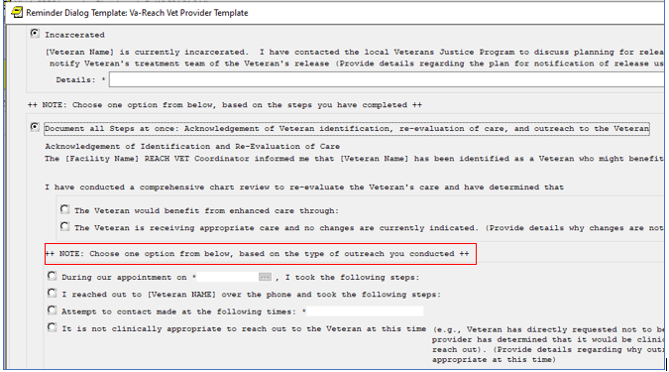

# Reminder GROUP: VA-GP TECS TECH COMP EXAM-CATARACT/CC/VM/HANDOUTS

Change Made: A new element and health factor was added to this group.

The group resides in the VA-TECS TECHNICIAN reminder dialog.

**BEFORE:**

Group: VA-GP TECS TECH COMP EXAM-CATARACT/CC/VM/HANDOUTS

Group: VA-GP TECS TECH-CATARACT SURGERY EVALUATION

Element: VA-HF TECS TECH CATARACT SURG EVAL-YES

Element: VA-HF TECS TECH CATARACT SURG EVAL-NO

Element: VA-HF TECS TECH CATARACT SURG EVAL-N/A

Group: VA-GP TECS TECH-COMMUNITY CARE

Element: VA-HF TECS TECH COMMUNITY CARE-YES

Element: VA-HF TECS TECH COMMUNITY CARE-NO

Group: BLANK LINE DIALOG & NOTE (DO NOT MODIFY)

Element: VA-TXT TECS TECH OKAY TO LEAVE MESSAGE

Group: BLANK LINE DIALOG & NOTE (DO NOT MODIFY)

Element: VA-TXT TECS TECH OPTICAL EDUCATION

**AFTER:**

Group: VA-GP TECS TECH COMP EXAM-CATARACT/CC/VM/HANDOUTS

Group: VA-GP TECS TECH-CATARACT SURGERY EVALUATION

Element: VA-HF TECS TECH CATARACT SURG EVAL-YES

Element: VA-HF TECS TECH CATARACT SURG EVAL-NO

Element: VA-HF TECS TECH CATARACT SURG EVAL-N/A

Group: VA-GP TECS TECH-COMMUNITY CARE

Element: VA-HF TECS TECH COMMUNITY CARE-YES

Element: VA-HF TECS TECH COMMUNITY CARE-NO

Group: BLANK LINE DIALOG & NOTE (DO NOT MODIFY)

Element: VA-TXT TECS TECH OKAY TO LEAVE MESSAGE

Group: BLANK LINE DIALOG & NOTE (DO NOT MODIFY)

Element: VA-TXT TECS TECH OPTICAL EDUCATION

Group: BLANK LINE DIALOG & NOTE (DO NOT MODIFY)

Element: VA-HF TECS TECH PT RESULT INSTRUCTIONS

Finding: VA-TECS TECH PT RESULT INSTRUCTIONS (HEALTH FACTOR)

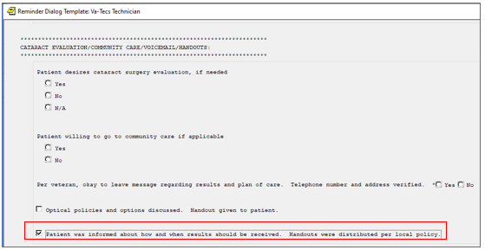

# Reminder ELEMENT: VA-TXT TELESTROKE PROVIDER CONSULT-CANCEL

Change Made: A misspelled word was corrected.

The element resides in the VA-ACUTE STROKE PROVIDER TEMPLATE reminder dialog.

**BEFORE:**

Element: VA-TXT TELESTROKE PROVIDER CONSULT-CANCEL

DIALOG/PROGRESS NOTE TEXT:

NTSP criteria for TeleStroke consult:

1. Any B.E.F.A.S.T symptomes with a last known well with 4.5 hours

OR

2. Hemiparesis plus any V.A.N. symptoms (Vision, Aphasia, or Neglect)

with a last known well within 23 hours

I discussed this with the physician above.

Please consult local neurology.

**AFTER:**

Element: VA-TXT TELESTROKE PROVIDER CONSULT-CANCEL

DIALOG/PROGRESS NOTE TEXT:

NTSP criteria for TeleStroke consult:

1. Any B.E.F.A.S.T symptoms with a last known well with 4.5 hours

OR

2. Hemiparesis plus any V.A.N. symptoms (Vision, Aphasia, or Neglect)

with a last known well within 23 hours

I discussed this with the physician above.

Please consult local neurology.

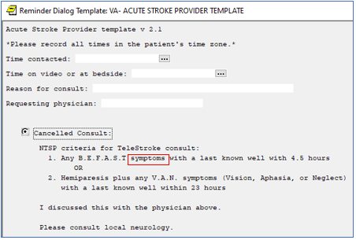

# Reminder ELEMENT: VA-ONC KID PATHWAYS VIEW INSTRUCTIONS/SHAREPOINT

Change Made: Additional text was included in the VIEW button.

The element resides in the VA-ONCOLOGY KIDNEY CANCER PATHWAYS reminder dialog.

**BEFORE:**

Element: VA-ONC KID PATHWAYS VIEW INSTRUCTIONS/SHAREPOINT

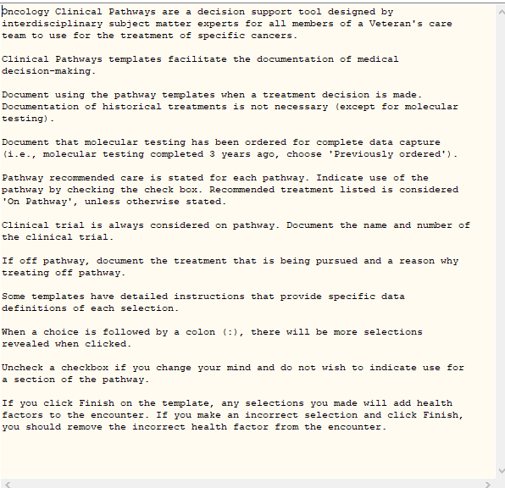

**AFTER:**

Element: VA-ONC KID PATHWAYS VIEW INSTRUCTIONS/SHAREPOINT

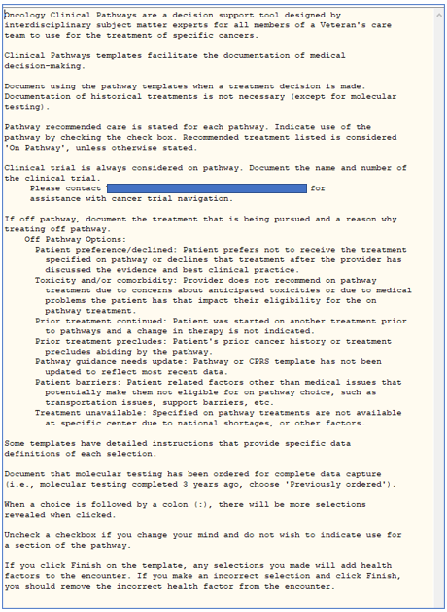

# Reminder ELEMENT: VA-FLU IMM NCP URL

Change Made: The immunization link (in the template field) has been updated for the 2023-2024 flu season.

The element resides in the VA-INFLUENZA IMMUNIZATION reminder dialog.

**BEFORE:**

Element: VA-FLU IMM NCP URL

Text: {FLD:NCP INFLUENZA IMMUNIZATION GUIDANCE}

Link > REDACTED

**AFTER:**

Element: VA-FLU IMM NCP URL

Text: {FLD:NCP INFLUENZA IMMUNIZATION GUIDANCE}

Link > REDACTED

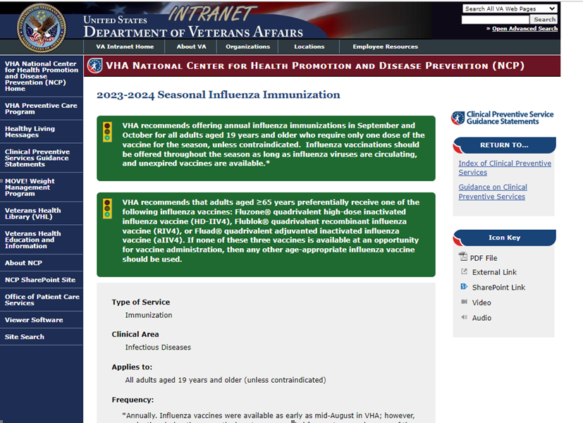

# Reminder DEFINITION: VA-RELATIONSHIP HEALTH AND SAFETY SCREEN

Change Made: The baseline frequency was changed from **1 year for ages 18 to 99** to **1 year for ages 18 and older**, to eliminate messages that the reminder definition cannot be determined (CNBD) for ages >99.

The reminder definition is the VA-RELATIONSHIP HEALTH AND SAFETY SCREEN.

**BEFORE:**

Definition: VA-RELATIONSHIP HEALTH AND SAFETY SCREEN

Baseline Frequency:

Do In Advance Time Frame: Wait until actually DUE

Sex Specific:

Ignore on N/A:

Frequency for Age Range: 1 year for ages 18 to 99

**AFTER:**

Definition: VA-RELATIONSHIP HEALTH AND SAFETY SCREEN

Baseline Frequency:

Do In Advance Time Frame: Wait until actually DUE

Sex Specific:

Ignore on N/A:

Frequency for Age Range: 1 year for ages 18 and older

# Reminder ELEMENTS: VA-TXTZ RHS RESOURCE - HOTLINE and VA-TXTZ RHS RESOURCE - HOTLINE 2

Change Made: The class has been changed to LOCAL to allow sites to include additional links, if needed.

The elements reside in the VA-IPVAP RELATIONSHIP HEALTH AND SAFETY SCREEN reminder dialog.

**BEFORE:**

ELEMENT: VA-TXTZ RHS RESOURCE - HOTLINE

DISABLE:

CLASS: NATIONAL//

DIALOG/PROGRESS NOTE TEXT:

- Offered information such as IPV National flyer with general IPV

education, National DV hotline number 1-800-799-SAFE(7233), and web address

{FLD:VA-RHS SCREEN THE HOTLINE}

ELEMENT: VA-TXTZ RHS RESOURCE - HOTLINE 2

DISABLE:

CLASS: NATIONAL//

DIALOG/PROGRESS NOTE TEXT:

- Offered information such as IPV National flyer with general IPV

education, National DV hotline number 1-800-799-SAFE(7233), and web address

{FLD:VA-RHS SCREEN THE HOTLINE}

**AFTER:**

ELEMENT: VA-TXTZ RHS RESOURCE - HOTLINE

DISABLE:

CLASS: LOCAL//

DIALOG/PROGRESS NOTE TEXT:

- Offered information such as IPV National flyer with general IPV

education, National DV hotline number 1-800-799-SAFE(7233), and web address

{FLD:VA-RHS SCREEN THE HOTLINE}

ELEMENT: VA-TXTZ RHS RESOURCE - HOTLINE 2

DISABLE:

CLASS: LOCAL//

DIALOG/PROGRESS NOTE TEXT:

- Offered information such as IPV National flyer with general IPV

education, National DV hotline number 1-800-799-SAFE(7233), and web address

{FLD:VA-RHS SCREEN THE HOTLINE}

Screen shot of part of the Reminder Dialog Template RHS SCREEN
Under The Individual accepts resources:
the radio button Yes is selected and the check box text for Offered information such as the National DV hotline number 1-800-755-SAFE(7233), web address www.thehotline.or and IPV National flyer with general IPV education

# Reminder ELEMENT: VA-TXTZ RHS SCREEN INFO BUTTON

Change Made: The template field dialog text was changed to read "For Screeners: Additional Screening Resources"

The element resides in the VA-IPVAP RELATIONSHIP HEALTH AND SAFETY SCREEN reminder dialog.

**BEFORE:**

ELEMENT: VA-TXTZ RHS SCREEN INFO BUTTON

DISABLE:

CLASS: NATIONAL//

DIALOG/PROGRESS NOTE TEXT:

{FLD:VA-RHS SCREENING LINK}

(the link dialog text read as "Relationship Health and Safety Screening Resources")

**AFTER:**

ELEMENT: VA-TXTZ RHS SCREEN INFO BUTTON

DISABLE:

CLASS: NATIONAL//

DIALOG/PROGRESS NOTE TEXT:

{FLD:VA-RHS SCREENING LINK}

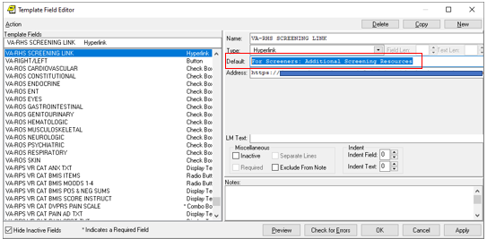

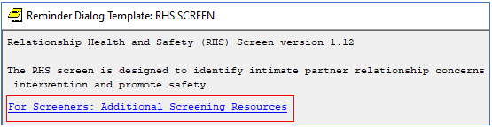

# Reminder GROUP: VA-GP RHS SESSION FORMAT

Change Made: The dialog text was changed to read "Session Format: Optional to complete"

The group resides in the VA-IPVAP RELATIONSHIP HEALTH AND SAFETY SCREEN reminder dialog.

**BEFORE:**

Group: VA-GP RHS SESSION FORMAT

DISABLE:

CLASS: NATIONAL//

DIALOG/PROGRESS NOTE TEXT:

Session Format: (Optional to complete if done as a stand-alone

note. Select the checkbox to activate.)

**AFTER:**

Group: VA-GP RHS SESSION FORMAT

DISABLE:

CLASS: NATIONAL//

DIALOG/PROGRESS NOTE TEXT:

Session Format: (Optional to complete)

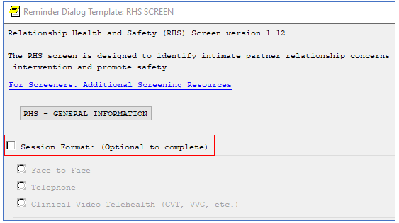

# Reminder GROUP: VA-TXTZ RHS PRIMARY SCREEN NEGATIVE and VA-TXTZ RHS PRIMARY SCREEN NEGATIVE 2

Change Made: The RESOLUTION section has been removed from these two groups.

The groups reside is the VA-IPVAP RELATIONSHIP HEALTH AND SAFETY SCREEN reminder dialog.

**BEFORE:**

Group: VA-TXTZ RHS PRIMARY SCREEN NEGATIVE

DISABLE:

CLASS: NATIONAL//

SEQUENCE:

5 VAL-TXT PRIM SCREEN NEGATIVE STATEMENT

10 VA-GP RHS RESOLUTION PRIM NEGATIVE *<< this sequence has been removed*

20 VA-GP RHS RESOURCE

30 VA-GP RHS EDUCATION

40 VA-GP RHS SAFETY PLAN

Group: VA-TXTZ RHS PRIMARY SCREEN NEGATIVE 2

DISABLE:

CLASS: NATIONAL//

SEQUENCE:

5 VAL-TXT PRIM SCREEN NEGATIVE STATEMENT

10 VA-GP RHS RESOLUTION PRIM NEGATIVE 2 *<< this sequence has been removed*

20 VA-GP RHS RESOURCE 2

30 VA-GP RHS EDUCATION

40 VA-GP RHS SAFETY PLAN 2

BEFORE Screen shot of part of the Reminder Dialog Template RHS SCREEN under PRIMARY SCREEN RESULTL with the radio button Primary Screen is NEGATIVE ... selected and the elements listed are:
Individual accepts future consult
Individual accepts warm hand-off/consult be placed, Clinical Provider Trained by IPVAP who conducted the screen will complete the RHS Assessment and related needs and Individual declines consult

**AFTER:**

Group: VA-TXTZ RHS PRIMARY SCREEN NEGATIVE

DISABLE:

CLASS: NATIONAL//

SEQUENCE:

5 VAL-TXT PRIM SCREEN NEGATIVE STATEMENT

20 VA-GP RHS RESOURCE

30 VA-GP RHS EDUCATION

40 VA-GP RHS SAFETY PLAN

Group: VA-TXTZ RHS PRIMARY SCREEN NEGATIVE 2

DISABLE:

CLASS: NATIONAL//

SEQUENCE:

5 VAL-TXT PRIM SCREEN NEGATIVE STATEMENT

20 VA-GP RHS RESOURCE 2

30 VA-GP RHS EDUCATION

40 VA-GP RHS SAFETY PLAN 2

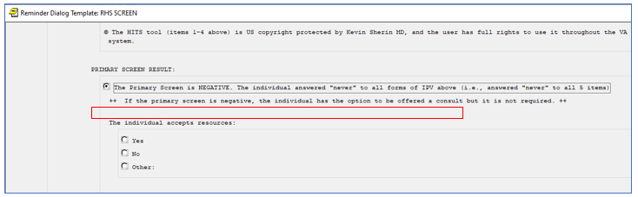

*(take note: the RESOLUTION section has been removed)*

# Reminder GROUPS: VA-GP RHS RESOURCE and VA-GP RHS RESOURCE 2

Change Made: The group text was changed to read "The individual accepts education and/or resources" and "for example a consult or referral" was added to the 'other' option (element).

The groups reside in the VA-IPVAP RELATIONSHIP HEALTH AND SAFETY SCREEN reminder dialog.

**BEFORE:**

Screen shot of BEFORE with 
Group: VA-OP RHS RESOURCE
TEXT: The individual accepts resources:
Group: VA-GP RHS RESOURCE - YES
  Element: VA-TXTZ RHS RESOURCE - IPV EDU
Element: VA-TXTZ RHS RESOURCE - HOTLINE
Element: VA-TXTZ RHS RESOURCE - IPV INFO
Element: VA-TXTZ RHS RESOURCE YES - OTHER
Element: VA-TXTZ RHS RESOURCE - NO
Element: VA-TXTZ RHS RESOURCE - OTHER

And to the right of that, a second Group: VA-GP RHS RESOURCE 2 that reads the same as the one on the right except at the end of each line beginning Element: VA-TXTZ RHS RESOURCE -  there is the number 2

**AFTER:**

Screen shot is the same as above except under the TEXT: it reads "The individual accepts education and/or resources" and instead of just "The Individual accepts resources"  and after the element: Element: VA-TXTZ RHS RESOURCE YES - OTHER, there is another line that reads "Text: other (for example a consult or referral): 

The second slide of the screen shot, just as described above, has the end of each Group or element followed by the number 2

The radio button before "The Primary Screen is NEGATIVE. The individual answered "never" to all forms of IPV above (i.e., answered "never" to all 6 items:  ++ If the primary screen is negative, the individual has the option to be offered a consult but it  is not required ++
This is followed by
"The individual accepts education and/or resources:
Followed by a radio button which is selected in front of Yes, followed by 4 check box options
- Offered verbal universal education about IPV
- Offered information such as the National PV hotline number 1-800-755-SAFE, web address www.thehotline.org and IP National flyer with general IPV education
- Offered IPV information to include state domestic violence hotline, local shelters and name of Intimate Partner Violence <<PLACEHOLDER for link to local resources>>
-OTHER (for example, consult or referral: with a free text box next to it.


# Reminder ELEMENTS: VAL-TXTZ RHS FUTURE CONSULT PLACED PRIM NEG, VAL-TXTZ RHS FUTURE CONSULT PLACED PRIM NEG 2, VA-TXTZ RHS CONSULT BY IPV PROVIDER, VA-TXTZ RHS CONSULT BY IPV PROVIDER 2, VAL-TXT RHS CONSULT DECLINED and VAL-TXT RHS CONSULT DECLINED 2

Change Made: Minor edits were made to the dialog text in each of the elements. All the elements reside under the RESOLUTION section.

The elements reside in the VA-IPVAP RELATIONSHIP HEALTH AND SAFETY SCREEN reminder dialog.

**BEFORE:**

BEFORE Screen shot showing the Dialog/Progress note text associated with the VAL-TXTZ RHS FUTURE CONSULT PLACED PRIM NEG DIALOG/PROGRESS NOTE TEXT:
Individual accepts future consult
ALTERNATE PROGRESS NOTE TEXT: Individual accepts future consult.  The same is on the right except the top reads  VAL-TXTZ RHS FUTURE CONSULT PLACED PRIM NEG 2

BEFORE Screen shot of Element: VA-TXTZ RHS CONSULT BY IPV PROVIDER 
DIALOG PROGRESS NOTE TEXT:  Clinical Provider Trained by IPVAP who conducted the screen will complete RHS Assessment and related needs.   
On the right is the same thing except the first line is Element: VA-TXTZ RHS CONSULT BY IPV PROVIDER 2

BEFORE Screen shots showing 
Element: VA-TXT RHS CONSULT DECLINED
DIALOG/PROGRESS NOTE TEXT:
Individual declines consult
ANTERNATE PROGRESS NOTE TEXT:
Individual declines consult.

The right of the screen shot is the same except the first line is 
Element: VA-TXT RHS CONSULT DECLINED 2

**AFTER:**

AFTER Screen shot showing the Dialog/Progress note text associated with the VAL-TXTZ RHS FUTURE CONSULT PLACED PRIM NEG DIALOG/PROGRESS NOTE TEXT:
Individual accepts future consult or referral
ALTERNATE PROGRESS NOTE TEXT: Individual accepts future consult or referral.
The same is on the right except the top reads  VAL-TXTZ RHS FUTURE CONSULT PLACED PRIM NEG 2

AFTER Screen shot of Element: VA-TXTZ RHS CONSULT BY IPV PROVIDER 
DIALOG PROGRESS NOTE TEXT:  Clinical Provider who conducted the screen will complete RHS Assessment and related needs.   
On the right is the same thing except the first line is Element: VA-TXTZ RHS CONSULT BY IPV PROVIDER 2

AFTER Screen shots showing 
Element: VA-TXT RHS CONSULT DECLINED
DIALOG/PROGRESS NOTE TEXT:
Individual declines consult or referral
ANTERNATE PROGRESS NOTE TEXT:
Individual declines consult or referral

The right of the screen shot is the same except the first line is 
Element: VA-TXT RHS CONSULT DECLINED 2