**Suicide Prevention Telehealth Consult Setup**

**Technical Guide**

Department of Veterans Affairs,

Veterans Health Administration,

Office of Mental Health and Suicide Prevention

**V 1.2 March 2021**

**Table of Contents**

1.0 Document Purpose 3

2.0 Overview of the Process 3

3.0 Vista Access Requirements 4

4.0 Create Consult Services 5

5.0 Consult Associated Stop Codes 9

6.0 Add Consult Services to Consult Hierarchy 10

7.0 Test IFC implementation 11

8.0 Quick Orders, Order Sets, and Menus 12

9.0 Consult TXML Template Linkage 15

1. Document Purpose

Overview:

The Suicide Prevention Telehealth Interfacility Consult (IFC) and Intake Assessment template were developed by the Veterans Health Administration Office of Mental Health and Suicide Prevention (OMHSP) in collaboration with subject matter experts within the SP 2.0 Clinical Telehealth Workgroup. These notes were designed to create a referral system within the Veterans Integrated Service Network (VISN) Clinical Resource Hubs (CRH) for Veterans with a history of suicidal self-directed violence to receive suicide-prevention psychotherapy interventions via telehealth.

Referring providers (LIPs) located in Spoke telehealth facilities from general mental health, specialty mental health, residential mental health and inpatient mental health will complete the referring IFC. Suicide Prevention Telehealth psychiatrists, psychologists, social workers and licensed professional mental health counselors located in the Hub site of the Clinical Resource Hubs will receive and respond to the consults using the Intake Assessment Template. The purpose of the templates is to use health factors to capture data, accurately track wait times and collect information about the referral sources and triage responses.

1. Overview of the Process

**Step 1:** Create IFC service.

**Step 2:** Associate the Stop Codes.

**Step 3:** Add the consult to the Consult Hierarchy.

**Step 4:** Test IFC implementation.

**Step 5:** Create/update menus, quick orders, and order sets.

**Step 6:** Associate TXML template to the referring consults.

1. Vista Access Requirements

The CAC/HIS will need the following access in VistA/CPRS to make the updates required in this Technical Guide:

* VistA secondary menu options:
  + [OR GPRS GUI CHART] - for access to CPRS GUI
  + [GMRC MGR] Consult Management - for consult and hierarchy set up
  + [SD ASSOCIATED STOP CODE] CONSULT ASSOCIATED STOP CODE - for reviewing and entering the Consult Associated Stop Code
  + [ORCM MENU] - for editing and adding quick orders, menus, etc.
  + [ORLP TEAM MENU] Team List Mgmt. Menu - for creating and editing consult teams
  + [GMRC REPORTS] Consult Tracking Reports
* Access to “Cor” Tabs in CPRS
* Restrict Patient Selection: set to NO
* User classes (for unlocking CAC options in the CPRS GUI allowing the ability to Edit/create shared TIU templates, link Consult Services to templates, and create new TIU field, respectively):
  + CLINICAL COORDINATOR
  + Locally Created User Classes (as needed)
* VistA Key* (one of the following CPRS keys will be needed for testing the consult ordering process on Test Patients):
  + ORES
  + ORELSE

*Note: only one of the keys above can be issued and used at one time. If the CAC/HIS needs to test the capabilities of each one, the previous key must be deleted before issuing another.

1. Create IFC Service

Every VISN CRH is supported by one facility – referred to as the Host site – that shares their instance of VistA with the VISN CRH. All other parent facilities within the VISN are Spoke sites. Spoke sites should complete the instructions in section A while CRH Host sites should complete section B.

Both Spoke sites and Host sites will be referring Veterans to their VISN CRH using their Suicide Prevention Telehealth consult. Spoke sites will send referring IFC services to the receiving IFC service at the CRH Host site. Within the Host site, the receiving IFC service will both be configured to receive IFC services from other facilities and be used as an intra-facility consult for providers referring Veterans from the Host site to the CRH.

1. Spoke site setup: *(skip to* ***B.*** *on page 7 for CRH Host site setup)*

Create your referring IFC Service:

**SUICIDE PREVENTION TELEHEALTH IFC *V##******STA6A***

*where V## represents your two-digit VISN and STA6A is your facility station number.*

*Examples: SUICIDE PREVENTION TELEHEALTH IFC REDACTED*

*SUICIDE PREVENTION TELEHEALTH IFC REDACTED*

***Note:*** *If your VISN and facility have not begun offering Suicide Prevention Telehealth services yet, please create the IFC service then set the Service Usage field to Disabled. The Clinical Resource Hubs will be separately instructed to notify the HIS/CAC teams at each facility in their VISN once they begin offering these services.*

***Note:*** *The following example uses referring Spoke site REDACTED, IFC information, and VISN number where appropriate.*

**From the Consult Management menu, select the “Set up Consult Services”**

**menu option by typing “SS” at the main prompt.**

RPT Consult Tracking Reports ...

SS Set up Consult Services

SU Service User Management

CS Consult Service Tracking

RX Pharmacy TPN Consults

GU Group update of consult/procedure requests

UA Determine users' update authority

UN Determine if user is notification recipient

NR Determine notification recipients for a service

TD Test Default Reason for Request

LH List Consult Service Hierarchy

PR Setup procedures

CP Copy Prosthetics services

CCT Menu for Closure Tools ...

DS Duplicate Sub-Service

FS Define Fee Services

IFC IFC Management Menu ...

MG Define FSC HCP Mail Group

TP Print Test Page

Select Consult Management Option: **SS** Set up Consult Services

Select Service/Specialty: **SUICIDE PREVENTION TELEHEALTH IFC V08 548**

Are you adding 'SUICIDE PREVENTION TELEHEALTH IFC V08 548' as

a new REQUEST SERVICES (the 2424TH)? No// **Y** (Yes)

REQUEST SERVICES SERVICE PRINTER:

SERVICE NAME: SUICIDE PREVENTION TELEHEALTH IFC V08

Replace

ABBREVIATED PRINT NAME (Optional):

INTERNAL NAME:

Select SYNONYM:

SERVICE USAGE:

SERVICE PRINTER:

SECONDARY PRINTER:

NOTIFY SERVICE ON DC: **AL** ALWAYS

REPRINT 513 ON DC:

PREREQUISITE:

Edit? NO//

PROVISIONAL DX PROMPT: **REQUIRE** REQUIRE

PROVISIONAL DX INPUT: **LEXICON** LEXICON

DEFAULT REASON FOR REQUEST:

Edit? NO//

RESTRICT DEFAULT REASON EDIT:

Inter-facility information

IFC ROUTING SITE: **675** ORLANDO VAMC FL VAMC 675

IFC REMOTE NAME: **SUICIDE PREVENTION TELEHEALTH IFC V08 675**

**The section below is used for notifications and permissions to manage and/or update the consult. Please confirm with your local mental health program staff on who should receive notifications and be able to manage and/or update these consults, if any.**

SERVICE INDIVIDUAL TO NOTIFY:

Select SERVICE TEAM TO NOTIFY:

Select NOTIFICATION BY PT LOCATION:

PROCESS PARENTS FOR NOTIFS:

Select UPDATE USERS W/O NOTIFICATIONS:

Select UPDATE TEAMS W/O NOTIFICATIONS:

Select UPDATE USER CLASS W/O NOTIFS:

Select ADMINISTRATIVE UPDATE USER:

Select ADMINISTRATIVE UPDATE TEAM:

PROCESS PARENTS FOR UPDATES:

SPECIAL UPDATES INDIVIDUAL:

RESULT MGMT USER CLASS:

UNRESTRICTED ACCESS:

Select SUB-SERVICE/SPECIALTY:

ADMINISTRATIVE:

Add/Edit Another Service? NO//

1. Host site setup: *(only if your facility is the Host site for your VISN CRH)*

Create the receiving IFC Service:

**SUICIDE PREVENTION TELEHEALTH IFC *V##******STA6A***

*where V## represents your two-digit VISN and STA6A is your facility station number.*

*Examples: SUICIDE PREVENTION TELEHEALTH IFC REDACTED*

*SUICIDE PREVENTION TELEHEALTH IFC REDACTED*

***Note:*** *If your VISN and facility have not begun offering Suicide Prevention Telehealth services yet, please create the IFC service then set the Service Usage field to Disabled. The Clinical Resource Hubs will be separately instructed to notify the HIS/CAC teams at each facility in their VISN once they begin offering these services.*

***Note:*** *The following example uses receiving CRH Host site 675 Orlando and referring Spoke site 548 West Palm Beach. Substitute your STA6A, IFC information, and VISN number where appropriate.*

**From the Consult Management menu, select the “Set up Consult Services”**

**menu option by typing “SS” at the main prompt.**

RPT Consult Tracking Reports ...

SS Set up Consult Services

SU Service User Management

CS Consult Service Tracking

RX Pharmacy TPN Consults

GU Group update of consult/procedure requests

UA Determine users' update authority

UN Determine if user is notification recipient

NR Determine notification recipients for a service

TD Test Default Reason for Request

LH List Consult Service Hierarchy

PR Setup procedures

CP Copy Prosthetics services

CCT Menu for Closure Tools ...

DS Duplicate Sub-Service

FS Define Fee Services

IFC IFC Management Menu ...

MG Define FSC HCP Mail Group

TP Print Test Page

Select Consult Management Option: **SS** Set up Consult Services

Select Service/Specialty: **SUICIDE PREVENTION TELEHEALTH IFC V08 675**

Are you adding 'SUICIDE PREVENTION TELEHEALTH IFC V08 675' as

a new REQUEST SERVICES (the 2424TH)? No// **Y** (Yes)

REQUEST SERVICES SERVICE PRINTER:

SERVICE NAME: SUICIDE PREVENTION TELEHEALTH IFC V08

Replace

ABBREVIATED PRINT NAME (Optional):

INTERNAL NAME:

Select SYNONYM:

SERVICE USAGE:

SERVICE PRINTER:

SECONDARY PRINTER:

NOTIFY SERVICE ON DC: **AL** ALWAYS

REPRINT 513 ON DC:

PREREQUISITE:

Edit? NO//

PROVISIONAL DX PROMPT: **REQUIRE** REQUIRE

PROVISIONAL DX INPUT: **LEXICON** LEXICON

DEFAULT REASON FOR REQUEST:

Edit? NO//

RESTRICT DEFAULT REASON EDIT:

Inter-facility information

IFC ROUTING SITE:

IFC REMOTE NAME:

Select IFC SENDING FACILITY: **548** WEST PALM BEACH VAMC FL VAMC 548

Are you adding 'WEST PALM BEACH VAMC' as

a new IFC SENDING FACILITY (the 1ST for this REQUEST SERVICES)? No// **Y**

(Yes)

Select IFC SENDING FACILITY: **Continue adding IFC SENDING FACILITIES until all Spoke sites within your VISN are listed.**

**The section below is used for notifications and permissions to manage and/or update the consult. Please confirm with your CRH program staff on who should receive notifications and be able to manage and/or update these consults.**

SERVICE INDIVIDUAL TO NOTIFY:

Select SERVICE TEAM TO NOTIFY:

Select NOTIFICATION BY PT LOCATION:

PROCESS PARENTS FOR NOTIFS:

Select UPDATE USERS W/O NOTIFICATIONS:

Select UPDATE TEAMS W/O NOTIFICATIONS:

Select UPDATE USER CLASS W/O NOTIFS:

Select ADMINISTRATIVE UPDATE USER:

Select ADMINISTRATIVE UPDATE TEAM:

PROCESS PARENTS FOR UPDATES:

SPECIAL UPDATES INDIVIDUAL:

RESULT MGMT USER CLASS:

UNRESTRICTED ACCESS:

Select SUB-SERVICE/SPECIALTY:

ADMINISTRATIVE:

Add/Edit Another Service? NO//

1. Consult Associated Stop Codes

All newly created Suicide Prevention Telehealth consult services must be associated with Stop Codes 502 and 179, with 502 being entered first then 179 entered second.

**Step 1:** At any prompt in VistA, type **^CONSULT** and choose the option:

**CONSULT ASSOCIATED STOP CODE [SD ASSOCIATED STOP CODE]**

**Step 2:** At the REQUEST SERVICES SERVICE NAME prompt, type **SUICIDE PREVENTION TELEHEALTH**

**Step 3:** At the ASSOCIATED STOP CODE prompt, type **502** and answer **Yes** then type **179** and answer **Yes**.

***Note:*** *The following example is for station 548 within VISN 8.*

Select REQUEST SERVICES SERVICE NAME: **SUICIDE PREVENTION TELEHEALTH**

1 SUICIDE PREVENTION TELEHEALTH (ALL SERVICES) GROUPER ONLY

2 SUICIDE PREVENTION TELEHEALTH IFC 548

CHOOSE 1-2: **2** SUICIDE PREVENTION TELEHEALTH IFC 548

Select ASSOCIATED STOP CODE: **502** MENTAL HEALTH CLINIC - IND 502

Are you adding 'MENTAL HEALTH CLINIC - IND' as

a new ASSOCIATED STOP CODE (the 1ST for this REQUEST SERVICES)? No// **Y**

(Yes)

Select ASSOCIATED STOP CODE: **179**  RT CLIN VID CARE HOME 179

Are you adding 'RT CLIN VID CARE HOME' as

a new ASSOCIATED STOP CODE (the 2ND for this REQUEST SERVICES)? No// **Y**

(Yes)

Select ASSOCIATED STOP CODE: **<Enter>**

1. Add Consult Service to Consult Hierarchy

Add your newly created Suicide Prevention Telehealth IFC service to the appropriate Grouper in your Consult Hierarchy according to your facility’s set-up (e.g., ALL SERVICES or MENTAL HEALTH).

*Optional: Create a new consult Grouper service with the title SUICIDE PREVENTION TELEHEALTH (ALL SERVICES) and set the SERVICE USAGE field to GROUPER ONLY. Add your newly created Suicide Prevention Telehealth IFC service to the Select SUB-SERVICE/SPECIALTY field then add this new Grouper to the appropriate Grouper in your Consult Hierarchy.*

**From the Consult Management menu, select the “Set up Consult Services”**

**menu option by typing “SS” at the main prompt.**

RPT Consult Tracking Reports ...

SS Set up Consult Services

SU Service User Management

CS Consult Service Tracking

RX Pharmacy TPN Consults

GU Group update of consult/procedure requests

UA Determine users' update authority

UN Determine if user is notification recipient

NR Determine notification recipients for a service

TD Test Default Reason for Request

LH List Consult Service Hierarchy

PR Setup procedures

CP Copy Prosthetics services

CCT Menu for Closure Tools ...

DS Duplicate Sub-Service

FS Define Fee Services

IFC IFC Management Menu ...

MG Define FSC HCP Mail Group

TP Print Test Page

Select Consult Management Option: **SS** Set up Consult Services

Select Service/Specialty: SUICIDE PREVENTION TELEHEALTH (ALL SERVICES)

GROUPER ONLY **Name of your Consult Grouper**

SERVICE NAME: SUICIDE PREVENTION TELEHEALTH (ALL SERVICES)

Replace

ABBREVIATED PRINT NAME (Optional):

INTERNAL NAME:

Select SYNONYM:

SERVICE USAGE: **GROUPER ONLY//**

**(Several blank Input fields are not being shown for this section to save space)**

SPECIAL UPDATES INDIVIDUAL:

RESULT MGMT USER CLASS:

UNRESTRICTED ACCESS:

Select SUB-SERVICE/SPECIALTY: **SUICIDE PREVENTION TELEHEALTH**

1 SUICIDE PREVENTION TELEHEALTH (ALL SERVICES) GROUPER ONLY

2 SUICIDE PREVENTION TELEHEALTH IFC V08 548

CHOOSE 1-2: **2** SUICIDE PREVENTION TELEHEALTH IFC V08 548

Are you adding 'SUICIDE PREVENTION TELEHEALTH IFC V08 548' as

a new SUB-SERVICE (the 1ST for this REQUEST SERVICES)? No// **Y**  (Yes)

MNEMONIC:

Select SUB-SERVICE/SPECIALTY:

ADMINISTRATIVE:

Add/Edit Another Service? NO//

If you created a new Consult Grouper, ensure it is also added into your Consult Hierarchy.

1. Test IFC implementation

Spoke and CRH host sites will need to notify each other once their new IFC services have been created in order to test IFC implementation prior to clinical use.

**Once ready, go to the Consult Management menu, select the “IFC Management Menu” menu option by typing “IFC” at the main prompt.**

RPT Consult Tracking Reports ...

SS Set up Consult Services

SU Service User Management

CS Consult Service Tracking

RX Pharmacy TPN Consults

GU Group update of consult/procedure requests

UA Determine users' update authority

UN Determine if user is notification recipient

NR Determine notification recipients for a service

TD Test Default Reason for Request

LH List Consult Service Hierarchy

PR Setup procedures

CP Copy Prosthetics services

CCT Menu for Closure Tools ...

DS Duplicate Sub-Service

FS Define Fee Services

IFC IFC Management Menu ...

MG Define FSC HCP Mail Group

TP Print Test Page

Select Consult Management Option: **IFC** IFC Management Menu

TI Test IFC implementation

LI List incomplete IFC transactions

IFC IFC Requests

TR IFC Transaction Report

LK Locate IFC by Remote Cslt #

BK Monitor IFC background job parameters

AI Print All Incomplete IFC Transactions

EP Edit IFC Processing Parameters

IP IFC Requests By Patient

IR IFC Requests by Remote Ordering Provider

MP Configure test account patients for IFC

PI Print IFC Requests

Select IFC Management Menu Option: **TI** Test IFC implementation

Select one of the following:

P procedure

C consult service

Would you like to test a procedure or consult service: **C** consult service

Select the Consult service that you'd like to test: **SUICIDE PREVENTION TELEHEALTH**

1 SUICIDE PREVENTION TELEHEALTH (ALL SERVICES) GROUPER ONLY

2 SUICIDE PREVENTION TELEHEALTH IFC V08 548

CHOOSE 1-2: **2** SUICIDE PREVENTION TELEHEALTH IFC V08 548

attempting to connect to remote system...

Congratulations! You’re configured correctly.

1. Quick Orders, Order Sets, and Menus

Both Spoke sites and Host sites will be referring Veterans to their VISN CRH using their Suicide Prevention Telehealth consult. Spoke sites will send referring IFC services to the receiving IFC service at the CRH Host site. Within the Host site, the receiving IFC service will both be used to receive IFC services from other facilities and be used as an intra-facility consult for providers referring Veterans from the Host site to the CRH. Therefore, both Spoke and Host sites will need to configure quick orders, order sets, and menus for their providers.

The CAC/HIS will need access to the OR PARAM COORDINATOR MENU option in VistA in order to build or modify quick orders, order sets, and menus. Local naming conventions may be used for the order dialogs.

***Note:*** *The following example uses 548 West Palm Beach within VISN 8.*

**From the Order Menu Management option, select the “Enter/edit quick orders” menu option by typing “QO” at the main prompt.**

OI Manage orderable items ...

PM Enter/edit prompts

GO Enter/edit generic orders

QO Enter/edit quick orders

QU Edit personal quick orders by user

ST Enter/edit order sets

AC Enter/edit actions

MN Enter/edit order menus

AO Assign Primary Order Menu

CP Convert protocols

SR Search/replace components

LM List Primary Order Menus

DS Disable/Enable order dialogs

CS Review Quick Orders for Inactive ICD9 Codes

MR Medication Quick Order Report

CA Quick Order Mixed-Case Report

CO Create Clinic Order QOs from Inpatient QOs

CV Convert IV Inpatient QO to Infusion QO

DF Quick Order Free-Text Report

FR IV Additive Frequency Utility

SP SUPPLY COVERSION UTILITY MENU ...

Select Order Menu Management Option: **QO** Enter/edit quick orders

Select QUICK ORDER NAME: **GMRCTZ SUICIDE PREVENTION TELEHEALTH IFC V08 548**

Are you adding 'GMRCTZ SUICIDE PREVENTION TELEHEALTH IFC V08 548' as

a new ORDER DIALOG? No// **Y** (Yes)

TYPE OF QUICK ORDER: **CONSULTS**

NAME: GMRCTZ SUICIDE PREVENTION TELEHEALTH IFC V08 548

Replace

DISPLAY TEXT: **Suicide Prevention Telehealth IFC to V08 CRH**

VERIFY ORDER:

DESCRIPTION:

Edit? NO//

Consult to Service/Specialty: **SUICIDE PREVENTION TELEHEALTH IFC V08 548**

Consult Type:

Reason for Request:

No existing text

Edit? No// (No)

Category: **OUTPATIENT**

Urgency: ROUTINE//

Clinically Indicated Date://

Place of Consultation:

Attention:

Provisional Diagnosis:

--------------------------------------------------------------------------

Consult to Service/Specialty: SUICIDE PREVENTION TELEHEALTH IFC 548GA

Category: OUTPATIENT

Urgency: ROUTINE

Clinically Indicated Date:

--------------------------------------------------------------------------

(P)lace, (E)dit, or (C)ancel this quick order? PLACE//

Auto-accept this order? NO//

**Important:** Suicide Prevention Telehealth consults are limited to Mental Health referring providers. Place the quick order on your local menu where it will primarily be seen by Mental Health providers.

*Optional: Discuss with your mental health program staff regarding if they would like you to create an order set containing the Suicide Prevention Telehealth IFC and Digital Divide Outpt consult services. If yes, it is recommended for you to build an order menu for clinical decision support that asks if the Veteran has an internet-connected, video-capable device. Clicking Yes would only submit the Suicide Prevention Telehealth IFC while clicking No would execute the order set for both Suicide Prevention Telehealth IFC and Digital Divide Outpt consults.*

Screen shot showing the Suicide Prevention Telehealth Device Question "Does the Veteran have an internet-connected, video-capable device?"
Yes
No

1. Consult TXML Template Linkage

Both Spoke and Host sites will need to link the TXML template to their consult.

**Step 1:** Save the Suicide Prevention Telehealth TXML template file to your desktop.

**Step 2:** Within CPRS, go to the Notes tab, click Options, then click Edit Shared Templates.

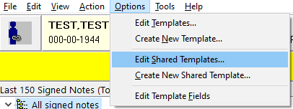

**Step 3:** In Template Editor, expand the Consult Reasons for Request folder.

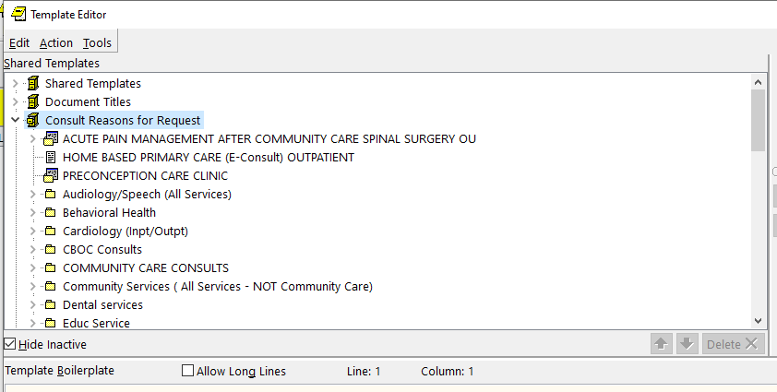

**Step 4:** Scroll down and select the folder to which you will import the consult TXML templates (e.g. mental health).

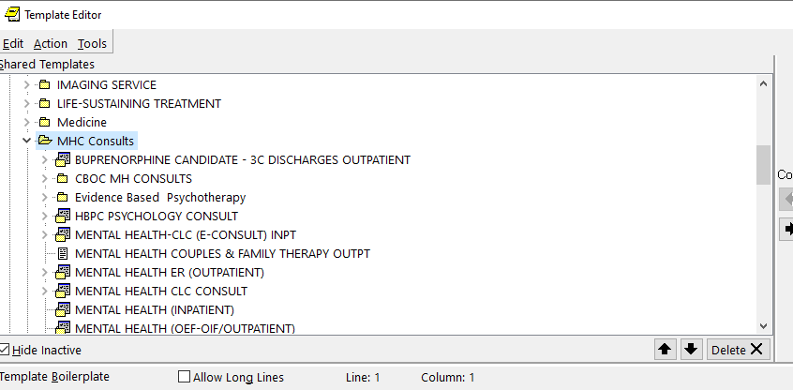

***Optional:*** *Create a new folder by clicking New Template, typing the name Suicide Prevention Telehealth, then selecting Folder from the Template Type dropdown.*

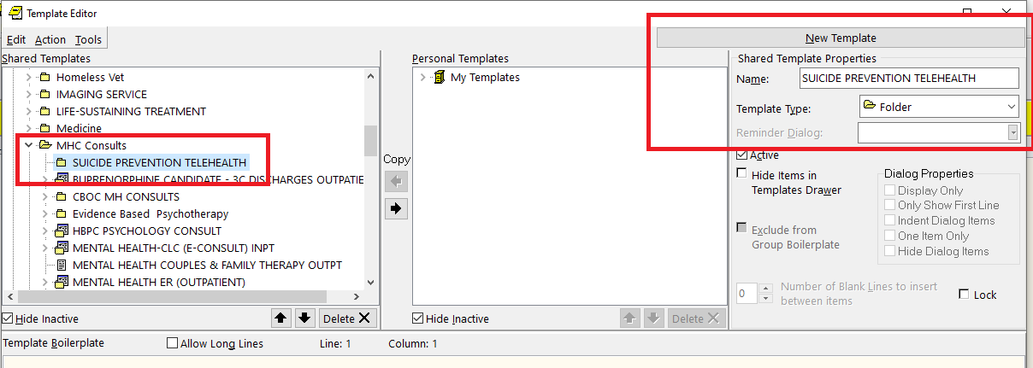

**Step 5:** With your destination folder selected, click Tools then click Import Template.

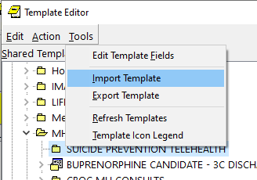

**Step 6:** Navigate to where you saved the TXML file, select the file, then click Open.

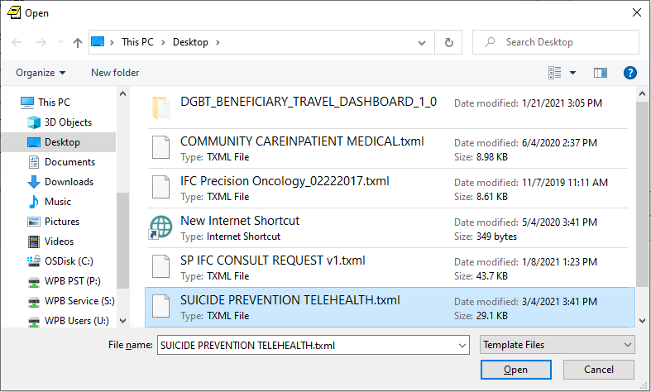

**Step 7:** Link the Suicide Prevention Telehealth consult to the template by typing the consult name in the Associated Consult Service field.

**Step 8:** Click Apply in the bottom right corner to save. This will update the template name to match the name of the Associated Consult Service.

***Note:*** *If your Apply button is grayed out, first click off of the Associated Consult Service field.*

