

**Update _2_0_225**

Clinical Reminders

VA-OSP TH INTAKE ASSESMENT UPDATE

Install Guide

**August 2021**

Product Development

Office of Information Technology

Department of Veterans Affairs

Table of Contents

Introduction 1

Install Details 4

Install Example 4

Post Installation 7

# Introduction

The original Suicide Prevention Telehealth Interfacility Consult (IFC) and Intake Assessment template were developed by the Veterans Health Administration Office of Mental Health and Suicide Prevention (OMHSP) in collaboration with subject matter experts within the SP 2.0 Clinical Telehealth Workgroup and nationally released earlier in FY21. These tools were designed to create a referral system within the Veterans Integrated Service Network (VISN) Clinical Resource Hubs (CRH) for Veterans with a history of suicidal self-directed violence to receive suicide-prevention psychotherapy interventions via telehealth. A focus group of therapists across several VISN CRHs, who have been using the original intake assessment template, provided feedback about improvements to the tool. Additionally, the SP 2.0 Clinical Telehealth program has learned lessons from both the Human Factors Engineering (HFE) workgroup review and the pilot process for Cognitive Behavior Therapy (CBT-SP) note templates, and these lessons learned have informed our edits to improve the quality of the intake assessment template and have contributed to our next version of this tool.

Referring providers (LIPs) located in Spoke and Hub telehealth facilities from general mental health, specialty mental health, residential mental health and inpatient mental health will complete the referring IFC.  Suicide Prevention Telehealth psychiatrists, psychologists, social workers and licensed professional mental health counselors located in the Hub site of the Clinical Resource Hubs will receive and respond to the consults using the Intake Assessment Template. The purpose of the templates is to use health factors to capture data, and collect information about the referral sources and triage responses.

UPDATE_2_0_225 contains 1 Reminder Exchange entry:

**UPDATE_2_0_225 VA-OSP TH INTAKE ASSESMENT UPDATE**

**The exchange file contains the following components:**

**REMINDER GENERAL FINDINGS**

VIEW PROGRESS NOTE TEXT

**TIU TEMPLATE FIELD**

WP 2/50 NOT REQ

WP 3/70

VA-OSP SP RISK MGMT

VA-OSP SRM CONSULT EMAIL

DATE

EB 20/240

DISPLAY TEXT SP OTHER LOCATION

EB 20/240 REQ

VA-HH:MM

DATE (REQ)

**HEALTH FACTORS**

VA-REMINDER UPDATES [C]

VA-UPDATE_2_0_225

VA-SUICIDE SAFETY PLAN [C]

VA-SP SAFETY PLAN REVIEWED

VA-OSP TH INTAKE ASSESSMENT [C]

VA-OSP TH SAFETY PLAN UPDATED

VA-OSP TH SAFETY PLAN NEW

VA-OSP TH NOT REC OTHER

VA-OSP TH NOT REC NOT INDICATED

VA-OSP TH NOT REC INCLUSION

VA-OSP TH NOT REC RECEIVING TX

VA-OSP TH NOT REC DIFFERENT ISSUE

VA-OSP TH PST-SP CONSENTED

VA-OSP TH DBT CONSENTED

VA-OSP TH CBT-SP CONSENTED

VA-OSP TH SAFETY PLANNING CONSENTED

VA-OSP TH DECLINED OTHER

VA-OSP TH DECLINED NOT MAIN CONCERN

VA-OSP TH DECLINED DISCUSS SUICIDE

VA-OSP TH DECLINED VIRTUAL

VA-OSP TH DECLINED MOTIVATION

VA-OSP TH DECLINED ATTENDANCE

VA-OSP TH TREATMENT DISCUSSION NONE

VA-OSP TH PST-SP DISCUSSED

VA-OSP TH DBT DISCUSSED

VA-OSP TH CBT-SP DISCUSSED

VA-OSP TH SAFETY PLANNING DISCUSSED

VA-SUICIDE RISK MANAGEMENT [C]

VA-SRM FU LOW ACUTE RISK

VA-SRM FU INTERMEDIATE ACUTE RISK

VA-SRM FU HIGH ACUTE RISK

VA-SUICIDE RISK ASSESSMENT [C]

VA-SUICIDE RISK ACUTE LOW

VA-SUICIDE RISK ACUTE INTERMEDIATE

VA-SUICIDE RISK ACUTE HIGH

VA-OSP TH DISCHARGE [C]

VA-OSP TH ACUTE RISK LOW

VA-OSP TH ACUTE RISK INTERMEDIATE

VA-OSP TH ACUTE RISK HIGH

VA-OSP TH CHRONIC RISK LOW

VA-OSP TH CHRONIC RISK INTERMEDIATE

VA-OSP TH CHRONIC RISK HIGH

VA-SUICIDE RISK EVALUATION TYPE [C]

VA-SUICIDE RISK UPDATE EVALUATION

VA-SUICIDE RISK NEW EVALUATION

VA-OSP TH FACE TO FACE

VA-OSP TH TELEPHONE

VA-OSP TH SESSION PARTIALLY VIDEO

VA-OSP TH VIDEO TO ATLAS

VA-OSP TH VIDEO TO CLINIC

VA-OSP TH VA DEVICE NO

VA-OSP TH VA DEVICE YES

VA-OSP TH VIDEO TO HOME OUTSIDE

VA-OSP TH VIDEO TO HOME RESIDENCE

VA-OSP TH REFERRAL OTHER

VA-OSP TH REFERRAL MH SPECIALTY

VA-OSP TH REFERRAL INPATIENT

VA-OSP TH REFERRAL RRTP

VA-OSP TH REFERRAL SP TEAM

VA-OSP TH REFERRAL PCMHI

VA-OSP TH REFERRAL MHC/BHIP

VA-OSP TH INTAKE ASSESSMENT NOTE

**REMINDER SPONSOR**

VHA OFFICE OF MENTAL HEALTH AND SUICIDE PREVENTION

**REMINDER TERM**

VA-REMINDER UPDATE_2_0_225

**HEALTH SUMMARY TYPE**

VA-OSP TH ACUTE RISK LEVELS 6M

VA-CSRE MOST RECENT

**HEALTH SUMMARY OBJECTS**

VA-OSP TH ACUTE RISK LEVELS 6M

VA-CSRE MOST RECENT

**TIU DOCUMENT DEFINTION**

VA-OSP TH ACUTE RISK LEVELS 6M

VA-CSRE MOST RECENT

**REMINDER DIALOG**

VA-OSP TH INTAKE

# Install Details

This update is being distributed as a web host file. The address for the host file is: **https://vaww.va.gov/reminders/docs/UPDATE_2_0_225.PRD**

The file will be installed using Reminder Exchange, programmer access is not required.

Installation:

=============

This update can be loaded with users on the system. Installation will take less than 5 minutes.

# Install Example

To Load the Web Host File. Navigate to Reminder exchange in Vista

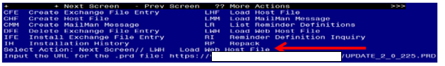

At the **Select Action:** prompt, enter **LWH** for Load Web Host File

At the **Input the url for the .prd file:** prompt, type the following web address:

**https://vaww.va.gov/reminders/docs/UPDATE_2_0_225.PRD**

You should see a message at the top of your screen that the file successfully loaded.

Terminal window screen shot of the message displaying the URL of the file that was successfully loaded.  Part of the URL has been redacted as it is a VA only internal web site URL.

Search and locate an entry titledUPDATE_2_0_225 VA-OSP TH INTAKE ASSESMENT UPDATE in reminder exchange. 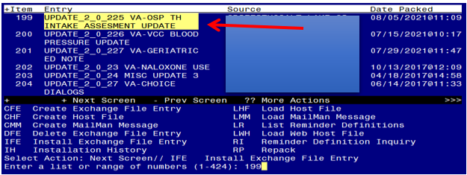

At the **Select Action** prompt, enter **IFE** for Install Exchange File Entry

Enter the number that corresponds with your entry UPDATE_2_0_225 VA-OSP TH INTAKE ASSESMENT UPDATE *(in this example it is entry 199. It will vary by site).* The date of the exchange file should be 08/05/2021.

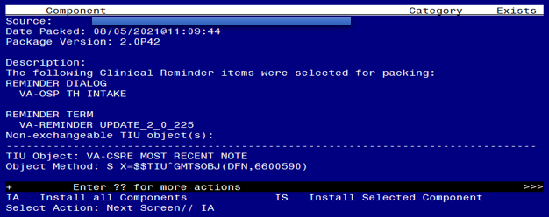

At the **Select Action** prompt, type **IA** for Install all Components and hit enter.

Select Action: Next Screen// IA Install all Components

You will see several prompts, for all new entries you will choose **I to Install**

For components that already exists but the packed component is different, choose **S to Skip.**

**You will be promped to install the reminder dialog component (VA-OSP TH INTAKE).** You will choose to install all even though some components may have an X to indicate that they exist.

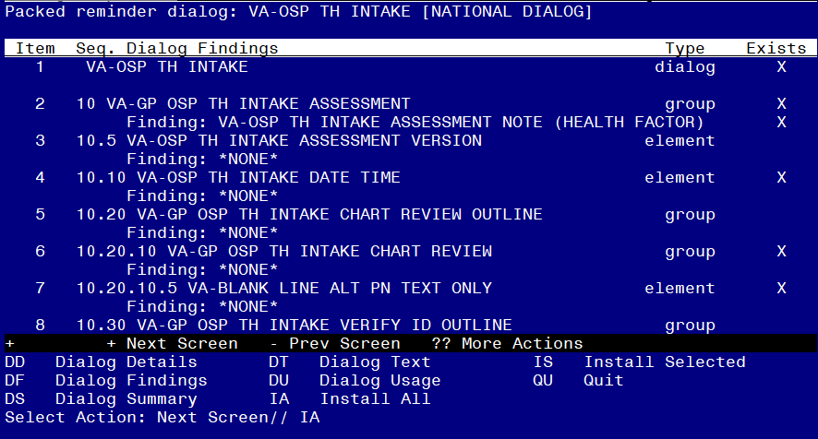

At the **Select Action** prompt, type **IA** to install the dialog: **VA-OSP TH INTAKE**

Select Action: Next Screen// IA Install All

Install reminder dialog and all components with no further changes: Y// Yes

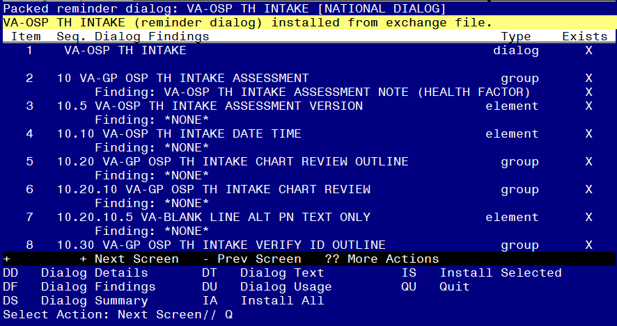

After completing this dialog install, you will type Q.

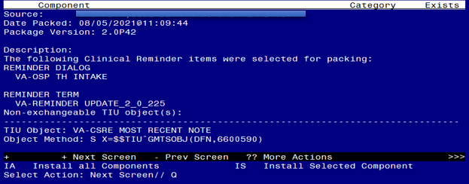

You will then be returned to this screen. At the **Select Action** prompt, type **Q.**

Install complete.

# Post Installation

1. **You should already have a note titled, SUICIDE PREVENTION TELEHEALTH INTAKE ASSESMENT. Open and confirm that the version now displays as version 2.2**
2. **Add your local data objects.**

Add your local data objects for patient address and patient phone numbers to the dialog text of the following reminder dialog elements:

1. VAL-OSP TH INTAKE EMERGENCY INFO VTH PHONE
2. VAL-OSP TH INTAKE EMERGENCY INFO VTH PT LOCATION HOME

Using the menu Reminder Dialog Management, Reminder Dialogs, change your view to Elements.

**Dialog List** Mar 03, 2021@08:30:32 Page: 1 of 35

REMINDER VIEW (ALL REMINDERS BY NAME)

Item Reminder Name Linked Dialog Name & Dialog Status

+ Enter ?? for more actions >>>

AR All reminders LR Linked Reminders QU Quit

CV Change View RN Name/Print Name

Select Item: Next Screen// **CV** Change View *<Enter>*

Select one of the following:

D Reminder Dialogs

E Dialog Elements

F Forced Values

G Dialog Groups

P Additional Prompts

R Reminders

RG Result Group (Mental Health)

RE Result Element (Mental Health)

TYPE OF VIEW: R// **E** *<Enter>*

*Next, type* ***SL*** *for search, press* ***<Enter>****, then search for* ***VAL-OSP TH INTAKE EMERGENCY INFO****.*

+ + Next Screen - Prev Screen ?? More Actions >>>

AD Add PT List/Print All QU Quit

CO Copy Dialog INQ Inquiry/Print

CV Change View TE Dialog Taxonomy Edit

Select Item: Next Screen// **SL** *<Enter>*

Search for: **VAL-OSP TH INTAKE EMERGENCY INFO** *<Enter>*

...searching for 'VAL-OSP TH INTAKE EMERGENCY INFO'

**Dialog List** Mar 03, 2021@08:49:59 Page: 1973 of 2012

DIALOG VIEW (DIALOG ELEMENTS)

+Item Dialog Name Dialog type Status

**27615 VAL-OSP TH INTAKE EMERGENCY INFO VTH P Dialog Element**

27616 VAL-OSP TH INTAKE EMERGENCY INFO VTH P Dialog Element

+ + Next Screen - Prev Screen ?? More Actions >>>

Find Next 'VAL-OSP TH INTAKE EMERGENCY INFO'? Yes// **NO** *<Enter>*

*After searching, you will see the sequence number for the elements in the left column. In this example, I am selecting 27615.*

Select Item: Next Screen// **27615** *<Enter>*

Dialog Name: VAL-OSP TH INTAKE EMERGENCY INFO VTH PHONE

Current dialog element/group name: VAL-OSP TH INTAKE EMERGENCY INFO VTH PHONE

Used by: VA-GP OSP TH INTAKE EMERGENCY INFO VTH PHONE (Dialog Group)

NAME: VAL-OSP TH INTAKE EMERGENCY INFO VTH PHONE

Replace *<Enter>*

DISABLE: *<Enter>*

CLASS: LOCAL// *<Enter>*

SPONSOR: VHA Office of Mental Health and Suicide Prevention

// *<Enter>*

REVIEW DATE: *<Enter>*

RESOLUTION TYPE: *<Enter>*

ORDERABLE ITEM: *<Enter>*

FINDING ITEM: *<Enter>*

Additional findings: none *<Enter>*

Select ADDITIONAL FINDING: *<Enter>*

DIALOG/PROGRESS NOTE TEXT:

Phone: **INSERT PATIENT PHONE OBJECT**

Edit? NO// **YES** *<Enter>*

*Add your local data object, then repeat the steps as needed to add your local data object for patient address to the remaining element VAL-OSP TH INTAKE EMERGENCY INFO VTH PT LOCATION HOME.*