**REMINDER UPDATE_2_0_309 VA-CSP CHANGES**

NOTE: All reminder dialog changes are included in reminder dialog group:

VA-GP CSP UPDATES AUGUST 22

Table of Contents

**1.** Reminder DIALOG: **VA-CSP PCAFC INTERVIEW** 2

**2.** Reminder DIALOG: **VA-CSP PROGRAM DENIAL** 3

**3.** Reminder DIALOG: **VA-CSP PROGRAM DISCHARGE** 5

**4.** Reminder DIALOG: **VA-CSP CEAT REVIEW RESPONSE NOTE** 7

**5.** Reminder DIALOG: **VA-CSP PCAFC INTAKE** 12

**6.** Reminder DIALOG: **VA-CSP PCAFC RE-ASSESSMENT** 14

*Note: To confirm updates made on any ‘national’ dialog element or group listed below, choose the INQ (Inquiry/Print) option in the Reminder Dialog Management Menu.*

# Reminder DIALOG: **VA-CSP PCAFC INTERVIEW**

Change Made: The version number and introduction text was edited.

**BEFORE**:

Element: VA-CSP PCAFC INTERVIEW VERSION

Text: Program of Comprehensive Assistance for Family Caregivers Veteran Assessment Version 2.4

Element: VA-CSP PCAFC INTERVIEW INTRO

Text:

The Program of Comprehensive Assistance for Family Caregivers

(PCAFC) provides services and additional benefits to designated

and approved Family Caregivers of eligible Veterans who incurred

or aggravated a serious injury in the line of duty on or after

September 11, 2001; or on or before May 7, 1975 and is for

individuals in need of personal care services for a minimum of

six continuous months based on any one of the following: (i)

An inability to perform an activity of daily living; or (ii) A

need for supervision, protection, or instruction.

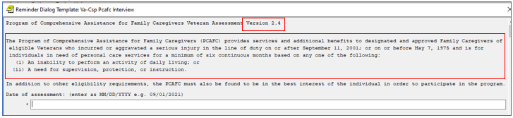

**AFTER**:

Element: VA-CSP PCAFC INTERVIEW VERSION

Text: Program of Comprehensive Assistance for Family Caregivers Veteran Assessment Version 3.1

Element: VA-CSP PCAFC INTERVIEW INTRO

Text:

The Program of Comprehensive Assistance for Family Caregivers

(PCAFC) provides services and additional benefits to designated

and approved Family Caregivers of eligible Veterans who incurred

or aggravated a serious injury in the line of duty and is for

individuals in need of personal care services for a minimum of

six continuous months based on any one of the following: (i)

An inability to perform an activity of daily living; or (ii) A

need for supervision, protection, or instruction.

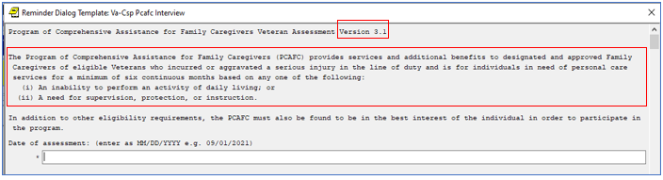

# Reminder DIALOG: **VA-CSP PROGRAM DENIAL**

Change Made: The version number changed and one selection option was removed from under ‘the individual is being denied for the following reason(s)’ group.

**BEFORE**:

Element: VA-CSP DENIAL NOTE VERSION

Text: Caregiver Support Program Denial Note Version 2.3

GROUP: VA-GP CSP DENIAL REASON

5 VA-CSP DENIAL REASON OUTSIDE OF US

10 VA-CSP DENIAL REASON APPLICATION DELAY

15 VA-CSP DENIAL REASON NOT A VET

20 VA-CSP DENIAL REASON NO INJURY

25 VA-CSP DENIAL REASON INJURY NOT WITHIN DATES

30 VA-CSP DENIAL REASON NOT NEEDED

33 VA-CSP DENIAL REASON NOT IN BEST INTEREST

35 VA-CSP DENIAL REASON OTHER SERVICES

40 VA-CSP DENIAL REASON WONT RECEIVE

45 VA-CSP DENIAL REASON NO PC

50 VA-CSP DENIAL REASON NOT 18

55 VA-CSP DENIAL REASON DOESNT RESIDE WITH

60 VA-CSP DENIAL REASON CG NOT CAPABLE

70 VA-CSP DENIAL REASON APPLICATION WITHDRAWN

80 VA-CSP DENIAL REASON VET DECEASED

85 VA-CSP DENIAL REASON CG DECEASED

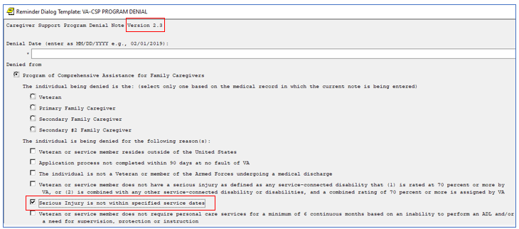

**AFTER**:

Element: VA-CSP DENIAL NOTE VERSION

Text: Caregiver Support Program Denial Note Version 3.1

GROUP: VA-GP CSP DENIAL REASON

5 VA-CSP DENIAL REASON OUTSIDE OF US

10 VA-CSP DENIAL REASON APPLICATION DELAY

15 VA-CSP DENIAL REASON NOT A VET

20 VA-CSP DENIAL REASON NO INJURY

25 VA-CSP DENIAL REASON NOT NEEDED

30 VA-CSP DENIAL REASON NOT IN BEST INTEREST

35 VA-CSP DENIAL REASON OTHER SERVICES

40 VA-CSP DENIAL REASON WONT RECEIVE

45 VA-CSP DENIAL REASON NO PC

50 VA-CSP DENIAL REASON NOT 18

55 VA-CSP DENIAL REASON DOESNT RESIDE WITH

60 VA-CSP DENIAL REASON CG NOT CAPABLE

65 VA-CSP DENIAL REASON APPLICATION WITHDRAWN

70 VA-CSP DENIAL REASON VET DECEASED

75 VA-CSP DENIAL REASON CG DECEASED

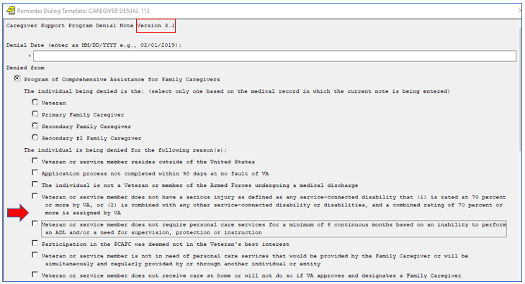

# Reminder DIALOG: **VA-CSP PROGRAM DISCHARGE**

Change Made: The version number changed and the ‘VA Error’ option was moved to now fall under the ‘Revoked’ group.

**BEFORE**:

Element: VA-CSP DISCHARGE NOTE VERSION

Text: Caregiver Support Program Discharge/Revocation Note Version 2.3

Group: VA-GP CSP REASON FOR DISCHARGE MAIN

5 VA-GP CSP REASON FOR DISCHARGE

10 VA-GP CSP REASON FOR DISCHARGE REVOKED

15 VA-CSP DISCHARGE REASON VA ERROR

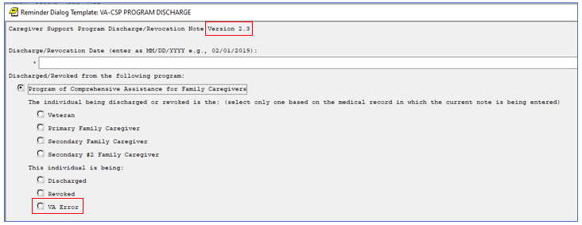

**AFTER**:

Element: VA-CSP DISCHARGE NOTE VERSION

Text: Caregiver Support Program Discharge/Revocation Note Version 3.1

Group: VA-GP CSP REASON FOR DISCHARGE MAIN

5 VA-GP CSP REASON FOR DISCHARGE

10 VA-GP CSP REASON FOR DISCHARGE REVOKED

5 VA-CSP DISCHARGE REASON FOR CAUSE

10 VA-CSP DISCHARGE REASON NON COMPLIANCE

15 VA-CSP DISCHARGE REASON VA ERROR

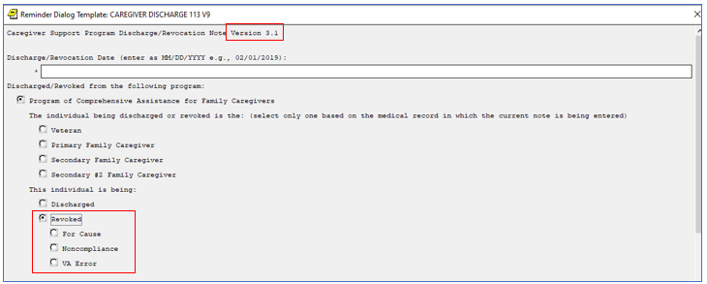

# Reminder DIALOG: **VA-CSP CEAT REVIEW RESPONSE NOTE**

Change Made: The version number changed, text has been removed from item #2 under the ‘Veteran Requirements’ section, one selection option has been removed from under the ‘Denied’ section and text has been edited under the ‘Veteran is unable to self-sustain in the community’ group.

**BEFORE**:

Element: VA-CSP CEAT VERSION NUMBER

Text: Centralized Eligibility and Appeals Team (CEAT) Review Note

Version 3.1

Group: VA-GP CSP CEAT INITIAL APP SERIOUS INJURY

Text: 2) The individual has a serious injury incurred or aggravated in

the line of duty in the active military, naval, or air service:

On or after September 11, 2001

or

On or before May 7, 1975

*Serious injury means any service-connected disability that (1)

is rated at 70 percent or more by VA, or (2) is combined with

any other service-connected disability or disabilities, and a

combined rating of 70 percent or more is assigned by VA.

Group: VA-GP CSP CEAT DENIED INITIAL

5 VA-CSP CEAT INITIAL APP DENIED OUTSIDE US

10 VA-CSP CEAT INITIAL APP DENIED 90 DAYS

15 VA-CSP CEAT INITIAL APP DENIED NOT VET

20 VA-CSP CEAT INITIAL APP DENIED NO INJURY

25 VA-CSP CEAT INITIAL APP DENIED INJURY NOT IN SD

30 VA-CSP CEAT INITIAL APP DENIED NOT REQUIRED

35 VA-CSP CEAT INITIAL APP DENIED NOT IN BEST INTREST

40 VA-CSP CEAT INITIAL APP DENIED FCG

45 VA-CSP CEAT INITIAL APP DENIED NO CARE AT HOME

50 VA-CSP CEAT INITIAL APP DENIED NO PACT TEAM

55 VA-CSP CEAT INITIAL APP DENIED NOT 18

60 VA-CSP CEAT INITIAL APP DENIED NOT LIVE WITH VET

65 VA-CSP CEAT INITIAL APP DENIED NOT CAPABLE

70 VA-CSP CEAT INITIAL APP DENIED WITHDREW

75 VA-CSP CEAT INITIAL APP DENIED DEATH

80 VA-CSP CEAT INITIAL APP DENIED CG DEATH

Group: VA-GP CSP CEAT INITIAL APP SELF SUSTAIN

Text: 3) Veteran is unable to self-sustain in the community.

*Unable to self-sustain in the community means that an eligible

Veteran requires personal care services each time he or she

completes three or more of the seven activities of daily living

(ADL) listed in the definition of an inability to perform an

activity of daily living in this section, and is fully dependent

on a caregiver to complete such ADLs or has a need for

supervision, protection, or instruction on a continuous basis.

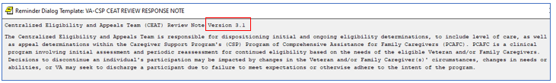

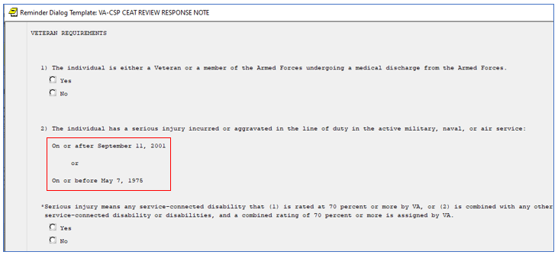

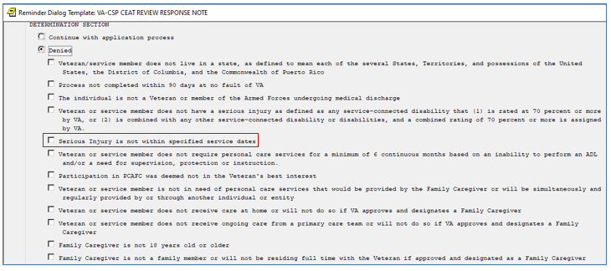

More of the BEFORE Reminder Dialog showing the content of 3) Veteran is unable to self-sustain in the community with the text:         *Unable to self-sustain in the community means that an eligible  Veteran requires personal care services each time he or she completes three or more of the seven activities of daily living  (ADL) listed in the definition of an inability to perform an activity of daily living in this section, and is fully dependent on a caregiver to complete such ADLs or has a need for supervision, protection, or instruction on a continuous basis.


**AFTER**:

Element: VA-CSP CEAT VERSION NUMBER

Text: Centralized Eligibility and Appeals Team (CEAT) Review Note

Version 4.1

Group: VA-GP CSP CEAT INITIAL APP SERIOUS INJURY

Text: 2) The individual has a serious injury incurred or aggravated in

the line of duty in the active military, naval, or air service:

*Serious injury means any service-connected disability that (1)

is rated at 70 percent or more by VA, or (2) is combined with

any other service-connected disability or disabilities, and a

combined rating of 70 percent or more is assigned by VA.

Group: VA-GP CSP CEAT DENIED INITIAL

5 VA-CSP CEAT INITIAL APP DENIED OUTSIDE US

10 VA-CSP CEAT INITIAL APP DENIED 90 DAYS

15 VA-CSP CEAT INITIAL APP DENIED NOT VET

20 VA-CSP CEAT INITIAL APP DENIED NO INJURY

30 VA-CSP CEAT INITIAL APP DENIED NOT REQUIRED

35 VA-CSP CEAT INITIAL APP DENIED NOT IN BEST INTREST

40 VA-CSP CEAT INITIAL APP DENIED FCG

45 VA-CSP CEAT INITIAL APP DENIED NO CARE AT HOME

50 VA-CSP CEAT INITIAL APP DENIED NO PACT TEAM

55 VA-CSP CEAT INITIAL APP DENIED NOT 18

60 VA-CSP CEAT INITIAL APP DENIED NOT LIVE WITH VET

65 VA-CSP CEAT INITIAL APP DENIED NOT CAPABLE

70 VA-CSP CEAT INITIAL APP DENIED WITHDREW

75 VA-CSP CEAT INITIAL APP DENIED DEATH

80 VA-CSP CEAT INITIAL APP DENIED CG DEATH

Group: VA-GP CSP CEAT INITIAL APP SELF SUSTAIN

Text: 3) Veteran is unable to self-sustain in the community:

* Unable to self-sustain in the community means that an eligible

Veteran either:

- Requires personal care services each time he or she completes

three or more of the seven activities of daily living (ADL)

listed in the definition of an inability to perform an activity

of daily living in this section, and is fully dependent on a

caregiver to complete such ADLs; or

- Has a need for supervision or protection based on symptoms or

residuals of neurological or other impairment or injury on a

continuous basis; or

- Has a need for regular or extensive instruction or supervision

without which the ability of the Veteran to function in daily

life would be seriously impaired on a continuous basis

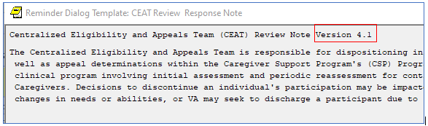

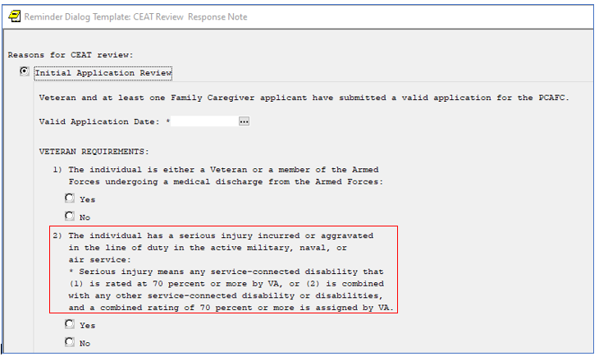

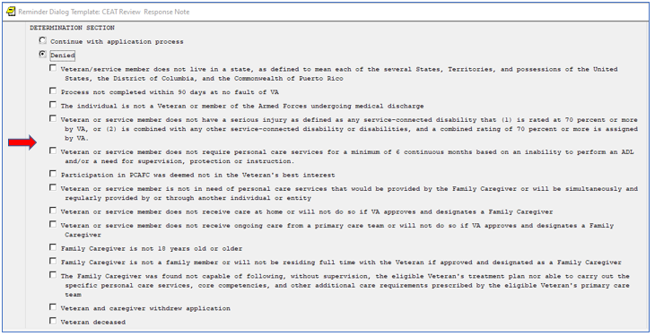

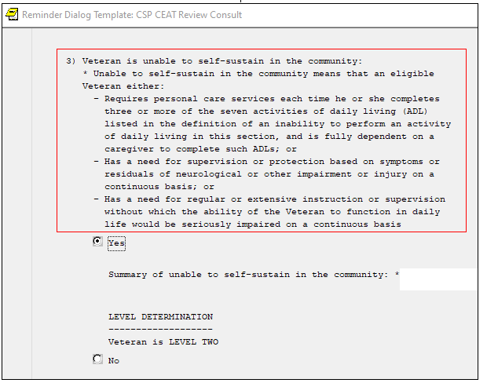

# Reminder DIALOG: **VA-CSP PCAFC INTAKE**

Change Made: The version number changed and text has been removed from item #2 under the ‘Veteran Requirements’ section.

**BEFORE**:

Element: VA-CSP PCAFC INTAKE VERSION

Text: Intake for the Program of Comprehensive Assistance for Family

Caregivers (PCAFC) Version 2.1

Group: VA-CSP GP PCAFC VETERAN REQUIREMENT Q2A

Text: 2) The individual has a serious injury incurred or aggravated

in the line of duty in the active military, naval, or air

service: On or after September 11, 2001 or On or before

May 7, 1975 * Serious injury means any service-connected

disability that (1) is rated at 70 percent or more by VA, or

(2) is combined with any other service-connected disability

or disabilities, and a combined rating of 70 percent or more

is assigned by VA.

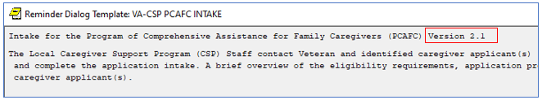

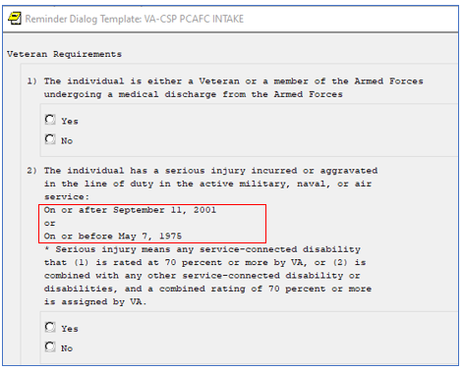

**AFTER**:

Element: VA-CSP PCAFC INTAKE VERSION

Text: Intake for the Program of Comprehensive Assistance for Family

Caregivers (PCAFC) Version 3.1

Group: VA-CSP GP PCAFC VETERAN REQUIREMENT Q2A

Text: 2) The individual has a serious injury incurred or aggravated

in the line of duty in the active military, naval, or air

service: * Serious injury means any service-connected

disability that (1) is rated at 70 percent or more by VA, or

(2) is combined with any other service-connected disability

or disabilities, and a combined rating of 70 percent or more

is assigned by VA.

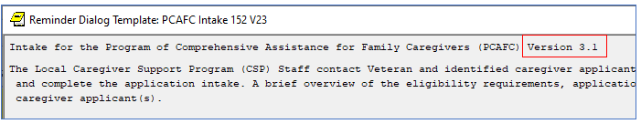

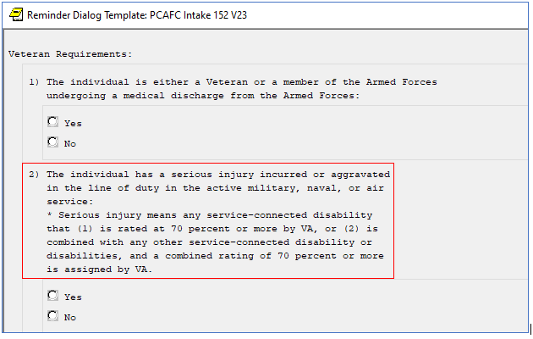

# Reminder DIALOG: **VA-CSP PCAFC RE-ASSESSMENT**

Change Made: The version number changed and

**BEFORE**:

Element: VA-CSP PCAFC RE-ASSESSMENT VERSION

Text: Program of Comprehensive Assistance for Family Caregivers (PCAFC)

Reassessment version 1.3

Group: VA-CSP GP PCAFC VETERAN REQUIREMENT Q2A

Text: 2) The individual has a serious injury incurred or aggravated

in the line of duty in the active military, naval, or air

service: On or after September 11, 2001 or On or before

May 7, 1975 * Serious injury means any service-connected

disability that (1) is rated at 70 percent or more by VA, or

(2) is combined with any other service-connected disability

or disabilities, and a combined rating of 70 percent or more

is assigned by VA.

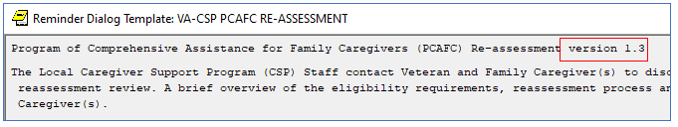

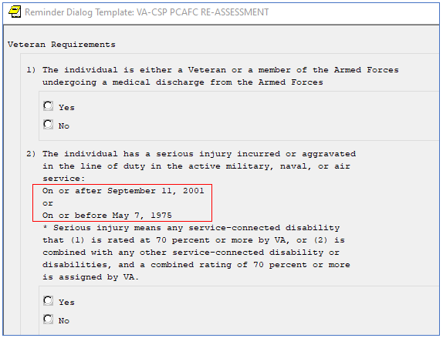

**AFTER**:

Element: VA-CSP PCAFC RE-ASSESSMENT VERSION

Text: Program of Comprehensive Assistance for Family Caregivers (PCAFC)

Reassessment version 2.1

Group: VA-CSP GP PCAFC VETERAN REQUIREMENT Q2A

Text: 2) The individual has a serious injury incurred or aggravated

in the line of duty in the active military, naval, or air

service: * Serious injury means any service-connected

disability that (1) is rated at 70 percent or more by VA, or

(2) is combined with any other service-connected disability

or disabilities, and a combined rating of 70 percent or more

is assigned by VA.

