# **TELE-EYE READER NOTE**

1. Change version from 4.0 to 5.1



1. Add optional comment box after ‘Image Quality Adequate’ selection

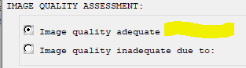



1. Reader template same patient---does not show the Macular Degeneration risk factor:

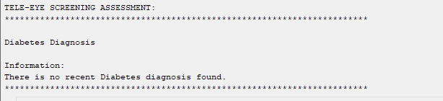

Added data objects for Glaucoma Risk and AMD Risk

* |VA-AMD RISK FACTORS|
* |VA-GLAUCOMA RISK FACTORS|

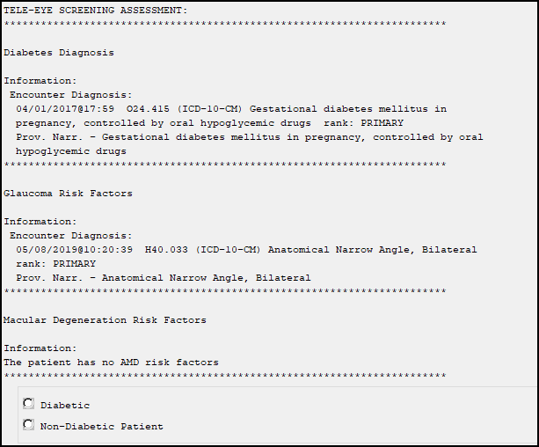

1. Add a unique health factor to each of the Type 1 and Type 2:

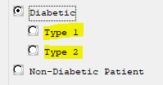

New health factors created:

* VA-TRR DIABETES TYPE 1
* VA-TRR DIABETES TYPE 2

1. For ‘Non-Diabetic Patient’ selection, expand to new elements, a required selection of one; add HF for each selection

0 At-Risk for Macular Degeneration

0 At-Risk for Glaucoma

0 At-Risk for Macular Degeneration and Glaucoma

0 Other:

New Health Factors:

* VA-TRR AT RISK FOR GLAUCOMA
* VA-TRR AT RISK FOR MAC DEGEN & GLAUCOMA
* VA-TRR AT RISK FOR MAC DEGENERATION
* VA-TRR AT RISK OTHER EYE CONDITION

Screen shot wit Non-Diabetic Patient with Risk Factors: radio buttons as follows:
0 At-Risk for Macular Degeneration
0 At-Risk for Glaucoma
0 At-Risk for Macular Degeneration 
and Glaucoma
0 Other: 



**ASSESSMENT SECTION**: Modify each sub-sections as outlined below, will be same across Type 1, Type 2, and Non-Diabetic categories (except there is one element that only pertains to the diabetic groups); also these will need to apply to both right and left eye reviews. Add HFs for each.

I identified the new options in red and below is preferred arrangement; also provided the autocode ICDs with appropriate Right vs Left eye ICD where needed:

**Diabetic Retinopathy**

1. Type 1
   1. Right
   2. Left

Screen shot of BEFORE with 
Check box selected followed by Evidence of previous retinal laser treatment

Screen shot of AFTER with 
Check box selected followed by Evidence of previous retinal laser treatment with a free text comment field after it.

1. Type 2
   1. Right
   2. Left

add optional comment box to this selection

Screen shot of BEFORE with 
Check box selected followed by Evidence of previous retinal laser treatment

Screen shot of AFTER with 
Check box selected followed by Evidence of previous retinal laser treatment with a free text comment field after it.

**Macula Assessment**

Right Eye Findings:     <add new elements, arrange in this order>

1. Macular pigmentary changes  < add optional comment box, no autocode needed>

**Health Factor:**

* VA-TRR MAC FINDING PIGMENTARY CHANGE RT

Screen Shot of Macular Pigmentary Changes selected followed by a free text field for comments.

1. Drusen    < add optional comment box, autocode:  Right eye ICD H35.361

**Health Factor:**

* VA-TRR MAC FINDING DRUSEN RT

**Taxonomy:**

* VA-TRR MACULAR DRUSEN RT

Screen Shot of  seleDrusencted followed by a free text field for comments.

1. Microaneurysm(s)/Intraretinal hemorrhage(s)   <add optional comment box, no autocode needed >

**Health Factor:**

* VA-TRR MAC FINDING INTRARETINAL HEMORRHAGE RT

Screen Shot of Microaneurysm(s)/Intraretinal Hemorrhage (s) selected followed by a free text field for comments.

1. **Exudates** <add optional comment box, no autocode needed >

**Health Factor:**

* VA-TRR MAC FINDING EXUDATES RT

Screen Shot of Exudates selected followed by a free text field for comments.

1. Macular Hole/Pseudohole   < add optional comment box, autocode: Right eye ICD H35.341

**Health Factor:**

* VA-TRR MAC FINDING MAC HOLE-RT

**Taxonomy:**

* VA-TRR MACULAR HOLE RT

Screen Shot of Macular Hole/Pseudohole selected followed by a free text field for comments.

1. Macular atrophy/scar  <add optional comment box, with encounter autocode:  Right eye ICD H31.011

**Health Factor:**

* VA-TRR MAC FINDING ATROPHY RT

**Taxonomy:**

* VA-TRR MACULAR ATROPHY RT

Screen Shot of Macular Atrophy/Scar selected followed by a free text field for comments.

Left Eye Findings:     <add new elements, arrange in this order>

1. Macular pigmentary changes  < add optional comment box, no autocode needed>

**Health Factor:**

* VA-TRR MAC FINDING PIGMENTARY CHANGE LT

Screen Shot of Macular Pigmentary Changes selected followed by a free text field for comments.

1. Drusen    < add optional comment box, autocode:  Left eye ICD H35.362>

**Health Factor:**

* VA-TRR MAC FINDING DRUSEN LT

**Taxonomy:**

* VA-TRR MACULAR DRUSEN LT

Screen Shot of  seleDrusencted followed by a free text field for comments.

1. Microaneurysm(s)/Intraretinal hemorrhage(s)   <add optional comment box, no autocode needed >

**Health Factor:**

* VA-TRR MAC FINDING INTRARETINAL HEMORRHAGE LT

Screen shot of Microaneurysm(s) /Intraretinal Hemorrhage (s) selected followed by a free text box for comments

1. **Exudates** <add optional comment box, no autocode needed >

**Health Factor:**

* VA-TRR MAC FINDING EXUDATES LT

Screen shot of Exudates selected followed by a free text box for comments

1. Macular Hole/Pseudohole   < add optional comment box, autocode: Left eye ICD H35.342

**Health Factor:**

* VA-TRR MAC FINDING MAC HOLE-LT

**Taxonomy:**

* VA-TRR MACULAR HOLE LT

Screen shot of Macular Hole/Pseudohole selected followed by a free text box for comments

1. Macular atrophy/scar  <add optional comment box, with encounter autocode:  Left eye ICD H31.012

**Health Factor:**

* VA-TRR MAC FINDING ATROPHY LT

**Taxonomy:**

* VA-TRR MACULAR ATROPHY LT

Screen shot of Macular Atrophy/Scar selected followed by a free text box for comments

**Optic Nerve Assessment**

Right Eye Findings:

1. Peripapillary atrophy: < no autocode ICD needed>
   1. **Health Factor:**

VA-TRR ON FINDING PERIPAPILLARY ATROPHY RT

Screen shot of Peripapillary Atrophy selected followed by a free text box for comments

1. Glaucoma Suspect: Based on appearance of optic disc:< include optional comment box, expand to new sub-selects below,; include optional comment box to the right of each sub-select option>

* Large cup-disc ratio < optional comment box>
* Asymmetric cupping- greater than fellow eye < optional comment box>
* Thinning/Notching of neuro-retinal rim < optional comment box>
* Nerve fiber layer defect < optional comment box>

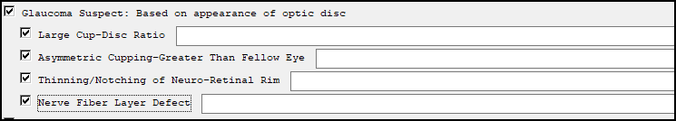

1. Physiologic cupping suspected – neuro-retinal rim and nerve fiber layer appear intact <no autocode>
   1. **Health Factor:**

VA-TRR ON FINDING PHYSIOLOGIC CUPPING SUSPECTED RT

Screen shot of Physiologic Cupping Suspected selected followed by a free text box for comments

1. Known Glaucoma <autocode: ICD h40.9 *is same code for either eye*
   1. **Health Factor:**

VA-TRR ON FINDING KNOWN GLAUCOMA RT

* 1. **Taxonomy:**

VA-TRR ON KNOWN GLAUCOMA

Screen shot of Known Glaucoma selected followed by a free text box for comments

1. Disc drusen:  < autocode Right eye ICD H47.321 >
   1. **Health Factor:**

VA-TRR ON FINDING DISC DRUSEN RT

* 1. **Taxonomy:**

VA-TRR ON DISC DRUSEN RT

Screen Shot of  Disc Drusen Selected followed by a free text field for comments.

1. Crowded disc with sharp margins < no autocode ICD needed >
   1. **Health Factor:**

VA-TRR ON FINDING DISC W/ SHARP MARGINS RT

Screen shot of Crowded Disk with Sharp Margins selected followed by a free text box for comments

1. Disc neovascularization:  < autocode:  Right eye ICD H47.091  >
   1. **Health Factor:**

VA-TRR ON FINDING DISC NEOVASCULARIZATION RT

* 1. **Taxonomy:**

VA-TRR ON DISC NEOVASCULARIZATION RT

Screen shot of Disc Neovascularization selected followed by a free text box for comments

1. Disc edema suspected:  < autocode:  Right eye ICD H47.091  >
   1. **Health Factor:**

VA-TRR ON FINDING DISC EDEMA SUSP RT

* 1. **Taxonomy:**

VA-TRR ON DISC EDEMA SUSPECT RT

Screen shot of  Disc Edema selected followed by a free text box for comments

1. Papilledema suspected < autocode:  ICD H47.10  *is same code for either eye*
   1. **Health Factor:**

VA-TRR ON FINDING PAPILLEDEMA SUSPECTED RT

* 1. **Taxonomy:**

VA-TRR ON PAPILLEDEMA SUSPECT

Screen shot of Papilledema Suspected selected followed by a free text box for comments

1. Pallor:  < autocode:  Right eye ICD H47.091  >
   1. **Health Factor:**

VA-TRR ON FINDING PALLOR RT

* 1. **Taxonomy:**

VA-TRR ON PALLOR RT

Screen shot of  Pallor selected followed by a free text box for comments

1. Remove ‘Elevated IOP’ from this Optic Nerve Head section, will place in the following ‘Other Assessment’ section

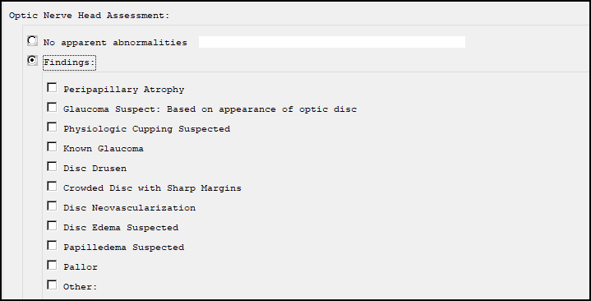

Left Eye Findings:

1. Peripapillary atrophy: < no autocode ICD needed>
   1. **Health Factor:**

VA-TRR ON FINDING PERIPAPILLARY ATROPHY LT

Screen shot of Papillary Atrophy selected followed by a free text box for comments

1. Glaucoma Suspect: Based on appearance of optic disc:< include optional comment box, expand to new sub-selects below,; include optional comment box to the right of each sub-select option>

* **Large cup-disc ratio <** optional comment box>
* **Asymmetric cupping- greater than fellow eye <** optional comment box>
* **Thinning/Notching of neuro-retinal rim <** optional comment box>
* **Nerve fiber layer defect <** optional comment box>



1. Physiologic cupping suspected – neuro-retinal rim and nerve fiber layer appear intact <no autocode>
   1. Health Factor:

VA-TRR ON FINDING PHYSIOLOGIC CUPPING SUSPECTED LT

Screen shot of  Physiologic Cupping Suspected selected followed by a free text box for comments

1. Known Glaucoma <autocode: ICD h40.9 *is same code for either eye*
   1. Health Factor:

VA-TRR ON FINDING KNOWN GLAUCOMA LT

* 1. Taxonomy:

VA-TRR ON KNOWN GLAUCOMA

Screen shot of Known Glacoma  selected followed by a free text box for comments

1. Disc drusen:  < autocode Left eye ICD H47.322
   1. Health Factor:

VA-TRR ON FINDING DISC DRUSEN LT

* 1. Taxonomy:

VA-TRR ON DISC DRUSEN LT

Screen shot of  Disc Drusen selected followed by a free text box for comments

1. Crowded disc with sharp margins < no autocode ICD needed >
   1. Health Factor:

VA-TRR ON FINDING DISC W/ SHARP MARGINS LT

Screen shot of Crowded Disc with Sharp Margins selected followed by a free text box for comments

1. Disc neovascularization:  < autocode:  Left eye ICD H47.092>
   1. Health Factor:

VA-TRR ON FINDING DISC NEOVASCULARIZATION LT

* 1. Taxonomy:

VA-TRR ON DISC NEOVASCULARIZATION LT

Screen shot of  Disc Neovascularization selected followed by a free text box for comments

1. Disc edema suspected:  < autocode:  Left eye ICD H47.092>
   1. Health Factor:

VA-TRR ON FINDING DISC EDEMA SUSP LT

* 1. Taxonomy:

VA-TRR ON DISC EDEMA SUSPECT LT

Screen shot of  Disc Edema Suspected selected followed by a free text box for comments

1. Papilledema suspected < autocode:  ICD H47.10  *is same code for either eye*
   1. Health Factor:

VA-TRR ON FINDING PAPILLEDEMA SUSPECTED LT

* 1. Taxonomy:

VA-TRR ON PAPILLEDEMA SUSPECT

Screen shot of  Papilledema Suspected selected followed by a free text box for comments

1. Pallor:  < autocode:  Left eye ICD H47.092>
   1. Health Factor:

VA-TRR ON FINDING PALLOR LT

* 1. Taxonomy:

VA-TRR ON PALLOR LT

Screen shot of Pallor selected followed by a free text box for comments

1. Remove ‘Elevated IOP’ from this Optic Nerve Head section, will place in the following ‘Other Assessment’ section



**Other Assessment**

Right Eye

1. Posterior Intraocular Lens Implant <autocode ICD Z96.1  (generic code is same regardless of R/L eye)
   1. **Health Factor:**

VA-TRR OTH ASSESS FINDING LENS IMPLANT RT

* 1. **Taxonomy:**

VA-TRR POSTERIOR IO LENS IMPLANT

Screen shot of Posterior Interocular Lens Implant selected followed by a free text field for comments.

1. Lenticular opacification – appears age-appropriate < autocode:  Right eye ICD H25.091>
   1. **Health Factor:**

VA-TRR OTH ASSESS FINDING LENTICULAR OPACIFICATION RT

* 1. **Taxonomy:**

VA-TRR LENTICULAR OPACIFICATION RT

Screen shot of Lenticular Opacification - Appears Age-Appropriate

1. Cataract – visual significance suspected < **change** autocode:  Right eye ICD H25.811>

Screen shot showing Diagnoses: Combined Forms of Age-Related Cataract, right Eye [ICD-10-CM H25.811]

1. Add Cataract – Known Condition

Screen shot of Cataract - Known Condition selected followed by a free text field for comments.

1. Chorioretinal scar <autocode right eye H31.001
   1. **Health Factor:**

VA-TRR OTH ASSESS FINDING CHORIORETINAL SCAR RT

* 1. **Taxonomy:**

VA-TRR CHORIORETINAL SCAR RT

Screen shot of Chorioretinal Scar selected followed by a free text field for comments.

1. Retinal vascular changes < right eye H35.011
   1. **Health Factor:**

VA-TRR OTH ASSESS FINDING RETINAL VASC CHANGE RT

* 1. **Taxonomy:**

VA-TRR RETINAL VASCULAR CHANGE RT

Screen shot of Retinal Vascular Changes selected followed by a free text field for comments.

1. Cotton wool spot(s) < autocode H35.82> *same code for either eye, it is an ‘unspecified’ code*
   1. **Health Factor:**

VA-TRR OTH ASSESS FINDING COTTON WOOL SPOT RT

* 1. **Taxonomy:**

VA-TRR COTTON WOOL SPOT

Screen shot of Cotton Wool Spot(s) selected followed by a free text field for comments.

1. Peripheral Retinal Degeneration <autocode ICD H35.40 same regardless of eye >
   1. **Health Factor:**

VA-TRR OTH ASSESS FINDING PERIPH RET DEGEN RT

* 1. **Taxonomy:**

VA-TRR PERIPHERAL RETINAL DEGENERATION

Screen shot of  Peripheral Retinal Degeneration selected followed by a free text field for comments.

1. Elevated Intraocular Pressure (>21 mmHg) < autocode right eye H40.051>
   1. **Health Factor:**

VA-TRR OTH ASSESS FINDING ELEVATED IOP RT

* 1. **Taxonomy:**

VA-TRR ELEVATED IOP RT

Screen shot of Elevated IOP selected followed by a free text field for comments.

1. Family history of glaucoma  < autocode ICD Z83.511  -  this is non-specific, so same code for either eye)
   1. **Health Factor:**

VA-TRR OTH ASSESS FINDING FAMILY HX GLAUCOMA RT

* 1. **Taxonomy:**

VA-TRR FAMILY HX OF GLAUCOMA

Screen shot of Family History of Glaucoma selected followed by a free text field for comments.

Left Eye

1. Posterior Intraocular Lens Implant <autocode ICD Z96.1  (generic code is same regardless of R/L eye)
   1. **Health Factor:**

VA-TRR OTH ASSESS FINDING LENS IMPLANT LT

* 1. **Taxonomy:**

VA-TRR POSTERIOR IO LENS IMPLANT

Screen shot of Posterior Intraocular Lens Implant selected followed by a free text field for comments.

1. Lenticular opacification – appears age-appropriate < autocode:  Left eye H25.092
   1. **Health Factor:**

VA-TRR OTH ASSESS FINDING LENTICULAR OPACIFICATION LT

* 1. **Taxonomy:**

VA-TRR LENTICULAR OPACIFICATION LT

Screen shot showing check box followed by Lenticular Opacification - Appears Age-Appropriate

1. Cataract -– visual significance suspected < **change** autocode:  Left eye H25.812

Screen shot showing Diagnoses: Combined Forms of Age-Related Cataract, left Eye [ICD-10-CM H25.812]

1. Add Cataract – Known Condition

Screen shot of Cataract - Known Condition  selected followed by a comment free text field.

1. Chorioretinal scar <autocode left eye H31.002>
   1. **Health Factor:**

VA-TRR OTH ASSESS FINDING CHORIORETINAL SCAR LT

* 1. **Taxonomy:**

VA-TRR CATARACT LT

Screen shot of Chorioretinal Scar selected followed by a comment free text field.

1. Retinal vascular changes < left eye H35.012>
   1. **Health Factor:**

VA-TRR OTH ASSESS FINDING RETINAL VASC CHANGE LT

* 1. **Taxonomy:**

VA-TRR RETINAL VASCULAR CHANGE LT

Screen shot of Retinal Vascular Changes  selected followed by a comment free text field.

1. Cotton wool spot(s) < autocode H35.82> *same code for either eye, it is an ‘unspecified’ code*
   1. **Health Factor:**

VA-TRR OTH ASSESS FINDING COTTON WOOL SPOT LT

* 1. **Taxonomy:**

VA-TRR COTTON WOOL SPOT

Screen shot of Cotton Wool Spot(s) selected followed by a comment free text field.

1. Peripheral Retinal Degeneration <autocode ICD H35.40 same regardless of eye >
   1. **Health Factor:**

VA-TRR OTH ASSESS FINDING PERIPH RET DEGEN LT

* 1. **Taxonomy:**

VA-TRR PERIPHERAL RETINAL DEGENERATION

Screen shot of Peripheral Retinal Degeneration  selected followed by a comment free text field.

1. Elevated Intraocular Pressure (>21 mmHg) < autocode left eye H40.052
   1. **Health Factor:**

VA-TRR OTH ASSESS FINDING ELEVATED IOP LT

* 1. **Taxonomy:**

VA-TRR CATARACT LT

Screen shot of Elevated IOP selected followed by a comment free text field.

1. Family history of glaucoma  < autocode ICD Z83.511  -  this is non-specific, so same code for either eye)
   1. **Health Factor:**

VA-TRR OTH ASSESS FINDING FAMILY HX GLAUCOMA LT

* 1. **Taxonomy:**

VA-TRR FAMILY HX OF GLAUCOMA

Screen shot of Family History of Glaucoma selected followed by a comment free text field.

1. Create new Oct Assessent Group

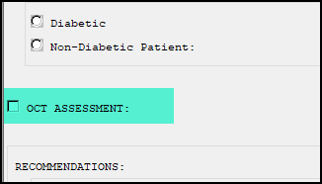

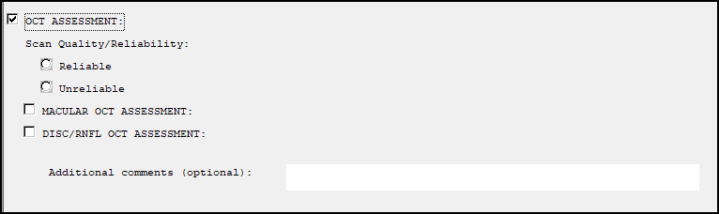

1. Oct Assessment Group
   1. Add Quality Group

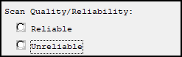

1. Oct Assessment Group
   1. Add Macular Oct Assessment group
      1. Add OD/OS/OU to each selection

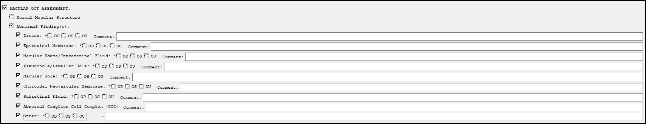

1. Macular OCT Assessment
   1. Add 3rd option Scan quality not adequate to determine w/ comment box

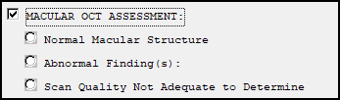

1. Macular OCT Assessment>Abnormal
   1. Add selection for Artifactual defect(s) noted w/ comment box

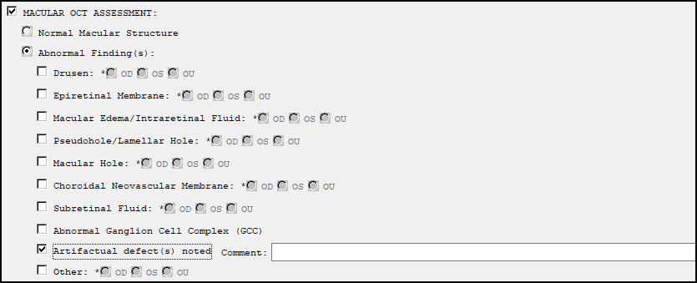

1. Disc/RNFL OCT Assessment
   1. Add 3rd option Scan quality not adequate to determine w/ comment box

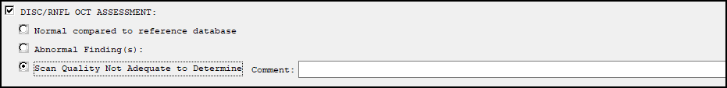

1. Disc/RNFL OCT Assessment>Abnormal
   1. Add selection for Artifactual defect(s) noted w/ comment box

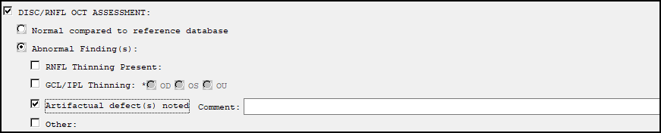

1. Disc/RNFL OCT Assessment>Abnormal>RNFL Thinning Present
   1. Change to one or more selections required

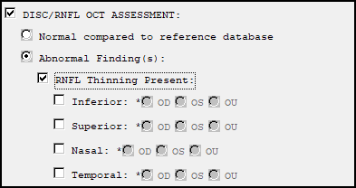

1. Disc/RNFL OCT Assessment>Abnormal>GCL/IPL Thinning section
   1. Add selections for Inferior, Superior, Nasal, and Temporal

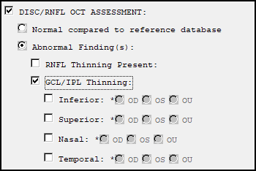

1. Oct Assessment Group
   1. Add Disc/RNFL Oct Assessment group
      1. Add OD/OS/OU to each selection

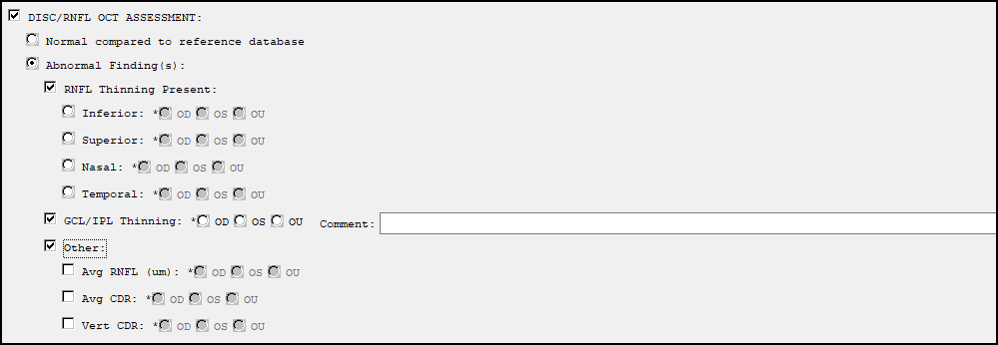

**EYE SCREENING RESULTS SECTION**

1. Edit verbiage in **RD template**
   1. Macular Findings-Change to Macular Degeneration

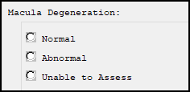

1. Edit verbiage in **RD template**
   1. Optic Nerve Head Findings-Change to Glaucoma

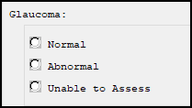

1. Edit verbiage so that when applies to note, reads as below (you just did this for the Imager template):

                Diabetic Retinopathy: Normal - No Diabetic Retinopathy Apparent

                 Macula:               Normal - **Age appropriate findings**

                 Optic Nerve:          Normal - **Age appropriate findings**

                Other Assessment:     Normal - **Age appropriate findings**

Screen shot showing EYE SCREENING RESULTS: 
Macula:               Normal - Age appropriate findings
Optic Nerve Head:          Normal - Age appropriate findings
Other Assessment:      Normal - Age appropriate findings


1. Diabetes
   1. Edit verbiage in Progress note
      1. Diabetic Retinopathy Normal
         1. Diabetic Retinopathy: Normal - No diabetic retinopathy apparent

Screen shot showing EYE SCREENING RESULTS:
Diabetic Retinopathy: Normal - No diabetic retinopathy apparent

1. Diabetes
   1. Edit verbiage in Progress note
      1. Diabetic Retinopathy Abnormal
         1. ABNORMAL - DIABETIC RETINOPATHY PRESENT

Screen shot showing EYE SCREENING RESULTS:
Diabetic Retinopathy: Abnormal - DIABETIC RETINOPATHY APPARENT

1. Diabetic Retinopathy Exam Normal
   1. Change HF print name to No diabetic retinopathy apparent
2. Diabetic Retinopathy Exam Abnormal
   1. Change HF print name to *DIABETIC RETINOPATHY DETECTED*
3. Macular Degeneration
   1. Edit Verbiage in Progress Note
      1. Macular Degeneration Normal
         1. Normal – No signs of macular degeneration

Screen shot showing EYE SCREENING RESULTS:
Macula: Normal - no signs of macular degeneration

1. Macular Degeneration
   1. Edit verbiage in Progress Note
      1. Macular Degeneration Normal
         1. Normal - No macular degeneration apparent

Screen shot showing EYE SCREENING RESULTS:
Macula: Normal - No macular degeneration apparent

1. Macular Degeneration
   1. Edit Verbiage in Progress Note
      1. Macular Degeneration Abnormal
         1. ABNORMAL – FURTHER ASSESSMENT NEEDED

Screen shot showing EYE SCREENING RESULTS:
Macula: ABNORMAL - FURTHER ASSESSMENT NEEDED

1. Macular Degeneration Exam Normal
   1. Change HF print name to No signs of macular degeneration
2. Macular Degeneration Exam Normal
   1. Change HF print name to No macular degeneration apparent
3. Macular Degeneration Exam Abnormal
   1. Change HF print name to *FURTHER ASSESSMENT NEEDED FOR MACULAR DEGENERATION*
4. Glaucoma
   1. Edit Verbiage in Progress Note
      1. Glaucoma Normal
         1. Normal – No signs of glaucomatous nerve damage

Screen shot showing EYE SCREENING RESULTS:
Glaucoma: Normal - no signs of glaucomatous nerve damage

1. Glaucoma
   1. Edit verbiage in Progress Note
      1. Glaucoma Normal
         1. Normal – No glaucomatous nerve damage apparent

Screen shot showing EYE SCREENING RESULTS:
Glaucoma: Normal - No glaucomatous nerve damage apparent

1. Glaucoma
   1. Edit verbiage in progress note
      1. Glaucoma Abnormal
         1. ABNORMAL – FURTHER ASSESSMENT NEEDED

Screen shot showing EYE SCREENING RESULTS:
Glaucoma: ABNORMAL - FURTHER ASSESSMENT NEEDED

1. Glaucoma Exam Normal
   1. Change HF print name to No signs of glaucoma nerve damage
2. Glaucoma Exam Normal
   1. Change HF print name to No glaucoma apparent
3. Glaucoma Exam Abnormal
   1. Change HF print name to * FURTHER ASSESSMENT NEEDED FOR GLAUCOMA*
4. Other Assessment Findings
   1. Change to Other Time-Sensitive Findings

Screen shot showing Other Time-Sensitive Findings:

1. Other Assessment
   1. Edit verbiage in progress note
      1. Normal
         1. Normal – No other time-critical findings

Screen shot showing EYE SCREENING RESULTS: 
Other Assessment: Normal - No other time-critical findings

1. Other Time-Sensitive Findings
   1. Edit verbiage in progress note
      1. Normal
         1. Normal – No other time-sensitive findings

Screen shot showing EYE SCREENING RESULTS: 
Other Assessment: Normal - No other time-sensitive findings

1. Other Time-Sensitive Findings
   1. Edit verbiage in progress note
      1. Other Findings

Screen shot showing EYE SCREENING RESULTS: 
Other Findings:

1. Other Assessment
   1. Edit verbiage in progress note
      1. Abnormal
         1. ABNORMAL – FURTHER ASSESSMENT NEEDED

Screen shot showing EYE SCREENING RESULTS: 
Other Assessment:  ABNORMAL - FURTHER ASSESSMENT NEEDED

1. Other Assessment Exam Abnormal
   1. Change HF print name to *FURTHER ASSESSMENT NEEDED FOR OTHER FINDINGS*
2. Other Assessment Exam Normal
   1. Change HF print name to No other time-sensitive findings apparent.
3. Edit verbiage so that when applies to note, reads as below (you just did this for the Imager template):

Screen shot showing When 'Abnormal" is selected on the Macula, Optic Nerve or Other Assessment Findings sections, edit to : Abnormal - Demonstrates need for follow up care.  The remainder is 
Macula: Abnormal - Demonstrates need for follow up care
Optic Nerve Head: Abnormal - Demonstrates need for follow up care
Other Assessment: Abnormal - Demonstrates need for follow up care


Screen shot showing EYE SCREENING RESULTS: 
Macula: Abnormal - Demonstrates need for follow up care
Optic Nerve Head: Abnormal - Demonstrates need for follow up care
Other Assessment: Abnormal - Demonstrates need for follow up care

1. Edit verbiage so that when applies to note, reads as below
   1. Normal

Screen shot showing EYE SCREENING RESULTS:
Diabetic Retinopathy: Normal - No diabetic retinopathy apparent
Macula: Normal - No signs of macular degeneration
Glaucoma: Normal - No signs of glaucomatous nerve damage
Other Assessment: Normal - No other time-critical findings

1. Edit verbiage so that when applies to note, reads as below
   1. Normal

Screen shot showing EYE SCREENING RESULTS:
Diabetic Retinopathy: Normal - No diabetic retinopathy apparent
Macula: Normal - No signs of macular degeneration
Glaucoma: Normal - No signs of glaucomatous nerve damage
Other Assessment: Normal - No other time-sensitive findings

1. Edit verbiage so that when applies to note, reads as below
   1. Abnormal

Screen shot showing EYE SCREENING RESULTS:
Diabetic Retinopathy: ABNORMAL - DIABETIC RETINOPATHY PRESENT
Macula: ABNORMAL - FURTHER ASSESMENT NEEDED
Glaucoma:  ABNORMAL - FURTHER ASSESMENT NEEDED
Other Assessment:  ABNORMAL - FURTHER ASSESMENT NEEDED

1. Edit verbiage so that when applies to note, reads as below
   1. Abnormal

Screen shot showing EYE SCREENING RESULTS:
Diabetic Retinopathy: ABNORMAL - DIABETIC RETINOPATHY PRESENT
Macula: ABNORMAL - FURTHER ASSESMENT NEEDED
Glaucoma:  ABNORMAL - FURTHER ASSESMENT NEEDED
Other Assessment:  ABNORMAL - FURTHER ASSESMENT NEEDED

1. Edit verbiage so that when applies to note, reads as below
   1. Unable to Assess

Screen shot showing EYE SCREENING RESULTS:
Diabetic Retinopathy: Unable to Assess
Macula: Unable to Assess
Glaucoma:  Unable to Assess
Other Assessment:  Unable to Assess

1. Edit verbiage so that when applies to note, reads as below
   1. Unable to Assess

Screen shot showing EYE SCREENING RESULTS:
Diabetic Retinopathy: Unable to Assess
Macula: Unable to Assess
Glaucoma:  Unable to Assess
Other Assessment:  Unable to Assess

1. Other Findings
   1. Change Normal verbiage to No other time-sensitive findings in dialog text

Screen shot showing Other Time-Sensitive Findings:
with radio buttons for 
No other time-sensitive findings
Abnormal - Further assessment needed
Unable to assess

1. Other Findings
   1. Change Normal verbiage to No other time-sensitive findings in progress note text

Screen shot showing EYE SCREENING RESULTS:
Other Findings: No other time-sensitive findings.

1. Other Findings:
   1. Change Abnormal verbiage to Abnormal – Further assessment needed in dialog text

Screen shot showing 
Other Time-Sensitive Findings 
followed by radio buttons for 
No other time -sensitive findings, Abnormal - Further assessment needed and Unable to Assess.  Abnormal - Further assessment need is highlighted

**RECOMMENDATIONS SECTION**

1. Add these 2 new elements in this group (only one option can be selected)

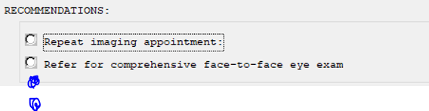

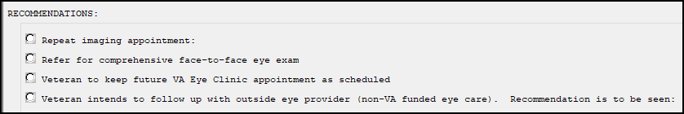

1. **Patient to keep future VA Eye Clinic appointment as scheduled** < add optional comment box; no calendar needed>

Screen shot showing a radio button for Veteran to keep further VA Eye Clinic appointment as scheduled with a comment box following

1. Add new health factor for keep future VA Eye Clinic appointment as scheduled
   1. Health Factor- **VA-TRR RECOMMEND VA EYE CLINIC APPT**
2. **Veteran intends to follow up with outside eye provider (non-VA funded eye care). Recommendation is to be seen:** <add these time options, same as in the ‘Refer for comprehensive exam’ selection>

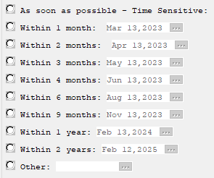

1. Veteran intends to follow up…
   1. Remove “within” on each selection

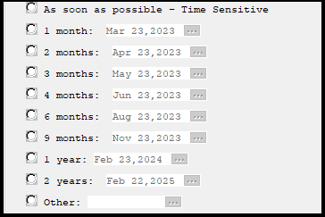

1. Veteran intends to follow up…
   1. Remove “Other” selection

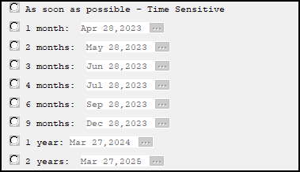

1. Veteran intends to follow up…
   1. Create HF for ASAP
      1. Health Factor= **VA-TRR REFER OUTSIDE PROV ASAP**
2. Veteran intends to follow up…
   1. Create HF for 1 Month
      1. Health Factor= **VA-TRR REFER OUTSIDE PROV 1 MONTH**
3. Veteran intends to follow up…
   1. Create HF for 2 Months
      1. Health Factor= **VA-TRR REFER OUTSIDE PROV 2 MONTHS**
4. Veteran intends to follow up…
   1. Create HF for 3 Months
      1. Health Factor= **VA-TRR REFER OUTSIDE PROV 3 MONTHS**
5. Veteran intends to follow up…
   1. Create HF for 4 Months
      1. Health Factor= **VA-TRR REFER OUTSIDE PROV 4 MONTHS**
6. Veteran intends to follow up…
   1. Create HF for 6 Months
      1. Health Factor= **VA-TRR REFER OUTSIDE PROV 6 MONTHS**
7. Veteran intends to follow up…
   1. Create HF for 9 Months
      1. Health Factor= **VA-TRR REFER OUTSIDE PROV 9 MONTHS**
8. Veteran intends to follow up…
   1. Create HF for 1 Year
      1. Health Factor= **VA-TRR REFER OUTSIDE PROV 1 YR**
9. Veteran intends to follow up…
   1. Create HF for 2 Years
      1. Health Factor= **VA-TRR REFER OUTSIDE PROV 2 YRS**
10. Within the ‘**Refer for comprehensive >> Refer to...** ‘section, edit verbiage to ‘VA Ophthalmology’; ‘VA Optometry’; ‘EITHER VA...’

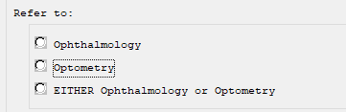

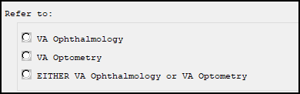

**Referral/Appointments:**

1. Comprehensive FTF
   1. VA Ophthalmology
      1. Remove “within” from selections



1. Comprehensive FTF
   1. VA Ophthalmology
      1. Remove “Other” option



1. Comprehensive FTF
   1. VA Optometry
      1. Remove “within” from selections



1. Comprehensive FTF
   1. VA Optometry
      1. Remove “Other”



1. Comprehensive FTF
   1. Either VA Ophthalmology or VA Optometry
      1. Remove “within” from selections



1. Comprehensive FTF
   1. Either VA Ophthalmology or VA Optometry
      1. Remove “Other”



1. Veteran intends to f/u w/ outside eye provider…
   1. Remove “within” from selections



1. Veteran intends to f/u w/ outside eye provider…
   1. Remove “Other” from selection



Add optional-select elements to the **Referral/appointment reason** components:

1. Diabetic findings <optional free text box> <add below as optional quick selects>:
   1. Non-proliferative diabetic retinopathy <optional comment box>
   2. Proliferative diabetic retinopathy suspected <optional comment box>
   3. Non-center involved diabetic macular edema suspected <optional comment box>
   4. Center-involved diabetic macular edema suspected <optional comment box>

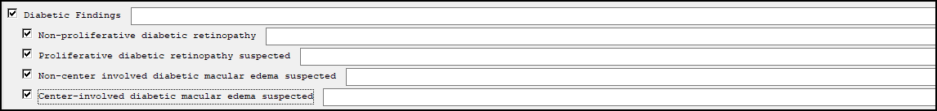

1. Macular findings <optional free text box> <add below as optional quick selects>:
   1. Dry macular degeneration suspected <optional comment box>
   2. Wet macular degeneration suspected <optional comment box>
   3. Epiretinal membrane suspected <comment box> <optional comment box>

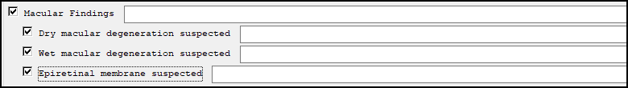

1. Optic Nerve findings <optional free text box> <add below as optional quick selects>:
   1. Glaucoma risk assessment recommended - based on appearance of optic disc <optional comment box>
   2. Known history of glaucoma –clinical monitoring is recommended <optional comment box>



1. **Retinal arteriolar embolus/plaque** <optional free text box> <add below as optional quick selects> (**this item is new, place after the ‘Visually Significant cataract suspected’ selection)
   1. Recommend PCP order carotid ultrasound, CBC with lipid panel, echocardiogram and/or other testing as necessary to investigate source.
   2. PCP added as additional signer
   3. Veteran should be contacted and educated to seek care urgently if experiences signs/symptoms of stroke: Paralysis or numbness or inability to move parts of the face, arm, or leg;

confusion- including trouble with speaking; headache with vomiting; trouble seeing in one or both eyes; metallic taste in mouth; difficulty in swallowing; trouble in walking or impaired coordination.

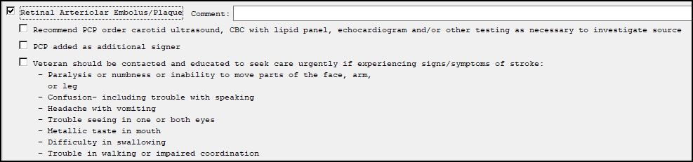

1. In highlighted area, create new optional selects in order below, moving the ‘Veteran is not a candidate....’ out from the Referral section to be within this grouping ( keep same HF) Place in Recommendation group.

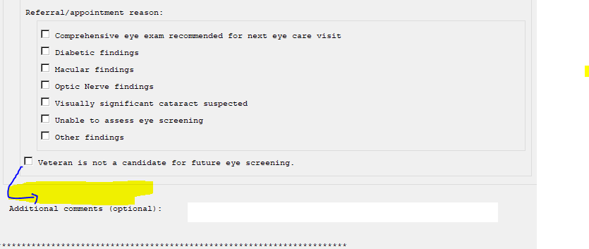

Here is the grouping order of the optional selects:

* Tele-Eye Screening is recommended to supplement outside eye care. <include the same dropdown return options as in the ‘Repeat imaging appointment’ section>

Screen shot showing the following radio buttons:
Return to imaging followed by a date box
Return 1 year
Return 2 years per EPRP (External Peer Review Program) 
Other:

* Recommend outside eye records be sent to VA for upload and reminder processing. If a VA eye clinic appointment is desired in future, Veteran can request through Direct Scheduling or Primary Care as appropriate.
* Veteran is not a candidate for future eye screening. < add optional comment box, keep same HF as before>
* Record indicates Veteran is a current smoker. Smoking cessation is recommended to reduce risk to ocular and overall health. VA provides smoking cessation services. Veteran can discuss with primary care team for more information.
* Recommend referral to VA Nutrition and Food Services (NFS) for education on positive nutritional habits and therapy to encourage disease prevention and management < add optional comment box>

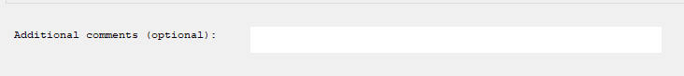

Screen shot showing RECOMENDATIONS: containing a section highlighted in green with check box Tele-Eye Screening Recommended followed by sub-check boxes
Return to imaging followed by a date box
Return 1 year
Return 2 years per EPRP (External Peer Review Program) 
Other:
Then check boxes again for Recommend outside eye records be sent to VA for upload and reminder processing.  If a VA eye clinic appointment is desired in the future, Veteran can request through Direct Scheduling or Primary Care as appropriate 
Veteran is not a candidate for further eye screening with a free text box after it.
Record indicative Veteran is a current tobacco user.  Tobacco cessation is recommended to reduce risk so ocular and overall health. VA provides tobacco cessation services.  Veteran can discuss with primary care team for more information.
Recommend referral to VA Nutrition and Food Services (NFS) for education on positive nutrition habits and therapy to encourage disease prevention and management followed by a free text field.

1. Add this new statement which requires a selection, where specified below:

Reader verifies that a review of past eye clinic records has been completed (if available) and a review for future eye appointments has been completed to help reduce duplication of care.

0 Yes

0 No

Screen shot reading
***************************
Digital retinal imaging has been shown to be an effective method of screening for conditions such as diabetic retinopathy, but it cannot substitute for
S comprehensive face-to-face eye exam.
***********************
Followed by a highlighted area where a new statement will be placed.  After that area, cumulative time of review and management section follows

Screen shot reading
***************************
Digital retinal imaging has been shown to be an effective method of screening for conditions such as diabetic retinopathy, but it cannot substitute for
S comprehensive face-to-face eye exam.
***********************
Followed by Reader verifies that a review of past eye clinic records has been completed (if available) and a review for future eye appointments has been completed to hep reduce duplication of care followed by Yes and No option choices.

1. Add this appendix of abbreviations be copied over from the TECS template? If so, put at very bottom of template.

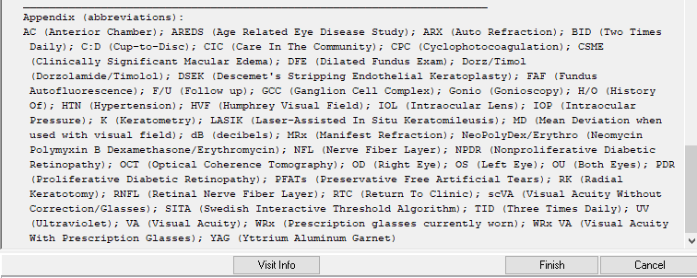



1. Changed dialog text for repeat imaging appointment>Return 2 years per EPRP **to** Return 2 years
2. Changed dialog text for Veteran intends to follow up with outside eye provider (non-VA funded eye care).  Recommendation: **to** Veteran intends to follow up with outside eye provider (non-VA funded eye care).  Recommended timeline for care: