

**Update_2_0_108**

Clinical Reminders

VA-DIALYSIS NUTRITION ASSESSMENT

Install Guide

**March 2021**

Product Development

Office of Information Technology

Department of Veterans Affairs

Table of Contents

Introduction 1

Install Details 2

Install Example 3

Post Installation 6

# Introduction

The VA-Dialysis Nutrition Assessment template will be used by renal dietitians to assess the nutrition status of dialysis patients.  This version is formatted for the annual assessment and may be modified for use with monthly or quarterly assessments according to facility policy and practice. This template is not mandated for use; however, all facilities should still install this template. POC for questions is REDACTED.

**UPDATE_2_0_108 contains 1 Reminder Exchange entry:**

UPDATE_2_0_108 VA-DIALYSIS NUTRITION ASSESSMENT

**The exchange file contains the following components:**

**TIU TEMPLATE FIELD**

EDIT 25+

NUM

TEXT NO LIMIT

**HEALTH FACTORS**

VA-REMINDER UPDATES

VA-UPDATE_2_0_108

VA-DIALYSIS NUTRITION

VA-DIALYSIS NUTRITION OTHER

VA-DIALYSIS MALNUTRITION UNDERNUTR

VA-DIALYSIS NUTRITION INCREASED NEEDS

VA-DIALYSIS NUTRITION KNOWLEDGE DEFICIT

VA-DIALYSIS NUTRITION ALTERED LABS

**REMINDER SPONSOR**

OFFICE OF NUTRITION AND FOOD SERVICES

**REMINDER TERM**

VA-REMINDER UPDATE_2_0_108

**REMINDER DIALOG**

VA-DIALYSIS NUTRITION ASSESSMENT

**HEALTH SUMMARY COMPONENT**

LAB TESTS SELECTED

LAB CUMULATIVE SELECTED 1

**HEALTH SUMMARY TYPE**

VA-DIAL NUTR BONE MINERAL LABS

VA-DIAL NUTR ADEQUACY LABS

VA-DIAL NUTR DIABETES LABS

VA-DIAL NUTR ANEMIA LABS

VA-DIAL NUTR VITAMIN LABS

VA-DIAL NUTR LIPID PROF LABS

VA-DIAL NUTR ELECTROLYTE LABS

VA-DIAL NUTR PROTEIN LABS

**HEALTH SUMMARY OBJECTS**

VA-DIAL NUTR BONE MINERAL LABS (TIU)

VA-DIAL NUTR ADEQUACY LABS (TIU)

VA-DIAL NUTR DIABETES LABS (TIU)

VA-DIAL NUTR ANEMIA LABS (TIU)

VA-DIAL NUTR VITAMIN LABS (TIU)

VA-DIAL NUTR LIPID PROFILE LABS (TIU)

VA-DIAL NUTR ELECTROLYTE LABS (TIU)

VA-DIAL NUTR PROTEIN LABS (TIU)

**TIU DOCUMENT DEFINITION**

VA-DIAL NUTR BONE MINERAL LABS

VA-DIAL NUTR ADEQUACY LABS

VA-DIAL NUTR DIABETES LABS

VA-DIAL NUTR ANEMIA LABS

VA-DIAL NUTR VITAMIN LABS

VA-DIAL NUTR LIPID PROFILE LABS

VA-DIAL NUTR ELECTROLYTE LABS

VA-DIAL NUTR PROTEIN LABS

# Install Details

This update is being distributed as a web host file. The address for the host file is: **https://Redacted /UPDATE_2_0_108.PRD**

The file will be installed using Reminder Exchange, programmer access is not required.

Installation:

=============

This update can be loaded with users on the system. Installation will take less than 15 minutes.

# Install Example

To Load the Web Host File. Navigate to Reminder exchange in Vista

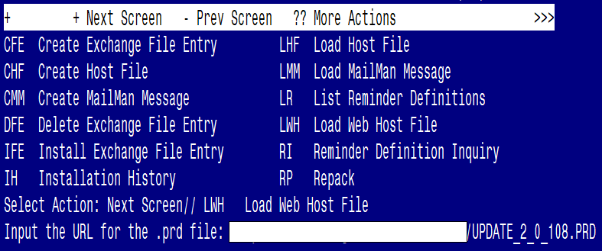

At the **Select Action:** prompt, enter **LWH** for Load Web Host File

At the **Input the url for the .prd file:** prompt, type the following web address:

**https://Redacted /UPDATE_2_0_108.PRD**

Screen shot of the message displaying the URL of the file that was successfully loaded.

You should see a message at the top of your screen that the file successfully loaded.

At the **Select Action** prompt, enter **IFE** for Install Exchange File Entry

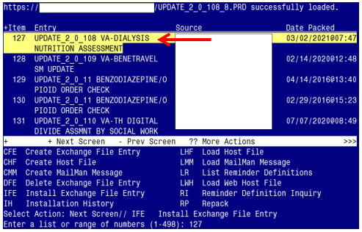

Enter the number that corresponds with your entry titled **UPDATE_2_0_108 VA-DIALYSIS NUTRITION ASSESSMENT** *(in this example it is entry 127, it will vary by site). Date Packed is 03/02/2021@07:47*

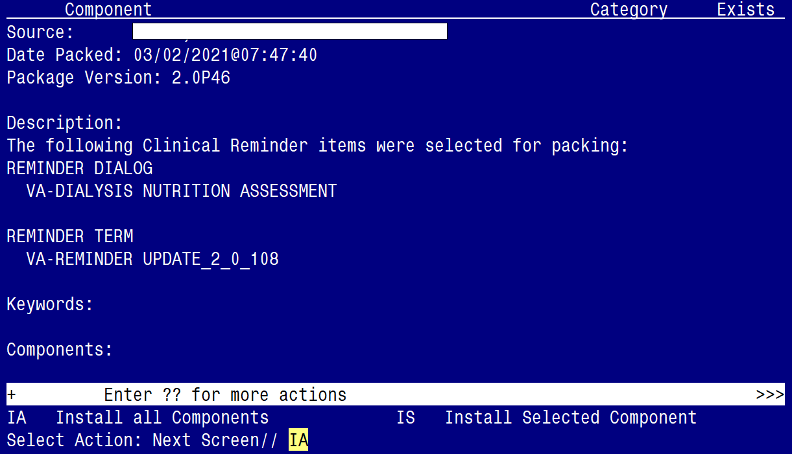

At the **Select Action** prompt, type **IA** for Install all Components and hit enter.

Select Action: Next Screen// IA Install all Components

During the installation, you will see several prompts:

You will Install (I) all new components and Overwrite (O) any existing components

**Next, you will be prompted to install the dialog component:**

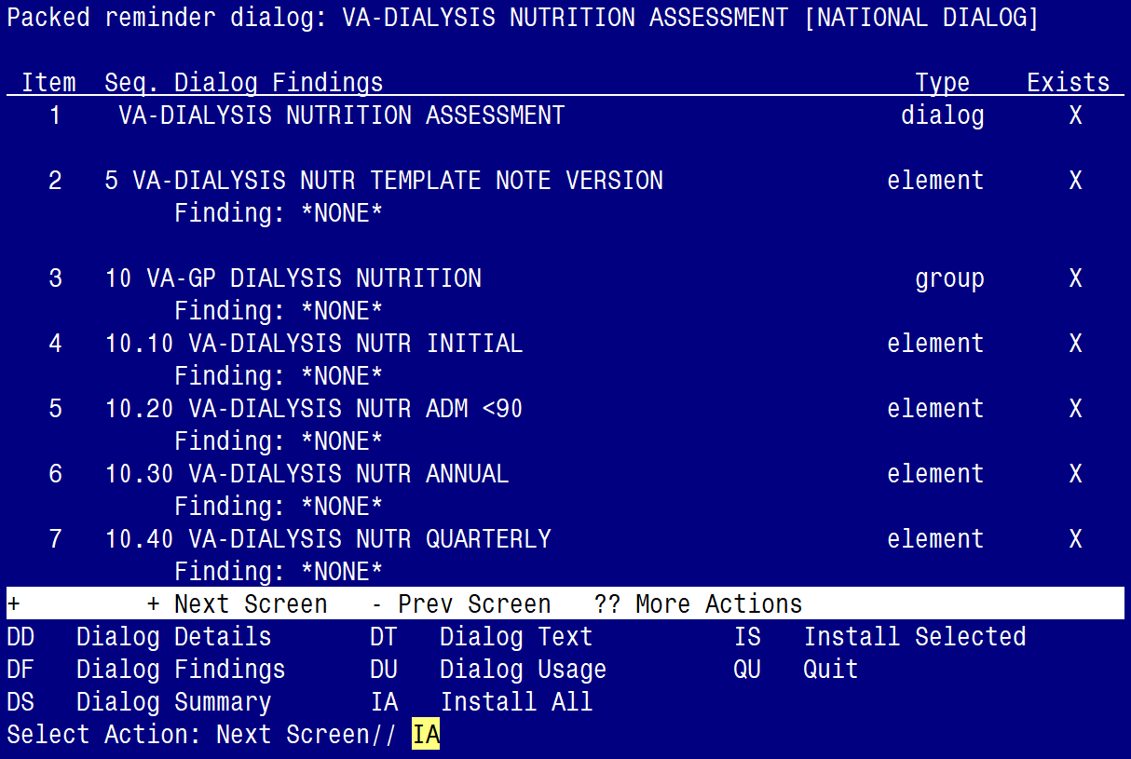

At the **Select Action** prompt, type **IA** to install the dialog:

**VA-DIALYSIS NUTRITION ASSESSMENT**

Install reminder dialog and all components with no further changes: Y//YES

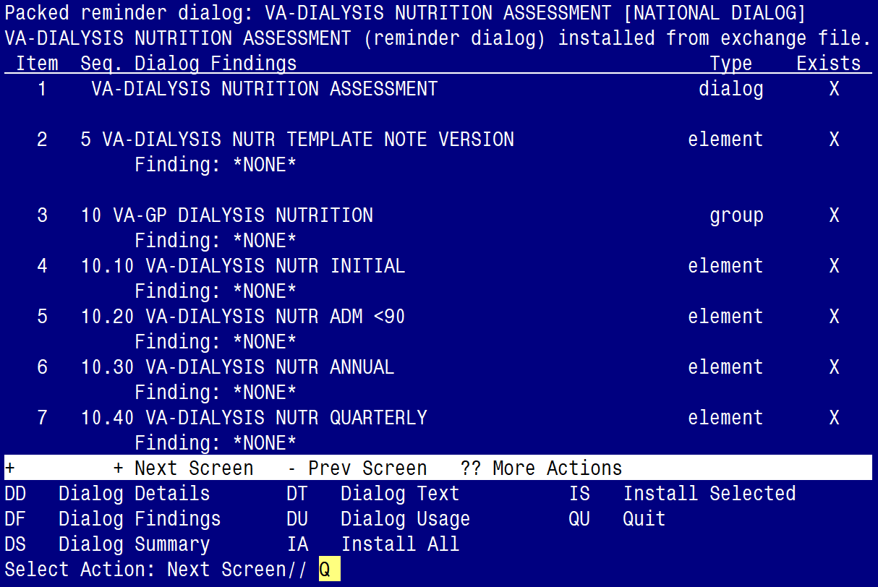

When the dialog has completed installation, you will then be returned to this screen. At the **Select Action** prompt, type **Q.**

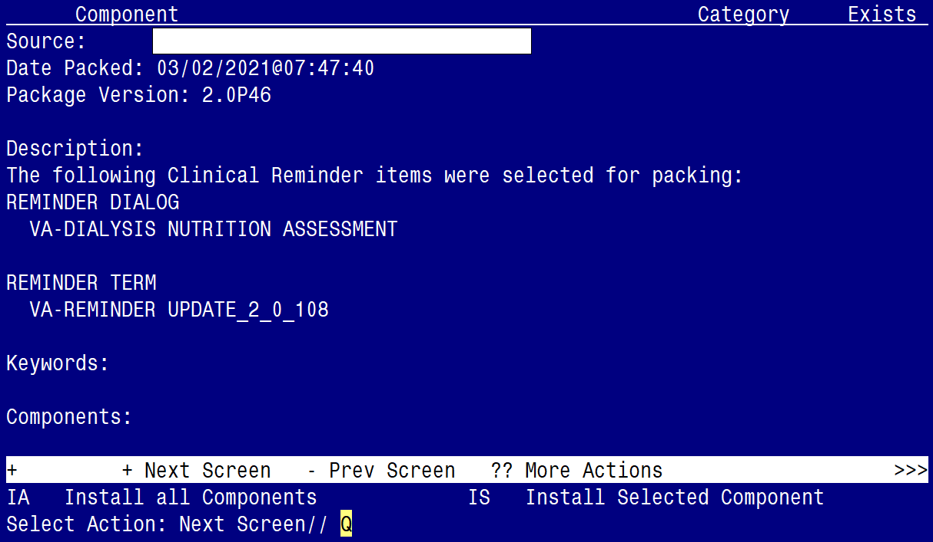

You will be returned to this screen. Type Q to quit.

Install Completed

# Post Installation

FOR POST-INSTALLATION ITEMS 1-8 below you will ONLY need to add lab tests to the identified Health Summary Types.

Step-by-step instructions for adding lab tests to each Health Summary Type are included, directly below post-installation item #1. Follow those instructions to add the specific labs tests to each Health Summary Type.

Health Summary Types to be edited:

* VA-DIAL NUTR BONE MINERAL LABS
* VA-DIAL NUTR PROTEIN LABS
* VA-DIAL NUTR ELECTROLYTE LABS
* VA-DIAL NUTR LIPID PROF LABS
* VA-DIAL NUTR VITAMIN LABS
* VA-DIAL NUTR ANEMIA LABS
* VA-DIAL NUTR DIABETES LABS
* VA-DIAL NUTR ADEQUACY LABS

1. **Update the** **|VA-DIAL NUTR BONE MINERAL LABS|** health summary type with the following local lab tests**:**

*CALCIUM*

*CALCIUM, PLASMA*

*MAGNESIUM*

*MAGNESIUM, PLASMA*

*PHOSPHORUS INORGANIC*

*PHOSPHORUS, PLASMA*

*PTH INTACT*

*INTACT PTH-CO*

*ALKALINE PHOSPHATASE*

*ALKALINE PHOSPHATASE, PLASMA*

* Contact your Lab ADPAC or LIM to confirm the specific lab test name(s).
* Add only the lab tests that are available in your system.
* This HS type time limit is set to 1 Month. This can be edited if your site chooses.
* Add them as selection items to component SLT under the Health Summary Type VA-DIAL NUTR BONE MINERAL LABS. Steps to add them are below:

*Step 1 - In VistA, go to the HEALTH SUMMARY MAINTENANCE Menu and select Option 6 – Create/Modify Health Summary Type: (see screenshot below)*

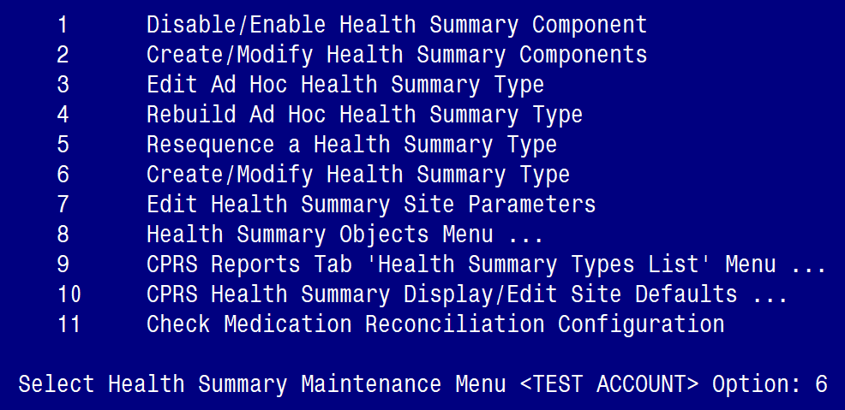

*Step 2 – Enter* **VA-DIAL NUTR BONE MINERAL LABS** *HS type: (see screenshot below)*

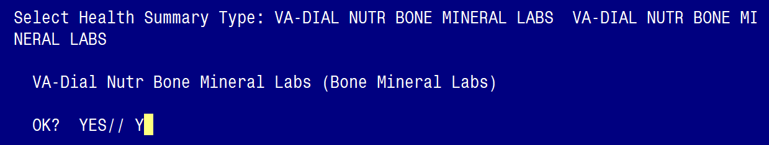

*Step 3 – Type Y for yes to continue: (see screenshot below)*

Screen shot saying: WARNING: you are about to edit a Health Summary Type that is being used by a Health Summary Object.  Changing the structure of this Health Summary Type will alter how the Object will display.  

Do you want to continue NO// YES is entered. 

*Step 4 – Press ENTER until you see “Select COMPONENT”, then type “SLT”: (see screenshot below)*

Screen shot of the terminal showing
NAME: VA-DIAL NUTR BONE MINDERAL LABS Replace
TITLE: Bone Mineral Labs//
SUPPRESS PRINT OF COMPONENTS WITHOUG DATA:  Default Yes is selceted
SUPPRESS SESITIVE PRINT DATA: Default No SSN is selected

Do you wish ot review the Summary Type structure before continuing? Default  NO selected
Select COMPONENT:  SLT is entered.

*Step 5 – Type “E” to Edit component parameters: (see screenshot below)*

Screen shot showing 
LAB TEST SELECTED is already a component of this summary.

Select one of the following 

E   Edit component parameters
D  Delete component from summary

Select Action is E for Edit component parameters.

*Step 6– Press ENTER until you see “Select SELECTION ITEM”: (see screenshot below)*

Screen shot showing

Summary Order:  5
OCCURENCE LIMIT:
TIME LIMIT: 2 Y
HEADER NAME:  Lab tests Selected

No selection item chosen,

Select items one at a time in the sequence you want them displayed. 

Select SELECTION ITEM: 
(the entries to put in are in the text of the document immediately following this screen shot.

*Step 7– Enter the following Lab Tests for the* **|VA-DIAL NUTR BONE MINERAL LABS| type***: (see list in italics below)*

*CALCIUM*

*CALCIUM, PLASMA*

*MAGNESIUM*

*MAGNESIUM, PLASMA*

*PHOSPHORUS INORGANIC*

*PHOSPHORUS, PLASMA*

*PTH INTACT*

*INTACT PTH-CO*

*ALKALINE PHOSPHATASE*

*ALKALINE PHOSPHATASE, PLASMA*

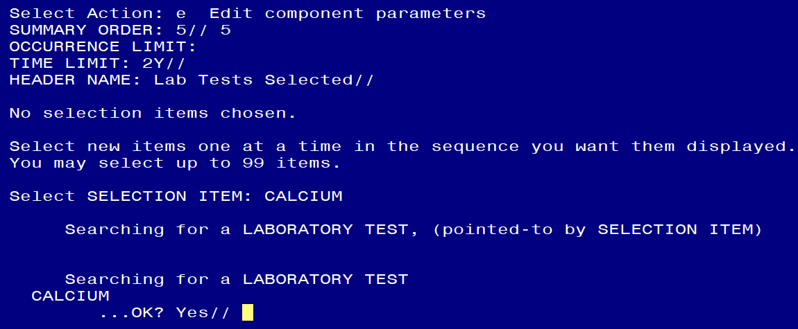

*Step 8– Select “N” to the ‘resequencing’ and ‘review’ question: (see screenshot below)*

Terminal Screen shot saying:

Do you ant to resequence the selection items? and the response is N for NO

Terminal Screen shot showing:

Do you wish to review the Summary Type structure before continuing?  The selection is the default NO

*Step 9– Finished.*

1. **Update the |VA-DIAL NUTR PROTEIN LABS|** health summary type with local lab tests:

*ALBUMIN (BCG)*

*PREALBUMIN, SERUM*

*TOTAL PROTEIN*

*C REACTIVE PROTEIN CRP*

*NET PROTEIN CATABOLIC RATE (NPCR)*

* Contact your Lab ADPAC or LIM to confirm the specific lab test name(s).
* Add only the lab tests that are available in your system.
* This HS type time limit is set to 1 Month. This can be edited if your site chooses.
* Add them as selection items to component SLT under the Health Summary Type VA-DIAL NUTR PROTEIN LABS
* Follow the blue screenshot steps as previously outlined.

1. **Update the |VA-DIAL NUTR ELECROLYTE LABS|** health summary type with local lab tests:

*SODIUM*

*SODIUM, PLASMA*

*POTASSIUM*

*POTASSIUM, PLASMA*

*CO2*

*CO2, PLASMA*

* Contact your Lab ADPAC or LIM to confirm the specific lab test name(s).
* Add only the lab tests that are available in your system.
* This HS type time limit is set to 1 Month. This can be edited if your site chooses.
* Add them as selection items to component SLT under the Health Summary Type VA-DIAL NUTR ELECTROLYTE LABS
* Follow the blue screenshot steps as previously outlined.

1. **Update the |VA-DIAL NUTR LIPID PROF LABS|** health summary type with local lab tests:

*CHOLESTEROL*

*CHOLESTEROL, PLASMA*

*TRIGS*

*TRIGLYCERIDE*

*HDL-CHOLESTEROL*

*HDL, PLASMA*

*LDL (CALC)*

*LDL-CALC, PLASMA*

* Contact your Lab ADPAC or LIM to confirm the specific lab test name(s).
* Add only the lab tests that are available in your system.
* This HS type time limit is set to 1 Month. This can be edited if your site chooses.
* Add them as selection items to component SLT under the Health Summary Type VA-DIAL NUTR LIPID PROF LABS
* Follow the blue screenshot steps as previously outlined.

1. **Update the |VA-DIAL NUTR VITAMIN LABS|** health summary type with local lab tests:

*VITAMIN B12*

*VITAMIN D, 25*

*FOLATE*

*ALUMINUM*

* Contact your Lab ADPAC or LIM to confirm the specific lab test name(s).
* Add only the lab tests that are available in your system.
* This HS type occurrence count is set to one (1). This can be edited if your site chooses.
* Add them as selection items to component SLT under the Health Summary Type VA-DIAL NUTR VITAMIN LABS
* Follow the blue screenshot steps as previously outlined.

1. **Update the |VA-DIAL NUTR ANEMIA LABS|** health summary type with local lab tests:

*FERRITIN*

*TOTAL IRON BINDING CAPACITY*

*TIBC*

*TRANSFERRIN*

*TRANSFERRIN, SERUM*

*WBC*

*WBC, BLOOD*

*RBC*

*HGB*

*HGB, BLOOD*

*HCT*

*HCT, BLOOD*

*MCV*

*RETIC PANEL*

*RETIC COUNT*

* Contact your Lab ADPAC or LIM to confirm the specific lab test name(s).
* Add only the lab tests that are available in your system.
* This HS type time limit is set to 3 Months. This can be edited if your site chooses.
* Add them as selection items to component SLT under the Health Summary Type VA-DIAL NUTR ANEMIA LABS.
* Follow the blue screenshot steps as previously outlined.

1. **Update the |VA-DIAL NUTR DIABETES LABS|** health summary type with local lab tests:

*GLUCOSE*

*GLUCOSE (LAST 1/1M)*

*HGBA1C*

*HCB A1C*

* Contact your Lab ADPAC or LIM to confirm the specific lab test name(s).
* Add only the lab tests that are available in your system.
* Add GLUCOSE to the **SLT** component.
* Add HGBA1C and HCB A1C to the **SCL1** component.
* This HS type time limits are set to 1 Month (SLT component) and 1 Occurrence (SCL1 component). This can be edited if your site chooses.
* Add them as selection items to component SLT and SCL1 under the Health Summary Type VA-DIAL NUTR DIABETES LABS.
* Follow the blue screenshot steps as previously outlined.

1. **Update the |VA-DIAL NUTR ADEQUACY LABS|** health summary type with local lab tests:

*PRE-BLOOD UREA NITROGEN (BUN)*

*PRE-BUN (UREA NITROGEN)*

*POST BUN*

*UREA REDUCTION RATIO (URR)*

*SINGLE POOL KINETIC MODELING (spKt/V)*

*N(PCR)*

* Contact your Lab ADPAC or LIM to confirm the specific lab test name(s).
* Add only the lab tests that are available in your system.
* This HS type time limit is set to 3 Months. This can be edited if your site chooses.
* Add them as selection items to component SLT under the Health Summary Type VA-DIAL NUTR ADEQUACY LABS.
* Follow the same screenshot steps as previously outlined.

1. **Make the Dialog template available to be attached to a Personal or Shared template or to be able to attach the dialog to a progress note title.**

From the Reminders Manager Menu:

Select Reminder Managers Menu Option: **CP** CPRS Reminder Configuration

CA Add/Edit Reminder Categories

CL CPRS Lookup Categories

CS CPRS Cover Sheet Reminder List

MH Mental Health Dialogs Active

PN Progress Note Headers

RA Reminder GUI Resolution Active

TIU TIU Template Reminder Dialog Parameter

DL Default Outside Location

PT Position Reminder Text at Cursor

Select CPRS Reminder Configuration Option: **TIU** TIU Template Reminder Dialog

Parameter

Reminder Dialogs allowed as Templates may be set for the following:

1 User USR [choose from NEW PERSON]

3 Service SRV [choose from SERVICE/SECTION]

4 Division DIV [choose from INSTITUTION]

5 System SYS [NATREM.FO-SLC.MED.VA.GOV]

Enter selection*:* **5**  *Choose the appropriate number for your site. Your site may do*

*this by System or other levels. The example below uses SYSTEM level*

Setting Reminder Dialogs allowed as Templates for System:

Select Display Sequence: **?**

148 VA-VETERANS CHOICE NOTE

149 VA-TBI SCREENING

151 VACO TRANSPLANT REFERRAL (D)

*When you type a question mark above, you will see the list of #’s (with dialogs) that*

*are already taken. Choose a number* ***NOT*** *on this list. For this example, looking*

*above I see the number 150 is not present, so I will use 150.*

Select Display Sequence: **150**

Are you adding 150 as a new Display Sequence? Yes// **Y** YES

Display Sequence: 150// <Enter>

Clinical Reminder Dialog**: VA-DIALYSIS NUTRITION ASSESSMENT** Enter>

OK? Yes// <Enter> (Yes)

1. **Setup of Note title**

The new note title that needs to be created is:

**DIALYSIS NUTRITION ASSESSMENT**

This note title is to be mapped to the following VHA Enterprise Standard Title:**NUTRITION NOTE**

Comprehensive information on Creating Document Definitions can be found beginning on page 47 of the [TIU/ASU Implementation Guide](http://www.va.gov/vdl/documents/Clinical/CPRS-Text_Integration_Utility_(TIU)/tiuim.pdf)

1. **Associate the reminder dialog with the note title in CPRS**

To do this, go to Template Editor, then Document Titles, select the appropriate folder (if applicable), and choose New Template (top right-hand corner).

Type in the following information:

Name: **DIALYSIS NUTRITION ASSESSMENT**

Template Type: Reminder Dialog

Reminder Dialog: **VA-DIALYSIS NUTRITION ASSESSMENT**

D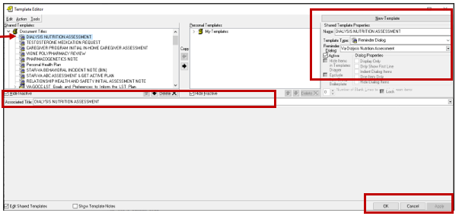

Next, type in the Associated Title, which in this case is **DIALYSIS NUTRITION ASSESSMENT** and hit Apply.

1. **Associate the new reminder dialog with a shared template in CPRS**

To do this, go to Template Editor, then Shared Templates, select the appropriate folder (if applicable), and choose New Template (top right-hand corner).

Type in the following information:

Name: **DIALYSIS NUTRITION ASSESSMENT**

Template Type: Reminder Dialog

Reminder Dialog: **VA-DIALYSIS NUTRITION ASSESSMENT**

Next, select Apply.

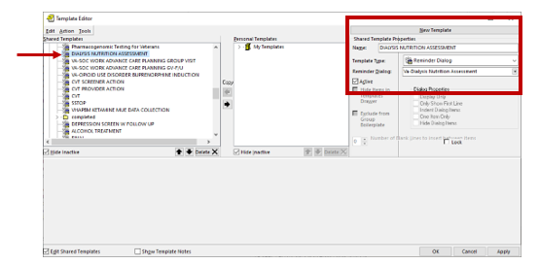

1. Within the Dialog Element **VAL-DIALYSIS NUTR AGE/SEX:**
   * insert your site’s object for PATIENT AGE and PATIENT SEX.
2. Within the Dialog Element **VAL-DIALYSIS NUTR WEIGHT:**
   * insert your site’s object for PATIENT WEIGHT.
3. Within the Dialog Element **VAL-DIALYSIS NUTR HEIGHT:**
   * insert your site’s object for PATIENT HEIGHT.
4. Within the Dialog Element **VAL-DIALYSIS NUTR BMI:**
   * insert your site’s object for BMI.
5. Within the Dialog Element **VAL-DIALYSIS NUTR ACTIVE OUTPT MEDS:**
   * insert your site’s object for ACTIVE OUTPATIENT MEDICATIONS.
   * Or if your Nutrition staff want combined ACTIVE medications, add that object.
6. Within the Dialog Element **VAL-DIALYSIS NUTR BMI WT LATEST RESULTS:**
   * insert your site’s object for BMI.
7. Within the Dialog Element **VAL-DIALYSIS NUTR ALB/TIBC LATEST RESULTS:**
   * insert your site’s object for ALBUMIN and TIBC lab tests.
8. Within the Dialog Element **VAL-DIALYSIS NUTR ALLERGIES**:
   * insert your site’s object for ALLERGIES.
9. Within the Dialog Element **VA-DIALYSIS NUTR ORDER**:
   * Check with your Dietetics staff to see if they want to use this option to place an order or to launch an order menu
   * Then, insert your site’s order or order menu to the Finding Item of this element.

**VA-DIALYSIS NUTR ORDER**

**Finding Item: Q.<<name of the order or order menu >>**

1. OPTIONAL: The following ELEMENTS have been set to ‘Exclude from Progress Note’. Should your Dietetics staff request to include the data from these elements within the progress note, you can remove the “YES” from the “Exclude from Progress Note” field:

VAL-DIALYSIS NUTR BONE MINERAL LABS

VAL-DIALYSIS NUTR PROTEIN LABS

VAL-DIALYSIS NUTR ELECTROLYTE LABS

VAL-DIALYSIS NUTR LIPID PROFILE LABS

VAL-DIALYSIS NUTR VITAMINS LABS

VAL-DIALYSIS NUTR ANEMIA STATUS LABS

VAL-DIALYSIS NUTR DIABETES LABS

VAL-DIALYSIS NUTR ADEQUACY LABS

VAL-DIALYSIS NUTR ALLERGIES

VAL-DIALYSIS NUTR ALB/TIBC LATEST RESULTS

VAL-DIALYSIS NUTR BMI WT LATEST RESULTS

VAL-DIALYSIS NUTR ACTIVE OUTPT MEDS

*ALTERNATE PROGRESS NOTE TEXT:*

*Edit? NO//*

*EXCLUDE FROM PROGRESS NOTE: YES// < -- Type @ sign to delete*

1. OPTIONAL: Add local reminder dialog groups and elements if needed.

If you Dietetics staff would like to insert local groups and elements from other dialogs (e.g. Patient Nutrition Education) into this template, you can insert them in the local reminder dialog group **VAL-GP DIALYSIS NUTR PLACEHOLDER**.