

Update _2_0_144

Clinical Reminders

VA-TECS PROGRAM TEMPLATES
Install Guide

August 2020

Product Development
Office of Information Technology
Department of Veterans Affairs

Table of Contents
Introduction 1
Install Details 10
Install Example 11
Post Installation 18
Appendix 23

Introduction
The Technology-based Eye Care Services (TECS) Program is a national telemedicine store and forward telehealth program. It is one of the programs funded by VA Office of Rural Health (ORH) Enterprise Wide Initiatives, but facilities can also implement and fund this program separate from ORH. TECS provides select eye clinic infrastructure and is a tool that can be used by eye clinics to provide access to care for their Veterans, especially post pandemic. TECS currently has 20 sites across the country and its growing. The TECS CPRS templates are linked healthcare factors (like diabetic tele retinal screening templates) that would be stored and distributed at the national level. This update includes five (5) dialog templates titled TECS Glaucoma Physician, TECS Glaucoma Technician, TECS Letters, TECS Physician and TECS Technician.

Per the Program Office, TECS is a national standard and all VA facilities will be using these templates. For clinical questions, contact REDACTED

UPDATE_2_0_144 contains 1 Reminder Exchange entry:
UPDATE_2_0_144 VA-TECS PROGRAM TEMPLATES

The exchange file contains the following components:

TIU TEMPLATE FIELD
VA-TECS OD/OS/OU
Y/N
VA-TECS CLINIC
TEXT (1-60 CHAR)
VA-TECS IOP MEASURE TOOL
DATE & TIME
TEXT (1-20 CHAR) REQ
WORD 2 LINES RQ
VA TECS TXT 2
VA-TECS AREDS VIT
VA-TECS BP/SG/CHL
VA TECS TXT NR
YES OR NO
WEEKS/MONTHS
VA-TECS FLOATERS/FLASHES
ALL-WP

HEALTH FACTORS
VA-REMINDER UPDATES
VA-UPDATE_2_0_144
VA-TECS PROVIDER
VA-TECS EYE ADQ PHOTO NO
VA-TECS EYE OTHER EXT PHOTO PATH
VA-TECS EYE TEAR LAKE/FILM IRREG
VA-TECS EYE LID LESION
VA-TECS EYE IRIS LESION
VA-TECS EYE PTERYGIUM
VA-TECS EYE CORNEA
VA-TECS EYE LENTIC
VA-TECS EYE IOL
VA-TECS EYE NL EXT PHOTO
VA-TECS EYE NO EXT PHOTO
VA-TECS EYE YES EXT PHOTO
VA-TECS GLAUC PROVIDER
VA-TECS NERV PROG NO PRIOR PHOTO
VA-TECS NERV PROG N
VA-TECS NERV PROG Y
VA-TECS DISC HEME N
VA-TECS DISC HEME Y
VA-TECS EYE OTHER VESSELS PATH
VA-TECS EYE HTN VESSELS
VA-TECS EYE NL VESSELS
VA-TECS EYE OTHER RET PATH
VA-TECS EYE CHORIORETINAL SCAR RET
VA-TECS EYE HOLLEN RET
VA-TECS EYE LESION RET
VA-TECS EYE VASC OC RET
VA-TECS EYE PR RET
VA-TECS EYE NPR RET
VA-TECS EYE NL RET
VA-TECS EYE MAC CHORIO SCAR YES
VA-TECS EYE OTHER MAC PATH
VA-TECS EYE EDEMA MAC
VA-TECS RTC/RECALL/VCP LIST NAME
VA-TECS EYE RET HEM MAC
VA-TECS EYE PIGM MAC
VA-TECS EYE ERM MAC
VA-TECS EYE CHOROIDAL PIG MAC
VA-TECS EYE DRUS MAC
VA-TECS EYE NL MAC
VA-TECS EYE CD OS
VA-TECS EYE CD OD
VA-TECS EYE DRUS NERVE
VA-TECS EYE ASYMMTERY CD
VA-TECS EYE OTHER NERVE PATH
VA-TECS EYE NEOVASC NERVE
VA-TECS EYE EDEMA NERVE
VA-TECS EYE ANOM NERVE
VA-TECS EYE HEMOR DISC
VA-TECS EYE PALE NERVE
VA-TECS EYE INCREASE CD
VA-TECS GLAUC PROG OTHER
VA-TECS GLAUC PROG RNFL
VA-TECS GLAUC PROG CD
VA-TECS GLAUC PROG HVF
VA-TECS GLAUC PROG IOP
VA-TECS DX MOD GLAUC
VA-TECS DX MILD GLAUC
VA-TECS DX HTN NO TX
VA-TECS DX GLAUC SUSP
VA-TECS PT STABLE N
VA-TECS PT STABLE Y
VA-TECS RISK TRAUMA
VA-TECS RISK IOP
VA-TECS RISK CCT
VA-TECS RISK FAMHX
VA-TECS RISK AGE
VA-TECS RISK RACE
VA-TECS EYE OCT NFL OTHER
VA-TECS EYE OCT NFL SEG1
VA-TECS EYE OCT NFL SEG5
VA-TECS EYE OCT NFL Q5N
VA-TECS EYE OCT NFL Q5T
VA-TECS EYE OCT NFL Q5I
VA-TECS EYE OCT NFL Q5S
VA-TECS EYE OCT NFL Q1N
VA-TECS EYE OCT NFL Q1T
VA-TECS EYE OCT NFL Q1I
VA-TECS EYE OCT NFL Q1S
VA-TECS EYE OCT NORM INTERP
VA-TECS AVE RNFL THICK
VA-TECS SIG RNFL PROG N
VA-TECS SIG RNFL PROG Y
VA-TECS SIG PROG CD N
VA-TECS SIG PROG CD Y
VA-TECS PREV OCT N
VA-TECS PREV OCT Y
VA-TECS GCC MAC N
VA-TECS GCC MAC Y
VA-TECS ANOM NERVE OCT N
VA-TECS ANOM NERVE OCT Y
VA-TECS AVE RNFL DIFF N
VA-TECS AVE RNFL DIFF Y
VA-TECS SIG STRENGTH INADQ
VA-TECS SIG STRENGTH ADQ
VA-TECS GLAUC TECH
VA-TECS EYE HVF NOT DONE
VA-TECS BASE PROG
VA-TECS BASE POS PROG
VA-TECS BASE STABLE
VA-TECS INF OTHER
VA-TECS INF PCS
VA-TECS INF NONSP
VA-TECS INF ALT
VA-TECS INF ARC
VA-TECS INF STEP
VA-TECS SUP OTHER
VA-TECS SUP PCS
VA-TECS SUP NONSP
VA-TECS SUP ALT
VA-TECS SUP STEP
VA-TECS SUP ARC
VA-TECS PTOSIS
VA-TECS CLOVERLEAF
VA-TECS RIM ART
VA-TECS RX WRONG
VA-TECS FIX LOSS
VA-TECS FALSE NEG
VA-TECS FALSE POS
VA-TECS HVF RELIABLE N
VA-TECS HVF RELIABLE Y
VA-TECS EYE HVF OTHER
VA-TECS EYE HVF 10-2 FAST
VA-TECS EYE HVF 10-2 STD
VA-TECS EYE HVF 30-2 FAST
VA-TECS EYE HVF 30-2 STD
VA-TECS EYE HVF 24-2 FAST
VA-TECS EYE HVF 24-2 STD
VA-TECS EYE PERRL ABN
VA-TECS EYE PERRL NORMAL
VA-TECS EYE PUPILS/AC COMMENT
VA-TECS EYE ADQ DILATION NO
VA-TECS TECHNICIAN
VA-TECS DILATED PRECAUTIONS-YES
VA-TECS EYE ADQ DILATION YES
VA-TECS EYE AFFERENT DEFECT NONE
VA-TECS EYE AFFERENT DEFECT YES
VA-TECS EYE HANDLIGHT EXAM REMARKABLE
VA-TECS EYE HANDLIGHT EXAM UNREMARKABLE
VA-TECS IOP-OS
VA-TECS IOP-OD
VA-TECS IOP METHOD
VA-TECS REFRAC-K2 OS
VA-TECS REFRAC-K1 OS
VA-TECS REFRAC-K2 OD
VA-TECS REFRAC-K1 OD
VA-TECS REFRAC-FINAL MRX OS
VA-TECS REFRAC-FINAL MRX OD
VA-TECS REFRAC-GLARE OS
VA-TECS REFRAC-GLARE OD
VA-TECS REFRAC-RX COMMENTS
VA-TECS REFRAC-VA MRX OS
VA-TECS REFRAC-VA MRX OD
VA-TECS REFRAC-MRX OS
VA-TECS REFRAC-MRX OD
VA-TECS REFRAC-VA ARX OS
VA-TECS REFRAC-VA ARX OD
VA-TECS REFRAC-ARX OS
VA-TECS REFRAC-ARX OD
VA-TECS REFRAC-VA WRX OS
VA-TECS REFRAC-VA WRX OD
VA-TECS REFRAC-WRX OS
VA-TECS REFRAC-WRX OD
VA-TECS REFRAC-SCVA OS
VA-TECS REFRAC-SCVA OD
VA-TECS EYE DROPS-DORZOLAMIDE/TIMOLOL
VA-TECS EYE DROPS-PUNCT TEACH NO
VA-TECS EYE DROPS-PUNCT TEACH YES
VA-TECS EYE DROPS-WHEEZING
VA-TECS EYE DROPS-OTH CONCERN
VA-TECS EYE DROPS-ABN TASTE
VA-TECS EYE DROPS-LID REDNESS
VA-TECS EYE DROPS-REDNESS
VA-TECS EYE DROPS-ITCHINESS
VA-TECS EYE DROPS-IRRITATION
VA-TECS EYE DROPS-FLAKEY EYELID
VA-TECS EYE DROPS-FATIGUE
VA-TECS EYE DROPS-DRY MOUTH
VA-TECS EYE DROPS-BREATHING TROUBLE
VA-TECS EYE DROP REFILL-MISSED OCC
VA-TECS EYE DROP REFILL-MISSED FREQ
VA-TECS EYE DROPS-MISSED OCCASIONALLY
VA-TECS EYE DROPS-MISSED WEEKLY
VA-TECS EYE DROPS-MISS DAILY
VA-TECS EYE DROPS-AZOPT TID
VA-TECS EYE DROPS-AZOPT BID
VA-TECS EYE DROPS-TIMOLOL GEL
VA-TECS EYE DROPS-TIMOLOL TID
VA-TECS EYE DROPS-TIMOLOL BID
VA-TECS EYE DROPS-LUMIGAN
VA-TECS EYE DROPS-TRAVAPROST
VA-TECS EYE DROPS-LATANOPROST
VA-TECS EYE DROPS-VYZULTA
VA-TECS EYE DROPS-BRIMONIDINE TID
VA-TECS EYE DROPS-BRIMONIDINE BID
VA-TECS EYE DROPS-SIMBRINZA TID
VA-TECS EYE DROPS-SIMBRINZA BID
VA-TECS EYE DROPS-RHOPRESSA
VA-TECS EYE DROPS-COMBIGAN TID
VA-TECS EYE DROPS-COMBIGAN BID
VA-TECS EYE PT HANDOUT YES
VA-TECS EYE OCT MAC OTHER
VA-TECS EYE OCT MAC IRF
VA-TECS EYE OCT MAC SRF
VA-TECS EYE OCT MAC PED
VA-TECS EYE OCT MAC DRUSN
VA-TECS EYE OCT MAC VMT
VA-TECS EYE OCT MAC EDEMA
VA-TECS EYE OCT MAC ERM
VA-TECS EYE OTHER RSLT
VA-TECS EYE FU TECS
VA-TECS EYE FU 65
VA-TECS EYE FU LESS 65
VA-TECS EYE FU LESS 50
VA-TECS EYE FU LESS 40
VA-TECS EYE PREV STUDY YES
VA-TECS EYE CAT LENS-PSEUDO YES
VA-TECS EYE CAT SURG HIGH RISK YES
VA-TECS EYE CAT REF SURG-PT DENY
VA-TECS EYE CAT OBSV RSLT
VA-TECS EYE CAT REF SURG YES
VA-TECS EYE RET CHOR SCAR RSLT
VA-TECS EYE RET PUC MAC RSLT
VA-TECS EYE RET HT WORP RSLT
VA-TECS EYE RET HT WRP RSLT
VA-TECS EYE RET OTHER RSLT
VA-TECS EYE RET PLQUE RSLT
VA-TECS EYE RET NEVI RSLT
VA-TECS EYE RET VASC RSLT
VA-TECS EYE MAC DEG OTHER RSLT
VA-TECS EYE MAC DEG ADV WET RSLT
VA-TECS EYE MAC DEG ADV DRY RSLT
VA-TECS EYE MAC DEG INT RSLT
VA-TECS EYE MAC DEG ERLY RSLT
VA-TECS EYE NERVE OTHER RSLT
VA-TECS EYE NERVE HGH RISK RSLT
VA-TECS EYE NERVE IOP RSLT
VA-TECS EYE NERVE HEME RSLT
VA-TECS EYE NERVE ASYM RSLT
VA-TECS EYE NERVE CD INC RSLT
VA-TECS EYE DM OTHER RSLT
VA-TECS EYE DM PDR RSLT
VA-TECS EYE DM CSME RSLT
VA-TECS EYE DM SEV RSLT
VA-TECS EYE DM MOD RSLT
VA-TECS EYE DM MILD RSLT
VA-TECS EYE PINGEUCULA
VA-TECS EYE PTOSIS
VA-TECS EYE COMM CARE-NO
VA-TECS EYE COMM CARE-YES
VA-TECS CAT SURG EVAL-NO
VA-TECS CAT SURG EVAL-YES
VA-TECS EYE PACHYMETRY OS
VA-TECS EYE PACHYMETRY OD
VA-TECS TOBACCO HX-YES
VA-TECS TOBACCO HX-NO
VA-TECS EYE MEDS-OTHER
VA-TECS EYE MEDS-ACETAZ METHAZOLAMIDE
VA-TECS EYE MEDS-PREDNISOLONE 1%
VA-TECS EYE MEDS-DICLOFENACE KETOROLAC
VA-TECS EYE MEDS-NEO POLYDEX
VA-TECS EYE MEDS-GENTAMICIN
VA-TECS EYE MEDS-POLYTRIM
VA-TECS EYE MEDS-VIGAMOX CILOXAN
VA-TECS EYE MEDS-SIMBRINZA
VA-TECS EYE MEDS-COSOPT
VA-TECS EYE MEDS-DORZALAMIDE
VA-TECS EYE MEDS-LEVOBUNOLOL TIMOLOL
VA-TECS EYE MEDS-LATANOPROST TRAVATAN
VA-TECS EYE MEDS-AREDS VITAMIN
VA-TECS EYE MEDS-LUBRICATING OINT
VA-TECS EYE MEDS-ARTIFICIAL TEARS
VA-TECS EYE MEDS-NONE
VA-TECS EYE DX-ADOPTED
VA-TECS EYE DX-OTHER PERSON
VA-TECS EYE DX SIBLING-OTHER
VA-TECS EYE DX SIBLING-BLINDNESS
VA-TECS EYE DX SIBLING-RETINAL DISEASE
VA-TECS EYE DX SIBLING-MACULAR DEGEN
VA-TECS EYE DX SIBLING-GLAUCOMA
VA-TECS EYE DX SIBLING-CATARACT
VA-TECS
VA-TECS EYE DX GRANDPARENT-OTHER
VA-TECS EYE DX GRANDPARENT-BLINDNESS
VA-TECS EYE DX GRANDPARENT-RETINAL DX
VA-TECS EYE DX GRANDPARENT-MAC DEGEN
VA-TECS EYE DX GRANDPARENT-GLAUCOMA
VA-TECS EYE DX GRANDPARENT-CATARACT
VA-TECS EYE DX MOTHER-OTHER
VA-TECS EYE DX MOTHER-BLINDNESS
VA-TECS EYE DX MOTHER-RETINAL DISEASE
VA-TECS EYE DX MOTHER-MACULAR DEGEN
VA-TECS EYE DX MOTHER-GLAUCOMA
VA-TECS EYE DX MOTHER-CATARACT
VA-TECS EYE DX FATHER-OTHER
VA-TECS EYE DX FATHER-BLINDNESS
VA-TECS EYE DX FATHER-RETINAL DISEASE
VA-TECS EYE DX FATHER-MACULAR DEGEN
VA-TECS EYE DX FATHER-GLAUCOMA
VA-TECS EYE DX FATHER-CATARACT
VA-TECS FAMILY EYE DISEASE-NONE
VA-TECS EYE TRAUMA-OTHER
VA-TECS EYE TRAUMA-MVA
VA-TECS EYE TRAUMA-PENETRATING INJ
VA-TECS EYE TRAUMA-FOREIGN BODY
VA-TECS EYE TRAUMA-INJURY
VA-TECS EYE TRAUMA-CHEMICAL
VA-TECS EYE TRAUMA-BLUNT
VA-TECS EYE TRAUMA-NONE
VA-TECS EYE PROC-OTHER
VA-TECS EYE PROC-PTOSIS REPAIR
VA-TECS EYE PROC-LID SURGERY
VA-TECS EYE PROC-BLEPHAROPLASTY
VA-TECS EYE PROC-PTERYGIUM
VA-TECS EYE PROC-RK
VA-TECS EYE PROC-LASIK
VA-TECS EYE PROC-DSEK
VA-TECS EYE PROC-CORNEAL TRANSPLANT
VA-TECS EYE PROC-SCLERAL BUCKLE
VA-TECS EYE PROC-PARS PLANA VITRECTOMY
VA-TECS EYE PROC-VEGF INJECTION
VA-TECS EYE PROC-FOCAL MACULAR LASER
VA-TECS EYE PROC-PANRET PHOTOCOAG
VA-TECS EYE PROC-CPC DIODE
VA-TECS EYE PROC-TUBE SHUNT
VA-TECS EYE PROC-TRABECULECTOMY
VA-TECS EYE PROC-LASER IRIDOTOMY
VA-TECS EYE PROC-LASER TRABECULOPLASTY
VA-TECS EYE PROC-YAG CAPSULOTOMY
VA-TECS EYE PROC-CATARACT IOL
VA-TECS EYE PROCEDURE-NONE
VA-TECS EYE DX-RETINAL TEAR
VA-TECS EYE DX-OTHER
VA-TECS EYE DX-AMBLYOPIA
VA-TECS EYE DX-ASTIGMATISM
VA-TECS EYE DX-PRESBYOPIA
VA-TECS EYE DX-HYPEROPIA
VA-TECS EYE DX-MYOPIA
VA-TECS EYE DX-DRY EYE SYNDROME
VA-TECS EYE DX-PSEUDOPHAKIA
VA-TECS EYE DX-CATARACTS
VA-TECS EYE DX-VASCULAR EVENT
VA-TECS EYE DX-RETINAL DETACHMENT
VA-TECS EYE DX-MAC DEGEN WET
VA-TECS EYE DX-MAC DEGEN DRY
VA-TECS EYE DX-DM MACULAR EDEMA
VA-TECS EYE DX-PROLIF DM RETINOPATHY
VA-TECS EYE DX-DM RETINOPATHY
VA-TECS EYE DX-GLAUCOMA SUSPECT
VA-TECS EYE DX-GLAUCOMA
VA-TECS EYE DISEASE-NONE
VA-TECS EYE EXAM-INSULIN
VA-TECS EYE EXAM-DIABETES
VA-TECS EYE EXAM ABN-DROOPY LIDS
VA-TECS EYE EXAM ABN-EYE TEARING
VA-TECS EYE EXAM ABN-GLARE SYMP
VA-TECS EYE EXAM ABN-FLOATERS
VA-TECS EYE EXAM ABN-FLASHES
VA-TECS EYE EXAM ABN-EYE PAIN
VA-TECS EYE EXAM ABN-DOUBLE VISION
VA-TECS EYE EXAM ABN-BURNING
VA-TECS EYE EXAM ABN-DECREASED VISION
VA-TECS EYE EXAM-NORMAL
VA-TECS REFERRED BY PC
VA-TECS EYE EXAM LOC-UNK
VA-TECS EYE EXAM LOC-OUTSIDE VA
VA-TECS LAST EYE EXAM 1-2 YRS
VA-TECS LAST EYE EXAM > 5 YRS
VA-TECS LAST EYE EXAM UNK
VA-TECS LAST EYE EXAM 3-5 YRS
VA-TECS CHIEF EYE COMPLAINT
VA-TECS LETTER
VA-TECS LETTER-HIGH RISK PT
VA-TECS LETTER-GLAUC HIGH RISK
VA-TECS LETTER-LOW RISK PT
VA-TECS LETTER-GLAUC LOW RISK

REMINDER SPONSOR
OFFICE OF TELEHEALTH SERVICES STORE AND FORWARD TELEHEALTH

REMINDER TERM
VA-REMINDER UPDATE_2_0_144

REMINDER DIALOG
VA-TECS GLAUCOMA PHYSICIAN
VA-TECS GLAUCOMA TECHNICIAN
VA-TECS PHYSICIAN
VA-TECS TECHNICIAN
VA-TECS LETTERS

HEALTH SUMMARY COMPONENT
PCE HEALTH FACTORS SELECTED

HEALTH SUMMARY TYPE
VA-TECS IOP
VA-TECS PACHYMETRY

HEALTH SUMMARY OBJECTS
VA-TECS IOP
VA-TECS PACHYMETRY

TIU DOCUMENT DEFINITION
VA-TECS IOP
VA-TECS PACHYMETRY

Install Details

This update is being distributed as a web host file. The address for the host file is: https://vaww.va.gov/reminders/docs/UPDATE_2_0_144.PRD

Installation:
=============
This update can be loaded with users on the system. Installation will take less than 30 minutes.

Install Example
To Load the Web Host File. Navigate to Reminder Exchange in Vista.

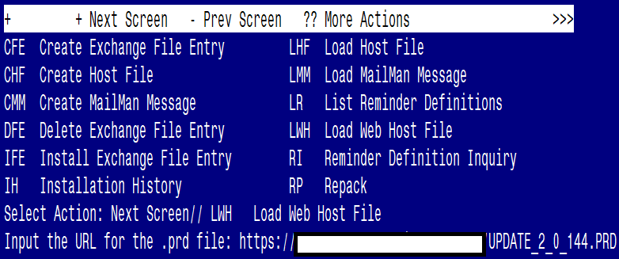

At the Select Action: prompt, enter LWH for Load Web Host File
At the Input the url for the .prd file: prompt, type the following web address:
https://vaww.va.gov/reminders/docs/UPDATE_2_0_144.PRD

You should see a message at the top of your screen that the file successfully loaded.

Search and locate an entry titled UPDATE_2_0_144 VA-TECS PROGRAM TEMPLATES in reminder exchange.
At the Select Action prompt, enter IFE for Install Exchange File Entry Enter the number that corresponds with your entry UPDATE_2_0_144 VA-TECS PROGRAM TEMPLATES (in this example it is entry 181. It will vary by site). The date of the exchange file should be 08/04/2020.
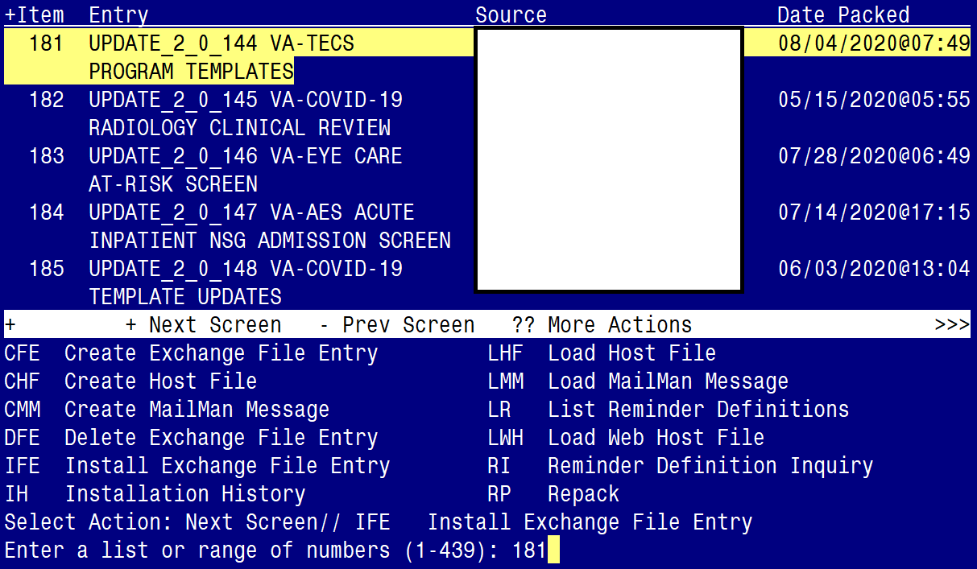

At the Select Action prompt, type IA for Install all Components and hit enter.
Select Action: Next Screen// IA Install all Components
You will see several prompts, for all new entries you will choose I to Install
For components that already exists, you will choose S to Skip.

You will be promped to install the FIRST reminder dialog component (VA-TECS GLAUCOMA PHYSICIAN)
- You will choose to install all even though some components may have an X to indicate that they exist.

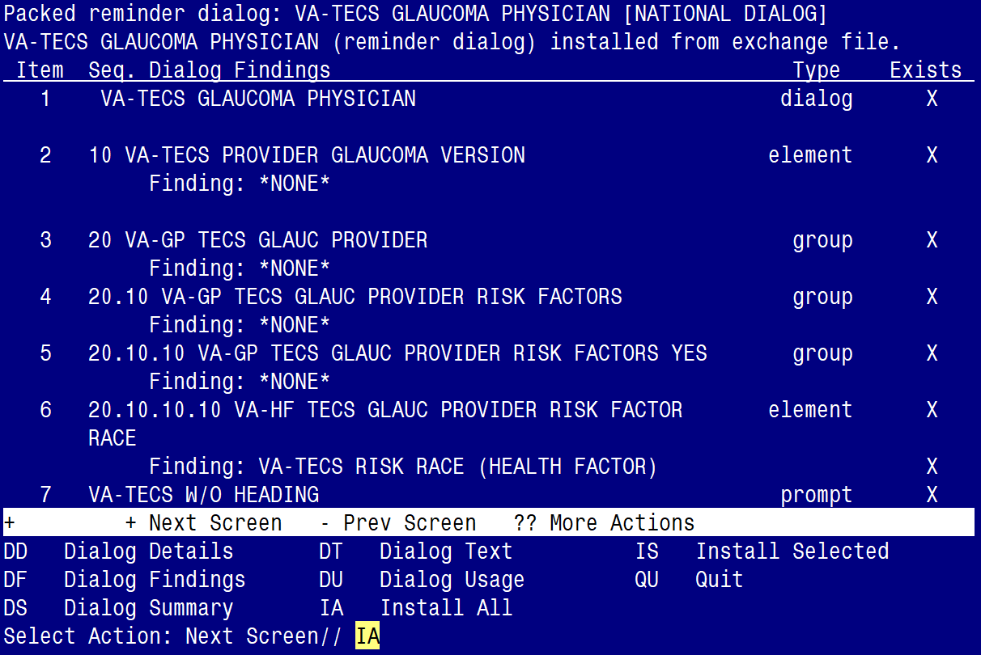

At the Select Action prompt, type IA to install the dialog – VA-TECS GLAUCOMA PHYSICIAN
Select Action: Next Screen// IA Install All
Install reminder dialog and all components with no further changes: Y// Yes
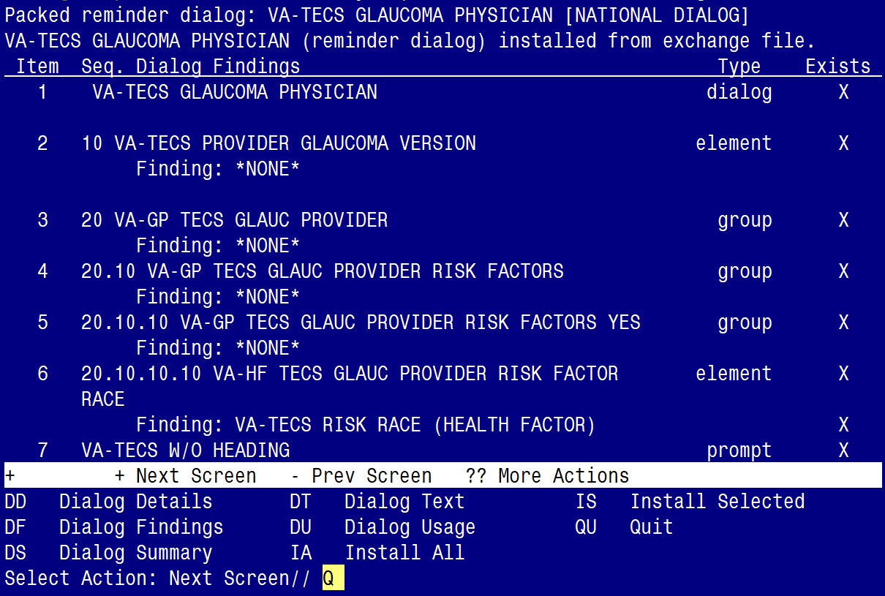

After completing this dialog install, you will type Q.

You will be promped to install the SECOND reminder dialog component (VA-TECS GLAUCOMA TECHNICIAN)
- You will choose to install all even though some components may have an X to indicate that they exist.

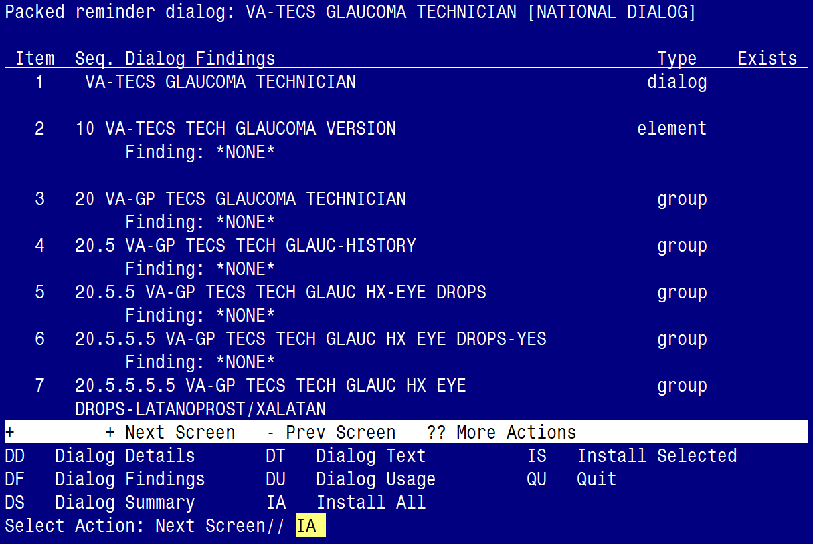

At the Select Action prompt, type IA to install the dialog – VA-TECS GLAUCOMA TECHNICIAN
Select Action: Next Screen// IA Install All
Install reminder dialog and all components with no further changes: Y// Yes
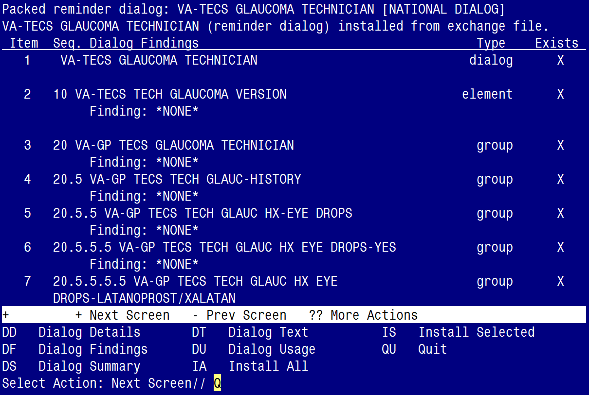

After completing this dialog install, you will type Q.

You will be promped to install the THIRD reminder dialog component (VA-TECS PHYSICIAN)
- You will choose to install all even though some components may have an X to indicate that they exist.

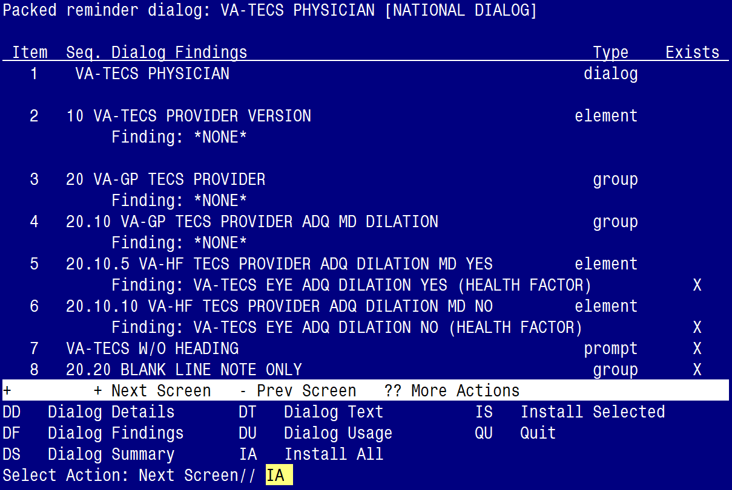

At the Select Action prompt, type IA to install the dialog – VA-TECS PHYSICIAN
Select Action: Next Screen// IA Install All
Install reminder dialog and all components with no further changes: Y// Yes

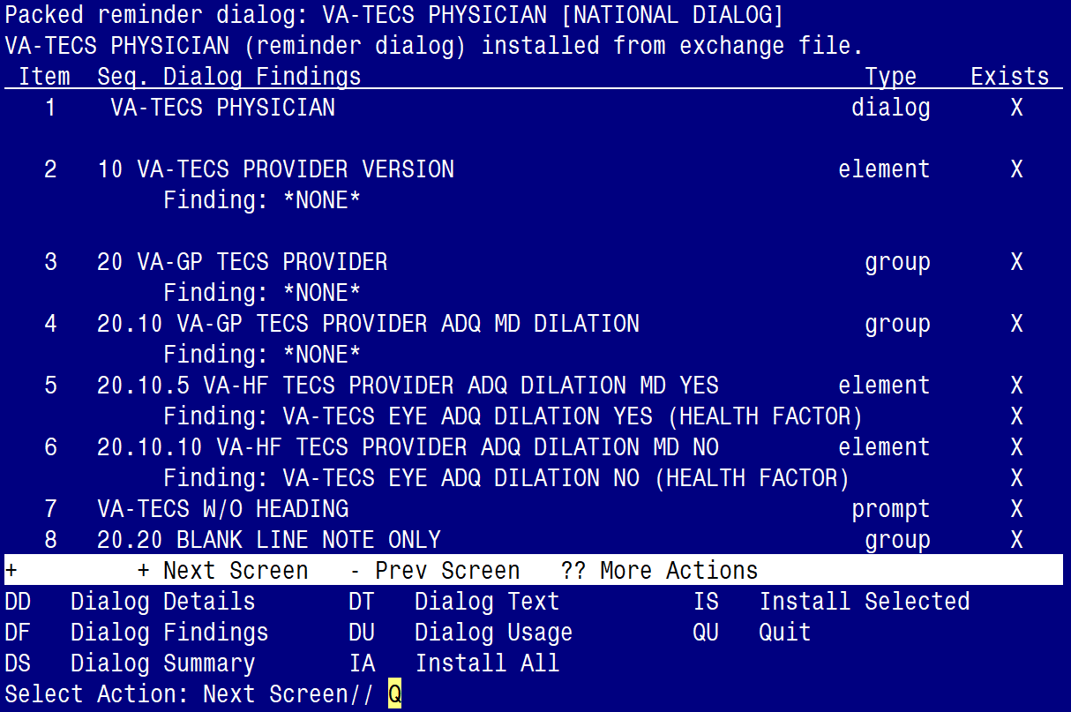

After completing this dialog install, you will type Q.

You will be promped to install the FOURTH reminder dialog component (VA-TECS TECHNICIAN)
- You will choose to install all even though some components may have an X to indicate that they exist.

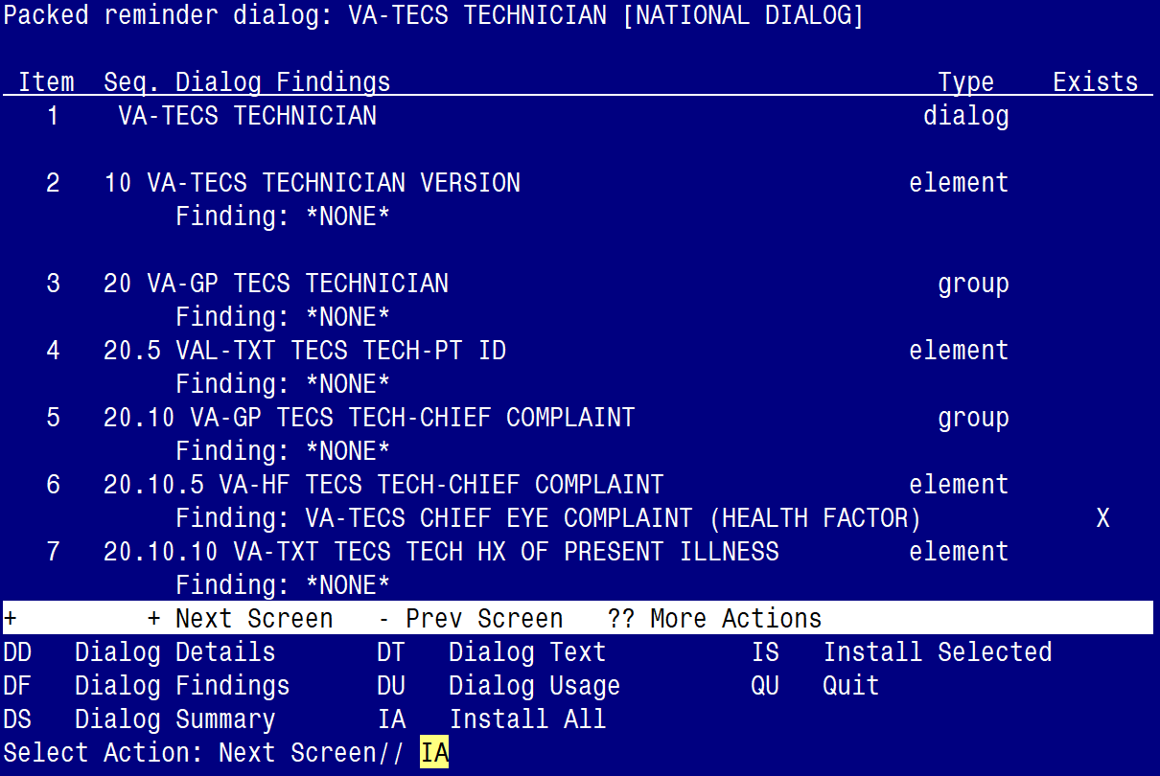

At the Select Action prompt, type IA to install the dialog – VA-TECS TECHNICIAN
Select Action: Next Screen// IA Install All
Install reminder dialog and all components with no further changes: Y// Yes

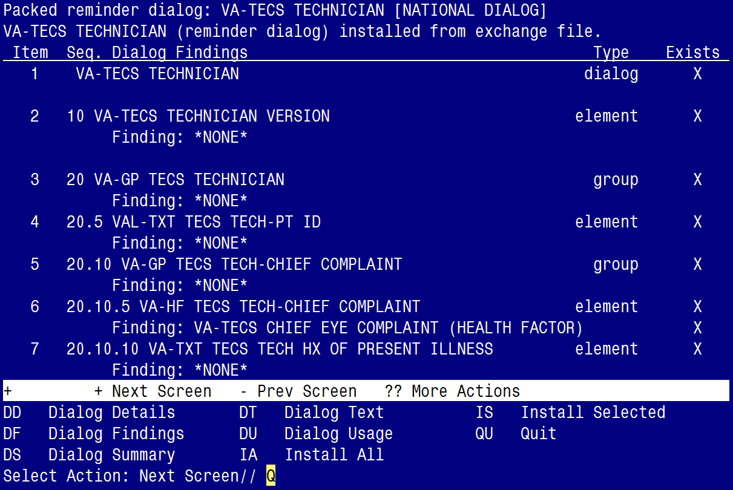

After completing this dialog install, you will type Q.

You will be promped to install the LAST (fifth) reminder dialog component (VA-TECS LETTERS)
- You will choose to install all even though some components may have an X to indicate that they exist.

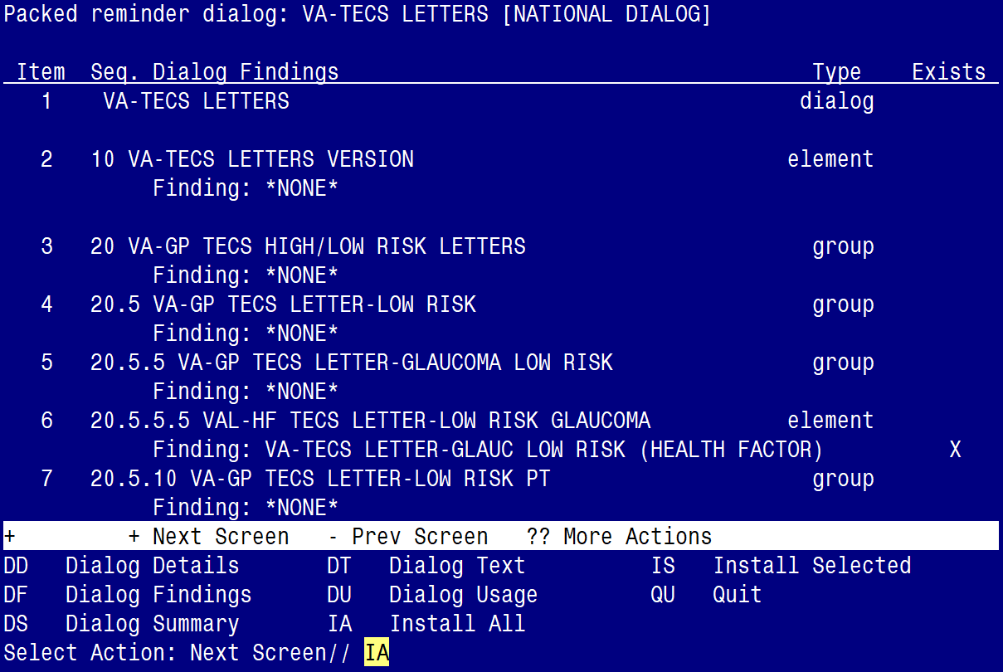

At the Select Action prompt, type IA to install the dialog – VA-TECS LETTERS
Select Action: Next Screen// IA Install All
Install reminder dialog and all components with no further changes: Y// Yes
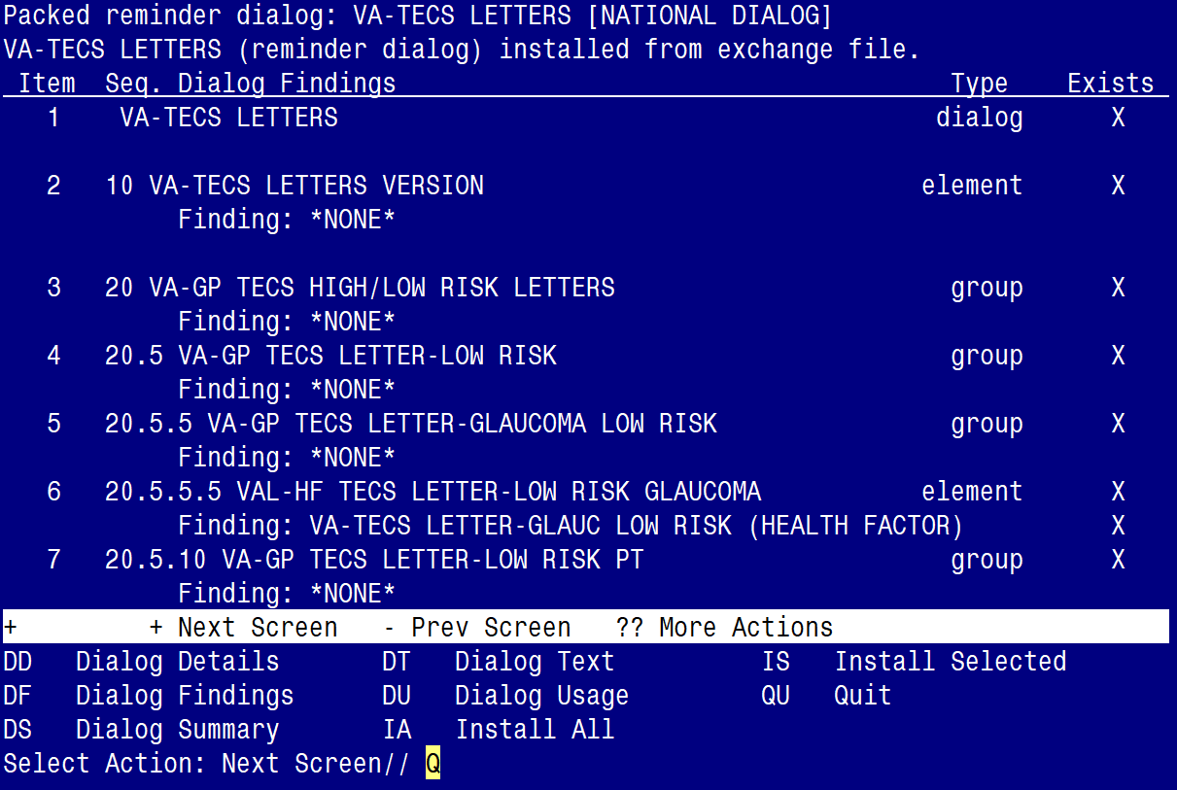

After completing this dialog install, you will type Q.

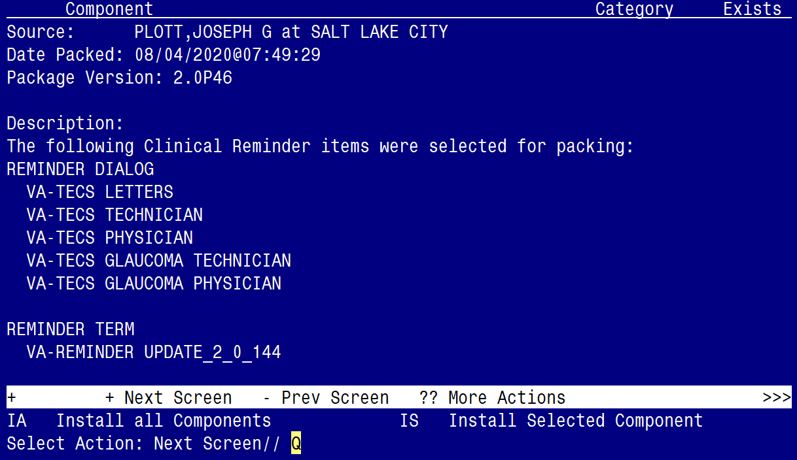

You will then be returned to this screen. At the Select Action prompt, type Q.

Install complete.

Post Installation

- Make the Dialogs able to be attached to a Personal/Shared template or to a progress note title.

From the Reminders Manager Menu:
Select Reminder Managers Menu Option: CP CPRS Reminder Configuration
CA Add/Edit Reminder Categories
CL CPRS Lookup Categories
CS CPRS Cover Sheet Reminder List
MH Mental Health Dialogs Active
PN Progress Note Headers
RA Reminder GUI Resolution Active
TIU TIU Template Reminder Dialog Parameter
DL Default Outside Location
PT Position Reminder Text at Cursor
Select CPRS Reminder Configuration Option: TIU TIU Template Reminder Dialog Parameter
Reminder Dialogs allowed as Templates may be set for the following:
1 User USR [choose from NEW PERSON]
3 Service SRV [choose from SERVICE/SECTION]
4 Division DIV [choose from INSTITUTION]
5 System SYS [NATREM.FO-SLC.MED.VA.GOV]
Enter selection: 5 Choose the appropriate number for your site. Your site may do this by System or other levels. The example below uses SYSTEM level

Setting Reminder Dialogs allowed as Templates for System:
Select Display Sequence: ?

148 VA-VETERANS CHOICE NOTE
149 VA-TBI SCREENING
When you type a question mark above, you will see the list of #’s (with dialogs) that are already taken. Choose a number NOT on this list. For this example, looking above I see the number 150 is not present, so I will use 150.
Select Display Sequence: 150
Are you adding 150 as a new Display Sequence? Yes// Y YES
Display Sequence: 150// <Enter> 150
Clinical Reminder Dialog: VA-TECS GLAUCOMA PHYSICIAN
then <enter> reminder dialog NATIONAL
OK? Yes// <Enter> (Yes)

- Repeat to add Clinical Reminder Dialog: VA-TECS GLAUCOMA TECHNCIAN
- Repeat to add Clinical Reminder Dialog: VA-TECS PHYSICIAN
- Repeat to add Clinical Reminder Dialog: VA-TECS TECHNICIAN
- Repeat to add Clinical Reminder Dialog: VA-TECS LETTERS

- Associate the new reminder dialogs with a shared template in CPRS
To do this, go to Template Editor, then Shared Templates, select the appropriate folder (if applicable), and choose New Template (top right-hand corner).

Type in the following information:
Name: EYE TECS GLAUCOMA PHYSICIAN
Template Type: Reminder Dialog
Reminder Dialog: VA- TECS GLAUCOMA PHYSICIAN

Name: EYE TECS GLAUCOMA TECHNICIAN
Template Type: Reminder Dialog
Reminder Dialog: VA-TECS GLAUCOMA TECHNCIAN

Name: EYE TECS PHYSICIAN
Template Type: Reminder Dialog
Reminder Dialog: VA-TECS PHYSICIAN

Name: EYE TECS TECHNICIAN
Template Type: Reminder Dialog
Reminder Dialog: VA-TECS TECHNICIAN

Name: EYE TECS LETTERS
Template Type: Reminder Dialog
Reminder Dialog: VA-TECS LETTERS

Next, select Apply.

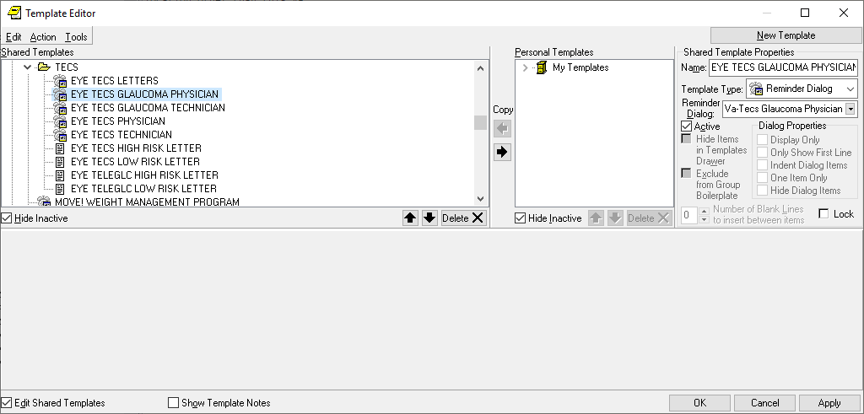

- Setup of specific Note titles
The new note titles that need to be created are:

EYE TECS GLAUCOMA PHYSICIAN
EYE TECS GLAUCOMA TECHNCIAN
EYE TECS PHYSICIAN
EYE TECS TECHNICIAN
EYE TECS LETTERS

A: “EYE” in the note title can be changed to “Optometry” or “Ophthalmology”, depending on the preferences of the local site. It should match the local eye clinic’s note naming convention as it will facilitate patient continuity of care. Confirm with your Optometry/Ophthalmology staff if they want “EYE” in the note title or “Optometry” or “Ophthalmology”

VHA Enterprise Standard Title: TELEHEALTH NOTE

B: The EYE TECS LETTERS title needs to be placed under the FORM LETTERS document class.

Note: Comprehensive information on Creating Document Definitions can be found beginning on page 47 of the TIU/ASU Implementation Guide

- Associate the reminder dialogs with the note titles in CPRS
To do this, go to Template Editor, then Document Titles, select the appropriate folder (if applicable), and choose New Template (top right-hand corner).

- Type in the following information:
Name: EYE TECS GLAUCOMA PHYSICIAN
Template Type: Reminder Dialog
Reminder Dialog: VA-TECS GLAUCOMA PHYSICIAN

Next, type in the Associated Title, which in this case is EYE TECS GLAUCOMA PHYSICIAN
Click APPLY.

- Repeat to add Reminder Dialog to note title: EYE TECS GLAUCOMA TECHNCIAN
- Repeat to add Reminder Dialog to note title: EYE TECS PHYSICIAN
- Repeat to add Reminder Dialog to note title: EYE TECS TECHNCIAN
- Repeat to add Reminder Dialog to note title: EYE TECS LETTERS

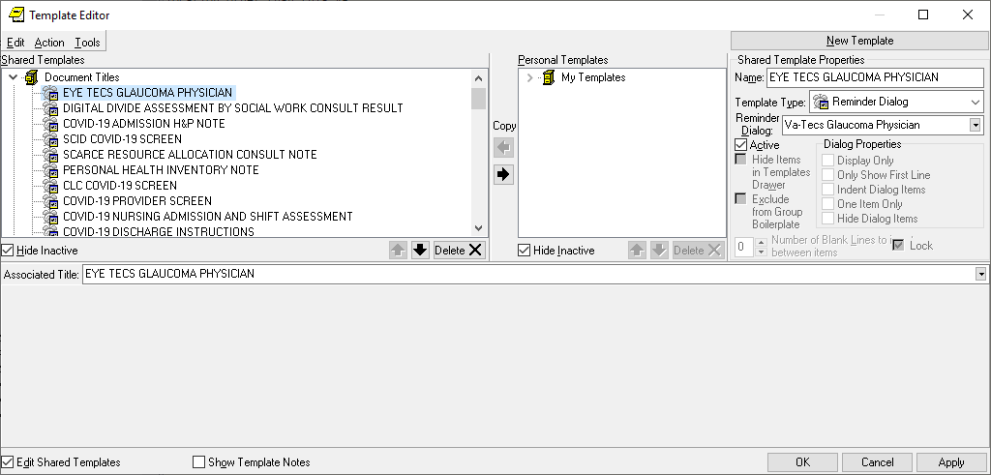

- Add/Edit ELEMENTS and GROUPS to include local data objects.

  - In the ELEMENT: VAL-HF TECS LETTER-LOW RISK GLAUCOMA
- Edit the placeholder and include your local data object for TODAY’S DATE
- Edit the placeholder and include your local data object for PATIENT NAME
- Edit the placeholder and include your local data object for PATIENT STREET
- Edit the placeholder and include your local data object for PATIENT CITY
- Edit the placeholder and include your local data object for PATIENT STATE
- Edit the placeholder and include your local data object for PATIENT ZIP CODE
- Edit the placeholder and include your local data object for PATIENT FIRST NAME/LAST NAME

  - In the ELEMENT: VAL-HF TECS LETTER-LOW RISK PATIENT
- Edit the placeholder and include your local data object for TODAY’S DATE
- Edit the placeholder and include your local data object for PATIENT NAME
- Edit the placeholder and include your local data object for PATIENT STREET
- Edit the placeholder and include your local data object for PATIENT CITY
- Edit the placeholder and include your local data object for PATIENT STATE
- Edit the placeholder and include your local data object for PATIENT ZIP CODE
- Edit the placeholder and include your local data object for PATIENT FIRST NAME/LAST NAME

  - In the ELEMENT: VAL-HF TECS LETTER-HIGH RISK GLAUCOMA
- Edit the placeholder and include your local data object for TODAY’S DATE
- Edit the placeholder and include your local data object for PATIENT NAME
- Edit the placeholder and include your local data object for PATIENT STREET
- Edit the placeholder and include your local data object for PATIENT CITY
- Edit the placeholder and include your local data object for PATIENT STATE
- Edit the placeholder and include your local data object for PATIENT ZIP CODE
- Edit the placeholder and include your local data object for PATIENT FIRST NAME/LAST NAME
  - In the ELEMENT: VAL-HF TECS LETTER-HIGH RISK PATIENT
- Edit the placeholder and include your local data object for TODAY’S DATE
- Edit the placeholder and include your local data object for PATIENT NAME
- Edit the placeholder and include your local data object for PATIENT STREET
- Edit the placeholder and include your local data object for PATIENT CITY
- Edit the placeholder and include your local data object for PATIENT STATE
- Edit the placeholder and include your local data object for PATIENT ZIP CODE
- Edit the placeholder and include your local data object for PATIENT FIRST NAME/LAST NAME

  - In the ELEMENT: VAL-TXT TECS TECH-PT ID
- Edit the placeholder and include your local data object for PATIENT NAME
- Edit the placeholder and include your local data object for PATIENT SSN
- Edit the placeholder and include your local data object for PATIENT AGE

  - In the ELEMENT: VAL-TXT OBJ A1C
- Edit the placeholder and include your local data object for LAST A1C

  - In the GROUP: VAL-GP TECS TECH-MEDICATION
- Edit the placeholder and include your local data object for ACTIVE MEDICATIONS

- Complete this step only if your site is participating in the TECS program. In the following four elements, edit the phone number labeled “XXX-XXX-XXXX”, to include the phone number for your site’s TECS contact (your Tele Eye Care Service staff will have this phone number):

Element: VAL-HF TECS LETTER-LOW RISK GLAUCOMA
Element: VAL-HF TECS LETTER-LOW RISK PATIENT
Element: VAL-HF TECS LETTER-HIGH RISK GLAUCOMA
Element: VAL-HF TECS LETTER-HIGH RISK PATIENT

NOTE: If there are any questions or problems during the installation, please notify your local IT support to log a national help desk ticket or contact the VA Service Desk and have them submit a national ticket to:
Category: Affected Service
Affected Service: VistA – CPRS: Clinical Reminders
Assignment Group: NTL SUP Clin 2

Appendix

- Set up AUTO PRINT for the EYE TECS LETTER:

The EYE TECS LETTERS need to print on one specific printer for the Eye Techs. Contact your Eye Techs for the printer name. Below are step by step instructions for setting up that one printer. You will need to use the ‘Document Parameter Edit’ menu in VistA.

Take Note: Each location (main facility and CBOCs) that perform Eye Tech services, need to be added to the DIVISION field below.

Take Note: Coordinate with your facility’s Eye Technicians to identify the printer that will auto-print these letters, as the staff who will mail the letters will retrieve them from the assigned printer.

DOCUMENT DEFINITION: EYE TECS LETTERS// EYE TECS LETTERS
REQUIRE RELEASE: NO//
REQUIRE MAS VERIFICATION: NO//
REQUIRE AUTHOR TO SIGN: YES//
ROUTINE PRINT EVENT(S): release//
STAT PRINT EVENT(S):
MANUAL PRINT AFTER ENTRY:
ALLOW CHART PRINT OUTSIDE MAS: YES//
ALLOW >1 RECORDS PER VISIT:
ENABLE IRT INTERFACE: NO//
SUPPRESS DX/CPT ON ENTRY: YES//
SEND ALERTS ON ADDENDA:
ORDER ID ENTRIES BY TITLE:
SEND ALERTS ON NEW ID ENTRY:
SEND COSIGNATURE ALERT:
HEADING: (Example from Atlanta is below)
Atlanta VA Healthcare System Regional Telehealth Services
Technology-Based Eye Care Services (TECS) Program
1670 Clairmont Road
Decatur, Ga. 30033

Edit? NO//
JUSTIFY HEADING: CENTER JUSTIFIED//
INSERT BLANK LINES: 5//
FOOTER:
Edit? NO//
JUSTIFY FOOTER:
CLOSING:
Regards,
Technology-Based Eye Care Services (TECS)

Edit? NO//
JUSTIFY CLOSING:
PAGE NUMBERS:
JUSTIFY PAGE NUMBERS:

Now enter the USER CLASSES for which cosignature will be required:

Select USERS REQUIRING COSIGNATURE:

Now enter the DIVISIONAL parameters:

Select DIVISION: ZNE GA// ?
Answer with DIVISION
Choose from:
ATLANTA VA CLINIC
ATLANTA VAMC
BLAIRSVILLE CBOC
EAST POINT VA CLINIC
FORT MCPHERSON
FULTON COUNTY VA CLINIC
NEWNAN CBOC
ZNE GA

You may enter a new DIVISION, if you wish
Please indicate the Medical Center Division

Answer with MEDICAL CENTER DIVISION NUM, or NAME, or FACILITY NUMBER, or
TREATING SPECIALTY
Do you want the entire 27-Entry MEDICAL CENTER DIVISION List? N (No)
Select DIVISION: ZNE GA//
CHART COPY PRINTER: EP1XPRT// (example printer name)
STAT CHART COPY PRINTER:
Select DIVISION:

If document is to be uploaded, specify Filing Alert Recipients:

Select FILING ALERT RECIPIENT:

EXCLUDE FROM COPY/PASTE:

- Establish the EYE CBOC TECS PHOTO CONSULT (XXX) OUTPT consult service

- Create the TECS REMOTE PROVIDER TEAM

May 21, 2020 Team Patient Manual Removal/Autolinked List page 1
TECS REMOTE PROVIDER TEAM
==============================
Type: MRAL
Subscribable: NO

Provider/users: << Add names here >>
List completed.

- Create the EYE CBOC TECS PHOTO CONSULT (XXX) OUTPT consult service

Take Note: If your site has already created these consults and the word “TECHS” is in the name of the consult service, you do not need to change the name.

Take Note: A consult service will need to be created for each location (main facility and CBOCs) that perform this service

Take Note: (“XXX”) represents your site abbreviation name or CBOC abbreviation name where Technology-based Eye Care Services (TECS) is being performed. This consult populates the modality work list of the camera. It is administratively closed by the reader once the photos are done. There are no notes that close this consult.
SERVICE NAME: EYE CBOC TECS PHOTO CONSULT (XXX) OUTPT
Replace
ABBREVIATED PRINT NAME (Optional):
INTERNAL NAME:
Select SYNONYM:
SERVICE USAGE:
SERVICE PRINTER:
SECONDARY PRINTER:
NOTIFY SERVICE ON DC:
REPRINT 513 ON DC:
PREREQUISITE:
Edit? NO// YES

== [ WRAP] == [INSERT]=========< PREREQUISITE >=== [Press <PF1>H for help] ===
** Consult Service Pre-requisite **

A STAT consult is defined as an IMMEDIATE need that MUST be completed
within 24 hours. It is MANDATORY that verbal communication with the
consultant is performed and documented in the service request.

A ROUTINE consult indicates the patient should be seen in accordance with
the Clinically Indicated Date (CID) based on the patient's need.

<=======T=======T=======T=======T=======T=======T=======T=======T===PROVISIONAL DX PROMPT: REQUIRE//
PROVISIONAL DX INPUT: LEXICON//
DEFAULT REASON FOR REQUEST: TECs photo attached.
Edit? NO//
RESTRICT DEFAULT REASON EDIT:
Inter-facility information
IFC ROUTING SITE:
IFC REMOTE NAME:
Select IFC SENDING FACILITY:

SERVICE INDIVIDUAL TO NOTIFY: << Insert Name Here >>//
Select SERVICE TEAM TO NOTIFY:
Select NOTIFICATION BY PT LOCATION:
PROCESS PARENTS FOR NOTIFS:
Select UPDATE USERS W/O NOTIFICATIONS: << Insert Name(s) Here >> // ?
Select UPDATE TEAMS W/O NOTIFICATIONS: TECS REMOTE PROVIDER TEAM // ?
Select UPDATE USER CLASS W/O NOTIFS:
Select ADMINISTRATIVE UPDATE USER: << Insert Name Here >> // ?
NOTIFICATION RECIPIENT:
Select ADMINISTRATIVE UPDATE TEAM: TECS REMOTE PROVIDER TEAM // ?
Select ADMINISTRATIVE UPDATE TEAM: TECS REMOTE PROVIDER TEAM //
NOTIFICATION RECIPIENTS:
PROCESS PARENTS FOR UPDATES:
SPECIAL UPDATES INDIVIDUAL:
RESULT MGMT USER CLASS:
UNRESTRICTED ACCESS:
Select SUB-SERVICE/SPECIALTY:
ADMINISTRATIVE:
Add/Edit Another Service? NO/

- Add consult to Grouper; add to the Telehealth Grouper.

SERVICE NAME: TELEHEALTH GROUP//
ABBREVIATED PRINT NAME (Optional):
INTERNAL NAME:
Select SYNONYM:
SERVICE USAGE: GROUPER ONLY//
Select SUB-SERVICE/SPECIALTY: L2 SCREENING CONSULT //?
Answer with SUB-SERVICE SUB-SERVICE/SPECIALTY
Do you want the entire 59-Entry SUB-SERVICE List? Y (Yes)
Choose from:
EYE CBOC TECHS PHOTO CONSULT (XXX) OUTPT

- Add stop code to consult

Select Consult Management Option: ^stop CONSULT ASSOCIATED STOP CODE

Select REQUEST SERVICES SERVICE NAME: EYE CBOC TECHS PHOTO CONS

Select ASSOCIATED STOP CODE: SF TH PAT SITE// add the TWO codes below
Answer with ASSOCIATED STOP CODE
Choose from:
OPHTHALMOLOGY
SF TH PAT SITE

