

**Update _2_0_156**

Clinical Reminders

VA-COVID-19 Antibody Testing

Install Guide

**July 2020**

Product Development

Office of Information Technology

Department of Veterans Affairs

Table of Contents

Introduction 1

Install Details 8

Install Example 9

Post Installation 15

# Introduction

DESCRIPTION:

1. NEW TEMPLATE - Coronavirus Disease 2019 (COVID-19) Antibody/Polymerase Chain Reaction (PCR) Panel Testing

The following template is for use in COVID-19 PCR/Antigen and Antibody

testing and tracking.

Our understanding of the antibody response to COVID-19 is still

developing.

Recommendation if the patient screens positive:

If patient screens positive, clinical staff will:

- Review COVID-19 Antibody testing information with Veteran

<https://Redacted/Antibody%20Testing%20Information%20Sheet.pdf>

- Ensure patient agrees to 5 tests over 8 weeks (minimum 3 tests over

4 weeks) if either is positive

- Document verbal consent for Antibody testing using this template

- Order both PCR/Antibody from this template

IF EITHER the PCR or Antibody test is positive, clinical staff will:

- Notify patient of the results

- Document verbal consent for repeat testing every two weeks using this

template

- Document symptoms at the time of future collections through this

template, per their local processes

The ordering options in this template are locally modifiable, your site can order one set of tests for the current date and time for each of the five testing intervals or they can order the initial set of tests and if the initial set is positive, they can order the remaining 4 sets of lab tests for the current date and time and future 2 week intervals. This will be a local decision and you can disable the ordering 4 sets option if that is an option that you will not use.

If you order all 4 sets of lab tests after the initial positive, the template can be used to document symptoms only at the time the patient returns for the lab test collection.

1. Other Covid-19 template updates
   1. Screening update version 5.2
      1. If patient reports that they have been diagnosed, there is a date prompt and the question about recovered has been removed and a note indicating no further screening is needed
      2. Exposure question added
      3. This change will also be reflected in the ED Triage and SCI/Nursing admission templates.
   2. Telephone follow up note version 3.1
      1. Symptoms updated to align with current screening
      2. Changed time from a radio button to a text box where a specific time is entered instead of a range
   3. Reminder dialog element VAL-COVID-19 RTW PROVIDER SIGNATURE updated to remove txml field from alternate progress note text.
   4. CLC template version 2.1
      1. Temperature guidelines updated
      2. Exposure question added
   5. SCI/D COVID Screen
      1. Health factors removed from diagnosis section
      2. Ability to revise a previously documented diagnosis removed
      3. Caregiver section changed to required Yes/No replies for each option
      4. New health factors added to caregiver no options

UPDATE_2_0_156 contains 1 Reminder Exchange entry:

**UPDATE_2_0_156 VA-COVID-19 ANTIBODY TESTING**

**The exchange file contains the following components:**

**TIU TEMPLATE FIELD**

BLANK SPACE1

DATE (*)

VA COVID PROVIDER

VA COVID SIGNATURE

VA-TIME SPENT

**HEALTH FACTORS**

VA-REMINDER UPDATES

VA-UPDATE_2_0_156

VA-SCI/D PQD

VA-SCI/D PQD-SCID

VA-SCI/D PQD-MULTIPLE SCLEROSIS

VA-SCI/D PQD-MOTOR NEURON OTHER

VA-SCI/D PQD-MOTOR NEURON POLIOMYELITIS

VA-SCI/D PQD-MOTOR NEURON PLS

VA-SCI/D PQD-MOTOR NEURON ALS

VA-SCI/D NEURO LEVEL-SENSORY LT

VA-SCI/D NLI-SL UNK/UNABLE

VA-SCI/D NEURO LEVEL-SENSORY RT

VA-SCI/D NLI-SR UNK/UNABLE

VA-SCI/D NEURO LEVEL-MOTOR LT

VA-SCI/D NLI-ML UNK/UNABLE

VA-SCI/D NEURO LEVEL-MOTOR RT

VA-SCI/D NLI-MR UNK/UNABLE

VA-SCI/D KURTZKE SCALE

VA-SCI/D KURTZKE SCALE 10.0

VA-SCI/D KURTZKE SCALE 9.5

VA-SCI/D KURTZKE SCALE 9.0

VA-SCI/D KURTZKE SCALE 8.5

VA-SCI/D KURTZKE SCALE 8.0

VA-SCI/D KURTZKE SCALE 7.5

VA-SCI/D KURTZKE SCALE 7.0

VA-SCI/D KURTZKE SCALE 6.5

VA-SCI/D KURTZKE SCALE 6.0

VA-SCI/D KURTZKE SCALE 5.5

VA-SCI/D KURTZKE SCALE 5.0

VA-SCI/D KURTZKE SCALE 4.5

VA-SCI/D KURTZKE SCALE 4.0

VA-SCI/D KURTZKE SCALE 3.5

VA-SCI/D KURTZKE SCALE 3.0

VA-SCI/D KURTZKE SCALE 2.5

VA-SCI/D KURTZKE SCALE 2.0

VA-SCI/D KURTZKE SCALE 1.5

VA-SCI/D KURTZKE SCALE 1.0

VA-SCI/D KURTZKE SCALE 0.0

VA-SCI/D NLI-SL L05

VA-SCI/D NLI-SL L04

VA-SCI/D NLI-SL L03

VA-SCI/D NLI-SL L02

VA-SCI/D NLI-SL L01

VA-SCI/D NLI-SR S04 S05 INTACT

VA-SCI/D NLI-SR S03

VA-SCI/D NLI-SR S02

VA-SCI/D NLI-SR S01

VA-SCI/D NLI-SR L05

VA-SCI/D NLI-SR L04

VA-SCI/D NLI-SR L03

VA-SCI/D NLI-SR L02

VA-SCI/D NLI-SR L01

VA-SCI/D NLI-SR T12

VA-SCI/D NLI-SR T11

VA-SCI/D NLI-SR T10

VA-SCI/D NLI-SR T09

VA-SCI/D NLI-SR T08

VA-SCI/D NLI-SR T07

VA-SCI/D NLI-SR T06

VA-SCI/D NLI-SR T05

VA-SCI/D NLI-SR T04

VA-SCI/D NLI-SR T03

VA-SCI/D NLI-SR T02

VA-SCI/D NLI-SR T01

VA-SCI/D NLI-SR C08

VA-SCI/D NLI-SR C07

VA-SCI/D NLI-SR C06

VA-SCI/D NLI-SR C05

VA-SCI/D NLI-SR C04

VA-SCI/D NLI-SR C03

VA-SCI/D NLI-SR C02

VA-SCI/D NLI-SR C01

VA-SCI/D NLI-SL S04 S05 INTACT

VA-SCI/D NLI-SL S03

VA-SCI/D NLI-SL S02

VA-SCI/D NLI-SL S01

VA-SCI/D NLI-SL T12

VA-SCI/D NLI-SL T11

VA-SCI/D NLI-SL T10

VA-SCI/D NLI-SL T09

VA-SCI/D NLI-SL T08

VA-SCI/D NLI-SL T07

VA-SCI/D NLI-SL T06

VA-SCI/D NLI-SL T05

VA-SCI/D NLI-SL T04

VA-SCI/D NLI-SL T03

VA-SCI/D NLI-SL T02

VA-SCI/D NLI-SL T01

VA-SCI/D NLI-SL C08

VA-SCI/D NLI-SL C07

VA-SCI/D NLI-SL C06

VA-SCI/D NLI-SL C05

VA-SCI/D NLI-SL C04

VA-SCI/D NLI-SL C03

VA-SCI/D NLI-SL C02

VA-SCI/D NLI-SL C01

VA-SCI/D NLI-MR S04 S05 INTACT

VA-SCI/D NLI-MR S03

VA-SCI/D NLI-MR S02

VA-SCI/D NLI-MR S01

VA-SCI/D NLI-MR L05

VA-SCI/D NLI-MR L04

VA-SCI/D NLI-MR L03

VA-SCI/D NLI-MR L02

VA-SCI/D NLI-MR L01

VA-SCI/D NLI-MR T12

VA-SCI/D NLI-MR T11

VA-SCI/D NLI-MR T10

VA-SCI/D NLI-MR T09

VA-SCI/D NLI-MR T08

VA-SCI/D NLI-MR T07

VA-SCI/D NLI-MR T06

VA-SCI/D NLI-MR T05

VA-SCI/D NLI-MR T04

VA-SCI/D NLI-MR T03

VA-SCI/D NLI-MR T02

VA-SCI/D NLI-MR T01

VA-SCI/D NLI-MR C08

VA-SCI/D NLI-MR C07

VA-SCI/D NLI-MR C06

VA-SCI/D NLI-MR C05

VA-SCI/D NLI-MR C04

VA-SCI/D NLI-MR C03

VA-SCI/D NLI-MR C02

VA-SCI/D NLI-MR C01

VA-SCI/D NLI-ML S04 S05 INTACT

VA-SCI/D NLI-ML S03

VA-SCI/D NLI-ML S02

VA-SCI/D NLI-ML S01

VA-SCI/D NLI-ML L05

VA-SCI/D NLI-ML L04

VA-SCI/D NLI-ML L03

VA-SCI/D NLI-ML L02

VA-SCI/D NLI-ML L01

VA-SCI/D NLI-ML T12

VA-SCI/D NLI-ML T11

VA-SCI/D NLI-ML T10

VA-SCI/D NLI-ML T09

VA-SCI/D NLI-ML T08

VA-SCI/D NLI-ML T07

VA-SCI/D NLI-ML T06

VA-SCI/D NLI-ML T05

VA-SCI/D NLI-ML T04

VA-SCI/D NLI-ML T03

VA-SCI/D NLI-ML T02

VA-SCI/D NLI-ML T01

VA-SCI/D NLI-ML C08

VA-SCI/D NLI-ML C07

VA-SCI/D NLI-ML C06

VA-SCI/D NLI-ML C05

VA-SCI/D NLI-ML C04

VA-SCI/D NLI-ML C03

VA-SCI/D NLI-ML C02

VA-SCI/D NLI-ML C01

VA-SCI/D ETIOLOGY

VA-SCI/D ETIOLOGY-OTH NON-TRAUMA

VA-SCI/D ETIOLOGY-RADIATION

VA-SCI/D ETIOLOGY-TOXIC

VA-SCI/D ETIOLOGY-GENETIC

VA-SCI/D ETIOLOGY-AUTOIMMUNE

VA-SCI/D ETIOLOGY-METABOLIC

VA-SCI/D ETIOLOGY-TUMOR

VA-SCI/D ETIOLOGY-SYRINGOMYELIA

VA-SCI/D ETIOLOGY-ARTHRITIC DZ

VA-SCI/D ETIOLOGY-COLUMNAR DEGEN

VA-SCI/D ETIOLOGY-INFECTION

VA-SCI/D ETIOLOGY-VASC CHNG

VA-SCI/D ETIOLOGY-OTH TRAUMA

VA-SCI/D ETIOLOGY-VIOLENCE

VA-SCI/D ETIOLOGY-VEHICULAR

VA-SCI/D ETIOLOGY-SPORTS

VA-SCI/D ETIOLOGY-FALL

VA-SCI/D ASIA

VA-SCI/D ASIA-E

VA-SCI/D ASIA-D

VA-SCI/D ASIA-C

VA-SCI/D ASIA-B

VA-SCI/D ASIA-A

VA-SCI/D CAREGIVER STATUS

VA-SCI/D VA BOWEL AND BLADDER N

VA-SCI/D COVID SCREEN

VA-SCI/D COVID BOWEL/BLADDER NO PLAN

VA-SCI/D COVID BOWEL/BLADDER PLAN

VA-SCI/D VA BOWEL AND BLADDER

VA-SCI/D CAREGIVER-UNPAID NON FAM MEMB N

VA-SCI/D COVID CG-UNPAID NO FAM NO PLAN

VA-SCI/D COVID CG-UNPAID NO FAM PLAN

VA-SCI/D CAREGIVER-UNPAID NON FAM MEMBER

VA-SCI/D CAREGIVER-UNPAID FAMILY MEMB N

VA-SCI/D COVID CG-UNPAID FAM NO PLAN

VA-SCI/D COVID CG-UNPAID FAM PLAN

VA-SCI/D CAREGIVER-UNPAID FAMILY MEMBER

VA-SCI/D CAREGIVER-PAID FAMILY MEMBER N

VA-SCI/D COVID CG-PAID FAM MEMB NO PLAN

VA-SCI/D COVID CG-PAID FAM MEMB PLAN

VA-SCI/D CAREGIVER-PAID FAMILY MEMBER

VA-SCI/D CAREGIVER-PAID NON AGENCY/FAM N

VA-SCI/D COVID CG-PAID NO AG/FAM NO PLAN

VA-SCI/D COVID CG-PAID NO AG/FAM PLAN

VA-SCI/D CAREGIVER-PAID NON AGENCY/FAM

VA-SCI/D CAREGIVER-PAID AGENCY N

VA-SCI/D COVID CG-PAID AGENCY NO PLAN

VA-SCI/D COVID CG-PAID AGENCY PLAN

VA-SCI/D CAREGIVER-PAID AGENCY

VA-SCI/D REVIEW DATE

VA-SCI/D CAREGIVER STATUS REVIEW DATE

VA-SCI/D CAREGIVER-NO

VA-TRAVEL SCREEN [C]

VA-COVID-19 PRIOR DIAGNOSIS

VA-COVID SCREEN NEGATIVE

VA-COVID SCREEN POSITIVE

VA-EXPOSURE TO COVID NO

VA-EXPOSURE TO COVID YES

VA-COVID-19

VA-NO HEADACHE LOSS OF TASTE OR SMELL

VA-SYMPTOM LOSS OF SMELL

VA-SYMPTOM LOSS OF TASTE

VA-SYMPTOM HEADACHE

VA-SCI/D COVID SCREEN ADDL SYMPTOM

VA-SCI/D COVID SCREEN NO ADDL SYMPTOM

VA-SCI/D COVID SCREEN OTHER SYMPTOM

VA-SCI/D COVID SCREEN CONJUNCTIVITIS

VA-SCI/D COVID SCREEN NAUSEA

VA-SCI/D COVID SCREEN LOSS SMELL

VA-SCI/D COVID SCREEN LOSS TASTE

VA-SCI/D COVID SCREEN MYALGIA

VA-SCI/D COVID SCREEN SORE THROAT

VA-COVID-19 OUTSIDE PCR SPEC COLLECTED

VA-COVID-19 PCR LAB OUTSIDE NEGATIVE

VA-COVID-19 PCR LAB OUTSIDE POSITIVE

VA-NO NAUSEA VOMITING OR DIARRHEA

VA-SYMPTOM VOMITING

VA-SYMPTOM NAUSEA

VA-TRAVEL DIARRHEA YES

VA-TRAVEL FLU NO

VA-TRAVEL FLU YES

VA-TRAVEL COUGH NO

VA-TRAVEL COUGH YES

VA-TRAVEL FEVER NO

VA-TRAVEL FEVER YES

VA-COVID-19 NO PRIOR DIAGNOSIS

VA-COVID-19 NOT WAITING FOR LABS

VA-COVID-19 WAITING FOR LABS

COVID-19

COVID-19:AB SYMPTOMS NO HISTORY

COVID-19:AB SYMPTOMS ONSET DATE REPORTED

COVID-19:AB SYMPTOMS REOCCURRENCE=NA

COVID-19:AB SYMPTOMS REOCCURRENCE=NO

COVID-19:AB SYMPTOMS REOCCURRENCE=YES

VA-TRAVEL DIARRHEA NO

VA-TRAVEL COUGH,SOB,SORE THROAT NO

VA-TRAVEL COUGH,SOB,SORE THROAT YES

**REMINDER SPONSOR**

Office of Geriatric Extended Care

Office of Nursing Service

**REMINDER TERM**

VA-REMINDER UPDATE_2_0_156

VA-SCI/D PQD (OBJ)

VA-SCI/D PRIMARY DIAGNOSIS

VA-SCI/D CAREGIVER STATUS

VA-COVID-19 PREVIOUS SYMPTOM SCREEN

VA-BL COVID SCREEN COMPLETE TODAY

**REMINDER DEFINITION**

VA-OBJ SCI/D PRIMARY QUALIFYING DIAGNOSIS

**REMINDER DIALOG**

VA-COVID-19 CLC SCREEN

VA-COVID-19 ANTIBODY/PCR PANEL TESTING

VA-COVID-19 UPDATE JUL 2020

**HEALTH SUMMARY TYPE**

VA-COVID-19 PREVIOUS SYMPTOM

COVID19 LAB RESULTS LAST 6

VA-SCI/D CAREGIVER STATUS

VA-SCI/D CAREGIVER REVIEW DATE

VA-SCI/D PRIM QUAL DIAGNOSIS

**HEALTH SUMMARY OBJECTS**

VA-COVID-19 PREVIOUS SYMPTOM (TIU)

COVID19 LAB RESULTS LAST 6 (TIU)

VA-SCI/D CAREGIVER STATUS

VA-SCI/D CAREGIVER REVIEW DATE (TIU)

VA-SCI/D PRIMARY QUALIFYING DIAGNOSIS (TIU)

**TIU DOCUMENT DEFINITION**

VA-COVID-19 PREVIOUS SYMPTOM

COVID19 LAB RESULTS LAST 6

VA-SCI/D CAREGIVER STATUS

VA-SCI/D CAREGIVER REVIEW DATE

VA-SCI/D PRIMARY QUALIFYING DIAGNOSIS

# Pre-Install

Using the Vista menu Reminder Dialog Manager, Reminder Dialog, change your view to ELEMENT and choose inquire/print for the reminder dialog element VAL-COVID-19 RTW PROVIDER SIGNATURE.

Change your view to GROUP and choose inquire/print for the reminder dialog group VAL-COVID-19 CLC SCREEN LOCAL GROUP.

Save this info for the post install, it will make adding information back post -install easier if your site has made local edits. Not all sites will have made local edits to this dialog element.

# Install Details

This update is being distributed as a web host file. The address for the host file is: **https://vaww.va.gov/reminders/docs/UPDATE_2_0_156.PRD**

The file will be installed using Reminder Exchange, programmer access is not required.

This update is also being distributed as a vista mailman message. The mailman message will be titled **UPDATE 156.PRD**

Installation:

=============

This update can be loaded with users on the system. Installation will take less than 30 minutes.

# Install Example

To Load the Web Host File. Navigate to Reminder exchange in Vista

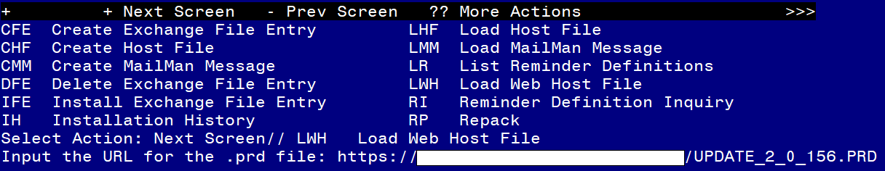

At the **Select Action:** prompt, enter **LWH** for Load Web Host File

At the **Input the url for the .prd file:** prompt, type the following web address:

[**https://Redacted/UPDATE_2_0_156.PRD**](https://Redacted/UPDATE_2_0_156.PRD)

You should see a message at the top of your screen that the file loaded successfully

If you are unable to load web host file, you will use vista mail to install the exchange file and use the LMM load Mailman Message Option. The subject of the email will be UPDATE 156. You will see a message similar to this one.



**Search and locate an entry titled UPDATE_2_0_156 VA-COVID-19 ANTIBODY TESTING**

in reminder exchange. 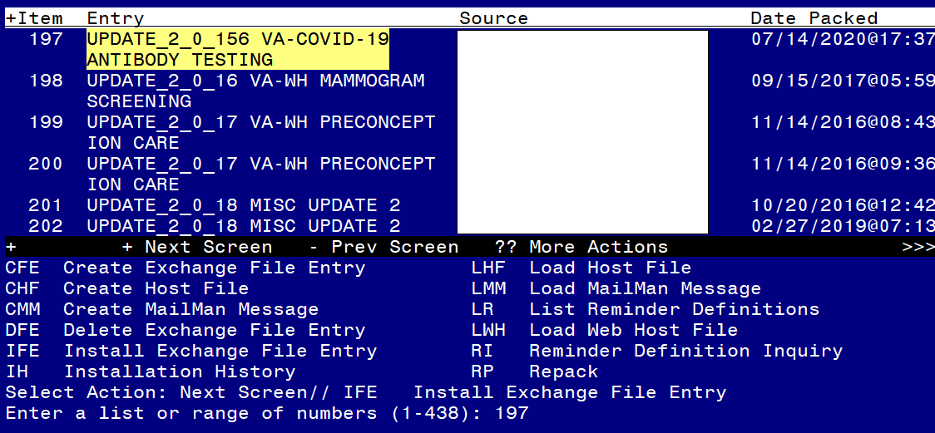

At the **Select Action** prompt, enter **IFE** for Install Exchange File Entry

Enter the number that corresponds with your entry **UPDATE_2_0_156 VA-COVID-19 ANTIBODY TESTING**  *(in this example it is entry 197 it will vary by site).* The date of the exchange file should be 07/14/2020.

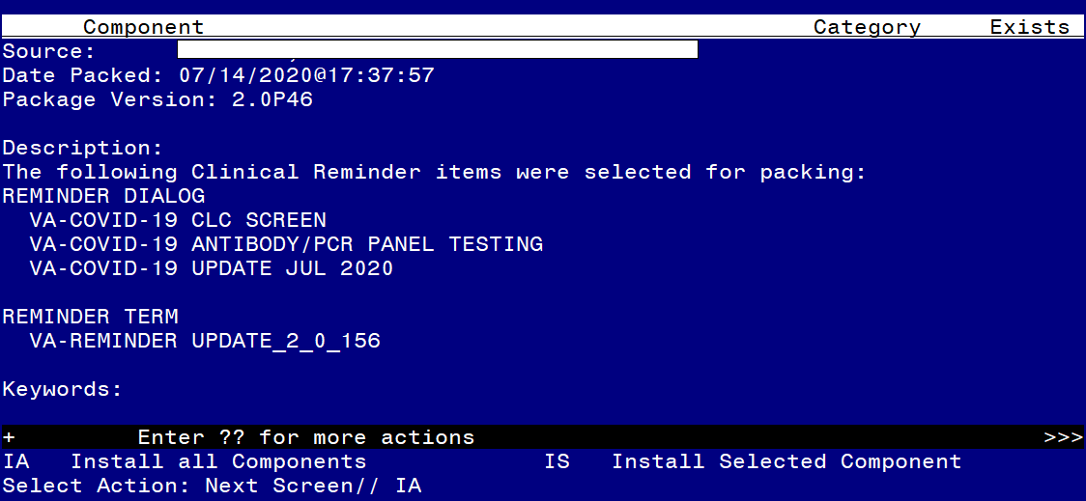

At the **Select Action** prompt, type **IA** for Install all Components and hit enter.

Select Action: Next Screen// IA Install all Components

You will see several prompts, for all new entries you will choose **I to Install**

For this component VA-TIME SPENT you will choose O to **Overwrite**, for all other components that already exists but the packed component is different, you will choose **S to Skip.**

You will then be promped to install the reminder dialog component – VA-COVID-19 UPDATE JUL 2020. Even though most components already exist, you will still choose IA to install all. 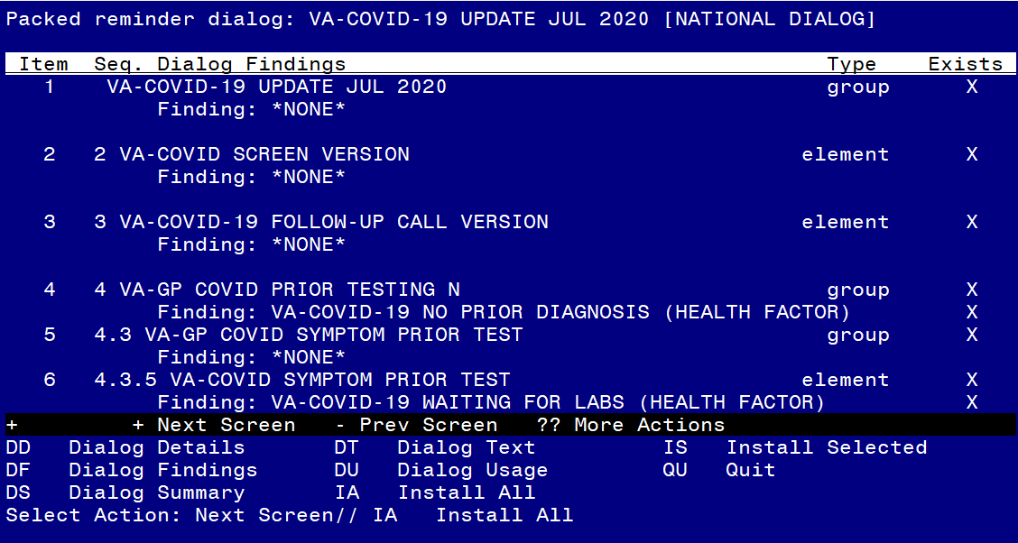

At the **Select Action** prompt, type **IA** to install the dialog – **VA-COVID-19 UPDATE JUL 2020**.

Select Action: Next Screen// IA Install All

Install reminder dialog and all components with no further changes: Y// Yes

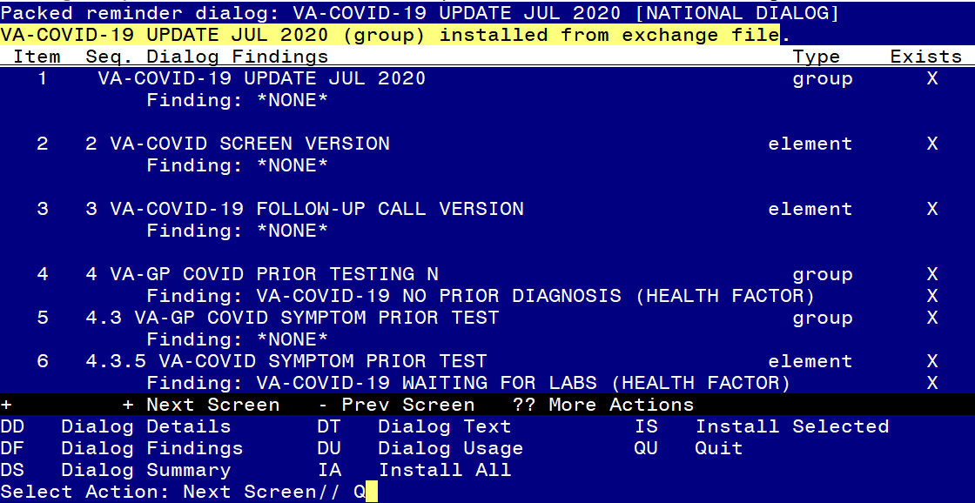 After completing this dialog install, you will type Q.

You will then be promped to install the reminder dialog component – VA-COVID-19 ANTIBODY/PCR PANEL TESTING . 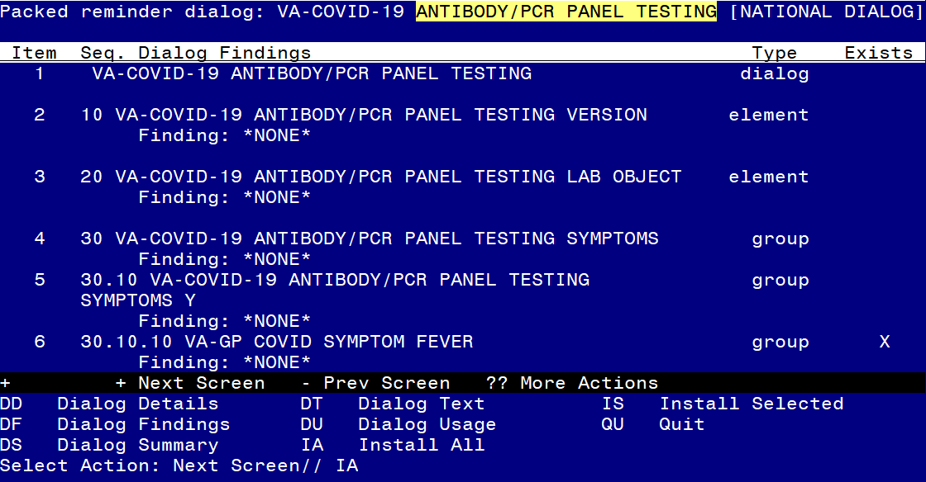

At the **Select Action** prompt, type **IA** to install the dialog – **VA-COVID-19 ANTIBODY/PCR PANEL TESTING**

Select Action: Next Screen// IA Install All

Install reminder dialog and all components with no further changes: Y// Yes

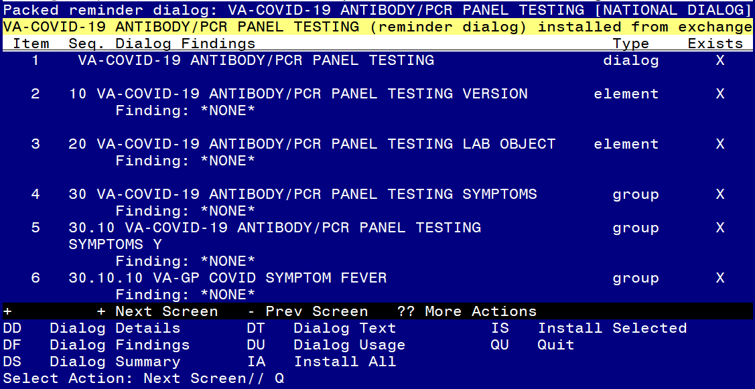

After completing this dialog install, you will type Q.

You will be promped to install the reminder dialog component – VA-COVID-19 CLC SCREEN. Even though most components already exist, you will still choose IA to install all.

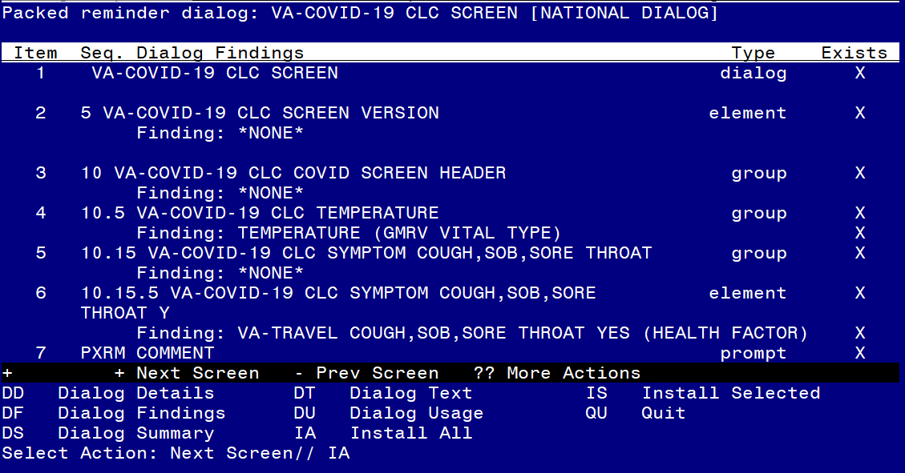

At the **Select Action** prompt, type **IA** to install the dialog – **VA-COVID-19 CLC SCREEN**

Select Action: Next Screen// IA Install All

Install reminder dialog and all components with no further changes: Y// Yes

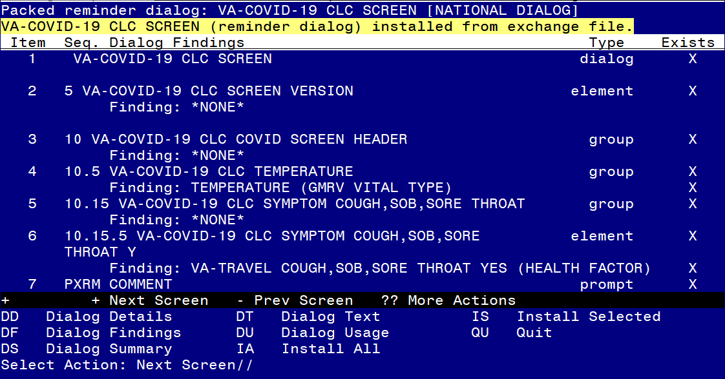

After completing this dialog install, you will type Q.

**You will then be prompted to install the health summary components.**

for all new entries you will choose **I to Install**

**You will then be brought back to this screen where you will type Q for quit**

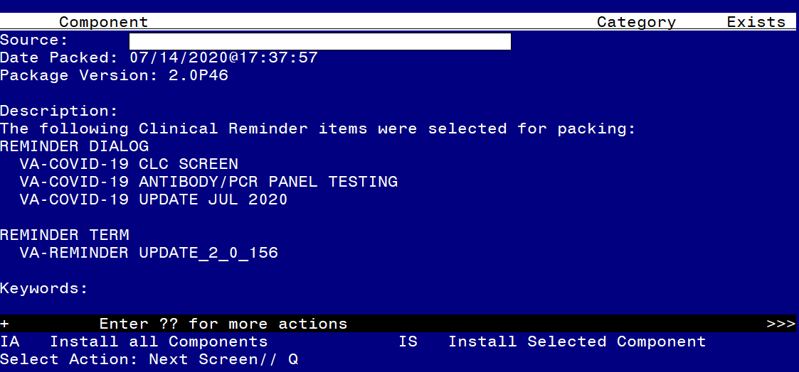

You will then be returned to this screen. At the **Select Action** prompt, type **Q.**

Install complete.

# Post Installation

1. **Make the Dialog able to be attached to a Personal/Shared template and/or progress note title.**

From the Reminders Manager Menu:

Select Reminder Managers Menu Option: **CP** CPRS Reminder Configuration

CA Add/Edit Reminder Categories

CL CPRS Lookup Categories

CS CPRS Cover Sheet Reminder List

MH Mental Health Dialogs Active

PN Progress Note Headers

RA Reminder GUI Resolution Active

TIU TIU Template Reminder Dialog Parameter

DL Default Outside Location

PT Position Reminder Text at Cursor

Select CPRS Reminder Configuration Option: **TIU** TIU Template Reminder Dialog Parameter

Reminder Dialogs allowed as Templates may be set for the following:

1 User USR [choose from NEW PERSON]

3 Service SRV [choose from SERVICE/SECTION]

4 Division DIV [choose from INSTITUTION]

5 System SYS [NATREM.FO-SLC.MED.VA.GOV]

Enter selection*:* 5  *Choose the appropriate number for your site. Your site may do this by System or other levels. The example below uses SYSTEM level*

Setting Reminder Dialogs allowed as Templates for System:

Select Display Sequence: **?**

148 VA-VETERANS CHOICE NOTE

149 VA-TBI SCREENING

*When you type a question mark above, you will see the list of #’s (with dialogs) that are already taken. Choose a number* ***NOT*** *on this list. For this example, looking above I see the number 150 is not present, so I will use 150.*

Select Display Sequence: **150**

Are you adding 150 as a new Display Sequence? Yes// **Y** YES

Display Sequence: 150// <Enter> 150

Clinical Reminder Dialog: VA-COVID-19 ANTIBODY/PCR PANEL TESTING

then **<enter>** reminder dialog NATIONAL

OK? Yes// <Enter> (Yes)

**Add to shared templates in CPRS**

To do this, go to Template Editor, then Shared Templates, select the appropriate folder (if applicable), and choose New Template (top right-hand corner).

Type in the following information:

Name: COVID-19 ANTIBODY/PCR PANEL TESTING

Template Type: Reminder Dialog

Reminder Dialog: VA-COVID-19 ANTIBODY/PCR PANEL TESTING

Next, select Apply.

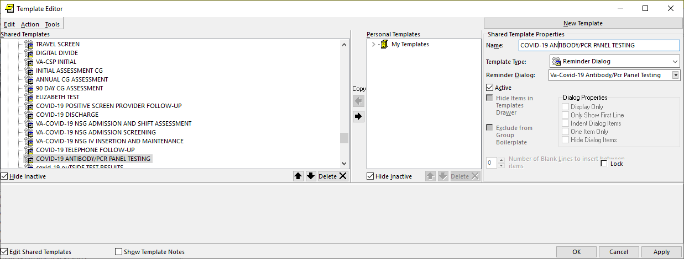

**Setup of specific Note title. (Optional)**

If your site wants to create a new note title specifically for this template, you can add this to the category that your site uses for your clinic notes. The note title should be:

**COVID-19 PCR AND ANTIBODY TESTING**

Map it to the VHA Enterprise Standard Title: INFECTIOUS DISEASE NOTE

Note: Comprehensive information on Creating Document Definitions can be found beginning on page 47 of the [TIU/ASU Implementation Guide](http://www.va.gov/vdl/documents/Clinical/CPRS-Text_Integration_Utility_(TIU)/tiuim.pdf)

1. **Edit Health Summary Type COVID19 LAB RESULTS LAST 6**
   1. **You will edit the Health Summary Type Component SLT (Select Lab Tests) and add all of your local lab tests for both COVID-19 PCR Antigen and COVID-19 Antibody testing.**
2. **Configure lab ordering.**
   1. **Sites can decide how to configure the order option, if you want only one test ordered each time, you will disable the dialog group for multiple tests, if your site wants to order the first test and then after it is positive order the other 4 tests with one order set you will not disable any items.**

The dialog group names are listed below:

* + - 1. Group VAL-COVID-19 ANTIBODY/PCR PANEL TESTING ORDER PCR ROUTINE – used for one-time order
         1. Add local order set for **routine** COVID-19 ANTIBODY TESTING and COVID-19 PCR ANTIGEN testing.
      2. Group VAL-COVID-19 ANTIBODY/PCR PANEL TESTING ORDER PCR STAT – used for one-time stat order
         1. Add local order set for **STAT or Urgent** COVID-19 PCR ANTIGEN and Routine COVID-19 ANTIBODY TESTING
      3. Group VAL-COVID-19 ANTIBODY/PCR PANEL TESTING ORDER PCR ROUTINE - used for one-time routine order and future orders for routine test at 2-week intervals.
         1. Add local order set for **routine** COVID-19 ANTIBODY TESTING and COVID-19 PCR ANTIGEN testing for now and then at 2 week intervals for a total of 4 sets (weeks 2,4,6 and 8).
         2. If your site does not want to display this option, you can edit the dialog group and at the disable prompt enter 2 - DISABLE AND DO NOT SEND MESSAGE.
      4. Element VAL-COVID-19 ANTIBODY/PCR PANEL TEST ORDERED – used by sites that order multiple tests and will allow to document only symptoms without placing an order. If you site is using the template for each order and not using the option to order multiple tests, you may want to disable this element.

1. **Open in CPRS or Review in Vista the template VA-SCREEN COVID and confirm the version number displays as 5.2**
2. **Open in CPRS or Review in Vista the template VA-COVID-19 TELEPHONE FOLLOW-UP and confirm the version number displays as 3.1.**
3. **Open in CPRS or Review in Vista the template VA-COVID-19 CLC SCREEN and confirm the version number is 2.1.**
4. **Open in CPRS or Review in Vista the template VA-COVID-19 SCI/D SCREEN and confirm the version number is 2.0.**
5. **Add local content to reminder dialog group VAL-COVID-19 CLC SCREEN LOCAL GROUP.**

Review the pre-install for this element and edit to make any local changes

1. **Add local content to reminder dialog element VAL-COVID-19 RTW PROVIDER SIGNATURE if needed. (Optional)**

Review the pre-install for this element and edit to make any local changes.

You should not have any txml fields in the alternate progress note text, do not edit this element to add any fields to the alternate text.

***NOTE****: If there are any questions or problems during the installation, please notify your local IT support to log a national help desk ticket or contact the VA Service Desk and have them submit a national ticket to:*

*Category: Affected Service*

*Affected Service: VistA – CPRS: Clinical Reminders*

*Assignment Group: Redacted*