

**Update _2_0_16**

Clinical Reminders

VA-WH MAMMOGRAM SCREENING

Install Guide

**October 2017**

Product Development

Department of Veterans Affairs

Contents

Introduction 3

Pre-Installation 6

Install Details 6

Install Example 7

Post-Install Set-up Instructions 17

Introduction

The mammogram screening reminder was originally released in 2005 by the Office of Women’s Health. In May 2017, the VHA adopted the American Cancer Society (ACS) breast cancer screening guidelines that give women a choice to begin screening at age 40. The guidelines also recommend starting yearly mammograms by age 45 and then every other year from age 55. The patch releases these edits to the existing national mammogram screening reminder.

Revisions:

1. Previously two reminder definitions and reminder dialogs were deployed; one for patients aged 50-74 and another aged 40-49. The 2017 revision will replace the two definitions and dialogs with one reminder definition and one reminder dialog. The reminder dialog will use branching logic to display three separate dialogs to the user based on the age of the patient; one for patients 40-44, one for patients 45-74, and one for patients >74.
2. The reminder definition baseline frequencies have been revised to the following:
   1. 0Y for patients 39 and younger
   2. 99Y for patients 40-44
   3. 1Y for patients 45-54
   4. 2Y for patients 55 and older
3. New health factors are deployed and appropriate terms and logic changes have been added to the reminder definition.
   1. VA-WH BR CA 40-44 BEGIN AGE 45
      1. Indicates a patient aged 40-44yo has chosen to begin annual mammogram screening at age 45. This health factor has a condition that will allow it to be evaluated as true only until the patient reaches age 45.
   2. VA-WH BR CA 40-44 WANTS SCREENING
      1. Indicates a patient has chosen to begin annual mammogram screening between ages 40-44. This health factor has a condition that will allow it to be evaluated as true only until the patient reaches age 45.
4. The condition within the currently deployed health factor WH BR CA 40-49 WANTS SCREENING, so that it will only be evaluated as true for patients until the patient reaches age 45. At age 45 the reminder will become applicable annually.
5. The 4-month frequency option has been removed from the reminder dialogs. The frequency finding was not removed from the reminder definition logic, so the reminder will still become applicable at 4 months for the appropriate patients. Providers can then choose a different frequency.
6. Logic added to the reminder definition to make the reminder applicable to patients aged 40-44, so the provider and patient can decide to begin screening at age 45 or between 40-44yo.
7. Logic added to have reminder to continue to become applicable after age 74, so provider and patient can decide to continue mammogram screening if patient is in good health and has life expectancy greater than 10 years.
8. Logic added to have reminder applicable annually for patients 45-54 and every two years for patients > 54yo. Providers will have opportunity to change frequency to annually for patients 55-74.
9. The reminder definition VA-WH DISCUSS BREAST CA SCREEN WOMAN 40-49 will be inactivated. The print name will be changed to “ZZDiscuss Breast CA (Discontined)” to indicate it should not be used.
10. The reminder dialog VA-WH DISCUSS BREAST CA WOMAN 40-49 will be disabled.

**Two reminder Definitions are being distributed with this update:**

VA-WH DISCUSS BREAST CA SCREEN WOMAN 40-49

VA-WH MAMMOGRAM SCREENING

UPDATE_2_0_16 contains 1 Reminder Exchange entry:

UPDATE_2_0_16 VA-WH MAMMOGRAM SCREENING

**The exchange file contains the following components:**

**TIU TEMPLATE FIELD**

BLANK TEXT FIELD FOR DIALOGS

VA-WH MAMMOGRAM GUIDANCE

**HEALTH FACTORS**

VA-REMINDER UPDATES

VA-UPDATE_2_0_16

WH MAMMOGRAM

WH BR CA SCREEN N/A 5 YRS-COMORBIDITIES

WH BR CA SCREEN N/A 5 YRS-LE<5YRS

WH MAMMOGRAM SCREEN NOT INDICATED

VA LIFE EXPECTANCY

VA LIMITED LIFE EXPECTANCY

WH BILATERAL MASTECTOMY

VA-WH BR CA DEFER 1Y

VA-WH BR CA DEFER 6M

WH ORDER MAMMOGRAM SCREEN HF

WH OUTSIDE INCOMPLETE MAMMOGRAM

WH OUTSIDE ABNL MAMMOGRAM

WH OUTSIDE NORMAL MAMMOGRAM

VA-WH BR CA 40-44 WANTS SCREENING

VA-WH BR CA 40-44 BEGIN AGE 45

WH MAMMOGRAM SCREEN FREQ - 2Y

WH MAMMOGRAM SCREEN FREQ - 1Y

WH MAMMOGRAM SCREEN FREQ - 6M

WH MAMMOGRAM DEFERRED

WH MAMMOGRAM DECLINED

WH BR CA 40-49 WANTS SCREENING

WH MAMMOGRAM SCREEN FREQ - 4M

REMINDER FACTORS

INACTIVATE BREAST CANCER SCREEN

WH ORDER MAMMOGRAM UNILAT HF

WH ORDER MAMMOGRAM BILAT HF

WH MAMMOGRAM OUTSIDE

WH BR CA 40-49 DEFER 5Y

WH BR CA 40-49 DEFER 1Y

WH BR CA 40-49 DEFER 6M

WH BR CA 40-49 BEGIN AGE 50

**REMINDER SPONSOR**

Women Veterans Health Program

Women Veterans Health Program and National Center for Health Promotion and Disease Prevention (NCP)

Mental Health Services and Women Veterans Health Program

Office of Patient Care Services

VHA National Center for Health Promotion and Disease Prevention (NCP) and VHA Office of Women's Health

National Center for Health Promotion and Disease Prevention (NCP)

**REMINDER TAXONOMY**

VA-BREAST TUMOR

VA-MAMMOGRAM/SCREEN

VA-TERMINAL CANCER PATIENTS

VA-WH BILATERAL MASTECTOMY

VA-MASTECTOMY

**REMINDER TERM**

VA-UPDATE_2_0_16

VA-AGE >39&<45

VA-AGE >74

VA-WH MAMMOGRAM AGE<55

VA-WH BR CA 40-44 WANTS SCREEN TERM

VA-WH BR CA 40-44 BEGIN AGE 45

VA-WH MAMMOGRAM ORDER

VA-WH HX BREAST CANCER/ABNORMAL MAM

VA-WH MAMMOGRAM SCREEN FREQ - 2Y

VA-WH MAMMOGRAM SCREEN FREQ - 1Y

VA-WH MAMMOGRAM SCREEN FREQ - 6M

VA-WH MAMMOGRAM SCREEN FREQ - 4M

VA-WH MAMMOGRAM UNSATISFACTORY IN RAD/WH PKG

VA-WH MAMMOGRAM SCREEN DEFER

VA-WH MAMMOGRAM SCREEN NOT INDICATED

VA-WH BREAST CARE ORDER HEALTH FACTOR

VA-WH MAMMOGRAM SCREEN DONE

VA-WH MAMMOGRAM SCREEN IN RAD PKG

VA-WH MAMMOGRAM SCREEN IN WH PKG

VA-TERMINAL CANCER PATIENT

VA-WH BILATERAL MASTECTOMY

**REMINDER DEFINITION**

VA-WH DISCUSS BREAST CA SCREEN WOMAN 40-49

VA-WH MAMMOGRAM SCREENING

**REMINDER DIALOG**

VA-WH DISCUSS BREAST CA WOMAN 40-49

VA-WH MAMMOGRAM SCREENING

# Pre-Installation

1. Create a copy of the reminder inquiry output for the current VA-WH MAMMOGRAM SCREENING and VA-WH DISCUSS BREAST CA SCREEN WOMAN 40-49 installed in VistA to use as a reference for mapping to the new reminder definition terms.
2. Create a copy of the detailed display of the VA-WH MAMMOGRAM SCREENING and VA-WH DISCUSS BREAST CA WOMAN 40-49 reminder dialogs to use as a reference for mapping findings to the new reminder dialog groups and elements.
3. In reminder Dialog manager, Dialog manager, Group Vies, Inquire on Group VA-WH GP ORDERS-MAMMOGRAM SCREEN and note the order used as a finding. You will need to map this order in the post install section.

# Install Details

This update is being distributed as a web host file. The address for the host file is: **https://REDACTEDS/UPDATE_2_0_16.PRD**

The file will be installed using Reminder Exchange, programmer access is not required.

*This patch can be installed with users on the system, but it should be done during non-peak hours.* *Estimated Installation Time: 5-10 minutes*

# Install Example

To Load the Web Host File. Navigate to Reminder exchange in Vista

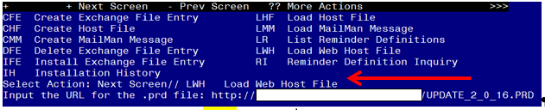

At the **Select Action:** prompt, enter **LWH** for Load Web Host File

At the **Input the url for the .prd file:** prompt, type the following web address:

**https://REDACTED UPDATE_2_0_16.PRD**

Terminal window screen shot of the message displaying the URL of the file that was successfully loaded.  Part of the URL has been redacted as it is a VA only internal web site URL.

You should see a message at the top of your screen that the file successfully loaded.

Search and locate an entry titled UPDATE_2_0_16 VA-WH MAMMOGRAM SCREENING in reminder exchange

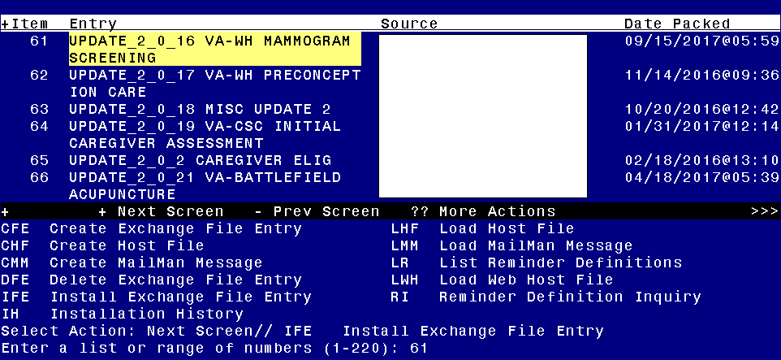

At the **Select Action** prompt, enter **IFE** for Install Exchange File Entry

Enter the number that corresponds with your entry titled UPDATE_2_0_16 VA-WH MAMMOGRAM SCREENING *(in this example it is entry 61, it will vary by site)*

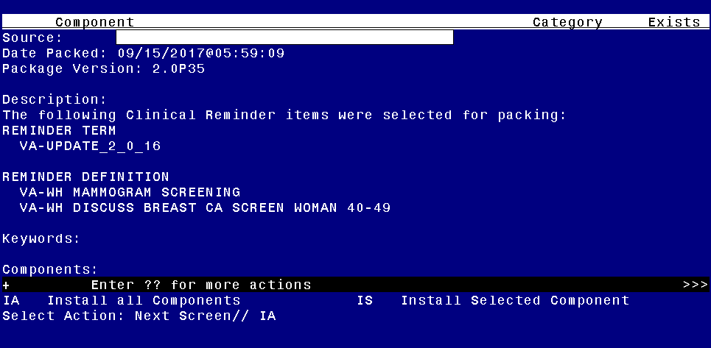

At the **Select Action** prompt, type **IA** for Install all Components and hit enter.

You will see several prompts, for all new entries you will choose I to Install, For existing entries you will Overwrite or MERGE if it is a reminder term. Here are the prompts you may see:

Select Action: Next Screen// IA Install all Components

TIU TEMPLATE FIELD entry named BLANK TEXT FIELD FOR DIALOGS already

exists and the packed component is identical, skipping.

TIU TEMPLATE FIELD entry named VA-WH MAMMOGRAM GUIDANCE already exists

but the packed component is different, what do you want to do?

Select one of the following:

C Create a new entry by copying to a new name

O Overwrite the current entry

U Update

Q Quit the install

S Skip, do not install this entry

Enter response: O// verwrite the current entry

Are you sure you want to overwrite? N// y YES

HEALTH FACTORS entry named VA-REMINDER UPDATES already exists and the

packed component is identical, skipping.

HEALTH FACTORS entry VA-UPDATE_2_0_16 is NEW,

what do you want to do?

Select one of the following:

C Create a new entry by copying to a new name

I Install

Q Quit the install

S Skip, do not install this entry

Enter response: I// nstall

HEALTH FACTORS entry named WH MAMMOGRAM already exists and the packed

component is identical, skipping.

HEALTH FACTORS entry named WH MAMMOGRAM SCREEN FREQ - 1Y already

exists and the packed component is identical, skipping.

HEALTH FACTORS entry named WH MAMMOGRAM SCREEN FREQ - 6M already

exists and the packed component is identical, skipping.

HEALTH FACTORS entry named WH BR CA SCREEN N/A 5 YRS-COMORBIDITIES

already exists and the packed component is identical, skipping.

HEALTH FACTORS entry named WH BR CA SCREEN N/A 5 YRS-LE<5YRS already

exists and the packed component is identical, skipping.

HEALTH FACTORS entry named WH MAMMOGRAM SCREEN NOT INDICATED already

exists and the packed component is identical, skipping.

HEALTH FACTORS entry named VA LIFE EXPECTANCY already exists and the

packed component is identical, skipping.

HEALTH FACTORS entry named VA LIMITED LIFE EXPECTANCY already exists

and the packed component is identical, skipping.

HEALTH FACTORS entry named WH BILATERAL MASTECTOMY already exists and

the packed component is identical, skipping.

HEALTH FACTORS entry VA-WH BR CA DEFER 1Y is NEW,

what do you want to do?

Select one of the following:

C Create a new entry by copying to a new name

I Install

Q Quit the install

S Skip, do not install this entry

Enter response: I// nstall

HEALTH FACTORS entry VA-WH BR CA DEFER 6M is NEW,

what do you want to do?

Select one of the following:

C Create a new entry by copying to a new name

I Install

Q Quit the install

S Skip, do not install this entry

Enter response: I// nstall

HEALTH FACTORS entry named WH ORDER MAMMOGRAM SCREEN HF already

exists and the packed component is identical, skipping.

HEALTH FACTORS entry named WH OUTSIDE INCOMPLETE MAMMOGRAM already

exists and the packed component is identical, skipping.

HEALTH FACTORS entry named WH OUTSIDE ABNL MAMMOGRAM already exists

and the packed component is identical, skipping.

HEALTH FACTORS entry named WH OUTSIDE NORMAL MAMMOGRAM already exists

and the packed component is identical, skipping.

HEALTH FACTORS entry VA-WH BR CA 40-44 WANTS SCREENING is NEW,

what do you want to do?

Select one of the following:

C Create a new entry by copying to a new name

I Install

Q Quit the install

S Skip, do not install this entry

Enter response: I// nstall

HEALTH FACTORS entry VA-WH BR CA 40-44 BEGIN AGE 45 is NEW,

what do you want to do?

Select one of the following:

C Create a new entry by copying to a new name

I Install

Q Quit the install

S Skip, do not install this entry

Enter response: I// nstall

HEALTH FACTORS entry named WH MAMMOGRAM DECLINED already exists and

the packed component is identical, skipping.

HEALTH FACTORS entry named WH MAMMOGRAM SCREEN FREQ - 2Y already

exists and the packed component is identical, skipping.

HEALTH FACTORS entry named WH MAMMOGRAM DEFERRED already exists and

the packed component is identical, skipping.

HEALTH FACTORS entry named WH BR CA 40-49 WANTS SCREENING already

exists and the packed component is identical, skipping.

HEALTH FACTORS entry named WH MAMMOGRAM SCREEN FREQ - 4M already

exists and the packed component is identical, skipping.

HEALTH FACTORS entry named REMINDER FACTORS already exists and the

packed component is identical, skipping.

HEALTH FACTORS entry named INACTIVATE BREAST CANCER SCREEN already

exists and the packed component is identical, skipping.

HEALTH FACTORS entry named WH ORDER MAMMOGRAM UNILAT HF already exists

and the packed component is identical, skipping.

HEALTH FACTORS entry named WH ORDER MAMMOGRAM BILAT HF already exists

and the packed component is identical, skipping.

HEALTH FACTORS entry named WH MAMMOGRAM OUTSIDE already exists and

the packed component is identical, skipping.

HEALTH FACTORS entry named WH BR CA 40-49 DEFER 5Y already exists and

the packed component is identical, skipping.

HEALTH FACTORS entry named WH BR CA 40-49 DEFER 1Y already exists and

the packed component is identical, skipping.

HEALTH FACTORS entry named WH BR CA 40-49 DEFER 6M already exists and

the packed component is identical, skipping.

HEALTH FACTORS entry named WH BR CA 40-49 BEGIN AGE 50 already exists

and the packed component is identical, skipping.

REMINDER SPONSOR entry named Women Veterans Health Program already

exists and the packed component is identical, skipping.

REMINDER SPONSOR entry named Women Veterans Health Program and

National Center for Health Promotion and Disease Prevention (NCP)

already exists and the packed component is identical, skipping.

REMINDER SPONSOR entry named Mental Health Services and Women

Veterans Health Program already exists and the packed component is

identical, skipping.

REMINDER SPONSOR entry named Office of Patient Care Services already

exists and the packed component is identical, skipping.

REMINDER SPONSOR entry named VHA National Center for Health Promotion

and Disease Prevention (NCP) and VHA Office of Women's Health already

exists and the packed component is identical, skipping.

REMINDER SPONSOR entry named National Center for Health Promotion and

Disease Prevention (NCP) already exists and the packed component is

identical, skipping.

REMINDER TAXONOMY entry named VA-MASTECTOMY already exists but the

packed component is different, what do you want to do?

Select one of the following:

C Create a new entry by copying to a new name

O Overwrite the current entry

U Update

Q Quit the install

S Skip, do not install this entry

Enter response: O// verwrite the current entry

Are you sure you want to overwrite? N// YES

REMINDER TAXONOMY entry named VA-BREAST TUMOR already exists but the

packed component is different, what do you want to do?

Select one of the following:

C Create a new entry by copying to a new name

O Overwrite the current entry

U Update

Q Quit the install

S Skip, do not install this entry

Enter response: O// verwrite the current entry

Are you sure you want to overwrite? N// YES

REMINDER TAXONOMY entry named VA-TERMINAL CANCER PATIENTS already

exists but the packed component is different, what do you want to do?

Select one of the following:

C Create a new entry by copying to a new name

O Overwrite the current entry

U Update

Q Quit the install

S Skip, do not install this entry

Enter response: O// verwrite the current entry

Are you sure you want to overwrite? N// YES

REMINDER TAXONOMY entry named VA-MAMMOGRAM/SCREEN already exists but

the packed component is different, what do you want to do?

Select one of the following:

C Create a new entry by copying to a new name

O Overwrite the current entry

U Update

Q Quit the install

S Skip, do not install this entry

Enter response: O// verwrite the current entry

Are you sure you want to overwrite? N// YES

REMINDER TAXONOMY entry named VA-WH BILATERAL MASTECTOMY already

exists but the packed component is different, what do you want to do?

Select one of the following:

C Create a new entry by copying to a new name

O Overwrite the current entry

U Update

Q Quit the install

S Skip, do not install this entry

Enter response: O// verwrite the current entry

Are you sure you want to overwrite? N// y YES

REMINDER TERM entry VA-UPDATE_2_0_16 is NEW,

what do you want to do?

Select one of the following:

C Create a new entry by copying to a new name

I Install

Q Quit the install

S Skip, do not install this entry

Enter response: I// nstall

REMINDER TERM entry VA-AGE >39&<45 is NEW,

what do you want to do?

Select one of the following:

C Create a new entry by copying to a new name

I Install

Q Quit the install

S Skip, do not install this entry

Enter response: I// nstall

REMINDER TERM entry VA-AGE >74 is NEW,

what do you want to do?

Select one of the following:

C Create a new entry by copying to a new name

I Install

Q Quit the install

S Skip, do not install this entry

Enter response: I// nstall

REMINDER TERM entry VA-WH MAMMOGRAM AGE<55 is NEW,

what do you want to do?

Select one of the following:

C Create a new entry by copying to a new name

I Install

Q Quit the install

S Skip, do not install this entry

Enter response: I// nstall

REMINDER TERM entry VA-WH BR CA 40-44 WANTS SCREEN TERM is NEW,

what do you want to do?

Select one of the following:

C Create a new entry by copying to a new name

I Install

Q Quit the install

S Skip, do not install this entry

Enter response: I// nstall

REMINDER TERM entry VA-WH BR CA 40-44 BEGIN AGE 45 is NEW,

what do you want to do?

Select one of the following:

C Create a new entry by copying to a new name

I Install

Q Quit the install

S Skip, do not install this entry

Enter response: I// nstall

REMINDER TERM entry named VA-WH MAMMOGRAM ORDER already exists but

the packed component is different, what do you want to do?

Select one of the following:

C Create a new entry by copying to a new name

M Merge findings

O Overwrite the current entry

U Update

Q Quit the install

S Skip, do not install this entry

Enter response: O// Merge findings

REMINDER TERM entry named VA-WH HX BREAST CANCER/ABNORMAL MAM already

exists and the packed component is identical, skipping.

REMINDER TERM entry named VA-WH MAMMOGRAM SCREEN FREQ - 2Y already

exists and the packed component is identical, skipping.

REMINDER TERM entry named VA-WH MAMMOGRAM SCREEN FREQ - 1Y already

exists and the packed component is identical, skipping.

REMINDER TERM entry named VA-WH MAMMOGRAM SCREEN FREQ - 6M already

exists and the packed component is identical, skipping.

REMINDER TERM entry named VA-WH MAMMOGRAM SCREEN FREQ - 4M already

exists and the packed component is identical, skipping.

REMINDER TERM entry named VA-WH MAMMOGRAM UNSATISFACTORY IN RAD/WH

PKG already exists but the packed component is different, what do you

want to do?

Select one of the following:

C Create a new entry by copying to a new name

M Merge findings

O Overwrite the current entry

U Update

Q Quit the install

S Skip, do not install this entry

Enter response: O// Merge findings

REMINDER TERM entry named VA-WH MAMMOGRAM SCREEN DEFER already exists

but the packed component is different, what do you want to do?

Select one of the following:

C Create a new entry by copying to a new name

M Merge findings

O Overwrite the current entry

U Update

Q Quit the install

S Skip, do not install this entry

Enter response: O// Merge findings

REMINDER TERM entry named VA-WH MAMMOGRAM SCREEN NOT INDICATED

already exists and the packed component is identical, skipping.

REMINDER TERM entry named VA-WH BREAST CARE ORDER HEALTH FACTOR

already exists and the packed component is identical, skipping.

REMINDER TERM entry named VA-WH MAMMOGRAM SCREEN DONE already exists but

the packed component is different, what do you want to do?

Select one of the following:

C Create a new entry by copying to a new name

M Merge findings

O Overwrite the current entry

U Update

Q Quit the install

S Skip, do not install this entry

Enter response: O// Merge findings

REMINDER TERM entry named VA-WH MAMMOGRAM SCREEN IN RAD PKG already

exists and the packed component is identical, skipping.

REMINDER TERM entry named VA-WH MAMMOGRAM SCREEN IN WH PKG already

exists and the packed component is identical, skipping.

REMINDER TERM entry named VA-TERMINAL CANCER PATIENT already exists

and the packed component is identical, skipping.

REMINDER TERM entry named VA-WH BILATERAL MASTECTOMY already exists but

the packed component is different, what do you want to do?

Select one of the following:

C Create a new entry by copying to a new name

M Merge findings

O Overwrite the current entry

U Update

Q Quit the install

S Skip, do not install this entry

Enter response: O// Merge findings

REMINDER TERM entry named VA-WH BR CA 40-49 WANTS SCREEN TERM

already exists and the packed component is identical, skipping.

REMINDER DEFINITION entry named VA-WH MAMMOGRAM SCREENING already

exists but the packed component is different, what do you want to do?

Select one of the following:

C Create a new entry by copying to a new name

O Overwrite the current entry

U Update

Q Quit the install

S Skip, do not install this entry

Enter response: O// verwrite the current entry

Are you sure you want to overwrite? N// YES

REMINDER DEFINITION entry named VA-WH DISCUSS BREAST CA SCREEN WOMAN

40-49 already exists but the packed component is different, what do

you want to do?

Select one of the following:

C Create a new entry by copying to a new name

O Overwrite the current entry

U Update

Q Quit the install

S Skip, do not install this entry

Enter response: O// verwrite the current entry

Are you sure you want to overwrite? N// YES

After the components have installed,

**You will be promped to install the first reminder dialog component:** Regarding the Reminder Dialog VA-WH MAMMORGRAM SCREENING:
Screen shot of the terminal window showing a list of elements, groups and dialogs with the text with IA for "Install All" entered at the "Select Action:" Prompt.  The correct entry is described in the text.

At the **Select Action** prompt, type **IA** to install the dialog **– VA-WH MAMMOGRAM SCREENING**

Select Action: Next Screen// IA Install All

Install reminder dialog and all components with no further changes: Y// YES

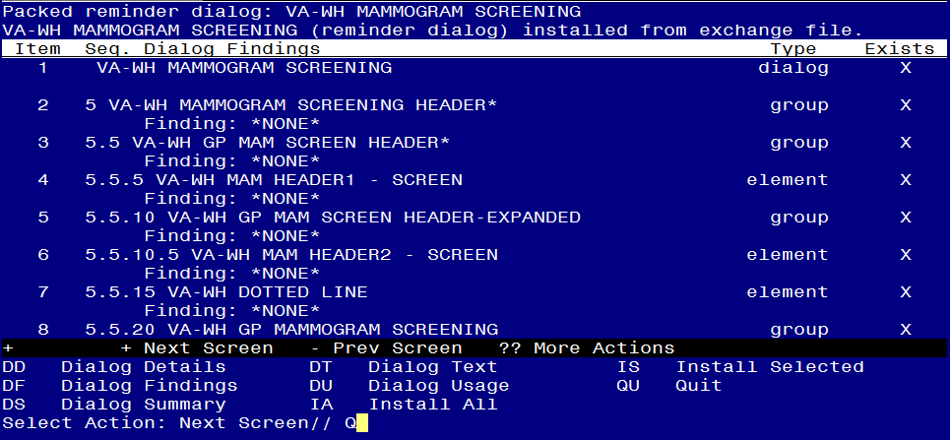

When the dialog has completed installation, you will then be returned to this screen. At the **Select Action** prompt, type **Q.**

**You will then be prompted to install the next Dialog component:**

Regarding the Reminder Dialog VA-WH DISCUSS BREAST CANCER WOMAN 40-49:
Screen shot of the terminal window showing a list of elements, groups and dialogs with the text with IA for "Install All" entered at the "Select Action:" Prompt.  The correct entry is described in the text.

At the **Select Action** prompt, type **IA** to install the dialog **– VA-WH DISCUSS BREAST CA WOMAN 40-49**

Select Action: Next Screen// IA Install All

Install reminder dialog and all components with no further changes: Y// YES

Screen shot of the last of the list of elements, groups and dialogs that need to be installed with a quit entered at the "Select Action:" prompt.  



When the dialog has completed installation, you will then be returned to this screen. At the **Select Action** prompt, type **Q.**

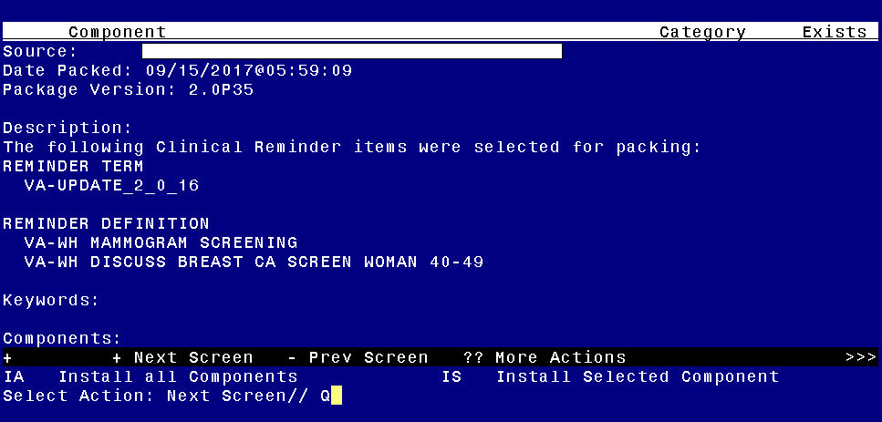

You will then be returned to this screen. At the **Select Action** prompt, type **Q.**

Install Completed

# Post-Install Set-up Instructions

## Map local health factors to new terms.

1. Term Name: **VA-WH BR CA 40-44 BEGIN AGE 45**
   1. Map any local findings that represent a patient has decided to begin annual mammogram screening at age 45.
2. Term name: **VA-WH BR CA 40-44 WANTS SCREEN TERM**
   1. Map any local finding(s) that represent a patient has decided to begin annual screening at age 40 and continue to age 44.
3. **Confirm following dialog groups and elements have appropriate local orders embedded.**
4. Group Name: **VA-WH GP ORDERS - MAMMOGRAM SCREEN**
   1. Map local mammogram screening order to the FINDING ITEM field. This group was not revised in this update, but sites should confirm the appropriate order is still embedded.

NAME: VA-WH GP ORDERS - MAMMOGRAM SCREEN

DISABLE:

CLASS: LOCAL//

SPONSOR: Women Veterans Health Program//

REVIEW DATE:

RESOLUTION TYPE:

ORDERABLE ITEM:

FINDING ITEM: Order should be placed here

1. **Confirm the reminder definition VA-WH DISCUSS BREAST CA SCREEN WOMAN 40-49 has been removed from the CPRS cover sheet list and that it is inactive.**
2. The following should display when accessing the reminder definition from the reminder definition manager menu.

Select Reminder Definition: VA-WH DISCUSS BREAST CA SCREEN WOMAN 40-49 NATIONAL (INACTIVE)