

**Update \_2\_0\_173B**

Clinical Reminders

VA-COVID-19 IMMUNIZATION REMINDER UPDATE B

Install Guide

**DECEMBER 2020**

Product Development

Office of Information Technology

Department of Veterans Affairs

Table of Contents

[Introduction 1](#_Toc57024368)

[Install Details 2](#_Toc57024369)

[Install Example 2](#_Toc57024370)

[Post Installation 6](#_Toc57024371)

# Introduction

DESCRIPTION: This update revises the VA-SARS-COV-2 IMMUNIZATION dialog, VA-SARS-COV-2 IMMUNIZATION TEMPLATE dialog and the two terms described below.

The VA-SARS-COV-2 VACCINE INDICATION 4 reminder term has been streamlined. This term allows sites to configure the reminder to be applicable to inpatients in specific hospital locations or assigned to specific treating specialties. The term now only has one finding. Specifics are in the post-installation steps.

Two health factors representing contraindications to the Moderna and Pfizer vaccines have been added to the VA-SARS-COV-2 VACCINE CONTRAINDICATION reminder term.

Changes to the dialogs:

1. Updated template fields
   1. URLs for EUA fact sheets added.
   2. Details on vaccination added.
   3. Pre-vaccination text revised.
   4. Post-vaccination text revised.
2. Updates to dialog groups and elements
   1. Separated post-vaccination text for dose 1 and dose 2.
   2. Added CPT codes for dose 1 and dose 2.
   3. Separated and enabled contraindication option for Pfizer and Moderna options.
   4. Added optional dialog group for scribes.
   5. Added optional dialog element for policy/protocol documentation.
   6. Enabled the administration group and historical group for Pfizer vaccine.
   7. ICD-10 Z23. option added. This option is hidden for inpatients.
   8. Telehealth/Virtual visit option hidden for inpatients.

UPDATE\_2\_0\_173B contains 1 Reminder Exchange entry:

**UPDATE\_2\_0\_173B VA-COVID-19 IMMUNIZATION REMINDER**

**The exchange file contains the following components:**

**REMINDER TERM**

VA-SARS-COV-2 VACCINE INDICATION 4

VA-SARS-COV-2 VACCINE CONTRAINDICATION

VA-REMINDER UPDATE\_2\_0\_173B

**REMINDER DIALOG**

VA-SARS-COV-2 IMMUNIZATION 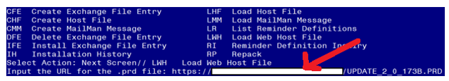

VA-SARS-COV-2 IMMUNIZATION TEMPLATE

# Install Details

This update is being distributed as a web host file. The address for the host file is: **<https://Redacted /UPDATE_2_0_173B.PRD>**

The file will be installed using Reminder Exchange, programmer access is not required.

This update can be loaded with users on the system. Installation will take less than 5 minutes

# Install Example

To Load the Web Host File. Navigate to Reminder exchange in Vista

At the **Select Action:** prompt, enter **LWH** for Load Web Host File

At the **Input the url for the .prd file:** prompt, type the following web address:

**https://Redacted /UPDATE\_2\_0\_173B.PRD**

Search and locate an entry titled **UPDATE\_2\_0\_173B VA-COVID-19 IMMUNIZATION REMINDER.**

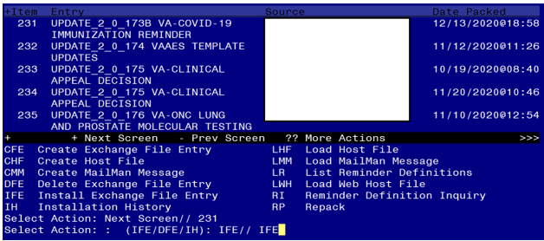

At the **Select Action** prompt, enter **IFE** for Install Exchange File Entry

Enter the number that corresponds with your entry **UPDATE\_2\_0\_173B VA-COVID-19 IMMUNIZATION REMINDER.**  *(in this example it is entry 231 it will vary by site).* The date of the exchange file should be 12/13/2020.

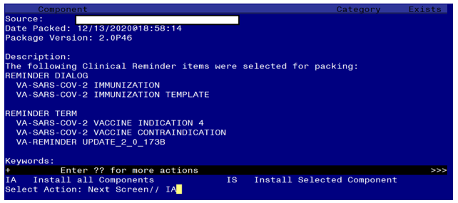

At the **Select Action** prompt, type **IA** for Install all Components and hit enter.

Select Action: Next Screen// IA Install all Components

During installation,

* Install all NEW items
* Overwrite TIU template fields
* Overwrite the reminder terms

**You will be promped to install the 1st reminder dialog component – You will choose to install all.**

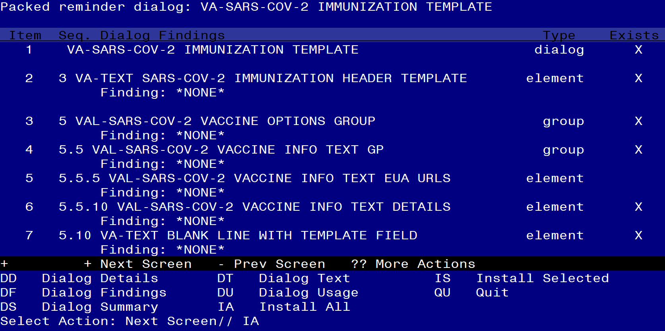

At the **Select Action** prompt, type **IA** to install the dialog –

Select Action: Next Screen// IA Install All

Install reminder dialog and all components with no further changes: Y// Yes

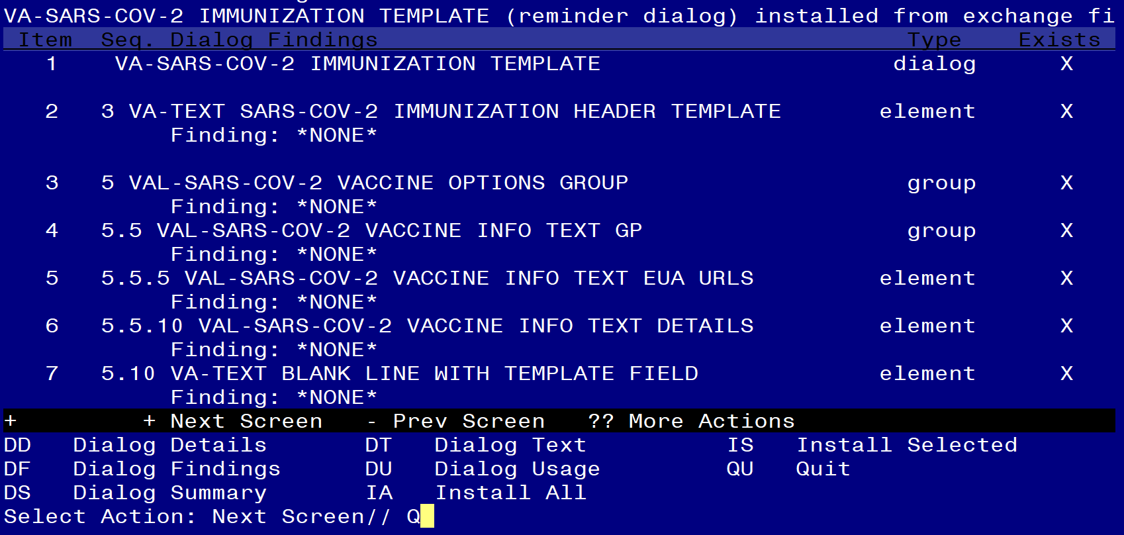

After completing this dialog install, you will type Q.

**You will be promped to install the 2nd reminder dialog component – You will choose to install all.**

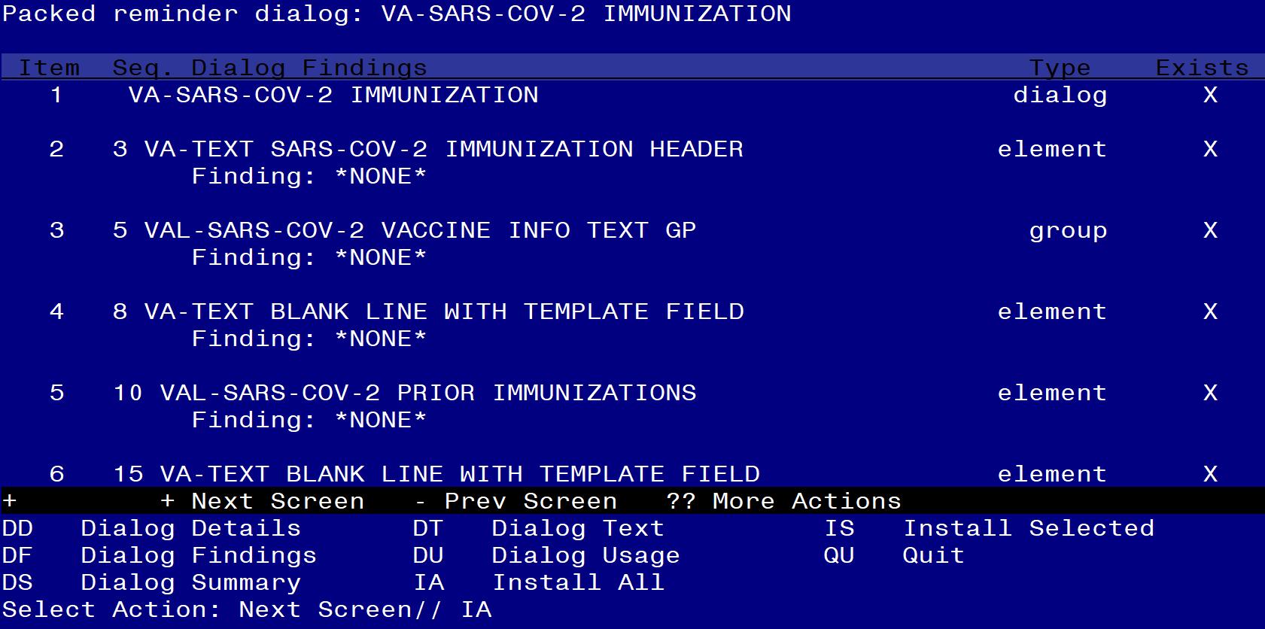

At the **Select Action** prompt, type **IA** to install the dialog –

Select Action: Next Screen// IA Install All

Install reminder dialog and all components with no further changes: Y// Yes

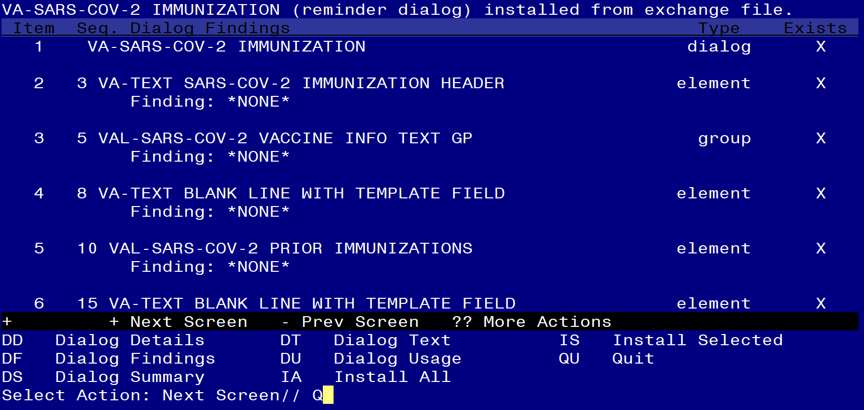

After completing this dialog install, you will type Q.

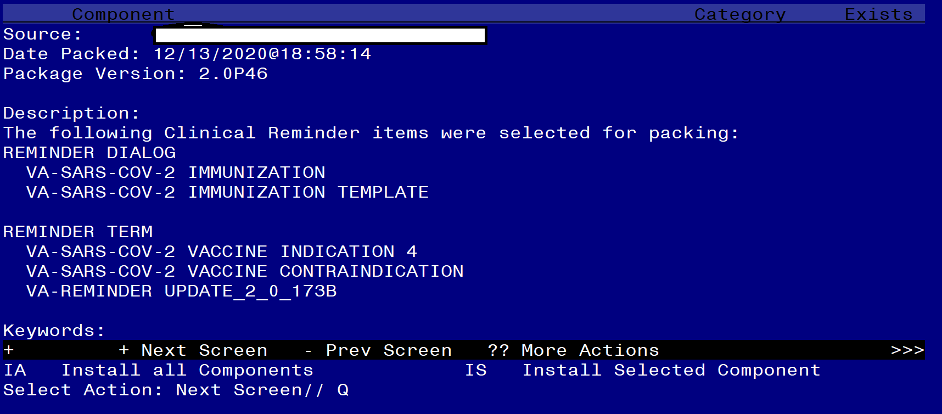

You will then be returned to this screen. At the **Select Action** prompt, type **Q.**

Install complete.

# Post-Installation

1. **Configure term VA-SARS-COV-2 VACCINE INDICATION 4, so the COVID-19 Immunization reminder is due for inpatients (as necessary).**

The term now contains one instance of the computed finding for VA-IS INPATIENT. Examples are in the reminder term and below describing how to set it up for A) all inpatients, B) for selected treating specialties, **or** C) for selected wards.

1. **To make the reminder due for all inpatients and limit to specific wards with the “Edit Cover Sheet Reminder List” option in CPRS:**
2. **Delete the condition in the finding to include all inpatients in the cohort.**
3. **Assign the reminder only to those wards that are appropriate.**

**Do not assign to acute medical or surgical wards or ICU.**

Navigate to the REMINDER MANAGERS MENU

CF Reminder Computed Finding Management ...

RM Reminder Definition Management ...

SM Reminder Sponsor Management ...

TXM Reminder Taxonomy Management

TRM Reminder Term Management ...

LM Reminder Location List Management ...

RX Reminder Exchange

RT Reminder Test

OS Other Supporting Menus ...

INFO Reminder Information Only Menu ...

DM Reminder Dialog Management ...

CP CPRS Reminder Configuration ...

RP Reminder Reports ...

MST Reminders MST Synchronization Management ...

PL Reminder Patient List Menu ...

PAR Reminder Parameters ...

VS NLM Value Set Menu

ROC Reminder Order Check Menu ...

CQM NLM Clinical Quality Measures Menu

XM Reminder Extract Menu ...

Select Reminder Managers Menu <TEST ACCOUNT> Option: **TRM**

TL List Reminder Terms

TI Inquire about Reminder Term

TE Add/Edit Reminder Term

TC Copy Reminder Term

TICS Integrity Check Selected

TICA Integrity Check All

TEST Term Test

Select Reminder Term Management <TEST ACCOUNT> Option: **TE**

Select Reminder Term: **VA-SARS-COV-2 VACCINE INDICATION 4**

Choose from:

CF VA-IS INPATIENT Finding # 1

Select Finding: **`1** VA-IS INPATIENT

Computed Finding Description:

Editing Finding Number: 1

FINDING ITEM: VA-IS INPATIENT// **<enter>**

BEGINNING DATE/TIME: **<enter>**

ENDING DATE/TIME: **<enter>**

OCCURRENCE COUNT: **<enter>**

COMPUTED FINDING PARAMETER: **<enter>**

CONDITION: I V("WARD LOCATION")="REMOVE THIS LINE OR EDIT AS IN THE TERM DESCRIPTION" Replace **@**

SURE YOU WANT TO DELETE? **Yes**

CONDITION CASE SENSITIVE: **<enter> Leave the finding item**

1. **OR if the reminder should be due for inpatients assigned to certain treating specialties:**
2. **Change the condition in FI(1) as below.**
3. **Assign the reminder to the SYSTEM level in CPRS.**

**Check with your MAS/Bed Management teams to verify that you have included all the appropriate treating specialties.**

In this example, the term will be true for inpatients who are assigned to a treating specialty with “NH” or “SPINAL” in the treating specialty name.

Navigate to the REMINDER MANAGERS MENU

CF Reminder Computed Finding Management ...

RM Reminder Definition Management ...

SM Reminder Sponsor Management ...

TXM Reminder Taxonomy Management

TRM Reminder Term Management ...

LM Reminder Location List Management ...

RX Reminder Exchange

RT Reminder Test

OS Other Supporting Menus ...

INFO Reminder Information Only Menu ...

DM Reminder Dialog Management ...

CP CPRS Reminder Configuration ...

RP Reminder Reports ...

MST Reminders MST Synchronization Management ...

PL Reminder Patient List Menu ...

PAR Reminder Parameters ...

VS NLM Value Set Menu

ROC Reminder Order Check Menu ...

CQM NLM Clinical Quality Measures Menu

XM Reminder Extract Menu ...

Select Reminder Managers Menu <TEST ACCOUNT> Option: **TRM**

TL List Reminder Terms

TI Inquire about Reminder Term

TE Add/Edit Reminder Term

TC Copy Reminder Term

TICS Integrity Check Selected

TICA Integrity Check All

TEST Term Test

Select Reminder Term Management <TEST ACCOUNT> Option: **TE**

Select Reminder Term: **VA-SARS-COV-2 VACCINE INDICATION 4**

Choose from:

CF VA-IS INPATIENT Finding # 1

Select Finding: **`1** VA-IS INPATIENT

Computed Finding Description:

Editing Finding Number: 1

FINDING ITEM: VA-IS INPATIENT// **<enter>**

BEGINNING DATE/TIME: **<enter>**

ENDING DATE/TIME: **<enter>**

OCCURRENCE COUNT: **<enter>**

COMPUTED FINDING PARAMETER: **<enter>**

CONDITION: I V("WARD LOCATION")="REMOVE THIS LINE OR EDIT AS IN THE TERM DESCRIPTION" Replace **…** With **I V("TREATING SPECIALTY")["NH"!V("TREATING**

**SPECIALTY")["SPINAL"**

CONDITION CASE SENSITIVE: **No**

**Leave the finding item**

1. **OR to have the reminder due for inpatients and use ward names in the condition:**
2. **Change the condition in FI(1) as below.**
3. **Assign the reminder to the SYSTEM level in CPRS.**

In this example, the term will be true for inpatients on wards named CLC1 and CLC2

Navigate to the REMINDER MANAGERS MENU

CF Reminder Computed Finding Management ...

RM Reminder Definition Management ...

SM Reminder Sponsor Management ...

TXM Reminder Taxonomy Management

TRM Reminder Term Management ...

LM Reminder Location List Management ...

RX Reminder Exchange

RT Reminder Test

OS Other Supporting Menus ...

INFO Reminder Information Only Menu ...

DM Reminder Dialog Management ...

CP CPRS Reminder Configuration ...

RP Reminder Reports ...

MST Reminders MST Synchronization Management ...

PL Reminder Patient List Menu ...

PAR Reminder Parameters ...

VS NLM Value Set Menu

ROC Reminder Order Check Menu ...

CQM NLM Clinical Quality Measures Menu

XM Reminder Extract Menu ...

Select Reminder Managers Menu <TEST ACCOUNT> Option: **TRM**

TL List Reminder Terms

TI Inquire about Reminder Term

TE Add/Edit Reminder Term

TC Copy Reminder Term

TICS Integrity Check Selected

TICA Integrity Check All

TEST Term Test

Select Reminder Term Management <TEST ACCOUNT> Option: **TE**

Select Reminder Term: **VA-SARS-COV-2 VACCINE INDICATION 4**

Choose from:

CF VA-IS INPATIENT Finding # 1

Select Finding: **`1** VA-IS INPATIENT

Computed Finding Description:

Editing Finding Number: 7

FINDING ITEM: VA-IS INPATIENT// **<enter>**

BEGINNING DATE/TIME: **<enter>**

ENDING DATE/TIME: **<enter>**

OCCURRENCE COUNT: **<enter>**

COMPUTED FINDING PARAMETER: **<enter>**

CONDITION: I V("WARD LOCATION")="REMOVE THIS LINE OR EDIT AS IN THE TERM DESCRIPTION" Replace **…** With **I V("WARD LOCATION")="CLC1"!V("WARD LOCATION")="CLC2"**

CONDITION CASE SENSITIVE: **No**

**Leave the finding item**

1. **If scribes are used locally, then the VAL-IM TEXT SCRIBE GP dialog group can be enabled to add the option below.**

**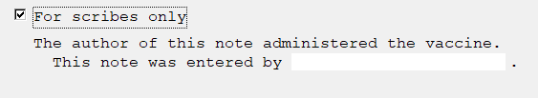**

**Navigate to the VAL-IM TEXT SCRIBE GP Group**

NAME: VAL-IM TEXT SCRIBE GP Replace

DISABLE: DISABLE AND DO NOT SEND MESSAGE// **@**

SURE YOU WANT TO DELETE? **Yes**

CLASS: LOCAL//

SPONSOR:

REVIEW DATE:

RESOLUTION TYPE:

ORDERABLE ITEM:

**Leave the group**

1. **Administration by policy/protocol: If a site has a policy that allows administration of the vaccine by policy or protocol, then 2 options exist:**
2. **Enable the VAL-TEXT ADMIN BY PROTOCOL dialog element to allow this to be documented on selected patients.**

**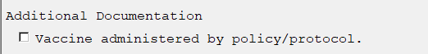**

**Navigate to the VAL-IM TEXT SCRIBE GP element**

NAME: VAL-TEXT ADMIN BY PROTOCOL Replace

DISABLE: DISABLE AND DO NOT SEND MESSAGE// **@**

SURE YOU WANT TO DELETE? **Yes**

CLASS: LOCAL//

SPONSOR:

**Leave the element**

1. **Or add appropriate information to the post-vaccination text in the following two TIU template fields.**

**IM SARS COV-2 ADMIN INFO POST TEXT D2 #1  
IM SARS COV-2 ADMIN INFO POST TEXT D2 #2**

**Example text to add:  
Vaccine administered by protocol without complications. The patient was   
 advised to remain in the facility for 15 minutes post vaccination.**

**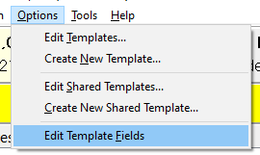**

**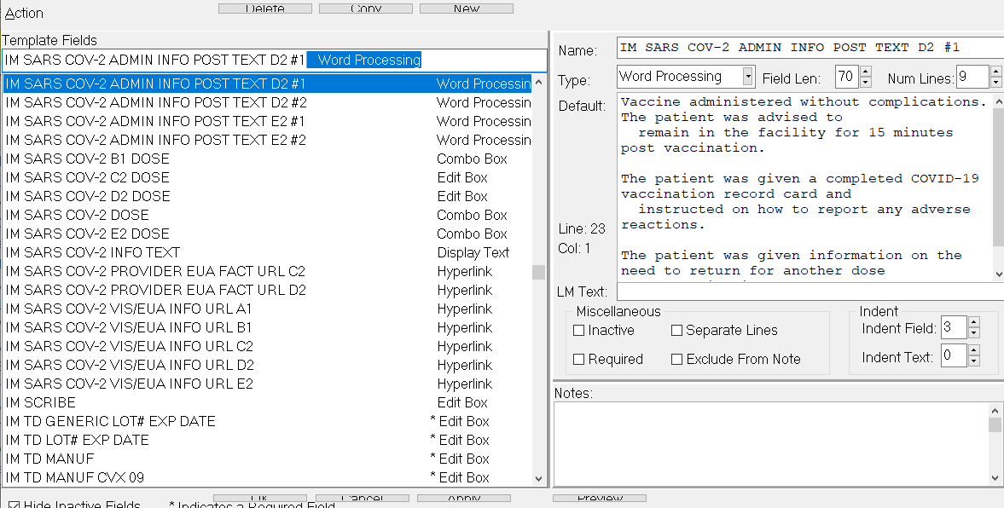**

1. **For sites that do not have the Pfizer vaccine, consider disabling the dialog group for documenting administration of the Pfizer vaccine. The group is VAL-SARS-COV-2 VACCINE ADMIN D2 GP.**

**Navigate to the group**

NAME: VAL-SARS-COV-2 VACCINE ADMIN D2 GP Replace

DISABLE: **2** DISABLE AND DO NOT SEND MESSAGE

CLASS: LOCAL//

**Leave reminder group**

1. **Edit appropriate lot number prompts for the appropriate vaccines (as necessary). It is important to follow the formatting in the example.**

Throughout the dialog groups, elements, and additional prompts, and install guide, the COVID-19 placeholder immunizations are stored and represented as listed below. The Pfizer and Moderna immunizations have been updated in the IMMUNIZATION file, but some groups and elements may still be named according the table below.

Ensure to edit the groups, elements, and additional prompts for the appropriate corresponding vaccine.

**Reminder: reminder dialog prompts MUST be updated with the correct lot # and expiration date information**

|  |  |  |  |  |  |  |
| --- | --- | --- | --- | --- | --- | --- |
|  | **VistA Reminder Designation** | **CVX** | **CPT** | **Series 1 CPT** | **Series 2 CPT** | **Prompt for Lot # and Expiration** |
| Pfizer | D2 | 208 | 91300 | 0001A | 0002A | IM SARS-COV-2 VACCINE D2 MVX LOT EXP |
| Moderna | C2 | 207 | 91301 | 0011A | 0012A | IM SARS-COV-2 VACCINE C2 MVX LOT EXP |

* 1. **Navigate to reminder dialogs and change view to Additional Prompts.** The example below is for the Moderna vaccine.

DIALOG VIEW (REMINDER DIALOGS - SOURCE REMINDER NAME)

+Item Reminder Dialog Name Source Reminder Status

316 VA-SARS-COV-2 IMMUNIZATION VA-SARS COV-2

317 VA-SCREEN COVID \*NONE\*

318 VA-SOC WORK ADVANCE CARE PLANNING GROUP \*NONE\*

319 VA-SOC WORK ADVANCE CARE PLANNING GV-F/ \*NONE\*

320 VA-SPINAL CORD INJURIES AND DISORDERS \*NONE\*

321 VA-SRA-CONSULT RESPONSE (D) \*NONE\*

322 VA-STAR ABC CARD \*NONE\*

323 VA-STAR BEHAVIOR INCIDENT NOTE (BIN) \*NONE\*

324 VA-TBI SCREENING VA-TBI SCREENING

325 VA-TBI/POLYTRAUMA REHAB/REINTEGRATION P \*NONE\* Linked

326 VA-TECS GLAUCOMA PHYSICIAN \*NONE\*

327 VA-TECS GLAUCOMA TECHNICIAN \*NONE\*

328 VA-TECS LETTERS \*NONE\*

329 VA-TECS PHYSICIAN \*NONE\*

+ Enter ?? for more actions >>>

AD Add Reminder Dialog PT List/Print All QU Quit

CV Change View RN Name/Print Name

Select Item: Next Screen// **CV**

Select one of the following:

D Reminder Dialogs

E Dialog Elements

F Forced Values

G Dialog Groups

P Additional Prompts

R Reminders

RG Result Group (Mental Health)

RE Result Element (Mental Health)

TYPE OF VIEW: R// **P**

* 1. **Search list and navigate to the IM SARS-COV-2 VACCINE….. prompts**

DIALOG VIEW (ADDITIONAL PROMPTS)

Item Dialog Name Dialog type Status

1 1 MJB COMMENT NONFORCED Additional Prompt

2 1 MJB READING Additional Prompt

3 ARCH COMMENT Additional Prompt

4 BP CUFF LARGE Additional Prompt

5 BP CUFF MEDIUM Additional Prompt

6 BP CUFF SMALL Additional Prompt

7 BP CUFF THIGH Additional Prompt

8 CKBOX NOT INDICATED/YES/NO Additional Prompt

9 CKBOX VA PC F/UP ABDOMEN Additional Prompt

10 CKBOX VA PC F/UP EXTREMITIES Additional Prompt

11 CKBOX VA PC F/UP HEART Additional Prompt

12 CKBOX VA PC F/UP LUNG Additional Prompt

13 CKBOX VA PC F/UP MOOD Additional Prompt

14 CKBOX VA PC F/UP NASAL CAVITY Additional Prompt

+ + Next Screen - Prev Screen ?? More Actions >>>

AD Add PT List/Print All QU Quit

CO Copy Dialog INQ Inquiry/Print

CV Change View TE Dialog Taxonomy Edit

Select Item: Next Screen// **SL**

Search for: **IM SARS-COV-2 VACCINE**

* 1. **Identify appropriate vaccine lot number prompt.**

In this example, the lot information prompt for the Moderna vaccine will be edited. All appropriate lot numbers for the Moderna vaccine will be entered as unique sequence numbers in the C2 prompt.

Each available vaccine lot information prompt will need to be edited.

Instruct pharmacy of the need to be notified of new vaccines and/or lot numbers.

**These prompts may need to be updated frequently.**

+Item Dialog Name Dialog type Status

32 IM SARS-COV-2 VACCINE C2 MVX LOT EXP Additional Prompt

33 IM SARS-COV-2 VACCINE D2 MVX LOT EXP Additional Prompt

34 IM SARS-COV-2 VACCINE E2 MVX LOT EXP Additional Prompt

35 INFLUENZA H1N1 MANUFACTURERS Additional Prompt

36 INFLUENZA HIGH DOSE MANUFACTURERS Additional Prompt

37 ORZ PXRM COMMENT 2 Additional Prompt

38 PXRM ADD TO PROBLEM LIST Additional Prompt

39 PXRM BRADEN 10-12 Additional Prompt

40 PXRM BRADEN 13-14 Additional Prompt

41 PXRM BRADEN 15-18 Additional Prompt

42 PXRM BRADEN 19-23 Additional Prompt

43 PXRM BRADEN 6-8 Additional Prompt

44 PXRM COMMENT Additional Prompt

45 PXRM CONTRAINDICATED Additional Prompt

+ + Next Screen - Prev Screen ?? More Actions >>>

AD Add PT List/Print All QU Quit

CO Copy Dialog INQ Inquiry/Print

CV Change View TE Dialog Taxonomy Edit

Select Item: Next Screen// **32**  **Enter item number for the appropriate prompt**

Dialog Name: IM SARS-COV-2 VACCINE C2 MVX LOT EXP **<enter>**

Current dialog element/group name: IM SARS-COV-2 VACCINE C2 MVX LOT EXP

Used by: VAL-SARS-COV-2 VACCINE C2 #1 GP (Dialog Group)

VAL-SARS-COV-2 VACCINE C2 #2 GP (Dialog Group)

NAME: IM SARS-COV-2 VACCINE C2 MVX LOT EXP Replace **<enter>**

DISABLE: **<enter>**

CLASS: LOCAL// **<enter>**

SPONSOR: **<enter>**

REVIEW DATE: **<enter>**

PROMPT CAPTION: MVX (Manuf); Lot#; Exp Date: Replace **<enter>**

EXCLUDE FROM PROGRESS NOTE: **<enter>**

DEFAULT VALUE: **<enter>**

Select CHECKBOX SEQUENCE: **? Enter ? to view list**

Answer with CHECKBOX SEQUENCE

Choose from:

1 MOD; LOT; mm/dd/yyyy

You may enter a new CHECKBOX SEQUENCE, if you wish

Type a Number between 1 and 500, 0 Decimal Digits

Select CHECKBOX SEQUENCE: **1** **Enter sequence number to be revised. Sequence 1 will**

**be the 1st checkbox at the top of the list in CPRS.**

CHECKBOX SEQUENCE: 1// **<enter>**

TEXT: MOD; LOT; mm/dd/yyyy ... (Enter “…” to replace all)

With **MOD; M3141; 12/01/2020 (This is an example only. Follow the exact formatting to**

**enter the MVX code, Lot Number, then Expiration Date.**

**The information must be separated by a semi-colon.)**

Replace ... With MOD; M3141; 12/01/2020 Replace **<enter>**

MOD; M3141; 12/01/2020

Select CHECKBOX SEQUENCE: **2** **Enter sequence number to be revised. Continue until**

**all appropriate lot numbers for this vaccine are entered. Delete any unneeded default lot number sequences included in the update.**

The TEXT field for each lot number must follow this format:

**