

**Update _2_0_173D**

Clinical Reminders

VA-COVID-19 IMMUNIZATION REMINDER UPDATE D

Install Guide

**DECEMBER 2020**

Product Development

Office of Information Technology

Department of Veterans Affairs

Table of Contents

Introduction 1

Install Details 2

Install Example 3

Post-Installation 7

# Introduction

DESCRIPTION: This update revises several items in the VA-SARS-COV-2 IMMUNIZATION dialog and VA-SARS-COV-2 IMMUNIZATION TEMPLATE dialog. This update also contains four local taxonomies that can be added to the terms used in the reminder cohort logic

Changes to the dialogs:

1. These 2 template fields will both be updated in this reminder dialog group: VAL-SARS-COV-2 VACCINE INFO TEXT GP ALLERGY

Add a new template field

IM SARS COV-2 PBM VACCINE ANAPHYLAXIS INFO URL

Update this template field text

IM SARS COV-2 INFO TEXT ANAPHYLAXIS

1. Update the text in these 3 template fields to include the statement about prior anaphylaxis to injectable therapy.

IM SARS COV-2 ADMIN C2 INFO PRE TEXT

IM SARS COV-2 ADMIN D2 INFO PRE TEXT

IM SARS COV-2 INFO TEXT CDC ACIP

1. Update the headers to v2.4   –  2 elements
   1. VA-TEXT SARS-COV-2 IMMUNIZATION HEADER
   2. VA-TEXT SARS-COV-2 IMMUNIZATION HEADER TEMPLATE
2. Reminder dialog element VAL-SARS-COV-2 VACCINE REFUSED PFIZER will be installed by Moderna only sites:
   1. The disable and send message was changed to disable and do not send message.

In addition to the dialog changes, there are 4 new taxonomies that are a class of local:

1. HEMODIALYSIS
2. HOMELESS
3. CHEMOTHERAPY
4. TRANSPLANT - SOLID ORGAN

UPDATE_2_0_173D contains 1 Reminder Exchange entry:

**UPDATE_2_0_173D VA-COVID-19 IMMUNIZATION REMINDER**

**The exchange file contains the following components:**

**TIU TEMPLATE FIELD**

IM SARS COV-2 PBM VACCINE ANAPHYLAXIS INFO URL

IM SARS COV-2 CDC VACCINE ANAPHYLAXIS INFO URL

IM SARS COV-2 PFIZER PRE SCREEN

IM SARS COV-2 INFO TEXT ANAPHYLAXIS

IM SARS COV-2 INFO TEXT CDC ACIP

IM SARS COV-2 ADMIN D2 INFO PRE TEXT

IM SARS COV-2 ADMIN C2 INFO PRE TEXT

**HEALTH FACTORS**

VA-REMINDER UPDATES

VA-UPDATE_2_0_173D

IMMUNIZATION

VA-SARS-COV-2 VACCINE REFUSAL

VA-SARS-COV-2 IMM REFUSAL - PFR CVX 208

**REMINDER SPONSOR**

NATIONAL CENTER FOR HEALTH PROMOTION AND DISEASE PREVENTION (NCP)

**REMINDER TAXONOMY**

TRANSPLANT - SOLID ORGAN

CHEMOTHERAPY

HOMELESS

HEMODIALYSIS

**REMINDER TERM**

VA-REMINDER UPDATE_2_0_173D

**REMINDER DIALOG**

VAL-SARS-COV-2 VACCINE REFUSED PFIZER

SARS-COV-2 IMMUN UPDATE 173D V2.4

# Install Details

This update is being distributed as a web host file. The address for the host file is: **https://Redacted /UPDATE_2_0_173D.PRD**

The file will be installed using Reminder Exchange, programmer access is not required.

This update can be loaded with users on the system. Installation will take less than 5 minutes

# Install Example

To Load the Web Host File. Navigate to Reminder exchange in Vista

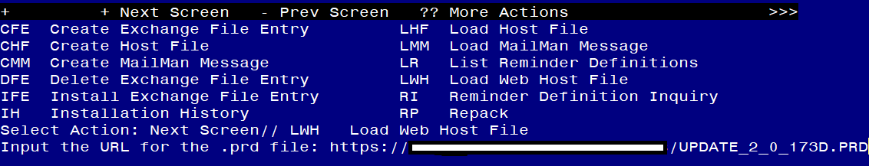

At the **Select Action:** prompt, enter **LWH** for Load Web Host File

At the **Input the url for the .prd file:** prompt, type the following web address:

**https://Redacted /UPDATE_2_0_173D.PRD**

Search and locate an entry titled **UPDATE_2_0_173D VA-COVID-19 IMMUNIZATION REMINDER.**

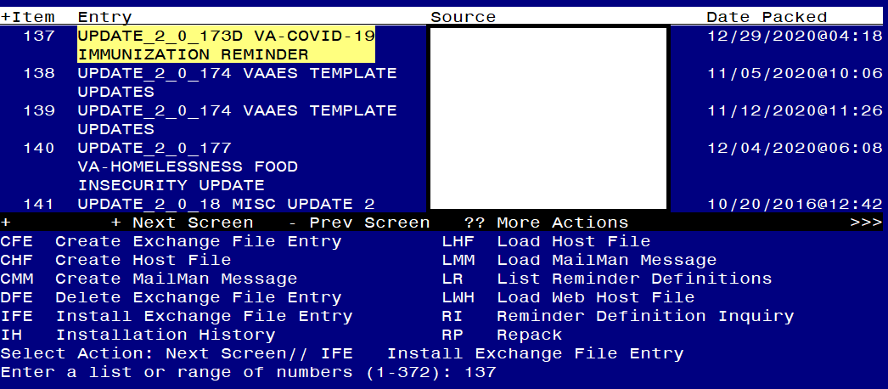

At the **Select Action** prompt, enter **IFE** for Install Exchange File Entry

Enter the number that corresponds with your entry **UPDATE_2_0_173D VA-COVID-19 IMMUNIZATION REMINDER.**  *(in this example it is entry 137 it will vary by site).* The date of the exchange file should be 12/29/2020.

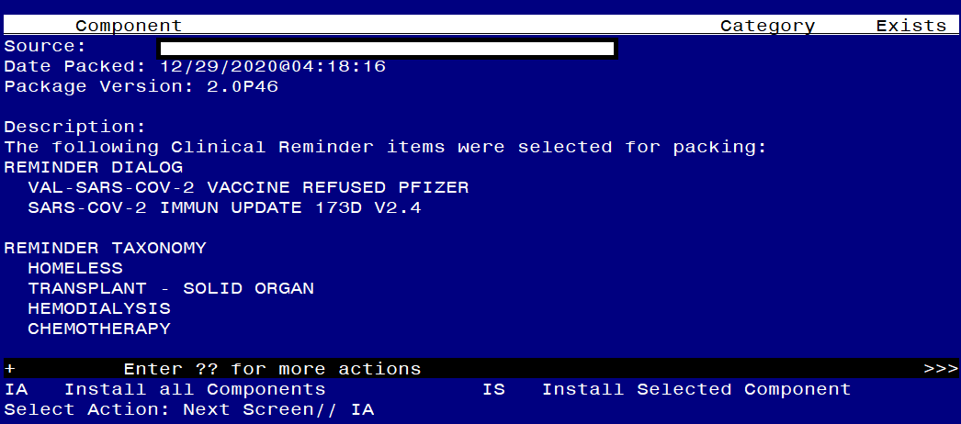

At the **Select Action** prompt, type **IA** for Install all Components and hit enter.

Select Action: Next Screen// IA Install all Components

During installation,

* Install all NEW items
* Overwrite all existing TIU template fields

**You will be promped to install the FIRST reminder dialog component – – if you are Pfizer site you will choose Q to quit and not install. If you are a Moderna only site, you will choose IA to install all.**

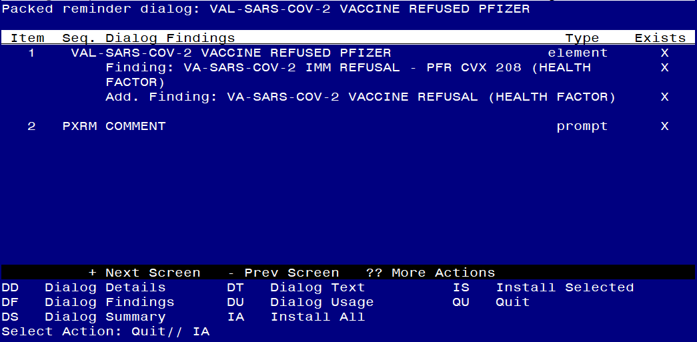

At the **Select Action** prompt, type **IA** to install the dialog – **VAL-SARS-COV-2 VACCINE REFUSED PFIZER**

Select Action: Next Screen// IA Install All or **Q QUIT IF YOU ARE A PFIZER SITE**

Install reminder dialog and all components with no further changes: Y// Yes

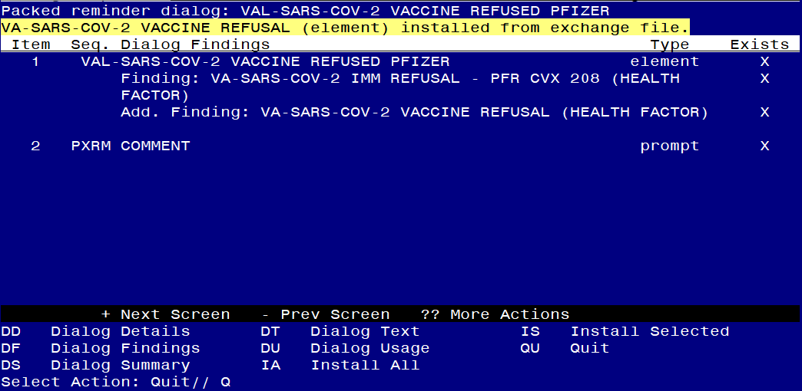

After completing this dialog install, you will type Q.

**You will be promped to install the NEXT reminder dialog component, You will choose to install all.**

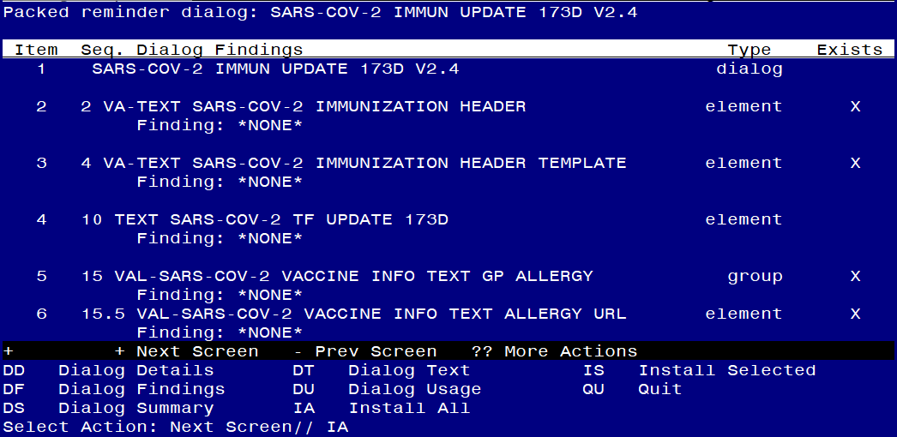

At the **Select Action** prompt, type **IA** to install the dialog – **SARS-COV-2 IMMUN UPDATE 173D V2.4**

Select Action: Next Screen// IA Install All

Install reminder dialog and all components with no further changes: Y// Yes

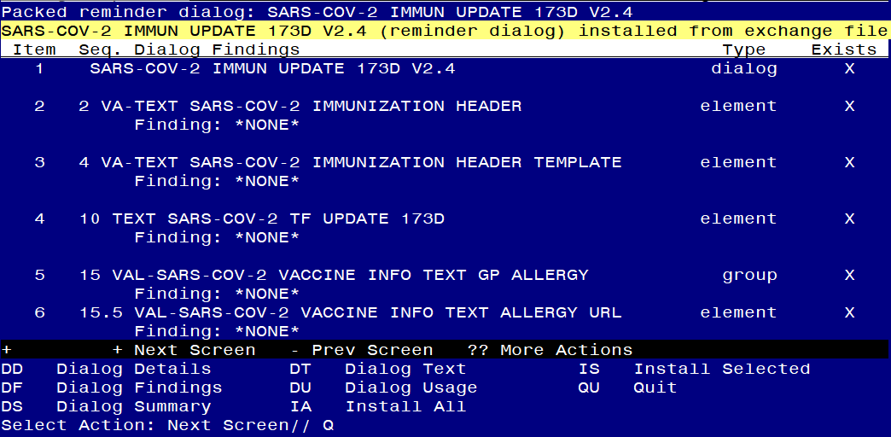

After completing this dialog install, you will type Q.

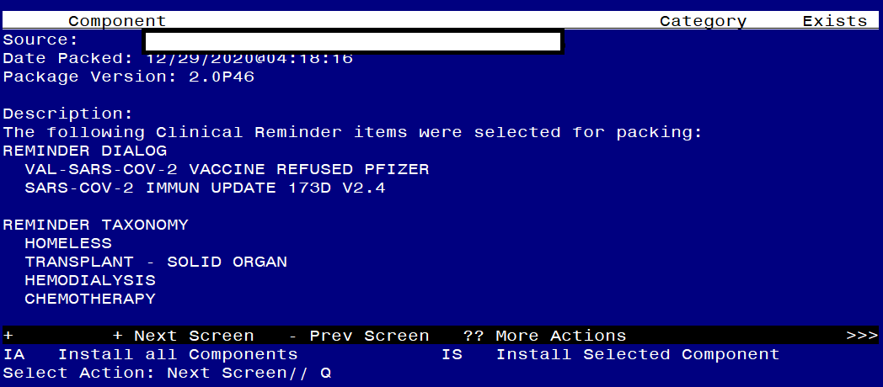

You will then be returned to this screen. At the **Select Action** prompt, type **Q.**

Install complete.

# Post-Installation

*You will need to close and reopen CPRS to see the txml field changes.*

1. **Configure term VA-SARS-COV-2 VACCINE INDICATION 1, so the COVID-19 Immunization reminder is due (as necessary).**

There are 4 new taxonomies that can be used to add patients to the cohort logic when instructed by your facility.

HEMODIALYSIS

HOMELESS

CHEMOTHERAPY

TRANSPLANT - SOLID ORGAN

**Below is one example, you can add more than one of the new taxonomies to this term following the same steps. The decision for which taxonomies to add to make the reminder due for the cohort of patients is a local facility decision.**

Navigate to the REMINDER MANAGERS MENU

CF Reminder Computed Finding Management ...

RM Reminder Definition Management ...

SM Reminder Sponsor Management ...

TXM Reminder Taxonomy Management

TRM Reminder Term Management ...

LM Reminder Location List Management ...

RX Reminder Exchange

RT Reminder Test

OS Other Supporting Menus ...

INFO Reminder Information Only Menu ...

DM Reminder Dialog Management ...

CP CPRS Reminder Configuration ...

RP Reminder Reports ...

MST Reminders MST Synchronization Management ...

PL Reminder Patient List Menu ...

PAR Reminder Parameters ...

VS NLM Value Set Menu

ROC Reminder Order Check Menu ...

CQM NLM Clinical Quality Measures Menu

XM Reminder Extract Menu ...

Select Reminder Managers Menu <TEST ACCOUNT> Option: **TRM**

TL List Reminder Terms

TI Inquire about Reminder Term

TE Add/Edit Reminder Term

TC Copy Reminder Term

TICS Integrity Check Selected

TICA Integrity Check All

TEST Term Test

Select Reminder Term Management <TEST ACCOUNT> Option: **TE**

Select Reminder Term: **VA-SARS-COV-2 VACCINE INDICATION 1**

Reminder Term has no findings!

Select Finding: TX.TRANSPLANT

Searching for a REMINDER TAXONOMY, (pointed-to by FINDING ITEM)

Searching for a REMINDER TAXONOMY

TRANSPLANT - SOLID ORGAN LOCAL

...OK? Yes// (Yes) : **<enter>**

Are you adding 'TRANSPLANT - SOLID ORGAN' as

a new FINDINGS (the 1ST for this REMINDER TERM)? No// Y (Yes)

Editing Finding Number: 1

FINDING ITEM: TRANSPLANT – SOLID ORGAN

BEGINNING DATE/TIME: **work with your site to determine the best beginning date and time. T-1Y or T-2Y could be used**

ENDING DATE/TIME: **<enter>**

OCCURRENCE COUNT: **<enter>**

COMPUTED FINDING PARAMETER: **<enter>**

CONDITION: : **<enter>**

CONDITION CASE SENSITIVE: **<enter>**

USE STATUS/COND IN SEARCH: : **<enter>**

No statuses defined for this finding item

Select one of the following:

A ADD STATUS

D DELETE A STATUS

S SAVE AND QUIT

Q QUIT WITHOUT SAVING CHANGES

Enter response: S// AVE AND QUIT: **<enter>**