

**Update _2_0_173E**

Clinical Reminders

VA-COVID-19 IMMUNIZATION REMINDER UPDATE E

Install Guide

**JANUARY 2021**

Product Development

Office of Information Technology

Department of Veterans Affairs

Table of Contents

Introduction 1

Install Details 1

Install Example 2

Post-Installation 6

# Introduction

DESCRIPTION: This update revises TIU template fields and adds a 4-day DUE IN ADVANCE timeframe to the VA-SARS COV-2 IMMUNIZATION reminder definition.

1. Update the headers to v2.5   –  2 elements
   1. VA-TEXT SARS-COV-2 IMMUNIZATION HEADER
   2. VA-TEXT SARS-COV-2 IMMUNIZATION HEADER TEMPLATE
2. Reminder dialog group VAL-SARS-COV-2 VACCINE INFO TEXT GP ACIP
   1. TIU template field IM SARS COV-2 CDC VACCINE INFO URL revised.
   2. TIU template field IM SARS COV-2 INFO TEXT CDC ACIP revised.
3. Reminder dialog group VAL-SARS-COV-2 VACCINE INFO TEXT GP ALLERGY
   1. TIU template field IM SARS COV-2 VA PRE SCREEN FORM added.
   2. TIU template field IM SARS COV-2 VACCINE ANAPHYLAXIS INFO URL revised.
   3. TIU template field IM SARS COV-2 INFO TEXT ANAPHYLAXIS revised.

The VA-SARS-COV-2 IMMUNIZATION dialog must be re-linked to the VA-SARS COV-2 reminder definition after installation. Instructions are in the post-install steps.

DO NOT INSTALL ALL ITEMS INCLUDED IN THE UPDATE. ONLY INSTALL THE ITEMS LISTED IN THE INSTRUCTIONS BELOW.

UPDATE_2_0_173E contains 1 Reminder Exchange entry:

**UPDATE_2_0_173E VA-COVID-19 IMMUNIZATION REMINDER**

# Install Details

This update is being distributed as a web host file. The address for the host file is: **https://Redacted /UPDATE_2_0_173E.PRD**

The file will be installed using Reminder Exchange, programmer access is not required.

This update can be loaded with users on the system. Installation will take less than 5 minutes

# 

# Install Example

To Load the Web Host File. Navigate to Reminder exchange in Vista

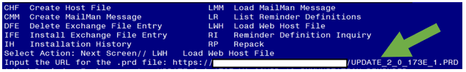

At the **Select Action:** prompt, enter **LWH** for Load Web Host File

At the **Input the url for the .prd file:** prompt, type the following web address:

**https://vaww.va.gov/reminders/docs/UPDATE_2_0_173E.PRD**

Search and locate an entry titled **UPDATE_2_0_173E VA-COVID-19 IMMUNIZATION REMINDER.**

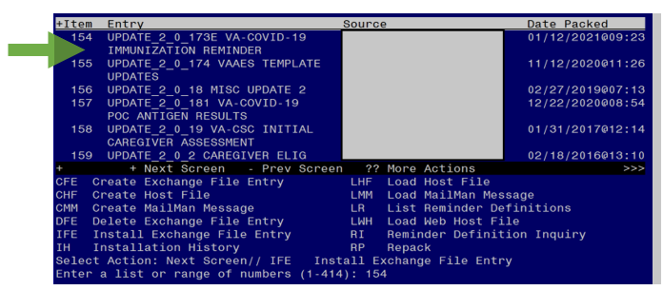

At the **Select Action** prompt, enter **IFE** for Install Exchange File Entry

Enter the number that corresponds with your entry **UPDATE_2_0_173E VA-COVID-19 IMMUNIZATION REMINDER.**  *(in this example it is entry 154 it will vary by site).* The date of the exchange file should be 01/12/2021.

**DO NOT INSTALL ALL ITEMS. ONLY INSTALL THE COMPONENTS LISTED BELOW.**

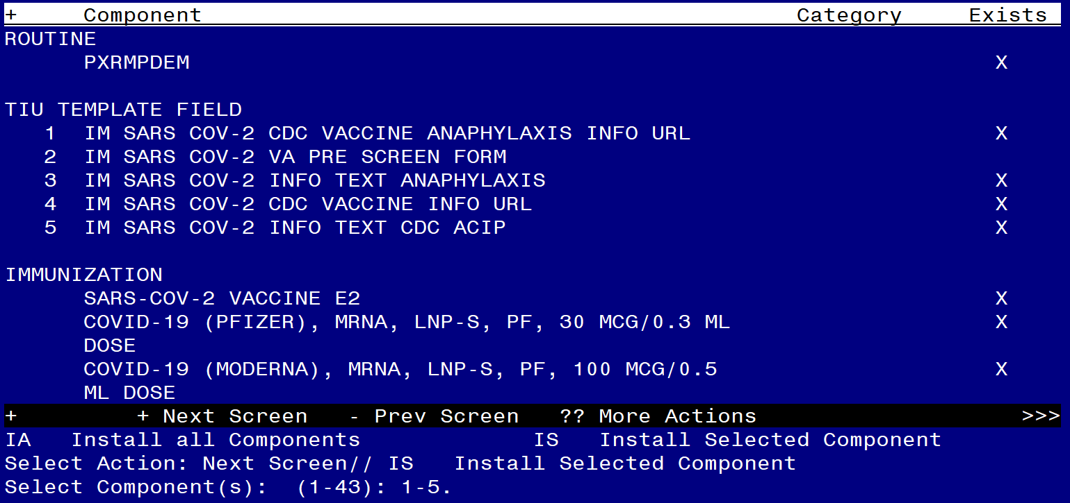

At the **Select Action** prompt, type **IS** for **Install Selected Components** and hit enter.

**Only select the item number for the TIU TEMPLATE FIELDS. In this example those items are 1-5.**

Install the new template field.

Overwrite the remaining template fields.

You will then return to the File list screen. Select enter until you reach the items below.

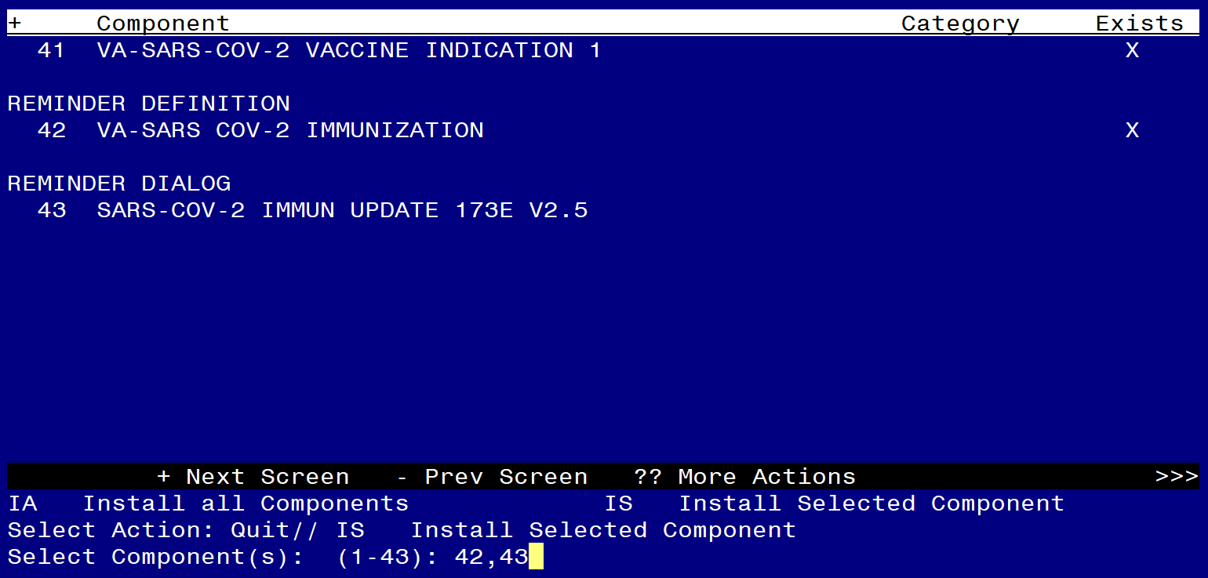

**Only select the item number for the** **VA-SARS COV-2 IMMUNIZATION definition and the SARS-COV-2 IMMUN UPDATE 173E V2.5 reminder dialog. In this example those items are 42 and 43.**

* Overwrite the reminder definition

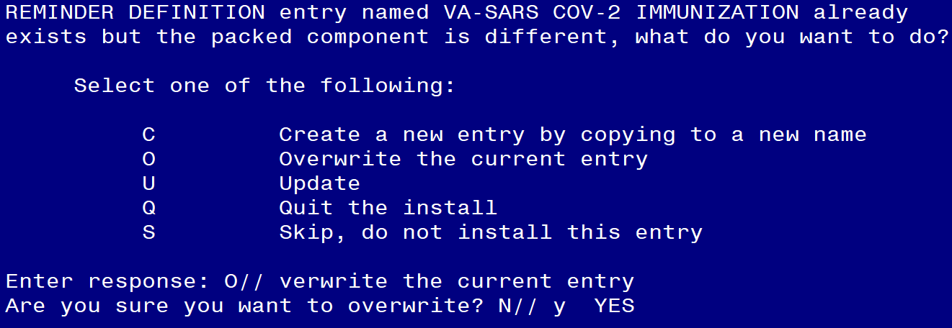

You will be promped to install the reminder dialog component. You will choose IA to install all.

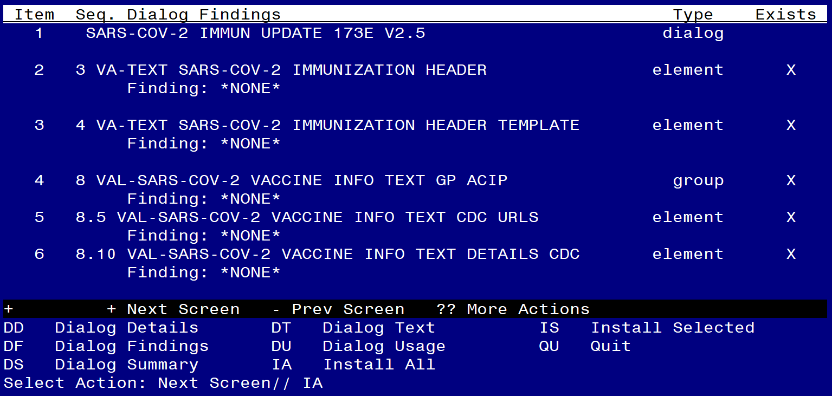

At the **Select Action** prompt, type **IA** to install the dialog – **SARS-COV-2 IMMUN UPDATE 173E V2.5**

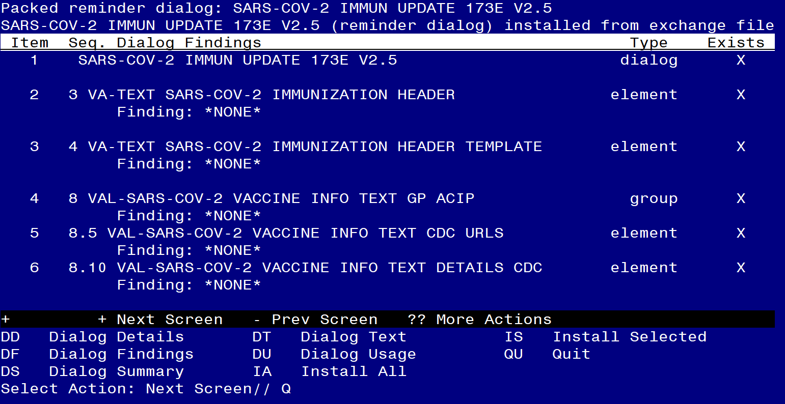

You will then be returned to this screen. At the **Select Action** prompt, type **Q.**

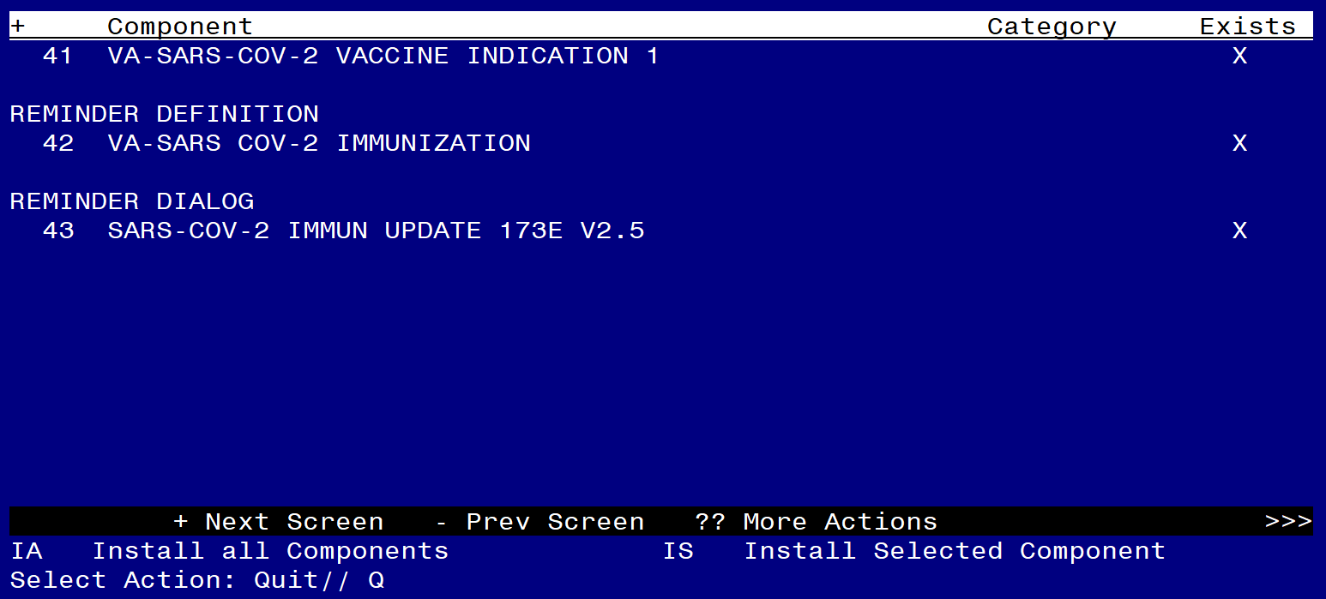

You will then be returned to this screen. At the **Select Action** prompt, type **Q.**

Install complete.

# Post-Installation

*You will need to close and reopen CPRS to see the txml field changes.*

1. **Relink the VA-SARS COV-2 IMMUNIZATION reminder definition to the VA-SARS-COV-2 IMMUNIZATION reminder dialog.**

CF Reminder Computed Finding Management ...

RM Reminder Definition Management ...

SM Reminder Sponsor Management ...

TXM Reminder Taxonomy Management

TRM Reminder Term Management ...

LM Reminder Location List Management ...

RX Reminder Exchange

RT Reminder Test

OS Other Supporting Menus ...

INFO Reminder Information Only Menu ...

DM Reminder Dialog Management ...

CP CPRS Reminder Configuration ...

RP Reminder Reports ...

MST Reminders MST Synchronization Management ...

PL Reminder Patient List Menu ...

PAR Reminder Parameters ...

VS NLM Value Set Menu

ROC Reminder Order Check Menu ...

CQM NLM Clinical Quality Measures Menu

XM Reminder Extract Menu ...

Select Reminder Managers Menu <TEST ACCOUNT> Option: **DM**  Reminder Dialog Management

DP Dialog Parameters ...

DI Reminder Dialogs

DR Dialog Reports ...

Select Reminder Dialog Management <TEST ACCOUNT> Option: **DI Reminder Dialogs**

**Dialog List** Jan 12, 2021@11:16:10 Page: 24 of 31

REMINDER VIEW (ALL REMINDERS BY NAME)

+Item Reminder Name Linked Dialog Name & Dialog Status

333 VA-SARS COV-2 IMMUNIZATION

334 VA-TBI SCREENING VA-TBI SCREENING

335 VA-TBI/POLYTRAUMA REHAB/REINTEGRAT VA-TBI/POLYTRAUMA REHAB/REI

336 VA-TESTOSTERONE DIAGNOSIS OBJECT

337 VA-TESTOSTERONE MED PRESCRIPTION O

338 VA-TETANUS/DIPHTHERIA (TD) IMMUNIZ VA-TETANUS/DIPHTHERIA (TD)

339 VA-TETANUS/DIPHTHERIA/PERTUSSIS (T VA-TETANUS/DIPHTHERIA/PERTU

340 VA-TH BL VVC CAPABLE

341 VA-TH VVC CAPABLE INFORMATION VA-TH VVC CAPABILITY ASSESS

342 VA-TH VVC TEST PENDING

343 VA-TRAVEL SCREEN VA-TRAVEL SCREEN

344 VA-VANOD SKIN ASSESSMENT VA-VANOD SKIN INITIAL ASSES

345 VA-VANOD SKIN REASSESSMENT VA-VANOD SKIN REASSESSMENT

346 VA-WH BL BR ALERT WITH NO OPEN PRO

+ + Next Screen - Prev Screen ?? More Actions >>>

AR All reminders LR Linked Reminders QU Quit

CV Change View RN Name/Print Name

Select Item: Next Screen// 333 **Search list and select item number for the VA-SARS COV-2 IMMUNIZATION definition. In this example, it is item 333.**

**Dialog Selection List** Jan 12, 2021@11:16:16 Page: 1 of

REMINDER NAME: VA-SARS COV-2 IMMUNIZATION

Item Dialog Name Latest Update Other Linked Reminders

Other dialogs generated from this reminder:

1 VA-SARS-COV-2 IMMUNIZATION *NONE*

2 VA-SARS-COV-2 IMMUNIZATION TEMPL *NONE*

+ Next Screen - Prev Screen ?? More Actions

LR Link Reminder QU Quit

Select Item: Quit// **LR Link Reminder**

REMINDER NAME: **VA-SARS COV-2 IMMUNIZATION (Link to the VA-SARS COV-2 IMMUNIZATION dialog)**

LINKED REMINDER DIALOG: VA-SARS-COV-2 IMMUNIZATION

1 VA-SARS-COV-2 IMMUNIZATION reminder dialog NATIONAL

2 VA-SARS-COV-2 IMMUNIZATION TEMPLATE reminder dialog NATIONAL

CHOOSE 1-2: **1 VA-SARS-COV-2 IMMUNIZATION**  reminder dialog NATIONAL

**Dialog Selection List** Jan 12, 2021@11:16:33 Page: 1 of

REMINDER NAME: VA-SARS COV-2 IMMUNIZATION

Item Dialog Name Latest Update Other Linked Reminders

This reminder is linked to dialog:

1 VA-SARS-COV-2 IMMUNIZATION

Other dialogs generated from this reminder:

2 VA-SARS-COV-2 IMMUNIZATION TEMPL *NONE*

+ Next Screen - Prev Screen ?? More Actions >>>

LR Link Reminder QU Quit

Select Item: Quit//  **Quit**