

**Update _2_0_173F**

Clinical Reminders

VA-COVID-19 IMMUNIZATION REMINDER UPDATE F

Install Guide

**March 2021**

Product Development

Office of Information Technology

Department of Veterans Affairs

Table of Contents

Introduction 1

Install Details 3

Install Example 4

Post-Installation 7

# Introduction

DESCRIPTION: This update revises several items in the VA-SARS-COV-2 IMMUNIZATION dialog and VA-SARS-COV-2 IMMUNIZATION TEMPLATE dialog.

1. Updates the detailed information section with the Janssen vaccine information.
   1. Update URLs when available for EUA documents
   2. Add specific text to the Detailed Information section
   3. Split the EUA Information and Requirements text into 2 sections – one for mRNA vaccines and one for others
2. Enables the option to record doses of Janssen vaccine
   1. *CPT codes are not available yet. The dialog has been released with CPT code 90471 linked to the administration option. The taxonomies will be updated once the appropriate CPT codes have been released nationally.*
3. Enables the option to record historical doses of Janssen vaccine
4. Changes the warning text for outside/historical to be clearer and more put it in a new template field.
5. Adds an option to allow entry of a health factor stating that the patient got vaccinated but does not have written or electronic documentation readily available to all entry of the prior immunizations. **COVID-19 VERBAL REPORT COVID VACCINE**
   1. 2 options are available for text instructions for sites to use or adjust for scripting for patients, 2nd one disabled for deployment
6. Adds refusal options for A1, B1, E2
7. Adds contraindication options for A1, B1, E2
8. Adds a section at the bottom of the dialog that will be sent out disabled but which would allow sites to record Janssen or AZN vaccine administration in patients who had a prior dose of an mRNA vaccine. Allows an authorized user to bypass the lock out caused by a first dose of one of the vaccines.
   1. If a user has the user class of COVID-19 IMMUNIZATION BYPASS then the option will display.

UPDATE_2_0_173F contains 1 Reminder Exchange entry:

**UPDATE_2_0_173F VA-COVID-19 IMMUNIZATION REMINDER**

**TIU TEMPLATE FIELDS**

IM SARS COV-2 VA SIDE EFFECTS AE REPORTING

IM SARS COV-2 VIS/EUA INFO URL E2

IM SARS COV-2 ADMIN E2 INFO PRE TEXT

IM SARS COV-2 ADMIN INFO POST TEXT E2 #2

IM SARS COV-2 E2 DOSE

BLANK TEXT FIELD FOR DIALOGS

IM SARS COV-2 DOSE #2 WARNING

IM SARS COV-2 ADMIN INFO POST TEXT E2 #1

IM SARS COV-2 VIS/EUA INFO URL B1

IM SARS COV-2 ADMIN B1 INFO PRE TEXT

IM SARS COV-2 ADMIN INFO POST TEXT A1

IM SARS COV-2 B1 DOSE

IM SARS COV-2 VIS/EUA INFO URL A1

IM SARS COV-2 ADMIN A1 INFO PRE TEXT

IM SARS COV-2 A1 DOSE

IM SARS COV-2 OUTSIDE INSTR 2

IM SARS COV-2 OUTSIDE INSTR 1

IM SARS COV-2 OUTSIDE WARNING

IM SARS COV-2 CDC VACCINE ANAPHYLAXIS INFO URL

IM SARS COV-2 VA PRE SCREEN FORM

IM SARS COV-2 INFO TEXT ANAPHYLAXIS

IM SARS COV-2 CDC VACCINE PHASED IMPLEMENTATION URL

IM SARS COV-2 CDC VACCINE INFO URL

IM SARS COV-2 VHA VACCINE INFO URL

IM SARS COV-2 INFO TEXT CDC ACIP

IM SARS COV-2 INFO TEXT OTHER

IM SARS COV-2 INFO TEXT

IM SARS COV-2 PROVIDER EUA FACT URL A1

IM SARS COV-2 VIS/EUA INFO URL D2

IM SARS COV-2 PROVIDER EUA FACT URL D2

IM SARS COV-2 VIS/EUA INFO URL C2

IM SARS COV-2 PROVIDER EUA FACT URL C2

**HEALTH FACTORS**

IMMUNIZATION

VA-SARS-COV-2 VACCINE ANATOMIC SITE

COVID-19

COVID-19 IMMUNIZATION DIALOG BYPASS USE

VA-SARS-COV-2 VACCINE CONTRAIND E2

VA-SARS-COV-2 VACCINE CONTRAIND A1

VA-SARS-COV-2 VACCINE CONTRAIND D2

VA-SARS-COV-2 VACCINE CONTRAIND C2

VA-SARS-COV-2 VACCINE REFUSAL

VA-SARS-COV-2 IMM REFUSAL - AZN CVX 210

VA-SARS-COV-2 IMM REFUSAL - JSN CVX 212

VA-SARS-COV-2 IMM REFUSAL - UNS CVX 213

VA-SARS-COV-2 IMM REFUSAL - PFR CVX 208

VA-SARS-COV-2 IMM REFUSAL - MOD CVX 207

COVID-19 VERBAL REPORT COVID VACCINE

**REMINDER TERMS**

VA-BL COVID-19 IMM BYPASS AUTHORIZATION

VA-SARS-COV-2 VACCINE E2 1 DOSE

VA-SARS-COV-2 VACCINE D2 1 DOSE

VA-SARS-COV-2 VACCINE C2 1 DOSE

**REMINDER TAXONOMIES**

VA-SARS-COV-2 IMM ASTRAZENECA SERIES 2

VA-SARS-COV-2 IMM ASTRAZENECA SERIES 1

VA-SARS-COV-2 IMM JANSSEN SERIES 1

# Pre-Installation

1. **If your site has a local health factor used when a patient states that they have already received COVID-19 vaccination and that is used to keep track of patients who do not need to be part of outreach efforts for scheduling, you should rename it to    “COVID-19 VERBAL REPORT COVID VACCINE” before installing this update.**
2. **Each of the 3 elements/groups under Detailed information group is overwritten – the parent group is not being overwritten. Any local additions to this section must be added after installation.**
3. **Refusal and contraindication groups are being overwritten. Any local additions to this section must be added after installation.**
4. **Any local changes to included template fields (list is above) will be overwritten and will need to be added after installation.**

# Install Details

This update is being distributed as a web host file. The address for the host file is: **https://Redacted /UPDATE_2_0_173F.PRD**

The file will be installed using Reminder Exchange, programmer access is not required.

This update can be loaded with users on the system. Installation will take less than 5 minutes

# Install Example

To Load the Web Host File. Navigate to Reminder exchange in Vista

Screen shot of the Reminder Exchange terminal window from the terminal window with LWH for "Load Web Host File" entered and a URL for PRD file downloads filled in (that is only active from inside the VA firewall and some of the URL has been redacted for use outside of the VA.)Graphical user interface, text


At the **Select Action:** prompt, enter **LWH** for Load Web Host File

At the **Input the url for the .prd file:** prompt, type the following web address:

**https://vaww.va.gov/reminders/docs/UPDATE_2_0_173F.PRD**

Search and locate an entry titled **UPDATE_2_0_173F VA-COVID-19 IMMUNIZATION REMINDER.**

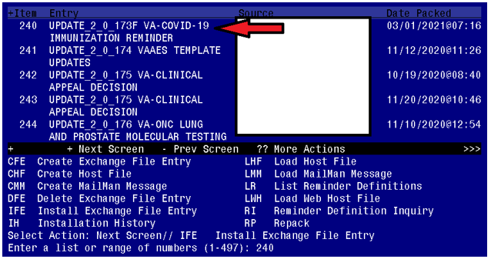

At the **Select Action** prompt, enter **IFE** for Install Exchange File Entry

Enter the number that corresponds with your entry **UPDATE_2_0_173F VA-COVID-19 IMMUNIZATION REMINDER.**  *(in this example it is entry 240 it will vary by site).* The date of the exchange file should be 03/01/2021.

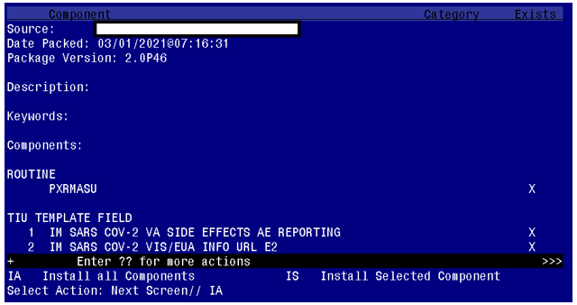

At the **Select Action** prompt, type **IA** for **Install All Components** and hit enter.

Install all new compenents

Skip existing health factors

Overwrite existing health summary types, objects, template fields, and terms

You will be promped to install the reminder dialog component. You will choose IA to install all.

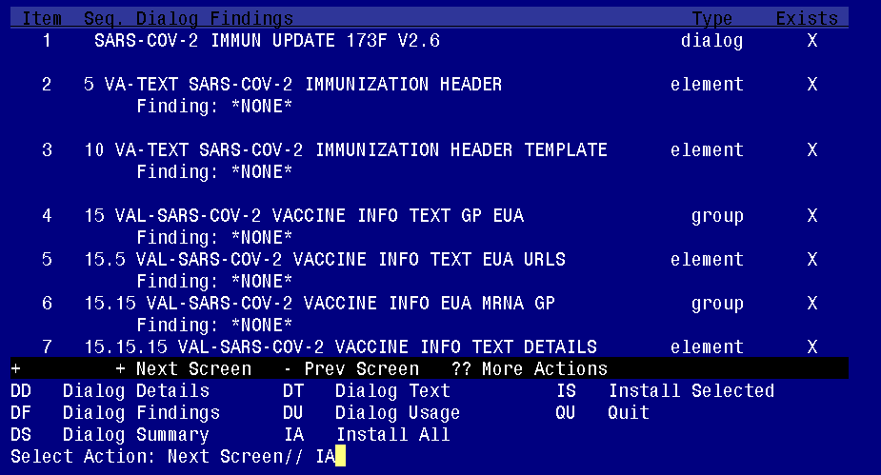

At the **Select Action** prompt, type **IA** to install the dialog – **SARS-COV-2 IMMUN UPDATE 173F V2.6**

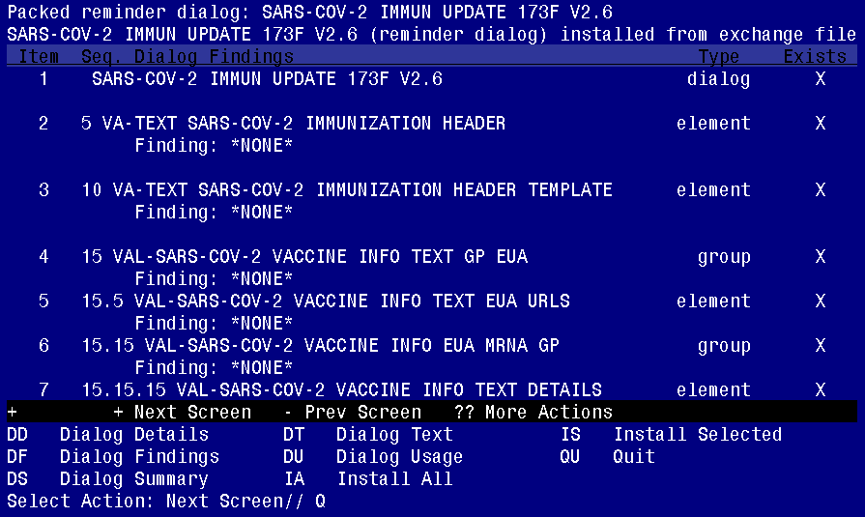

You will then be returned to this screen. At the **Select Action** prompt, type **Q.**

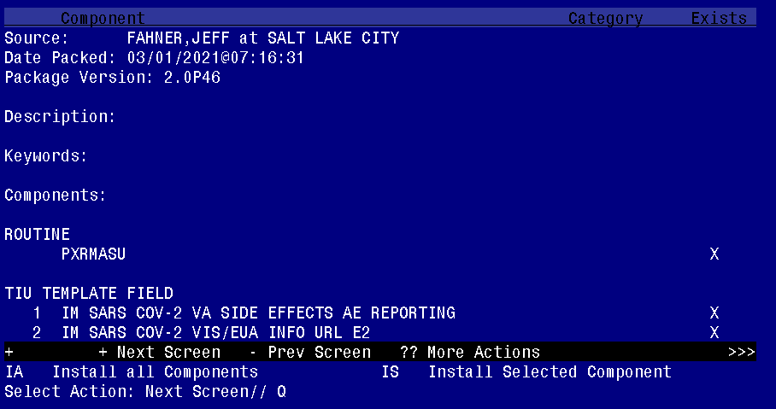

You will then be returned to this screen. At the **Select Action** prompt, type **Q.**

Install complete.

# Post-Installation

*You will need to close and reopen CPRS to see txml field changes.*

1. **Create new TIU User Class**

Staff with the new TIU user class of **COVID-19 IMMUNIZATION BYPASS** will have access to a section at the bottom of the dialog, which will allow documentation of Janssen or AZN vaccine administration in patients who had a prior dose of an mRNA vaccine. The section allows an authorized user to bypass the lock out caused by a first dose of one of the vaccines.

The group VAL-SARS-COV-2 VACCINE ADMIN E2 GP BYPASS is deployed disabled. The group will need to be enabled for use.

**Activation of this group and management of the user class is a local vaccine leadership decision and should be coordinated with appropriate local staff.**

1. **Navigate to the TIU Maintenance Menu**

1 TIU Parameters Menu ...

2 Document Definitions (Manager) ...

3 User Class Management ...

4 TIU Template Mgmt Functions ...

5 TIU Alert Tools

6 Active Title Cleanup Report

7 TIUHL7 Message Manager

8 Title Mapping Utilities ...

9 Text Event Edit

10 Unauthorized Abbreviations (Enter/Edit)

11 List Unauthorized Abbreviations

13 Contingency Downtime Bookmark Progress Notes

Select TIU Maintenance Menu <TEST ACCOUNT> Option: **3 User Class Management**

--- User Class Management Menu ---

1 User Class Definition

2 List Membership by User

3 List Membership by Class

Select User Class Management <TEST ACCOUNT> Option: **1 User Class Definition**

Select User Class Status: ACTIVE// Active

Start With Class: FIRST//

Go To Class: LAST//

Searching for the User Classes.............

**User Classes** Mar 01, 2021@07:59:43 Page: 1 of 9

ACTIVE USER CLASSES 122 Classes

Class Name Abbrev

1 ADMINISTRATIVE COMPLETER

2 ALLERGIST ALLRG

3 ANESTHESIOLOGIST ANES

4 ASSOCIATE CHIEF OF STAFF ACOS

5 ATTENDING PHYSICIAN ATT

6 AUDIOLOGIST AUD

7 CARDIOLOGIST CARD

8 CHAPLAIN CHAP

9 CHIEF RESIDENT CR

10 CHIEF, MEDICAL SERVICE CMED

11 CHIEF, MIS CMIS

12 CHIEF, PSYCHIATRY SERVICE CPSYCH

13 CHIEF, SURGICAL SERVICE CSURG

14 CLINICAL CLERK CLCLRK

15 CLINICAL COORDINATOR CLPAC

+ + Next Screen - Prev Screen ?? More Actions

Find Expand/Collapse Class Change View

Create a Class List Members Quit

Edit User Class

Select Action: Next Screen// **CR Create a Class**

Select CLASS: **COVID-19 IMMUNIZATION BYPASS The name must be as specified.**

Are you adding 'COVID-19 IMMUNIZATION BYPASS' as

a new USR CLASS (the 130TH)? No// **Yes**

NAME: COVID-19 IMMUNIZATION BYPASS Replace

DISPLAY NAME:// **COVID 19 Imm Bypass**

ABBREVIATION:

ACTIVE: **1 Active**

Select SUBCLASS: ............

1. **Enable the VAL-SARS-COV-2 VACCINE ADMIN A1 GP once site is ready to administer Janssen vaccine and lot number(s) have been added to the IM SARS-COV-2 VACCINE A1 MVX LOT EXP prompt.**

NAME: VAL-SARS-COV-2 VACCINE ADMIN A1 GP Replace

DISABLE: DISABLE AND DO NOT SEND MESSAGE// **@**

SURE YOU WANT TO DELETE? **Yes**

CLASS: LOCAL//

1. **Each of the 3 elements/groups under Detailed information group is overwritten – the parent group is not being overwritten. Any local additions to this section must be added.**
2. **Refusal and contraindication groups are overwritten. Any local additions to this section must be added.**
3. **Any local changes to included template fields (list is above) need to be added.**
4. **The Pfizer refused element is deployed disabled and all others are enabled. Ensure the appropriate refusal elements (highlighted below) are enabled/disabled based on local vaccine availability.**

109 20.28.3 Group: VAL-SARS-COV-2 VACCINE REFUSED

110 20.28.3.2 Element: VAL-SARS-COV-2 VACCINE REFUSED MODERNA

111 20.28.3.4 Element: VAL-SARS-COV-2 VACCINE REFUSED PFIZER (Disabled)

112 20.28.3.6 Element: VAL-SARS-COV-2 VACCINE REFUSED JANSSEN

113 20.28.3.8 Element: VAL-SARS-COV-2 VACCINE REFUSED ASTRAZENECA (Disable