

**Update _2_0_173H**

Clinical Reminders

VA-COVID-19 IMMUNIZATION REMINDER UPDATE H

Install Guide

**May 2021**

Product Development

Office of Information Technology

Department of Veterans Affairs

Table of Contents

Introduction 1

Install Details 2

Install Example 2

Post-Installation 5

# Introduction

DESCRIPTION: This update revises the top portion (above the COVID-19 Immunization Actions section) of the VA-SARS-COV-2 IMMUNIZATION and VA-SARS-COV-2 IMMUNIZATION TEMPLATE reminder dialogs. Age range information for each approved vaccine has been added. Branching logic has also been added to display adolescent specific information for the Pfizer vaccine if the patient is 12-17 years old. The update also revises the text in the following four template fields.

IM SARS COV-2 INFO TEXT PRIORITIZATION WARNING

* Update: Essential worker warning removed from dialog.

IM SARS COV-2 INFO TEXT CDC ACIP

* Update: Essential worker warning removed from dialog, COVID-19 vaccines and other vaccines may now be administered without regard to timing, and persons with a history of an episode of an immune-mediated syndrome characterized by thrombosis and thrombocytopenia, such as heparin-induced thrombocytopenia, should not receive the Janssen COVID-19 vaccine if it has been ≤90 days since their illness resolved.

IM SARS COV-2 VA SIDE EFFECTS AE REPORTING

* Update: URL for the VA side effects reporting form has been updated.

IM SARS COV-2 INFO TEXT ANAPHYLAXIS

* Update: Persons with a history of an episode of an immune-mediated syndrome characterized by thrombosis and thrombocytopenia, such as heparin-induced thrombocytopenia, should not receive the Janssen COVID-19 vaccine if it has been ≤90 days since their illness resolved.

UPDATE_2_0_173H contains 1 Reminder Exchange entry:

**UPDATE_2_0_173H VA-COVID-19 IMMUNIZATION REMINDER**

|  |
| --- |
|  |

**REMINDER TERMS**

|  |
| --- |
| VA-REMINDER UPDATE_2_0_173H  VA-COVID-19 ADOLESCENT AGE RANGE |

**REMINDER SPONSOR**

NATIONAL CENTER FOR HEALTH PROMOTION AND DISEASE PREVENTION (NCP)

**TEMPLATE FIELDS**

|  |
| --- |
| IM SARS COV-2 INFO TEXT CDC ACIP |
| IM SARS COV-2 INFO TEXT ANAPHYLAXIS |
| IM SARS COV-2 ADOLESCENT-CHILD APPROVAL TEXT |
| IM SARS COV-2 INFO TEXT EUA AGES |
| IM SARS COV-2 VA PRE SCREEN FORM |
| IM SARS COV-2 CDC VACCINE PHASED IMPLEMENTATION URL |
| IM SARS COV-2 CDC VACCINE INFO URL |
| IM SARS COV-2 VHA VACCINE INFO URL |
| IM SARS COV-2 INFO TEXT OTHER |
| IM SARS COV-2 INFO TEXT |
| IM SARS COV-2 PROVIDER EUA FACT URL A1 |
| IM SARS COV-2 PROVIDER EUA FACT URL D2 |
| IM SARS COV-2 PROVIDER EUA FACT URL C2 |

**HEALTH SUMMARY COMPONENT**

PCE IMMUNIZATIONS SELECTED

PCE IMMUNIZATIONS SELECT CHRON

**HEALTH SUMMARY TYPE**

SARS-COV-2 IMMUNIZATION

**HEALTH SUMMARY OBJECTS**

SARS-COV-2 IMMUNIZATION (TIU)

**TIU DOCUMENT DEFINITION**

SARS-COV-2 IMMUNIZATION

**REMINDER DIALOG**

SARS-COV-2 IMMUN UPDATE 173H V2.8

# Install Details

This update is being distributed as a web host file. The address for the host file is: **https://vaww.va.gov/reminders/docs/UPDATE_2_0_173H.PRD**

The file will be installed using Reminder Exchange, programmer access is not required.

This update can be loaded with users on the system. Installation will take less than 5 minutes

# Install Example

To Load the Web Host File. Navigate to Reminder exchange in Vista

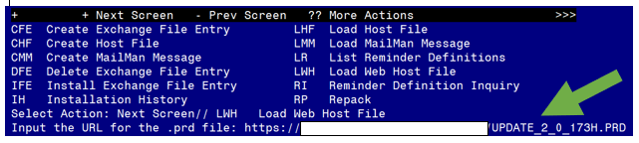

At the **Select Action:** prompt, enter **LWH** for Load Web Host File

At the **Input the url for the .prd file:** prompt, type the following web address:

**https://REDACTED /UPDATE_2_0_173H.PRD**

Search and locate an entry titled **UPDATE_2_0_173H VA-COVID-19 IMMUNIZATION REMINDER.**

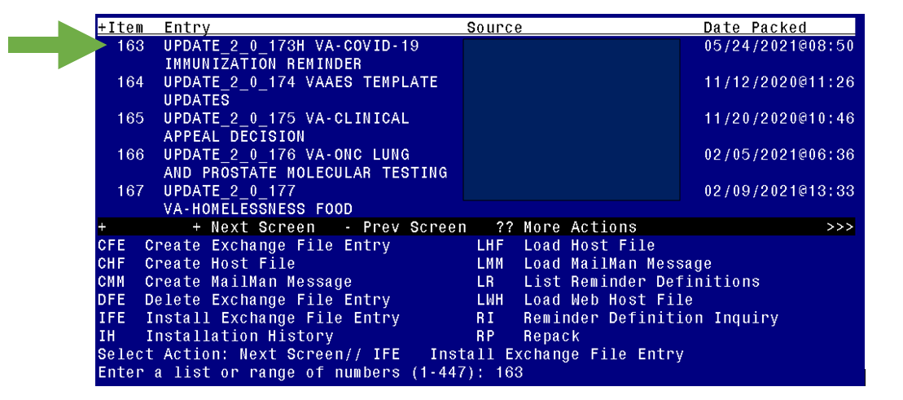

At the **Select Action** prompt, enter **IFE** for Install Exchange File Entry

Enter the number that corresponds with your entry **UPDATE_2_0_173H VA-COVID-19 IMMUNIZATION REMINDER.**  *(in this example it is entry 163 it will vary by site).* The date of the exchange file should be 05/24/2021.

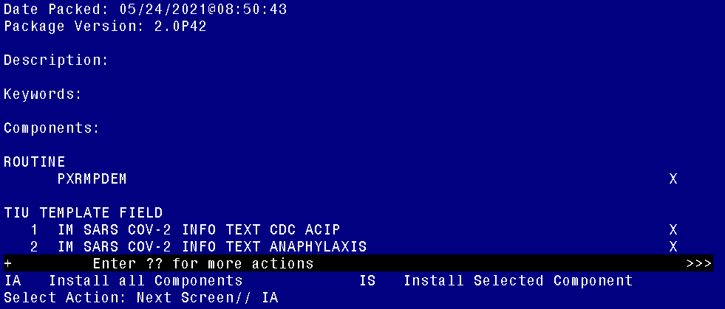

At the **Select Action** prompt, type **IA** for **Install All Components** and hit enter.

Overwrite the template fields

Overwrite the health summary type

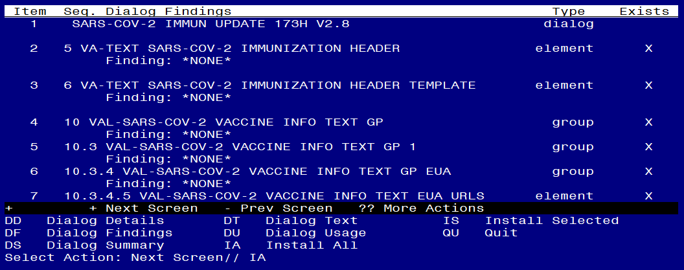

At the **Select Action** prompt, type **IA** for **Install All Components** and hit enter. This element is only used to deploy the TIU template fields.

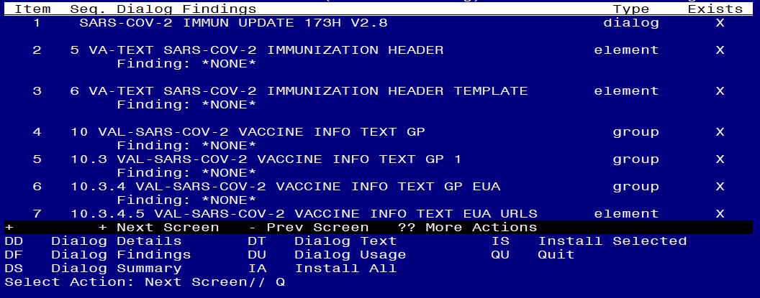

You will then be returned to this screen. At the **Select Action** prompt, type **Q.**

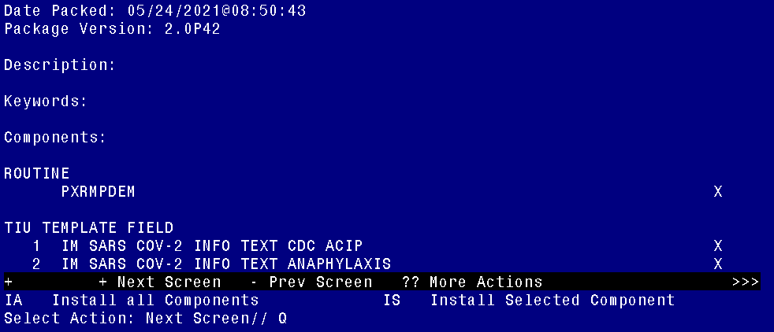

You will then be returned to this screen. At the **Select Action** prompt, type **Q.**

# Post-Installation

1. **Confirm the following changes in the VA-SARS-COV-2 IMMUNIZATION reminder dialog.**
2. **Essential workers warning removed.**

IM SARS COV-2 INFO TEXT PRIORITIZATION WARNING before (Only displayed for outpatients):

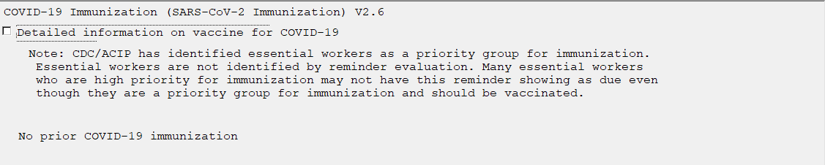

IM SARS COV-2 INFO TEXT PRIORITIZATION WARNING after:

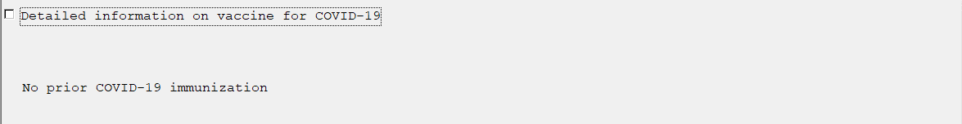

1. **The URL for the VA side effects reporting form has been updated.**

IM SARS COV-2 VA SIDE EFFECTS AE REPORTING template field is in each vaccine administration option.

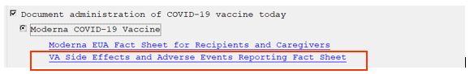

1. **COVID-19 Vaccine VHA/CDC Recommendations have been updated.**

IM SARS COV-2 INFO TEXT CDC ACIP before (highlighted sections have been edited):

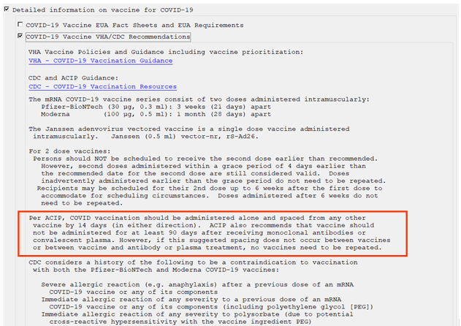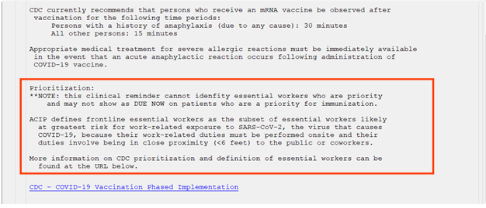

IM SARS COV-2 INFO TEXT CDC ACIP after:

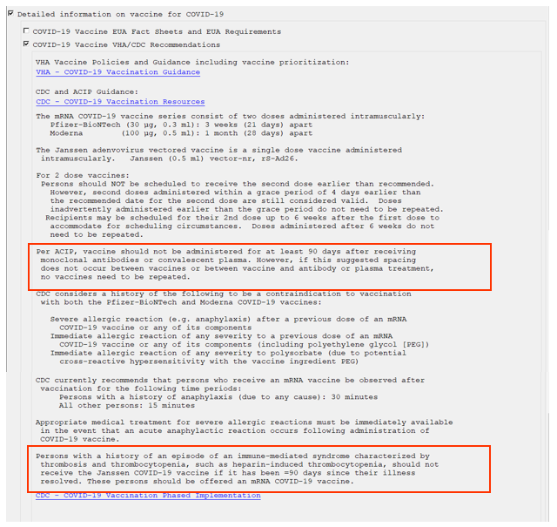

1. **Information of precautions related to allergy and anaphylaxis updated.**

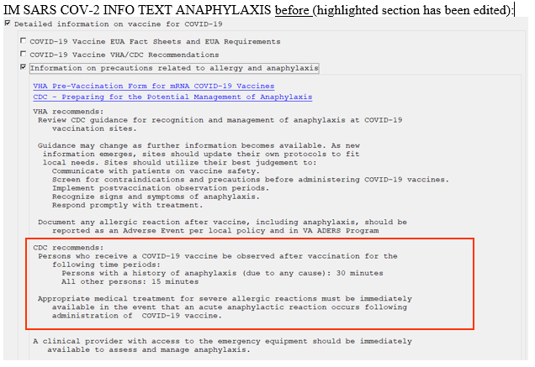

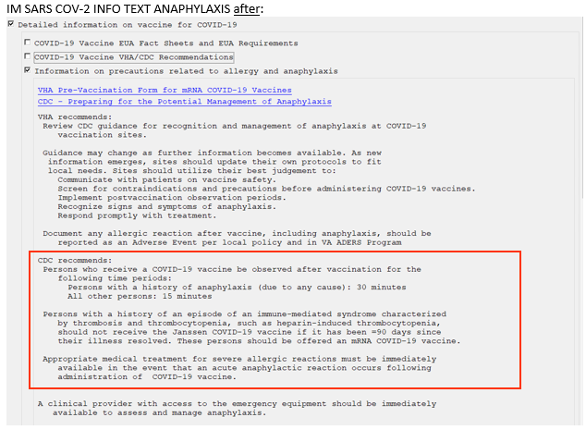

1. **The age-range information for each approved vaccine displays.**

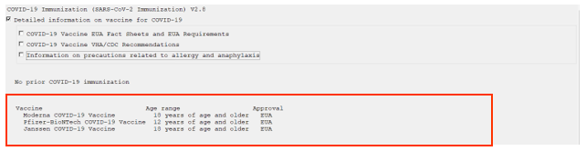

1. **The following information displays for patients 12-17yo.**

