

**Update _2_0_173I**

Clinical Reminders

VA-COVID-19 IMMUNIZATION REMINDER UPDATE I

Install Guide

**AUGUST 2021**

Product Development

Office of Information Technology

Department of Veterans Affairs

Table of Contents

Introduction 1

Install Details 6

Install Example 6

Post-Installation 12

# Introduction

DESCRIPTION:

The COVID-19 reminder definition and dialog are being updated to include the NOVAVAX Vaccine options.

The dialog was updated so that it no longer locks a user out of options after one dose was given, for example if Dose 1 of Moderna is given, a user can document a Pfizer or Janssen dose following, they are no longer locked out of the other options.

If the patient has a prior series 1 dose of any other vaccine and no series 1 of the one being administered and the user chooses to document series 2, provide a suggestion that the first dose of the vaccine type should be series 1.

Moved the vaccine list and age ranges under the detailed information.

Options to document additional doses of Pfizer and Moderna vaccines are included in the dialog and these can be enabled by each facility when they begin to administer those doses.

Update the bypass section to include all vaccines

Added section under record Prior COVID-19 Vaccine (historical) to document non-US approved vaccine types

This update also includes a fix to the detailed text for the seasonal influenza reminder

2021-2022 Influenza vaccine formulations on VA Formulary

Product                                           Type    CVX     CPT\\

  VistA Name                                           Approved for age

Afluria Quadrivalent Prefilled syringes           IIV4    150     90686

  INFLUENZA, INJECTABLE, QUADRIVALENT, PRES FREE       >=3 years

Afluria Quadrivalent Multiple-Dose Vial           IIV4    158     90688

  INFLUENZA, INJECTABLE, QUADRIVALENT                  >=3 years

Fluad Quadrivalent Adjuvanted Prefilled Syringe   IIV4    205     90694

  INFLUENZA, QUADRIVALENT, ADJUVANTED                  >=65 years

Reminder definition updates:

UPDATE JUNE 2021

Change vaccine B1 to be a 2 dose vaccine

  Remove 99Y from the finding

  Add FF 6, 16 and 26

Add term for future appointment to resolve the reminder temporarily

Add baseline frequency for all ages

Remove unused terms and FFs to simplify logic

Added placeholder logic for additional doses if needed

Historical documentation of WHO approved vaccinations will resolve the reminder (AstraZenica; BIBP, SinoPharm; and CornaVac, Sinovac)

UPDATE_2_0_173I contains 1 Reminder Exchange entry:

**UPDATE_2_0_173I VA-COVID-19 IMMUNIZATION REMINDER**

REMINDER GENERAL FINDINGS

1 VIEW PROGRESS NOTE TEXT

TIU TEMPLATE FIELD

2 IM SARS COV-2 ADOLESCENT-CHILD APPROVAL TEXT

3 IM SARS COV-2 INFO TEXT EUA AGES

4 IM SARS COV-2 CDC VACCINE ANAPHYLAXIS INFO URL

5 IM SARS COV-2 CDC VACCINE CLINICAL CONSIDERATIONS

URL

6 IM SARS COV-2 CDC VACCINE INFO URL

7 IM SARS COV-2 VA PRE SCREEN FORM

8 IM SARS COV-2 VHA VACCINE INFO URL

9 IM SARS COV-2 PROVIDER EUA FACT URL A1

10 IM SARS COV-2 PROVIDER EUA FACT URL D2

11 IM SARS COV-2 PROVIDER EUA FACT URL C2

12 BLANK TEXT FIELD FOR DIALOGS

13 IM SARS COV-2 VIS/EUA INFO URL D2

14 IM SARS COV-2 ADMIN D2 INFO PRE TEXT

15 IM SARS COV-2 ADMIN INFO POST TEXT D2 #2

16 IM SARS COV-2 D2 DOSE

17 IM SARS COV-2 D2 DOSE #3

18 IM SARS COV-2 DOSE #2 WARNING

19 IM SARS COV-2 ADMIN INFO POST TEXT D2 #1

20 IM SARS COV-2 VIS/EUA INFO URL C2

21 IM SARS COV-2 ADMIN C2 INFO PRE TEXT

22 IM SARS COV-2 ADMIN INFO POST TEXT C2 #2

23 IM SARS COV-2 C2 DOSE

24 IM SARS COV-2 DOSE C2 #3 WARNING

25 IM SARS COV-2 C2 DOSE #3

26 IM SARS COV-2 ADMIN INFO POST TEXT C2 #1

27 IM SARS COV-2 VIS/EUA INFO URL E2

28 IM SARS COV-2 ADMIN E2 INFO PRE TEXT

29 IM SARS COV-2 ADMIN INFO POST TEXT E2 #2

30 IM SARS COV-2 E2 DOSE

31 IM SARS COV-2 ADMIN INFO POST TEXT E2 #1

32 IM SARS COV-2 VA SIDE EFFECTS AE REPORTING

33 IM SARS COV-2 VIS/EUA INFO URL B1

34 IM SARS COV-2 ADMIN B1 INFO PRE TEXT

35 IM SARS COV-2 ADMIN INFO POST TEXT B1 #2

36 IM SARS COV-2 B1 DOSE

37 IM SARS COV-2 DOSE B1 #3 WARNING

38 IM SARS COV-2 B1 DOSE #3

39 IM SARS COV-2 ADMIN INFO POST TEXT B1 #1

40 IM SARS COV-2 VIS/EUA INFO URL A1

41 IM SARS COV-2 ADMIN A1 INFO PRE TEXT

42 IM SARS COV-2 ADMIN INFO POST TEXT A1 #B

43 IM SARS COV-2 A1 DOSE

44 IM SARS COV-2 DOSE A1 #2 WARNING

45 IM SARS COV-2 A1 DOSE #2

46 IM SARS COV-2 ADMIN INFO POST TEXT A1

47 IM SCRIBE

48 IM SARS COV-2 OUTSIDE INSTR 2

49 IM SARS COV-2 OUTSIDE INSTR 1

50 IM SARS COV-2 OUTSIDE WARNING

51 IM SARS COV-2 DOSE E2 #3 WARNING

52 IM SARS COV-2 E2 DOSE #3

IMMUNIZATION

SARS-COV-2 (COVID-19) VACCINE, UNSPECIFIED

COVID-19 (ASTRAZENECA), VECTOR-NR, RS-CHADOX1,

PF, 0.5 ML

COVID-19 (PFIZER), MRNA, LNP-S, PF, 30 MCG/0.3 ML

DOSE

COVID-19 (MODERNA), MRNA, LNP-S, PF, 100 MCG/0.5

ML DOSE

COVID-19 (NOVAVAX), SUBUNIT, RS-NANOPARTICLE+MATRI

X-M1 ADJUVANT, PF, 0.5 ML

COVID-19 (JANSSEN), VECTOR-NR, RS-AD26, PF, 0.5 ML

COVID-19 (QAZCOVID-IN) IV NON-US VACCINE

COVID-19 NON-US VACCINE, PRODUCT UNKNOWN

COVID-19 (EPIVACCORONA) PS NON-US VACCINEX

COVID-19 (JIANGSU PROVINCE CENTERS FOR DISEASE

CONTROL AND PREVENTION) PS NON-US VACCINE

COVID-19 (ANHUI ZHIFEI LONGCOM BIOPHARMACEUTICAL

+ INSTITUTE OF MICROBIOLOGY) PS NON-US VACCINE

COVID-19 (CANSINO BIOLOGICAL INC./BEIJING

INSTITUTE OF BIOTECHNOLOGY) VVNR NON-US VACCINE

COVID-19 (COVIVAC) LAV NON-US VACCINE

COVID-19 (SPUTNIK LIGHT) VVNR NON-US VACCINE

COVID-19 (SPUTNIK V) VVNR NON-US VACCINE

COVID-19 (COVAXIN) IV NON-US VACCINE

COVID-19 (SINOVAC), INACTIVATED VIRUS, NON-US

COVID-19 (BIBP, SINOPHARM) IV NON-US VACCINE

HEALTH FACTORS

53 VA-REMINDER UPDATES [C]

54 VA-UPDATE_2_0_173I

55 IMMUNIZATION [C]

56 VA-SARS-COV-2 VACCINE ANATOMIC SITE

57 COVID-19 [C]

58 COVID-19 IMMUNIZATION DIALOG BYPASS USE

59 VA-SARS-COV-2 IMMUN EDUC VVC/TELE VST

60 VA-SARS-COV-2 VACCINE CONTRAIND B1

61 VA-SARS-COV-2 VACCINE CONTRAIND E2

62 VA-SARS-COV-2 VACCINE CONTRAIND A1

63 VA-SARS-COV-2 VACCINE CONTRAIND D2

64 VA-SARS-COV-2 VACCINE CONTRAIND C2

65 VA-SARS-COV-2 VACCINE DEFERRED

66 VA-SARS-COV-2 VACCINE REFUSAL

67 VA-SARS-COV-2 IMM REFUSAL - NVX CVX 211

68 VA-SARS-COV-2 IMM REFUSAL - AZN CVX 210

69 VA-SARS-COV-2 IMM REFUSAL - JSN CVX 212

70 VA-SARS-COV-2 IMM REFUSAL - UNS CVX 213

71 VA-SARS-COV-2 IMM REFUSAL - PFR CVX 208

72 VA-SARS-COV-2 IMM REFUSAL - MOD CVX 207

73 COVID-19 VERBAL REPORT COVID VACCINE

REMINDER SPONSOR

74 NATIONAL CENTER FOR HEALTH PROMOTION AND DISEASE

PREVENTION (NCP)

75 OFFICE OF NURSING SERVICE

76 VA NATIONAL CENTER FOR HEALTH PROMOTION AND

DISEASE PREVENTION (NCP)

REMINDER COMPUTED FINDINGS

VA-AGE

VA-ASU USER CLASS

VA-IS INPATIENT

VA-APPOINTMENTS FOR A PATIENT

REMINDER TAXONOMY

77 VA-SARS-COV-2 IMM PFIZER SERIES 3

78 VA-SARS-COV-2 IMM PFIZER SERIES 2

79 VA-SARS-COV-2 IMM PFIZER SERIES 1

80 VA-SARS-COV-2 IMM MODERNA SERIES 3

81 VA-SARS-COV-2 IMM MODERNA SERIES 2

82 VA-SARS-COV-2 IMM MODERNA SERIES 1

83 VA-SARS-COV-2 IMM ASTRAZENECA SERIES 2

84 VA-SARS-COV-2 IMM ASTRAZENECA SERIES 1

85 VA-SARS-COV-2 IMM NOVAVAX SERIES 3

86 VA-SARS-COV-2 IMM NOVAVAX SERIES 2

87 VA-SARS-COV-2 IMM NOVAVAX SERIES 1

88 VA-SARS-COV-2 IMM JANSSEN SERIES 2

89 VA-SARS-COV-2 IMM JANSSEN SERIES 1

90 VA-IMMUNIZATION ICD10 CODE

91 VA-SARS-COV-2 IMM ASTRAZENECA SERIES 3

REMINDER LOCATION LIST

92 COVID-19 VACCINATION CLINICS

REMINDER TERM

93 VA-REMINDER UPDATE_2_0_173I

94 VA-COVID-19 ADOLESCENT AGE RANGE

95 VA-BL COVID-19 IMM BYPASS AUTHORIZATION

96 VA-CURRENT INPATIENT

97 VA-SARS-COV-2 VACCINE E2 2 DOSE

98 VA-SARS-COV-2 IM DOSE NOT ASTRAZENECA

99 VA-SARS-COV-2 IM DOSE NOT MODERNA

100 VA-SARS-COV-2 VACCINE E2 1 DOSE

101 VA-SARS-COV-2 VACCINE B1 2 DOSE

102 VA-SARS-COV-2 VACCINE B1 1 DOSE

103 VA-SARS-COV-2 IM DOSE NOT NOVAVAX

104 VA-SARS-COV-2 VACCINE A1 1 DOSE

105 VA-SARS-COV-2 VACCINE D2 2 DOSE

106 VA-SARS-COV-2 VACCINE D2 1 DOSE

107 VA-SARS-COV-2 IM DOSE NOT PFIZER

108 VA-SARS-COV-2 VACCINE C2 2 DOSE

109 VA-SARS-COV-2 VACCINE C2 1 DOSE

110 VA-COVID-19 VACCINATION CLINIC FUTURE APPT

111 VA-SARS-COV-2 VACCINE DOSE #1 OF 2

112 VA-SARS-COV-2 VACCINE REFUSAL

113 VA-SARS-COV-2 VACCINE CONTRAINDICATION

114 VA-SARS-COV-2 VACCINE E2

115 VA-SARS-COV-2 VACCINE D2

116 VA-SARS-COV-2 VACCINE C2

117 VA-SARS-COV-2 VACCINE B1

118 VA-SARS-COV-2 VACCINE A1

119 VA-SARS-COV-2 VACCINE INDICATION AGE

120 VA-SARS-COV-2 VACCINE WHO APPROVED ALL (INCL US)

121 VA-SARS-COV-2 VACCINE INDICATION ADDL DOSE NEEDED

122 VA-SARS-COV-2 VACCINE WHO APPROVED NON-US

COMPLETED

123 VA-SARS-COV-2 VACCINE INDICATION 6

124 VA-SARS-COV-2 VACCINE INDICATION 5

125 VA-SARS-COV-2 VACCINE INDICATION 4

126 VA-SARS-COV-2 VACCINE INDICATION 3

127 VA-SARS-COV-2 VACCINE INDICATION 2

128 VA-SARS-COV-2 VACCINE INDICATION 1

REMINDER DEFINITION

129 VA-SARS COV-2 IMMUNIZATION

HEALTH SUMMARY COMPONENT

PCE IMMUNIZATIONS SELECT CHRON

HEALTH SUMMARY TYPE

130 SARS-COV-2 IMMUNIZATION

HEALTH SUMMARY OBJECTS

131 SARS-COV-2 IMMUNIZATION (TIU)

TIU DOCUMENT DEFINITION

132 SARS-COV-2 IMMUNIZATION

REMINDER DIALOG

133 VAL-FLU IMM DETAILED INFO BUTTON

134 VA-SARS-COV-2 IMMUNIZATION

# Pre-Install

This update will overwrite the dialog components that have your lot numbers embedded for the covid-19 immunizations.

Create a backup of the groups that contain your local lot numbers. You can reinstall this backup exchange file post install to restore your lot numbers.

https://REDACTED /COVID-19_LOCAL_BACKUP_173I.pptx

or

See the document COVID-19 LOCAL BACKUP 173I-508.pptx

In addition to backing them up and restoring post-install, If you would like to, you can inquire and save the reminder dialog prompts that contain your local lot number additions prior to installation to confirm post install.

In Dialog manager, reminder Dialog, change view to prompts, choose INQ and save an INQURY of the following prompts: IM SARS-COV-2 VACCINE C2 MVX LOT EXP, IM SARS-COV-2 VACCINE D2 MVX LOT EXP and IM SARS-COV-2 VACCINE A1 MVX LOT EXP

# Install Details

This update is being distributed as a web host file. The address for the host file is: **https://Redacted/UPDATE_2_0_173I.PRD**

The file will be installed using Reminder Exchange, programmer access is not required.

This update can be loaded with users on the system. Installation will take less than 5 minutes

# Install Example

To Load the Web Host File. Navigate to Reminder exchange in Vista

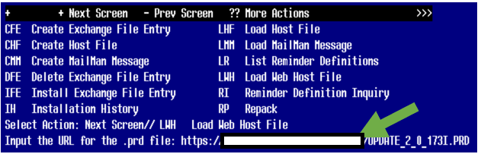

At the **Select Action:** prompt, enter **LWH** for Load Web Host File

At the **Input the url for the .prd file:** prompt, type the following web address:

**https://vaww.va.gov/reminders/docs/UPDATE_2_0_173I.PRD**

Search and locate an entry titled **UPDATE_2_0_173I VA-COVID-19 IMMUNIZATION REMINDER.**

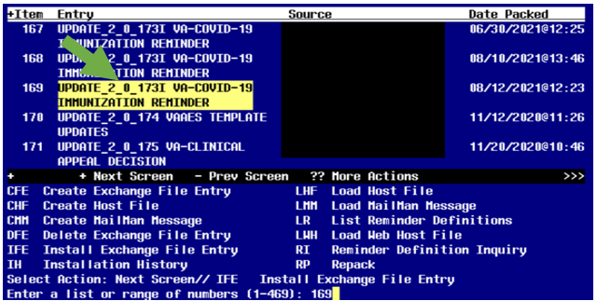

At the **Select Action** prompt, enter **IFE** for Install Exchange File Entry

Enter the number that corresponds with your entry **UPDATE_2_0_173I VA-COVID-19 IMMUNIZATION REMINDER.**  *(in this example it is entry 169 it will vary by site).* The date of the exchange file should be 08/12/2021.

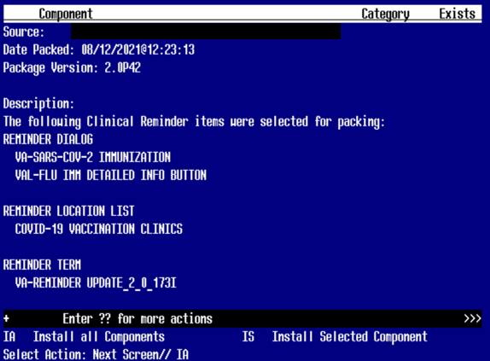

At the **Select Action** prompt, type **IA** for **Install all Components** and hit enter.

Install the new TEMPLATE FIELDS.

Overwrite any TEMPLATE FIELDS that you are prompted to overwrite

Install the new HEALTH FACTORS.

Skip any HEALTH FACTORS that you are prompted to overwrite

Install the new REMINDER TAXONOMIES

Install the new REMINDER LOCATION LIST

Install the the new REMINDER TERM.

Skip any REMINDER TERMS that you are prompted to overwrite with TWO exceptions, you will Overwrite the REMINDER TERM VA-SARS-COV-2 VACCINE DOSE #1 OF 2 and Overwrite the REMINDER TERM :VA-SARS-COV-2 VACCINE INDICATION AGE

REMINDER TERM entry named VA-SARS-COV-2 VACCINE DOSE #1 OF 2 already

exists but the packed component is different, what do you want to do?

Select one of the following:

C Create a new entry by copying to a new name

M Merge findings

O Overwrite the current entry

U Update

Q Quit the install

S Skip, do not install this entry

Enter response: O// verwrite the current entry

Are you sure you want to overwrite? N// Y

REMINDER TERM entry named VA-SARS-COV-2 VACCINE INDICATION AGE already

exists but the packed component is different, what do you want to do?

Select one of the following:

C Create a new entry by copying to a new name

O Overwrite the current entry

U Update

Q Quit the install

S Skip, do not install this entry

Enter response: O// verwrite the current entry

Are you sure you want to overwrite? N// Y

OVERWRITE the reminder definition

REMINDER DEFINITION entry named VA-SARS COV-2 IMMUNIZATION already

exists but the packed component is different, what do you want to do?

Select one of the following:

C Create a new entry by copying to a new name

O Overwrite the current entry

U Update

Q Quit the install

S Skip, do not install this entry

Enter response: O// verwrite the current entry

Are you sure you want to overwrite? N// Y

OVERWRITE any HEALTH SUMMARY TYPE entries that you are prompted to overwrite

HEALTH SUMMARY TYPE entry named SARS-COV-2 IMMUNIZATION already exists

but the packed component is different, what do you want to do?

Select one of the following:

C Create a new entry by copying to a new name

O Overwrite the current entry

U Update

Q Quit the install

S Skip, do not install this entry

Enter response: O// verwrite the current entry

Are you sure you want to overwrite? N// YES

OVERWRITE any HEALTH SUMMARY OBJECTS entries that you are prompted to overwrite

HEALTH SUMMARY OBJECTS entry named SARS-COV-2 IMMUNIZATION (TIU)

already exists but the packed component is different, what do you

want to do?

Select one of the following:

C Create a new entry by copying to a new name

O Overwrite the current entry

U Update

Q Quit the install

S Skip, do not install this entry

Enter response: O// verwrite the current entry

Are you sure you want to overwrite? N// YES

You will then be prompted to install the first dialog component. You will choose IA to install all even though some items will already have an X to indicate they exist.

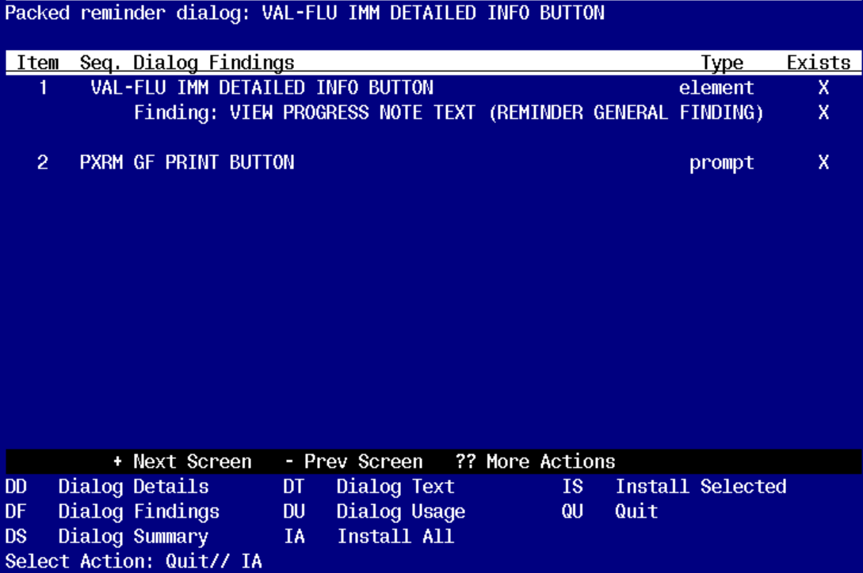

At the **Select Action** prompt, type **IA** to install the dialog – **VAL-FLU IMM DETAILED INFO BUTTON**

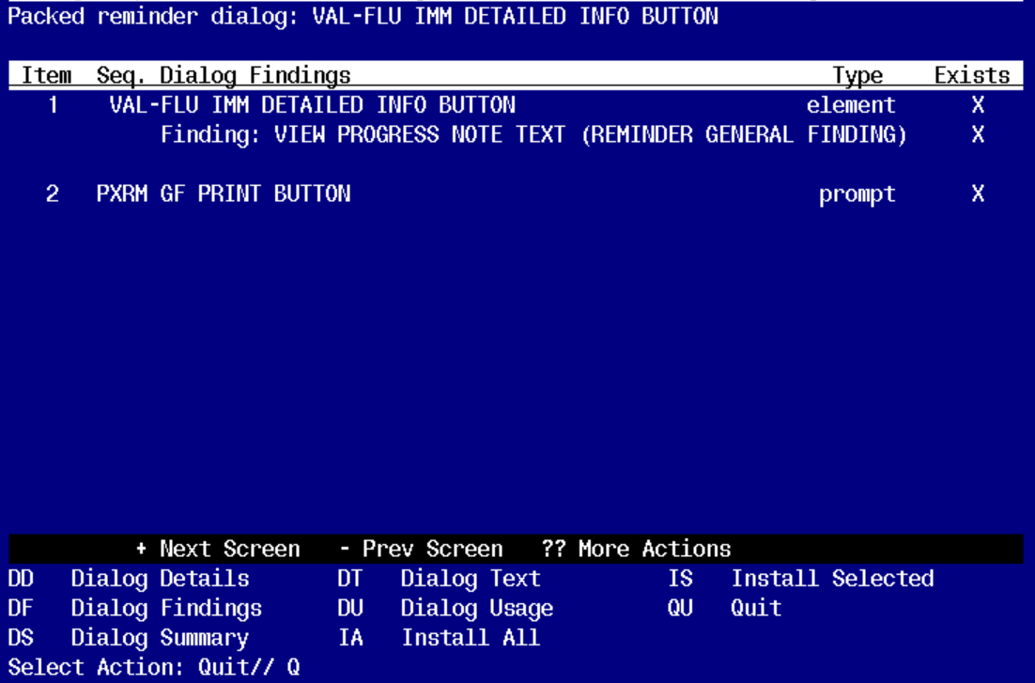

You will then be returned to this screen. At the **Select Action** prompt, type **Q.**

You will be promped to install the next reminder dialog component. You will choose IA to install all even though some items will already have an X to indicate they exist.

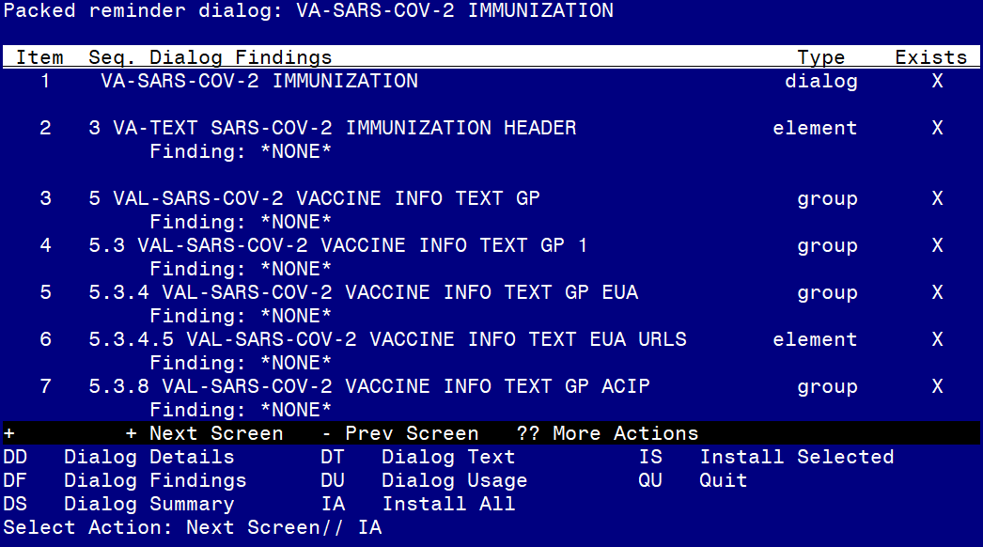

At the **Select Action** prompt, type **IA** to install the dialog – **VA-SARS-COV-2 IMMUNIZATION**

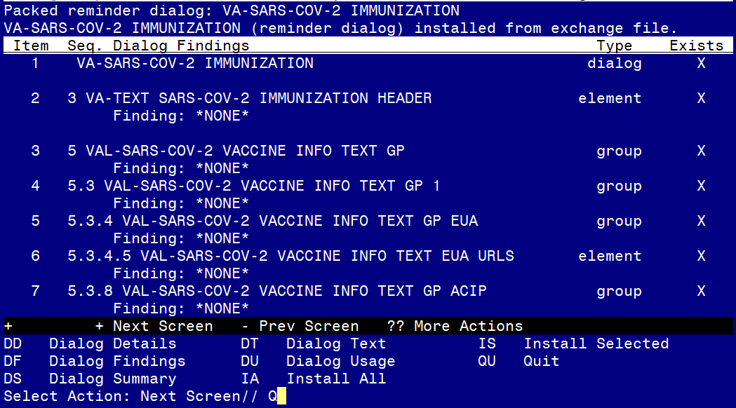

You will then be returned to this screen. At the **Select Action** prompt, type **Q.**

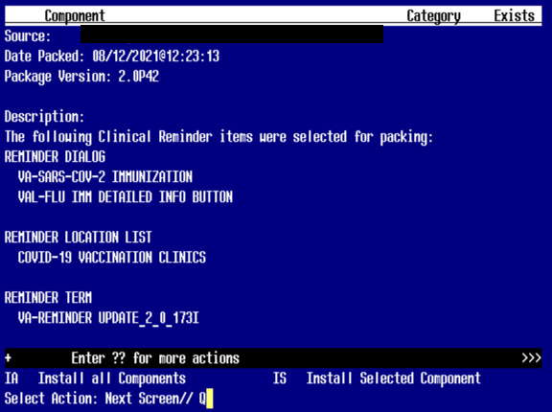

You will then be returned to this screen. At the **Select Action** prompt, type **Q.**

Install complete.

# Post-Installation

*You will need to close and reopen CPRS to see the txml field changes.*

1. **Install the exchange file that you created in the pre install step.**

**\*\*\*You have to do this to restore your lot #s/expiration dates.  If you do not do this, you will have to re-enter all of your available lot #s into the prompts and your users will have no options to choose from until you do this.\*\*\***

1. **Ensure the appropriate refusal elements (highlighted below) are enabled/disabled based on local vaccine availability.**

120 20.28.3 Group: VAL-SARS-COV-2 VACCINE REFUSED

121 20.28.3.2 Element: VAL-SARS-COV-2 VACCINE REFUSED MODERNA

122 20.28.3.4 Element: VAL-SARS-COV-2 VACCINE REFUSED PFIZER

123 20.28.3.6 Element: VAL-SARS-COV-2 VACCINE REFUSED JANSSEN

124 20.28.3.10 Element: VAL-SARS-COV-2 VACCINE REFUSED NOVAVAX

125 20.28.3.12 Element: VAL-SARS-COV-2 VACCINE REFUSED ASTRAZENECA

1. **Verify the lot numbers and refusal options are appropriate for your site, please open the reminder dialog and ensure your local lot numbers are displayed and the appropriate refusal options display.**
2. **Enable third/additional dose options if appropriate for your site.**

FDA and CDC have recommended a 3rd dose in the series for moderately to severely immunocompromised patients

This is for Moderna and Pfizer only at this time

To enable the 3rd dose option you will need to remove the ‘disable’ entry from one or both of these dialog elements

Moderna additional dose dialog group

Group: VAL-SARS-COV-2 VACCINE ADMIN C2 D#3 GP

Pfizer additional dose dialog group

Group: VAL-SARS-COV-2 VACCINE ADMIN D2 D#3 GP

1. **Update reminder location list: COVID-19 VACCINATION CLINICS.**
2. **Complete this step if you want the reminder to resolve when the patient already has a future appointment scheduled in a COVID-19 vaccination clinic.**

CF Reminder Computed Finding Management ...

RM Reminder Definition Management ...

SM Reminder Sponsor Management ...

TXM Reminder Taxonomy Management

TRM Reminder Term Management ...

LM Reminder Location List Management ...

RX Reminder Exchange

RT Reminder Test

OS Other Supporting Menus ...

INFO Reminder Information Only Menu ...

DM Reminder Dialog Management ...

CP CPRS Reminder Configuration ...

RP Reminder Reports ...

MST Reminders MST Synchronization Management ...

PL Reminder Patient List Menu ...

PAR Reminder Parameters ...

VS NLM Value Set Menu

ROC Reminder Order Check Menu ...

CQM NLM Clinical Quality Measures Menu

XM Reminder Extract Menu ...

Select Reminder Managers Menu <TEST ACCOUNT> Option: LM Reminder Location List Management

LL List Location Lists

LI Location List Inquiry

LE Add/Edit Reminder Location List

LC Copy Location List

Select Reminder Location List Management <TEST ACCOUNT> Option: LE Add/Edit Reminder Location List

Select Location List: COVID-19 VACCINATION CLINICS LOCAL

NAME: COVID-19 VACCINATION CLINICS Replace

CLASS: LOCAL//

SPONSOR:

REVIEW DATE:

DESCRIPTION:

Edit? NO//

Select CLINIC STOP:

Select HOSPITAL LOCATION: ADD YOUR CLINIC LOCATIONS AT THIS PROMPT

**If your site wants the reminder to only resolve for future appointment and wants the reminder to be due if a patient has an appointment for the current date to document administration using the reminder:**

**EDIT THE REMINDER TERM:** VA-COVID-19 VACCINATION CLINIC FUTURE APPT and CHANGE the beginning date and time in the finding item CF.VA-APPOINTMENTS FOR A PATIENT to be T+1.

1. **Complete this step if you DO NOT WANT the reminder to resolve when the patient already has a future appointment scheduled in a COVID-19 vaccination clinic or if your site does not have any COVID-19 vaccination clinics.**

**EDIT THE REMINDER TERM:** VA-COVID-19 VACCINATION CLINIC FUTURE APPT and delete the finding item CF.VA-APPOINTMENTS FOR A PATIENT.

**If you do not either add items to the location list OR remove the location list from the reminder term, you will receive a vista warning message every time a chart is opened:**

