

**Update _2_0_173O**

Clinical Reminders

VA-COVID-19 IMMUNIZATION REMINDER UPDATE

Install Guide

**December 2021**

Product Development

Office of Information Technology

Department of Veterans Affairs

Table of Contents

Introduction 1

Pre-Install 3

Install Details 3

Install Example 3

Post-Installation 7

# Introduction

DESCRIPTION:

This reminder update 173O makes updates to the VA-SARS-COV-2 IMMUNIZATION reminder dialog and associated progress note template.

Dialog Updates:

1. Update branching logic in the Pfizer Tris-Sucrose dialog group. The branching logic did not work correctly for patients who had a prior Janssen dose of vaccine and who were to receive a booster dose of Pfizer.
2. Add a dialog group for recording historical Pfizer TS immunizations.
3. Update all the reminder terms that contain the original Pfizer formulation to also contain the new formulation.

Thank you to the following test sites who installed and tested this reminder update:

New Mexico VA Health Care System (Albuquerque)

VA Nebraska Western Iowa Health Care System

Ralph J Johnson VA Medical Center (Charleston)

Aleda E. Lutz VA Medical Center (Saginaw)

VA Maryland Health Care System (Baltimore)

VA Bronx

UPDATE_2_0_1730 contains 1 Reminder Exchange entry: UPDATE_2_0_173O VA-COVID-19 IMMUNIZATION REMINDER with the following components:

HEALTH FACTORS

REMINDER FACTORS [C]

VA-UPDATE_2_0_173O

IMMUNIZATION [C]

COVID-19 VERBAL REPORT COVID VACCINE

VA-SARS-COV-2 VACCINE ANATOMIC SITE

REMINDER SPONSOR

NATIONAL CENTER FOR HEALTH PROMOTION AND DISEASE PREVENTION (NCP)

VA NATIONAL CENTER FOR HEALTH PROMOTION AND DISEASE PREVENTION (NCP)

REMINDER TAXONOMY

VA-SARS-COV-2 IMM PFIZER TRIS/SUC SERIES BOOSTER

VA-IMMUNOCOMPROMISED FOR COVID-19 ADDL DOSE

VA-HIV INFECTION

LONG TERM SYSTEMIC STEROID

VA-PNEUMOC DZ RISK - CHEMOTHERAPY

VA-SARS-COV-2 IMM PFIZER TRIS/SUC SERIES 3

VA-SARS-COV-2 IMM PFIZER TRIS/SUC SERIES 2

VA-SARS-COV-2 IMM PFIZER TRIS/SUC SERIES 1

REMINDER TERM

VA-SARS-COV-2 VACCINES BOOSTER AUTHORIZED

VA-SARS-COV-2 VACCINES

VA-SARS-COV-2 VACCINE WHO APPROVED ALL (INCL US)

VA-SARS-COV-2 VACCINE DOSE C IN STD SERIES

VA-SARS-COV-2 VACCINE DOSE #1 OF 2

VA-SARS-COV-2 IM DOSE NOT NOVAVAX

VA-SARS-COV-2 IM DOSE NOT MODERNA

VA-SARS-COV-2 IM DOSE NOT JANSSEN

VA-SARS-COV-2 IM DOSE NOT ASTRAZENECA

VAL-SARS-COV-2 VACC FOR BOOSTER BL

VA-COVID-19 IMMUNIZATIONS DOSE 3

VA-COVID-19 IMMUNIZATIONS DOSE 2

VA-COVID-19 IMMUNIZATIONS DOSE 1

VA-COVID-19 IMMUNIZATIONS

VA-COVID-19 IMMUNIZATION BL

VA-SARS-COV-2 VACCINE D2

VA-REMINDER UPDATE_2_0_173O

VA-SARS-COV-2 VACCINE D2 3 DOSE

VA-SARS-COV-2 VACCINE D2 2 DOSE

VA-SARS-COV-2 VACCINE D2 1 DOSE

VA-SARS-COV-2 VACCINE A1 1 DOSE

VA-SARS-COV-2 VACCINE C2 3 DOSE

VA-SARS-COV-2 VACCINE C2 2 DOSE

VA-SARS-COV-2 VACCINE C2 1 DOSE

VA-CD4 COUNT

VA-STEROID PREDN EQUIV 5-6.6MG

VA-STEROID PREDN EQUIV 6.6-9MG

VA-STEROID PREDN EQUIV 10-19MG

VA-STEROID PREDN EQUIV >=20MG

VA-CHEMO/IMMUNOSUPPRESSIVE DRUGS

VA-SARS-COV-2 IM DOSE NOT PFIZER

REMINDER DEFINITION

VAL-IMMUNOCOMPROMISING DRUGS/LABS/DX FOR COVID-19

HEALTH SUMMARY TYPE

SARS-COV-2 IMMUNIZATION

HEALTH SUMMARY OBJECTS

SARS-COV-2 IMMUNIZATION (TIU)

TIU DOCUMENT DEFINITION

SARS-COV-2 IMMUNIZATION (TIU)

REMINDER DIALOG

SARS-COV-2 IMMUN UPDATE 173O V2.15

# Pre-Install

1. You should have installed update 173N prior to installing this update.
2. If you have entered any lot numbers for the new formulation of Pfizer, you may want to create an exchange file with this item: IM SARS-COV-2 VACCINE D2 TRIS-SUCROSE MVX LOT EXP. You will install that exchange file post install to restore your lot numbers. This would not be expected because this formulation has not yet been sent to any VA at the time of release.
3. Terms that are likely to have local mappings are highlighted in BLUE above and **you should not overwrite those** .
4. Terms that should be overwritten are highlighted in GREEN above.
5. Items in yellow are new and you should expect to install those.

# Install Details

This update is being distributed as a web host file. The address for the host file is: **https://Redacted /UPDATE_2_0_173O.PRD**

The file will be installed using Reminder Exchange, programmer access is not required.

This update can be loaded with users on the system. Installation will take less than 5 minutes

# Install Example

To Load the Web Host File. Navigate to Reminder exchange in Vista

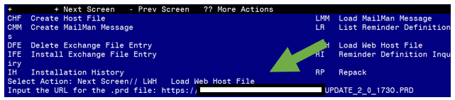

At the **Select Action:** prompt, enter **LWH** for Load Web Host File

At the **Input the url for the .prd file:** prompt, type the following web address:

**https://Redacted /UPDATE_2_0_173O.PRD**

**You should see a message that the file was successfully loaded.**

**Terminal window screen shot of the message displaying the URL of the file that was successfully loaded.  Part of the URL has been redacted as it is a VA only internal web site URL.**

**This will install one exchange entries in your exchange file**

Added Reminder Exchange entry UPDATE_2_0_173O VA-COVID-19 IMMUNIZATION REMINDER

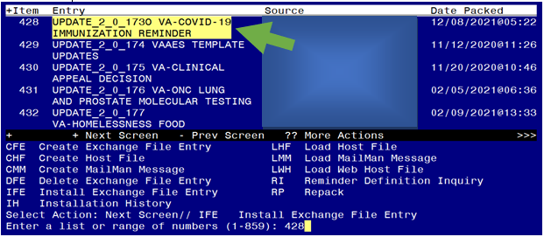

Search and locate an entry titled **UPDATE_2_0_173O VA-COVID-19 IMMUNIZATION REMINDER.**

At the **Select Action** prompt, enter **IFE** for Install Exchange File Entry

Enter the number that corresponds with your entry **UPDATE_2_0_173O VA-COVID-19 IMMUNIZATION REMINDER.**  *(in this example it is entry 428 it will vary by site).* The date of the exchange file should be 12/08/2021. .

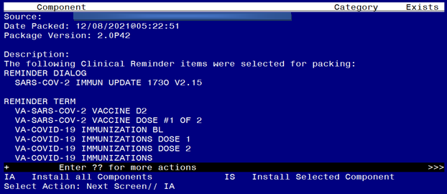

At the **Select Action** prompt, type **IA** for **Install all Components** and hit enter.

Any items that are NEW in any categories, you should INSTALL

If you are prompted to overwrite any health factors, you should choose SKIP

If you are prompted to overwrite any taxonomies, you should choose SKIP

It is important that you OVERWRITE these reminder terms if prompted:

VA-SARS-COV-2 VACCINES BOOSTER AUTHORIZED

VA-SARS-COV-2 VACCINES

VA-SARS-COV-2 VACCINE WHO APPROVED ALL (INCL US)

VA-SARS-COV-2 VACCINE DOSE C IN STD SERIES

VA-SARS-COV-2 VACCINE DOSE #1 OF 2

VA-SARS-COV-2 IM DOSE NOT NOVAVAX

VA-SARS-COV-2 IM DOSE NOT MODERNA

VA-SARS-COV-2 IM DOSE NOT JANSSEN

VA-SARS-COV-2 IM DOSE NOT ASTRAZENECA

VAL-SARS-COV-2 VACC FOR BOOSTER BL

VA-COVID-19 IMMUNIZATIONS DOSE 3

VA-COVID-19 IMMUNIZATIONS DOSE 2

VA-COVID-19 IMMUNIZATIONS DOSE 1

VA-COVID-19 IMMUNIZATIONS

VA-COVID-19 IMMUNIZATION BL

VA-SARS-COV-2 VACCINE D2

It is important that you skip and **DO NOT** overwrite your previously mapped terms for drugs and labs if you are prompted to overwrite:

VA-CD4 COUNT

VA-STEROID PREDN EQUIV 5-6.6MG

VA-STEROID PREDN EQUIV 6.6-9MG

VA-STEROID PREDN EQUIV 10-19MG

VA-STEROID PREDN EQUIV >=20MG

VA-CHEMO/IMMUNOSUPPRESSIVE DRUGS

You can overwrite the HEALTH SUMMARY TYPE entry if prompted

You will then be prompted to install the reminder dialog component, you will choose IA to install even though most items will have an X to indicate they already exist.

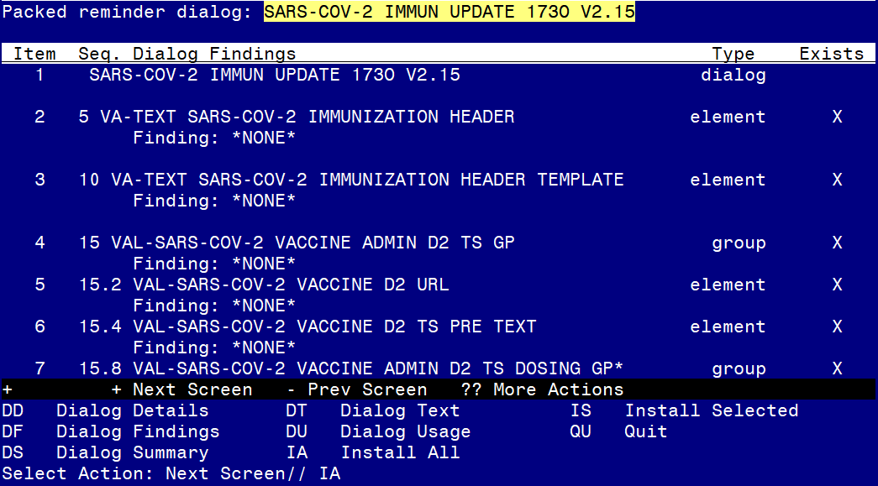

At the **Select Action** prompt, type **IA** to install the dialog – **SARS-COV-2 IMMUN UPDATE 173O V2.15.**

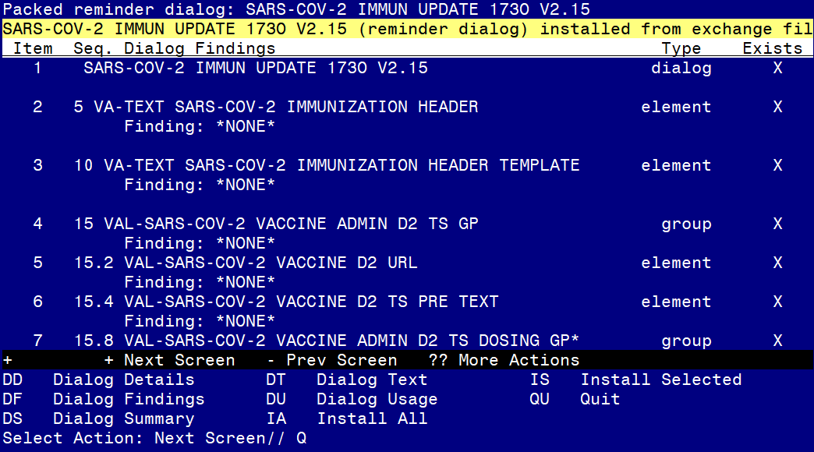

You will then be returned to this screen. At the **Select Action** prompt, type **Q.**

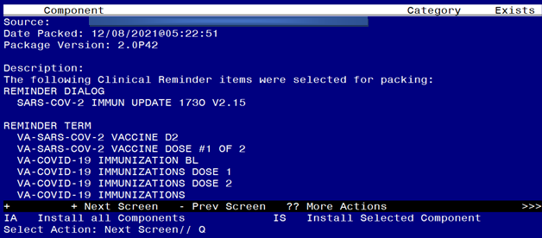

You will then be returned to this screen. At the **Select Action** prompt, type **Q.**

Install complete.

# Post-Installation

1. If you backup up this prompt, IM SARS-COV-2 VACCINE D2 TRIS-SUCROSE MVX LOT EXP, install your backup and then check your lot #s to make sure they are still present.

**Steps for When your site starts to give the new formulation**:

1. You will need to enable the dialog group  
   **VAL-SARS-COV-2 VACCINE ADMIN D2 TS GP**
2. You may want to add additional text to the description for the old and the new formulations. E.g. “Pfizer COVID-19 vaccine Tris-sucrose (gray cap) ** NEW formulation”. Recognize that if the Pharmacy is drawing syringes for your immunization clinic, then the nurses will never see the gray cap.
   1. Pfizer CVX 208: Group: VAL-SARS-COV-2 VACCINE ADMIN D2 GP
   2. Pfizer CVX 217: Group: VAL-SARS-COV-2 VACCINE ADMIN D2 **TS** GP
3. You will need to use the separate dialog prompt for all lot #s of the new formulation  
   **IM SARS-COV-2 VACCINE D2 TRIS-SUCROSE MVX LOT EXP**
4. You will want to disable the old Pfizer formulation dialog group once you have used up that vaccine.   
   Disable: 20.14.6 Group: VAL-SARS-COV-2 VACCINE ADMIN D2 GP

|  |  |  |  |  |  |  |  |  |  |
| --- | --- | --- | --- | --- | --- | --- | --- | --- | --- |
|  | MVX | Dialog Abbrev | CVX | CPT | Series 1 CPT | Series 2 CPT | Series 3 CPT | Booster CPT | Prompt for Lot # and Expiration |
| Pfizer | PFR | D2 | 208 | 91300 | 0001A | 0002A | 0003A | 0004A | IM SARS-COV-2 VACCINE D2 MVX LOT EXP |
| Pfizer TS | PFR | D2 TS | 217 | 91305 | 0051A | 0052A | 0053A | 0054A | IM SARS-COV-2 VACCINE D2 TS MVX LOT EXP |
| Moderna | MOD | C2 | 207 | 91301 | 0011A | 0012A | 0013A |  | IM SARS-COV-2 VACCINE C2 MVX LOT EXP |
| Moderna | MOD | C2 | 207 | 91306 |  |  |  | 0064A |  |
| Janssen | JSN | A1 | 212 | 91303 | 0031A |  |  | 0034A | IM SARS-COV-2 VACCINE A1 MVX LOT EXP |