

**Update _2_0_173X**

Clinical Reminders

VA-COVID-19 IMMUNIZATION PRIMARY AND BOOSTER REMINDER UPDATES

Primary Series and Booster Reminders and Associated Dialogs

Install Guide

**January 2023**

Product Development

Office of Information Technology

Department of Veterans Affairs

Table of Contents

Introduction 1

Pre-Install 3

Install Details 9

Install Example 9

Post-Installation 16

# Introduction

DESCRIPTION:

Reminder UPDATE_2_0_173V released the split versions of the Covid-19 Immunization documentation reminder into a Primary Series and a Booster Series. This update tweaks the logic to ensure reminders are evaluating appropriately on patients.

Changes:

* + - * update Janssen logic - FF31 updated. COUNT of Janssen>0
      * Add HF of VA-SARS-COV-2 IMM CLIN REV NO ADDL DOSE to primary series definition to resolve and this also includes at least 1 vaccine given
      * Add forced prompt IM SERIES 1 to bivalent options.

VAL-COVID-10 BOOSTER ACTIONS ADMIN TODAY PFIZER BIVALENT

VAL-COVID-19 BOOSTER ACTIONS ADMIN TODAY MODERNA BIVALENT

* + - * Add outside text to booster historical options in group VAL-GP COVID-19 BOOSTER ACTIONS HISTORICAL. Re-sequenced following 3 elements

VAL-SARS-COV-2 VACCINE OUTSIDE TEXT

VAL-SARS-COV-2 VACCINE OUTSIDE WARNING REDOCUMENT

VAL-GP SARS-COV-2 VACCINE OUTSIDE NO DOCS

* + - * Added taxonomies back to primary options as additional findings

VA-SARS-COV-2 IMM MODERNA SERIES 1

VA-SARS-COV-2 IMM MODERNA SERIES 2

VA-SARS-COV-2 IMM MODERNA SERIES 3

VA-SARS-COV-2 IMM PFIZER SERIES 1

VA-SARS-COV-2 IMM PFIZER SERIES 2

VA-SARS-COV-2 IMM PFIZER SERIES 3

VA-SARS-COV-2 IMM PFIZER TRIS/SUC SERIES 1

VA-SARS-COV-2 IMM PFIZER TRIS/SUC SERIES 2

VA-SARS-COV-2 IMM PFIZER TRIS/SUC SERIES 3

VA-SARS-COV-2 IMM JANSSEN SERIES 1

VA-SARS-COV-2 IMM JANSSEN SERIES 2

VA-SARS-COV-2 IMM NOVAVAX SERIES 1

VA-SARS-COV-2 IMM NOVAVAX SERIES 2

* + - * Dialog group VA-GP COVID-19 BOOSTER ACTIONS REFUSE/CONTRAINDICATE/DEFER made to 1 choice only
      * Template field IM SARS COV-2 VIS/EUA INFO URL C2 was updated to correct EAU sheet
      * Defer HF’s were made into national terms so sites could add any local items that meant the same thing to those terms.

A site did find a caveat to the reminder system. If patient is part of normal population and has had complete series of monovalent at correct intervals and the bivalent booster at the correct interval, both Primary Series and Booster reminders are DONE status. If then the patient becomes immunocompromised due to a diagnosis or a drug, the Primary Series reminder will be DUE again. The guidance from NCP is to use the “Defer indefinitely” option which will turn off the Primary Series Reminder. This will be a clinical decision

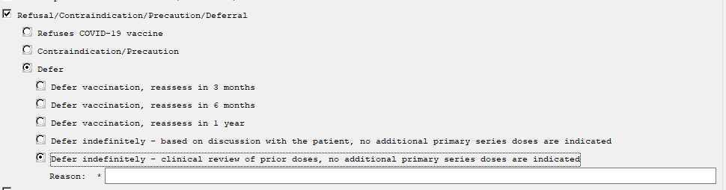

CDC immunization pathways

[At-A-Glance COVID-19 Vaccination Schedules (cdc.gov)](https://www.cdc.gov/vaccines/covid-19/downloads/COVID-19-vacc-schedule-at-a-glance-508.pdf)

Thank you to the following test sites who installed and tested this reminder update:

New Mexico VA Health Care System (Albuquerque)

Chillicothe Ohio VA Medical Center

Ralph J Johnson VA Medical Center (Charleston)

VA Maryland Health Care System (Baltimore)

James J Peters VA Medical center (Bronx)

UPDATE_2_0_173X contains 1 Reminder Exchange entry:

UPDATE_2_0_173X VA-COVID-19 IMMUNIZATION PRIMARY AND BOOSTER

REMINDER GENERAL FINDINGS

1 VIEW PROGRESS NOTE TEXT

TIU TEMPLATE FIELD

2 BLANK TEXT FIELD FOR DIALOGS

3 IM SARS COV-2 OUTSIDE INSTR 2

4 IM SARS COV-2 OUTSIDE INSTR 1

5 IM SARS COV-2 OUTSIDE WARNING

6 IM PHARMACY PHONE NUMBERS

7 IM SARS COV-2 ADMIN BOOSTER INFO PRE TEXT

8 IM SARS COV-2 BOOSTER PFIZER EUA VHA VACCINE INFO

URL

9 IM SARS COV-2 ADMIN BOOSTER INFO POST TEXT PFIZER

#1

10 IM SARS COV-2 ADMIN BOOSTER INFO POST TEXT C2 #1

11 IM SARS COV-2 ADMIN C2 INFO PRE TEXT

12 IM SARS COV-2 BOOSTER MODERNA EUA VHA VACCINE

INFO URL

13 IM SARS COV-2 CDC VACCINE UNDERLYING CONDITIONS

14 IM SARS COV-2 CDC VACCINE INFO URL

15 IM SARS COV-2 VA PRE SCREEN FORM

16 IM SARS COV-2 VA SIDE EFFECTS AE REPORTING

17 COVID-19 BOOSTER PFIZER RECIPIENT

18 COVID-19 BOOSTER MODERNA RECIPIENT

19 IM SCRIBE

20 VA-VANOD BLANK

21 IM SARS COV-2 VIS/EUA INFO URL D2

22 IM SARS COV-2 ADMIN D2 INFO PRE TEXT

23 IM SARS COV-2 ADMIN INFO POST TEXT D2 #2

24 IM SARS COV-2 DOSE SERIES BOOSTER WARNING

25 IM SARS COV-2 DOSE D2 #3 WARNING

26 IM SARS COV-2 D2 DOSE #3

27 IM SARS COV-2 DOSE #2 WARNING

28 IM SARS COV-2 ADMIN INFO POST TEXT D2 #1 LONG

INTERVAL

29 IM SARS COV-2 ADMIN INFO POST TEXT D2 #1

30 IM SARS COV-2 VIS/EUA INFO URL E2

31 IM SARS COV-2 ADMIN E2 INFO PRE TEXT

32 IM SARS COV-2 ADMIN INFO POST TEXT E2 #2

33 IM SARS COV-2 E2 DOSE

34 IM SARS COV-2 DOSE E2 #3 WARNING

35 IM SARS COV-2 E2 DOSE #3

36 IM SARS COV-2 ADMIN INFO POST TEXT E2 #1

37 IM SARS COV-2 VIS/EUA INFO URL B1

38 IM SARS COV-2 ADMIN B1 INFO PRE TEXT

39 IM SARS COV-2 ADMIN INFO POST TEXT B1 #2

40 IM SARS COV-2 DOSE B1 #3 WARNING

41 IM SARS COV-2 B1 DOSE #3

42 IM SARS COV-2 ADMIN INFO POST TEXT B1 #1

43 IM SARS COV-2 VIS/EUA INFO URL A1

44 IM SARS COV-2 ADMIN A1 INFO TTS COUNSELING

45 IM SARS COV-2 ADMIN A1 INFO PRE TEXT

46 IM SARS COV-2 ADMIN INFO POST TEXT A1 #B

47 IM SARS COV-2 DOSE A1 #2 WARNING

48 IM SARS COV-2 A1 DOSE #2

49 IM SARS COV-2 ADMIN INFO POST TEXT A1

50 IM SARS COV-2 DOSE D2 #B WARNING

51 IM SARS COV-2 D2 DOSE #3 BOOSTER

52 IM SARS COV-2 VIS/EUA INFO URL C2

53 IM SARS COV-2 ADMIN INFO POST TEXT C2 #2

54 IM SARS COV-2 DOSE C2 #3 WARNING

55 IM SARS COV-2 C2 DOSE #3

56 IM SARS COV-2 ADMIN INFO POST TEXT C2 #1 LONG

INTERVAL

57 IM SARS COV-2 ADMIN INFO POST TEXT C2 #1

58 IM COVID-19 BOOSTER INFO

59 VA-COVID-19 VACCINE SCHEDULE AT A GLANCE

60 IM SARS COV-2 PROVIDER EUA FACT URL A1

61 IM SARS COV-2 PROVIDER EUA FACT URL B1

62 IM SARS COV-2 PROVIDER EUA FACT URL D2

63 IM SARS COV-2 PROVIDER EUA FACT URL C2

64 IM SARS COV-2 CDC VACCINE CLINICAL CONSIDERATIONS

BOOSTERURL

65 IM SARS COV-2 CDC VACCINE ANAPHYLAXIS INFO URL

66 IM SARS COV-2 CDC VACCINE CLINICAL CONSIDERATIONS

URL

67 IM SARS COV-2 VHA VACCINE INFO URL

IMMUNIZATION

COVID-19 (PFIZER), MRNA, LNP-S, BIVALENT BOOSTER,

PF, 30 MCG/0.3 ML DOSE

COVID-19 (MODERNA), MRNA, LNP-S, BIVALENT

BOOSTER, PF, 50 MCG/0.5 ML OR 25MCG/0.25 ML DOSE

COVID-19 (CANSINO BIOLOGICAL INC./BEIJING

INSTITUTE OF BIOTECHNOLOGY) VVNR NON-US VACCINE

SARS-COV-2 COVID-19 PS NON-US VACCINE (BIOLOGICAL

E LIMITED, CORBEVAX)

SARS-COV-2 COVID-19 INACTIVATED NON-US VACCINE

PRODUCT (MINHAI BIOTECHNOLOGY CO, KCONVAC)

SARS-COV-2 COVID-19 PS NON-US VACCINE (MEDIGEN,

MVC-COV1901)

SARS-COV-2 COVID-19 DNA NON-US VACCINE (ZYDUS

CADILA, ZYCOV-D)

SARS-COV-2 COVID-19 PS NON-US VACCINE (ANHUI

ZHIFEI LONGCOM, ZIFIVAX)

SARS-COV-2 COVID-19 VLP NON-US VACCINE (MEDICAGO,

COVIFENZ)

SARS-COV-2 (COVID-19) VACCINE, UNSPECIFIED

COVID-19 NON-US VACCINE, PRODUCT UNKNOWN

COVID-19 (SPUTNIK V) VVNR NON-US VACCINE

COVID-19 (SPUTNIK LIGHT) VVNR NON-US VACCINE

COVID-19 (SINOVAC), INACTIVATED VIRUS, NON-US

COVID-19 (SANOFI-PASTEUR), D614, RECOMB, PRES

DTM, AS03 ADJUVANT ADD, PF, 5MCG/0.5ML

COVID-19 (SANOFI-PASTEUR), D614, RECOMB, PRES

DTM, AS03 ADJUVANT ADD, PF, 10MCG/0.5ML

COVID-19 (QAZCOVID-IN) IV NON-US VACCINE

COVID-19 (JIANGSU PROVINCE CENTERS FOR DISEASE

CONTROL AND PREVENTION) PS NON-US VACCINE

COVID-19 (EPIVACCORONA) PS NON-US VACCINEX

COVID-19 (COVIVAC) LAV NON-US VACCINE

COVID-19 (COVAXIN) IV NON-US VACCINE

COVID-19 (BIBP, SINOPHARM) IV NON-US VACCINE

COVID-19 (ANHUI ZHIFEI LONGCOM BIOPHARMACEUTICAL

+ INSTITUTE OF MICROBIOLOGY) PS NON-US VACCINE

COVID-19 (PFIZER), MRNA, LNP-S, PF, 30 MCG/0.3 ML

DOSE, TRIS-SUCROSE (AGES 12+ YEARS)

COVID-19 (PFIZER), MRNA, LNP-S, PF, 30 MCG/0.3 ML

DOSE

COVID-19 (PFIZER), MRNA, LNP-S, PF, 3 MCG/0.2 ML

DOSE, TRIS-SUCROSE (6 MO-4 YEARS)

COVID-19 (PFIZER), MRNA, LNP-S, PF, 10 MCG/0.2 ML

DOSE, TRIS-SUCROSE (AGES 5-11 YEARS)

COVID-19 (NOVAVAX), SUBUNIT, RS-NANOPARTICLE+MATRI

X-M1 ADJUVANT, PF, 0.5 ML

COVID-19 (MODERNA), MRNA, LNP-S, PF, PEDIATRIC

(AGES 6-11 YRS) 50 MCG/0.5 ML DOSE

COVID-19 (MODERNA), MRNA, LNP-S, PF, PEDIATRIC

(AGES 6 MO - 5 YRS) 25 MCG/0.25 ML DOSE

COVID-19 (MODERNA), MRNA, LNP-S, PF, 50 MCG/0.5

ML DOSE

COVID-19 (MODERNA), MRNA, LNP-S, PF, 100

MCG/0.5ML DOSE OR 50 MCG/0.25ML DOSE

COVID-19 (JANSSEN), VECTOR-NR, RS-AD26, PF, 0.5 ML

COVID-19 (ASTRAZENECA), VECTOR-NR, RS-CHADOX1,

PF, 0.5 ML

HEALTH FACTORS

68 VA-REMINDER UPDATES [C]

69 VA-UPDATE_2_0_173X

70 IMMUNIZATION [C]

71 VA-COVID-19 BOOSTER VACCINE DEFER PERMANENT

72 VA-COVID-19 BOOSTER VACCINE DEFER 1Y

73 VA-COVID-19 BOOSTER VACCINE DEFER 6M

74 VA-COVID-19 BOOSTER VACCINE DEFER 3M

75 COVID-19 VERBAL REPORT COVID VACCINE

76 VA-SARS-COV-2 IMMUN EDUC VVC/TELE VST

77 VA-COVID-19 [C]

78 VA-SARS-COV-2 IMM CLIN REV NO ADDL DOSE

79 COVID-19 VACCINE DEFER PERMANENT

80 COVID-19 VACCINE DEFER 1Y

81 COVID-19 VACCINE DEFER 6M

82 COVID-19 VACCINE DEFER 3M

83 VA-COVID-19 VACCINE DEFER PERMANENT

84 VA-COVID-19 VACCINE DEFER 1Y

85 VA-COVID-19 VACCINE DEFER 6M

86 VA-COVID-19 VACCINE DEFER 3M

87 VA-SARS-COV-2 IMM REFUSAL - BOOSTER/ADDL DOSE

88 VA-SARS-COV-2 VACCINE REFUSAL

89 VA-SARS-COV-2 VACCINE DEFERRED

90 VA-SARS-COV-2 VACCINE CONTRAIND B1

91 VA-SARS-COV-2 VACCINE CONTRAIND A1

92 VA-SARS-COV-2 VACCINE CONTRAIND E2

93 VA-SARS-COV-2 VACCINE CONTRAIND C2

94 VA-SARS-COV-2 VACCINE CONTRAIND D2

95 VA-SARS-COV-2 IMM REFUSAL - NVX CVX 211

96 VA-SARS-COV-2 IMM REFUSAL - AZN CVX 210

97 VA-SARS-COV-2 IMM REFUSAL - JSN CVX 212

98 VA-SARS-COV-2 IMM REFUSAL - UNS CVX 213

99 VA-SARS-COV-2 IMM REFUSAL - PFR CVX 208

100 VA-SARS-COV-2 IMM REFUSAL - MOD CVX 207

101 VA-SARS-COV-2 VACCINE BOOSTER CONTRAINDICATED

102 VA-SARS-COV-2 IMM REFUSAL BOOSTER

103 VA-COVID-19 PRIMARY SERIES VACCINE DEFER 1Y

104 VA-COVID-19 PRIMARY SERIES VACCINE DEFER 6M

105 VA-SARS-COV-2 PRIMARY SERIES VACCINE REFUSAL

106 VA-COVID-19 PRIMARY SERIES VACCINE DEFER 3M

REMINDER SPONSOR

107 NATIONAL CENTER FOR HEALTH PROMOTION AND DISEASE

PREVENTION (NCP)

108 VA NATIONAL CENTER FOR HEALTH PROMOTION AND

DISEASE PREVENTION (NCP)

109 POPULATION HEALTH

REMINDER COMPUTED FINDINGS

VA-REMINDER DEFINITION

VA-IMMUNIZATION AND LOCATION LOT INFO

VA-IS INPATIENT

VA-APPOINTMENTS FOR A PATIENT

VA-AGE

REMINDER TAXONOMY

110 VAL-SARS-COV-2 PFIZER BIVALENT BOOSTER

111 VAL-SARS-COV-2 IMM MODERNA BIVALENT BOOSTER

112 VA-IMMUNIZATION ICD10 CODE

113 VA-IMMUNOCOMPROMISED FOR COVID-19 ADDL DOSE

114 VA-HIV INFECTION

115 LONG TERM SYSTEMIC STEROID

116 VA-PNEUMOC DZ RISK - CHEMOTHERAPY

117 VA-SARS-COV-2 IMM PFIZER SERIES 3

118 VA-SARS-COV-2 IMM PFIZER SERIES 2

119 VA-SARS-COV-2 IMM PFIZER SERIES 1

120 VA-SARS-COV-2 IMM NOVAVAX SERIES 2

121 VA-SARS-COV-2 IMM NOVAVAX SERIES 1

122 VA-SARS-COV-2 IMM JANSSEN SERIES 2

123 VA-SARS-COV-2 IMM JANSSEN SERIES 1

124 VA-SARS-COV-2 IMM MODERNA SERIES 3

125 VA-SARS-COV-2 IMM MODERNA SERIES 2

126 VA-SARS-COV-2 IMM MODERNA SERIES 1

REMINDER TERM

127 VA-REMINDER UPDATE_2_0_173X

128 VA-COVID-19 CONTRAINDICATION

129 VA-SARS-COV-2 VACCINE WHO APPROVED ALL (INCL US)

130 VA-IM NO DOSES AVAIL PFZ 300

131 VA-IM NO DOSES AVAIL MOD 229

132 VA-CURRENT INPATIENT

133 VA-SARS-COV-2 VACCINE WHO PFIZER

134 VA-SARS-COV-2 VACCINE WHO MODERNA

135 VA-SARS-COV-2 VACCINE WHO JANSSEN

136 VA-SARS-COV-2 VACCINE WHO APPROVED ALL (INCL US)

BOOSTER

137 VA-SARS-COV-2 VACCINE WHO NOVAVAX

138 VA-COVID-19 IM DEFER INDEFINITE

139 VA-SARS-COV-2 VACCINE REFUSAL

140 VA-SARS-COV-2 VACCINE DEFERRAL

141 VA-SARS-COV-2 VACCINE CONTRAINDICATION

142 VA-COVID-19 VACCINATION CLINIC FUTURE APPT

143 VA-CD4 COUNT

144 VA-STEROID PREDN EQUIV 5-6.6MG

145 VA-STEROID PREDN EQUIV 6.6-9MG

146 VA-STEROID PREDN EQUIV 10-19MG

147 VA-STEROID PREDN EQUIV >=20MG

148 VA-CHEMO/IMMUNOSUPPRESSIVE DRUGS

149 VA-SARS-COV-2 VACCINE INDICATION ADDL DOSE NEEDED

150 VA-SARS-COV-2 VACCINE FOR BL

151 VA-SARS-COV-2 VACCINE DOSE C IN STD SERIES

152 VA-IM NO DOSES AVAIL PFZ TS 217

153 VA-SARS-COV-2 VACCINE D2 2 DOSE

154 VA-SARS-COV-2 VACCINE D2 1 DOSE

155 VA-SARS-COV-2 IM DOSE NOT PFIZER

156 VA-AGE >64

157 VA-SARS-COV-2 VACCINE E2 2 DOSE

158 VA-SARS-COV-2 IM DOSE NOT ASTRAZENECA

159 VA-SARS-COV-2 IM DOSE NOT MODERNA

160 VA-SARS-COV-2 VACCINE E2 1 DOSE

161 VA-IM NO DOSES AVAIL NOV 211

162 VA-SARS-COV-2 VACCINE B1 2 DOSE

163 VA-SARS-COV-2 VACCINE B1 1 DOSE

164 VA-SARS-COV-2 IM DOSE NOT NOVAVAX

165 VA-IM NO DOSES AVAIL JSN 212

166 VA-SARS-COV-2 VACCINE C2 2 DOSE

167 VA-SARS-COV-2 VACCINE C2 1 DOSE

168 VA-SARS-COV-2 VACCINE A1 1 DOSE

169 VA-IM NO DOSES AVAIL PFZ 208

170 VA-SARS-COV-2 VACCINE D2 3 DOSE

171 VA-IM NO DOSES AVAIL MOD 207

172 VA-SARS-COV-2 VACCINE BIVALENT

173 VA-SARS-COV-2 ALL CDC VACCINES

174 VA-COVID-19 VACCINE DEFERRAL PERMANENT

175 VA-COVID-19 PRIMARY SERIES VACCINE DEFERRAL 1Y

176 VA-COVID-19 PRIMARY SERIES VACCINE DEFERRAL 6M

177 VA-SARS-COV-2 VACCINE PRIMARY SERIES REFUSAL

178 VA-SARS-COV-2 VACCINE PRIMARY SERIES DEFERRAL

179 VA-COVID-19 PRIMARY SERIES VACCINE DEFERRAL 3M

REMINDER DEFINITION

180 VAL-BL COVID-19 CONTRAINDICATION

181 VA-SARS COV-2 IMMUNIZATION COUNT OVER EIGHT

182 VA-SARS COV-2 IMMUNIZATION COUNT EIGHT

183 VA-SARS COV-2 IMMUNIZATION COUNT SEVEN

184 VA-SARS COV-2 IMMUNIZATION COUNT SIX

185 VA-SARS COV-2 IMMUNIZATION COUNT FIVE

186 VA-SARS COV-2 IMMUNIZATION COUNT FOUR

187 VA-SARS COV-2 IMMUNIZATION COUNT THREE

188 VA-SARS COV-2 IMMUNIZATION COUNT TWO

189 VA-SARS COV-2 IMMUNIZATION COUNT ONE

190 VA-SARS COV-2 IMMUNIZATION COUNT ZERO

191 VAL-IMMUNOCOMPROMISING DRUGS/LABS/DX FOR COVID-19

192 VA-SARS COV-2 IMMUNIZATION

193 VA-SARS COV-2 IMMUNIZATION PRIMARY SERIES

194 VA-SARS COV-2 IMMUNIZATION BOOSTER SERIES

HEALTH SUMMARY COMPONENT

CLINICAL REMINDERS FINDINGS

PCE IMMUNIZATIONS SELECT CHRON

HEALTH SUMMARY TYPE

195 VA-COVID CONTRA

196 SARS-COV-2 IMMUNIZATION

HEALTH SUMMARY OBJECTS

197 VA-COVID CONTRA (TIU)

198 SARS-COV-2 IMMUNIZATION (TIU)

TIU DOCUMENT DEFINITION

199 VA-COVID CONTRA

200 SARS-COV-2 IMMUNIZATION

REMINDER DIALOG

201 VA-SARS-COV-2 BOOSTER IMMUNIZATION

202 VA-SARS-COV-2 IMMUNIZATION TEMPLATE

**203 VA-SARS-COV-2 IMMUNIZATION**

# Pre-Install

1. Any local modifications to template fields or to the dialog will be overwritten. Please make note of your local modifications and evaluate whether they are still needed or valid prior to re-entering them in the post-install.
2. Terms that are likely to have local mappings are highlighted in BLUE above and **you should not overwrite those**. Make a note of those.
3. Check the following dialog components for mapped quick orders. If you have quick orders mapped, you should document these prior to install so that post install these can be restored
   1. VAL-COVID-19 BOOSTER ACTIONS ORDER (dialog element)
   2. VAL-SARS-COV-2 VACCINE ORDERING GP (dialog group)
4. Reminder UPDATE_2_0_173W is a pre-requisite for installing this update.

# Install Details

This update is being distributed as a web host file.

The file will be installed using Reminder Exchange, programmer access is not required.

This update can be loaded with users on the system. Installation will take less than 5 minutes

# Install Example

To Load the Web Host File. Navigate to Reminder exchange in Vista

At the **Select Action:** prompt, enter **LWH** for Load Web Host File

**Copy and pasted the below text.**

**https://REDACTED/UPDATE_2_0_173X.PRD**

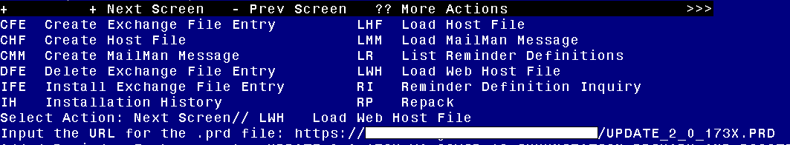

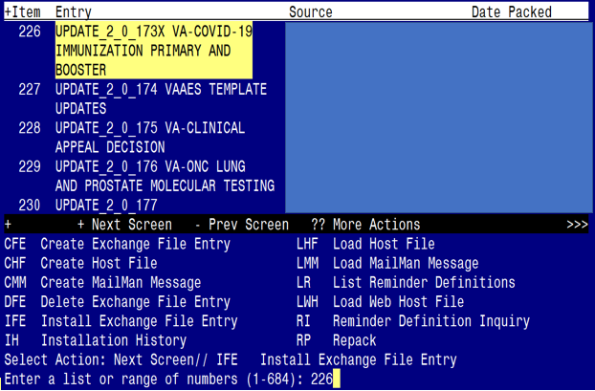At the **Select Action** prompt, enter **IFE** for Install Exchange File Entry

Enter the number that corresponds with your entry **UPDATE_2_0_173X VA-COVID-19 IMMUNIZATION PRIMARY AND BOOSTER.**  *(in this example it is entry 226 it will vary by site, the date on the file should be 12/21/22).*

The following instructions apply to all sites

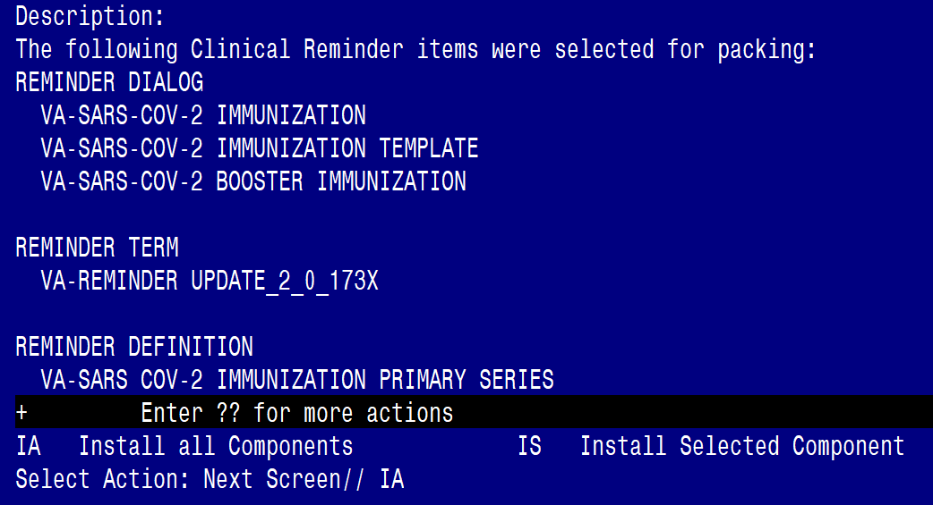

At the **Select Action** prompt, type **IA** for **Install all Components** and hit enter.

Any items that are NEW in any of the below categories, you should INSTALL

OVERWRITE any TIU TEMPLATE FIELDS that you are prompted to overwrite

SKIP any HEALTH FACTORS if you are prompted to overwrite

SKIP any REMINDER SPONSORS if you are prompted to overwrite

OVERWRITE any REMINDER TAXONOMIES that you are prompted to overwrite

OVERWRITE any REMINDER TERMS that you are prompted to overwrite EXCEPT those that have local mappings as indicated in blue above and listed again below. DO NOT overwrite your previously mapped terms for drugs and labs, if you are prompted SKIP the items below.

VA-CD4 COUNT

VA-STEROID PREDN EQUIV 5-6.6MG

VA-STEROID PREDN EQUIV 6.6-9MG

VA-STEROID PREDN EQUIV 10-19MG

VA-STEROID PREDN EQUIV >=20MG

VA-CHEMO/IMMUNOSUPPRESSIVE DRUGS

VA-COVID-19 VACCINATION CLINIC FUTURE APPT

OVERWRITE any REMINDER DEFINITIONS that you are prompted to overwrite.

OVERWRITE any HEALTH SUMMARY TYPE entries if you are prompted to overwrite

SKIP any HEALTH SUMMARY OBJECTS entries if you are prompted to overwrite

SKIP any TIU DOCUMENT DEFINITION entries if you are prompted to overwrite

If you see these prompts, please replace:

Finding IM.COVID-19 (CANSINO BIOLOGICAL INC./BEIJING INSTITUTE OF BIOTECHNOLOGY)  
VVNR NON-US VACCINE does not exist, what do you want to do?

 Select one of the following:               
          D         Delete  
          P         Replace with an existing entry  
          Q         Quit the install

Enter response**: P**  Replace with an existing entry  
Select IMMUNIZATION NAME: **COVID-19 VVNR NON-US VACCINE (CANSINO BIOLOGICAL INC./BEIJING INSTITUTE OF BIOTECHNOLOGY)       506**

Selection item IMM.COVID-19 (CANSINO BIOLOGICAL INC./BEIJING INSTITUTE OF BIOTECHNOLOGY) VVNR NON-US VACCINE does not exist, what do you want to do?

    Select one of the following:

          D         Delete  
          P         Replace with an existing entry  
          Q         Quit the install

Enter response: **P**  Replace with an existing entry  
Select IMMUNIZATION NAME: **COVID-19 VVNR NON-US VACCINE (CANSINO BIOLOGICAL INC./BEIJING INSTITUTE OF BIOTECHNOLOGY)**       506

You will then be prompted to install the first dialog component. You will choose IA to install all even though some items will already have an X to indicate they exist. .

Regarding the VA-SARS-COV-2 BOOSTER IMMUNIZATION (NATIONAL DIALOG):
Screen shot of the terminal window showing a list of elements, groups and dialogs with the text with IA for "Install All" entered at the "Select Action:" Prompt.  The correct entry is described in the text.

At the **Select Action** prompt, type **IA** to install the dialog – **SARS-COV-2 BOOSTER IMMUNIZATION**

Regarding the VA-SARS-COV-2 BOOSTER IMMUNIZATION (NATIONAL DIALOG):
Screen shot of the last of the list of elements, groups and dialogs that needed to be installed with a Q for quit entered at the "Select Action:" prompt because they now all exist.  

You will then be returned to this screen. At the **Select Action** prompt, type **Q.**

You will then be prompted to install the NEXT dialog component. You will choose IA to install all even though some items will already have an X to indicate they exist.

Regarding the VA-SARS-COV-2  IMMUNIZATION  TEMPLATE:
Screen shot of the terminal window showing a list of elements, groups and dialogs with the text with IA for "Install All" entered at the "Select Action:" Prompt.  The correct entry is described in the text.

At the **Select Action** prompt, type **IA** to install the dialog – **VA-SARS-COV-2 IMMUNIZATION TEMPLATE**

Regarding the VA-SARS-COV-2  IMMUNIZATION  TEMPLATE:
Screen shot of the last of the list of elements, groups and dialogs that needed to be installed with a Q for quit entered at the "Select Action:" prompt because they now all exist.  

You will then be returned to this screen. At the **Select Action** prompt, type **Q.**

You will then be prompted to install the next dialog component. You will choose IA to install all even though some items will already have an X to indicate they exist.

Regarding te VA-SARS-COV-2 IMMUNIZATION (NATIONAL DIALOG):
Screen shot of the terminal window showing a list of elements, groups and dialogs with the text with IA for "Install All" entered at the "Select Action:" Prompt.  The correct entry is described in the text.

At the **Select Action** prompt, type **IA** to install the dialog – **SARS-COV-2 IMMUNIZATION**

Regarding te VA-SARS-COV-2 IMMUNIZATION (NATIONAL DIALOG):
Screen shot of the last of the list of elements, groups and dialogs that needed to be installed with a Q for quit entered at the "Select Action:" prompt because they now all exist.  

You will then be returned to this screen. At the **Select Action** prompt, type **Q.**

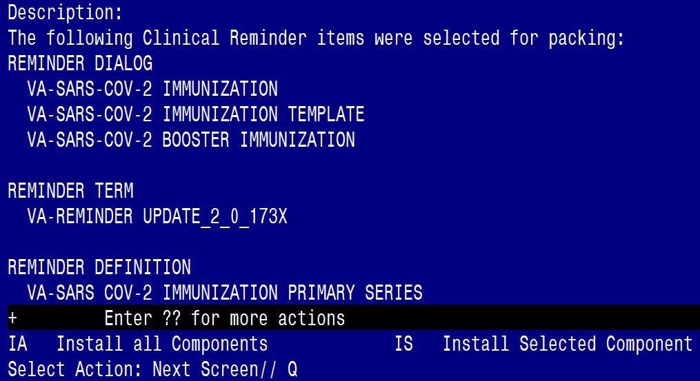

You will then be returned to this screen. At the **Select Action** prompt, type **Q.**

Install complete.

# Post-Installation

1. Re-enter any required local modifications.
   1. Add your quick orders from pre install step to VAL-COVID-19 BOOSTER ACTIONS ORDER
2. Add your quick orders from pre install step to VAL-SARS-COV-2 VACCINE ORDERING GP