

**Update _2_0_173Y**

Clinical Reminders

VA-COVID-19 IMMUNIZATION REMINDER UPDATE

Install Guide

**May 2023**

Product Development

Office of Information Technology

Department of Veterans Affairs

Table of Contents

Introduction 1

Install Details 6

Install Example 6

Post-Installation 13

# Introduction

DESCRIPTION:

There will be one cover sheet reminder – print name, COVID-19 Immunization. You will need to add this to your cover sheet in the post install.

The previous reminders/dialogs, COVID-19 Primary series and COVID-19 Booster have been inactivated/disabled. Print names for both of these have also been prefixed with ZZ

The new reminder will be due on all patients who have:

not received a COVID-19 bivalent dose of vaccine

and

have never had a COVID-19 monovalent vaccine

or

it has been at least 56 days since their last COVID-19 monovalent vaccine

If they have received a non-bivalent vaccine in the last 56 days, the reminder will be in the Not Applicable folder until after 56 days.

The reminder will resolve with an administration of a **single bivalent dose** or a documented allergy with a VIMM form contraindication.

The current cohort logic **does not** include the permissive recommendations of a 2nd bivalent dose for ages over 65 or for certain immunocompromised diagnosis.

The provider can at their clinical discretion provide a second dose to these populations. The reminder can be opened from the applicable folder or the note template can be used to document additional doses even if the reminder is not due, the user would need to change the series to 2 or 3 as appropriate.

UPDATE_2_0_173Y contains 1 Reminder Exchange entry:

UPDATE_2_0_173Y VA-COVID IMMUNIZATION UPDATE

REMINDER GENERAL FINDINGS

1 VIEW PROGRESS NOTE TEXT

TIU TEMPLATE FIELD

2 BLANK TEXT FIELD FOR DIALOGS

3 IM SARS COV-2 OUTSIDE INSTR 2

4 IM SARS COV-2 OUTSIDE INSTR 1

5 IM SARS COV-2 OUTSIDE WARNING

6 IM PHARMACY PHONE NUMBERS

7 IM SARS COV-2 ADMIN INFO POST TEXT B1 #2

8 IM SARS COV-2 DOSE SERIES BOOSTER WARNING

9 IM SARS COV-2 DOSE B1 #3 WARNING

10 IM SARS COV-2 ADMIN B1 INFO PRE TEXT

11 IM SARS COV-2 VIS/EUA INFO URL B1

12 IM SARS COV-2 ADMIN BOOSTER INFO PRE TEXT

13 IM SARS COV-2 VIS/EUA INFO URL D2

14 IM SARS COV-2 ADMIN BOOSTER INFO POST TEXT PFIZER

#1

15 IM SARS COV-2 ADMIN BOOSTER INFO POST TEXT C2 #1

16 IM SARS COV-2 ADMIN C2 INFO PRE TEXT

17 IM SARS COV-2 VIS/EUA INFO URL C2

18 IM SARS COV-2 CDC VACCINE UNDERLYING CONDITIONS

19 IM SARS COV-2 CDC VACCINE INFO URL

20 IM SARS COV-2 VA PRE SCREEN FORM

21 IM SARS COV-2 VA SIDE EFFECTS AE REPORTING

22 COVID-19 BOOSTER PFIZER RECIPIENT

23 COVID-19 BOOSTER MODERNA RECIPIENT

24 IM SCRIBE

25 VA-VANOD BLANK

26 COVID-19 CDC GUIDANCE

27 IM SARS COV-2 B1 DOSE #3

28 IM SARS COV-2 DOSE #2 WARNING

29 IM SARS COV-2 ADMIN INFO POST TEXT B1 #1

30 IM SARS COV-2 VIS/EUA INFO URL A1

31 IM SARS COV-2 ADMIN A1 INFO TTS COUNSELING

32 IM SARS COV-2 ADMIN A1 INFO PRE TEXT

33 IM SARS COV-2 ADMIN INFO POST TEXT A1 #B

34 IM SARS COV-2 DOSE A1 #2 WARNING

35 IM SARS COV-2 A1 DOSE #2

36 IM SARS COV-2 ADMIN INFO POST TEXT A1

37 COVID 19 VHA RESOURCES

38 IM SARS COV-2 PROVIDER EUA FACT URL B1

39 IM SARS COV-2 PROVIDER EUA FACT URL A1

40 IM SARS COV-2 PROVIDER EUA FACT URL C2

41 IM SARS COV-2 PROVIDER EUA FACT URL D2

42 COVID 19 CDC RESOURCES

IMMUNIZATION

COVID-19 (PFIZER), MRNA, LNP-S, BIVALENT BOOSTER,

PF, 30 MCG/0.3 ML DOSE

COVID-19 (MODERNA), MRNA, LNP-S, BIVALENT

BOOSTER, PF, 50 MCG/0.5 ML OR 25MCG/0.25 ML DOSE

COVID-19 VVNR NON-US VACCINE (CANSINO BIOLOGICAL

INC./BEIJING INSTITUTE OF BIOTECHNOLOGY)

SARS-COV-2 COVID-19 PS NON-US VACCINE (BIOLOGICAL

E LIMITED, CORBEVAX)

SARS-COV-2 COVID-19 INACTIVATED NON-US VACCINE

PRODUCT (MINHAI BIOTECHNOLOGY CO, KCONVAC)

SARS-COV-2 COVID-19 PS NON-US VACCINE (MEDIGEN,

MVC-COV1901)

SARS-COV-2 COVID-19 DNA NON-US VACCINE (ZYDUS

CADILA, ZYCOV-D)

SARS-COV-2 COVID-19 PS NON-US VACCINE (ANHUI

ZHIFEI LONGCOM, ZIFIVAX)

SARS-COV-2 COVID-19 VLP NON-US VACCINE (MEDICAGO,

COVIFENZ)

SARS-COV-2 (COVID-19) VACCINE, UNSPECIFIED

COVID-19 NON-US VACCINE, PRODUCT UNKNOWN

COVID-19 (SPUTNIK V) VVNR NON-US VACCINE

COVID-19 (SPUTNIK LIGHT) VVNR NON-US VACCINE

COVID-19 (SINOVAC), INACTIVATED VIRUS, NON-US

COVID-19 (SANOFI-PASTEUR), D614, RECOMB, PRES

DTM, AS03 ADJUVANT ADD, PF, 5MCG/0.5ML

COVID-19 (SANOFI-PASTEUR), D614, RECOMB, PRES

DTM, AS03 ADJUVANT ADD, PF, 10MCG/0.5ML

COVID-19 (QAZCOVID-IN) IV NON-US VACCINE

COVID-19 (JIANGSU PROVINCE CENTERS FOR DISEASE

CONTROL AND PREVENTION) PS NON-US VACCINE

COVID-19 (EPIVACCORONA) PS NON-US VACCINEX

COVID-19 (COVIVAC) LAV NON-US VACCINE

COVID-19 (COVAXIN) IV NON-US VACCINE

COVID-19 (BIBP, SINOPHARM) IV NON-US VACCINE

COVID-19 (ANHUI ZHIFEI LONGCOM BIOPHARMACEUTICAL

+ INSTITUTE OF MICROBIOLOGY) PS NON-US VACCINE

COVID-19 (PFIZER), MRNA, LNP-S, PF, 30 MCG/0.3 ML

DOSE, TRIS-SUCROSE (AGES 12+ YEARS)

COVID-19 (PFIZER), MRNA, LNP-S, PF, 30 MCG/0.3 ML

DOSE

COVID-19 (PFIZER), MRNA, LNP-S, PF, 3 MCG/0.2 ML

DOSE, TRIS-SUCROSE (6 MO-4 YEARS)

COVID-19 (PFIZER), MRNA, LNP-S, PF, 10 MCG/0.2 ML

DOSE, TRIS-SUCROSE (AGES 5-11 YEARS)

COVID-19 (NOVAVAX), SUBUNIT, RS-NANOPARTICLE+MATRI

X-M1 ADJUVANT, PF, 0.5 ML

COVID-19 (MODERNA), MRNA, LNP-S, PF, PEDIATRIC

(AGES 6-11 YRS) 50 MCG/0.5 ML DOSE

COVID-19 (MODERNA), MRNA, LNP-S, PF, PEDIATRIC

(AGES 6 MO - 5 YRS) 25 MCG/0.25 ML DOSE

COVID-19 (MODERNA), MRNA, LNP-S, PF, 50 MCG/0.5

ML DOSE

COVID-19 (MODERNA), MRNA, LNP-S, PF, 100

MCG/0.5ML DOSE OR 50 MCG/0.25ML DOSE

COVID-19 (JANSSEN), VECTOR-NR, RS-AD26, PF, 0.5 ML

COVID-19 (ASTRAZENECA), VECTOR-NR, RS-CHADOX1,

PF, 0.5 ML

HEALTH FACTORS

43 VA-REMINDER UPDATES [C]

44 VA-UPDATE_2_0_173Y

45 IMMUNIZATION [C]

46 VA-COVID-19 DEFER VACCINE 1Y

47 VA-COVID-19 DEFER VACCINE 6M

48 VA-COVID-19 DEFER VACCINE 3M

49 COVID-19 VERBAL REPORT COVID VACCINE

50 VA-SARS-COV-2 IMMUN EDUC VVC/TELE VST

51 VA-COVID-19 [C]

52 VA-SARS-COV-2 IMM CLIN REV NO ADDL DOSE

53 COVID-19 VACCINE DEFER PERMANENT

54 VA-COVID-19 VACCINE DEFER PERMANENT

55 VA-COVID-19 PRIMARY SERIES VACCINE DEFER 1Y

56 COVID-19 VACCINE DEFER 1Y

57 VA-COVID-19 PRIMARY SERIES VACCINE DEFER 6M

58 COVID-19 VACCINE DEFER 6M

59 VA-SARS-COV-2 PRIMARY SERIES VACCINE REFUSAL

60 VA-COVID-19 PRIMARY SERIES VACCINE DEFER 3M

61 COVID-19 VACCINE DEFER 3M

62 VA-SARS-COV-2 VACCINE DEFERRED

63 VA-SARS-COV-2 VACCINE CONTRAIND B1

64 VA-SARS-COV-2 VACCINE CONTRAIND A1

65 VA-SARS-COV-2 VACCINE CONTRAIND E2

66 VA-SARS-COV-2 VACCINE CONTRAIND C2

67 VA-SARS-COV-2 VACCINE CONTRAIND D2

68 VA-COVID-19 BOOSTER VACCINE DEFER PERMANENT

69 VA-COVID-19 BOOSTER VACCINE DEFER 1Y

70 VA-COVID-19 BOOSTER VACCINE DEFER 6M

71 VA-COVID-19 BOOSTER VACCINE DEFER 3M

72 VA-SARS-COV-2 VACCINE BOOSTER CONTRAINDICATED

73 VA-SARS-COV-2 IMM REFUSAL BOOSTER

REMINDER SPONSOR

74 NATIONAL CENTER FOR HEALTH PROMOTION AND DISEASE

PREVENTION (NCP)

75 VA NATIONAL CENTER FOR HEALTH PROMOTION AND

DISEASE PREVENTION (NCP)

76 POPULATION HEALTH

REMINDER COMPUTED FINDINGS

VA-REMINDER DEFINITION

VA-IMMUNIZATION AND LOCATION LOT INFO

VA-IS INPATIENT

VA-ALLERGY

VA-FILEMAN DATE

REMINDER TAXONOMY

77 VA-IMMUNIZATION ICD10 CODE

78 VA-SARS-COV-2 IMM NOVAVAX SERIES 2

79 VA-SARS-COV-2 IMM NOVAVAX SERIES 1

80 VA-SARS-COV-2 IMM JANSSEN SERIES 2

81 VA-SARS-COV-2 IMM JANSSEN SERIES 1

REMINDER TERM

82 VA-REMINDER UPDATE_2_0_173Y

83 VA-COVID-19 CONTRAINDICATION

84 VA-SARS-COV-2 VACCINE WHO APPROVED ALL (INCL US)

85 VA-IM NO DOSES AVAIL NOV 211

86 VA-IM NO DOSES AVAIL PFZ 300

87 VA-IM NO DOSES AVAIL MOD 229

88 VA-CURRENT INPATIENT

89 VA-SARS-COV-2 VACCINE B1 2 DOSE

90 VA-SARS-COV-2 VACCINE B1 1 DOSE

91 VA-SARS-COV-2 IM DOSE NOT NOVAVAX

92 VA-IM NO DOSES AVAIL JSN 212

93 VA-SARS-COV-2 VACCINE D2 2 DOSE

94 VA-SARS-COV-2 VACCINE C2 2 DOSE

95 VA-SARS-COV-2 VACCINE D2 1 DOSE

96 VA-SARS-COV-2 VACCINE C2 1 DOSE

97 VA-SARS-COV-2 VACCINE A1 1 DOSE

98 VA-SARS-COV-2 ALL CDC VACCINES

99 VA-COVID-19 VACCINE DEFERRAL PERMANENT

100 VA-COVID-19 PRIMARY SERIES VACCINE DEFERRAL 1Y

101 VA-COVID-19 PRIMARY SERIES VACCINE DEFERRAL 6M

102 VA-SARS-COV-2 VACCINE PRIMARY SERIES REFUSAL

103 VA-SARS-COV-2 VACCINE PRIMARY SERIES DEFERRAL

104 VA-SARS-COV-2 VACCINE CONTRAINDICATION

105 VA-SARS-COV-2 VACCINE WHO PFIZER

106 VA-SARS-COV-2 VACCINE WHO MODERNA

107 VA-SARS-COV-2 VACCINE WHO NOVAVAX

108 VA-SARS-COV-2 VACCINE WHO JANSSEN

109 VA-COVID-19 PRIMARY SERIES VACCINE DEFERRAL 3M

110 VA-SARS-COV-2 VACCINE INDICATION ADDL DOSE NEEDED

111 VA-SARS-COV-2 VACCINE WHO APPROVED ALL EXCEPT

BIVALENT (INCL US)

112 VA-SARS-COV-2 VACCINE BOOSTER SERIES DEFERRAL

113 VA-SARS-COV-2 VACCINE BIVALENT

114 VA-SARS-COV-2 BIVALENT CDC VACCINES FILEMAN

REFUSAL

115 VA-SARS-COV-2 ALL NON BIVALENT

116 VA-SARS-COV-2 BIVALENT CDC VACCINES

117 VA-SARS-COV-2 BIVALENT VACCINE DEFERRAL

REMINDER DEFINITION

118 VAL-BL COVID-19 CONTRAINDICATION

119 VA-SARS COV-2 IMMUNIZATION COUNT OVER EIGHT

120 VA-SARS COV-2 IMMUNIZATION COUNT EIGHT

121 VA-SARS COV-2 IMMUNIZATION COUNT SEVEN

122 VA-SARS COV-2 IMMUNIZATION COUNT SIX

123 VA-SARS COV-2 IMMUNIZATION COUNT FIVE

124 VA-SARS COV-2 IMMUNIZATION COUNT FOUR

125 VA-SARS COV-2 IMMUNIZATION COUNT THREE

126 VA-SARS COV-2 IMMUNIZATION COUNT TWO

127 VA-SARS COV-2 IMMUNIZATION COUNT ONE

128 VA-SARS COV-2 IMMUNIZATION COUNT ZERO

129 VA-SARS COV-2 IMMUNIZATION PRIMARY SERIES

130 VA-SARS COV-2 IMMUNIZATION

131 VA-SARS COV-2 IMMUNIZATION BOOSTER SERIES

HEALTH SUMMARY COMPONENT

CLINICAL REMINDERS FINDINGS

PCE IMMUNIZATIONS SELECT CHRON

HEALTH SUMMARY TYPE

132 VA-COVID CONTRA

133 SARS-COV-2 IMMUNIZATION

HEALTH SUMMARY OBJECTS

134 VA-COVID CONTRA (TIU)

135 SARS-COV-2 IMMUNIZATION (TIU)

TIU DOCUMENT DEFINITION

136 VA-COVID CONTRA

137 SARS-COV-2 IMMUNIZATION

REMINDER DIALOG

138 VA-SARS-COV-2 BOOSTER IMMUNIZATION

139 VA-SARS-COV-2 IMMUNIZATION TEMPLATE

140 VA-SARS-COV-2 IMMUNIZATION

# Install Details

This update is being distributed as a web host file.

The file will be installed using Reminder Exchange, programmer access is not required.

This update can be loaded with users on the system. Installation will take less than 5 minutes

# Install Example

To Load the Web Host File. Navigate to Reminder exchange in Vista

At the **Select Action:** prompt, enter **LWH** for Load Web Host File

**Copy and pasted the below text.**

**https://redacted/UPDATE_2_0_173Y.PRD**

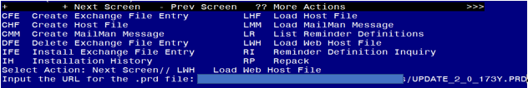

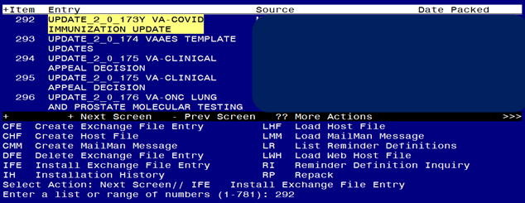

At the **Select Action** prompt, enter **IFE** for Install Exchange File Entry

Enter the number that corresponds with your entry **UPDATE_2_0_173Y VA-COVID IMMUNIZATION UPDATE.**  *(in this example it is entry 292 it will vary by site, the date on the file should be 05/26/2023).*

The following instructions apply to all sites

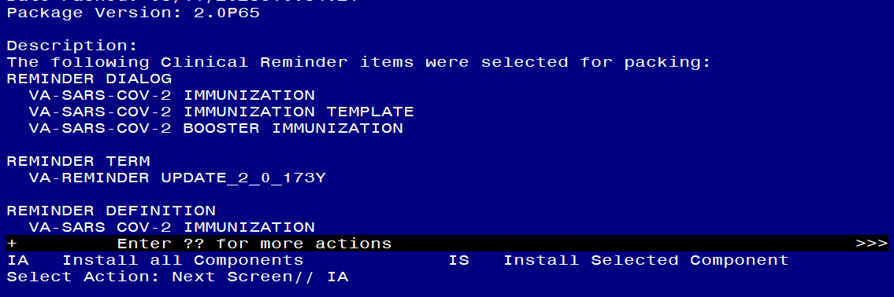

At the **Select Action** prompt, type **IA** for **Install all Components** and hit enter.

Any items that are NEW in any of the below categories, you should INSTALL

OVERWRITE any TIU TEMPLATE FIELDS that you are prompted to overwrite

SKIP any HEALTH FACTORS if you are prompted to overwrite

SKIP any REMINDER SPONSORS if you are prompted to overwrite

OVERWRITE any REMINDER TAXONOMIES that you are prompted to overwrite

OVERWRITE any REMINDER TERMS that you are prompted to overwrite

If you see these prompt during install, do the following

Finding IM.COVID-19 (MODERNA), MRNA, LNP-S, BIVALENT BOOSTER, PF, 50 MCG/0.5 ML OR 25MCG/0.25 ML DOSE does not exist, what do you want to do?

Select one of the following:

D Delete

P Replace with an existing entry

Q Quit the install

Enter response: **P** Replace with an existing entry

Select IMMUNIZATION NAME: **229** COVID-19 (MODERNA), MRNA, LNP-S, BIVALENT, PF, 50 MCG/0.5 ML OR 25MCG/0.25 ML DOSE 229

Finding IM.COVID-19 (PFIZER), MRNA, LNP-S, BIVALENT BOOSTER, PF, 30 MCG/0.3 ML DOSE does not exist, what do you want to do?

Select one of the following:

D Delete

P Replace with an existing entry

Q Quit the install

Enter response: **P**  Replace with an existing entry

Select IMMUNIZATION NAME: **300**  COVID-19 (PFIZER), MRNA, LNP-S, BIVALENT, PF, 30 MCG/0.3 ML DOSE 300

OVERWRITE any REMINDER DEFINITIONS that you are prompted to overwrite.

OVERWRITE any HEALTH SUMMARY TYPE entries if you are prompted to overwrite

If you see these prompt during install, do the following

Selection item IMM.COVID-19 (MODERNA), MRNA, LNP-S, BIVALENT BOOSTER, PF, 50 MCG/0.5 ML OR 25MCG/0.25 ML DOSE does not exist, what do you want to do?

Select one of the following:

D Delete

P Replace with an existing entry

Q Quit the install

Enter response: **P** Replace with an existing entry

Select IMMUNIZATION NAME: **229** COVID-19 (MODERNA), MRNA, LNP-S, BIVALENT, PF, 50 MCG/0.5 ML OR 25MCG/0.25 ML DOSE 229

Selection item IMM.COVID-19 (PFIZER), MRNA, LNP-S, BIVALENT BOOSTER, PF, 30 MCG/0.3 ML DOSE does not exist, what do you want to do?

Select one of the following:

D Delete

P Replace with an existing entry

Q Quit the install

Enter response: **P**  Replace with an existing entry

Select IMMUNIZATION NAME: **300**  COVID-19 (PFIZER), MRNA, LNP-S, BIVALENT, PF, 30 MCG/0.3 ML DOSE 300....

SKIP any HEALTH SUMMARY OBJECTS entries if you are prompted to overwrite

SKIP any TIU DOCUMENT DEFINITION entries if you are prompted to overwrite

You will then be prompted to install the first dialog component. You will choose IA to install all even though some items will already have an X to indicate they exist. .

Regarding the Reminder Dialog, SARS-COV-2 BOOSTER IMMUNIZATION:
Screen shot of the terminal window showing a list of elements, groups and dialogs with the text with IA for "Install All" entered at the "Select Action:" Prompt.  The correct entry is described in the text.

At the **Select Action** prompt, type **IA** to install the dialog – **SARS-COV-2 BOOSTER IMMUNIZATION**

Regarding the Reminder Dialog, SARS-COV-2 BOOSTER IMMUNIZATION:
Screen shot of the last of the list of elements, groups and dialogs that needed to be installed with a Q for quit entered at the "Select Action:" prompt because they now all exist. 


You will then be returned to this screen. At the **Select Action** prompt, type **Q.**

You will then be prompted to install the NEXT dialog component. You will choose IA to install all even though some items will already have an X to indicate they exist.

Regarding the VA-SARS-COV-2 IMMUNIZATION TEMPLATE:
Screen shot of the terminal window showing a list of elements, groups and dialogs with the text with IA for "Install All" entered at the "Select Action:" Prompt.  The correct entry is described in the text.

At the **Select Action** prompt, type **IA** to install the dialog – **VA-SARS-COV-2 IMMUNIZATION TEMPLATE**

Regarding the VA-SARS-COV-2 IMMUNIZATION TEMPLATE:
Screen shot of the last of the list of elements, groups and dialogs that needed to be installed with a Q for quit entered at the "Select Action:" prompt because they now all exist.  

You will then be returned to this screen. At the **Select Action** prompt, type **Q.**

You will then be prompted to install the next dialog component. You will choose IA to install all even though some items will already have an X to indicate they exist.

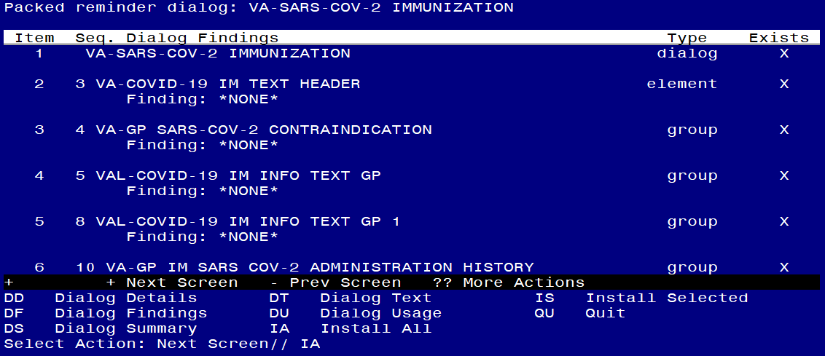

At the **Select Action** prompt, type **IA** to install the dialog – **SARS-COV-2 IMMUNIZATION**

Regarding the Reminder Dialog SARS-COV-2 IMMUNIZATION:
Screen shot of the last of the list of elements, groups and dialogs that needed to be installed with a Q for quit entered at the "Select Action:" prompt because they now all exist.  

You will then be returned to this screen. At the **Select Action** prompt, type **Q.**

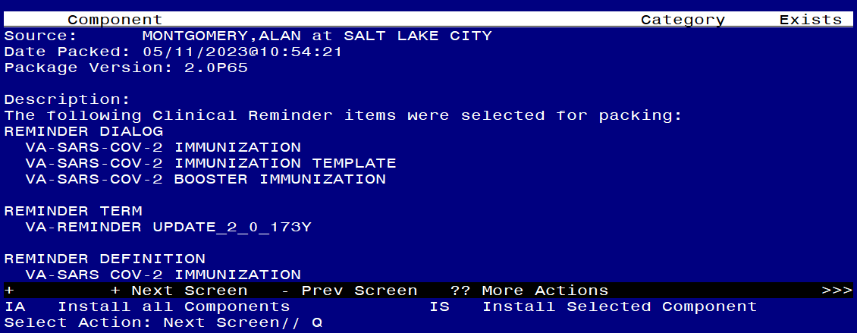

You will then be returned to this screen. At the **Select Action** prompt, type **Q.**

Install complete.

# Post-Installation

1. Review the dialogs to make sure only the vaccine options that your site administers show as available to administer. (Moderna Bivalent and Pfizer Bivalent options will be enabled upon install, Novavax and Janssen are disabled upon install)
   1. Disable any dialog groups for vaccine types not in use at your site – E.G., if you are exclusively a Moderna & Janssen site, then disable the reminder dialog groups for Pfizer and enable the Janssen option.
2. Make sure that the reminder definition VA-SARS COV-2 IMMUNIZATION print name COVID-19 Immunization is assigned to the CPRS cover sheet at the appropriate level (This replaces the two that were previously assigned to your cover sheet).
3. Open the reminder and confirm the version displays as 4.1
4. Review the dialog group VAL-SARS-COV-2 VACCINE ORDERING GP, if your site uses the reminder dialog to place an order, you can add the order or order set for the appropriate bivalent COVID-19 formulation as a finding to this group or to the subcomponents/elements contained in that group.