

**Update_2_0_178**

Clinical Reminders

VA-MISC Update 13

Install Guide

**January 2021**

Product Development

Office of Information Technology

Department of Veterans Affairs

**Table of Contents**

Introduction 1

Pre-Installation 5

Install Details 6

Install Example 6

Post Installation 33

# Introduction

This update contains several minor spelling corrections and other changes to existing clinical reminder content, a full list of the changes can be found here:

**[See the document MISC_UPDATE_13_CHANGES](https://vaww.va.gov/reminders/docs/MISC_UPDATE_13_CHANGES.pdf)**

**UPDATE_2_0_178 contains 1 Reminder Exchange entry:**

UPDATE_2_0_178 VA-MISC UPDATE 13

**The exchange file contains the following components:**

**TIU TEMPLATE FIELD**

BLANK TEXT FIELD FOR DIALOGS

WORD PROCESSING 10-2-02

VA-TELE URGENT CRISIS LINE

VA-PHASER SHAREPOINT

IM MENINGOCOCCAL VACCINE NCP GUIDANCE

NCP HERPES ZOSTER DETAILED GUIDANCE

CDC ZOSTER VACCINE RECOMMENDATIONS

NCP HERPES ZOSTER GUIDANCE

IM TD GENERIC LOT# EXP DATE

IM COMMENT COMPLICATONS

IM VIS TD URL

IM VIS TD DT

IM TD MANUF CVX 09

IM INJECTION RIGHT/LEFT

IM TD MANUF CVX 113

IM VIS HPV9 DT

DATE (*)

**ROUTINE**

PXRMBMI

**VA DRUG CLASS**

CN302

CN101

**GMRV VITAL TYPE**

BLOOD PRESSURE

**MH TESTS AND SURVEYS**

CIWA-AR-

**EDUCATION TOPICS**

VA-HTN NUTRITION EDUCATION

VA-HTN EDUCATION

**IMMUNIZATION**

MENINGOCOCCAL MCV4, UNSPECIFIED FORMULATION

MENINGOCOCCAL MCV4O

MENINGOCOCCAL MCV4P

MENINGOCOCCAL POLYSACCHARIDE (GROUPS A, C, Y, W-135) TT CONJUGATE

INFLUENZA, HIGH DOSE SEASONAL

INFLUENZA, HIGH-DOSE, QUADRIVALENT

INFLUENZA, INJECTABLE, MDCK, QUADRIVALENT

INFLUENZA, RECOMBINANT, QUADRIVALENT,INJECTABLE, PRESERVATIVE FREE

INFLUENZA, INJECTABLE, MDCK, PRESERVATIVE FREE, QUADRIVALENT

INFLUENZA, TRIVALENT, ADJUVANTED

INFLUENZA, INTRADERMAL, QUADRIVALENT, PRESERVATIVE FREE

INFLUENZA, INJECTABLE, QUADRIVALENT

INFLUENZA, RECOMBINANT, INJECTABLE, PRESERVATIVE FREE

INFLUENZA, INJECTABLE, MDCK, PRESERVATIVE FREE

INFLUENZA NASAL, UNSPECIFIED FORMULATION

INFLUENZA, INJECTABLE, QUADRIVALENT, PRESERVATIVE FREE

INFLUENZA, LIVE, INTRANASAL, QUADRIVALENT

INFLUENZA, SEASONAL, INTRADERMAL, PRESERVATIVE FREE

INFLUENZA, SEASONAL, INJECTABLE

INFLUENZA, SEASONAL, INJECTABLE, PRESERVATIVE FREE

INFLUENZA VACCINE, QUADRIVALENT, ADJUVANTED

INFLUENZA, LIVE, INTRANASAL

INFLUENZA, UNSPECIFIED FORMULATIO

MENINGOCOCCAL MPSV4

HEP B, ADULT

TD (ADULT), 2 LF TETANUS TOXOID, PRESERVATIVE FREE, ADSORBED

TD (ADULT), 5 LF TETANUS TOXOID, PRESERVATIVE FREE, ADSORBED

**HEALTH FACTORS**

VA-VAAES NEURO AVPU

VA-VAAES NEURO AVPU UNRESPONSIVE

VA-VAAES NEURO AVPU PAIN

VA-VAAES NEURO AVPU VOICE

VA-VAAES NEURO AVPU ALERT

VA-SCI/D BLADDER MGMT-SURG PROCEDURES

VA-SCI/D BLADDER SURG HX-SUPRAPUBIC CATH

VA-SCI/D BLADDER SURG HX-SACR ANT STIM

VA-SCI/D BLADDER SURG HX-ILEOVESICOSTOMY

VA-SCI/D BLADDER SURG HX-ILEAL CONDUIT

VA-SCI/D BLADDER SURG HX-CONTINENT STOMA

VA-SCI/D BLADDER SURG HX-AUGMENTATION

VA-SCI/D BLADDER SURG HX-NONE

VA SCI/D BLADDER SURG HX-OTHER

VA-SCI/D BLADDER SURG HX-ART SPHINCTER

VA-SCI/D BLADDER SURG HX-SPHINCTEROTOMY

VA-HEALTH AND WELL BEING [C]

VA-WHS-AFHS-PATIENT PRIORITIES FOLLOW-UP

VA-WHS-AFHS-IDENTIFY PATIENT PRIORITIES

VA-WHS-AGE-FRIENDLY-MOBILITY

VA-WHS-AGE-FRIENDLY-MENTATION

VA-WHS-AGE-FRIENDLY MEDICATION

VA-WHS-AGE-FRIENDLY-WHAT MATTERS

VA-WHS-AGE-FRIENDLY-4MS

VA-WHS - MY STORY

VA-WHS - NATIVE AMERICAN HEALING

VA-WHS - FUNCTIONAL NUTRITION

VA-WHS - MAP TO THE MAP

VA-WHS - INTRODUCTION TO WHOLE HEALTH

VA-WHS - CHANGING THE CONVERSATION

VA-WHS - PERSONAL HEALTH INVENTORY

VA-WHS - PERSONAL HEALTH PLANNING

VA-WHS - AROMATHERAPY

VA-WHS - WHOLE HEALTH EDUCATION

VA-WHS - YOGA

VA-WHS - WHOLE HEALTH COACHING

VA-WHS - THERAPEUTIC OR HEALING TOUCH

VA-WHS - TAI CHI

VA-WHS - RELAXATION TECHNIQUES

VA-WHS - REIKI

VA-WHS - MINDFULNESS OTHER THAN MBSR

VA-WHS - MEDITATION

VA-WHS - MINDFULNESS BASED STRESS REDUCE

VA-WHS - INTEGRATIVE HEALTH

VA-WHS - BFA

VA-WHS - TAKING CHARGE LIFE AND HEALTH

VA-WHS - GUIDED IMAGERY

VA-WHS - QI GONG

VA-WHS - EXPRESSIVE ARTS

VA-REMINDER UPDATES

VA-UPDATE_2_0_178

HYPERTENSION

HTN REFERRED OTHER

TELE URGENT CARE

TELE URGENT TYPE PHONE HF

TELE URGENT TYPE VIDEO HF

TELE URGENT PLAN NEAREST ER HF

TELE URGENT PLAN URGENT CARE HF

TELE URGENT PLAN LESS THAN 72 HRS HF

TELE URGENT PLAN PACT HF

TELE URGENT PLAN TELE URGENT HF

TELE URGENT RFR OTHER HF

TELE URGENT RFR EYE HF

TELE URGENT RFR CV HF

TELE URGENT RFR NEURO HF

TELE URGENT RFR URINARY HF

TELE URGENT RFR GI HF

TELE URGENT RFR SKIN HF

TELE URGENT RFR ENT HF

TELE URGENT RFR MUSCULO HF

INCORRECT DIAGNOSES

INCORRECT HTN DIAGNOSIS

HTN NO EDUC INTERVENTION WARRANTED

**REMINDER SPONSOR**

VA National Center for Health Promotion and Disease Prevention (NCP)

Office of Quality & Performance

Office of Patient Care Services

**REMINDER COMPUTED FINDINGS**

VA-BMI

**REMINDER TAXONOMY**

VA-IMMUNIZATION INJECTION 90471

VA-HYPERTENSION CODES

**REMINDER TERM**

VA-OPIOID DRUG CLASS (CN101) (TERM)

VA-BENZODIAZEPINE DRUG CLASS (CN302) (TERM)

VA-MENINGOCOCCAL ACWY VACCINE CONJUGATE

VA-NEWS AVPU N/A

VA-SCI/D BLADDER MGMT-SURG HX (OBJ)

VA-INFLUENZA IMM SEASONAL VACCINE FORMULATIONS

VA-HEALTH AND WELL BEING

VA-REMINDER UPDATE_2_0_178

VA-HTN NO EDUC INTERVENTION WARRANTED

VA-HTN EXERCISE EDUCATION

VA-HTN INCORRECT DIAGNOSIS

VA-HTN NUTRITION EDUCATION

**REMINDER DEFINITION**

VA-OPIOD (CN101) BUT NOT BENZODIAZEPINE (CN302)

VA-BENZODIAZEPINE (CN302) BUT NOT OPIOID (CN101)

VA-HTN LIFESTYLE EDUCATION

**TIU DOCUMENT DEFINTION**

VA-WRIISC ACTIVE PROBLEMS

ACTIVE MEDS COMBINED

ALLERGIES/AADR

**REMINDER ORDER CHECK RULES**

VA-OPIOID DRUG CLASS (CN101) (RULE)

VA-BENZODIAZEPINE DRUG CLASS (CN302) (RULE)

**REMINDER DIALOG**

VA-GP MISC UPDATE 13

VA-HTN LIFESTYLE EDUCATION

# Pre-Installation

Prior to installing this Update:

1. Check your Reminder Exchange Install History (IH) and ensure you have installed the following (previously released) Updates:
   * UPDATE_2_0_164 VA-MISCELLANEOUS UPDATE 12
   * UPDATE_2_0_163 VA-INFLUENZA REMINDER UPDATE
   * UPDATE_2_0_170 VA-INFLUENZA REMINDER UPDATE
   * UPDATE_2_0_168 VA-TD AND TDAP REMINDER UPDATES
   * UPDATE_2_0_97 VA-SPINAL CORD INJURIES AND DISORDERS
   * UPDATE_2_0_160 VA-AES ACUTE INPATIENT NSG SHIFT ASSESSMENT BUNDLE
   * UPDATE_2_0_174 VA-AES TEMPLATE UPDATES
   * UPDATE_2_0_112 VA-PHASER TEMPLATE
   * UPDATE_2_0_158 VA-TELE URGENT CARE
   * UPDATE_2_0_166 VA-HYPERTENSION REMINDER UPDATE
2. Inquire/Print (INQ) the following ELEMENTS to capture/save the objects embedded in each. When you reach the Post-Installation steps, you can use the saved inquiry to add the objects back into each ELEMENT.
   * VAL-TELE URGENT PROBLEM LIST
   * VAL-TELE URGENT ALLERGIES
   * VAL-TELE URGENT ACTIVE MEDS
   * VAL-TELE URGENT DEMOGRAPHICS

# Install Details

This update is being distributed as a web host file. The address for the host file is: **https://REDACTED /UPDATE_2_0_178.PRD**

The file will be installed using Reminder Exchange, programmer access is not required.

Installation:

=============

This update can be loaded with users on the system. Installation will take less than 20 minutes.

# Install Example

To Load the Web Host File. Navigate to Reminder exchange in VistA

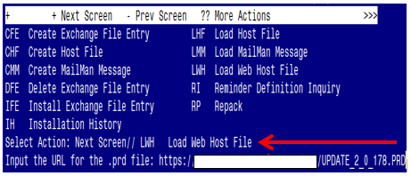

At the **Select Action:** prompt, enter **LWH** for Load Web Host File

At the **Input the url for the .prd file:** prompt, type the following web address:

**https://REDACTED/UPDATE_2_0_178.PRD**

You should see a message at the top of your screen that the file successfully loaded.

Terminal window screen shot of the message displaying the URL of the file that was successfully loaded.  Part of the URL has been redacted as it is a VA only internal web site URL.

Search for and locate the reminder exchange entry titled UPDATE_2_0_178 VA-MISC UPDATE 13.

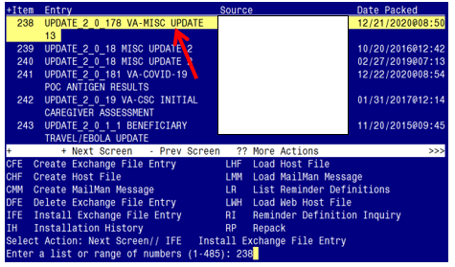

At the **Select Action** prompt, enter **IFE** for Install Exchange File Entry

Enter the number that corresponds with your entry titled **UPDATE_2_0_178 VA-MISC UPDATE 13** *(in this example it is entry 238, it will vary by site).* The exchange file date should be 12/21/2020.

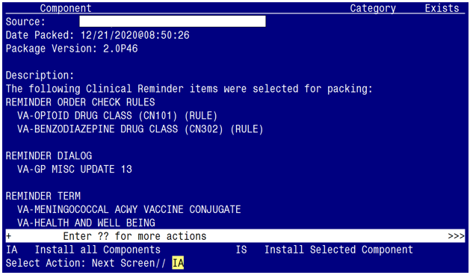

At the **Select Action** prompt, type **IA** for Install all Components and hit enter.

Select Action: Next Screen// IA Install all Components

You may (or MAY NOT) be prompted to address the following components:

The following highlighted colors are to guide you on which option to choose:

Yellow indicates to choose - I to INSTALL

Green indicates to choose - O to OVERWRITE

Blue indicates to choose - S to SKIP

Purple indicates to choose - M to MERGE

**Take Note**: When you install in your TEST system, you may be prompted to address two Immunization Finding Items. Those items have been added in the list of components below, with a highlight color that indicates to choose – D to Delete

TIU TEMPLATE FIELD entry VA-TELE URGENT CRISIS LINE is NEW,

what do you want to do?

Select one of the following:

C Create a new entry by copying to a new name

I Install

Q Quit the install

S Skip, do not install this entry

Enter response: I// I

TIU TEMPLATE FIELD entry named VA-PHASER SHAREPOINT already exists

but the packed component is different, what do you want to do?

Select one of the following:

C Create a new entry by copying to a new name

O Overwrite the current entry

U Update

Q Quit the install

S Skip, do not install this entry

Enter response: O// Overwrite the current entry

Are you sure you want to overwrite? N// Y

TIU TEMPLATE FIELD entry IM TD MANUF CVX 09 is NEW,

what do you want to do?

Select one of the following:

C Create a new entry by copying to a new name

I Install

Q Quit the install

S Skip, do not install this entry

Enter response: I// I

TIU TEMPLATE FIELD entry IM TD MANUF CVX 113 is NEW,

what do you want to do?

Select one of the following:

C Create a new entry by copying to a new name

I Install

Q Quit the install

S Skip, do not install this entry

Enter response: I// I

TIU TEMPLATE FIELD entry IM VIS HPV9 DT is NEW,

what do you want to do?

Select one of the following:

C Create a new entry by copying to a new name

I Install

Q Quit the install

S Skip, do not install this entry

Enter response: I// I

EDUCATION TOPICS entry named VA-HTN NUTRITION EDUCATION already exists

but the packed component is different, what do you want to do?

Select one of the following:

C Create a new entry by copying to a new name

O Overwrite the current entry

U Update

Q Quit the install

S Skip, do not install this entry

Enter response: O// Overwrite the current entry

Are you sure you want to overwrite? N// Y

EDUCATION TOPICS entry named VA-HTN EXERCISE already exists but the

packed component is different, what do you want to do?

Select one of the following:

C Create a new entry by copying to a new name

O Overwrite the current entry

U Update

Q Quit the install

S Skip, do not install this entry

Enter response: O// Overwrite the current entry

Are you sure you want to overwrite? N// Y

HEALTH FACTORS entry named VA-VAAES NEURO AVPU already exists but the

packed component is different, what do you want to do?

Select one of the following:

C Create a new entry by copying to a new name

O Overwrite the current entry

U Update

Q Quit the install

S Skip, do not install this entry

Enter response: O// S

HEALTH FACTORS entry named VA-VAAES NEURO AVPU UNRESPONSIVE already

exists but the packed component is different, what do you want to do?

Select one of the following:

C Create a new entry by copying to a new name

O Overwrite the current entry

U Update

Q Quit the install

S Skip, do not install this entry

Enter response: O// S

HEALTH FACTORS entry named VA-VAAES NEURO AVPU PAIN already exists

but the packed component is different, what do you want to do?

Select one of the following:

C Create a new entry by copying to a new name

O Overwrite the current entry

U Update

Q Quit the install

S Skip, do not install this entry

Enter response: O// S

HEALTH FACTORS entry named VA-VAAES NEURO AVPU VOICE already exists

but the packed component is different, what do you want to do?

Select one of the following:

C Create a new entry by copying to a new name

O Overwrite the current entry

U Update

Q Quit the install

S Skip, do not install this entry

Enter response: O// S

HEALTH FACTORS entry named VA-VAAES NEURO AVPU ALERT already exists

but the packed component is different, what do you want to do?

Select one of the following:

C Create a new entry by copying to a new name

O Overwrite the current entry

U Update

Q Quit the install

S Skip, do not install this entry

Enter response: O// S

HEALTH FACTORS entry named VA-SCI/D BLADDER MGMT-SURG PROCEDURES

already exists but the packed component is different, what do you

want to do?

Select one of the following:

C Create a new entry by copying to a new name

O Overwrite the current entry

U Update

Q Quit the install

S Skip, do not install this entry

Enter response: O// S

HEALTH FACTORS entry named VA-SCI/D BLADDER SURG HX-SUPRAPUBIC CATH

already exists but the packed component is different, what do you

want to do?

Select one of the following:

C Create a new entry by copying to a new name

O Overwrite the current entry

U Update

Q Quit the install

S Skip, do not install this entry

Enter response: O// S

HEALTH FACTORS entry named VA-SCI/D BLADDER SURG HX-SACR ANT STIM

already exists but the packed component is different, what do you

want to do?

Select one of the following:

C Create a new entry by copying to a new name

O Overwrite the current entry

U Update

Q Quit the install

S Skip, do not install this entry

Enter response: O// S

HEALTH FACTORS entry named VA-SCI/D BLADDER SURG HX-ILEOVESICOSTOMY

already exists but the packed component is different, what do you

want to do?

Select one of the following:

C Create a new entry by copying to a new name

O Overwrite the current entry

U Update

Q Quit the install

S Skip, do not install this entry

Enter response: O// S

HEALTH FACTORS entry named VA-SCI/D BLADDER SURG HX-ILEAL CONDUIT

already exists but the packed component is different, what do you

want to do?

Select one of the following:

C Create a new entry by copying to a new name

O Overwrite the current entry

U Update

Q Quit the install

S Skip, do not install this entry

Enter response: O// S

HEALTH FACTORS entry named VA-SCI/D BLADDER SURG HX-CONTINENT STOMA

already exists but the packed component is different, what do you

want to do?

Select one of the following:

C Create a new entry by copying to a new name

O Overwrite the current entry

U Update

Q Quit the install

S Skip, do not install this entry

Enter response: O// S

HEALTH FACTORS entry named VA-SCI/D BLADDER SURG HX-AUGMENTATION

already exists but the packed component is different, what do you

want to do?

Select one of the following:

C Create a new entry by copying to a new name

O Overwrite the current entry

U Update

Q Quit the install

S Skip, do not install this entry

Enter response: O// S

HEALTH FACTORS entry named VA-SCI/D BLADDER SURG HX-NONE already

exists but the packed component is different, what do you want to do?

Select one of the following:

C Create a new entry by copying to a new name

O Overwrite the current entry

U Update

Q Quit the install

S Skip, do not install this entry

Enter response: O// S

HEALTH FACTORS entry named VA SCI/D BLADDER SURG HX-OTHER already

exists but the packed component is different, what do you want to do?

Select one of the following:

C Create a new entry by copying to a new name

O Overwrite the current entry

U Update

Q Quit the install

S Skip, do not install this entry

Enter response: O// S

HEALTH FACTORS entry named VA-SCI/D BLADDER SURG HX-ART SPHINCTER

already exists but the packed component is different, what do you

want to do?

Select one of the following:

C Create a new entry by copying to a new name

O Overwrite the current entry

U Update

Q Quit the install

S Skip, do not install this entry

Enter response: O// S

HEALTH FACTORS entry named VA-SCI/D BLADDER SURG HX-SPHINCTEROTOMY

already exists but the packed component is different, what do you

want to do?

Select one of the following:

C Create a new entry by copying to a new name

O Overwrite the current entry

U Update

Q Quit the install

S Skip, do not install this entry

Enter response: O// S

HEALTH FACTORS entry named VA-HEALTH AND WELL BEING [C] already exists

but the packed component is different, what do you want to do?

Select one of the following:

C Create a new entry by copying to a new name

O Overwrite the current entry

U Update

Q Quit the install

S Skip, do not install this entry

Enter response: O// Overwrite the current entry

Are you sure you want to overwrite? N// Y

HEALTH FACTORS entry VA-WHS-AFHS-PATIENT PRIORITIES FOLLOW-UP is NEW,

what do you want to do?

Select one of the following:

C Create a new entry by copying to a new name

I Install

Q Quit the install

S Skip, do not install this entry

Enter response: I// I

HEALTH FACTORS entry VA-WHS-AFHS-IDENTIFY PATIENT PRIORITIES is NEW,

what do you want to do?

Select one of the following:

C Create a new entry by copying to a new name

I Install

Q Quit the install

S Skip, do not install this entry

Enter response: I// I

HEALTH FACTORS entry VA-WHS-AGE-FRIENDLY-MOBILITY is NEW,

what do you want to do?

Select one of the following:

C Create a new entry by copying to a new name

I Install

Q Quit the install

S Skip, do not install this entry

Enter response: I// I

HEALTH FACTORS entry VA-WHS-AGE-FRIENDLY-MENTATION is NEW,

what do you want to do?

Select one of the following:

C Create a new entry by copying to a new name

I Install

Q Quit the install

S Skip, do not install this entry

Enter response: I// I

HEALTH FACTORS entry VA-WHS-AGE-FRIENDLY MEDICATION is NEW,

what do you want to do?

Select one of the following:

C Create a new entry by copying to a new name

I Install

Q Quit the install

S Skip, do not install this entry

Enter response: I// I

HEALTH FACTORS entry VA-WHS-AGE-FRIENDLY-WHAT MATTERS is NEW,

what do you want to do?

Select one of the following:

C Create a new entry by copying to a new name

I Install

Q Quit the install

S Skip, do not install this entry

Enter response: I// I

HEALTH FACTORS entry VA-WHS-AGE-FRIENDLY-4MS is NEW,

what do you want to do?

Select one of the following:

C Create a new entry by copying to a new name

I Install

Q Quit the install

S Skip, do not install this entry

Enter response: I// I

HEALTH FACTORS entry named VA-WHS - MY STORY already exists but the

packed component is different, what do you want to do?

Select one of the following:

C Create a new entry by copying to a new name

O Overwrite the current entry

U Update

Q Quit the install

S Skip, do not install this entry

Enter response: O// S

HEALTH FACTORS entry named VA-WHS - NATIVE AMERICAN HEALING already

exists but the packed component is different, what do you want to do?

Select one of the following:

C Create a new entry by copying to a new name

O Overwrite the current entry

U Update

Q Quit the install

S Skip, do not install this entry

Enter response: O// S

HEALTH FACTORS entry named VA-WHS - FUNCTIONAL NUTRITION already

exists but the packed component is different, what do you want to do?

Select one of the following:

C Create a new entry by copying to a new name

O Overwrite the current entry

U Update

Q Quit the install

S Skip, do not install this entry

Enter response: O// S

HEALTH FACTORS entry named VA-WHS - MAP TO THE MAP already exists but

the packed component is different, what do you want to do?

Select one of the following:

C Create a new entry by copying to a new name

O Overwrite the current entry

U Update

Q Quit the install

S Skip, do not install this entry

Enter response: O// S

HEALTH FACTORS entry named VA-WHS - INTRODUCTION TO WHOLE HEALTH

already exists but the packed component is different, what do you

want to do?

Select one of the following:

C Create a new entry by copying to a new name

O Overwrite the current entry

U Update

Q Quit the install

S Skip, do not install this entry

Enter response: O// S

HEALTH FACTORS entry named VA-WHS - CHANGING THE CONVERSATION already

exists but the packed component is different, what do you want to do?

Select one of the following:

C Create a new entry by copying to a new name

O Overwrite the current entry

U Update

Q Quit the install

S Skip, do not install this entry

Enter response: O// S

HEALTH FACTORS entry named VA-WHS - PERSONAL HEALTH INVENTORY already

exists but the packed component is different, what do you want to do?

Select one of the following:

C Create a new entry by copying to a new name

O Overwrite the current entry

U Update

Q Quit the install

S Skip, do not install this entry

Enter response: O// S

HEALTH FACTORS entry named VA-WHS - PERSONAL HEALTH PLANNING already

exists but the packed component is different, what do you want to do?

Select one of the following:

C Create a new entry by copying to a new name

O Overwrite the current entry

U Update

Q Quit the install

S Skip, do not install this entry

Enter response: O// S

HEALTH FACTORS entry named VA-WHS - AROMATHERAPY already exists but

the packed component is different, what do you want to do?

Select one of the following:

C Create a new entry by copying to a new name

O Overwrite the current entry

U Update

Q Quit the install

S Skip, do not install this entry

Enter response: O// S

HEALTH FACTORS entry named VA-WHS - WHOLE HEALTH EDUCATION already

exists but the packed component is different, what do you want to do?

Select one of the following:

C Create a new entry by copying to a new name

O Overwrite the current entry

U Update

Q Quit the install

S Skip, do not install this entry

Enter response: O// S

HEALTH FACTORS entry named VA-WHS - YOGA already exists but the

packed component is different, what do you want to do?

Select one of the following:

C Create a new entry by copying to a new name

O Overwrite the current entry

U Update

Q Quit the install

S Skip, do not install this entry

Enter response: O// S

HEALTH FACTORS entry named VA-WHS - WHOLE HEALTH COACHING already

exists but the packed component is different, what do you want to do?

Select one of the following:

C Create a new entry by copying to a new name

O Overwrite the current entry

U Update

Q Quit the install

S Skip, do not install this entry

Enter response: O// S

HEALTH FACTORS entry named VA-WHS - THERAPEUTIC OR HEALING TOUCH

already exists but the packed component is different, what do you

want to do?

Select one of the following:

C Create a new entry by copying to a new name

O Overwrite the current entry

U Update

Q Quit the install

S Skip, do not install this entry

Enter response: O// S

HEALTH FACTORS entry named VA-WHS - TAI CHI already exists but the

packed component is different, what do you want to do?

Select one of the following:

C Create a new entry by copying to a new name

O Overwrite the current entry

U Update

Q Quit the install

S Skip, do not install this entry

Enter response: O// S

HEALTH FACTORS entry named VA-WHS - RELAXATION TECHNIQUES already

exists but the packed component is different, what do you want to do?

Select one of the following:

C Create a new entry by copying to a new name

O Overwrite the current entry

U Update

Q Quit the install

S Skip, do not install this entry

Enter response: O// S

HEALTH FACTORS entry named VA-WHS - REIKI already exists but the

packed component is different, what do you want to do?

Select one of the following:

C Create a new entry by copying to a new name

O Overwrite the current entry

U Update

Q Quit the install

S Skip, do not install this entry

Enter response: O// S

HEALTH FACTORS entry named VA-WHS - MINDFULNESS OTHER THAN MBSR

already exists but the packed component is different, what do you

want to do?

Select one of the following:

C Create a new entry by copying to a new name

O Overwrite the current entry

U Update

Q Quit the install

S Skip, do not install this entry

Enter response: O// S

HEALTH FACTORS entry named VA-WHS - MEDITATION already exists but the

packed component is different, what do you want to do?

Select one of the following:

C Create a new entry by copying to a new name

O Overwrite the current entry

U Update

Q Quit the install

S Skip, do not install this entry

Enter response: O// S

HEALTH FACTORS entry named VA-WHS - MINDFULNESS BASED STRESS REDUCE

already exists but the packed component is different, what do you

want to do?

Select one of the following:

C Create a new entry by copying to a new name

O Overwrite the current entry

U Update

Q Quit the install

S Skip, do not install this entry

Enter response: O// S

HEALTH FACTORS entry named VA-WHS - INTEGRATIVE HEALTH already exists

but the packed component is different, what do you want to do?

Select one of the following:

C Create a new entry by copying to a new name

O Overwrite the current entry

U Update

Q Quit the install

S Skip, do not install this entry

Enter response: O// S

HEALTH FACTORS entry named VA-WHS - BFA already exists but the packed

component is different, what do you want to do?

Select one of the following:

C Create a new entry by copying to a new name

O Overwrite the current entry

U Update

Q Quit the install

S Skip, do not install this entry

Enter response: O// S

HEALTH FACTORS entry named VA-WHS - TAKING CHARGE LIFE AND HEALTH

already exists but the packed component is different, what do you

want to do?

Select one of the following:

C Create a new entry by copying to a new name

O Overwrite the current entry

U Update

Q Quit the install

S Skip, do not install this entry

Enter response: O// S

HEALTH FACTORS entry named VA-WHS - GUIDED IMAGERY already exists but

the packed component is different, what do you want to do?

Select one of the following:

C Create a new entry by copying to a new name

O Overwrite the current entry

U Update

Q Quit the install

S Skip, do not install this entry

Enter response: O// S

HEALTH FACTORS entry named VA-WHS - QI GONG already exists but the

packed component is different, what do you want to do?

Select one of the following:

C Create a new entry by copying to a new name

O Overwrite the current entry

U Update

Q Quit the install

S Skip, do not install this entry

Enter response: O// S

HEALTH FACTORS entry named VA-WHS - EXPRESSIVE ARTS already exists

but the packed component is different, what do you want to do?

Select one of the following:

C Create a new entry by copying to a new name

O Overwrite the current entry

U Update

Q Quit the install

S Skip, do not install this entry

Enter response: O// S

HEALTH FACTORS entry named VA-REMINDER UPDATES already exists but the

packed component is different, what do you want to do?

Select one of the following:

C Create a new entry by copying to a new name

O Overwrite the current entry

U Update

Q Quit the install

S Skip, do not install this entry

Enter response: O// Overwrite the current entry

Are you sure you want to overwrite? N// Y

HEALTH FACTORS entry VA-UPDATE_2_0_178 is NEW,

what do you want to do?

Select one of the following:

C Create a new entry by copying to a new name

I Install

Q Quit the install

S Skip, do not install this entry

Enter response: I// I

HEALTH FACTORS entry named HYPERTENSION already exists but the packed

component is different, what do you want to do?

Select one of the following:

C Create a new entry by copying to a new name

O Overwrite the current entry

U Update

Q Quit the install

S Skip, do not install this entry

Enter response: O// S

HEALTH FACTORS entry named HTN REFERRED OTHER already exists but the

packed component is different, what do you want to do?

Select one of the following:

C Create a new entry by copying to a new name

O Overwrite the current entry

U Update

Q Quit the install

S Skip, do not install this entry

Enter response: O// S

HEALTH FACTORS entry named TELE URGENT CARE already exists but the

packed component is different, what do you want to do?

Select one of the following:

C Create a new entry by copying to a new name

O Overwrite the current entry

U Update

Q Quit the install

S Skip, do not install this entry

Enter response: O// S

HEALTH FACTORS entry named TELE URGENT TYPE PHONE HF already exists

but the packed component is different, what do you want to do?

Select one of the following:

C Create a new entry by copying to a new name

O Overwrite the current entry

U Update

Q Quit the install

S Skip, do not install this entry

Enter response: O// S

HEALTH FACTORS entry named TELE URGENT TYPE VIDEO HF already exists

but the packed component is different, what do you want to do?

Select one of the following:

C Create a new entry by copying to a new name

O Overwrite the current entry

U Update

Q Quit the install

S Skip, do not install this entry

Enter response: O// S

HEALTH FACTORS entry named TELE URGENT PLAN NEAREST ER HF already

exists but the packed component is different, what do you want to do?

Select one of the following:

C Create a new entry by copying to a new name

O Overwrite the current entry

U Update

Q Quit the install

S Skip, do not install this entry

Enter response: O// S

HEALTH FACTORS entry named TELE URGENT PLAN URGENT CARE HF already

exists but the packed component is different, what do you want to do?

Select one of the following:

C Create a new entry by copying to a new name

O Overwrite the current entry

U Update

Q Quit the install

S Skip, do not install this entry

Enter response: O// S

HEALTH FACTORS entry named TELE URGENT PLAN LESS THAN 72 HRS HF

already exists but the packed component is different, what do you

want to do?

Select one of the following:

C Create a new entry by copying to a new name

O Overwrite the current entry

U Update

Q Quit the install

S Skip, do not install this entry

Enter response: O// S

HEALTH FACTORS entry named TELE URGENT PLAN PACT HF already exists

but the packed component is different, what do you want to do?

Select one of the following:

C Create a new entry by copying to a new name

O Overwrite the current entry

U Update

Q Quit the install

S Skip, do not install this entry

Enter response: O// S

HEALTH FACTORS entry named TELE URGENT PLAN TELE URGENT HF already

exists but the packed component is different, what do you want to do?

Select one of the following:

C Create a new entry by copying to a new name

O Overwrite the current entry

U Update

Q Quit the install

S Skip, do not install this entry

Enter response: O// S

HEALTH FACTORS entry named TELE URGENT RFR OTHER HF already exists

but the packed component is different, what do you want to do?

Select one of the following:

C Create a new entry by copying to a new name

O Overwrite the current entry

U Update

Q Quit the install

S Skip, do not install this entry

Enter response: O// S

HEALTH FACTORS entry named TELE URGENT RFR EYE HF already exists but

the packed component is different, what do you want to do?

Select one of the following:

C Create a new entry by copying to a new name

O Overwrite the current entry

U Update

Q Quit the install

S Skip, do not install this entry

Enter response: O// S

HEALTH FACTORS entry named TELE URGENT RFR CV HF already exists but

the packed component is different, what do you want to do?

Select one of the following:

C Create a new entry by copying to a new name

O Overwrite the current entry

U Update

Q Quit the install

S Skip, do not install this entry

Enter response: O// S

HEALTH FACTORS entry named TELE URGENT RFR NEURO HF already exists

but the packed component is different, what do you want to do?

Select one of the following:

C Create a new entry by copying to a new name

O Overwrite the current entry

U Update

Q Quit the install

S Skip, do not install this entry

Enter response: O// S

HEALTH FACTORS entry named TELE URGENT RFR URINARY HF already exists

but the packed component is different, what do you want to do?

Select one of the following:

C Create a new entry by copying to a new name

O Overwrite the current entry

U Update

Q Quit the install

S Skip, do not install this entry

Enter response: O// S

HEALTH FACTORS entry named TELE URGENT RFR GI HF already exists but

the packed component is different, what do you want to do?

Select one of the following:

C Create a new entry by copying to a new name

O Overwrite the current entry

U Update

Q Quit the install

S Skip, do not install this entry

Enter response: O// S

HEALTH FACTORS entry named TELE URGENT RFR SKIN HF already exists but

the packed component is different, what do you want to do?

Select one of the following:

C Create a new entry by copying to a new name

O Overwrite the current entry

U Update

Q Quit the install

S Skip, do not install this entry

Enter response: O// S

HEALTH FACTORS entry named TELE URGENT RFR ENT HF already exists but

the packed component is different, what do you want to do?

Select one of the following:

C Create a new entry by copying to a new name

O Overwrite the current entry

U Update

Q Quit the install

S Skip, do not install this entry

Enter response: O// S

HEALTH FACTORS entry named TELE URGENT RFR MUSCULO HF already exists

but the packed component is different, what do you want to do?

Select one of the following:

C Create a new entry by copying to a new name

O Overwrite the current entry

U Update

Q Quit the install

S Skip, do not install this entry

Enter response: O// S

HEALTH FACTORS entry named INCORRECT DIAGNOSES already exists but the

packed component is different, what do you want to do?

Select one of the following:

C Create a new entry by copying to a new name

O Overwrite the current entry

U Update

Q Quit the install

S Skip, do not install this entry

Enter response: O// S

HEALTH FACTORS entry named INCORRECT HTN DIAGNOSIS already exists but

the packed component is different, what do you want to do?

Select one of the following:

C Create a new entry by copying to a new name

O Overwrite the current entry

U Update

Q Quit the install

S Skip, do not install this entry

Enter response: O// S

HEALTH FACTORS entry named HTN NO EDUC INTERVENTION WARRANTED already

exists but the packed component is different, what do you want to do?

Select one of the following:

C Create a new entry by copying to a new name

O Overwrite the current entry

U Update

Q Quit the install

S Skip, do not install this entry

Enter response: O// S

REMINDER TAXONOMY entry named VA-HYPERTENSION CODES already exists

but the packed component is different, what do you want to do?

Select one of the following:

C Create a new entry by copying to a new name

O Overwrite the current entry

U Update

Q Quit the install

S Skip, do not install this entry

Enter response: O// S

REMINDER TERM entry named VA-MENINGOCOCCAL ACWY VACCINE CONJUGATE

already exists but the packed component is different, what do you

want to do?

Select one of the following:

C Create a new entry by copying to a new name

M Merge findings

O Overwrite the current entry

U Update

Q Quit the install

S Skip, do not install this entry

Enter response: O// M

Finding IM.MENINGOCOCCAL POLYSACCHARIDE (GROUPS A, C, Y, W-135) TT CONJUGATE does not exist, what do you want to do?

Select one of the following:

D Delete

P Replace with an existing entry

Q Quit the install

REMINDER TERM entry named VA-NEWS AVPU N/A already exists but the

packed component is different, what do you want to do?

Select one of the following:

C Create a new entry by copying to a new name

M Merge findings

O Overwrite the current entry

U Update

Q Quit the install

S Skip, do not install this entry

Enter response: O// Overwrite the current entry

Are you sure you want to overwrite? N// Y

REMINDER TERM entry named VA-SCI/D BLADDER MGMT-SURG HX (OBJ) already

exists but the packed component is different, what do you want to do?

Select one of the following:

C Create a new entry by copying to a new name

M Merge findings

O Overwrite the current entry

U Update

Q Quit the install

S Skip, do not install this entry

Enter response: O// Overwrite the current entry

Are you sure you want to overwrite? N// Y

REMINDER TERM entry named VA-INFLUENZA IMM SEASONAL VACCINE

FORMULATIONS already exists but the packed component is different,

what do you want to do?

Select one of the following:

C Create a new entry by copying to a new name

M Merge findings

O Overwrite the current entry

U Update

Q Quit the install

S Skip, do not install this entry

Enter response: O// M

Finding IM.INFLUENZA VACCINE, QUADRIVALENT, ADJUVANTED does not exist, what do you want to do?

Select one of the following:

D Delete

P Replace with an existing entry

Q Quit the install

REMINDER TERM entry named VA-HEALTH AND WELL BEING already exists but

the packed component is different, what do you want to do?

Select one of the following:

C Create a new entry by copying to a new name

M Merge findings

O Overwrite the current entry

U Update

Q Quit the install

S Skip, do not install this entry

Enter response: O// M

REMINDER TERM entry VA-REMINDER UPDATE_2_0_178 is NEW,

what do you want to do?

Select one of the following:

C Create a new entry by copying to a new name

I Install

Q Quit the install

S Skip, do not install this entry

Enter response: I// I

REMINDER DEFINITION entry named VA-HTN LIFESTYLE EDUCATION already

exists but the packed component is different, what do you want to do?

Select one of the following:

C Create a new entry by copying to a new name

O Overwrite the current entry

U Update

Q Quit the install

S Skip, do not install this entry

Enter response: O// Overwrite the current entry

Are you sure you want to overwrite? N// Y

REMINDER ORDER CHECK RULES entry named VA-BENZODIAZEPINE DRUG CLASS

(CN302) (RULE) already exists but the packed component is different,

what do you want to do?

Select one of the following:

C Create a new entry by copying to a new name

O Overwrite the current entry

U Update

Q Quit the install

S Skip, do not install this entry

Enter response: O// Overwrite the current entry

Are you sure you want to overwrite? N// Y

REMINDER ORDER CHECK RULES entry named VA-OPIOID DRUG CLASS (CN101)

(RULE) already exists but the packed component is different, what do

you want to do?

Select one of the following:

C Create a new entry by copying to a new name

O Overwrite the current entry

U Update

Q Quit the install

S Skip, do not install this entry

Enter response: O// Overwrite the current entry

Are you sure you want to overwrite? N// Y

**You will be promped to install the FIRST dialog component:**

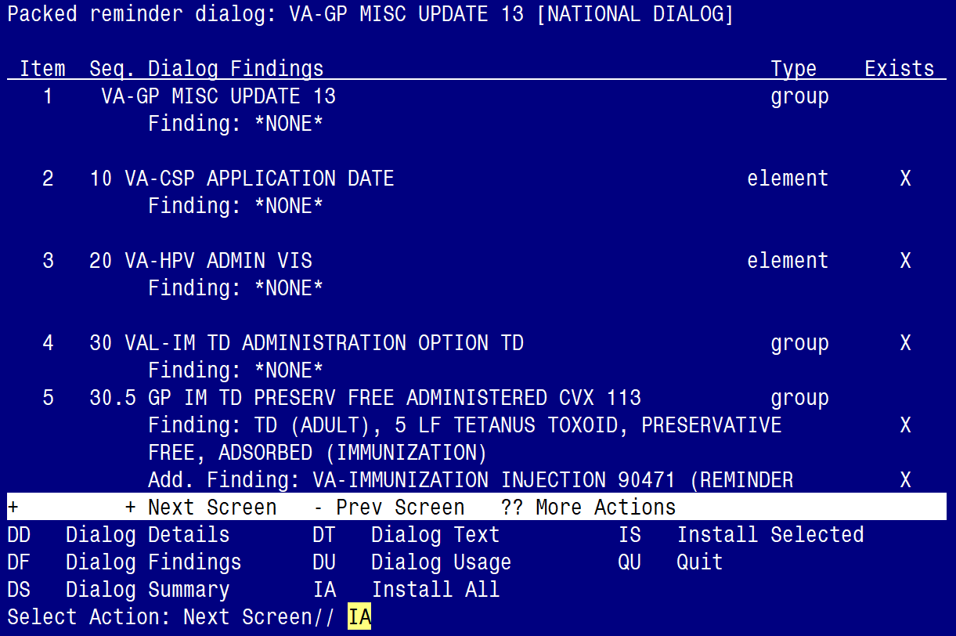

At the **Select Action** prompt, type **IA** to install the dialog – **VA-GP MISC UPDATE 13**

Select Action: Next Screen// IA Install All

Install reminder dialog and all components with no further changes: Y// ES

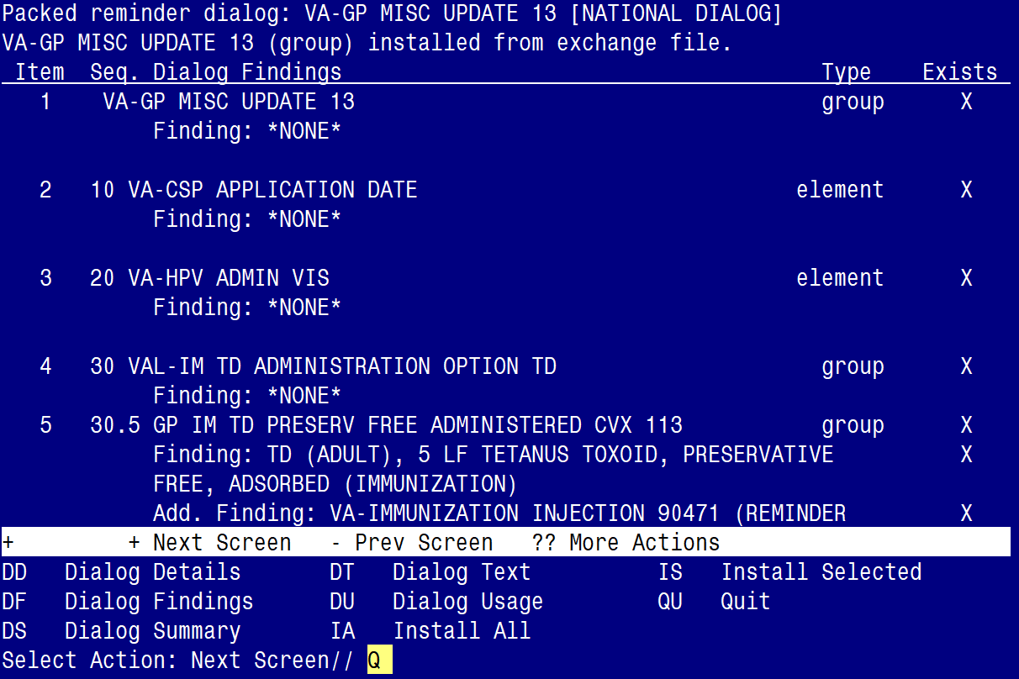

When the dialog has completed installation, you will then be returned to this screen. At the **Select Action** prompt, type **Q.**

**When promped to install the SECOND dialog component, just select QUIT:**

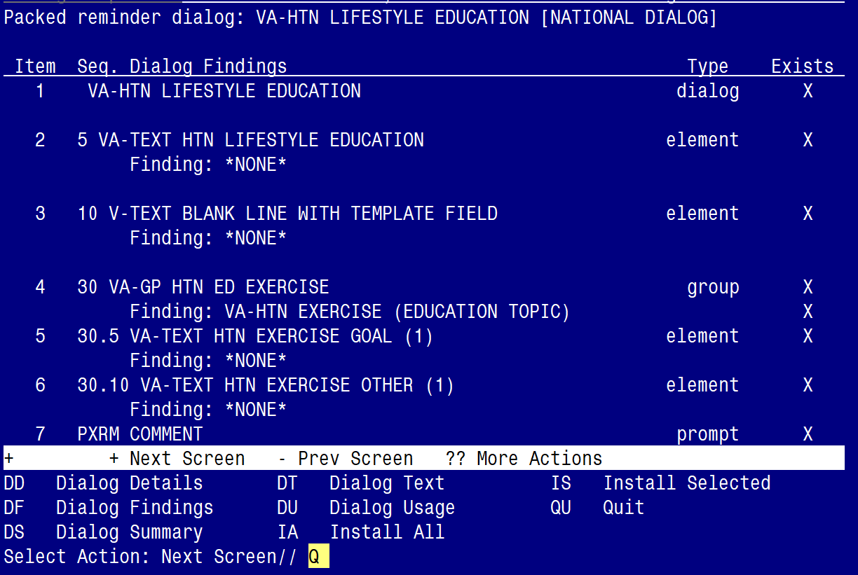

At the **Select Action** prompt, type Q to QUIT the dialog – **VA-HTN LIFESTYLE EDUCATION**

Select Action: Next Screen// Q QUIT

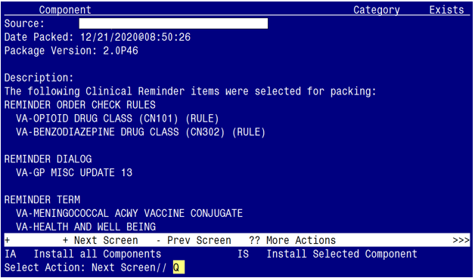

You will be returned to this screen. Type Q to quit.

Install Completed

# Post Installation

1. Confirm the following two ORDER CHECK RULES are set with a status of PRODUCTION. If not, the status will need to be changed from inactive to production.

* **VA-BENZODIAZEPINE DRUG CLASS (CN302)**
* **VA-OPIOID DRUG CLASS (CN101)**

**Take the following steps to confirm/edit the status of both Order Check Rules:**

Select Reminder Managers Menu <TEST ACCOUNT> Option: ROC Reminder Order Check Menu

GE Add/Edit Reminder Order Check Items Group

GI Reminder Order Check Items Inquiry

RE Add/Edit Reminder Order Check Rule

RI Reminder Order Check Rule Inquiry

TEST Reminder Order Check Test

Select Reminder Order Check Menu <TEST ACCOUNT> Option: RE Add/Edit Reminder Order Check Rule

Select Reminder Order Check Rule by one of the following:

N: ORDER CHECK RULE NAME

R: REMINDER DEFINITION

T: REMINDER TERM

Q: QUIT

Select Reminder Order Check Rule by: (N/R/T/Q): N// n ORDER CHECK RULE NAME

Select Reminder Order Check Rule: VA-BENZODIAZEPINE DRUG CLASS (CN302) (RULE)

**RULE NAME**: **VA-BENZODIAZEPINE DRUG CLASS (CN302) (RULE)**

**DISPLAY NAME**: **Potential dangerous drug combination with a BENZODIAZEPINE**

**STATUS**: **PROD**

**SEVERITY**: **HIGH**

**RULE NAME**: **VA-OPIOID DRUG CLASS (CN101) (RULE)**

**DISPLAY NAME**: **Potential dangerous drug combination with an OPIOID**

**STATUS**: **PROD**

**SEVERITY**: **HIGH**

1. Refer to the Inquire/Print (INQ) you saved during the Pre-Installation steps and edit the following ELEMENTS to add objects back into each ELEMENT.

* **VAL-TELE URGENT PROBLEM LIST**
* **VAL-TELE URGENT ALLERGIES**
* **VAL-TELE URGENT ACTIVE MEDS**
* **VAL-TELE URGENT DEMOGRAPHICS**

*NOTE: If you require further technical assistance, if there are any questions or problems during the installation, please notify your local IT support to log a national help desk ticket or contact the VA Service Desk and have them submit a national ticket to:*

*Category: Affected Servuce*

*Affected Service: VistA -CPRS: Clinical Reminders*

*Assignment Group: NTL SUP Clin 2*