

**Update _2_0_181**

Clinical Reminders

VA-COVID-19 POC ANTIGEN RESULTS NOTE

Install Guide

**December 2020**

Product Development

Office of Information Technology

Department of Veterans Affairs

Table of Contents

Introduction 1

Install Details 2

Install Example 2

Post Installation 5

# Introduction

DESCRIPTION:

This template is for use by a Licensed Independent Practitioner (LIP)  or Advanced Practice Provider (APP) interpreting the COVID-19 POC Antigen test and directing next steps for testing and/or patient instructions.

The only option that will set the CPRS COVID-19 banner is SYMPTOMATIC POSITIVE, it will set the banner to clinically positive if there are no other positive PCR tests in the lab package.

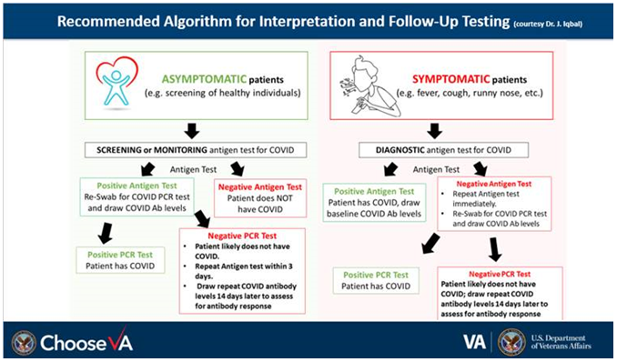

UPDATE_2_0_181 contains 1 Reminder Exchange entry:

UPDATE_2_0_181 VA-COVID-19 POC ANTIGEN RESULTS NOTE

The exchange file contains the following components:

**HEALTH FACTORS**

VA-REMINDER UPDATES

VA-UPDATE_2_0_181

VA-COVID-19

VA-COVID-19 SUSPECTED

**REMINDER TERM**

VA-REMINDER UPDATE_2_0_181

**REMINDER DIALOG**

VA-COVID-19 POC ANTIGEN RESULTS NOTE

# Install Details

This update is being distributed as a web host file. The address for the host file is:

**https://REDACTED /UPDATE_2_0_181.PRD**

The file will be installed using Reminder Exchange, programmer access is not required.

This update can be loaded with users on the system. Installation will take less than 5 minutes.

# Install Example

To Load the Web Host File. Navigate to Reminder exchange in Vista

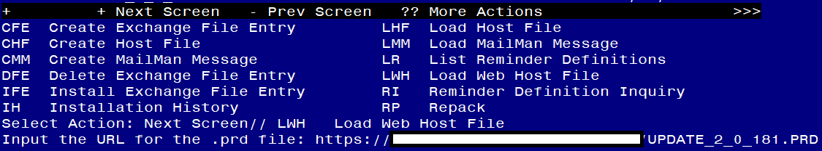

At the **Select Action:** prompt, enter **LWH** for Load Web Host File

At the **Input the url for the .prd file:** prompt, type the following web address:

**https://REDACTED /UPDATE_2_0_181.PRD**

You should see a message at the top of your screen that the file loaded successfully

Terminal window screen shot of the message displaying the URL of the file that was successfully loaded.  Part of the URL has been redacted as it is a VA only internal web site URL.

Search and locate an entry titled **UPDATE_2_0_181 VA-COVID-19 POC ANTIGEN RESULTS**

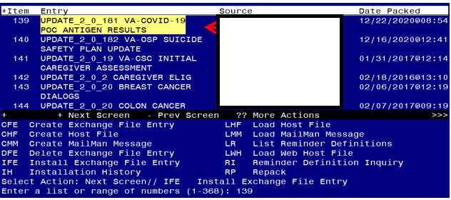

At the **Select Action** prompt, enter **IFE** for Install Exchange File Entry

Enter the number that corresponds with your entry **UPDATE_2_0_181 VA-COVID-19 POC ANTIGEN RESULTS.**  *(in this example it is entry 139 it will vary by site).* The date of the exchange file should be 12/22/2020.

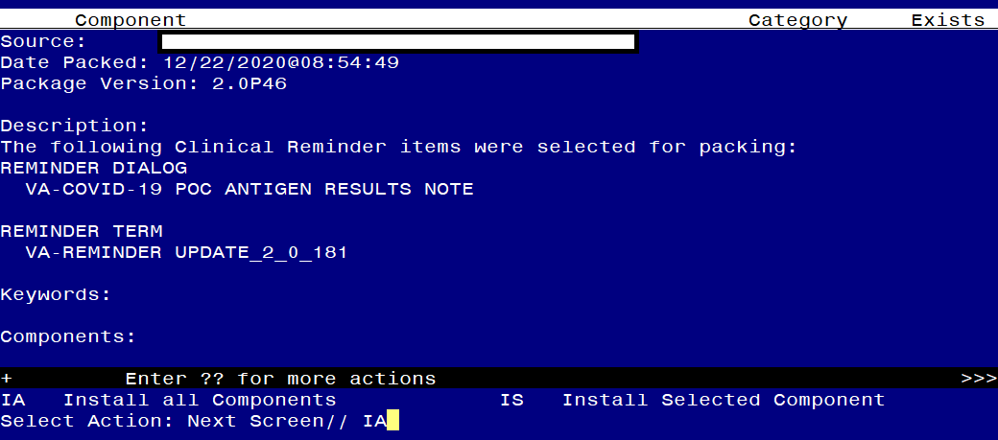

At the **Select Action** prompt, type **IA** for Install all Components and hit enter.

Select Action: Next Screen// IA Install all Components

You will see several prompts, for all new entries you will choose **I to Install**

**You will be promped to install the reminder dialog component – You will choose to install all even though some components may have an X to indicate that they exist.**

For VA-COVID-19 POC ANTIGEN RESULTS NOTE 
Screen shot of the terminal window showing a list of elements, groups and dialogs with the text with IA for "Install All" entered at the "Select Action:" Prompt.  The correct entry is described in the text.

At the **Select Action** prompt, type **IA** to install the dialog – **VA-COVID-19 POC ANTIGEN RESULTS NOTE**

Select Action: Next Screen// IA Install All

Install reminder dialog and all components with no further changes: Y// Yes

For VA-COVID-19 POC ANTIGEN RESULTS NOTE 
Screen shot of the last of the list of elements, groups and dialogs that needed to be installed with a Q for quit entered at the "Select Action:" prompt because they now all exist.  

After completing this dialog install, you will type Q.

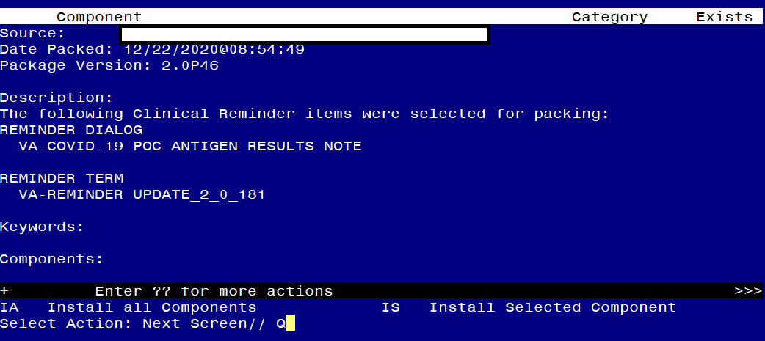

You will then be returned to this screen. At the **Select Action** prompt, type **Q.**

Install complete.

# Post Installation

1. **Setup of Note title**

You will need to create a new note title for this template. The note title needed is:

**COVID-19 POC ANTIGEN RESULTS NOTE**

*The note title should be mapped to the following VHA Enterprise Standard Title:* INFECTIOUS DISEASE NOTE

Note: Comprehensive information on Creating Document Definitions can be found beginning on page 47 of the [TIU/ASU Implementation Guide](http://www.va.gov/vdl/documents/Clinical/CPRS-Text_Integration_Utility_(TIU)/tiuim.pdf)

1. **Associate the new reminder dialogs with the note title in CPRS**

To do this, in VistA go to Reminder Manager, then CPRS Reminder Configuration then LINK- Link Reminder Dialog to Template.

Type in the following information:

Select CPRS Reminder Configuration <TEST ACCOUNT> Option: **LInk** Link Reminder Dialog to Template

Select Dialog Definition: **VA-COVID-19 POC ANTIGEN RESULTS NOTE** reminder dialog NATIONAL

...OK? Yes// (Yes)

Enter template name: **COVID-19 POC ANTIGEN RESULTS NOTE**

Link template to Document Title? **YES**

Select Document Definition: **COVID-19 POC ANTIGEN RESULTS NOTE**

1. Edit the reminder dialog element VAL-COVID-19 CONTACT VA NURSE HOTLINE and replace “(XXX) XXX-XXXX” in the dialog text with your facility VA nurse hotline phone information.
2. Add your local quick order for COVID-19 PCR testing as a finding item to the reminder dialog element **VAL-COVID-19 ANTIGEN TESTING ORDER**.
3. Enable the COVID-19 Antibody testing order element if appropriate for your site and add your local quick order for COVID-19 Antibody testing as a finding item to the reminder dialog element **VAL-COVID-19 ANTIBODY TESTING ORDER**.

Before enabling the Antibody test in this template, coordinate with your Lab Manager and Infection Control/Infectious Disease staff.

If it is enabled, consider editing the reminder dialog text and adding directions for various testing locations to ensure COVID-19 positive patients do not have to move about the facility to get tested. E.g. AntiBODY testing can be added in the ED and the COVID-19 Pod where blood draw is available.

The order is used in multiple places in the dialog, when enabled, it will show as an ordering option:

Example 1:

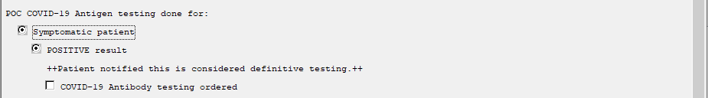

Example 2:

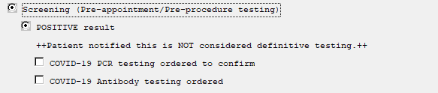

1. Add local content if needed - OPTIONAL

This template was built with the standard follow up instructions included. If a site would like to add guidance or information specific to that site, you can add text to the local reminder dialog element VAL-COVID-19 ANTIGEN TESTING POS LOCAL INFO for patients with a positive result and VAL-COVID-19 ANTIGEN TESTING SYMPTOMATIC PATIENT NEG for symptomatic patients with negative POC results. These dialog elements are at the end of the sections. This dialog elements will install disabled and you will need to remove the disable flag for them to be used.