

**Update _2_0_183**

Clinical Reminders

VA-SCARCE RESOURCE ALLOCATION UPDATE

Install Guide

**February 2021**

Product Development

Office of Information Technology

Department of Veterans Affairs

Table of Contents

Introduction 1

Install Details 2

Install Example 3

Post Installation 6

# Introduction

DESCRIPTION:

The consult process set forth in this guide was developed to support the guidance in “[Meeting the Challenge of Pandemic Influenza: Ethical Guidance for Leaders and Health Care Professionals In the Veterans Health Administration](http://www.ethics.va.gov/docs/policy/meeting_the_challenge_of_pan_flu_ethical_guidance_vha_2010_web_posting_2013.pdf)”. The possible use of this process for Scarce Resource Allocation (SRA) during the current COVID-19 Pandemic was directed in a memo from the VHA  Executive in Charge, Dr. Richard A. Stone, titled “Crisis Standards of Care in VHA during the COVID-19 Pandemic”, dated April 8, 2020.  This memo authorizes the establishment and implementation of “crisis standards of care” in specific circumstances.  This process is only to be implemented during specific conditions, when directed by facility and/or VISN leadership. However, the processes need to be built, tested, and ready to implement by all facilities so that when it is needed and authorized, it is ready to implement.

The TXML templates to be attached to the consult orders have been upgraded based upon input from users and a development team to allow for an option to annotate the individual data pieces that are used in the SRA Sequential Organ Failure Assessment (SOFA) scoring (e.g., respiratory, coagulation, liver, cardiovascular, central nervous system, renal). The only major change to the reminder dialog for the SRA Consult Note is a change to the link to the guidance document, which is now - [Ethics Guidance for Pandemics 2020](https://vaww.ethics.va.gov/activities/pandemic/Ethics_Guidance_for_Pandemics_2020.pdf) -https://REDACTED/ Ethics_Guidance_for_Pandemics_2020.pdf.

UPDATE_2_0_183 contains 1 Reminder Exchange entry:

**UPDATE_2_0_183 VA-SCARCE RESOURCE ALLOCATION**

**The exchange file contains the following components:**

**TIU TEMPLATE FIELD**

VA-SRA-NEXT DATE-TIME

VA-SRA-NEXT CONSULT DATE-TIME

VA-SRA-COMMENTS

VA-SRA-OPTIONAL COMMENTS

VA-SRA-DOC-LINK

**HEALTH FACTORS**

VA-REMINDER UPDATES

VA-UPDATE_2_0_183

VA-SRA-TRIAGE NO LIFE-SAVING RESOURCES

VA-SRA-TRIAGE-USE NON-LS AND PALLIATIV

VA-SRA-TRIAGE-WITHDRAW SCARCE LS RESOUR

VA-SRA-TRIAGE-MAKE PATIENT DNR

VA-SRA-TRIAGE RESOURCES

VA-SRA-TRIAGE-DO NOT USE LS RESOURCES

VA-SRA-TRIAGE-ADD LIFE-SAVING RESOURCES

VA-SRA-TRIAGE-CONTINUE RESOURCES IN USE

VA-SRA-TRIAGE CODE

VA-SRA-TRIAGE-PRIORITY GREEN

VA-SRA-TRIAGE-PRIORITY YELLOW

VA-SRA-TRIAGE-PRIORITY RED

VA-SRA-TRIAGE-PRIORITY BLUE

**REMINDER SPONSOR**

NATIONAL CENTER FOR ETHICS IN HEALTH CARE

**REMINDER TERM**

VA-REMINDER UPDATE_2_0_183

**REMINDER DIALOG**

VA-SRA-CONSULT RESPONSE (D)

# Install Details

This update is being distributed as a web host file. The address for the host file is: **https://REDACTED /UPDATE_2_0_183.PRD**

The file will be installed using Reminder Exchange, programmer access is not required.

Installation:

=============

This update can be loaded with users on the system. Installation will take less than 10 minutes.

# Install Example

To Load the Web Host File. Navigate to Reminder exchange in Vista

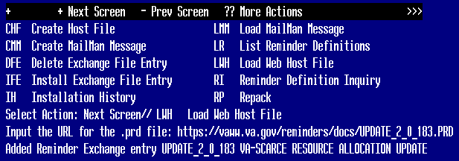

At the **Select Action:** prompt, enter **LWH** for Load Web Host File

At the **Input the url for the .prd file:** prompt, type the following web address:

[**https://Redacted/UPDATE_2_0_183.PRD**](https://vaww.va.gov/reminders/docs/UPDATE_2_0_183.PRD)

You should see a message at the top of your screen that the file successfully loaded.

Search and locate an entry titled UPDATE_2_0_183 VA-SCARCE RESOURCE ALLOCATION UPDATE in reminder exchange.

Redacted

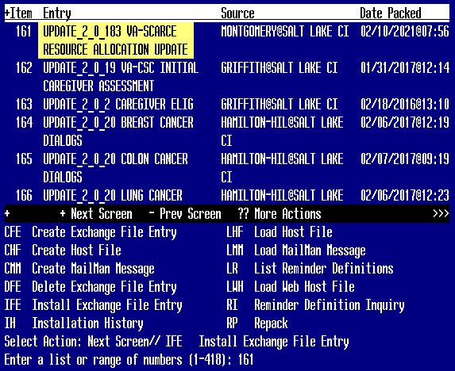

At the **Select Action** prompt, enter **IFE** for Install Exchange File Entry

Enter the number that corresponds with your entry UPDATE_2_0_183 VA-SCARCE RESOURCE ALLOCATION *(in this example it is entry161 it will vary by site).* The date of the exchange file should be 02/10/2021.

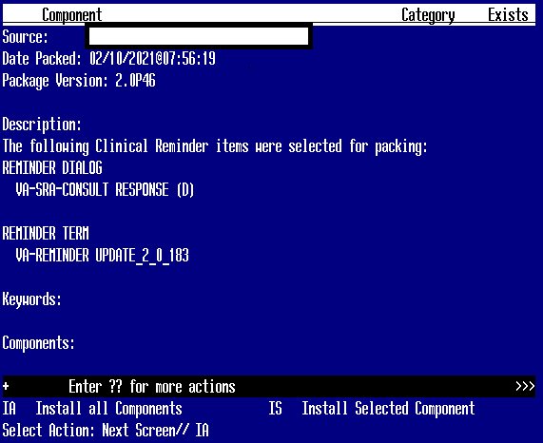

At the **Select Action** prompt, type **IA** for Install all Components and hit enter.

Select Action: Next Screen// IA Install all Components

You will see several prompts, for all new entries you will choose **I to Install**

For components that already exists but the packed component is different, you will choose **S to Skip.**

**You will be promped to install the reminder dialog component – You will choose to install all even though the components have an X to indicate that they exist. These components have been updated and should be installed.**

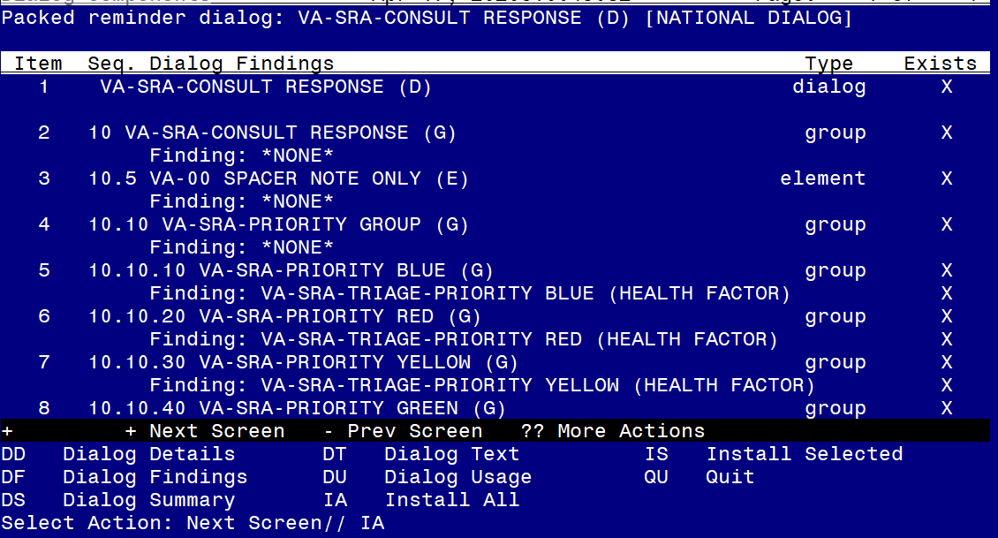

At the **Select Action** prompt, type **IA** to install the dialog **– VA-SRA-CONSULT RESPONSE (D)**

Select Action: Next Screen// IA Install All

Install reminder dialog and all components with no further changes: Y// Yes

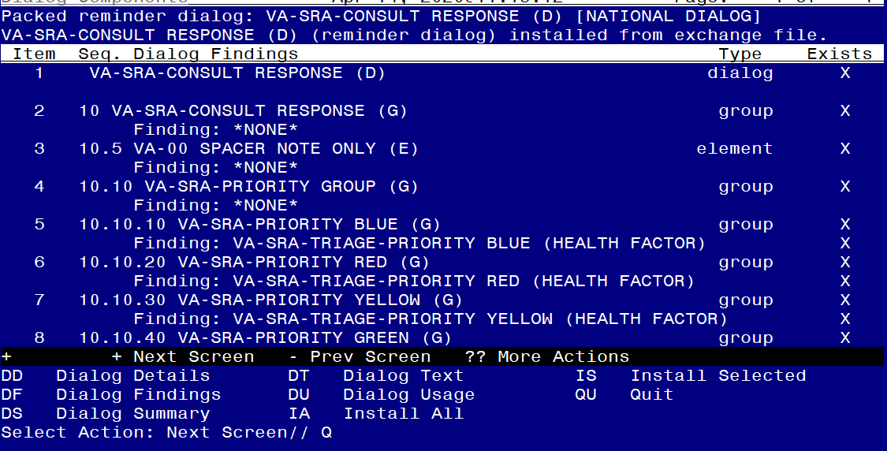

After completing this dialog install, you will type Q.

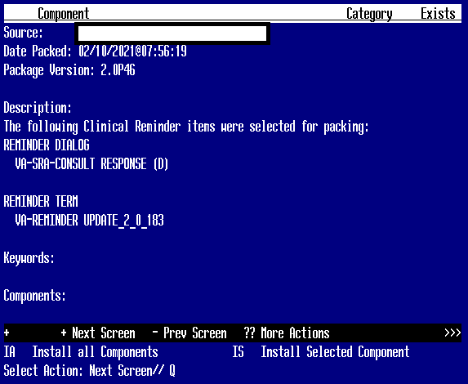

You will then be returned to this screen. At the **Select Action** prompt, type **Q.**

Install complete.

# Post Installation

1. Open the template and make sure you see the changes identified.

***NOTE****: If there are any questions or problems during the installation, please notify your local IT support to log a national help desk ticket or contact the VA Service Desk and have them submit a national ticket to:*

*Category: Affected Service*

*Affected Service: VistA – CPRS: Clinical Reminders*

*Assignment Group: NTL SUP Clin 2*