

**Update _2_0_184**

# Clinical Reminders

**VA-COVID-19 TEMPLATE UPDATES**

# Install Guide

## January 2021

Product Development Office of Information Technology Department of Veterans Affairs

Table of Contents

INTRODUCTION 1

PRE-INSTALL 5

INSTALL DETAILS 7

INSTALL EXAMPLE 7

POST INSTALLATION 14

# Introduction

DESCRIPTION:

The following COVID-19 reminder dialogs were updated to add immunization status: VA-COVID-19 SCREEN

VA-COVID-19 CLC SCREEN VA-COVID-19 SCI SCREEN

VA-COVID-19 TELEPHONE FOLLOW-UP VA-COVID-19 PROVIDER FOLLOW-UP

The screening template that is embedded in several other templates was updated to ask the symptom questions even if the patient has had a diagnosis of COVID-19.

The outside lab template that is embedded in several other templates was updated to distinguish between PCR/Non PCR and provide additional guidance about which options set the banner.

UPDATE_2_0_184 contains 1 Reminder Exchange entry:

### UPDATE_2_0_184 VA-COVID-19 TEMPLATE UPDATES

**The exchange file contains the following components: REMINDER DIALOG LINK TYPE**

VA-ALCOHOL POSITIVE WARM HANDOFF CHECK

### TIU TEMPLATE FIELD

DATE (*) VA-WORD

VA-SOFA SCORE 2

TEXT (1-30 CHAR)

VA-WORD 6 LINES

VA-COVID 19 INTERIM GUIDANCE VA-WORD 2 LINES

VA-CRC SOCIAL

HYPERLINK COVID-19 PREVENT SPREAD HYPERLINK COVID-19 PATIENT EDU HYPERLINK COVID-19 CARE AT HOME HYPERLINK COVID-19 DISP NONHOSP PT VA-CDC DURATION ISOLATION

HYPERLINK COVID-19 HOW TO PROTECT SELF VA-COVID TEST RESULTS PHONE INFORMATION VA-PPE TYPE

TEXT (1-10 CHAR) REQ

VA-COVID 19 CDC SYMPTOMS VA-COVID SYMPTOM TEXT OTHER NON-VA

OTHER TEXT

### HEALTH FACTORS

VA-COVID-19

VA-COVID-19 UNK OUTSIDE LAB TEST NEG VA-COVID-19 UNK OUTSIDE LAB TEST POS VA-COVID-19 NON PCR AG LAB OUTSIDE NEG VA-COVID-19 NON PCR AG LAB OUTSIDE POS

VA-COVID-19 OUTSIDE PCR SPEC COLLECTED VA-COVID-19 PCR LAB OUTSIDE NEGATIVE

VA-COVID-19 PCR LAB OUTSIDE POSITIVE VA-COVID-19 LAB OUTSIDE POSITIVE

VA-REMINDER UPDATES VA-UPDATE_2_0_184

VA-TRAVEL SCREEN [C]

VA-EXPOSURE TO COVID NO VA-EXPOSURE TO COVID YES

VA-NO HEADACHE LOSS OF TASTE OR SMELL VA-SYMPTOM LOSS OF SMELL

VA-SYMPTOM LOSS OF TASTE VA-SYMPTOM HEADACHE

VA-NO NAUSEA VOMITING OR DIARRHEA VA-SYMPTOM VOMITING

VA-SYMPTOM NAUSEA

VA-TRAVEL DIARRHEA YES VA-TRAVEL FLU NO

VA-TRAVEL FLU YES VA-TRAVEL COUGH NO

VA-TRAVEL COUGH YES VA-TRAVEL FEVER NO VA-TRAVEL FEVER YES VA-SCI/D COVID SCREEN

VA-SCI/D COVID SCREEN ADDL SYMPTOM

VA-SCI/D COVID SCREEN NO ADDL SYMPTOM VA-SCI/D COVID SCREEN OTHER SYMPTOM VA-SCI/D COVID SCREEN CONJUNCTIVITIS VA-SCI/D COVID SCREEN NAUSEA

VA-SCI/D COVID SCREEN LOSS SMELL VA-SCI/D COVID SCREEN LOSS TASTE VA-SCI/D COVID SCREEN MYALGIA

VA-SCI/D COVID SCREEN SORE THROAT VA-COVID SCREEN NEGATIVE

VA-COVID SCREEN POSITIVE

VA-COVID-19 NO PRIOR DIAGNOSIS VA-COVID-19 PRIOR DIAGNOSIS

VA-TRAVEL DIARRHEA NO

VA-TRAVEL COUGH,SOB,SORE THROAT NO VA-TRAVEL COUGH,SOB,SORE THROAT YES VA-COVID-19 INPATIENT SOFA SCORE

VA-ADMISSION FAMILY POA VA-TOBACCO USE SCREEN [C]

VA-TOBACCO USE DECLINED TO ANSWER VA-TOBACCO NEVER USED

VA-TOBACCO QUIT 15 YRS OR MORE VA-TOBACCO QUIT 5 TO < 15 YRS

VA-TOBACCO QUIT 1 TO < 5 YRS VA-TOBACCO QUIT < 1 YEAR

VA-TOBACCO FORMER USER

VA-TOBACCO USE 30 YEARS OR MORE

VA-TOBACCO USE > 15 LESS THAN 30 YEARS VA-TOBACCO USE 5 TO 15 YEARS

VA-TOBACCO USE 1 TO < 5 YEARS VA-TOBACCO USE < 1 YEAR

VA-TOBACCO USE COUNSEL NO VA-TOBACCO USE COUNSEL YES

VA-TOBACCO USE MED NOTIFY PROVIDER VA-TOBACCO USE MED NO

VA-TOBACCO USE MED YES VA-TOBACCO USE ADVICE

VA-TOBACCO DOESNT USE WI 30 MIN WAKEUP VA-TOBACCO USE WI 30 MIN OF WAKEUP

VA-TOBACCO USER SOME DAYS VA-TOBACCO USER EVERY DAY

VA-COVID-19 MED HX HOMELESSNESS VA-COVID-19 MED HX OBESITY

VA-COVID-19 MED HX BREASTFEEDING VA-COVID-19 MED HX OTHER

VA-COVID-19 MED HX CANCER VA-COVID-19 MED HX HTN

VA-COVID-19 MED HX PREGNANCY

VA-COVID-19 MED HX IMMUNOCOMPROMISED VA-COVID-19 MED HX LIVER DISEASE

VA-COVID-19 MED HX CKD

VA-COVID-19 MED HX DIABETES

VA-COVID-19 MED HX HEART DISEASE VA-COVID-19 MED HX LUNG DISEASE VA-COVID-19 MED HX AGE

VA-COVID-19 DATE OF SYMPTON ONSET VA-COVID-19 ROS OTHER

VA-COVID-19 ROS GI VA-COVID-19 ROS CV

VA-COVID-19 ROS RESP VA-COVID-19 ROS ENT

VA-COVID-19 ROS GENERAL

VA-COVID-19 TRANSPORTATION NEVER VA-COVID-19 TRANSPORTATION WEEKLY VA-COVID-19 TRANSPORTATION 2-3/WEEK VA-COVID-19 TRANSPORTATION DAILY

VA-COVID-19 LEFT HOUSE NEVER VA-COVID-19 LEFT HOUSE WEEKLY VA-COVID-19 LEFT HOUSE 2-3/WEEK VA-COVID-19 LEFT HOUSE DAILY

VA-COVID-19 RESIDENTIAL LIVING VA-COVID-19 HOUSEHOLD CONTACT

VA-COVID-19 HEALTH CARE WORKER VA-COVID-19 PLAN ADMISSION

VA-COVID-19 PLAN TRANSFER

VA-COVID-19 DC SUSPECTED FALSE NEGATIVE VA-COVID-19 DC SUSPECTED, NO TEST

VA-COVID-19 DC TEST POSITIVE VA-COVID-19 DC TEST NEGATIVE

VA-COVID-19 DC TEST PENDING RESULTS VA-COVID-19 PLAN REMAIN HOME

VA-COVID-19 PLAN DISCHARGE HOME

VA-COVID-19 PLAN REFERRAL

VA-COVID-19 SUSPECTED SEVERE VA-COVID-19 SUSPECTED MILD

VA-COVID-19 SUSPECTED MODERATE VA-COVID-19 SUSPECTED

VA-COVID-19 SCREENED LOW SUSPICION VA-COVID-19 FE COUGH DURING INTERVIEW VA-COVID-19 FE LOOKS ILL

VA COVID-19 FE NO RESPIRATORY DIFFICULTY VA-COVID-19 FE CYANOSIS

VA-COVID-19 FE ACCESSORY MUSC RESP VA-COVID-19 FE RESP DISTRESS

VA-COVID-19 FE ALERT

VA-COVID-19 MED HX ESRD

VA-COVID-19 VISIT TYPE PHONE VA-COVID-19 VISIT TYPE F2F

VA-COVID-19 NOT WAITING FOR LABS VA-COVID-19 WAITING FOR LABS

### REMINDER TERM

VA-COVID-19 OUTSIDE RESULTS

VA-COVID-19 OUTSIDE PCR LAB POSITIVE VA-REMINDER UPDATE_2_0_184

VA-COVID-19 IMMUNIZATION BL

VA-COVID-19 SOFA SCORE <48 HOURS

VA-MH TOBACCO CESSATION ORDER SUPRESSION VA-SEX MALE

**HEALTH SUMMARY TYPE** SARS-COV-2 IMMUNIZATION INFLUENZA LAB RESULTS COVID19 LAB RESULTS

VA-RECENT VITALS

**HEALTH SUMMARY OBJECTS** SARS-COV-2 IMMUNIZATION (TIU) INFLUENZA LAB RESULTS (TIU) COVID19 LAB RESULTS (TIU)

VA-RECENT VITALS (TIU)

**TIU DOCUMENT DEFINITION** SARS-COV-2 IMMUNIZATION INFLUENZA LAB RESULTS COVID19 LAB RESULTS

VA-RECENT VITALS

### REMINDER DIALOG

VA-COVID-19 UPDATE JAN 2021

VA-COVID-19 INPATIENT PROVIDER

VA-COVID-19 INPATIENT ADMISSION H&P VA-COVID-19 PROVIDER FOLLOW-UP

VA-SCREEN COVID

# Pre-Install

Using the Vista menu Reminder Manger, TRM Reminder Term Management, TI Inquire about Reminder Term, review the reminder term VA-MH TOBACCO CESSATION ORDER SUPRESSION and save the inquiry for the post install.

Using the Vista menu Reminder Dialog Manager, Reminder Dialog, change your view to GROUP and choose inquire/print for the following reminder dialog groups:

VAL-GP COVID ASSESSMENT COVID MILD

VAL-GP COVID ASSESSMENT ESC OF CARE F2F NON ED VAL-GP COVID ASSESSMENT ESC OF CARE VIRTUAL

VA-GP COVID ASSESSMENT ESC OF CARE F2F NON ED URGENT VA-GP COVID ASSESSMENT ESC OF CARE VIRTUAL URGENT VAL-GP COVID ASSESSMENT LAB TESTS**

VAL-COVID-19 PENDING LOCAL INFORMATION

VAL-COVID 19 RESULTS NEGATIVE RECOMMENDATIONS VAL-COVID 19 RESULTS NEGATIVE LOCAL INFORMATION VAL-COVID-19 STOP HOME ISOLATION INFO

VAL-COVID-19 PREVENTION LOCAL VAL-COVID PLAN REFERRAL

VAL-COVID PLAN TRANSFER VAL-COVID PLAN ADMISSION

VAL-COVID-19 PREVENTION LOCAL INFORMATION VAL-COVID-19 POSITIVE LOCAL INFORMATION VAL-COVID-19 CLC SCREEN LOCAL GROUP

VAL-GP-COVID-19 INPATIENT IMAGING VAL-COVID LOCAL GROUP

VAL-TOBACCO USE LENGTH FIVE TO FIFTEEN VAL-TOBACCO USE LENGTH FIFTEEN TO THIRTY VAL-TOBACCO USE LENGTH THIRTY OR MORE VAL-GP TOBACCO QUIT TIMEFRAME <1 YEAR VAL-TOBACCO QUIT TIMEFRAME 1 TO <5

VAL-TOBACCO QUIT TIMEFRAME 5 TO <15 VAL-TOBACCO QUIT TIMEFRAME 15 OR MORE

Change your view to Elements

VAL-TH VVC TELEPHONE TRIAGE CONTACT PHONE OBJECT VAL-TH VVC TELEPHONE TRIAGE PATIENT LOCATION HOME VAL-COVID PATIENT INFORMATION

VAL-COVID PERTINENT MEDICAL HX OBESITY VAL-COVID ALLERGY AND MEDICATIONS

VAL-COVID FOCUSED EXAM TEMP

VAL-COVID PLAN DISCHARGE HOME FOLLOW UP VAL-COVID-19 STOP HOME ISOLATION SEVERE VAL-COVID-19 STOP HOME ISOLATION MILD

VAL-COVID-19 DIRECTIONS TO PACT

VAL-COVID PROVIDER NOTE

VAL-COVID-19 INPATIENT VIEW ALLERGIES VAL-COVID-19 INPATIENT MEDICATIONS VAL-COVID-19 INPATIENT LABS

VAL-COVID-19 INPATIENT MEDICATIONS PN

VAL-COVID-19 INPATIENT CONSULTANT CONTACT INFO VAL-COVID-19 INPATIENT PHYSICAL EXAM

VAL-COVID-19 INPATIENT CONSULTANT CONTACT INFO ADMIT VAL-COVID-19 DISPLAY ONLY

VAL-COVID-19 INPATIENT IMAGES

VAL-COVID-19 INPATIENT PROBLEM LIST

VAL-COVID-19 INPATIENT ACTIVE OUTPATIENT MEDS VAL-COVID-19 INPATIENT MICROBIOL COVID 2

VAL-COVID-19 INPATIENT MICROBIOL INFLUENZA PCR 2

Save this info for the post install, it will make adding information back post -install easier if your site has made local edits. Not all sites will have made local edits to these dialog groups.

If you have made significant local edits to these dialog groups, you can also create a local dialog group that contains each of these items as sequences in that group and then create a reminder exchange file to back this group up. After installing, you can install that exchange file after installation of this update. Find the following PPT file COVID-19_LOCAL_BACKUP-184 in the VistA Documentation Library at https://www.va.gov/vdl.:

**\*\*If you create a local dialog group for backup of these components, do not include the group VAL-GP COVID ASSESSMENT LAB TESTS, for this group, you will need to inquire and save this specific group pre-install and re-do any local changes post install. \*\*\***

# Install Details

Installation:

=============

This update can be loaded with users on the system. Installation will take less than 30 minutes. You will need to allow additional time for the pre and post install steps.

This update is being distributed as a web host file. The address for the host file is: https://REDACTED /UPDATE_2_0_184.PRD

The file will be installed using Reminder Exchange, programmer access is not required.

*If you install in your test account, because your test account does not have the COVID immunizations in the immunization file, you may get prompted to replace the immunization finding or you may get an error.*

# Install Example

To Load the Web Host File. Navigate to Reminder exchange in Vista

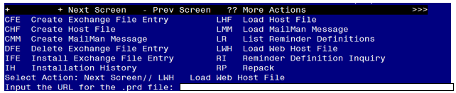

At the **Select Action:** prompt, enter **LWH** for Load Web Host File

At the **Input the url for the .prd file:** prompt, type the following web address: https://vaww.va.gov/reminders/docs/UPDATE_2_0_184.PRD Terminal window screen shot of the message displaying the URL of the file that was successfully loaded.  Part of the URL has been redacted as it is a VA only internal web site URL.

You should see a message at the top of your screen that the file loaded successfully

Search and locate an entry titled **UPDATE_2_0_184 VA-COVID-19 TEMPLATE UPDATES** in reminder exchange.

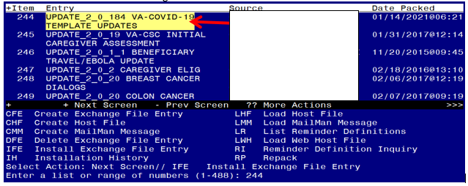

At the **Select Action** prompt, enter **IFE** for Install Exchange File Entry

Enter the number that corresponds with your entry **UPDATE_2_0_184 VA-COVID-19 TEMPLATE UPDATES** *(in this example it is entry 243 it will vary by site).* The date of the exchange file should be 01/14/2021.

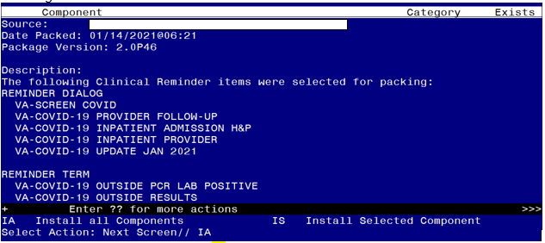

At the **Select Action** prompt, type **IA** for Install all Components and hit enter. Select Action: Next Screen// IA Install all Components

You will see several prompts, for all new entries you will choose **I to Install**

*For components that already exists but the packed component is different, you will choose* ***S to Skip.***

***There are two exceptions, for ONLY these reminder terms you will O to Overwrite:***

*VA-COVID-19 OUTSIDE PCR LAB POSITIVE VA-COVID-19 OUTSIDE RESULTS*

*If you install in your test account, because your test account does not have the COVID immunizations in the immunization file, you may get prompted to replace the immunization finding or you may get an error.*

## You will be prompted to install the FIRST reminder dialog component – You will choose to install all even though some components may have an X to indicate that they exist.

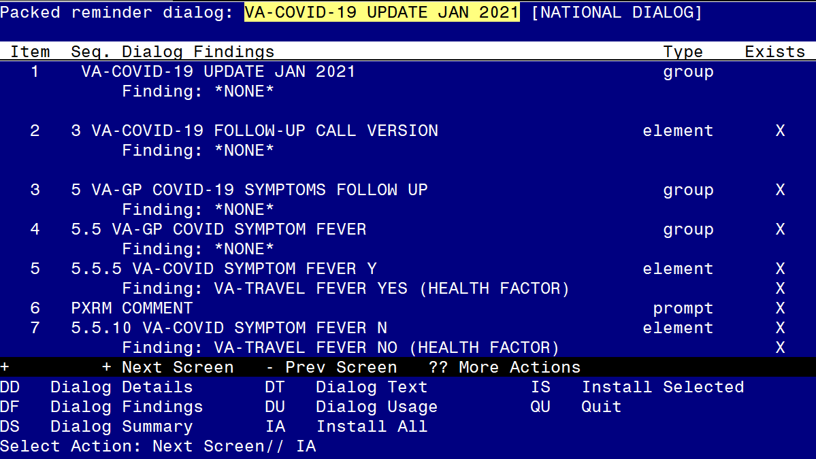

At the **Select Action** prompt, type **IA** to install the dialog – **VA-COVID-19 UPDATE JAN 2021**

Select Action: Next Screen// IA Install All

Install reminder dialog and all components with no further changes: Y// Yes

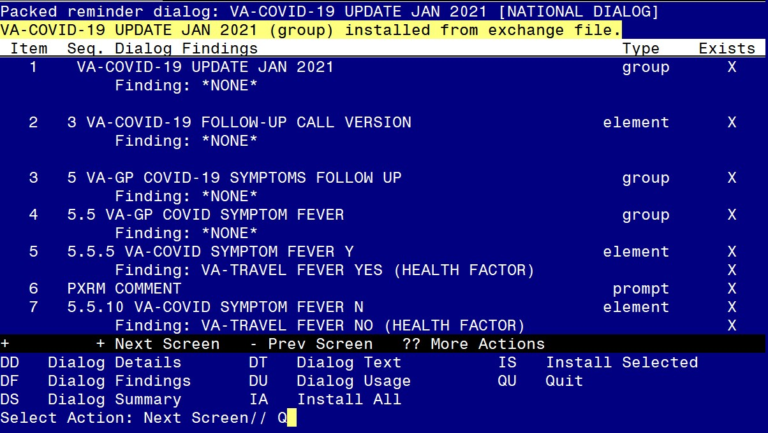

After completing this dialog install, you will type Q.

## You will be prompted to install the next reminder dialog component – You will choose to install all even though some components may have an X to indicate that they exist.

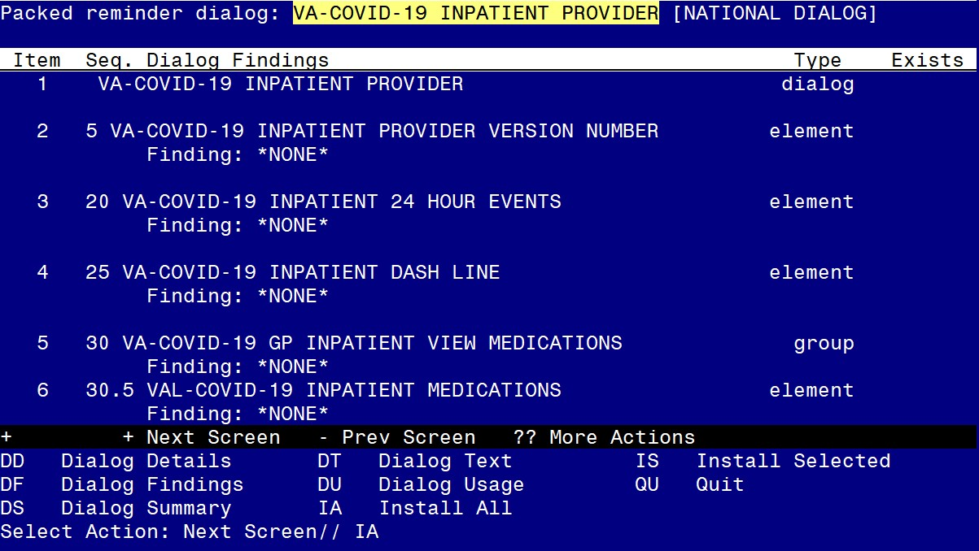

At the **Select Action** prompt, type **IA** to install the dialog – VA-COVID-19 INPATIENT PROVIDER

Select Action: Next Screen// IA Install All

Install reminder dialog and all components with no further changes: Y// Yes

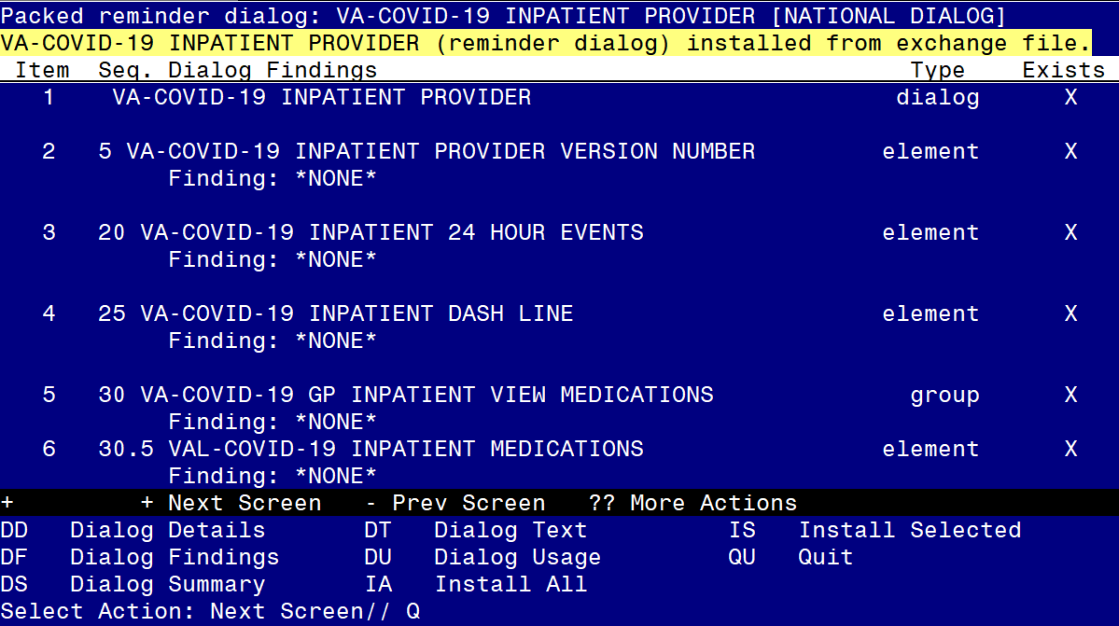

After completing this dialog install, you will type Q.

## You will be prompted to install the next reminder dialog component – You will choose to install all even though some components may have an X to indicate that they exist.

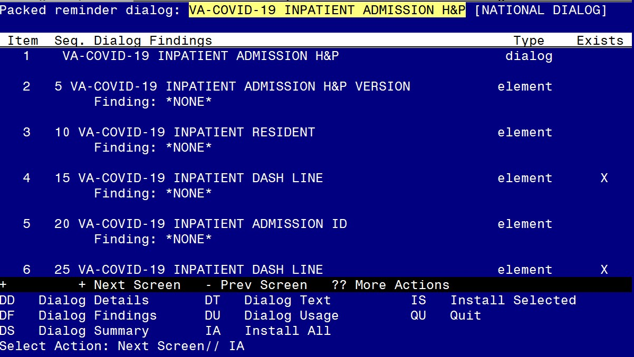

At the **Select Action** prompt, type **IA** to install the dialog – **VA-COVID-19 INPATIENT ADMISSION H&P**

Select Action: Next Screen// IA Install All

Install reminder dialog and all components with no further changes: Y// Yes

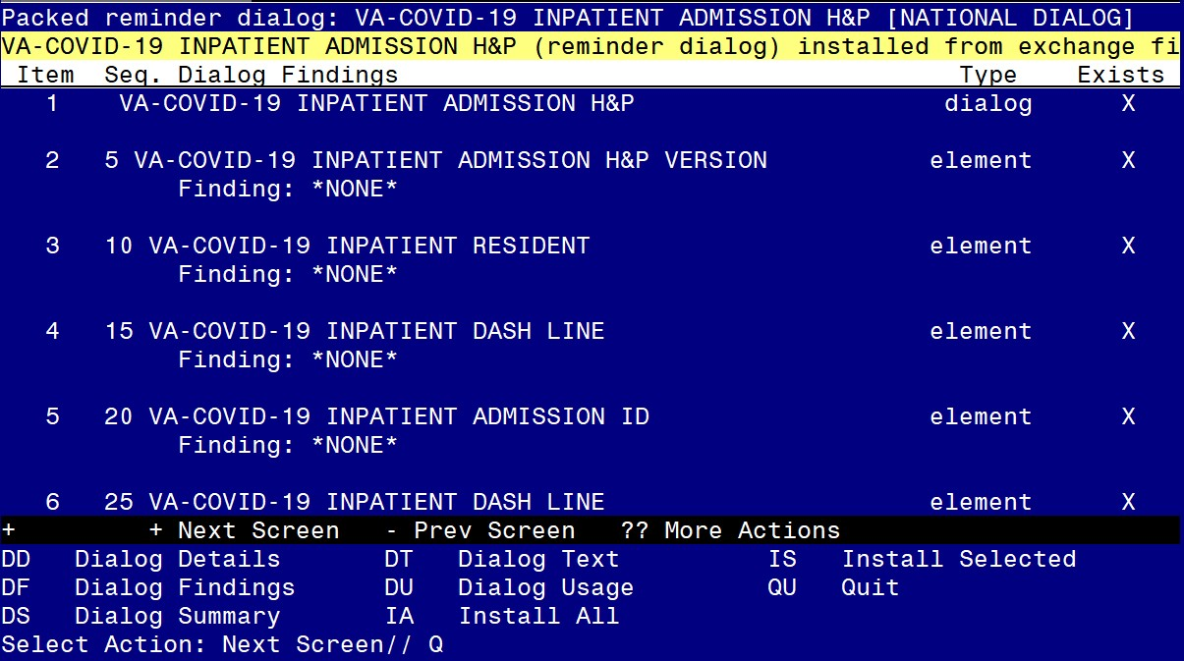

After completing this dialog install, you will type Q.

## You will be prompted to install the next reminder dialog component – You will choose to install all even though some components may have an X to indicate that they exist.

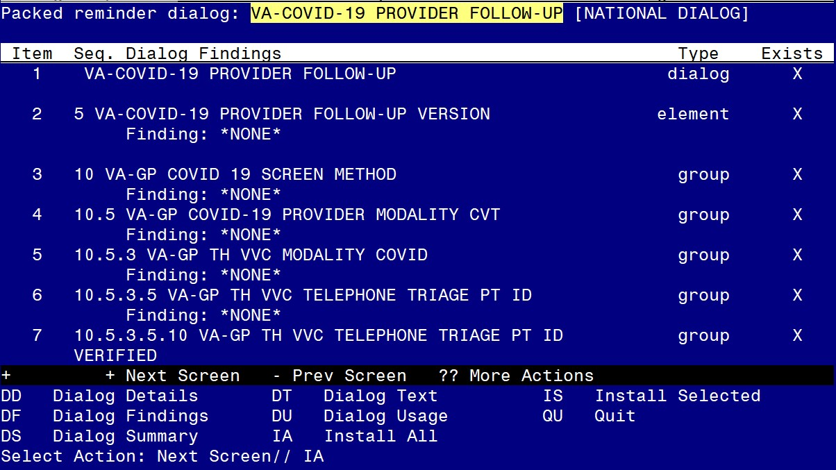

At the **Select Action** prompt, type **IA** to install the dialog – VA-COVID-19 PROVIDER FOLLOW-UP

Select Action: Next Screen// IA Install All

Install reminder dialog and all components with no further changes: Y// Yes

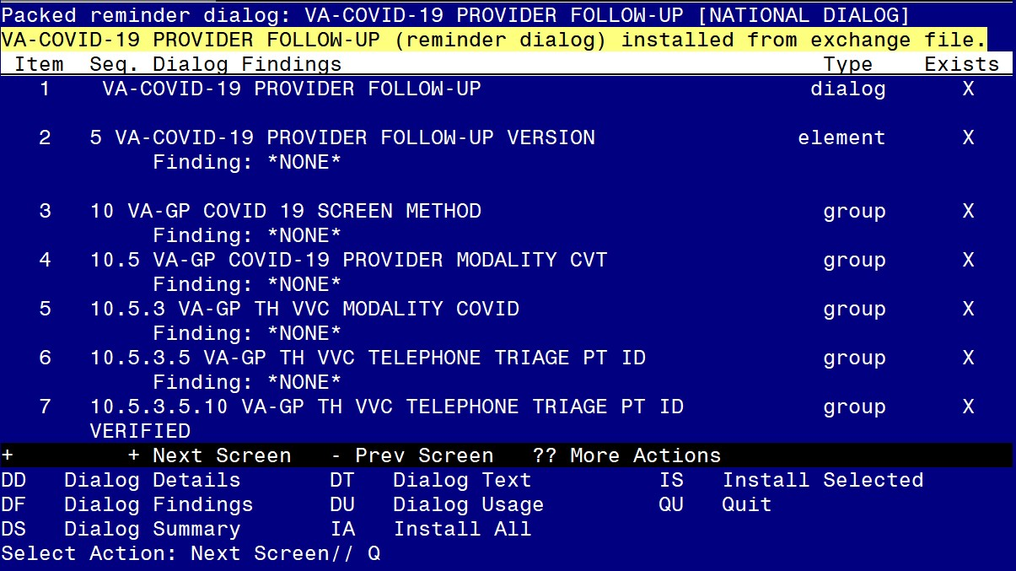

After completing this dialog install, you will type Q.

## You will be prompted to install the LAST reminder dialog component – You will choose to install all even though some components may have an X to indicate that they exist.

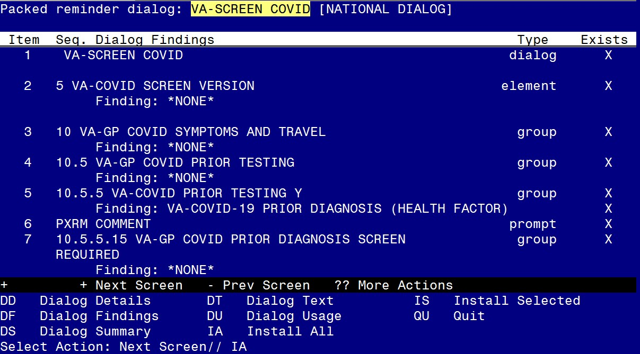

At the **Select Action** prompt, type **IA** to install the dialog – **VA-SCREEN COVID**

Select Action: Next Screen// IA Install All

Install reminder dialog and all components with no further changes: Y// Yes

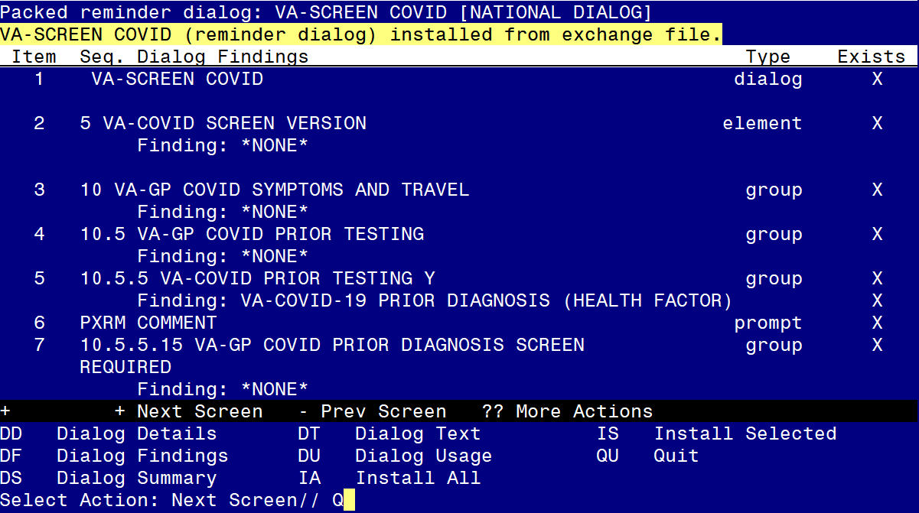

After completing this dialog install, you will type Q.

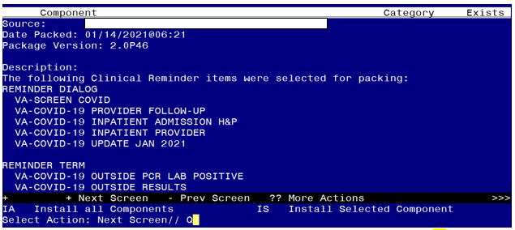

You will then be returned to this screen. At the **Select Action** prompt, type **Q.**

Install complete.

# Post Installation

### Open the COVID-19 Screen Template (VA-SCREEN COVID) and confirm the version is 6.1

1. **Open the COVID-19 Provider Screen Template (VA-COVID-19 PROVIDER FOLLOW-UP) and confirm the version is 4.1**

### Open the COVID-19 Telephone Follow-Up (VA-COVID-19 TELEPHONE FOLLOW-UP) and confirm the version is 5.1

1. **Open the COVID-19 Outside Lab Template (VA-COVID-19 OUTSIDE TEST RESULTS) and confirm the version is 4.1**

### Open the COVID-19 Inpatient Provider Note (VA-COVID-19 INPATIENT PROVIDER ) and confirm the version is 2.1

1. **Open the COVID-19 Inpatient Provider H&P (VA-COVID-19 INPATIENT ADMISSION H&P) and confirm the version is 2.1**
2. **Update the reminder term VA-MH TOBACCO CESSATION ORDER SUPRESSION if you overwrote during install.** Using the Vista menu Reminder Manger, TRM Reminder Term Management, TI Inquire into the reminder term VA- MH TOBACCO CESSATION ORDER SUPRESSION and make sure that it matches the pre install inquiry, if it does not, use the TE Add/Edit Reminder Term option and update the finding items in the term to match your preinstall inquiry.

### Add local content to reminder dialog groups and elements if needed. (Optional)

Review the pre-install for these items and edit to make any local changes. If you had made changes to the below items before, you will need to re-do any local

modifications to the following groups. If you made a backup of these prior to installation, you can install selected the reminder dialog group from your backup file and this will restore your local changes to the following items:

Groups:

VAL-GP COVID ASSESSMENT COVID MILD

VAL-GP COVID ASSESSMENT ESC OF CARE F2F NON ED VAL-GP COVID ASSESSMENT ESC OF CARE VIRTUAL

VA-GP COVID ASSESSMENT ESC OF CARE F2F NON ED URGENT VA-GP COVID ASSESSMENT ESC OF CARE VIRTUAL URGENT VAL-GP COVID ASSESSMENT LAB TESTS**

VAL-COVID-19 PENDING LOCAL INFORMATION

VAL-COVID 19 RESULTS NEGATIVE RECOMMENDATIONS VAL-COVID 19 RESULTS NEGATIVE LOCAL INFORMATION VAL-COVID-19 STOP HOME ISOLATION INFO

VAL-COVID-19 PREVENTION LOCAL VAL-COVID PLAN REFERRAL

VAL-COVID PLAN TRANSFER VAL-COVID PLAN ADMISSION

VAL-COVID-19 PREVENTION LOCAL INFORMATION VAL-COVID-19 POSITIVE LOCAL INFORMATION VAL-COVID-19 CLC SCREEN LOCAL GROUP

VAL-GP-COVID-19 INPATIENT IMAGING VAL-COVID LOCAL GROUP

VAL-TOBACCO USE LENGTH FIVE TO FIFTEEN VAL-TOBACCO USE LENGTH FIFTEEN TO THIRTY VAL-TOBACCO USE LENGTH THIRTY OR MORE VAL-GP TOBACCO QUIT TIMEFRAME <1 YEAR VAL-TOBACCO QUIT TIMEFRAME 1 TO <5

VAL-TOBACCO QUIT TIMEFRAME 5 TO <15 VAL-TOBACCO QUIT TIMEFRAME 15 OR MORE

Elements

VAL-TH VVC TELEPHONE TRIAGE CONTACT PHONE OBJECT VAL-TH VVC TELEPHONE TRIAGE PATIENT LOCATION HOME VAL-COVID PATIENT INFORMATION

VAL-COVID PERTINENT MEDICAL HX OBESITY VAL-COVID ALLERGY AND MEDICATIONS

VAL-COVID FOCUSED EXAM TEMP

VAL-COVID PLAN DISCHARGE HOME FOLLOW UP VAL-COVID-19 STOP HOME ISOLATION SEVERE VAL-COVID-19 STOP HOME ISOLATION MILD

VAL-COVID-19 DIRECTIONS TO PACT VAL-COVID PROVIDER NOTE

VAL-COVID-19 INPATIENT VIEW ALLERGIES VAL-COVID-19 INPATIENT MEDICATIONS

VAL-COVID-19 INPATIENT LABS

VAL-COVID-19 INPATIENT MEDICATIONS PN

VAL-COVID-19 INPATIENT CONSULTANT CONTACT INFO VAL-COVID-19 INPATIENT PHYSICAL EXAM

VAL-COVID-19 INPATIENT CONSULTANT CONTACT INFO ADMIT VAL-COVID-19 DISPLAY ONLY

VAL-COVID-19 INPATIENT IMAGES

VAL-COVID-19 INPATIENT PROBLEM LIST

VAL-COVID-19 INPATIENT ACTIVE OUTPATIENT MEDS VAL-COVID-19 INPATIENT MICROBIOL COVID 2

VAL-COVID-19 INPATIENT MICROBIOL INFLUENZA PCR 2

For this dialog group VAL-GP COVID ASSESSMENT LAB TESTS, review your pre- install inquiry and re-do any local modifications.