

### Update _2_0_186

**Clinical Reminders**

**VA-COVID PREVENTIVE HEALTH INVENTORY**

**Install Guide**

### February 2021

Product Development Office of Information Technology Department of Veterans Affairs

## Table of Contents

INTRODUCTION 1

INSTALL DETAILS 4

INSTALL EXAMPLE 4

POST INSTALLATION 7

# Introduction

DESCRIPTION:

COVID-19 Preventive Health Inventory

Background: During the pandemic, VA has seen a decline in the performance of preventive health measures for many reasons, most notably due a shift to virtual care to minimize risk of infectious exposure. As part of the Moving Forward Initiative, a note template and note title “COVID-19 Preventive Health Inventory” has been developed as a tool to be used by PACT teams to facilitate population outreach and assist Veterans in receiving needed preventive health services.

Primary Care teams regularly review patient panels and identify Veterans who are overdue for preventive health care. Patients identified by the team will be contacted virtually by a PACT RN or PACT LPN and use this template to address multiple preventive health needs, to assist in initiating orders and to coordinate needed services. Teams are encouraged to assist Veterans in coordinating services preferably during one visit to a medical center or CBOC to minimize infectious risk.

This template does not replace or add to current processes of addressing preventive health through established clinical reminders or as clinically determined by the primary care provider.

UPDATE_2_0_186 contains 1 Reminder Exchange entry:

#### UPDATE_2_0_186 VA-COVID PREVENTIVE HEALTH INVENTORY

#### The exchange file contains the following components:

#### REMINDER GENERAL FINDINGS

VIEW PROGRESS NOTE TEXT

#### REMINDER DIALOG LINK TYPE

VA-COVID-19 INVENTORY-SUICIDE SCREEN POS HAND OFF VA-CSSRS RN WARM HANDOFF CHECK

**TIU TEMPLATE FIELD** VA-WORD OTHER NON-VA OTHER TEXT VA-LOCATIONS

VA-COVID PHI SITE

#### HEALTH FACTORS

VA-REMINDER UPDATES VA-UPDATE_2_0_186

VA-COVID-19

VA-COVID-19 PHI VVC

VA-COVID-19 PHI TELEPHONE VA-CRC HF CATEGORY

VA-CRC FOLLOW UP DECLINED

VA-CRC AVG RISK ORDER COLONOSCOPY VA-CRC AVG RISK ORDER FOBT/FIT INCORRECT DIAGNOSES

VA-INCORRECT DIABETES DIAGNOSIS-PROVIDER VA-DIABETIC FOOT EXAM

VA-COVID-19 PHI DM FOOT UNBL TO INSP VA-COVID-19 PHI DM FOOT INSP DECL

VA-COVID-19 PHI DM FOOT INSP ABN

VA-COVID 19 PHI DM FOOT INSP NO ABN VA-COVID-19 PHI PT DENIES DIABETES WH MAMMOGRAM

WH MAMMOGRAM DECLINED

WH ORDER MAMMOGRAM SCREEN HF HYPERTENSION

HTN SELF-RECORDED BP MENTAL HEALTH

VA-CSSRS DECLINED WH PAP SMEAR

WH OUTSIDE NORMAL PAP

WH OUTSIDE ABNORMAL (OTHER) PAP WH OUTSIDE ABNORMAL (ASCUS) PAP WH PAP SMEAR DECLINED

WH ORDER PAP SMEAR SCREEN HF IMMUNIZATION

VA-INFLUENZA IMM NONE CURRENT SEASON VA-FLU EDUCATION VIRTUAL/TELEHEALTH VST VA-INFLUENZA IMM REFUSED

#### REMINDER SPONSOR

VHA ONCOLOGY

Office of Nursing Service Office of Patient Care Services

NATIONAL CENTER FOR HEALTH PROMOTION AND DISEASE PREVENTION (NCP)

Office of Mental Health Services

VA National Center for Health Promotion and Disease Prevention (NCP)

#### REMINDER TAXONOMY

VA-DIABETES

#### REMINDER TERM

VA-REMINDER UPDATE_2_0_186

VA-BL CRC DIAGNOSTIC REMINDER DUE VA-BL CRC FOLLOW UP REMINDER DUE VA-BL CRC AVERAGE RISK REMINDER DUE VA-BL CRC REMINDERS DUE TERM

VA-BL CRC AVERAGE RISK REMINDER DUE DIALOG VA-INCORRECT DIABETES DIAGNOSIS

VA-DIABETES DIAGNOSIS VA-BL DIABETES

VA-BL TELERETINAL REMINDER DUE VA-BL DIABETES/FOOT EXAM DONE VA-BL DIABETES/KIDNEY DONE

VA-BL HGB A1C > 7.9

VA-BL DIABETES/A1C DONE VA-BL WH MAMMOGRAM N/A

VA-BL WH MAMMOGRAM DONE

VA-BLOOD PRESSURE READING WITHIN PAST YEAR VA-BL SUICIDE SCREEN N/A

VA-BL SUICIDE SCREEN DONE VA-BL WH PAP N/A

VA-BL WH PAP DONE

VA-INFLUENZA IMM SEASON STOP DATE VA-BL INFLUENZA DONE

#### REMINDER DEFINITION

VA-REPLACE DEFINITION

VA-BL CRC REMINDERS DUE VA-BL DIABETES

#### HEALTH SUMMARY TYPE

FUTURE CLINIC VISITS (ALL) VA-CRC REM STATUS

VA-MICROALBUMIN VA-LAST A1C

VA-LAST MAMMOGRAM VA-BLOOD PRESSURE VA-SUICIDE SCREEN LAST PAP SMEAR

VA-OBJ FLU VACCINE DATE

**HEALTH SUMMARY OBJECTS** FUTURE CLINIC VISITS (TIU) VA-CRC REM STATUS (TIU) VA-MICROALBUMIN (TIU) VA-A1C LAST (TIU)

VA-LAST MAMMOGRAM (TIU) VA-BLOOD PRESSURE (TIU)

VA-SUICIDE SCREEN (TIU) LAST PAP SMEAR (TIU)

VA-FLU VACCINE DATE (TIU)

**TIU DOCUMENT DEFINITION** FUTURE CLINIC VISITS VA-CRC REM STATUS VA-MICROALBUMIN VA-A1C LAST

VA-LAST MAMMOGRAM VA-BLOOD PRESSURE VA-SUICIDE SCREEN LAST PAP SMEAR

VA-FLU VACCINE DATE

#### REMINDER DIALOG

VA-COVID-19 PREVENTIVE HEALTH INVENTORY

# Install Details

This update is being distributed as a web host file. The address for the host file is:

#### https://Redacted /UPDATE_2_0_186.PRD

The file will be installed using Reminder Exchange, programmer access is not required.

This update can be loaded with users on the system. Installation will take less than 15 minutes. Please allow up to an hour for post installation setup tasks.

# Install Example

To Load the Web Host File. Navigate to Reminder exchange in Vista

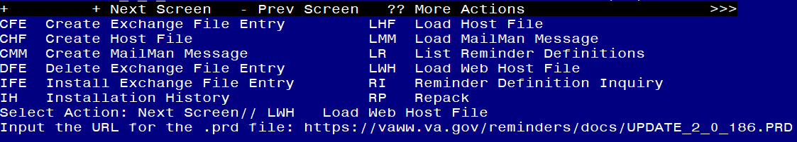

At the **Select Action:** prompt, enter **LWH** for Load Web Host File

At the **Input the url for the .prd file:** prompt, type the following web address:

#### <https://vaww.va.gov/reminders/docs/UPDATE_2_0_186.PRD>

You should see a message at the top of your screen that the file loaded successfully



Search and locate an entry titled **UPDATE_2_0_186 VA-COVID PREVENTIVE HEALTH INVENTORY**

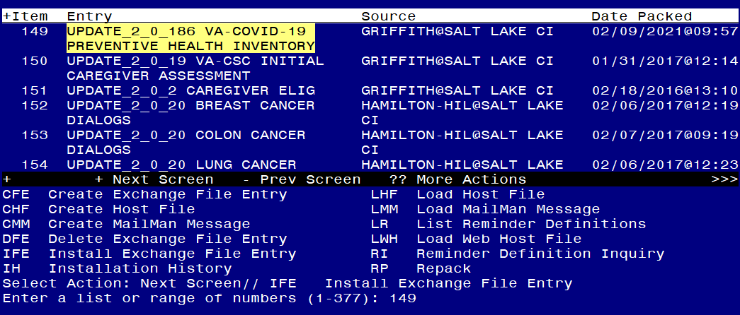

At the **Select Action** prompt, enter **IFE** for Install Exchange File Entry

Enter the number that corresponds with your entry **UPDATE_2_0_186 VA-COVID PREVENTIVE HEALTH INVENTORY.** *(in this example it is entry 149 it will vary by site).* The date of the exchange file should be 02/09/2021.

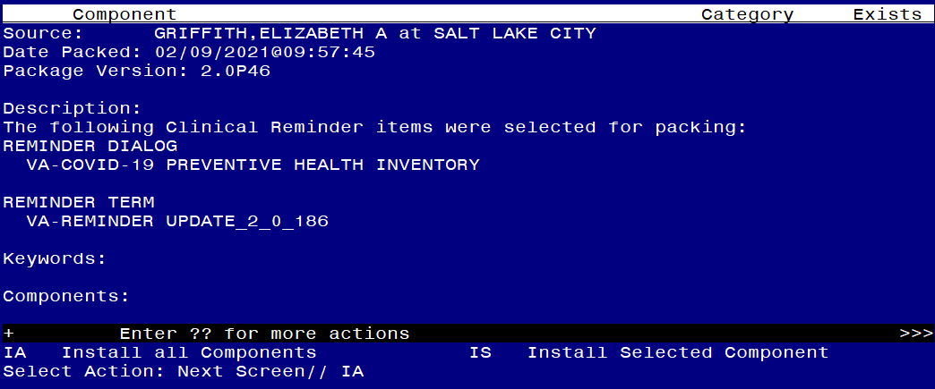

At the **Select Action** prompt, type **IA** for Install all Components and hit enter. Select Action: Next Screen// IA Install all Components

You will see several prompts, for all new entries you will choose **I to Install If you are prompted to overwrite any items, choose S to SKIP.**

#### You will be prompted to install the reminder dialog component – You will choose to install all even though some components may have an X to indicate that they exist.

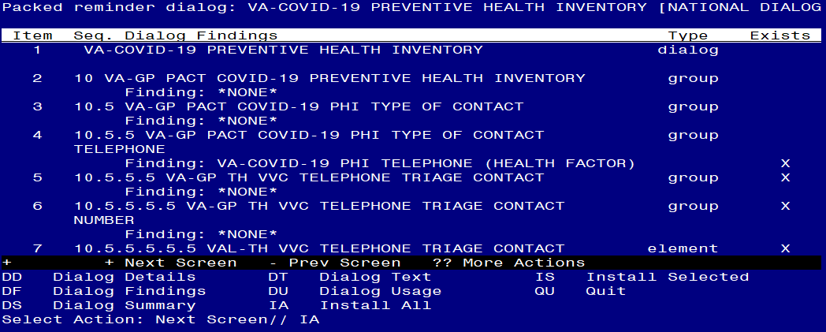

At the **Select Action** prompt, type **IA** to install the dialog – **VA-COVID-19 PREVENTIVE HEALTH INVENTORY**

Select Action: Next Screen// IA Install All

Install reminder dialog and all components with no further changes: Y// Yes

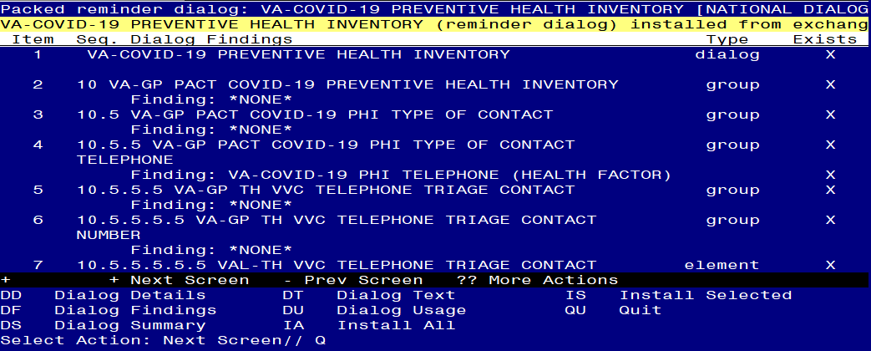

After completing this dialog install, you will type Q.

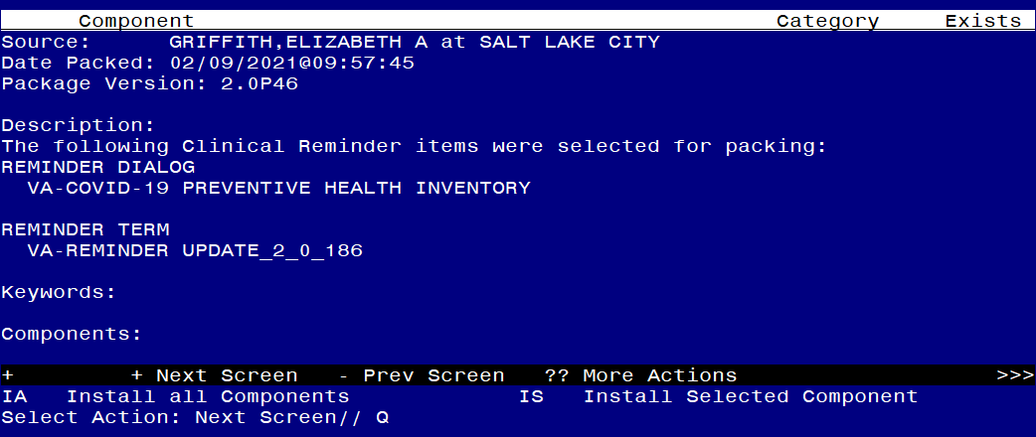

You will then be returned to this screen. At the **Select Action** prompt, type **Q.**

Install complete.

# Post Installation

1. **Update the following REMINDER TERMS to edit the computed finding parameter field in the existing finding item VA-REMINDER DEFINITION.** No other fields will need to be edited. Example step by step instructions are available after the list:

List of Reminder Terms:

Edit reminder term VA-BL INFLUENZA DONE in finding item 1 replace the current entry in the computed finding parameter field VA-REPLACE DEFINITION with VA- INFLUENZA SEASONAL IMMUNIZATION

Edit reminder term VA-BL CRC AVERAGE RISK REMINDER DUE in finding item 1 replace the current entry in the computed finding parameter field VA-REPLACE DEFINITION with VA-CRC AVERAGE RISK.

Edit reminder term VA-BL CRC AVERAGE RISK REMINDER DUE DIALOG in finding item 1 replace the current entry in the computed finding parameter

field VA-REPLACE DEFINITION with VA-CRC AVERAGE RISK

Edit reminder term VA-BL CRC FOLLOW UP REMINDER DUE in finding item

1 replace the current entry in the computed finding parameter field VA-REPLACE DEFINITION with VA-CRC FOLLOW UP COLONOSCOPY

Edit reminder term VA-BL CRC DIAGNOSTIC REMINDER DUE in finding item

1 replace the current entry in the computed finding parameter field VA-REPLACE DEFINITION with VA-CRC DIAGNOSTIC COLONOSCOPY

Edit reminder term VA-BL WH MAMMOGRAM DONE in finding item 1 replace the current entry in the computed finding parameter field VA-REPLACE DEFINITION with VA-WH MAMMOGRAM SCREENING

Edit reminder term VA-BL WH MAMMOGRAM N/A in finding item 1 replace the current entry in the computed finding parameter field VA-REPLACE DEFINITION with VA-WH MAMMOGRAM SCREENING

Edit reminder term VA-BL WH PAP DONE in finding item 1 replace the current entry in the computed finding parameter field VA-REPLACE DEFINITION with VA- WH PAP SMEAR SCREENING

Edit reminder term VA-BL WH PAP N/A in finding item 1 replace the current entry in the computed finding parameter field VA-REPLACE DEFINITION with VA-WH PAP SMEAR SCREENING

Edit reminder term VA-BL SUICIDE SCREEN DONE in finding item 1 replace the current entry in the computed finding parameter field VA-REPLACE DEFINITION with VA-PRIMARY SUICIDE SCREEN

Edit reminder term VA-BL SUICIDE SCREEN N/A in finding item 1 replace the current entry in the computed finding parameter field VA-REPLACE DEFINITION with VA-PRIMARY SUICIDE SCREEN

Edit reminder term VA-BL TELERETINAL REMINDER DUE in finding item

1 replace the current entry in the computed finding parameter field VA-REPLACE DEFINITION with VA-EYE CARE AT-RISK SCREEN (NURSE) if *you are using*

*the national reminder, if you are not using the national reminder, add your local teleretinal eye reminder definition name*

If after completing the edit, you get an error like the one listed below, check that the computed finding parameter has the correct definition name with no spelling errors or additional spaces.

FATAL: Term finding number 1 uses computed finding VA-REMINDER DEFINITION. The

Press ENTER to continue or '^' to exit:

Computed Finding Parameter is set to VA-INFLUENZA SEASONAL IMMUNIZATION , that

NOTICE THE EXTRA SPACE AFTER IMMUNIZATION NAME

reminder does not exist.

The term is VA-BL INFLUENZA DONE (1861).

Here is one step by step example, you should follow the steps below for all of the reminder terms listed:

Select Reminder Term Management <TEST ACCOUNT> Option: TE Add/Edit Reminder Term

Select Reminder Term: VA-BL INFLUENZA DONE NATIONAL

...OK? Yes// (Yes)

NAME: VA-BL INFLUENZA DONE Replace CLASS: NATIONAL//

SPONSOR: NATIONAL CENTER FOR HEALTH PROMOTION AND DISEASE PREVENTION (NCP) //

REVIEW DATE:

DESCRIPTION:

This term will be used for branching logic Edit? NO//

Choose from:

CF VA-REMINDER DEFINITION Finding # 1

Select Finding: `1 VA-REMINDER DEFINITION Editing Finding Number: 1

FINDING ITEM: VA-REMINDER DEFINITION// BEGINNING DATE/TIME:

ENDING DATE/TIME:

OCCURRENCE COUNT:

COMPUTED FINDING PARAMETER: VA-REPLACE DEFINITION Replace ... With VA-INFLUENZA SEASONAL IMMUNIZATION

Replace

VA-INFLUENZA SEASONAL IMMUNIZATION CONDITION: I V("STATUS")="RESOLVED" Replace CONDITION CASE SENSITIVE:

USE STATUS/COND IN SEARCH:

Choose from:

CF VA-REMINDER DEFINITION Finding # 1

Select Finding:

#### Edit the following reminder terms to add your local lab tests:

VA-BL DIABETES/A1C DONE – add all of your local Hemoglobin A1C lab tests as a finding item and add a beginning date and time of T-1Y. If you are not sure which lab tests to add, please contact your local Lab.

VA-BL HGB A1C > 7.9 - – add all of your local Hemoglobin A1C lab tests as a finding item and add a condition of I V>7.9. If you are not sure which lab tests to add, please contact your local Lab.

VA-BL DIABETES/KIDNEY DONE - add all of your local Microalbumin lab tests as a finding item and add a beginning date and time of T-1Y. If you are not sure which lab tests to add, please contact your local Lab.

#### Edit the reminder term VA-BL DIABETES/FOOT EXAM DONE.

Add any local health factor(s) that indicate a diabetic foot exam has been completed. Add a beginning date and time of each finding to T-1Y.

#### Edit the reminder term VA-INCORRECT DIABETES DIAGNOSIS

Add any local health factor(s) that indicate a diabetes diagnosis is incorrect.

#### Add your quick local orders to the following dialog elements/groups:

* 1. Reminder Dialog Group: VAL-COVID-19 PHI CRC ORDER FOBT/FIT – add your local quick order that represents a FIT test
  2. Reminder Dialog Element: VAL-COVID-19 PHI CRC ORDER COLONOSCOPY – add your local quick order that represents a colonoscopy order
  3. Reminder Dialog Group: VAL-COVID-19 PHI MAMMOGRAM ORDER – add your local quick order for Mammogram Screening.
  4. Reminder Dialog Element: VA-COVID-19 PHI A1C ORDER – add your local quick order for a hemoglobin A1C lab test
  5. Reminder Dialog Element: VA-COVID-19 PHI MICROALBUMIN ORDER – add your local quick order for a microalbumin lab test
  6. Reminder Dialog Group: VA-COVID-19 PHI TELE-EYE ORDER – add your local quick order for tele-eye screening (teleretinal or TECS as applicable)
  7. Reminder Dialog Element: VAL-COVID-19 PHI RTC ORDER – add your local quick order or menu for return to clinic orders
  8. Reminder Dialog Element: VAL-COVID-19 PHI BLOOD PRESSURE UNABLE PROSTHETICS CONSULT – add your local prosthetics order for a blood pressure cuff

1. **Edit the HEALTH SUMMARY TYPE VA-LAST MAMMOGRAM**, select component CM and add VA-WH MAMMOGRAM SCREENING the selection prompt

Create/Modify Health Summary Type

Select Health Summary Type: VA-LAST MAMMOGRAM VA-Last Mammogram (Last Mammogram)

OK? YES//

WARNING: You are about to edit a Health Summary Type that is being used by a Health Summary Object. Changing the structure of this Health Summary Type will alter how the Object will display.

Do want to continue? NO// YES

NAME: VA-LAST MAMMOGRAM Replace TITLE:

SUPPRESS PRINT OF COMPONENTS WITHOUT DATA: SUPPRESS SENSITIVE PRINT DATA:

LOCK:

OWNER: OCONNOR,DAWN M//

Do you wish to review the Summary Type structure before continuing? NO// Y Select COMPONENT: CM

1. CM CLINICAL REMINDERS MAINTENANCE CM
2. CMB CLINICAL REMINDERS BRIEF CMB

CHOOSE 1-2: 1 CLINICAL REMINDERS MAINTENANCE CM

CLINICAL REMINDERS MAINTENANCE is already a component of this summary.

Select one of the following:

E Edit component parameters

1. Delete component from summary Select Action: Edit component parameters SUMMARY ORDER: 5// 5

HEADER NAME: Last Mammogram// No selection items chosen.

Select new items one at a time in the sequence you want them displayed. You may select any number of items.

Select SELECTION ITEM: VA-WH MAMMOGRAM SCREENING

Searching for a REMINDER DEFINITION, (pointed-to by SELECTION ITEM) Searching for a REMINDER DEFINITION

VA-WH MAMMOGRAM SCREENING NATIONAL

...OK? Yes// (Yes)

Select SELECTION ITEM:

Select COMPONENT:

Do you wish to review the Summary Type structure before continuing? NO//

Please hold on while I resequence the summary order.

1. **Edit the HEALTH SUMMARY TYPE VA-SUICIDE SCREEN** select component CM and add VA-PRIMARY SUICIDE SCREEN the selection prompt

Select Build Health Summary Type Menu <TEST ACCOUNT> Option: 1 Create/Modify Health Summary Type

Select Health Summary Type: VA-SUICIDE SCREEN VA-Suicide Screen (Suicide Screen)

OK? YES//

WARNING: You are about to edit a Health Summary Type that is being used by a Health Summary Object. Changing the structure of this Health Summary Type will alter how the Object will display.

Do want to continue? NO// YES NAME: VA-SUICIDE SCREEN Replace TITLE:

SUPPRESS PRINT OF COMPONENTS WITHOUT DATA: SUPPRESS SENSITIVE PRINT DATA:

LOCK:

OWNER: OCONNOR,DAWN M//

Do you wish to review the Summary Type structure before continuing? NO// Y Select COMPONENT: CM

1. CM CLINICAL REMINDERS MAINTENANCE CM
2. CMB CLINICAL REMINDERS BRIEF CMB

CHOOSE 1-2: 1 CLINICAL REMINDERS MAINTENANCE CM

CLINICAL REMINDERS MAINTENANCE is already a component of this summary.

Select one of the following:

1. Edit component parameters

D Delete component from summary Select Action: Edit component parameters SUMMARY ORDER: 5// 5

HEADER NAME: Suicide Screen// No selection items chosen.

Select new items one at a time in the sequence you want them displayed. You may select any number of items.

Select SELECTION ITEM: VA-PRIMARY SUICIDE SCREEN

Searching for a REMINDER DEFINITION, (pointed-to by SELECTION ITEM) Searching for a REMINDER DEFINITION

VA-PRIMARY SUICIDE SCREEN NATIONAL

...OK? Yes// (Yes)

Select SELECTION ITEM:

Select COMPONENT:

Do you wish to review the Summary Type structure before continuing? NO//

Please hold on while I resequence the summary order.

##### You should close and re-open CPRS to display the objects properly.

1. **Update the Health Summary Type VA-MICROALBUMIN and add your local lab tests for microalbumin. -** add all of your local Microalbumin lab tests as selection items to the Select Lab Test component. If you are not sure which lab tests to add, please contact your local Lab.
2. **Confirm your site allows patients to self-schedule mammograms.** Check with your local WH Coordinator and confirm that patients can self-schedule a

mammogram. If they cannot, you will need to edit the reminder dialog element VAL- COVID-19 PHI MAMMOGRAM SELF SCHEDULE and set the disable prompt to 2. This will disable the option and make it not viewable in the template.

#### Add your local data objects

* 1. Add your local data object for patient phone number to the dialog text of the reminder dialog element VAL-TH VVC TELEPHONE TRIAGE CONTACT PHONE OBJECT
  2. Add your local data object for patient address to the dialog text of the reminder dialog element VAL-TH VVC TELEPHONE TRIAGE PATIENT LOCATION HOME

#### Setup of specific Note Title

The note title to create to associate with this template is: COVID-19 PREVENTIVE HEALTH INVENTORY

You can add this to the document class that your PACT note titles are in. VHA Enterprise Standard Title: PACT NOTE

Note: Comprehensive information on Creating Document Definitions can be found beginning on page 47 of the [TIU/ASU Implementation Guide](http://www.va.gov/vdl/documents/Clinical/CPRS-Text_Integration_Utility_(TIU)/tiuim.pdf)

#### Link the new reminder dialog with the note title in CPRS

From the Reminder Manager Menu, choose CP CPRS Reminder Configuration, and then choose LINK Link Reminder Dialog to Template.

Select CPRS Reminder Configuration <TEST ACCOUNT> Option: LINK Link Reminder Dialog to Template

Select Dialog Definition: VA-COVID-19 PREVENTIVE HEALTH INVENTORY reminder dialog NATIONAL ...OK? Yes// (Yes)

Enter template name: COVID-19 PREVENTIVE HEALTH INVENTORY Link template to Document Title? YES

Select Document Definition: COVID-19 PREVENTIVE HEALTH INVENTORY

##### Check notification settings for your facility.

For the workflow process to work correctly and providers to get the notification to sign orders, you should have the notification ORDER REQUIRES ELECTRONIC SIGNATURE set to On. If you do not have this alert set to On, your site will need to work out a method for the provider to be notified that there are orders waiting to be signed.



***NOTE****: If there are any questions or problems during the installation, please notify your local IT support to log a national help desk ticket or contact the VA Service Desk and have them submit a national ticket to:*

*Category: Affected Service*

*Affected Service: VistA – CPRS: Clinical Reminders Assignment Group: NTL SUP Clin 2*