

**Update _2_0_188**

Clinical Reminders

VA-TH DIGITAL DIVIDE UPDATES

Install Guide

**May 2021**

Product Development

Office of Information Technology

Department of Veterans Affairs

Table of Contents

Introduction 1

Pre-installation 2

Install Details 2

Install Example 2

Post Installation 6

# Introduction

**Description:**

The Office of Connected Care released the VA-TH DIGITAL DIVIDE ASSMNT BY SOCIAL WORK consult result reminder dialog, the digital divide outpatient consult txml template, and the video device consult txml template in 2020. This update revises those items.

UPDATE_2_0_188 contains 1 Reminder Exchange entry:

UPDATE_2_0_188 VA-TH DIGITAL DIVIDE ASSMNT BY SOCIAL WORK

**The exchange file contains the following components:**

**TIU TEMPLATE FIELD**

WORD PROCESSING (REQ)

TEXT (1-60 CHARACTERS) REQ

LIFELINESUPPORT.ORG

VA-FED POVERTY LEVEL THRESHOLD

LIFELINE ELIGIBILITY

GEN WORD PROCESSING

WORD PROCESSING 68 LENGTH 10 LINE REQ

TH EVERYONEON URL

VA-TH DD EBB URL

LIFELINESUPPORT.ORG

**HEALTH FACTORS**

VA-REMINDER UPDATES

VA-UPDATE_2_0_188

VA-TH DIGITAL DIVIDE

VA-TH DD PREFERS SMARTPHONE

VA-TH DD PREFERS TABLET

VA-TH DD DEVICE ADDRESS CPRS

VA-TH DD DEVICE ADDRESS FACILITY

VA-TH DD DEVICE ADDRESS ALTERNATE

VA-TH DD DEVICE REQUIRES PERIPHERALS

VA-TH DD PREFERS SMARTPHONE

VA-TH DD PREFERS TABLET

VA-TH DD HOME INTERNET W/VIDEO NO

VA-TH DD HOME INTERNET W/VIDEO YES

VA-TH DD LIFELINE NOT ELIGIBLE

VA-TH DD LIFELINE PENDING

**REMINDER SPONSOR**

Office of Connected Care

**REMINDER TERM**

VA-REMINDER UPDATE_2_0_188

**REMINDER DIALOG**

VA-TH DIGITAL DIVIDE ASSMNT BY SOCIAL WORK

# Pre-installation

1. **Copy content from local elements from original release, if necessary.**

The original release of the VA-TH DIGITAL DIVIDE ASSMNT BY SOCIAL WORK reminder dialog included two local elements, VAL-TH DIGITAL DIVIDE DEVICE LIFELINE LOCAL SECTION and VAL-TH DIGITAL DIVIDE DEVICE HEADER LOCAL SECTION. Copy local modifications to these two elements to reenter after installation, if necessary.

# Install Details

This update is being distributed as a web host file. The address for the host file is: **https://Redacted /UPDATE_2_0_188.PRD**

The file will be installed using Reminder Exchange, programmer access is not required.

Installation:

=============

This update can be loaded with users on the system. Installation will take less than 10 minutes.

# Install Example

To Load the Web Host File. Navigate to Reminder exchange in Vista

At the **Select Action:** prompt, enter **LWH** for Load Web Host File

At the **Input the url for the .prd file:** prompt, type the following web address:

**https://Redacted /UPDATE_2_0_188.PRD**

Terminal window screen shot of the message displaying the URL of the file that was successfully loaded.  Part of the URL has been redacted as it is a VA only internal web site URL.You should see a message at the top of your screen that the file successfully loaded.

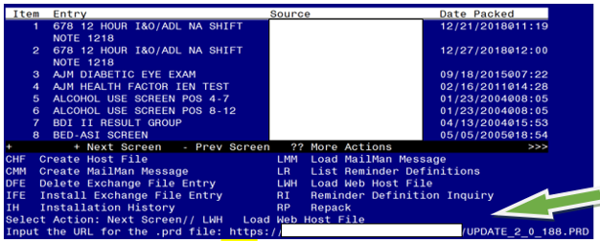

Search and locate an entry titled UPDATE_2_0_188 VA-TH DIGITAL DIVIDE ASSMNT BY SOCIAL WORK in reminder exchange.

At the **Select Action** prompt, enter **IFE** for Install Exchange File Entry

Enter the number that corresponds with your entry titled **UPDATE_2_0_188 VA-TH DIGITAL DIVIDE ASSMNT BY SOCIAL WORK** *(in this example it is entry 178 it will vary by site).* The date of the exchange file should be 05/10/2021.

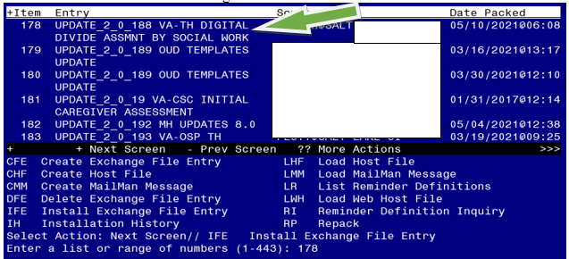

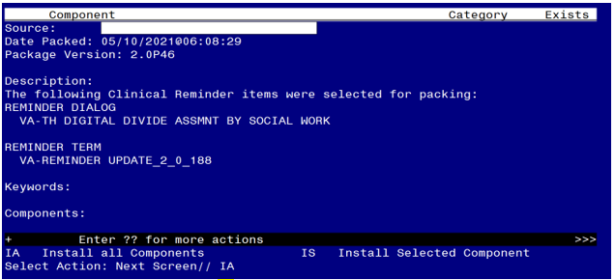

At the **Select Action** prompt, type **IA** for Install all Components and hit enter.

Select Action: Next Screen// IA Install all Components

You will see several prompts, for all new entries you will choose **I to Install**

**Install all new items.**

**Skip existing health factors.**

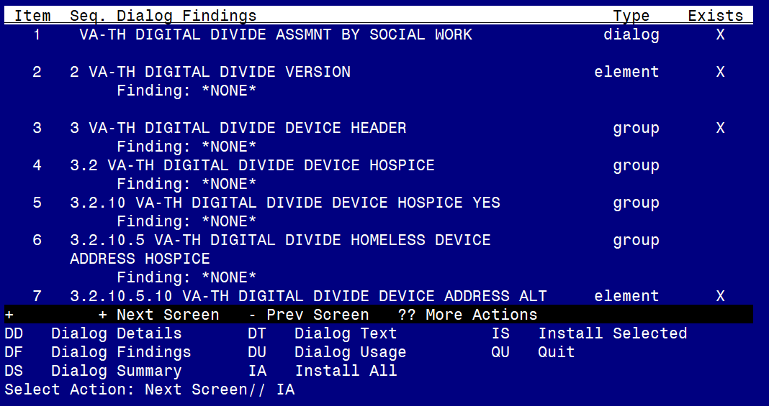

At the **Select Action** prompt, type **IA** to install the dialog – **VA-TH DIGITAL DIVIDE ASSMNT BY SOCIAL WORK**

Select Action: Next Screen// IA Install All

Install reminder dialog and all components with no further changes: Y// Yes

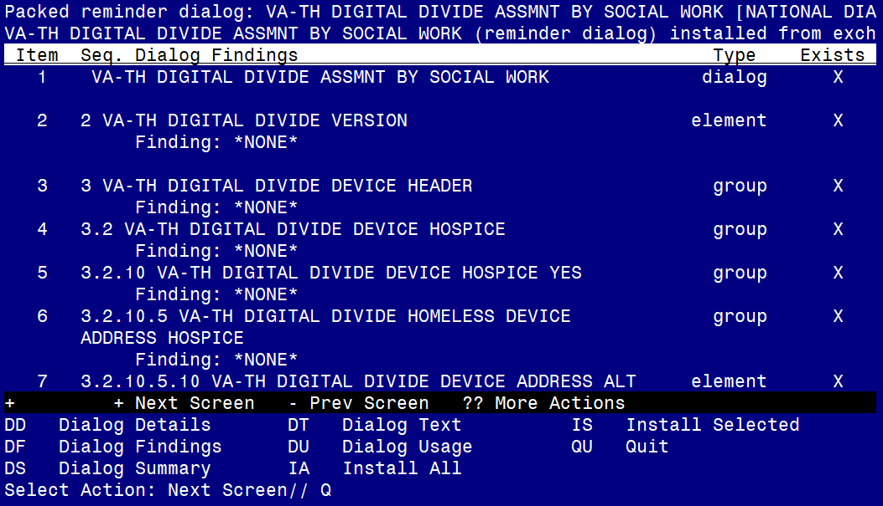

When the dialog has completed installation, you will then be returned to this screen. At the **Select Action** prompt, type **Q.**

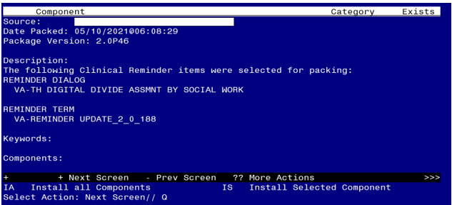

You will then be returned to this screen. At the **Select Action** prompt, type **Q.**

Install complete.

# Post Installation

1. **The VA-TH DIGITAL DIVIDE ASSMNT BY SOCIAL WORK dialog should already be linked to the DIGITAL DIVIDE ASSESSMENT BY SOCIAL WORK CONSULT RESULT note title. Confirm the updated dialog displays when the note title is selected. If the dialog is not linked to the title, follow the steps below.**

**1a. Make the Dialog able to be attached to a Personal/Shared template or to a progress**

**note title.**

From the Reminders Manager Menu:

Select Reminder Managers Menu Option: **CP**

CA Add/Edit Reminder Categories

CL CPRS Lookup Categories

CS CPRS Cover Sheet Reminder List

MH Mental Health Dialogs Active

PN Progress Note Headers

RA Reminder GUI Resolution Active

TIU TIU Template Reminder Dialog Parameter

DL Default Outside Location

PT Position Reminder Text at Cursor

Select CPRS Reminder Configuration Option: **TIU**

Reminder Dialogs allowed as Templates may be set for the following:

1 User USR [choose from NEW PERSON]

3 Service SRV [choose from SERVICE/SECTION]

4 Division DIV [choose from INSTITUTION]

5 System SYS [NATREM.FO-SLC.MED.VA.GOV]

Enter selection*:* 5  *Choose the appropriate number for your site. Your site may do this by System or other levels. The example below uses SYSTEM level*

Setting Reminder Dialogs allowed as Templates for System:

Select Display Sequence: **?**

78 VA-VETERANS CHOICE NOTE

79 VA-TBI SCREENING

*When you type a question mark above, you will see the list of #’s (with dialogs) that are already taken. Choose a number* ***NOT*** *on this list. For this example, looking above I see the number 80 is not present, so I will use 80 .*

Select Display Sequence: **80**

Are you adding 80 as a new Display Sequence? Yes// **Y** YES

Display Sequence: 80// <Enter> 80

Clinical Reminder Dialog**: type in the name of the dialog**

**VA-TH DIGITAL DIVIDE ASSMNT BY SOCIAL WORK**

then **<enter>** reminder dialog NATIONAL

OK? Yes// <Enter> (Yes)

**1b. Setup of Note title/ Associate the reminder dialog with the note title or shared template in CPRS**

Check VistA for the note title **DIGITAL DIVIDE ASSESSMENT BY SOCIAL WORK CONSULT RESULT**. Create a new progress note title **DIGITAL DIVIDE ASSESSMENT BY SOCIAL WORK CONSULT RESULT** if necessary**.** The program office released instructions to create the title in late 2019.

**1c. Setup of Note title (if not already completed).**

The new note title is:

**DIGITAL DIVIDE ASSESSMENT BY SOCIAL WORK CONSULT RESULT**

The DIGITAL DIVIDE ASSESSMENT BY SOCIAL WORK CONSULT RESULT title should be created for use with the reminder dialog.

Name: DIGITAL DIVIDE ASSESSMENT BY SOCIAL WORK CONSULT RESULT

VHA Enterprise Standard Title: CONSULT

Note: Comprehensive information on Creating Document Definitions can be found beginning on page 47 of the [TIU/ASU Implementation Guide](http://www.va.gov/vdl/documents/Clinical/CPRS-Text_Integration_Utility_(TIU)/tiuim.pdf)

**1d. Associate dialog with the note title.**

* + Open Template Editor and from Shared Templates, select File “Document Titles”

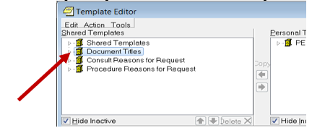

* + Click ‘triangle’ to left of Document Titles to expand.
  + Select the folder where the title **DIGITAL DIVIDE ASSESSMENT BY SOCIAL WORK CONSULT RESULT** will be located.
  + Select “**New Template**” on the top right side of the Template Editor
  + In the “**Name**” field enter “DIGITAL DIVIDE ASSESSMENT BY SOCIAL WORK CONSULT RESULT”.
  + Change **Template type** to Reminder Dialog.
  + In reminder Dialog field enter “VA-TH Digital Divide Assmnt By Social Work”

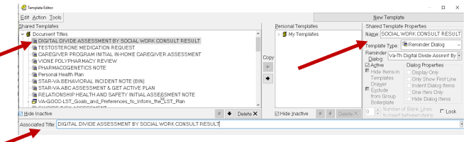

* Enter the Progress Note title DIGITAL DIVIDE ASSESSMENT BY SOCIAL WORK CONSULT RESULT in the Associated Title field. Click Apply and OK
* Test the progress note title in CPRS to see new dialog is attached.

1. **Enable local elements to add local content to dialog if necessary.**

The elements are deployed disabled, so they will need to be enabled if used. The elements are added to the opening window (VAL-TH DIGITAL DIVIDE DEVICE HEADER LOCAL SECTION), the option for documenting the patient is interested in a device (VAL-TH DIGITAL DIVIDE DEVICE LOCAL SECTION), and the option for documenting the patient is interested in the LifeLine program (VAL-TH DIGITAL DIVIDE DEVICE LIFELINE LOCAL SECTION). Enter local content to these two elements if needed.

1. **Import the Digital Divide Order and Video Device Order txml templates.**
2. **Link the new Digital Device Order consult template to the existing DIGITAL DIVIDE OUTPT consult. Confirm the updated template displays when the order is selected.**
3. **Link the new Video Device Order to the existing VIDEO DEVICE ORDER consult. Confirm the updated template displays when the order is selected.**