

**Update _2_0_189**

Clinical Reminders

OUD TEMPLATES UPDATE

Install Guide

**October 2021**

Product Development

Office of Information Technology

Department of Veterans Affairs

Table of Contents

Introduction 1

Pre-Install 2

Install Details 6

Install Example 7

Post Installation 15

# Introduction

This reminder update serves to update the Opioid Use Disorder templates (Assessment, Initiation and Follow-Up).

**All three templates have the following changes:**  
1. Changed all references from OUD to “OUD or Opioid dependence”

1. Changed medication assisted treatment to medication treatment
2. Remove intended users’ statement
3. Added next appt/duration of visit
4. Changed “confirm oud diagnosis” text to “indication for buprenorphine” follow up
5. Formatting changes to improve line up of text and boxes

**Assessment and Initiation Templates had the following changes:**

1. Added criteria for Opioid Dependence with guidance for choosing
2. Added optional local group placeholder to allow site customization on initiation and assessment template. This will be defaulted to disable

VAL-GP BUPE INITIATION PLACEHOLDER

VAL-GP BUPE ASSESSMENT PLACEHOLDER

1. Added 6 new HF”s for opioid dependence assessment section
   1. VA-MH OUD DEPENDENCE ICD10-1 DESIRE
   2. VA-MH OUD DEPENDENCE ICD10-2 DIFFICULT
   3. VA-MH OUD DEPENDENCE ICD10-3 WITHDRAWAL
   4. VA-MH OUD DEPENDENCE ICD10-4 TOLERANCE
   5. VA-MH OUD DEPENDENCE ICD10-5 NEGLECT
   6. VA-MH OUD DEPENDENCE ICD10-6 PERSIST

**Initiation Template had the following changes:**

1. Change note title: from OPIOID USE DISORDER BUPRENORPHINE INITIATION to OUD/OPIOID DEPENDENCE BUPRENORPHINE INITIATION
2. Added vital signs to initiation template which links w/vital signs package
3. Added text to allow for oral consent for buprenorphine treatment to align with VA policy change
4. Changed national groups (VA) to local (VAL-GP) groups for the following to accommodate local and changing prescribing practices: (Initiation template)

VAL-MH OUD BUPE OFFICE INITIATION BUPRENORPHINE ORDERS

VAL-MH OUD BUPE INITIATION ADMINISTERED BUPRENORPHINE 1 MG

VAL-MH OUD BUPE INITIATION ADMINISTERED BUPRENORPHINE 2 MG

VAL-MH OUD BUPE INITIATION ADMINISTERED BUPRENORPHINE 4 MG

VAL-GP MH OUD BUPE INITIATION MEDS

1. Hid help text on “withdrawal” and “sedation” in new group
   1. VA-GP MH OUD BUPE INITIATION HELP TEXT PROBLEMS
   2. These are now hidden unless open to improve real estate.
2. Fixed two broken url links in initiation template
   1. Buprenorphine education from imed consent
      1. Template field name: VA-MH OUD IMED CONSENT BUPE ED
   2. Template field name: VA-MH SAMHSA TIP 63 URL

**Assessment Template had the following changes:**

1. Change note title: from OPIOID USE DISORDER ASSESSMENT to OUD/OPIOID DEPENDENCE ASSESSMENT
2. Added 2 NEW Links to assessment template:

-ICD 10 vs OUD chart:   
Template field name: VA-MH OUD VS OPIOID DEPENDENCE URL

-Bupe for pain  
Template field name: VA-MH OUD BUPE FOR PAIN URL

**Follow-up Template had the following changes:**

1. Added text reminding end user about entering PDMP note according to local direction (this may be obsolete with new PMP button).

**Three reminder dialogs are being distributed with this update**

VA-MH OUD ASSESSMENT TEMPLATE

VA-MH OUD BUPRENORPHINE FOLLOW UP

VA-MH OUD BUPRENORPHINE INITIATION TEMPLATE

UPDATE_2_0_189 contains 1 Reminder Exchange entry:

**UPDATE_2_0_189 OUD TEMPLATES UPDATE**

**The exchange file contains the following components:**

TIU TEMPLATE FIELD

1 GEN COMMENT FL 15

2 BLANK SPACE1

3 VA-MH OUD OTHER NO INDENT

4 VA-MH SAMHSA TIP 63 URL

5 VA-MH OUD PROVIDER GUIDE BUPE HOME

6 VA-MH OUD EXAM PSYCH TEXT

7 WP-2LINES

8 VA-MH OUD EXAM DERM TEXT

9 VA-MH OUD EXAM MSK TEXT

10 VA-MH OUD EXAM GI TEXT

11 VA-MH OUD EXAM RESP TEXT

12 VA-MH OUD EXAM CV TEXT

13 VA-MH OUD EXAM HEENT TEXT

14 VA-MH OUD GEN WORD PROC NARROW

15 MH OUD STORM REPORT

16 VA-MH OUD IMED CONSENT BUPE ED

17 VA-MH OUD MAT

18 VA-MH OUD HANDOUT BUPE CLINIC

19 VA-MH OUD HANDOUT BUPE HOME

20 VA-MH OUD BUPE CONSENT

21 WP 3/70

22 WP FREE TEXT

23 VA-MH OUD APPT

24 DATE

25 VA-MH FILM/TAB

26 VA-MH OUD MED BUPRENORPHINE

27 VA-MH OUD MEDS MAX MG

28 VA-MH OUD HOURS

29 VA-MH OUD MED DOSE 1/2 1

30 VA-MH OUD MED DOSE 1-2

31 COMMENT 35

32 COMMENT 15

33 COMMENT 10

34 YES/NO

35 VA-MH OUD EDIT BOX 70X5

36 WP 2 LINE1

37 VA-MH ADDITIONAL INFORMATION

38 VA-MH OUD DIAGNOSIS

39 VA-MH OUD BUPE FOR PAIN URL

40 VA-MH OUD VS OPIOID DEPENDENCE URL

41 VA-MH OUD MILD MOD SEVERE

42 00 EDIT BOX 12

43 VA-MH OPIOID DEPENDENCE POS NEG

44 GEN TEXT BOX 50

45 GEN WORD PROC NARROW

46 00 EDIT BOX 70X5

47 VA-MH DOCUMENT NEXT STEPS

48 TEXT (1-60 CHAR)

49 VA-MH OUD OTHER

50 VA-MH EMPLOYMENT HX2

51 VA-MH HOUSING SITUATION

52 VA-MH RELATIONSHIP HX

53 VA-MH DIAGNOSIS HX

54 VA-MH OUD SPECIFY TEXT

55 VA-MH OUD FREQUENCY TEXT3

56 VA-MH OUD FREQUENCY TEXT1

57 VA-MH OUD FREQUENCY TEXT2

58 GEN WORD PROCESSING

59 VA-MH OUD PROG TOWARD GOAL

60 VA-MH OUD 100-300 MG

61 EBOX40

62 IC/BLANK LINE 74 CHARACTERS T DIALOG USE

63 VA-MH OUD WITHDRAWAL SYMPTOMS

64 VA-MH OUD NONE

65 VA-MH OUD BUPE SE

66 VA-MH OUD RISK FACTORS

67 VA-MH YES/NO/NA

68 VA-MH REFERRAL SOURCE

HEALTH FACTORS

69 VA-REMINDER UPDATES

70 VA-UPDATE_2_0_189

71 VA-MH OUD TEMPLATES

72 VA-MH OUD BUPE INITIATION UDAS ORDERED

73 VA-NALOXONE

74 VA-PATIENT DECLINED NALOXONE

75 VA-MH OUD BUPE INITIATION INPATIENT

76 VA-MH OUD BUPE INITIATION OFFICE EDUCATE

77 VA-MH OUD BUPE INITIATION OBSERVE

78 VA-MH OUD BUPE INITIATION HOME EDUCATE

79 VA-MH OUD BUPE INITIATION HOME

80 VA-MH OUD BUPE INITIATION TEMPLATE

81 VA-MH OUD ASSESS DSM 5-2 REDUCE USE

82 VA-MH OUD ASSESS DSM 5-11 WITHDRAWAL

83 VA-MH OUD ASSESS DSM 5-10 TOLERANCE

84 VA-MH OUD ASSESS DSM 5-9 PHYSICAL PROB

85 VA-MH OUD ASSESS DSM 5-8 HAZARDOUS

86 VA-MH OUD ASSESS DSM 5-7 ACTIVITIES

87 VA-MH OUD ASSESS DSM 5-6 SOCIAL PROBLEMS

88 VA-MH OUD ASSESS DSM 5-5 FAILURE

89 VA-MH OUD ASSESS DSM 5-4 CRAVING

90 VA-MH OUD ASSESS DSM 5-3 OBTAIN OPIOIDS

91 VA-MH OUD ASSESS DSM 5-1 LARGER AMOUNT

92 VA-MH OUD DEPENDENCE ICD10-6 PERSIST

93 VA-MH OUD DEPENDENCE ICD10-5 NEGLECT

94 VA-MH OUD DEPENDENCE ICD10-4 TOLERANCE

95 VA-MH OUD DEPENDENCE ICD10-3 WITHDRAWAL

96 VA-MH OUD DEPENDENCE ICD10-2 DIFFICULT

97 VA-MH OUD DEPENDENCE ICD10-1 DESIRE

98 VA-MH OUD ASSESS TREATMENT DECLINED

99 VA-MH OUD ASSESS TREATMENT ACCEPTED

100 VA-MH OUD ASSESS TREATMENT OFFERED

101 VA-MH OUD ASSESS MEETS CRITERIA

102 VA-MH OUD ASSESS DOES NOT MEET CRITERIA

103 VA-MH OUD BUPE FOLLOW UP AS PRESCRIBED

104 VA-MH OUD FOLLOW UP OFFER NALOXONE

105 VA-MH OUD BUPE FOLLOW UP NEEDS ADJUST

106 VA-MH OUD BUPE FOLLOW UP STABLE

107 VA-MH OUD BUPE FOLLOW UP ASSESSMENT PLAN

108 VA-MH OUD BUPE FOLLOW UP VIEW UDAS

109 VA-MH OUD BUPE FOLLOW UP OTHER SUBSTANCE

110 VA-MH OUD BUPE FOLLOW UP TEMPLATE

111 VA-MH OUD ASSESS

REMINDER SPONSOR

112 Mental Health Services

113 Office of Mental Health Services

114 Mental Health Services and Women Veterans Health

Program

REMINDER TERM

115 VA-REMINDER UPDATE_2_0_189

HEALTH SUMMARY COMPONENT

LAB TESTS SELECTED

VITAL SIGNS DETAILED DISPLAY

MHA Score

LAB CUMULATIVE SELECTED 1

HEALTH SUMMARY TYPE

116 VA-BUPRENORPHINE INDUCTION LAB

117 VITALS TODAY

118 OB AUDC

119 VA-UDAS/BUPE OBJECT

HEALTH SUMMARY OBJECTS

120 VA-BUPRENORPHINE INDUCTION LAB REVIEW (TIU)

121 VITALS TODAY (TIU)

122 AUDC (TIU)

123 VA-UDAS/BUPE OBJECT (TIU)

TIU DOCUMENT DEFINITION

124 VA-BUPRENORPHINE INDUCTION LAB REVIEW

125 VITALS TODAY

VA-WRIISC ACTIVE PROBLEMS

ACTIVE MEDICATIONS

126 AUDIT-C

127 VA-UDAS/BUPE OBJECT

REMINDER DIALOG

128 VA-MH OUD BUPRENORPHINE INITIATION TEMPLATE

129 VA-MH OUD BUPRENORPHINE FOLLOW UP

130 VA-MH OUD ASSESSMENT TEMPLATE

# Pre-Install

1. You should ensure you have installed reminder update 121 which is a prerequisite for this update
2. For Health Summary Type below, you should print out the selection items that are part of the Health Summary Type. You may be prompted to OVERWRITE these during the install, and you want to ensure that you have any locally added items as selection items on your Health Summary Type:
   1. VA-BUPRENORPHINE INDUCTION LAB
   2. VITALS TODAY
   3. OB AUDC
   4. VA-UDAS/BUPE OBJECT
3. For the following elements/groups, check to see if you have quick orders as the finding item or additional finding. In the Post Install section, you will add your quick orders back

* VAL-MH OUD ASSESS NALOXONE ORDERED
* VAL-MH OUD BUPE INITIATION MEDS 2 MG TABS
* VAL-MH OUD BUPE INITIATION MEDS 8 MG TABS
* VAL-MH OUD BUPE INITIATION MEDS 2 MG FILM
* VAL-MH OUD BUPE INITIATION MEDS 8 MG FILM
* VAL-MH OUD BUPE INITIATION MEDS 2 MG TABS DISCHARGE
* VAL-MH OUD BUPE INITIATION MEDS 8 MG TABS DISCHARGE
* VAL-MH OUD BUPE INITIATION MEDS 2 MG FILM DISCHARGE
* VAL-MH OUD BUPE INITIATION MEDS 8 MG FILM DISCHARGE
* VAL-MH OUD BUPE INITIATION WITHDRAWAL CLONIDINE
* VAL-MH OUD BUPE INITIATION WITHDRAWAL ACETAMINOPHEN
* VAL-MH OUD BUPE INITIATION WITHDRAWAL ONDANSETRON
* VAL-MH OUD BUPE INITIATION WITHDRAWAL LOPERAMIDE
* VAL-MH OUD BUPE INITIATION ORDER LABS CBC
* VAL-MH OUD BUPE INITIATION ORDER LABS BMP
* VAL-MH OUD BUPE INITIATION ORDER LABS HEPATITIS A
* VAL-MH OUD BUPE INITIATION ORDER LABS HEPATITIS B
* VAL-MH OUD BUPE INITIATION ORDER LABS HEPATITIS C
* VAL-MH OUD BUPE INITIATION ORDER LABS LFT
* VAL-MH OUD BUPE INITIATION ORDER LABS HIV-GP
* VAL-MH OUD BUPE INITIATION ORDER LABS UDAS
* VAL-MH OUD BUPE INITIATION ORDER LABS HCG
* VAL-MH OUD ASSESS2 PLAN OFFER MAT CARE ACCEPTS UDAS ORDERED
* VAL-MH OUD FOLLOW UP MEDS 2MG FILM DISCHARGE
* VAL-MH OUD BUPE FOLLOW UP MEDS 2 MG TABS DISCHARGE
* VAL-MH OUD BUPE FOLLOW UP MEDS 8 MG FILM DISCHARGE
* VAL-MH OUD BUPE FOLLOW UP MEDS 8 MG TABS DISCHARGE
* VAL-MH OUD BUPE FOLLOW UP MEDS SUBLOCADE (IF SITES HAVE ENABLED)
* VAL-MH OUD BUPE FOLLOW UP MEDS SUBLOCADE DISCHARGE (IF SITES HAVE ENABLED)
* VAL-MH OUD BUPE FOLLOW UP ORDER LABS HCG
* VAL-MH OUD BUPE FOLLOW UP REFER ADDICTIONS
* VAL-MH OUD BUPE FOLLOW UP REFER MENTAL HEALTH

# Install Details

This update is being distributed as a web host file. The address for the host file is: [REDACTED/UPDATE_2_0_189.PRD](https://vaww.va.gov/reminders/docs/UPDATE_2_0_189.PRD) (Can also be found at [Index of /Patches_By_Application/PXRM-CLINICAL REMINDERS/PRD-Files (worldvista.org)](https://foia-vista.worldvista.org/Patches_By_Application/PXRM-CLINICAL%20REMINDERS/PRD-Files/)

The file will be installed using Reminder Exchange, programmer access is not required.

Installation:

=============

This update can be loaded with users on the system. Installation will take less than 20 minutes.

# Install Example

To Load the exchange file, use LWH. The URL is Redacted/ [UPDATE_2_0_189.PRD](https://vaww.va.gov/reminders/docs/UPDATE_2_0_189.PRD)

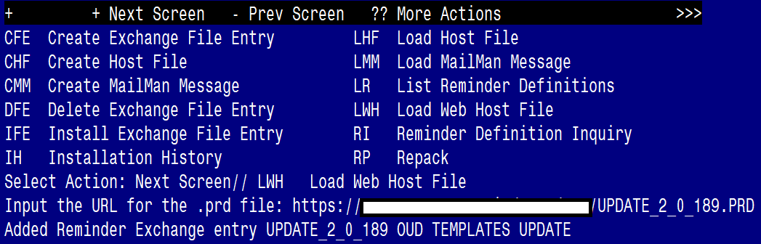

If you use LWH and it works, you will see something similar to this message. Make sure the file was loaded successfully.

Terminal window screen shot of the message displaying the URL of the file that was successfully loaded.  Part of the URL has been redacted as it is a VA only internal web site URL.

Most components will be the same and will be skipped. Here are general rules for prompts to which you will have to respond.

If a component exists, but is different, use **OVERWRITE** action

If a component is new, use **INSTALL** action

For Health Summary Object OB AUDC, if the component exists, but is different you should **SKIP**

Search and locate an entry titled UPDATE_2_0_189 OUD TEMPLATES UPDATE in reminder exchange. If you were a test site, you may have more than 1 entry with this name. Be sure and choose the entry with date of 10/12/2021

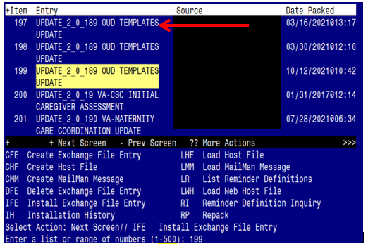

At the **Select Action** prompt, enter **IFE** for Install Exchange File Entry

Enter the number that corresponds with your entry titled UPDATE_2_0_189 OUD TEMPLATES UPDATE *(in this example it is entry 199, it will vary by site)* that is dated 10/12/2021.

At the **Select Action** prompt, type **IA** for Install all Components and hit enter.

You will see several prompts:

For all new entries you will choose I to Install

For entries that Exist, but the packed component is different, use OVERWRITE

For Health Summary Object OB AUDC, if the component exists, but is different you should **SKIP**

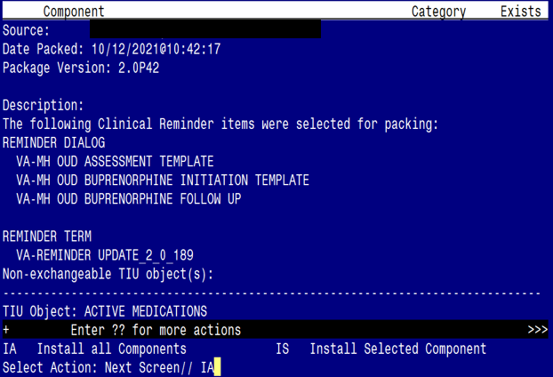

Dialog installation may not necessarily appear in the order listed in the install guide

**You will be promped to install the first reminder dialog component:**

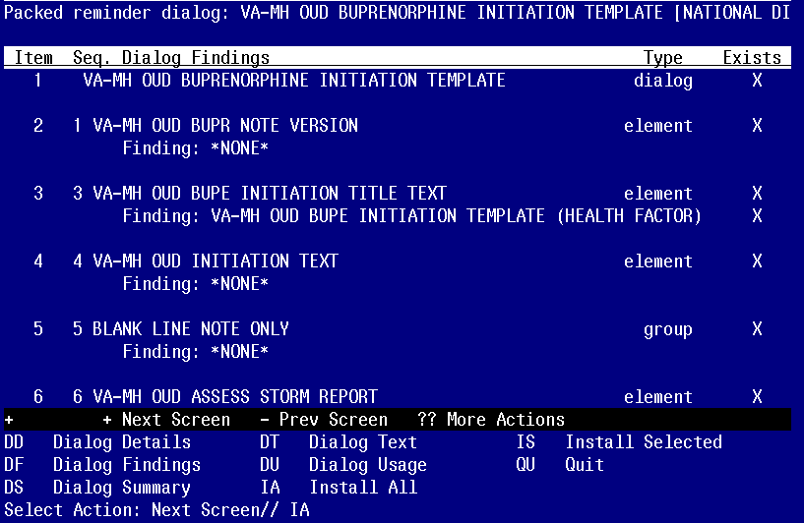

At the **Select Action** prompt, type **IA** to install the dialog **– VA-MH OUR BUPRENORPHINE INITIATION TEMPLATE**

Select Action: Next Screen// IA Install All

Install reminder dialog and all components with no further changes: Y// YES

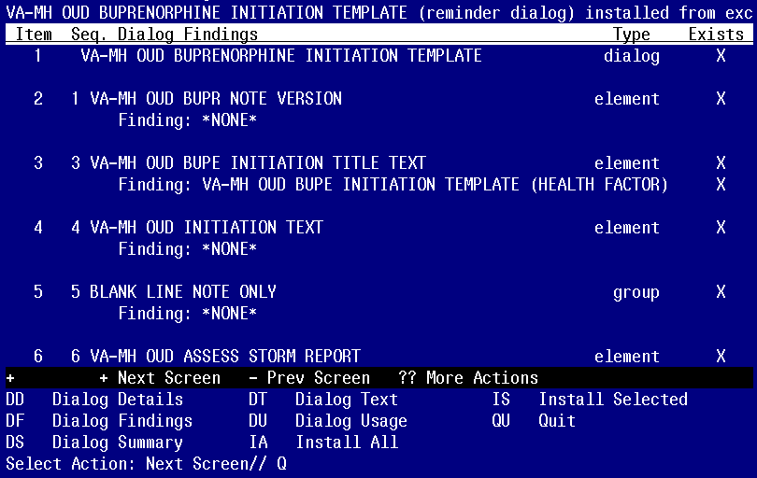

When the dialog has completed installation, you will then be returned to this screen. At the **Select Action** prompt, type **Q.**

**You will be promped to install the next reminder dialog component:**

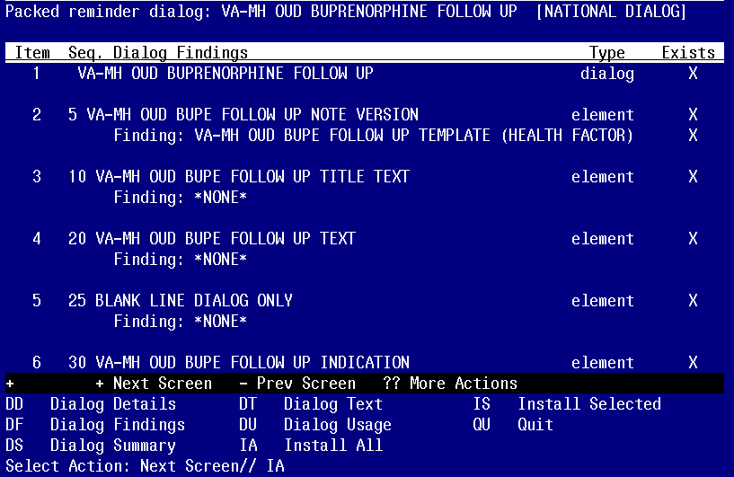

At the **Select Action** prompt, type **IA** to install the dialog **– VA-MH OUF BUPRENORPHINE FOLLOW UP**

Select Action: Next Screen// IA Install All

Install reminder dialog and all components with no further changes: Y// YES

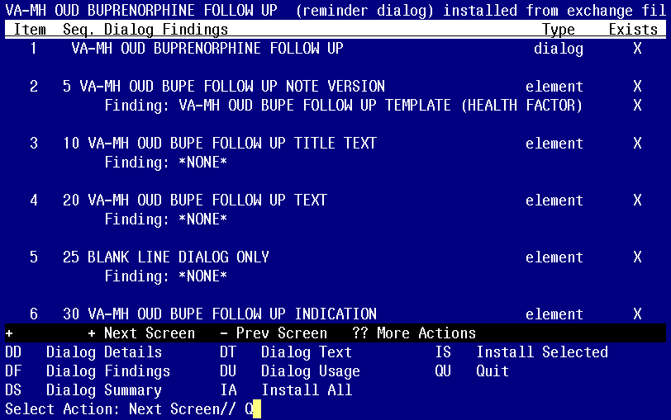

When the dialog has completed installation, you will then be returned to this screen. At the **Select Action** prompt, type **Q.**

**You will be promped to install the next reminder dialog component:** 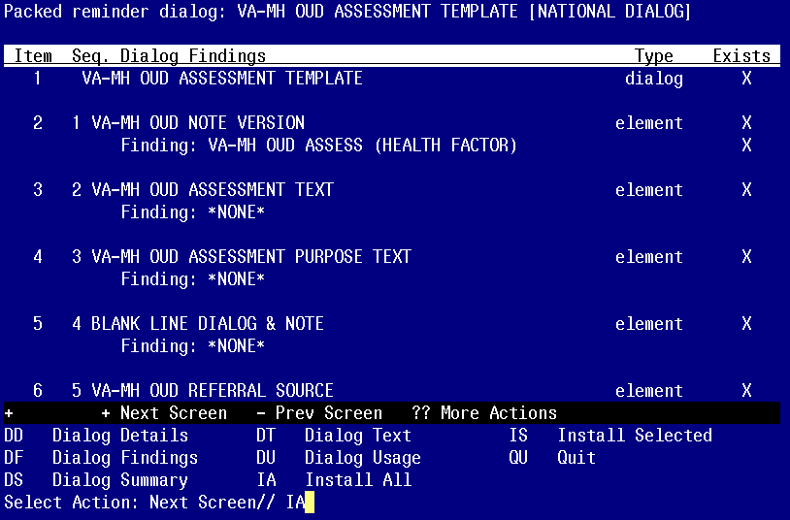

At the **Select Action** prompt, type **IA** to install the dialog **– VA-MH OUD ASSESSMENT TEMPLATE**

Select Action: Next Screen// IA Install All

Install reminder dialog and all components with no further changes: Y// YES

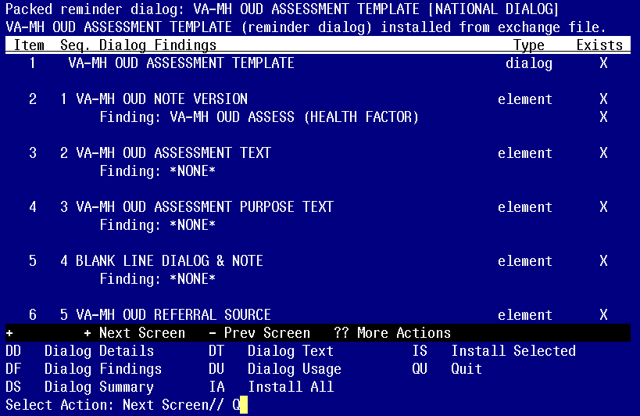

When the dialog has completed installation, you will then be returned to this screen. At the **Select Action** prompt, type **Q.**

This will complete the Dialog Install section.

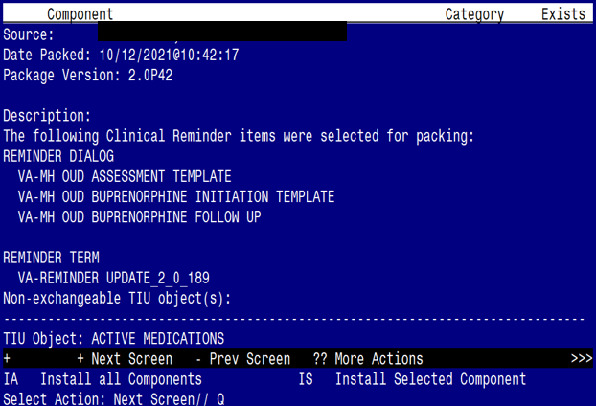

**Type Q to exit the installation**

# Post Installation

1. If you had any local items as Selection Items in the Health Summary Types that were Overwritten, you should add those back now. These should have been captured as part of the Pre-Install step.
2. Change the name of TIU title OPIOID USE DISORDER BUPRENORPHINE INITIATION to OUD/OPIOID DEPENDENCE BUPRENORPHINE INITIATION.
3. Change the name of TIU title OPIOID USE DISORDER ASSESSMENT to OUD/OPIOID DEPENDENCE ASSESSMENT.
4. Change the name of TIU title OPIOID DEPENDENCE/OUD BUPRENORPHINE FOLLOW UP to OUD/OPIOID DEPENDENCE BUPRENORPHINE FOLLOW UP
5. Add finding items/additional findings back to the following elements/groups from pre-install

* VAL-MH OUD ASSESS NALOXONE ORDERED
* VAL-MH OUD BUPE INITIATION MEDS 2 MG TABS
* VAL-MH OUD BUPE INITIATION MEDS 8 MG TABS
* VAL-MH OUD BUPE INITIATION MEDS 2 MG FILM
* VAL-MH OUD BUPE INITIATION MEDS 8 MG FILM
* VAL-MH OUD BUPE INITIATION MEDS 2 MG TABS DISCHARGE
* VAL-MH OUD BUPE INITIATION MEDS 8 MG TABS DISCHARGE
* VAL-MH OUD BUPE INITIATION MEDS 2 MG FILM DISCHARGE
* VAL-MH OUD BUPE INITIATION MEDS 8 MG FILM DISCHARGE
* VAL-MH OUD BUPE INITIATION WITHDRAWAL CLONIDINE
* VAL-MH OUD BUPE INITIATION WITHDRAWAL ACETAMINOPHEN
* VAL-MH OUD BUPE INITIATION WITHDRAWAL ONDANSETRON
* VAL-MH OUD BUPE INITIATION WITHDRAWAL LOPERAMIDE
* VAL-MH OUD BUPE INITIATION ORDER LABS CBC
* VAL-MH OUD BUPE INITIATION ORDER LABS BMP
* VAL-MH OUD BUPE INITIATION ORDER LABS HEPATITIS A
* VAL-MH OUD BUPE INITIATION ORDER LABS HEPATITIS B
* VAL-MH OUD BUPE INITIATION ORDER LABS HEPATITIS C
* VAL-MH OUD BUPE INITIATION ORDER LABS LFT
* VAL-MH OUD BUPE INITIATION ORDER LABS HIV-GP
* VAL-MH OUD BUPE INITIATION ORDER LABS UDAS
* VAL-MH OUD BUPE INITIATION ORDER LABS HCG
* VAL-MH OUD ASSESS2 PLAN OFFER MAT CARE ACCEPTS UDAS ORDERED
* VAL-MH OUD FOLLOW UP MEDS 2MG FILM DISCHARGE
* VAL-MH OUD BUPE FOLLOW UP MEDS 2 MG TABS DISCHARGE
* VAL-MH OUD BUPE FOLLOW UP MEDS 8 MG FILM DISCHARGE
* VAL-MH OUD BUPE FOLLOW UP MEDS 8 MG TABS DISCHARGE
* VAL-MH OUD BUPE FOLLOW UP MEDS SUBLOCADE (IF SITES HAVE ENABLED)
* VAL-MH OUD BUPE FOLLOW UP MEDS SUBLOCADE DISCHARGE (IF SITES HAVE ENABLED)
* VAL-MH OUD BUPE FOLLOW UP ORDER LABS HCG
* VAL-MH OUD BUPE FOLLOW UP REFER ADDICTIONS
* VAL-MH OUD BUPE FOLLOW UP REFER MENTAL HEALTH

Install complete.