

**Update_2_0_194**

Clinical Reminders

VA-COVID-19 CPRS STATUS VERSION 6

Install Guide

**April 2021**

Product Development

Office of Information Technology

Department of Veterans Affairs

**Table of Contents**

Introduction 1

Install Details 4

Install Example 5

Post Installation 9

# Introduction

Description: Banner Version 6 changes

1. **Resolved Clinically takes precedence**: in v5, if patient had an indicator of “Resolved Clinically” and their positive PCR test was over 14 days old, the banner would display as “Prior Positive”. Any prior positive PCR over 14 days old would cause the banner to display as “Prior Positive” unless a new positive test was entered.

With V6, the entry of a health factor indicating “Resolved Clinically” will take precedence unless there is a new positive PCR that is more than 60 days after an entry of “Resolved Clinically”. An entry of “Resolved Clinically” will affect the banner display permanently for any patient who has a prior positive PCR unless there is a new PCR positive that is more than 60 days after the “Resolved Clinically”.

If there is no entry of “Resolved Clinically”, then the banner will continue to use the “Prior Positive” display after 14 days.

If an entry of ‘Resolved Clinically’ is present, it will continue to display into the future instead of reverting to ‘Prior Positive’.

Screen shot of the yellow COVID banner saying Resolved Clinically and a date and then Positive Test date is also displayed.  Resolved Clinically is a health factor that leads to the replacement of Prior Positive.

In this example, the patient had a positive PCR in March 2020 and then it was entered that they were ‘Resolved Clinically’. After that entry, the patient tested positive again by PCR on 5/11/20. The ‘Resolved Clinically’ is what is displayed since the new positive is still within 60 days of the entry of clinical resolution of illness.

Screen shot showing the banner for a patient that has a Health Factor for Resolved Clinically but then test positive again.  In this case Resolved Clinically and the date of that health factor is displayed but the Positive Test date displayed is the most recent.

Then the patient is re-infected and tests positive in July 2020. The banner would have displayed for 2 weeks as ‘POSITIVE’. If no other entries are made after that new positive, then the banner looks like this 14 days after the positive test.

Screen shot showing that unless there is a Resolved Clinically health Factor, the Prior Positive will be displayed with the date of the test result. In the screen shot banner, the date of the test says Outside Test with a date.

This status could be updated to ‘Resolved Clinically’ at any time with entry of that health factor even many months later.

1. **A positive Antigen test will display**:

If there is a positive antigen test and it is the most recent test and there is no more recent indication of " Resolved Clinically", the positive antigen test will display in the banner.

There are 4 possible options for display - the first 3 display if the positive antigen test was done in the past 14 days:

a. Antigen Test Positive

b. Antigen Test Positive PCR test collected, results pending:

c. Antigen Test Positive PCR test pending collection:

d. Prior Antigen Test Positive

Once the PCR is resulted, then that is what will display instead of the Ag test.

A positive antigen test will display instead of "Resolved Clinically" until a new "Resolved Clinically" is entered or a PCR is resulted.

Example of (a)

Screen shot showing the test will say POSITIVE Antigen Test with a date until the PCR test is completed.  

If a PCR is pending and not received in the lab – as in c. above.

Screen shot showing that if there is a POSITIVE Antigen and a PCR test was collected, both will be displayed with the associate date.

1. A negative Antigen or Negative self-reported outside COVID-19 PCR will display as “testing Completed – see details” instead of “Not tested”.
   1. The results will show when you click on the banner to see the detailed information.

Banner showing the testing was done outside, the banner will say Test Completed - see details.  Details can be seen by double clicking on the banner.

1. **The detailed display text has been expanded** to include:
   1. A section for COVID-19 immunizations
   2. A section for site specified orderable items that can be used for orders for isolation/precautions or for other COVID-19 related orderable items that a site wants to display in the details. Only pending or active orders will display and there is a limit of 6. This is optional.

The description of COVID-19 RESOLVED in the COVID-19 STATUS ADJUSTMENT template was also updated:

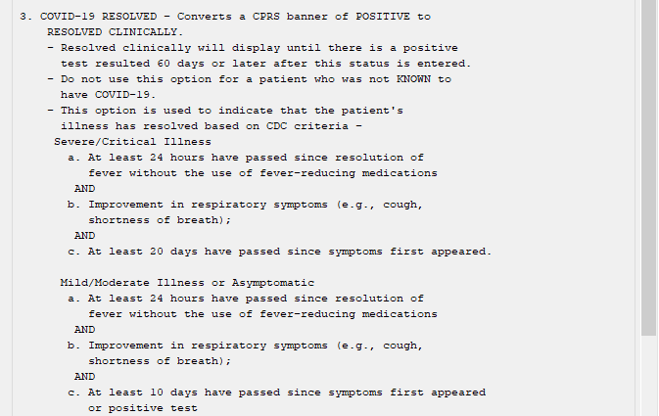

**UPDATE_2_0_194 contains 1 Reminder Exchange entry:**

UPDATE_2_0_194 VA-COVID-19 CPRS STATUS VERSION 6

**The exchange file contains the following components:**

**HEALTH FACTORS**

VA-REMINDER UPDATES

VA-UPDATE_2_0_194

VA-COVID-19

VA-COVID-19 NO LONGER SUSPECTED

VA-COVID-19 INCORRECT PRIOR POSITIVE PCR

VA-COVID-19 RESOLVED

VA-COVID-19 SUSPECTED

VA-COVID-19 UNK OUTSIDE LAB TEST NEG

VA-COVID-19 UNK OUTSIDE LAB TEST POS

VA-COVID-19 NON PCR AG LAB OUTSIDE NEG

VA-COVID-19 NON PCR AG LAB OUTSIDE POS

VA-COVID-19 OUTSIDE PCR SPEC COLLECTED

VA-COVID-19 PCR LAB OUTSIDE NEGATIVE

VA-COVID-19 PCR LAB OUTSIDE POSITIVE

VA-COVID-19 LAB OUTSIDE POSITIVE

**REMINDER SPONSOR**

NATIONAL CENTER FOR HEALTH PROMOTION AND DISEASE PREVENTION (NCP)

**REMINDER TAXONOMY**

VA-COVID-19 SNOMED CODES

**REMINDER TERM**

VA-REMINDER UPDATE_2_0_194

VA-COVID-19 AG LAB RESULTS POSITIVE HF

VA-COVID-19 AG LAB RESULTS POSITIVE

VA-COVID-19 RELATED ORDERABLE ITEMS FOR BANNER DISPLAY

VA-SARS-COV-2 VACCINES

VA-COVID-19 PROB LIST DX

VA-COVID-19 PCR LAB ORDERS

VA-COVID-19 CLINICAL INFO

VA-COVID-19 OUTSIDE RESULTS

VA-COVID-19 PRESUMED

VA-COVID-19 ANTIBODY LAB TEST

VA-COVID-19 PCR/AG LAB RESULTS

VA-COVID-19 NO LONGER PRESUMED

VA-COVID-19 INCORRECT PRIOR POSITIVE PCR RESULT

VA-COVID-19 PCR LAB RESULTS POSITIVE

VA-COVID-19 OUTSIDE PCR LAB POSITIVE

VA-COVID-19 OUTSIDE PCR SPECIMEN COLLECTED

VA-COVID-19 RECOVERED

VA-COVID-19 OUTSIDE PCR LAB NEGATIVE

VA-COVID-19 PCR LAB RESULTS NEGATIVE

**REMINDER DEFINITION**

VA-COVID-19 CPRS STATUS

**REMINDER DIALOG**

VA-GP COVID-19 STATUS V6

# Install Details

This update is being distributed as a web host file. The address for the host file is:

**https://REDACTED /UPDATE_2_0_194.PRD**

The file will be installed using Reminder Exchange, programmer access is not required.

Installation:

=============

This update can be loaded with users on the system. Installation will take less than 5 minutes.

# Pre-Install

Using the Vista menu, Reminder Term management, Term Inquiry, inquire and save the following reminder terms for reference post install. If you follow the install guide closely, your mapping should be preserved.

1. VA-COVID-19 PCR LAB RESULTS NEGATIVE
2. VA-COVID-19 PCR LAB RESULTS POSITIVE
3. VA-COVID-19 PCR LAB ORDERS
4. VA-COVID-19 PCR/AG LAB RESULTS
5. VA-COVID-19 ANTIBODY LAB TEST

# Install Example

To Load the Web Host File. Navigate to Reminder exchange in VistA

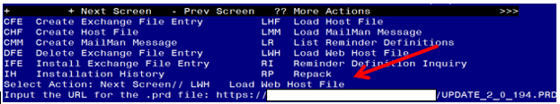

At the **Select Action:** prompt, enter **LWH** for Load Web Host File

At the **Input the url for the .prd file:** prompt, type the following web address:

**https://REDACTED /UPDATE_2_0_194.PRD**

You should see a message at the top of your screen that the file successfully loaded.

Terminal window screen shot of the message displaying the URL of the file that was successfully loaded.  Part of the URL has been redacted as it is a VA only internal web site URL.

Search for and locate the reminder exchange entry titled UPDATE_2_0_194 VA-COVID-19 CPRS STATUS VERSION 6.

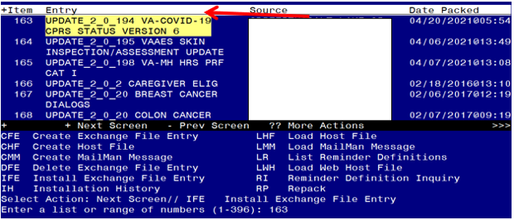

At the **Select Action** prompt, enter **IFE** for Install Exchange File Entry

Enter the number that corresponds with your entry titled **UPDATE_2_0_194 VA-COVID-19 CPRS STATUS VERSION 6**  *(in this example it is entry 163, it will vary by site)* The date on the exchange file should be 04/20/2021.

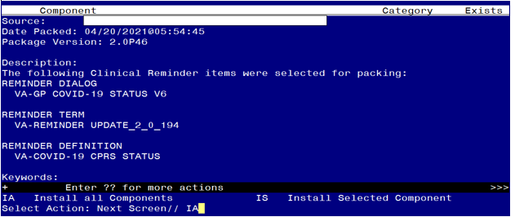

At the **Select Action** prompt, type **IA** for Install all Components and hit enter.

Select Action: Next Screen// IA Install all Components

During the installation, you will see several prompts:

Install all new components

MERGE any existing REMINDER TERM components that you are prompted to overwrite with one exception, for this term VA-COVID-19 OUTSIDE PCR LAB POSITIVE you should overwrite

REMINDER TERM entry named **VA-COVID-19 OUTSIDE PCR LAB POSITIVE**

already exists but the packed component is different, what do you

want to do?

Select one of the following:

C Create a new entry by copying to a new name

M Merge findings

O Overwrite the current entry

U Update

Q Quit the install

S Skip, do not install this entry

Enter response: O// verwrite the current entry

Are you sure you want to overwrite? N// Y

OVERWRITE the reminder definition component

*\*\*\*Note: if you are installing in your TEST account, the immunization file may not have the COVID-19 immunization entries and you will get prompted to replace those finding items, you can replace them in your TEST account with any other immunization.*

**You will be prompted to install the reminder dialog component – You will choose to install all even though some components may have an X to indicate that they exist.**

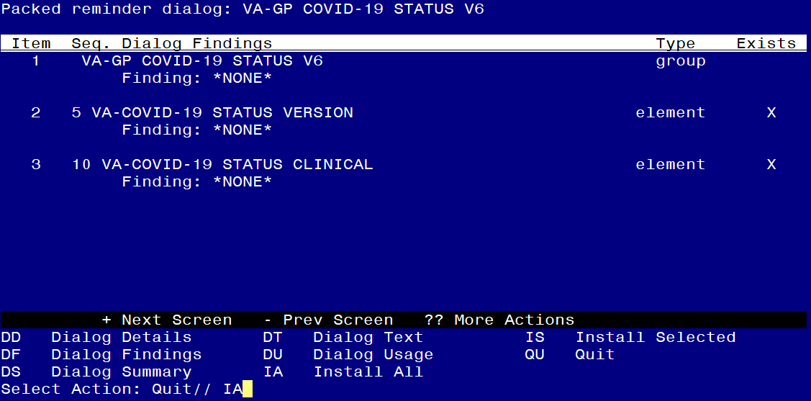

At the **Select Action** prompt, type **IA** to install the dialog – **VA-GP COVID-19 STATUS V6**

Select Action: Next Screen// IA Install All

Install reminder dialog and all components with no further changes: Y// Yes

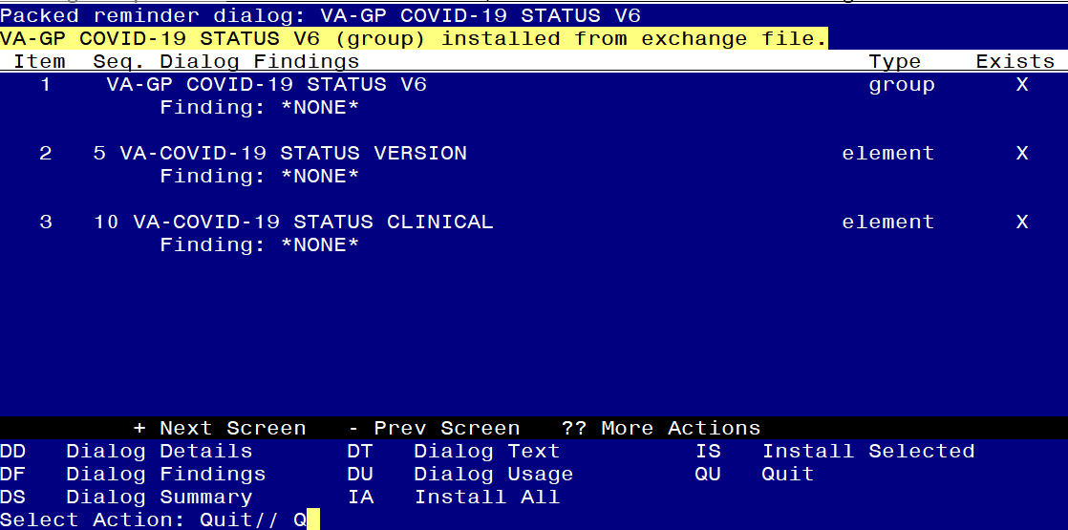

After completing this dialog install, you will type Q.

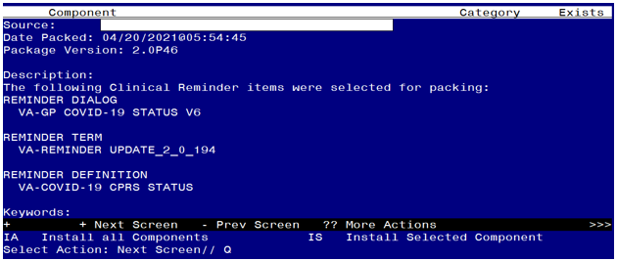

You will be returned to this screen. Type Q to quit.

Install Completed

# Post Installation

Review the following terms from the pre-install and edit to add your local items if needed, if you chose to merge instead of overwrite during the installation, no changes should be needed:

1. **VA-COVID-19 PCR LAB RESULTS NEGATIVE**

This term should only contain lab test (LT) findings for COVID-19 PCR lab tests

1. **VA-COVID-19 PCR LAB RESULTS POSITIVE**

This term should only contain lab test (LT) findings for COVID-19 PCR lab tests

1. **VA-COVID-19 PCR LAB ORDERS**

This term should only contain orderable items (OI) findings for COVID-19 PCR lab test orderable items

1. **VA-COVID-19 PCR/AG LAB RESULTS**

This term should only contain lab test (LT) findings for COVID-19 PCR and COVID-19 Antigen lab tests

1. **VA-COVID-19 ANTIBODY LAB TEST**

This term should only contain lab test (LT) findings for COVID-19 ANTIBODY Tests

There are two new reminder terms that can be mapped

1. **VA-COVID-19 AG LAB RESULTS POSITIVE**

Add your local lab test (LT) findings for COVID-19 antigen tests

1. **VA-COVID-19 RELATED ORDERABLE ITEMS FOR BANNER DISPLAY**

This term is optional for use.

Any orderable item added to this term will display in the detailed display of the CPRS banner.  This can be used for active and pending orders for infection control precautions by adding the orderable items for those precautions that a site decides to display in the details of the banner click event.

If a site needs to use this to display prior orders for monoclonal antibody treatment, then you may need to set a time period in the begin date such as T-90D and add other statuses for those orderable items (expired, active, pending, etc).

Do not add drug findings to this term - the CSUB object is set for orderable items only.