

**Update _2_0_197**

Clinical Reminders

VA-AES NON-VENTILATOR ORAL CARE UPDATE

Install Guide

**April 2021**

Product Development

Office of Information Technology

Department of Veterans Affairs

Table of Contents

Introduction 1

Install Details 5

Install Example 5

Post Installation 10

# Introduction

The release contains the new reminder dialog VA-AES NON-VENTILATOR ORAL CARE TEMPLATE and miscellaneous updates to the VA-AES ACUTE INPATIENT NSG ADMISSION SCREEN.

**VA-AES ACUTE INPATIENT NSG ADMISSION SCREEN - Updated**

This update will provide the following updates within the VA-AES ACUTE INPATIENT NSG ADMISSION SCREEN:

* Branching logic of C-SSRS changed from suppressing the C-SSRS if completed “today” to suppressing if completed within the past 24 hours.
* Removed the national health factors used within the outpatient tobacco reminder and replaces them with unique health factors with the VA-VAAES name spacing.

**VA-AES NON-VENTILATOR ORAL CARE TEMPLATE - New**

The new VA-AES NON-VENTILATOR ORAL CARE TEMPLATE will replace the VA-ORAL CARE TEMPLATE released nationally in 2018. The VA-ORAL CARE TEMPLATE will be disabled and will need to be replaced with the new VA-AES NON-VENTILATOR ORAL CARE TEMPLATE. The new template is intended for use for inpatients in the medical/surgical care setting.  It may be utilized in other areas but is not mandated.  The content is also embedded (and will be updated with installation) within the Shift Assessment template as well as the Frequent Documentation templates that are already connected to the VAAES ACUTE INPATIEN NSG SHIFT ASSESSMENT note title and the VAAES NURSING FREQUENT DOCUMENTATION note title.  No additional note titles are required. Sites may choose to use as a shared template and/or embed within existing local templates or attach to a progress note title for use in other areas outside of medical/surgical settings.

Health factors are included and will be collected for nurse sensitive indicators and to determine if there is a correlation between hospital acquired pneumonia (HAP) and oral care.  Prevention of 100 cases of non-ventilated HAP provides a direct health care cost avoidance estimate of $4 million and saves the lives of over 20 Veterans. The VA-AES NON-VENTILATOR ORAL CARE TEMPLATE is sponsored by the Office of Nursing Service.

For questions, contact REDACTED

For more information, visit HAPPEN: [**H**ospital](https://dvagov.sharepoint.com/sites/vhanursing/HAPPEN) [**A**cquired **P**neumonia **P**revention by **E**ngaging **N**urses](https://dvagov.sharepoint.com/sites/vhanursing/HAPPEN) [(HAPPEN)](https://dvagov.sharepoint.com/sites/vhanursing/HAPPEN)

UPDATE_2_0_197 contains 1 Reminder Exchange entry:

**UPDATE_2_0_197 VA-AES NON-VENTILATOR ORAL CARE UPDATE**

**The exchange file contains the following components:**

**ROUTINE**

PXRMCDEF

PXRMDATE

**MH TESTS AND SURVEYS**

C-SSRS

**TIU TEMPLATE FIELD**

VA-GEN WORD PROCESSING

VA-TOBACCO EDUCATION

**HEALTH FACTORS**

VA-REMINDER UPDATES

VA-UPDATE_2_0_197

VA-ORAL CARE

VA-ORAL CARE REFUSED

VA-ORAL CARE EDUCATION PROVIDED

VA-ORAL CARE DENTURES/PARTIAL PLATES-NO

VA-ORAL CARE ASSIST DENTURE/PARTIAL-NO

VA-ORAL CARE ASSIST DENTURE/PARTIAL-YES

VA-ORAL CARE OBS DENTURES/PARTIAL-NO

VA-ORAL CARE OBS DENTURES/PARTIAL-YES

VA-ORAL CARE DENTURES/PARTIAL-YES

VA-ORAL CARE ASSISTED BRUSHING-NO

VA-ORAL CARE ASSISTED BRUSHING 3

VA-ORAL CARE ASSISTED BRUSHING 2

VA-ORAL CARE ASSISTED BRUSHING 1

VA-VAAES ORAL CARE

VA-ORAL CARE OBSERVED BRUSHING-NO

VA-ORAL CARE OBSERVED BRUSHING 3

VA-ORAL CARE OBSERVED BRUSHING 2

VA-ORAL CARE OBSERVED BRUSHING 1

VA-ORAL CARE OTHER SHIFT

VA-ORAL CARE NIGHT SHIFT

VA-ORAL CARE EVENING SHIFT

VA-ORAL CARE DAY SHIFT

VA-VAAES OC BRUSH TEETH SWABBING PERFORM

VA-VAAES ORAL CARE COMMENT

VA-VAAES ORAL CARE EDUCATION PROVIDED

VA-VAAES OC DENT/PART CLEAN DECLINED

VA-VAAES OC DENT/PART CLEAN WITH ASST

VA-VAAES OC DENT/PART CLEAN INDEP

VA-VAAES OC BRUSH TEETH DECLINED

VA-VAAES OC BRUSH TEETH WITH ASSIST

VA-VAAES OC BRUSH TEETH INDEP

VA-VAAES ORAL CARE NON-VENT PATIENT

VA-VAAES ORAL CARE MUCOSITIS FUN/SYMP 5

VA-VAAES ORAL CARE MUCOSITIS FUN/SYMP 4

VA-VAAES ORAL CARE MUCOSITIS FUN/SYMP 3

VA-VAAES ORAL CARE MUCOSITIS FUN/SYMP 2

VA-VAAES ORAL CARE MUCOSITIS FUN/SYMP 1

VA-VAAES ORAL CARE MUCOSITIS CLIN GRAD 5

VA-VAAES ORAL CARE MUCOSITIS CLIN GRAD 4

VA-VAAES ORAL CARE MUCOSITIS CLIN GRAD 3

VA-VAAES ORAL CARE MUCOSITIS CLIN GRAD 2

VA-VAAES ORAL CARE MUCOSITIS CLIN GRAD 1

VA-VAAES ORAL CARE MUCOSITIS SCALE

VA-VAAES RESP

VA-VAAES RESP SUP VB OCM TEETH CHLOR

VA-VAAES RESP SUP VB OCM ROUT ORAL

VA-VAAES RESP SUP VB OCM DEN CARE

VA-VAAES RESP SUP VB OCM TEETH BRUSH

VA-VAAES RESP SUP VB OCM ORAL SUC

VA-VAAES RESP SUP VB OCM DEEP SUC

VA-VAAES RESP SUP VB OC CONTRA

VA-VAAES RESP SUP VB OC NO

VA-VAAES RESP SUP VB OC YES

VA-VAAES ORAL CARE VENT PATIENT

VA-SUICIDE RISK EVALUATION TYPE [C]

VA-SUICIDE RISK UPDATE EVALUATION

VA-SUICIDE RISK NEW EVALUATION

VA-VAAES SUICIDE

VA-VAAES SUICIDE CSSRS ENV CHECK

VA-VAAES SUICIDE CSSRS 1:1

VA-VAAES SUICIDE CSSRS WARM HAND OFF

VA-VAAES SUICIDE SCREEN

VA-VAAES RISK

VA-VAAES RISK TOB-RN NOT SCREENED

VA-VAAES TOBACCO USE DECLINED TO ANSWER

VA-VAAES TOBACCO NEVER USED

VA-VAAES TOBACCO FORMER USER

VA-VAAES RISK TOB-ED PROV

VA-VAAES RISK TOB-RN ED REFERRAL

VA-VAAES RISK TOB-RN ED COMPLETE

VA-VAAES RISK TOB-RN ED DECLINED

VA-VAAES RISK TOB-RN ED NOW

VA-VAAES TOBACCO USE CURRENT NRT ACCEPT

VA-VAAES TOBACCO USE CURRENT NRT DECLINE

VA-VAAES RISK TOB-RN TYPE

VA-VAAES TOBACCO USER SOME DAYS

VA-VAAES TOBACCO USER EVERY DAY

VA-VAAES NON VENT ORAL CARE 3.2

**REMINDER SPONSOR**

OFFICE OF NURSING SERVICE

**REMINDER COMPUTED FINDINGS**

VA-REMINDER DEFINITION

VA-FILEMAN DATE

**REMINDER TERM**

VA-REMINDER UPDATE_2_0_197

VA-C-SSRS DONE TODAY POSITIVE QUESTION 8

VA-C-SSRS DONE TODAY POSITIVE QUESTION 5

VA-C-SSRS DONE TODAY POSITIVE QUESTION 4

VA-C-SSRS DONE TODAY POSITIVE QUESTION 3

VA-BL C-SSRS DONE TODAY POSITIVE

VA-BL NSG C-SSRS DONE WITHIN 24HRS

**REMINDER DEFINITION**

VA-BL C-SSRS DONE TODAY POSITIVE

VA-BL NSG C-SSRS DONE WITHIN 24H

**HEALTH SUMMARY COMPONENT**

PCE HEALTH FACTORS SELECTED

**HEALTH SUMMARY TYPE**

VA-CSRE DONE TODAY

**HEALTH SUMMARY OBJECTS**

VA-CSRE DONE TODAY (TIU)

**TIU DOCUMENT DEFINTION**

VA-CSRE DONE TODAY

**REMINDER DIALOG**

VA-ORAL CARE TEMPLATE

VA-GP AES UPDATE MARCH 2021

VA-AES NON-VENTILATOR ORAL CARE TEMPLATE

# Install Details

This update is being distributed as a web host file. The address for the host file is: **https://REDACTED /UPDATE_2_0_197.PRD**

The file will be installed using Reminder Exchange, programmer access is not required.

Installation:

=============

This update can be loaded with users on the system. Installation will take less than 15 minutes.

# Install Example

To Load the Web Host File. Navigate to Reminder exchange in Vista

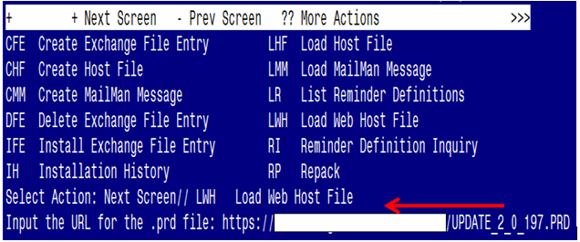

At the **Select Action:** prompt, enter **LWH** for Load Web Host File

At the **Input the url for the .prd file:** prompt, type the following web address:

[**https://Redacted/UPDATE_2_0_197.PRD**](https://Redacted/UPDATE_2_0_197.PRD)

You should see a message at the top of your screen that the file successfully loaded.

Terminal window screen shot of the message displaying the URL of the file that was successfully loaded.  Part of the URL has been redacted as it is a VA only internal web site URL.

Search and l

ocate an entry titled **UPDATE_2_0_197 VA-AES NON-VENTILATOR ORAL CARE UPDATE** in reminder exchange.

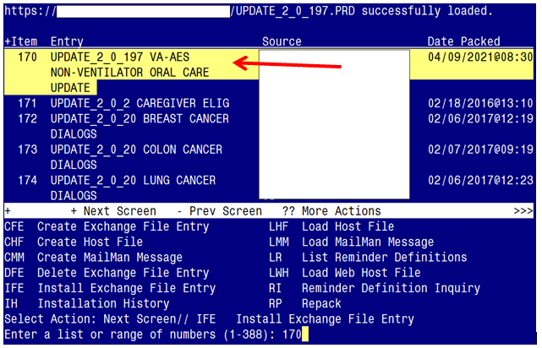

At the **Select Action** prompt, enter **IFE** for Install Exchange File Entry

Enter the number that corresponds with your entry UPDATE_2_0_197 VA-AES NON-VENTILATED ORAL CARE *(in this example it is entry 170. It will vary by site).* The date of the exchange file should be 04/09/2021@08:30.

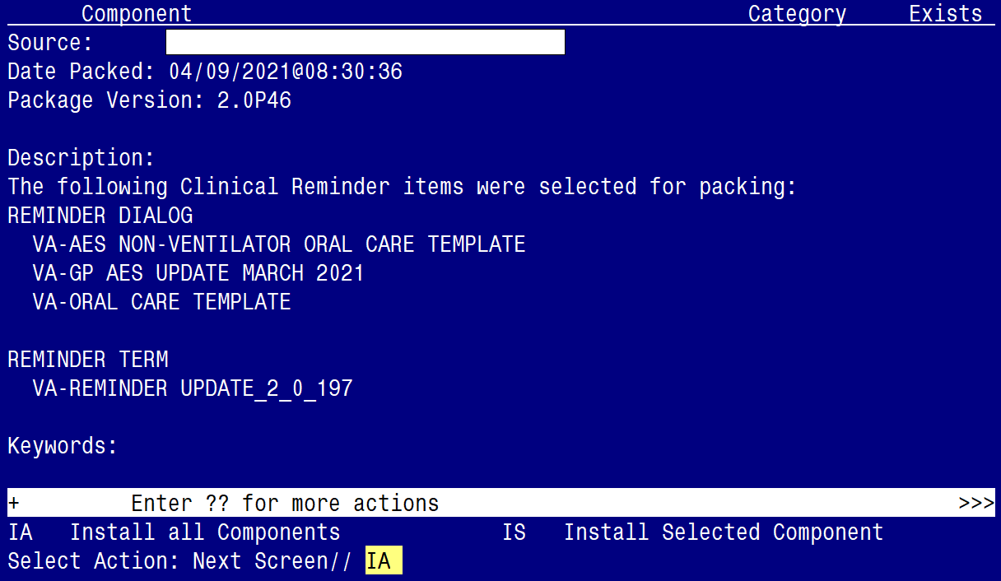

At the **Select Action** prompt, type **IA** for Install all Components and hit enter.

Select Action: Next Screen// IA Install all Components

You will see several prompts, for all new entries you will choose **I to Install**

For components that already exists but the packed component is different, choose **S to Skip.**

**You will be promped to install the 1st reminder dialog component (VA-ORAL CARE TEMPLATE).** You will choose to install all even though some components may have an X to indicate that they exist.

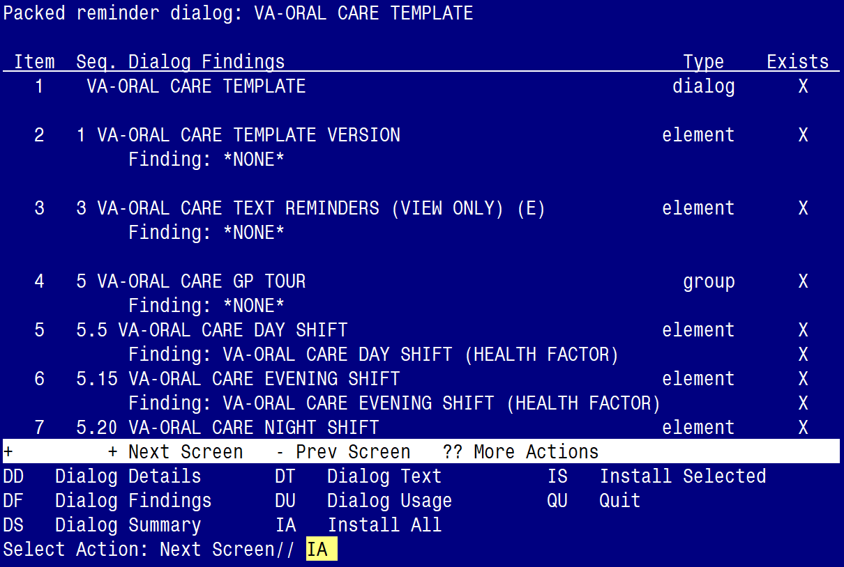

At the **Select Action** prompt, type **IA** to install the dialog:

**VA-ORAL CARE TEMPLATE**

Select Action: Next Screen// IA Install All

Install reminder dialog and all components with no further changes: Y// Yes

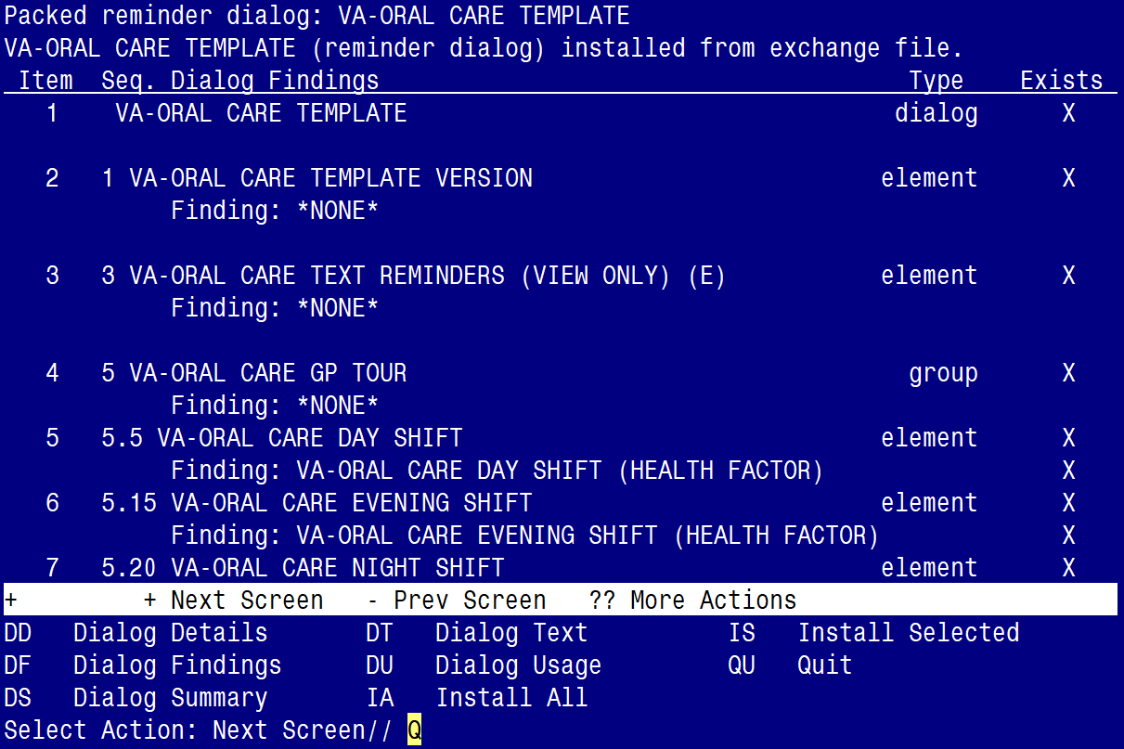

After completing this dialog install, you will type Q.

**You will be promped to install the 2nd reminder dialog component (VA-GP AES UPDATE MARCH 2021).** You will choose to install all even though some components may have an X to indicate that they exist.

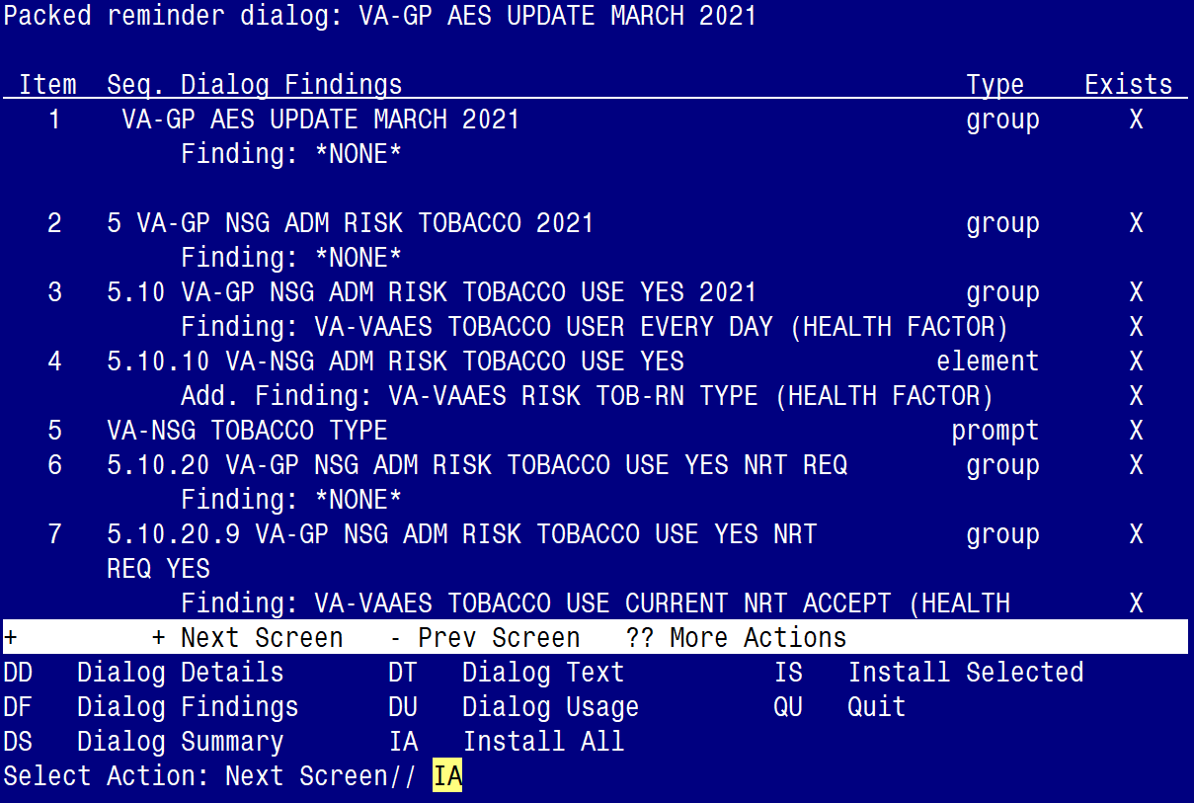

At the **Select Action** prompt, type **IA** to install the dialog:

**VA-AES UPDATE MARCH 2021**

Select Action: Next Screen// IA Install All

Install reminder dialog and all components with no further changes: Y// Yes

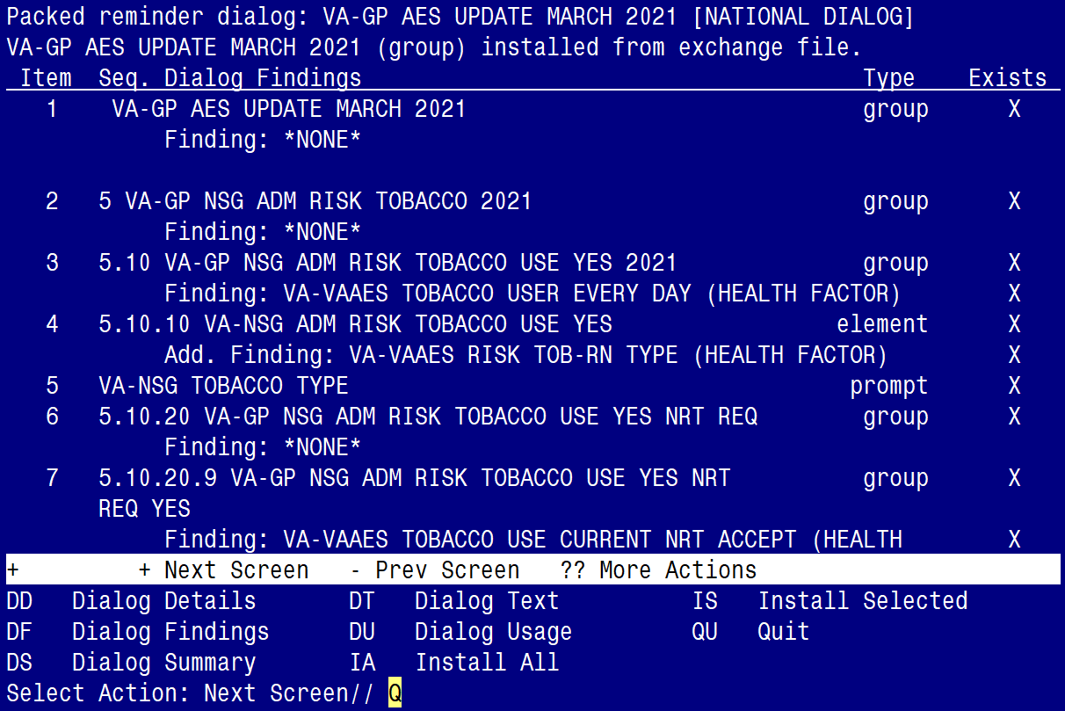

After completing this dialog install, you will type Q.

**You will be promped to install the 3rd reminder dialog component (VA-AES NON-VENTILATOR ORAL CARE TEMPLATE).** You will choose to install all even though some components may have an X to indicate that they exist.

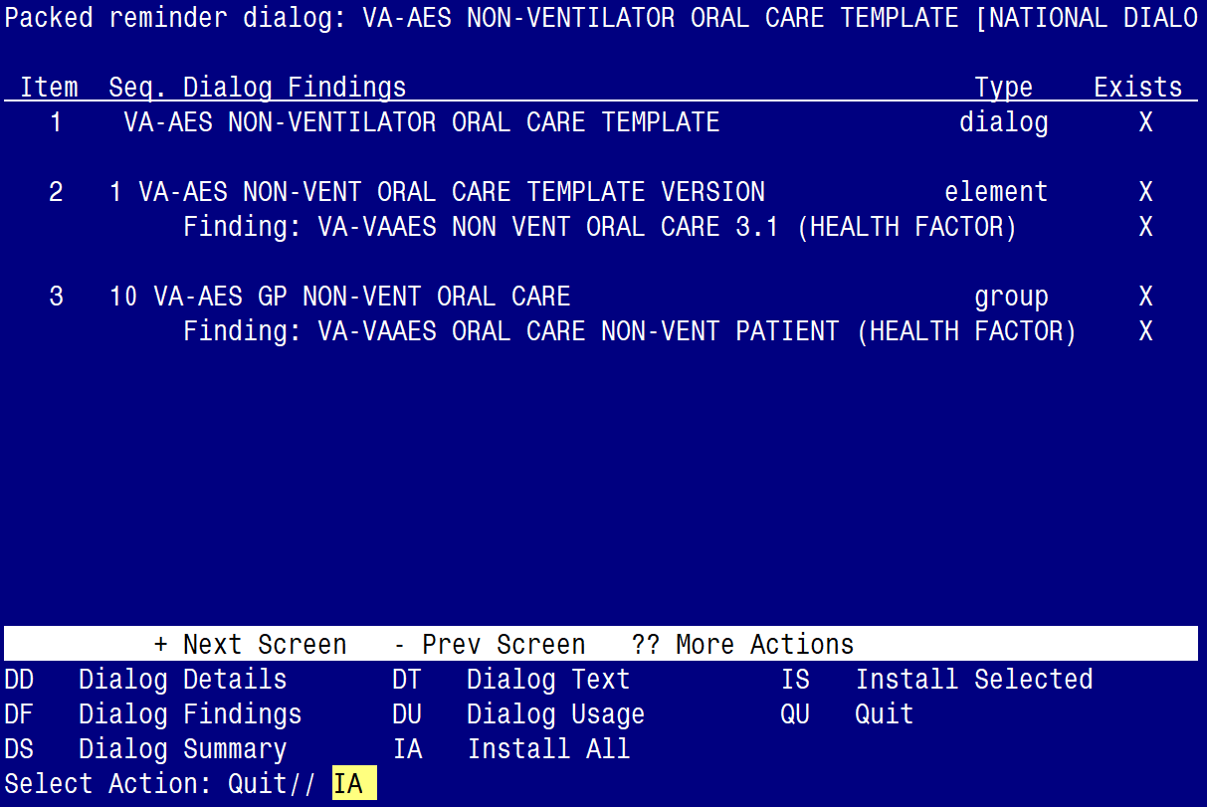

At the **Select Action** prompt, type **IA** to install the dialog:

**VA-AES NON-VENTILATOR ORAL CARE TEMPLATE**

Select Action: Next Screen// IA Install All

Install reminder dialog and all components with no further changes: Y// Yes

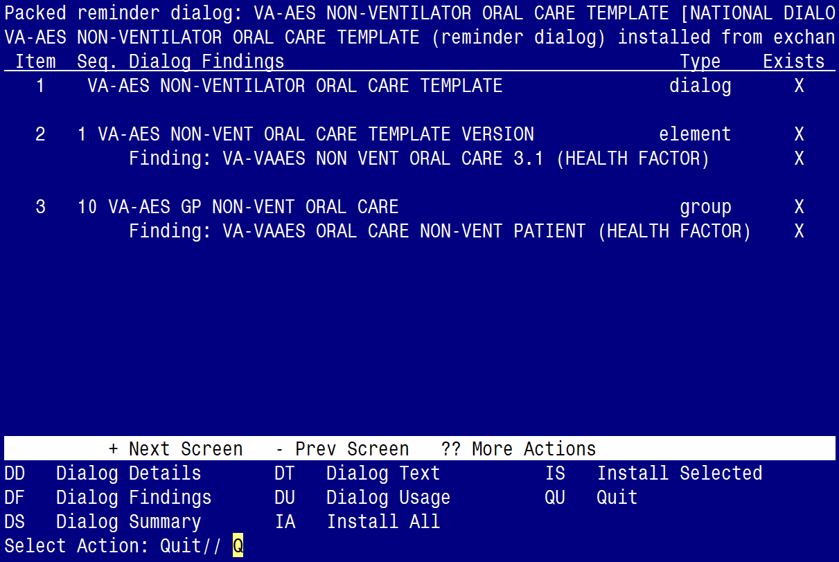

After completing this dialog install, you will type Q.

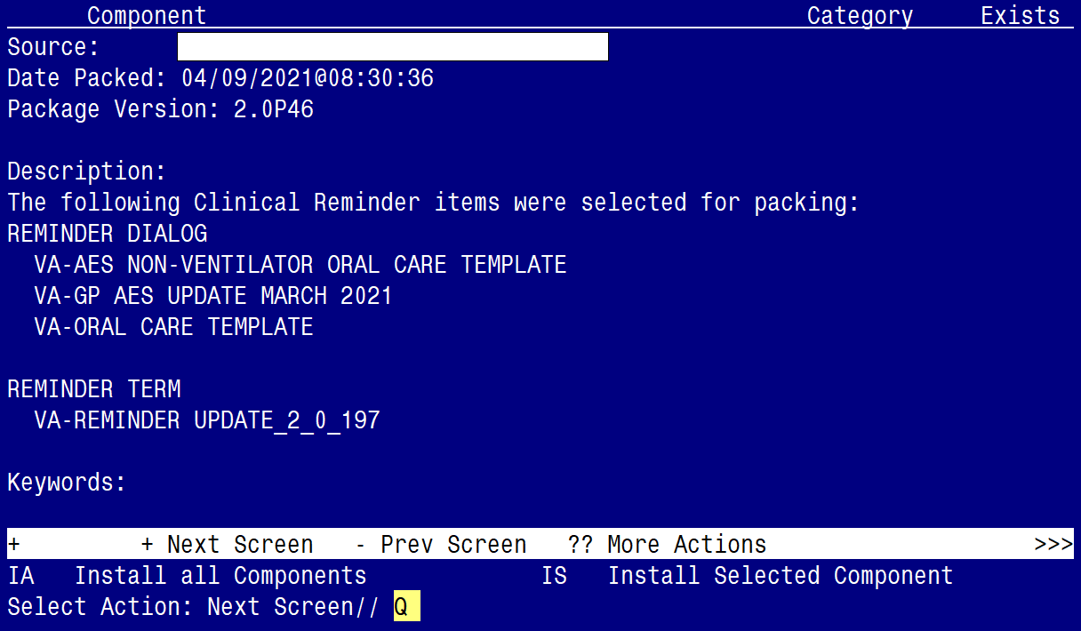

You will then be returned to this screen. At the **Select Action** prompt, type **Q.**

Install complete.

# Post Installation

1. **Make the Dialog able to be attached to a Personal/Shared template or to a progress note title.**

From the Reminders Manager Menu:

Select Reminder Managers Menu Option: **CP** CPRS Reminder Configuration

CA Add/Edit Reminder Categories

CL CPRS Lookup Categories

CS CPRS Cover Sheet Reminder List

MH Mental Health Dialogs Active

PN Progress Note Headers

RA Reminder GUI Resolution Active

TIU TIU Template Reminder Dialog Parameter

DL Default Outside Location

PT Position Reminder Text at Cursor

Select CPRS Reminder Configuration Option: **TIU** TIU Template Reminder Dialog Parameter

Reminder Dialogs allowed as Templates may be set for the following:

1 User USR [choose from NEW PERSON]

3 Service SRV [choose from SERVICE/SECTION]

4 Division DIV [choose from INSTITUTION]

5 System SYS [NATREM.FO-SLC.MED.VA.GOV]

Enter selection*:* 5  *Choose the appropriate number for your site. Your site may do this by System or other levels. The example below uses SYSTEM level*

Setting Reminder Dialogs allowed as Templates for System:

Select Display Sequence: **?**

148 VA-VETERANS CHOICE NOTE

149 VA-TBI SCREENING

*When you type a question mark above, you will see the list of #’s (with dialogs) that are already taken. Choose a number* ***NOT*** *on this list. For this example, looking above I see the number 150 is not present, so I will use 150.*

Select Display Sequence: **150**

Are you adding 150 as a new Display Sequence? Yes// **Y** YES

Display Sequence: 150// <Enter> 150

Clinical Reminder Dialog**: VA-AES NON-VENTILATOR ORAL CARE TEMPLATE**

then **<enter>** reminder dialog NATIONAL

OK? Yes// <Enter> (Yes)

1. **Associate the new reminder dialog with a shared template in CPRS**

To do this, go to Template Editor, then Shared Templates, select the appropriate folder (if applicable), and choose New Template (top right-hand corner).

Type in the following information:

Name: **VA-AES NON-VENTILATOR ORAL CARE TEMPLATE**

Template Type: Reminder Dialog

Reminder Dialog: **VA-AES NON-VENTILATOR ORAL CARE TEMPLATE**

Next, select Apply.

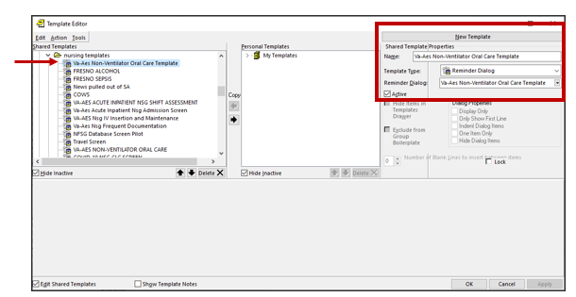

1. **Remove the disabled VA-ORAL CARE TEMPLATE from Shared Templates and/or attached progress note titles.** If you are unfamiliar with where VA-ORAL CARE TEMPLATE may be used, consider using the “Find Shared Template” option within the Template editor within CPRS. *Prior to using this option, PLEASE NOTE: This option will search by the name of the shared template and not the name of the associated reminder dialog. Therefore, you may want to use “Oral Care” in search. Also, please be aware it will take time to run this search as it searchers all of the shared templates.*

From the Template Editor, Click on action menu and select “Find Shared Templates”. Enter Oral Care and click Find

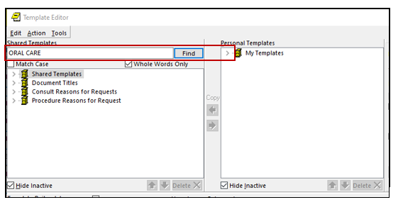

When a shared Template is found, verify that it is associated with the reminder dialog VA-ORAL CARE TEMPLATE. If VA-ORAL CARE TEMPLATE is associated, remove and associate with VA-AES NON-VENTILATOR ORAL CARE TEMPLATE. Click “Apply”.

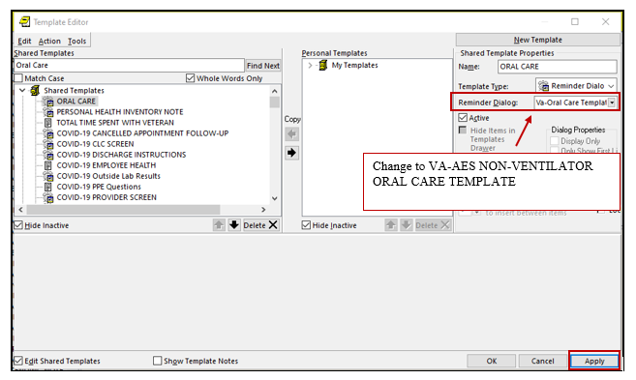

Click Find Next and repeat step above until all VA-ORAL CARE TEMPLATES have been found and replaced.

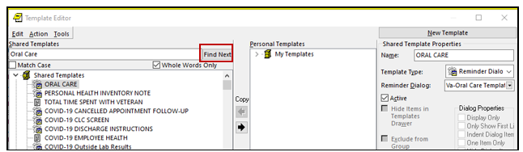

1. Perform a Reminder Dialog Search to determine if the dialog group called **VA-ORAL CARE GP TOUR** has been added as a sequence to any of your site’s local reminder dialogs. If found, replacedialog group **VA-ORAL CARE GP TOUR** with the new dialog group **VA-AES GP NON-VET ORAL CARE.**

To determine if the VA-ORAL CARE GP TOUR group resides within any of your site’s local templates, use the Reminder Dialog Search Report (SEA) option.

(Reminder Dialog Management 🡪Dialog Reports)

1. Select Reminder Dialog Management <TEST ACCOUNT> Option: ^sea   Reminder Dialog Search Report

Search for coding system? N// O

Search for Finding Item(s) used in dialog component(s)? N// O

Search for specific Reminder Dialog component(s)? N// y  YES

Select Dialog Definition: VA-ORAL CARE GP TOUR  dialog group     NATIONAL

...OK? Yes//   (Yes)

Select Dialog Definition:

Search for Reminder Dialog by CPRS parameter(s)? N// O

Display match criteria on the report? N// y  YES

Browse or Print? B// p  Print

DEVICE: HOME// ;;999  VIRTUAL TELNET

Clinical Reminders Dialogs search report.

Reminder Dialogs:

Dialog: NURSING-REHAB ADLS

Match Criteria:

Dialog : VA-ORAL CARE GP TOUR

1. For each local dialog found, replace the group titled VA-ORAL CARE GP TOUR with the group VA-AES GP NON-VET ORAL CARE.
2. Verify **Oral care for Non-ventilated patient selection** has been updated within the **VAAES Acute Inpatient Nsg Shift Assessment** and **VAAES Nursing Frequent Documentation** progress notes**.**

In the templates, click on Activites of Daily Living 🡪 Oral Care 🡪 Non-ventilated patient

