

**Update _2_0_198**

Clinical Reminders

VA-MH HRS PATIENT RECORD FLAG

Install Guide

**August 2021**

Product Development

Office of Information Technology

Department of Veterans Affairs

Table of Contents

Introduction 1

Install Details 2

Install Example 3

Post Installation 7

# Introduction

**Description:**

**THERE ARE TWO REMINDER DIALOGS INCLUDED IN THIS RELEASE.**

1. **VA-MH HRS PRF CATEGORY I - HIGH RISK FOR SUICIDE**

This dialog provides documentation options for placement, continuation, transfer, and inactivation of a Patient Record Flag (PRF) for High Risk for Suicide (HRS). HRS-PRF review should occur no later than every 90 days and documentation of all flag actions is required. Use of this template alone will not trigger flag actions. This template replaces existing templates and will be used by the Suicide Prevention Coordinators to document all flag actions, including enhanced documentation of clinical rationale for flag inactivation. Once populated, it also provides instructions to staff about how to manage veterans identified as high risk for suicide.

1. **VA-MH HRF PLACEMENT CONSULT**

This dialog that will be used by the suicide prevention coordinators at each site to complete a consult that will be entered when a new suicidal behavior is recorded in the Suicide Behavior and Overdose Report or Comprehensive Suicide Risk evaluation templates.

UPDATE_2_0_198 contains 1 Reminder Exchange entry:

**UPDATE_2_0_198 VA-MH HRS PATIENT RECORD FLAG**

**The exchange file contains the following components:**

**TIU TEMPLATE FIELD**

VA-WORDR

**HEALTH FACTORS**

VA-REMINDER UPDATES

VA-UPDATE_2_0_198

VA-HIGH RISK FOR SUICIDE

VA-HRS PRF ASSIGNED SPC

VA-HRS PRF CONTINUED

VA-HRS PRF ACTIVATED

VA-HRS PRF NEXT REVIEW DATE

VA-HRS PRF RECEIVING FACILITY

VA-HRS PRF TRANSFER DATE

VA-HRS PRF TRANSFERRING FACILITY

VA-HRS PRF TRANSFERRED

VA-HRS PRF CARING COMM NO DIED

VA-HRS PRF CARING COMM NO IFSM

VA-HRS PRF CARING COMM NO CORR

VA-HRS PRF CARING COMM YES

VA-HRS PRF STRESS

VA-HRS PRF COPING MEDICAL

VA-HRS PRF COPING MH

VA-HRS PRF COPING PD

VA-HRS PRF LETHAL MEANS NO

VA-HRS PRF MAINTAIN SAFETY

VA-HRS PRF SUICIDE PLAN NO

VA-HRS PRF SUICIDAL INTENT ADMIT NO

VA-HRS PRF INPAT NO

VA-HRS PRF RECENT SDV NO

VA-HRS PRF MH ENGAGE NO

VA-HRS PRF MH ENGAGE YES

VA-HRS PRF INACTIVATE CLIN REVIEW

VA-HRS PRF DECEASED

VA-HRS PRF IFSM SAFETY PLAN

VA-HRS PRF IFSM CARE COORD

VA-HRS PRF IFSM COMM REFERRAL

VA-HRS PRF INELIG FORMER SERV MEM

VA-HRS PRF INACTIVATED

VA-HRS PRF CONSULT

VA-HRS PRF CONSULT ACTIVATE FLAG NO

VA-HRS PRF CONSULT FLAG IN PLACE

VA-HRS PRF CONSULT ACTIVATE FLAG YES

**REMINDER SPONSOR**

Office of MH and Suicide Prevention

**REMINDER TERM**

VA-REMINDER UPDATE_2_0_198

**REMINDER DIALOG**

VA-MH HRS PRF CATEGORY I - HIGH RISK FOR SUICIDE

VA-MH HRF PLACEMENT CONSULT

# Install Details

This update is being distributed as a web host file. The address for the host file is: **https://REDACTED /UPDATE_2_0_198.PRD**

The file will be installed using Reminder Exchange, programmer access is not required.

Installation:

=============

This update can be loaded with users on the system. Installation will take less than 15 minutes.

# Install Example

To Load the Web Host File. Navigate to Reminder exchange in Vista

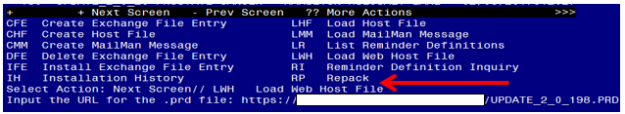

At the **Select Action:** prompt, enter **LWH** for Load Web Host File

At the **Input the url for the .prd file:** prompt, type the following web address:

**https://vaww.va.gov/reminders/docs/UPDATE_2_0_198.PRD**

You should see a message at the top of your screen that the file successfully loaded.

Terminal window screen shot of the message displaying the URL of the file that was successfully loaded.  Part of the URL has been redacted as it is a VA only internal web site URL.

Search and locate an entry titled **UPDATE_2_0_198 VA-MH HRS PATIENT RECORD FLAG** in reminder exchange.

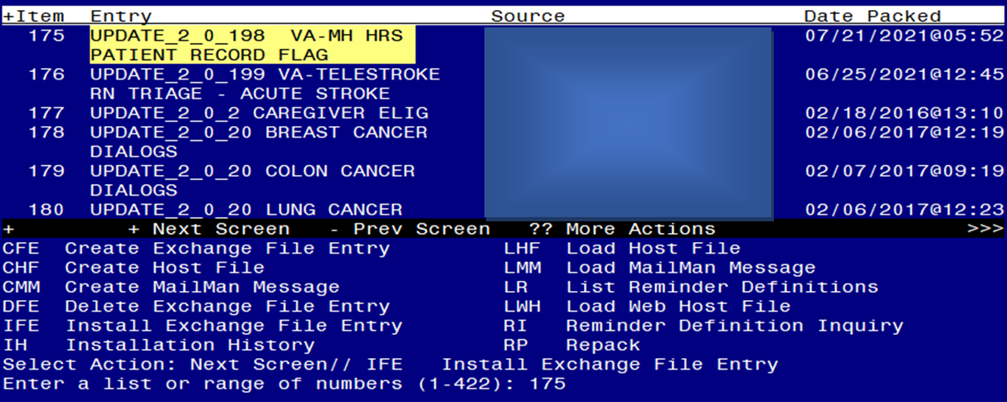

At the **Select Action** prompt, enter **IFE** for Install Exchange File Entry

Enter the number that corresponds with your entry UPDATE_2_0_198 VA-MH HRS PATIENT RECORD FLAG *(in this example it is entry 175. It will vary by site).* The date of the exchange file should be 07/21/2021.

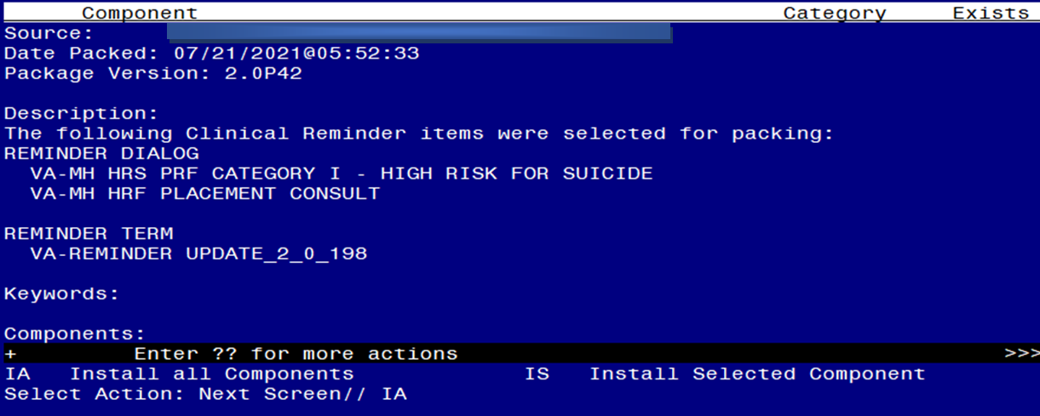

At the **Select Action** prompt, type **IA** for Install all Components and hit enter.

Select Action: Next Screen// IA Install all Components

You will see several prompts, for all new entries you will choose **I to Install**

For components that already exists but the packed component is different, choose **O to Overwrite.**

**You will be promped to install the FIRST reminder dialog component (VA-MH HRF PLACEMENT CONSULT).** You will choose to install all even though some components may have an X to indicate that they exist.

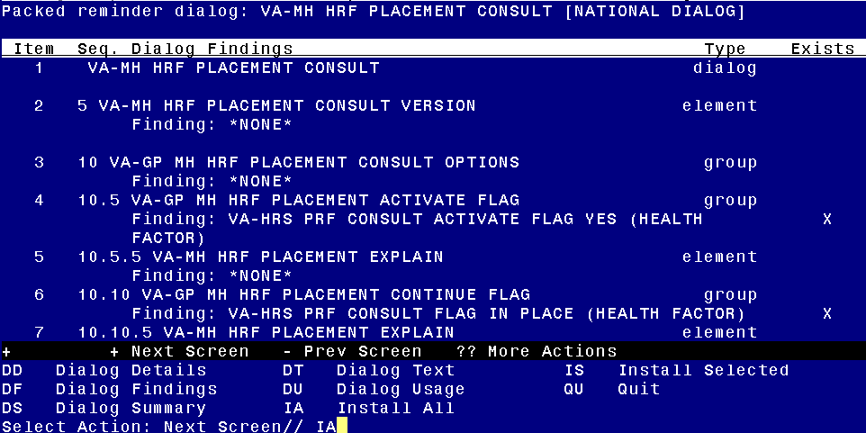

At the **Select Action** prompt, type **IA** to install the dialog: **VA-MH HRF PLACEMENT CONSULT**

Select Action: Next Screen// IA Install All

Install reminder dialog and all components with no further changes: Y// Yes

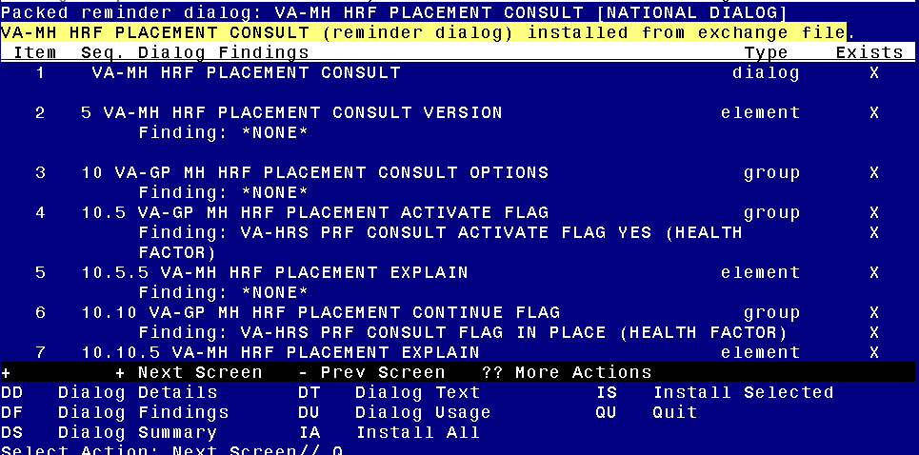

After completing this dialog install, you will type Q.

**You will be promped to install the NEXT reminder dialog component (VA-MH HRS PRF CATEGORY I - HIGH RISK FOR SUICIDE).** You will choose to install all even though some components may have an X to indicate that they exist.

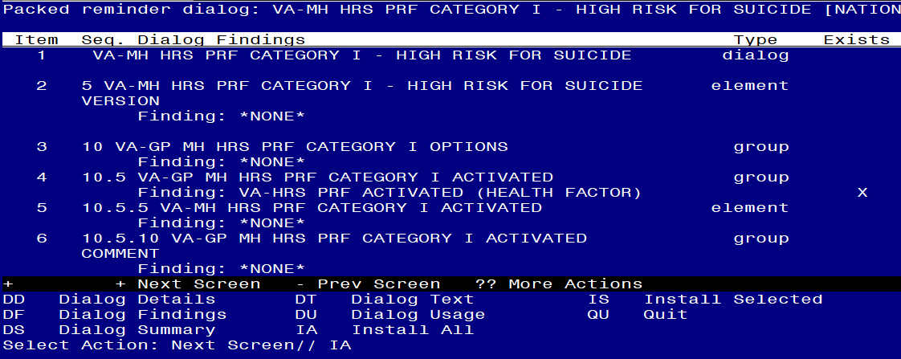

At the **Select Action** prompt, type **IA** to install the dialog: **VA-MH HRS PRF CATEGORY I - HIGH RISK FOR SUICIDE**

Select Action: Next Screen// IA Install All

Install reminder dialog and all components with no further changes: Y// Yes

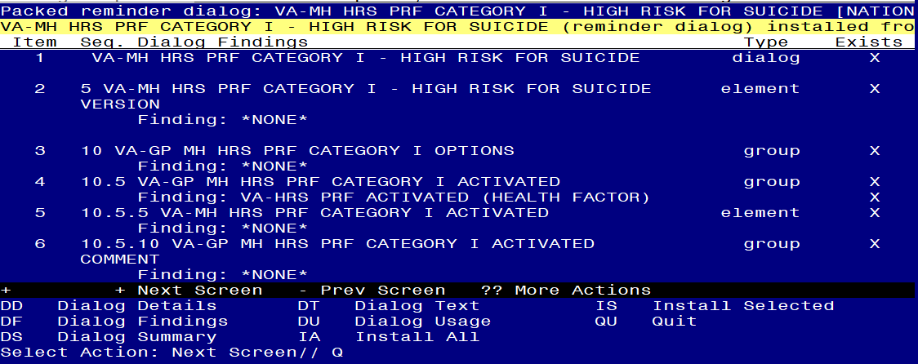

After completing this dialog install, you will type Q.

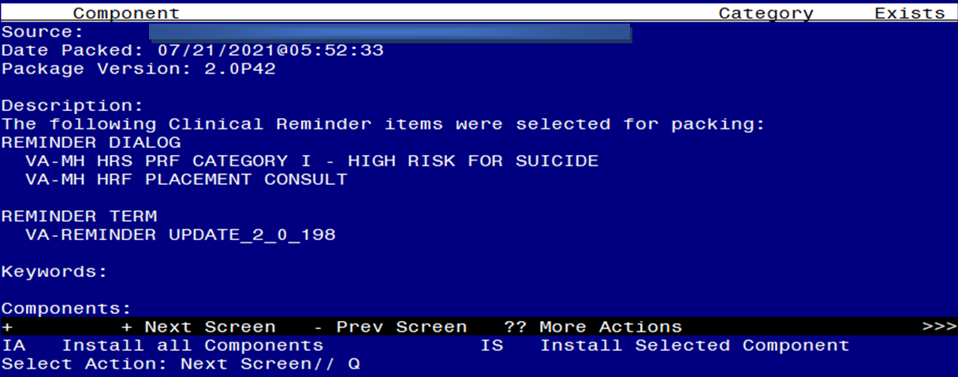

You will then be returned to this screen. At the **Select Action** prompt, type **Q.**

Install complete.

# Post Installation

1. **Make the Dialog template available to be attached to a Personal or Shared template or to be able to attach the dialog to a progress note title.**

Select Reminder Managers Menu <TEST ACCOUNT> Option: **CP** CPRS Reminder Configuration

CA Add/Edit Reminder Categories

CL CPRS Lookup Categories

CS CPRS Cover Sheet Reminder List

MH Mental Health Dialogs Active

PN Progress Note Headers

RA Reminder GUI Resolution Active

TIU TIU Template Reminder Dialog Parameter

DEVL Evaluate Coversheet List on Dialog Finish

DL Default Outside Location

PT Position Reminder Text at Cursor

LINK Link Reminder Dialog to Template

TEST CPRS Coversheet Time Test

NP New Reminder Parameters

GEC GEC Status Check Active

WH WH Print Now Active

Select CPRS Reminder Configuration <TEST ACCOUNT> Option: **TIU** TIU Template Reminder Dialog Parameter

Reminder Dialogs allowed as Templates may be set for the following:

1 User USR [choose from NEW PERSON]

3 Service SRV [choose from SERVICE/SECTION]

4 Division DIV [SALT LAKE CITY]

5 System SYS [NATREM.FO-SLC.MED.VA.GOV]

Enter selection: **5** *Choose the appropriate number for your site. Your site may do this by System or other levels. The example below uses SYSTEM level.*

Setting Reminder Dialogs allowed as Templates for System: XXXXX

Select Display Sequence: **?**

388 VA-COVID-19 TELEPHONE FOLLOW-UP

389 VA-SRA-CONSULT RESPONSE (D)

*When you type a question mark above, you will see the list of #’s (with dialogs) that are already taken. Choose a number* ***NOT*** *on this list. For this example, 390 is not present so I will use 390.*

Select Display Sequence: **390**

Are you adding 390 as a new Display Sequence? Yes// **YES**

Display Sequence: 390// <Enter> 390

Clinical Reminder Dialog: **VA-MH HRS PRF CATEGORY I - HIGH RISK FOR SUICIDE**  reminder dialog NATIONAL

...OK? Yes// <Enter> (Yes)

Select Display Sequence: **391**

Are you adding 391 as a new Display Sequence? Yes// **YES**

Display Sequence: 391// <Enter> 391

Clinical Reminder Dialog: **VA-MH HRF PLACEMENT CONSULT**  reminder dialog NATIONAL

...OK? Yes// <Enter> (Yes)

1. **Setup of Note Titles.**
2. The note title should already exist to attach to the first template : PATIENT RECORD FLAG CATEGORY I - HIGH RISK FOR SUICIDE
3. You will need to create a new note title for the other template, this should be added to the category that your CONSULT note titles are located in:

NOTE TITLE: **SUICIDE PREVENTION HIGH RISK FLAG CONSULT RESPONSE**

VHA Enterprise Standard Title: **MENTAL HEALTH CONSULT**

1. **Associate the reminder dialogs with the note title in CPRS**
2. If you have this note title already associated with a local template, you will need to update it to be linked to the reminder dialog.

In CPRS, open the Template Editor, expand Document Titles, select the appropriate folder (if applicable), then click New Template (top right-hand corner).

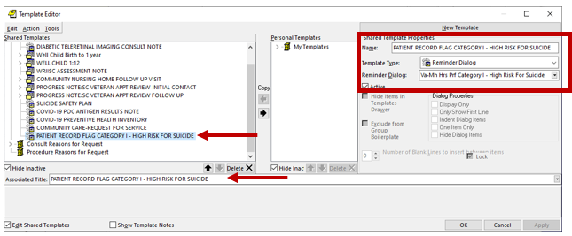

Type in the following information:

Name: **PATIENT RECORD FLAG CATEGORY I - HIGH RISK FOR SUICIDE**

Template Type: **Reminder Dialog**

Reminder Dialog: **VA-MH HRS PRF CATEGORY I - HIGH RISK FOR SUICIDE**

Next, type in the Associated Title name – **PATIENT RECORD FLAG CATEGORY I - HIGH RISK FOR SUICIDE**– then click Apply.

1. In CPRS, open the Template Editor, expand Document Titles, select the appropriate folder (if applicable), then click New Template (top right-hand corner).

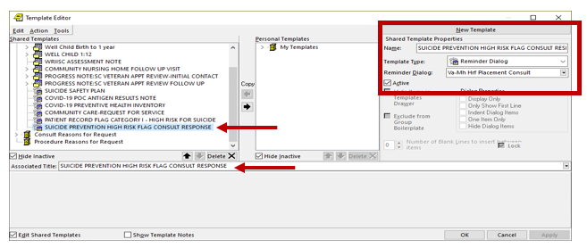

Type in the following information:

Name: **SUICIDE PREVENTION HIGH RISK FLAG CONSULT RESPONSE**

Template Type: **Reminder Dialog**

Reminder Dialog: **VA-MH HRF PLACEMENT CONSULT**

Next, type in the Associated Title name – **SUICIDE PREVENTION HIGH RISK FLAG CONSULT RESPONSE**– then click Apply.