

**Update _2_0_199**

Clinical Reminders

VA-TELESTROKE RN TRIAGE – ACUTE STROKE

Install Guide

**June 2021**

Product Development

Office of Information Technology

Department of Veterans Affairs

Table of Contents

Introduction 1

Install Details 2

Install Example 2

Post Installation 6

# Introduction

The National Tele-Stroke Program (NTSP) Nurse Triage Template is needed so that triage nurses for the NTSP can accurately document each triage encounter as it occurs while on the phone with staff at VA facilities receiving NTSP services.   The triage nurse follows the NTSP triage protocol for acute ischemic stroke and the triage template will provide a tool to document important information on patient symptoms and triage decisions outlined in the protocol. The template will also be designed so that data can be abstracted for NTSP quality reports.

For questions, contact Redacted

UPDATE_2_0_199 contains 1 Reminder Exchange entry:

**UPDATE_2_0_199 VA-TELESTROKE RN TRIAGE - ACUTE STROKE**

**The exchange file contains the following components:**

**TIU TEMPLATE FIELD**

WORD PROCESSING

TEXT (1-20 CHAR) REQ

TEXT (1-50 CHAR)R

DATE & TIME (REQ)

**HEALTH FACTORS**

VA-REMINDER UPDATES

VA-UPDATE_2_0_199

VA-ACUTE STROKE TRIAGE

VA-ACUTE STROKE TRIAGE-PHONE CONSULT REQ

VA-ACUTE STROKE TRIAGE LOC-FLOOR

VA-ACUTE STROKE TRIAGE LOC-ICU

VA-ACUTE STROKE TRIAGE LOC-ED

VA-ACUTE STROKE TRIAGE-CRITERIA MET

VA-ACUTE STROKE TRIAGE-RUE NUMBNESS

VA-ACUTE STROKE TRIAGE-LUE NUMBNESS

VA-ACUTE STROKE TRIAGE-RLE NUMBNESS

VA-ACUTE STROKE TRIAGE-LLE NUMBNESS

VA-ACUTE STROKE TRIAGE-GAZE DEVIATION

VA-ACUTE STROKE TRIAGE-LOSS OF VISION

VA-ACUTE STROKE TRIAGE-NEGLECT

VA-ACUTE STROKE TRIAGE-LT HEMIPARESIS

VA-ACUTE STROKE TRIAGE-RT HEMIPARESIS

VA-ACUTE STROKE TRIAGE-RUE WEAKNESS

VA-ACUTE STROKE TRIAGE-LUE WEAKNESS

VA-ACUTE STROKE TRIAGE-RLE WEAKNESS

VA-ACUTE STROKE TRIAGE-LLE WEAKNESS

VA-ACUTE STROKE TRIAGE-APHASIA

VA-ACUTE STROKE TRIAGE LKW WAKE UP STRK

VA-ACUTE STROKE TRIAGE LKW > 23 HRS

VA-ACUTE STROKE TRIAGE LKW W/IN 23 HRS

VA-ACUTE STROKE TRIAGE-SLURRED SPEACH

VA-ACUTE STROKE TRIAGE-DIFF FNDNG WORDS

VA-ACUTE STROKE TRIAGE-DIFF COMP WORDS

VA-ACUTE STROKE TRIAGE-FACIAL NUMBNESS

VA-ACUTE STROKE TRIAGE-FACIAL DROOP

VA-ACUTE STROKE TRIAGE-DOUBLE VISION

VA-ACUTE STROKE TRIAGE-BLURRED VISION

VA-ACUTE STROKE TRIAGE-WALKING DFCLTY

VA-ACUTE STROKE TRIAGE-INCOORDINATION

VA-ACUTE STROKE TRIAGE LKW > 8HR

VA-ACUTE STROKE TRIAGE LKW W/IN 8HR

**REMINDER SPONSOR**

OFFICE OF TELEHEALTH SERVICES STORE AND FORWARD TELEHEALTH

**REMINDER TERM**

VA-REMINDER UPDATE_2_0_199

**REMINDER DIALOG**

VA-TELESTROKE RN TRIAGE-ACUTE STROKE

# Install Details

This update is being distributed as a web host file. The address for the host file is: **https://Redacted /UPDATE_2_0_199.PRD**

The file will be installed using Reminder Exchange, programmer access is not required.

Installation:

=============

This update can be loaded with users on the system. Installation will take less than 15 minutes.

# Install Example

To Load the Web Host File. Navigate to Reminder exchange in Vista

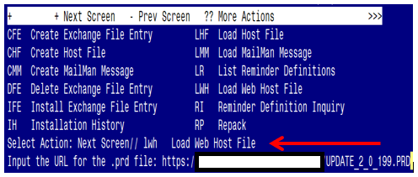

At the **Select Action:** prompt, enter **LWH** for Load Web Host File

At the **Input the url for the .prd file:** prompt, type the following web address:

[**https://Redacted/docs/UPDATE_2_0_199.PRD**](https://Redacted/docs/UPDATE_2_0_199.PRD)

You should see a message at the top of your screen that the file successfully loaded.

Terminal window screen shot of the message displaying the URL of the file that was successfully loaded.  Part of the URL has been redacted as it is a VA only internal web site URL.

Search and locate an entry titled **UPDATE_2_0_199 VA-TELESTROKE RN TRIAGE – ACUTE STROKE** in reminder exchange.

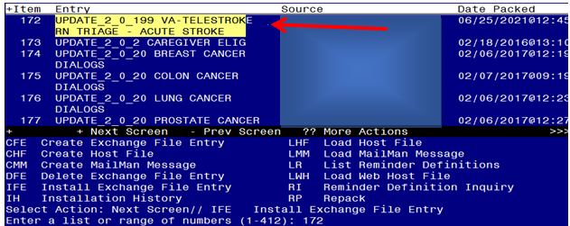

At the **Select Action** prompt, enter **IFE** for Install Exchange File Entry

Enter the number that corresponds with your entry **UPDATE_2_0_199 VA-TELESTROKE RN TRIAGE – ACUTE STROKE** *(in this example it is entry 172. It will vary by site).* The date of the exchange file should be 06/25/2021.

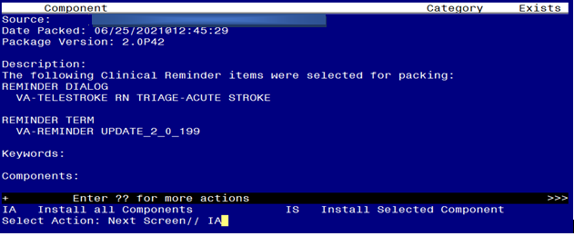

At the **Select Action** prompt, type **IA** for Install all Components and hit enter.

Select Action: Next Screen// IA Install all Components

You will see several prompts, for all new entries you will choose **I to Install**

For components that already exists but the packed component is different, choose **S to Skip.**

**You will be promped to install the reminder dialog component (VA-TELESTROKE RN TRIAGE-ACUTE STOKE).** You will choose to install all even though some components may have an X to indicate that they exist.

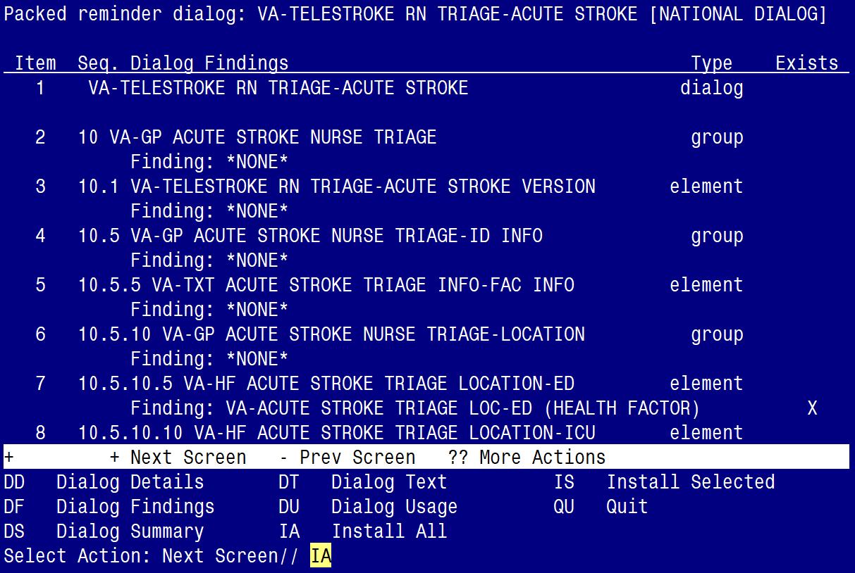

At the **Select Action** prompt, type **IA** to install the dialog:

**VA-TELESTROKE RN TRIAGE-ACUTE STOKE**

Select Action: Next Screen// IA Install All

Install reminder dialog and all components with no further changes: Y// Yes

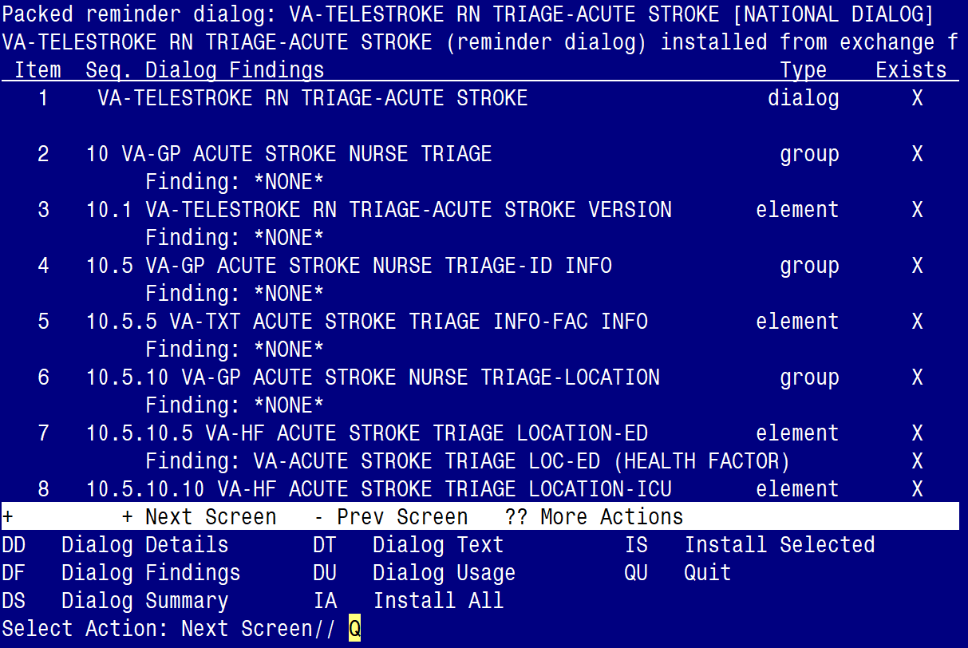

After completing this dialog install, you will type Q.

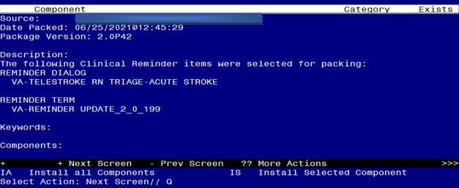

You will then be returned to this screen. At the **Select Action** prompt, type **Q.**

Install complete.

# Post Installation

1. **Make the Dialog able to be attached to a Personal/Shared template or to a progress note title.**

From the Reminders Manager Menu:

Select Reminder Managers Menu Option: **CP** CPRS Reminder Configuration

CA Add/Edit Reminder Categories

CL CPRS Lookup Categories

CS CPRS Cover Sheet Reminder List

MH Mental Health Dialogs Active

PN Progress Note Headers

RA Reminder GUI Resolution Active

TIU TIU Template Reminder Dialog Parameter

DL Default Outside Location

PT Position Reminder Text at Cursor

Select CPRS Reminder Configuration Option: **TIU** TIU Template Reminder Dialog Parameter

Reminder Dialogs allowed as Templates may be set for the following:

1 User USR [choose from NEW PERSON]

3 Service SRV [choose from SERVICE/SECTION]

4 Division DIV [choose from INSTITUTION]

5 System SYS [NATREM.FO-SLC.MED.VA.GOV]

Enter selection*:* 5  *Choose the appropriate number for your site. Your site may do this by System or other levels. The example below uses SYSTEM level*

Setting Reminder Dialogs allowed as Templates for System:

Select Display Sequence: **?**

148 VA-VETERANS CHOICE NOTE

149 VA-TBI SCREENING

*When you type a question mark above, you will see the list of #’s (with dialogs) that are already taken. Choose a number* ***NOT*** *on this list. For this example, looking above I see the number 150 is not present, so I will use 150.*

Select Display Sequence: **150**

Are you adding 150 as a new Display Sequence? Yes// **Y** YES

Display Sequence: 150// <Enter> 150

Clinical Reminder Dialog**: VA-TELESTROKE RN TRIAGE-ACUTE STROKE**

then **<enter>** reminder dialog NATIONAL

OK? Yes// <Enter> (Yes)

1. **Setup of specific Note title**

The new note title that need to be created is:

**TELESTROKE RN TRIAGE ACUTE STROKE**

        VHA Enterprise Standard Title: TELEHEALTH NOTE

Note: Comprehensive information on Creating Document Definitions can be found beginning on page 47 of the [TIU/ASU Implementation Guide](http://www.va.gov/vdl/documents/Clinical/CPRS-Text_Integration_Utility_(TIU)/tiuim.pdf)

1. **Associate the reminder dialog with the note title in CPRS**

To do this, go to Template Editor, then Document Titles, select the appropriate folder (if applicable), and choose New Template (top right-hand corner).

1. Type in the following information:

Name: **TELESTROKE RN TRIAGE ACUTE STROKE**

Template Type: Reminder Dialog

Reminder Dialog: **VA-TELESTROKE RN TRIAGE-ACUTE STROKE**

Next, type in the Associated Title, which in this case is:

**TELESTROKE RN TRIAGE ACUTE STROKE**

and click APPLY.

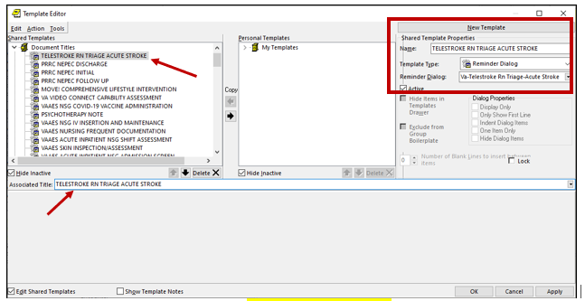

1. **Create a new template field titled VA-PROVIDER TYPE**

* Log into CPRS > Select a ‘test’ patient > click on the NOTES tab > click on OPTIONS, then EDIT TEMPLATE FIELDS.
* Create a new template field titled **VA-PROVIDER TYPE**. See screenshot below:

NAME: VA-PROVIDER TYPE

TYPE: Radio Buttons

ITEMS: MD and RN

REQUIRED: Yes

