

**Update_2_0_200**

Clinical Reminders

VA-COVID-19 SCREEN UPDATE

Install Guide

**April 2021**

Product Development

Office of Information Technology

Department of Veterans Affairs

Table of Contents

Introduction 1

Pre-Install 3

Install Details 3

Install Example 4

Post Installation 7

# Introduction

DESCRIPTION:

The national Infectious Disease and Infection Control experts, along with input from other program offices and in review of feedback from the field, have updated the COVID-19 Screening template. The symptoms reflect the questions posed by the CDC more precisely. These changes are also being created in a tool for Cerner sites, which will be coming through the Cerner channels.

Immunization is being removed from the COVID-19 Screening template to provide consistency with the Cerner tool. It is being added in Update 194 as additional information in the banner.

The screening template will be updated in each of the locations where it is currently in use (Screen, ED Triage, CLC, SCI/D) as well as the symptoms being updated in additional templates where they currently exist (Telephone follow-up and Antibody testing).

The CLC and SCI/D have an unable to screen option for use with patients that are unable to answer the screening questions.

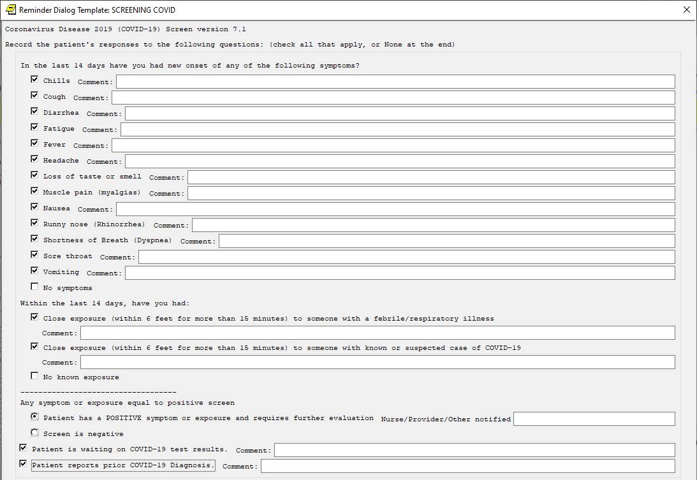

UPDATE_2_0_200 contains 1 Reminder Exchange entry:

**UPDATE_2_0_200 VA-COVID-19 SCREEN UPDATE**

**The exchange file contains the following components:**

**TIU TEMPLATE FIELD**

VA-COVID-COVID-19 AB INFORMATION SHEET

**HEALTH FACTORS**

VA-TRAVEL SCREEN [C]

VA-EXPOSURE TO COVID NO

VA-EXPOSURE TO COVID YES

VA-COVID-19

VA-EXPOSURE TO FEVER/RESP ILL 14D

VA-COVID-19 NO SYMPTOMS

VA-SYMPTOM VOMITING

VA-SYMPTOM SORE THROAT

VA-SYMPTOM SHORTNESS OF BREATH

VA-SYMPTOM RUNNY NOSE

VA-SYMPTOM NAUSEA

VA-SYMPTOM MUSCLE PAIN

VA-SYMPTOM LOSS OF TASTE OR SMELL

VA-SYMPTOM HEADACHE

VA-SYMPTOM FEVER

VA-SYMPTOM FATIGUE

VA-SYMPTOM DIARRHEA

VA-SYMPTOM COUGH

VA-SYMPTOM CHILLS

VA-COVID-19 OUTSIDE PCR SPEC COLLECTED

VA-COVID-19 NON PCR AG LAB OUTSIDE NEG

VA-COVID-19 UNK OUTSIDE LAB TEST NEG

VA-COVID-19 PCR LAB OUTSIDE NEGATIVE

VA-COVID-19 NON PCR AG LAB OUTSIDE POS

VA-COVID-19 UNK OUTSIDE LAB TEST POS

VA-COVID-19 PCR LAB OUTSIDE POSITIVE

VA-COVID-19 PRIOR DIAGNOSIS

VA-COVID WAITING TEST RESULTS

VA-COVID SCREEN NEGATIVE

VA-COVID SCREEN POSITIVE

VA-TRAVEL 21 DAYS UNABLE TO ANSWER

VA-NO HEADACHE LOSS OF TASTE OR SMELL

VA-SYMPTOM LOSS OF TASTE

VA-SYMPTOM LOSS OF SMELL

**REMINDER SPONSOR**

Office of Geriatric Extended Care

**REMINDER TERM**

VA-REMINDER UPDATE_2_0_200

VA-COVID-19 SCREEN COMPLETE TODAY

**REMINDER DIALOG**

VA-COVID-19 CLC SCREEN

VA-GP COVID-19 SCREEN UPDATE 7

# Pre-Install

Using the Vista menu Reminder Dialog Manager, Reminder Dialog, change your view to GROUP and choose inquire/print for the reminder dialog group, VAL-COVID-19 CLC SCREEN LOCAL GROUP.

Save this info for the post install, it will make adding information back post -install easier if your site has made local edits. Not all sites will have made local edits to this dialog groups.

# Install Details

Installation:

=============

This update can be loaded with users on the system. Installation will take less than 5 minutes. You will need to allow additional time for the pre and post install steps.

This update is being distributed as a web host file. The address for the host file is:

https://REDACTED /docs/UPDATE_2_0_200.PRD

The file will be installed using Reminder Exchange, programmer access is not required.

# Install Example

To Load the Web Host File. Navigate to Reminder exchange in Vista

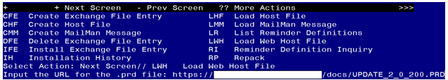

At the **Select Action:** prompt, enter **LWH** for Load Web Host File

At the **Input the url for the .prd file:** prompt, type the following web address:

https://REDACTED /UPDATE_2_0_200.PRD

You should see a message at the top of your screen that the file loaded successfully

Terminal window screen shot of the message displaying the URL of the file that was successfully loaded.  Part of the URL has been redacted as it is a VA only internal web site URL.

Search and locate an entry titled **UPDATE_2_0_200 VA-COVID-19 SCREEN UPDATE** in reminder exchange. 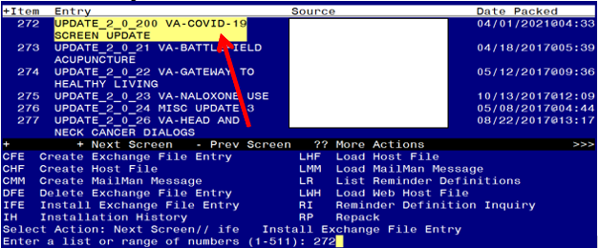

At the **Select Action** prompt, enter **IFE** for Install Exchange File Entry

Enter the number that corresponds with your entry **UPDATE_2_0_200 VA-COVID-19 SCREEN UPDATE** *(in this example it is entry 272 it will vary by site).* The date of the exchange file should be 04/01/2021. 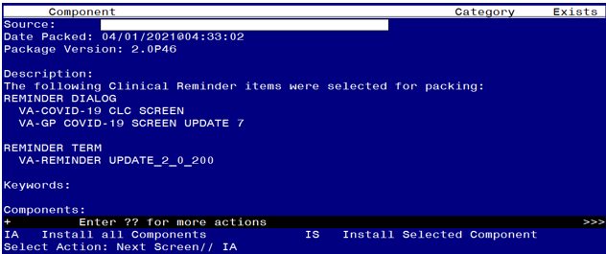

At the **Select Action** prompt, type **IA** for Install all Components and hit enter.

Select Action: Next Screen// IA Install all Components

You will see several prompts, for all new entries you will choose **I to Install**

*For components that already exists but the packed component is different, you will choose* ***S to Skip.***

**You will be prompted to install the FIRST reminder dialog component – You will choose to install all even though some components may have an X to indicate that they exist.**

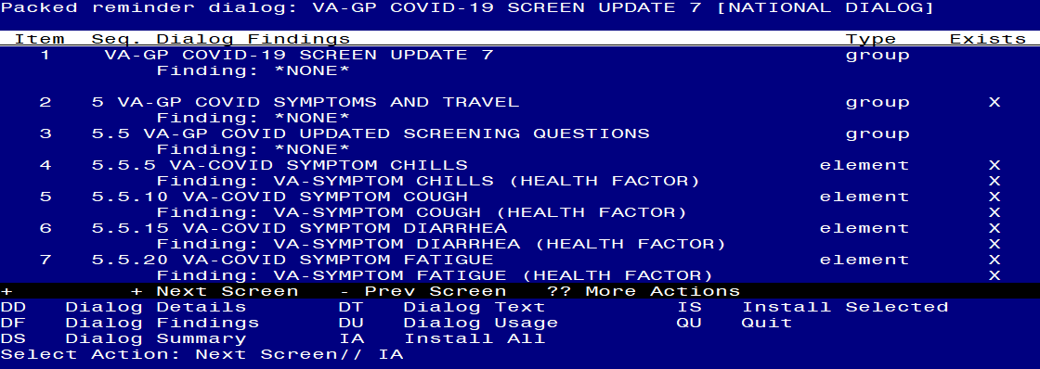

At the **Select Action** prompt, type **IA** to install the dialog – **VA-GP COVID-19 SCREEN UPDATE 7**

Select Action: Next Screen// IA Install All

Install reminder dialog and all components with no further changes: Y// Yes

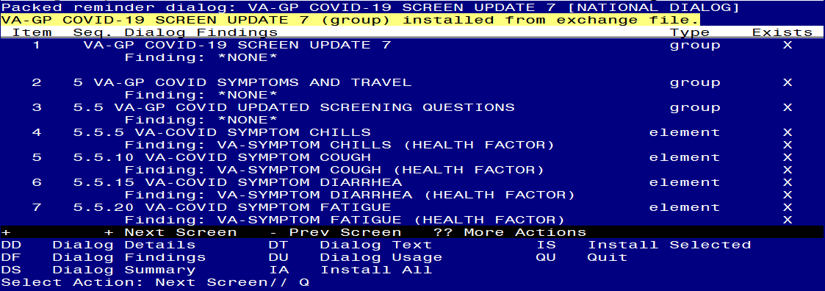

After completing this dialog install, you will type Q.

**You will be prompted to install the next reminder dialog component – You will choose to install all even though some components may have an X to indicate that they exist.**

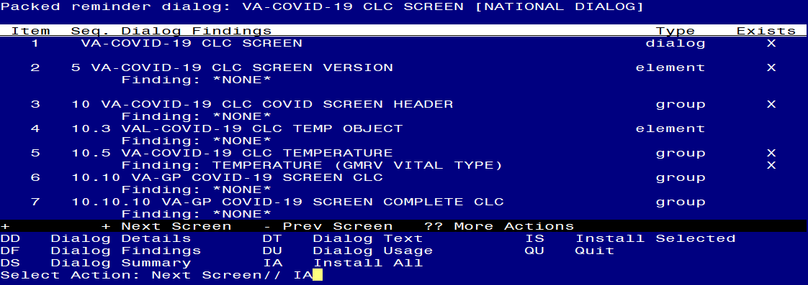

At the **Select Action** prompt, type **IA** to install the dialog – **VA-COVID-19 CLC SCREEN**

Select Action: Next Screen// IA Install All

Install reminder dialog and all components with no further changes: Y// Yes

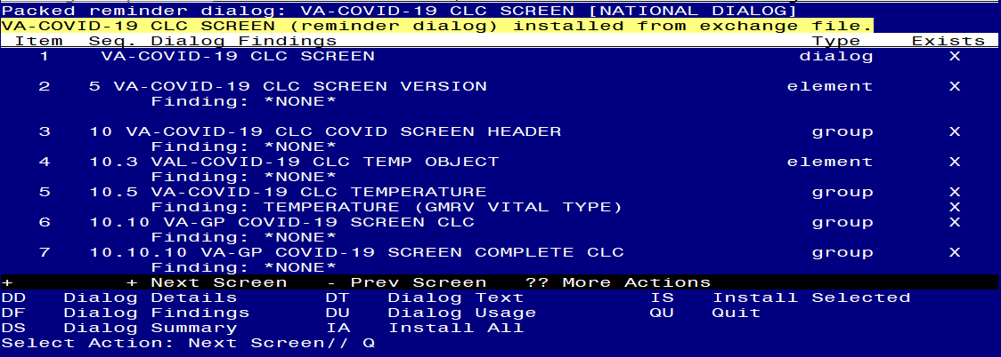

After completing this dialog install, you will type Q.

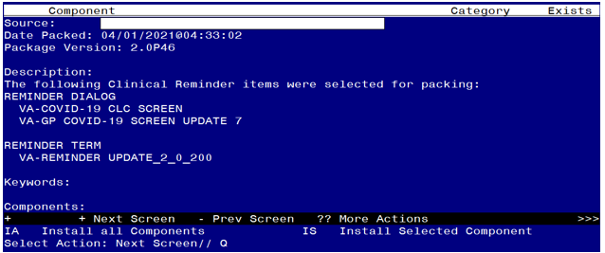

You will then be returned to this screen. At the **Select Action** prompt, type **Q.**

Install complete.

# Post Installation

1. **Open/review the COVID-19 Screen Template (VA-SCREEN COVID) and confirm the version is 7.1**
2. **Open/review the CLC COVID-19 SCREEN (VA-COVID-19 CLC SCREEN) and confirm the version is 4.1**
3. **Open/review the COVID-19 Telephone Follow-Up (VA-COVID-19 TELEPHONE FOLLOW-UP) and confirm the version is 6.1.**
4. **Open/review the SCI/D COVID-19 SCREEN (VA-COVID-19 SCI/D SCREEN) and confirm the version is 4.1**
5. **Open/review the COVID-19 ANTIBODY/PCR PANEL TESTING template (VA-COVID-19 ANTIBODY/PCR PANEL TESTING) and confirm the version is 2.1.**
6. **Open/review the EMERGENCY ROOM TRIAGE template and confirm the COVID-19 screen embedded in the template is version 7.1**
7. **Add local content to reminder dialog groups and elements if needed. (Optional)**

Review the pre-install for the reminder dialog group, VAL-COVID-19 CLC SCREEN LOCAL GROUP and make any changes that are appropriate for your site.