**Update_2_0_205**

Clinical Reminders

VA-MISC Update 14

Install Guide

**June 2021**

Product Development

Office of Information Technology

Department of Veterans Affairs

**Table of Contents**

Introduction 1

Pre-Installation 5

Install Details 5

Install Example 6

Post Installation 18

# Introduction

This update contains several minor spelling corrections and other changes to existing clinical reminder content, a full list of the changes can be found here:

**[MISC_UPDATE_14_CHANGES](https://vaww.va.gov/reminders/docs/MISC_UPDATE_14_CHANGES.pdf)**

**UPDATE_2_0_205 contains 1 Reminder Exchange entry:**

UPDATE_2_0_205 VA-MISC UPDATE 14

**The exchange file contains the following components:**

**GMRV VITAL TYPE**

BLOOD PRESSURE

**TIU TEMPLATE FIELD**

BLANK TEXT FIELD FOR DIALOGS

WORD PROCESSING 10-2-02

VA-TELE URGENT CRISIS LINE

TEXT (MAX=120 CHARACTERS)

IC/BLANK LINE 74 CHARACTERS T DIALOG USE

WORD 2 LINES

WORDFLD_EDIT_50REQ

CHECK ALL THAT APPLY3

BLANK (1)SPACE

ACP-GV INDIVID

BLANK (2)

WORD 2 LINES RQ

ACP-GV INSTRUCTIONS WORKSHEET

ACP-GV INTRO

VA-ONC PW SCRIPT

VA-PHP WHOLE HEALTH LIBRARY URL

**HEALTH FACTORS**

VA-REMINDER UPDATES [C]

VA-UPDATE_2_0_205

HYPERTENSION [C]

TELE URGENT CARE [C]

TELE URGENT TYPE PHONE HF

TELE URGENT TYPE VIDEO HF

TELE URGENT PLAN NEAREST ER HF

TELE URGENT PLAN URGENT CARE HF

TELE URGENT PLAN LESS THAN 72 HRS HF

TELE URGENT PLAN PACT HF

TELE URGENT PLAN TELE URGENT HF

TELE URGENT RFR OTHER HF

TELE URGENT RFR EYE HF

TELE URGENT RFR CV HF

TELE URGENT RFR NEURO HF

TELE URGENT RFR URINARY HF

TELE URGENT RFR GI HF

TELE URGENT RFR SKIN HF

TELE URGENT RFR ENT HF

TELE URGENT RFR MUSCULO HF

VA-MH-RRTP [C]

VA-MH-RRTP PTSD CC OTHER

VA-MH-RRTP PTSD CC NONVA RRTP

VA-MH-RRTP PTSD CC NONVA INPT

VA-MH-RRTP PTSD CC NONVA OUTPT

VA-MH-RRTP PTSD CC VET CENT

VA-MH-RRTP PTSD CC VA

WH PAP SMEAR [C]

WH ORDER COLPOSCOPY HF

WH ORDER REPEAT PAP HF

VA-SOCIAL WORK ACP [C]

VA-ACP GV SUPPORT PERSON: FRIEND

VA-ACP GV SUPPORT PERSON: TRUSTED OTHER

VA-ACP GV SUPPORT PERSON: GRANDCHILD

VA-ACP GV SUPPORT PERSON: GRANDPARENT

VA-ACP GV SUPPORT PERSON: SIBLING

VA-ACP GV SUPPORT PERSON: PARENT

VA-ACP GV SUPPORT PERSON: ADULT CHILD

VA-ACP GV SUPPORT PERSON: SPOUSE

VA-ACP GV SUPPORT PERSON: NONE

VA-ACP GV ATTEND COL OTHER

VA-ACP GV ATTEND COL WHOLE HEALTH

VA-ACP GV ATTEND COL CAREGIVER

VA-ACP GV ATTEND INDIVIDUAL

VA-ACP GV ATTEND CREATED BY STAFF

VA-ACP GV ATTEND ESTABLISHED GROUP

REMINDER FACTORS [C]

ACP GV ATTEND TELEPHONIC GROUP

ACP GV ATTEND TELEHEALTH CVT

VA-ACP GV ATTEND VA-VIRTUAL MED CENTER

ACP GV ATTEND TELEHEALTH VA VIDEO

VA-ACP GV ATTEND IN PERSON

VA-ACP GV POST Q11-NOT ANSWERED

VA-ACP GV POST Q11-DEFINITELY WILL

VA-ACP GV POST Q11-PROBABLY WILL

VA-ACP GV POST Q11-NOT SURE

VA-ACP GV POST Q11-PROBABLY WILL NOT

VA-ACP GV POST Q11-DEFINITELY WILL NOT

VA-ACP GV POST Q9-NOT ANSWERED

VA-ACP GV POST Q9-OTHER

VA-ACP GV POST Q9-NEED TIME TO THINK

VA-ACP GV POST Q9-UPDATE ADV DIR

VA-ACP GV POST Q9-LEARN

VA-ACP GV POST Q9-UNCLEAR GOALS

VA-ACP GV POST Q9-FILE COPY

VA-ACP GV POST Q9-NON-FAMILY

VA-ACP GV POST Q9-HEALTHCARE PROVIDER

VA-ACP GV POST Q9-FAMILY TALK

VA-ACP GV POST Q9-COMPLETE

VA-ACP GV POST Q9-CHECK CURRENT ADV DIR

VA-ACP GV POST Q8-KNOWLEDGE/NOT ANSWERED

VA-ACP GV POST Q8-KNOWLEDGE/EXTREMELY

VA-ACP GV POST Q8-KNOWLEDGE/QUITE A BIT

VA-ACP GV POST Q8-KNOWLEDGE/MODERATELY

VA-ACP GV POST Q8-KNOWLEDGE/A LIT BIT

VA-ACP GV POST Q8-KNOWLEDGE/NOT AT ALL

VA-ACP GV PRE Q7-NOT ANSWERED

VA-ACP GV PRE Q7-NO

VA-ACP GV PRE Q7-YES

VA-ACP GV PRE Q6-NOT ANSWERED

VA-ACP GV PRE Q6-NO

VA-ACP GV PRE Q6-YES

VA-ACP GV PRE Q5-NOT ANSWERED

VA-ACP GV PRE Q5-NO

VA-ACP GV PRE Q5-YES

VA-ACP GV PRE Q4-NOT ANSWERED

VA-ACP GV PRE Q4-NO

VA-ACP GV PRE Q4-YES

VA-ACP GV PRE Q3-NOT ANSWERED

VA-ACP GV PRE Q3-NO

VA-ACP GV PRE Q3-YES

VA-ACP GV PRE Q2-NOT ANSWERED

VA-ACP GV PRE Q2-NO

VA-ACP GV PRE Q2-YES

VA-ACP GV PRE Q1-NOT ANSWERED

VA-ACP GV PRE Q1-KNOWLEDGE/QUITE A BIT

VA-ACP GV PRE Q1-KNOWLEDGE/EXTREMELY

VA-ACP GV PRE Q1-KNOWLEDGE/MODERATELY

VA-ACP GV PRE Q1-KNOWLEDGE/A LITTLE BIT

VA-ACP GV PRE Q1-KNOWLEDGE/NOT AT ALL

VA-ACP GV DONE

TELE URGENT CLC REFERRAL

TELE URGENT REFERRAL SOURCE OTHER

TELE URGENT VETERAN SELF REFERRAL

TELE URGENT CCC RN REFERRAL

VA-DIALYSIS NUTRITION [C]

VA-DIALYSIS NUTRITION INCREASED NEEDS

VA-HEALTH AND WELL BEING [C]

VA-WHS - BAA

VA-WHS - BFA

HTN REFERRED TO DIETICIAN

DOMESTIC/INTERPERSONAL VIOLENCE SCREEN [C]

VA-IPVAP/A - FORM TEC CP

VA-IPVAP/A - FORM TEC PY

VA-IPVAP/A - FORM TEC

**REMINDER SPONSOR**

OFFICE OF QUALITY & PERFORMANCE

VA NATIONAL CENTER FOR HEALTH PROMOTION AND DISEASE PREVENTION (NCP

WOMEN VETERANS HEALTH PROGRAM

VHA ONCOLOGY

**REMINDER TERM**

VA-REMINDER UPDATE_2_0_205

**HEALTH SUMMARY TYPE**

PERSONAL HEALTH INVENTORY OBJ

**HEALTH SUMMARY OBJECTS**

PERSONAL HEALTH INVENTORY OBJ (TIU)

**TIU DOCUMENT DEFINTION**

PERSONAL HEALTH INVENTORY OBJ

VA-WRIISC ACTIVE PROBLEMS

ALLERGIES/ADR

**REMINDER DIALOG**

VA-GP MISC UPDATE 14

# Pre-Installation

Prior to installing this Update:

1. Check your Reminder Exchange Install History (IH) and ensure you have installed the following (previously released) Updates:
   * UPDATE_2_0_34 VA-WH PAP SMEAR SCREENING
   * UPDATE_2_0_52 VA-RELATIONSHIP HEALTH AND SAFETY ASSESSMENT
   * UPDATE_2_0_58 VA-LUNG CANCER DIALOG UPDATES
   * UPDATE_2_0_82 VA-ADVANCE CARE PLANNING
   * UPDATE_2_0_104 VA-MHRRT DIALOG UPDATE
   * UPDATE_2_0_108 VA-DIALYSIS NUTRITION ASSESSMENT
   * UPDATE_2_0_114 VA-MISCELLANEOUS UPDATE 11
   * UPDATE_2_0_158 VA-TELE URGENT CARE
   * UPDATE_2_0_162 VA-PERSONAL HEALTH INVENTORY
   * UPDATE_2_0_166 VA-HYPERTENSION REMINDER UPDATE
   * UPDATE_2_0_176 VA-ONCOLOGY LUNG AND PROSTATE MOLECULAR TESTING
   * UPDATE_2_0_178 VA-MISCELLANEOUS UPDATE 13
   * UPDATE_2_0_191 VA-OSTEOPOROSIS SCREENING
2. Inquire/Print (INQ) the following ELEMENTS to capture/save the objects embedded in each. When you reach the Post-Installation steps, you can use the saved inquiry to add the objects back into each ELEMENT.
   * VAL-TELE URGENT PROBLEM LIST
   * VAL-TELE URGENT ALLERGIES
   * VAL-TELE URGENT ACTIVE MEDS
   * VAL-TELE URGENT DEMOGRAPHICS
3. Inquire/Print (INQ) the following ELEMENTS to capture/save the local orders mapped in each. When you reach the Post-Installation steps, you can use the saved inquiry to add the orders back into each ELEMENT.
   * VA-WH OR PAP SMEAR REPEAT - OUTPATIENT
   * VA-WH OR COLPOSCOPY – OUTPATIENT
   * VA-HBV OI IMMUNIZATION
   * VA-HBV OI SEROLOGIC PANEL
   * VA-HF HTN REFERRAL DIETICIAN

# Install Details

This update is being distributed as a web host file. The address for the host file is: **https://vaww.va.gov/reminders/docs/UPDATE_2_0_205.PRD**

The file will be installed using Reminder Exchange, programmer access is not required.

Installation:

=============

This update can be loaded with users on the system. Installation will take less than 20 minutes.

# Install Example

To Load the Web Host File. Navigate to Reminder exchange in Vista

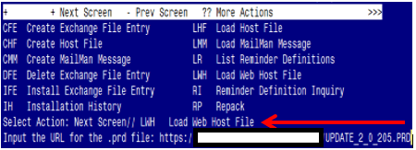

At the **Select Action:** prompt, enter **LWH** for Load Web Host File

At the **Input the url for the .prd file:** prompt, type the following web address:

**https://vaww.va.gov/reminders/docs/UPDATE_2_0_205.PRD**

You should see a message at the top of your screen that the file successfully loaded.

Terminal window screen shot of the message displaying the URL of the file that was successfully loaded.  Part of the URL has been redacted as it is a VA only internal web site URL.

Search for and locate the reminder exchange entry titled UPDATE_2_0_205 VA-MISC UPDATE 14.

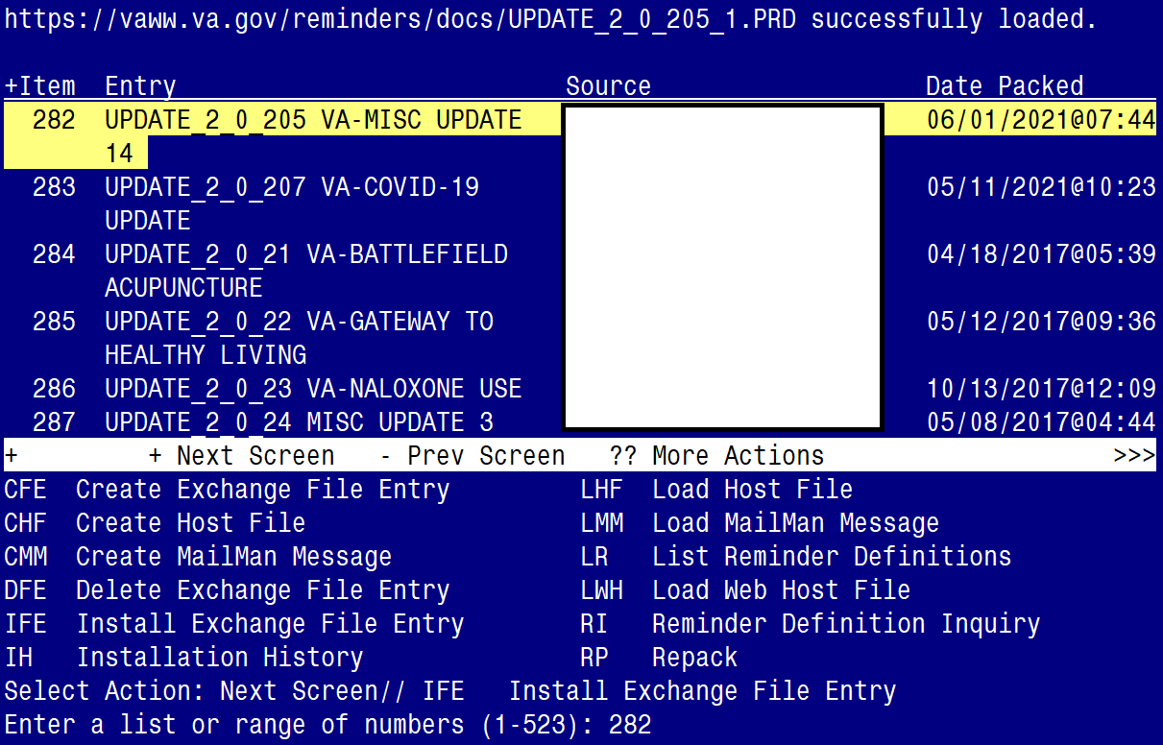

At the **Select Action** prompt, enter **IFE** for Install Exchange File Entry

Enter the number that corresponds with your entry titled **UPDATE_2_0_205 VA-MISC UPDATE 14** *(in this example it is entry 282, it will vary by site).* The exchange file date should be 06/02/2021@07:44.

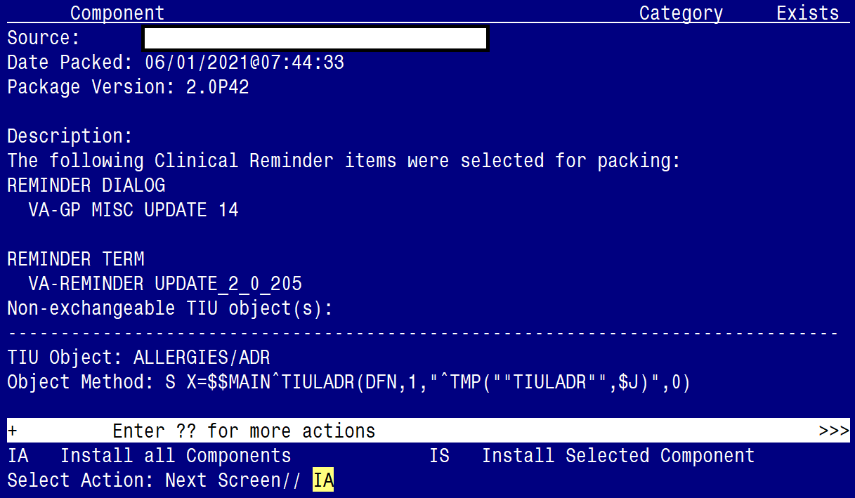

At the **Select Action** prompt, type **IA** for Install all Components and hit enter.

Select Action: Next Screen// IA Install all Components

You may (or MAY NOT) be prompted to address the following components:

The following highlighted colors are to guide you on which option to choose:

Yellow indicates to choose - I to INSTALL

Green indicates to choose - O to OVERWRITE

Blue indicates to choose - S to SKIP

Note: If you are presented a component NOT outlined in the item-list below, select S to SKIP

TIU TEMPLATE FIELD entry named VA-ONC PW SCRIPT already exists but

the packed component is different, what do you want to do?

Select one of the following:

C Create a new entry by copying to a new name

O Overwrite the current entry

U Update

Q Quit the install

S Skip, do not install this entry

Enter response: O// Overwrite the current entry

Are you sure you want to overwrite? N// Y

TIU TEMPLATE FIELD entry named VA-PHP WHOLE HEALTH LIBRARY URL

already exists but the packed component is different, what do you

want to do?

Select one of the following:

C Create a new entry by copying to a new name

O Overwrite the current entry

U Update

Q Quit the install

S Skip, do not install this entry

Enter response: O// Overwrite the current entry

Are you sure you want to overwrite? N// Y

HEALTH FACTORS entry named VA-REMINDER UPDATES [C] already exists but

the packed component is different, what do you want to do?

Select one of the following:

C Create a new entry by copying to a new name

O Overwrite the current entry

U Update

Q Quit the install

S Skip, do not install this entry

Enter response: O// Overwrite the current entry

Are you sure you want to overwrite? N// Y

HEALTH FACTORS entry VA-UPDATE_2_0_205 is NEW,

what do you want to do?

Select one of the following:

C Create a new entry by copying to a new name

I Install

Q Quit the install

S Skip, do not install this entry

Enter response: I// Install.

HEALTH FACTORS entry named HTN SELF-RECORDED BP already exists but

the packed component is different, what do you want to do?

Select one of the following:

C Create a new entry by copying to a new name

O Overwrite the current entry

U Update

Q Quit the install

S Skip, do not install this entry

Enter response: O// Skip, do not install this entry.................

HEALTH FACTORS entry named VA-MH-RRTP [C] already exists but the

packed component is different, what do you want to do?

Select one of the following:

C Create a new entry by copying to a new name

O Overwrite the current entry

U Update

Q Quit the install

S Skip, do not install this entry

Enter response: O// Skip, do not install this entry

HEALTH FACTORS entry VA-MH-RRTP PTSD CC OTHER is NEW,

what do you want to do?

Select one of the following:

C Create a new entry by copying to a new name

I Install

Q Quit the install

S Skip, do not install this entry

Enter response: I// nstall

HEALTH FACTORS entry VA-MH-RRTP PTSD CC NONVA RRTP is NEW,

what do you want to do?

Select one of the following:

C Create a new entry by copying to a new name

I Install

Q Quit the install

S Skip, do not install this entry

Enter response: I// nstall

HEALTH FACTORS entry VA-MH-RRTP PTSD CC NONVA INPT is NEW,

what do you want to do?

Select one of the following:

C Create a new entry by copying to a new name

I Install

Q Quit the install

S Skip, do not install this entry

Enter response: I// nstall

HEALTH FACTORS entry VA-MH-RRTP PTSD CC NONVA OUTPT is NEW,

what do you want to do?

Select one of the following:

C Create a new entry by copying to a new name

I Install

Q Quit the install

S Skip, do not install this entry

Enter response: I// nstall

HEALTH FACTORS entry VA-MH-RRTP PTSD CC NONVA OUTPT is NEW,

what do you want to do?

Select one of the following:

C Create a new entry by copying to a new name

I Install

Q Quit the install

S Skip, do not install this entry

Enter response: I// nstall

HEALTH FACTORS entry VA-MH-RRTP PTSD CC VA is NEW,

what do you want to do?

Select one of the following:

C Create a new entry by copying to a new name

I Install

Q Quit the install

S Skip, do not install this entry

Enter response: I// nstall

HEALTH FACTORS entry named VA-SOCIAL WORK ACP [C] already exists but

the packed component is different, what do you want to do?

Select one of the following:

C Create a new entry by copying to a new name

O Overwrite the current entry

U Update

Q Quit the install

S Skip, do not install this entry

Enter response: O// Skip, do not install this entry.........

HEALTH FACTORS entry VA-ACP GV ATTEND COL OTHER is NEW,

what do you want to do?

Select one of the following:

C Create a new entry by copying to a new name

I Install

Q Quit the install

S Skip, do not install this entry

Enter response: I// nstall

HEALTH FACTORS entry VA-ACP GV ATTEND COL WHOLE HEALTH is NEW,

what do you want to do?

Select one of the following:

C Create a new entry by copying to a new name

I Install

Q Quit the install

S Skip, do not install this entry

Enter response: I// nstall

HEALTH FACTORS entry VA-ACP GV ATTEND COL CAREGIVER is NEW,

what do you want to do?

Select one of the following:

C Create a new entry by copying to a new name

I Install

Q Quit the install

S Skip, do not install this entry

Enter response: I// nstall

HEALTH FACTORS entry ACP GV ATTEND TELEPHONIC GROUP is NEW,

what do you want to do?

Select one of the following:

C Create a new entry by copying to a new name

I Install

Q Quit the install

S Skip, do not install this entry

Enter response: I// nstall

HEALTH FACTORS entry ACP GV ATTEND TELEHEALTH CVT is NEW,

what do you want to do?

Select one of the following:

C Create a new entry by copying to a new name

I Install

Q Quit the install

S Skip, do not install this entry

Enter response: I// nstall

HEALTH FACTORS entry ACP GV ATTEND TELEHEALTH VA VIDEO is NEW,

what do you want to do?

Select one of the following:

C Create a new entry by copying to a new name

I Install

Q Quit the install

S Skip, do not install this entry

Enter response: I// nstall

HEALTH FACTORS entry TELE URGENT CLC REFERRAL is NEW,

what do you want to do?

Select one of the following:

C Create a new entry by copying to a new name

I Install

Q Quit the install

S Skip, do not install this entry

Enter response: I// nstall

HEALTH FACTORS entry VA-WHS - BAA is NEW,

what do you want to do?

Select one of the following:

C Create a new entry by copying to a new name

I Install

Q Quit the install

S Skip, do not install this entry

Enter response: I// nstall

HEALTH FACTORS entry named HTN REFERRED TO DIETICIAN already exists

but the packed component is different, what do you want to do?

Select one of the following:

C Create a new entry by copying to a new name

O Overwrite the current entry

U Update

Q Quit the install

S Skip, do not install this entry

Enter response: O// Skip, do not install this entry

HEALTH FACTORS entry named VA-IPVAP/A - FORM TEC CP already exists

but the packed component is different, what do you want to do?

Select one of the following:

C Create a new entry by copying to a new name

O Overwrite the current entry

U Update

Q Quit the install

S Skip, do not install this entry

Enter response: O// Skip, do not install this entry

HEALTH FACTORS entry named VA-IPVAP/A - FORM TEC PY already exists

but the packed component is different, what do you want to do?

Select one of the following:

C Create a new entry by copying to a new name

O Overwrite the current entry

U Update

Q Quit the install

S Skip, do not install this entry

Enter response: O// Skip, do not install this entry

HEALTH FACTORS entry named VA-IPVAP/A - FORM TEC already exists but

the packed component is different, what do you want to do?

Select one of the following:

C Create a new entry by copying to a new name

O Overwrite the current entry

U Update

Q Quit the install

S Skip, do not install this entry

Enter response: O// Skip, do not install this entry

REMINDER TERM entry VA-REMINDER UPDATE_2_0_205 is NEW,

what do you want to do?

Select one of the following:

C Create a new entry by copying to a new name

I Install

Q Quit the install

S Skip, do not install this entry

Enter response: I// nstall

HEALTH SUMMARY TYPE entry named PERSONAL HEALTH INVENTORY OBJ already

exists but the packed component is different, what do you want to do?

Select one of the following:

C Create a new entry by copying to a new name

O Overwrite the current entry

U Update

Q Quit the install

S Skip, do not install this entry

Enter response: O// Overwrite the current entry

Are you sure you want to overwrite? N// Y

HEALTH SUMMARY OBJECTS entry named PERSONAL HEALTH INVENTORY OBJ

(TIU) already exists but the packed component is different, what do

you want to do?

Select one of the following:

C Create a new entry by copying to a new name

O Overwrite the current entry

U Update

Q Quit the install

S Skip, do not install this entry

Enter response: O// verwrite the current entry

Are you sure you want to overwrite? N// Y

**You will be promped to install the dialog component:**

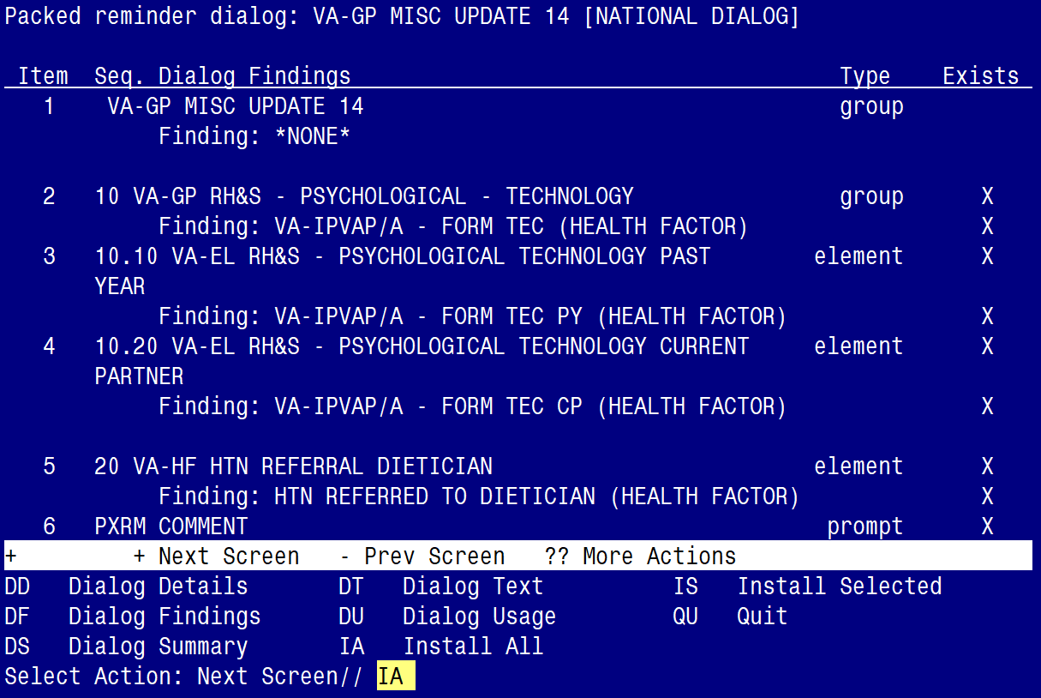

At the **Select Action** prompt, type **IA** to install the dialog – **VA-GP MISC UPDATE 14**

Select Action: Next Screen// IA Install All

Install reminder dialog and all components with no further changes: Y// ES

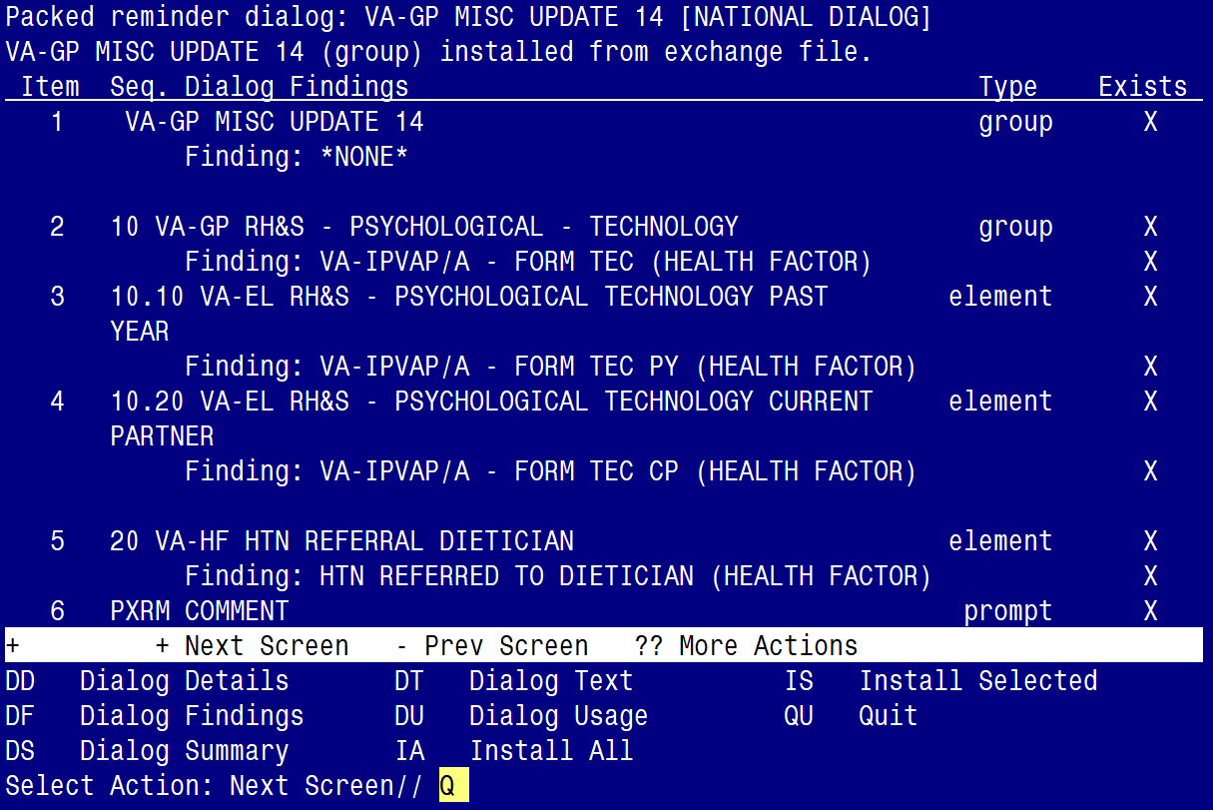

When the dialog has completed installation, you will then be returned to this screen. At the **Select Action** prompt, type **Q.**

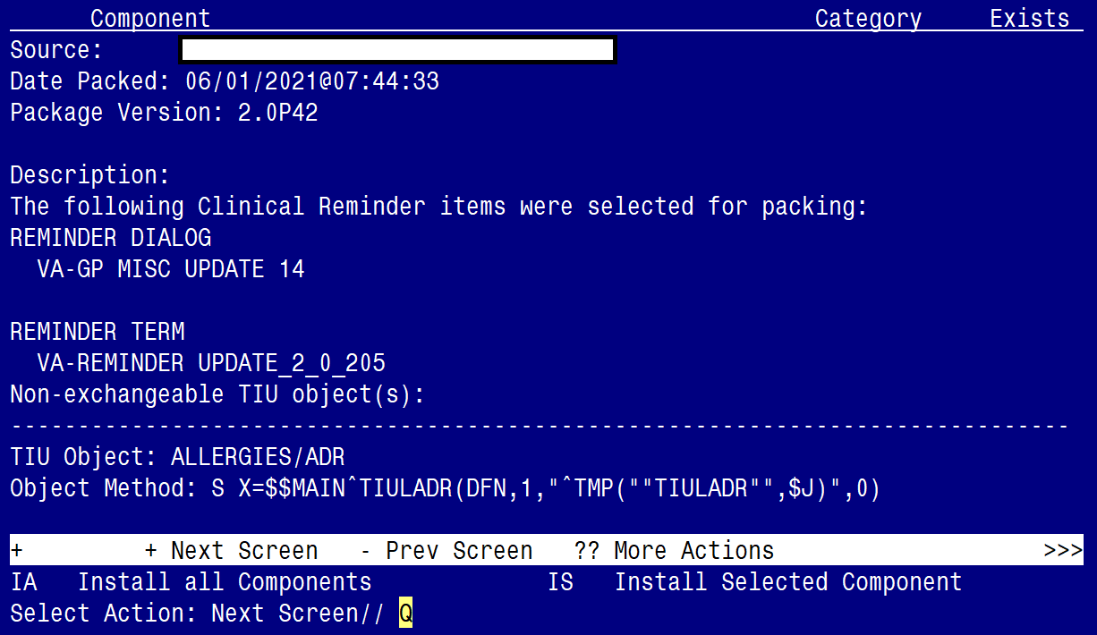

You will be returned to this screen. Type Q to quit.

Install Completed

# Post Installation

1. Refer to the Inquire/Print (INQ) you saved during the Pre-Installation steps and edit the following ELEMENTS to add objects back into each ELEMENT.

* **VAL-TELE URGENT PROBLEM LIST**
* **VAL-TELE URGENT ALLERGIES**
* **VAL-TELE URGENT ACTIVE MEDS**
* **VAL-TELE URGENT DEMOGRAPHICS**

1. Refer to the Inquire/Print (INQ) you saved during the Pre-Installation steps and edit the following ELEMENTS to re-map orders back to the Finding Items within each ELEMENT.
   * **VA-WH OR PAP SMEAR REPEAT - OUTPATIENT**
   * **VA-WH OR COLPOSCOPY – OUTPATIENT**
   * **VA-HBV OI IMMUNIZATION**
   * **VA-HBV OI SEROLOGIC PANEL**
   * **VA-HF HTN REFERRAL DIETICIAN**
2. Edit the Health Summary Type titled “PERSONAL HEALTH INVENTORY OBJ”.
   1. Add the SPN component
   2. With MAX occurrence limit of 1
   3. Add the selection item PERSONAL HEALTH INVENTORY NOTE
   4. (see below for step by steps).

*Step 1 - In VistA, go to the HEALTH SUMMARY MAINTENANCE Menu and select Option 6 – Create/Modify Health Summary Type: (see screenshot below)*

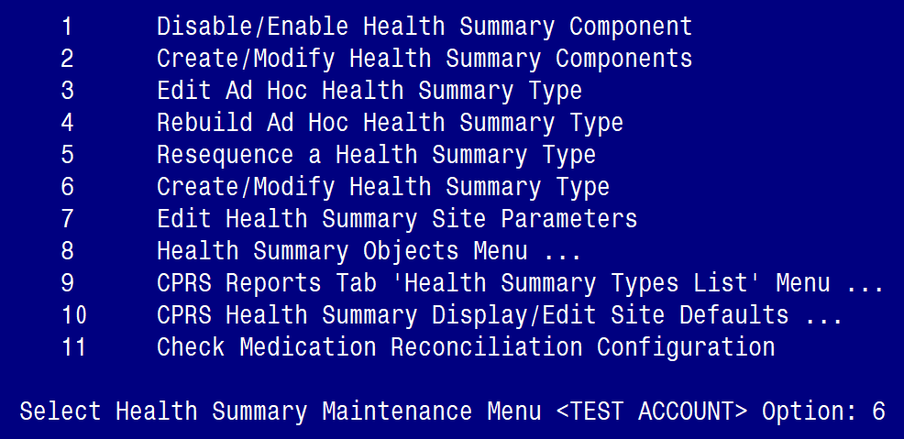

*Step 2 – Enter* **PERSONAL HEALTH INVENTORY OBJ** at the “Select Health Summary Type” prompt*: (see screenshot below)*

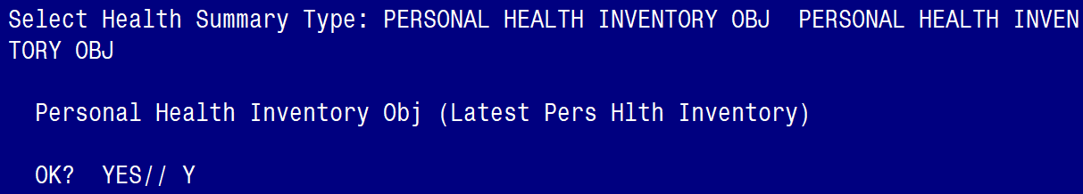

*Step 3 – Type Y for yes to continue: (see screenshot below)*

Screen shot showing WARNING: You are about to edit a Health Summary Type this is being used bay a Health Summary Object.  Changing the structure of this Health Summary Type will alter how the Object will display.

Do you want to continue?  NO// Y

*Step 4 – Press N for no at the question “Do you wish to copy COMPONENTS from an existing Health Summary Type?: (see screenshot below)*

Screen shot showing
NAME: PERSONAL HEALTH INVENTORY OBJ Replace
TITLE: Latest Pers Hlth Inventory Replace
SUPPRESS PRINT OF COMPONENTS WITHOUT DATA:  yes//
SUPPRESS SENSITIVE PRINT DATA:  NO SSN//
LOCK:
OWNER:
Do you wish ot copy COMPONENTS from an existing Health Summary Type? YES//NO

*Step 5 – Type “SPN” at the Select COMPONENT prompt: (see screenshot below)*

Screen shot showing the same as the previous screen shot but an additional line
Select COMPONENT: SPN

*Step 6– Enter a “1” at the OCCURRENCE LIMIT prompt and type PERSONAL HEALTH INVENTORY NOTE at the “Select SELECTION ITEM” prompt (see screenshot below)*

Screen show showing 

SUMMARY ORDER: 5//5
OCCURRENCE LIMIT: 1
TIME LIMIT:
HEADER NAME: Selected Prog Notes//

No selection items chosen.

Select new items one at a time in the sequence you want them displayed.  You may select any number of items.

Select SELECTION ITEM: PERAONAL HEALTH INVENTORY NOTE

*Step 7– Hit ENTER on your keyboard when you see “YES//”: (see screenshot below)*

Screen shots saying -
Searching for a TIU DOCUMENT DEFINITIN PERSONAL HEALTH INVENTORY NOTE   TITLE
Std Title:  INTEGRATIVE HEALTH NOTE
....OK?  Yes//

*Step 8– Hit ENTER on your keyboard when you see the “Select SELECTION ITEM” prompt, and ENTER again at the “Select COMPONENT” prompt, then type “Y” for yes at the “Do you wish to review the Summary Type structure before continuing?” prompt: (see screenshot below)*

Screen showing that enter was pressed so that the response to the OK in the previous screen shot was (Yes) and that Select SELECTION ITEM: and Select COMPONENT:  did not have entries.  The final line is:
Do you wish ot review the Summary Type structure before continuing and Yes is entered

*Step 9– Confirm the Health Summary Type appears as you see below: (see screenshot below)*

Screen shot showing 

Abb is SPN
Ord is 5
Component Name is Selected Prog Notes
Max Occ is 1
There are n entries for Time, Hospital Location, ICD Text, Pro Nar, CPT MOD .  Under SELECTION IS PERSONAL HEALTH INVENTORY NOTE

*Step 10– Hit ENTER on your keyboard at the “Select COMPONENT” prompt and ENTER at the “Do you wish to review the Summary Type structure before continuing?”: (see screenshot below)*

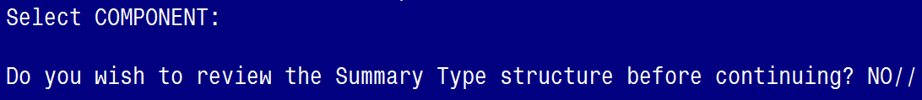

*Step 11 – Finished.*