

Update_2_0_205

Clinical Reminders

VA-MISC Update 14

Install Guide

June 2021

Product Development
Office of Information Technology
Department of Veterans Affairs

Table of Contents
Introduction 1
Pre-Installation 5
Install Details 5
Install Example 6
Post Installation 17

Introduction

This update contains several minor spelling corrections and other changes to existing clinical reminder content, a full list of the changes can be found here:

MISC_UPDATE_14_CHANGES

UPDATE_2_0_205 contains 1 Reminder Exchange entry:
UPDATE_2_0_205 VA-MISC UPDATE 14

The exchange file contains the following components:

GMRV VITAL TYPE
BLOOD PRESSURE

TIU TEMPLATE FIELD
BLANK TEXT FIELD FOR DIALOGS
WORD PROCESSING 10-2-02
VA-TELE URGENT CRISIS LINE
TEXT (MAX=120 CHARACTERS)
IC/BLANK LINE 74 CHARACTERS T DIALOG USE
WORD 2 LINES
WORDFLD_EDIT_50REQ
CHECK ALL THAT APPLY3
BLANK (1)SPACE
ACP-GV INDIVID
BLANK (2)
WORD 2 LINES RQ
ACP-GV INSTRUCTIONS WORKSHEET
ACP-GV INTRO
VA-ONC PW SCRIPT
VA-PHP WHOLE HEALTH LIBRARY URL

HEALTH FACTORS
VA-REMINDER UPDATES [C]
VA-UPDATE_2_0_205
HYPERTENSION [C]
TELE URGENT CARE [C]
TELE URGENT TYPE PHONE HF
TELE URGENT TYPE VIDEO HF
TELE URGENT PLAN NEAREST ER HF
TELE URGENT PLAN URGENT CARE HF
TELE URGENT PLAN LESS THAN 72 HRS HF
TELE URGENT PLAN PACT HF
TELE URGENT PLAN TELE URGENT HF
TELE URGENT RFR OTHER HF
TELE URGENT RFR EYE HF
TELE URGENT RFR CV HF
TELE URGENT RFR NEURO HF
TELE URGENT RFR URINARY HF
TELE URGENT RFR GI HF
TELE URGENT RFR SKIN HF
TELE URGENT RFR ENT HF
TELE URGENT RFR MUSCULO HF
VA-MH-RRTP [C]
VA-MH-RRTP PTSD CC OTHER
VA-MH-RRTP PTSD CC NONVA RRTP
VA-MH-RRTP PTSD CC NONVA INPT
VA-MH-RRTP PTSD CC NONVA OUTPT
VA-MH-RRTP PTSD CC VET CENT
VA-MH-RRTP PTSD CC VA
WH PAP SMEAR [C]
WH ORDER COLPOSCOPY HF
WH ORDER REPEAT PAP HF
VA-SOCIAL WORK ACP [C]
VA-ACP GV SUPPORT PERSON: FRIEND
VA-ACP GV SUPPORT PERSON: TRUSTED OTHER
VA-ACP GV SUPPORT PERSON: GRANDCHILD
VA-ACP GV SUPPORT PERSON: GRANDPARENT
VA-ACP GV SUPPORT PERSON: SIBLING
VA-ACP GV SUPPORT PERSON: PARENT
VA-ACP GV SUPPORT PERSON: ADULT CHILD
VA-ACP GV SUPPORT PERSON: SPOUSE
VA-ACP GV SUPPORT PERSON: NONE
VA-ACP GV ATTEND COL OTHER
VA-ACP GV ATTEND COL WHOLE HEALTH
VA-ACP GV ATTEND COL CAREGIVER
VA-ACP GV ATTEND INDIVIDUAL
VA-ACP GV ATTEND CREATED BY STAFF
VA-ACP GV ATTEND ESTABLISHED GROUP
REMINDER FACTORS [C]
ACP GV ATTEND TELEPHONIC GROUP
ACP GV ATTEND TELEHEALTH CVT
VA-ACP GV ATTEND VA-VIRTUAL MED CENTER
ACP GV ATTEND TELEHEALTH VA VIDEO
VA-ACP GV ATTEND IN PERSON
VA-ACP GV POST Q11-NOT ANSWERED
VA-ACP GV POST Q11-DEFINITELY WILL
VA-ACP GV POST Q11-PROBABLY WILL
VA-ACP GV POST Q11-NOT SURE
VA-ACP GV POST Q11-PROBABLY WILL NOT
VA-ACP GV POST Q11-DEFINITELY WILL NOT
VA-ACP GV POST Q9-NOT ANSWERED
VA-ACP GV POST Q9-OTHER
VA-ACP GV POST Q9-NEED TIME TO THINK
VA-ACP GV POST Q9-UPDATE ADV DIR
VA-ACP GV POST Q9-LEARN
VA-ACP GV POST Q9-UNCLEAR GOALS
VA-ACP GV POST Q9-FILE COPY
VA-ACP GV POST Q9-NON-FAMILY
VA-ACP GV POST Q9-HEALTHCARE PROVIDER
VA-ACP GV POST Q9-FAMILY TALK
VA-ACP GV POST Q9-COMPLETE
VA-ACP GV POST Q9-CHECK CURRENT ADV DIR
VA-ACP GV POST Q8-KNOWLEDGE/NOT ANSWERED
VA-ACP GV POST Q8-KNOWLEDGE/EXTREMELY
VA-ACP GV POST Q8-KNOWLEDGE/QUITE A BIT
VA-ACP GV POST Q8-KNOWLEDGE/MODERATELY
VA-ACP GV POST Q8-KNOWLEDGE/A LIT BIT
VA-ACP GV POST Q8-KNOWLEDGE/NOT AT ALL
VA-ACP GV PRE Q7-NOT ANSWERED
VA-ACP GV PRE Q7-NO
VA-ACP GV PRE Q7-YES
VA-ACP GV PRE Q6-NOT ANSWERED
VA-ACP GV PRE Q6-NO
VA-ACP GV PRE Q6-YES
VA-ACP GV PRE Q5-NOT ANSWERED
VA-ACP GV PRE Q5-NO
VA-ACP GV PRE Q5-YES
VA-ACP GV PRE Q4-NOT ANSWERED
VA-ACP GV PRE Q4-NO
VA-ACP GV PRE Q4-YES
VA-ACP GV PRE Q3-NOT ANSWERED
VA-ACP GV PRE Q3-NO
VA-ACP GV PRE Q3-YES
VA-ACP GV PRE Q2-NOT ANSWERED
VA-ACP GV PRE Q2-NO
VA-ACP GV PRE Q2-YES
VA-ACP GV PRE Q1-NOT ANSWERED
VA-ACP GV PRE Q1-KNOWLEDGE/QUITE A BIT
VA-ACP GV PRE Q1-KNOWLEDGE/EXTREMELY
VA-ACP GV PRE Q1-KNOWLEDGE/MODERATELY
VA-ACP GV PRE Q1-KNOWLEDGE/A LITTLE BIT
VA-ACP GV PRE Q1-KNOWLEDGE/NOT AT ALL
VA-ACP GV DONE
TELE URGENT CLC REFERRAL
TELE URGENT REFERRAL SOURCE OTHER
TELE URGENT VETERAN SELF REFERRAL
TELE URGENT CCC RN REFERRAL
VA-DIALYSIS NUTRITION [C]
VA-DIALYSIS NUTRITION INCREASED NEEDS
VA-HEALTH AND WELL BEING [C]
VA-WHS - BAA
VA-WHS - BFA
HTN REFERRED TO DIETICIAN
DOMESTIC/INTERPERSONAL VIOLENCE SCREEN [C]
VA-IPVAP/A - FORM TEC CP
VA-IPVAP/A - FORM TEC PY
VA-IPVAP/A - FORM TEC

REMINDER SPONSOR
OFFICE OF QUALITY & PERFORMANCE
VA NATIONAL CENTER FOR HEALTH PROMOTION AND DISEASE PREVENTION (NCP
WOMEN VETERANS HEALTH PROGRAM
VHA ONCOLOGY

REMINDER TERM
VA-REMINDER UPDATE_2_0_205

HEALTH SUMMARY TYPE
PERSONAL HEALTH INVENTORY OBJ

HEALTH SUMMARY OBJECTS
PERSONAL HEALTH INVENTORY OBJ (TIU)

TIU DOCUMENT DEFINTION
PERSONAL HEALTH INVENTORY OBJ
VA-WRIISC ACTIVE PROBLEMS
ALLERGIES/ADR

REMINDER DIALOG
VA-GP MISC UPDATE 14

Pre-Installation

Prior to installing this Update:

- Check your Reminder Exchange Install History (IH) and ensure you have installed the following (previously released) Updates:

  - UPDATE_2_0_34 VA-WH PAP SMEAR SCREENING
  - UPDATE_2_0_52 VA-RELATIONSHIP HEALTH AND SAFETY ASSESSMENT
  - UPDATE_2_0_58 VA-LUNG CANCER DIALOG UPDATES
  - UPDATE_2_0_82 VA-ADVANCE CARE PLANNING
  - UPDATE_2_0_104 VA-MHRRT DIALOG UPDATE
  - UPDATE_2_0_108 VA-DIALYSIS NUTRITION ASSESSMENT
  - UPDATE_2_0_114 VA-MISCELLANEOUS UPDATE 11
  - UPDATE_2_0_158 VA-TELE URGENT CARE
  - UPDATE_2_0_162 VA-PERSONAL HEALTH INVENTORY
  - UPDATE_2_0_166 VA-HYPERTENSION REMINDER UPDATE
  - UPDATE_2_0_176 VA-ONCOLOGY LUNG AND PROSTATE MOLECULAR TESTING
  - UPDATE_2_0_178 VA-MISCELLANEOUS UPDATE 13
  - UPDATE_2_0_191 VA-OSTEOPOROSIS SCREENING

- Inquire/Print (INQ) the following ELEMENTS to capture/save the objects embedded in each. When you reach the Post-Installation steps, you can use the saved inquiry to add the objects back into each ELEMENT.

  - VAL-TELE URGENT PROBLEM LIST
  - VAL-TELE URGENT ALLERGIES
  - VAL-TELE URGENT ACTIVE MEDS
  - VAL-TELE URGENT DEMOGRAPHICS

- Inquire/Print (INQ) the following ELEMENTS to capture/save the local orders mapped in each. When you reach the Post-Installation steps, you can use the saved inquiry to add the orders back into each ELEMENT.

  - VA-WH OR PAP SMEAR REPEAT - OUTPATIENT
  - VA-WH OR COLPOSCOPY – OUTPATIENT
  - VA-HBV OI IMMUNIZATION
  - VA-HBV OI SEROLOGIC PANEL
  - VA-HF HTN REFERRAL DIETICIAN

Install Details

This update is being distributed as a web host file. The address for the host file is: https://Redacted/UPDATE_2_0_205.PRD

The file will be installed using Reminder Exchange, programmer access is not required.

Installation:
=============
This update can be loaded with users on the system. Installation will take less than 20 minutes.

Install Example
To Load the Web Host File. Navigate to Reminder exchange in Vista

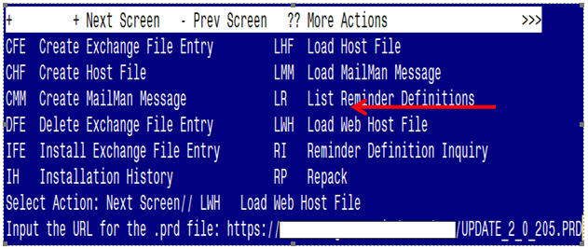

At the Select Action: prompt, enter LWH for Load Web Host File
At the Input the url for the .prd file: prompt, type the following web address:
https://REDACTED /UPDATE_2_0_205.PRD
You should see a message at the top of your screen that the file successfully loaded.

Search for and locate the reminder exchange entry titled UPDATE_2_0_205 VA-MISC UPDATE 14.

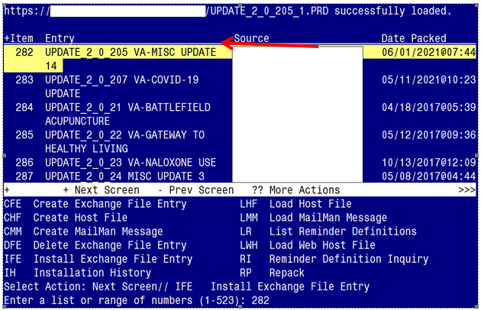

At the Select Action prompt, enter IFE for Install Exchange File Entry
Enter the number that corresponds with your entry titled UPDATE_2_0_205 VA-MISC UPDATE 14 (in this example it is entry 282, it will vary by site). The exchange file date should be 06/02/2021@07:44.

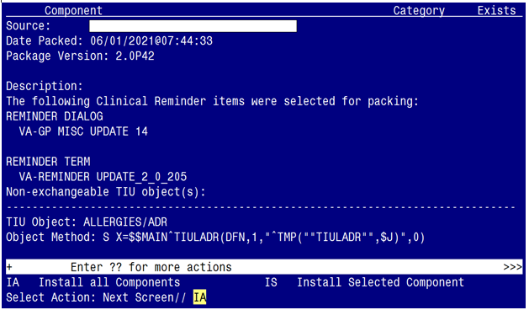

At the Select Action prompt, type IA for Install all Components and hit enter.
Select Action: Next Screen// IA Install all Components

You may (or MAY NOT) be prompted to address the following components:
The following highlighted colors are to guide you on which option to choose:
Yellow indicates to choose - I to INSTALL
Green indicates to choose - O to OVERWRITE
Blue indicates to choose - S to SKIP

Note: If you are presented a component NOT outlined in the item-list below, select S to SKIP

TIU TEMPLATE FIELD entry named VA-ONC PW SCRIPT already exists but
the packed component is different, what do you want to do?

Select one of the following:

C Create a new entry by copying to a new name
O Overwrite the current entry
U Update
Q Quit the install
S Skip, do not install this entry

Enter response: O// Overwrite the current entry
Are you sure you want to overwrite? N// Y

TIU TEMPLATE FIELD entry named VA-PHP WHOLE HEALTH LIBRARY URL
already exists but the packed component is different, what do you
want to do?

Select one of the following:

C Create a new entry by copying to a new name
O Overwrite the current entry
U Update
Q Quit the install
S Skip, do not install this entry

Enter response: O// Overwrite the current entry
Are you sure you want to overwrite? N// Y

HEALTH FACTORS entry named VA-REMINDER UPDATES [C] already exists but
the packed component is different, what do you want to do?

Select one of the following:

C Create a new entry by copying to a new name
O Overwrite the current entry
U Update
Q Quit the install
S Skip, do not install this entry

Enter response: O// Overwrite the current entry
Are you sure you want to overwrite? N// Y

HEALTH FACTORS entry VA-UPDATE_2_0_205 is NEW,
what do you want to do?

Select one of the following:

C Create a new entry by copying to a new name
I Install
Q Quit the install
S Skip, do not install this entry

Enter response: I// Install.

HEALTH FACTORS entry named HTN SELF-RECORDED BP already exists but
the packed component is different, what do you want to do?

Select one of the following:

C Create a new entry by copying to a new name
O Overwrite the current entry
U Update
Q Quit the install
S Skip, do not install this entry

Enter response: O// Skip, do not install this entry.................

HEALTH FACTORS entry named VA-MH-RRTP [C] already exists but the
packed component is different, what do you want to do?

Select one of the following:

C Create a new entry by copying to a new name
O Overwrite the current entry
U Update
Q Quit the install
S Skip, do not install this entry

Enter response: O// Skip, do not install this entry

HEALTH FACTORS entry VA-MH-RRTP PTSD CC OTHER is NEW,
what do you want to do?

Select one of the following:

C Create a new entry by copying to a new name
I Install
Q Quit the install
S Skip, do not install this entry

Enter response: I// nstall

HEALTH FACTORS entry VA-MH-RRTP PTSD CC NONVA RRTP is NEW,
what do you want to do?

Select one of the following:

C Create a new entry by copying to a new name
I Install
Q Quit the install
S Skip, do not install this entry

Enter response: I// nstall

HEALTH FACTORS entry VA-MH-RRTP PTSD CC NONVA INPT is NEW,
what do you want to do?

Select one of the following:

C Create a new entry by copying to a new name
I Install
Q Quit the install
S Skip, do not install this entry

Enter response: I// nstall

HEALTH FACTORS entry VA-MH-RRTP PTSD CC NONVA OUTPT is NEW,
what do you want to do?

Select one of the following:

C Create a new entry by copying to a new name
I Install
Q Quit the install
S Skip, do not install this entry

Enter response: I// nstall

HEALTH FACTORS entry VA-MH-RRTP PTSD CC NONVA OUTPT is NEW,
what do you want to do?

Select one of the following:

C Create a new entry by copying to a new name
I Install
Q Quit the install
S Skip, do not install this entry

Enter response: I// nstall

HEALTH FACTORS entry VA-MH-RRTP PTSD CC VA is NEW,
what do you want to do?

Select one of the following:

C Create a new entry by copying to a new name
I Install
Q Quit the install
S Skip, do not install this entry

Enter response: I// nstall

HEALTH FACTORS entry named VA-SOCIAL WORK ACP [C] already exists but
the packed component is different, what do you want to do?

Select one of the following:

C Create a new entry by copying to a new name
O Overwrite the current entry
U Update
Q Quit the install
S Skip, do not install this entry

Enter response: O// Skip, do not install this entry.........

HEALTH FACTORS entry VA-ACP GV ATTEND COL OTHER is NEW,
what do you want to do?

Select one of the following:

C Create a new entry by copying to a new name
I Install
Q Quit the install
S Skip, do not install this entry

Enter response: I// nstall

HEALTH FACTORS entry VA-ACP GV ATTEND COL WHOLE HEALTH is NEW,
what do you want to do?

Select one of the following:

C Create a new entry by copying to a new name
I Install
Q Quit the install
S Skip, do not install this entry

Enter response: I// nstall

HEALTH FACTORS entry VA-ACP GV ATTEND COL CAREGIVER is NEW,
what do you want to do?

Select one of the following:

C Create a new entry by copying to a new name
I Install
Q Quit the install
S Skip, do not install this entry

Enter response: I// nstall

HEALTH FACTORS entry ACP GV ATTEND TELEPHONIC GROUP is NEW,
what do you want to do?

Select one of the following:

C Create a new entry by copying to a new name
I Install
Q Quit the install
S Skip, do not install this entry

Enter response: I// nstall

HEALTH FACTORS entry ACP GV ATTEND TELEHEALTH CVT is NEW,
what do you want to do?

Select one of the following:

C Create a new entry by copying to a new name
I Install
Q Quit the install
S Skip, do not install this entry

Enter response: I// nstall

HEALTH FACTORS entry ACP GV ATTEND TELEHEALTH VA VIDEO is NEW,
what do you want to do?

Select one of the following:

C Create a new entry by copying to a new name
I Install
Q Quit the install
S Skip, do not install this entry

Enter response: I// nstall

HEALTH FACTORS entry TELE URGENT CLC REFERRAL is NEW,
what do you want to do?

Select one of the following:

C Create a new entry by copying to a new name
I Install
Q Quit the install
S Skip, do not install this entry

Enter response: I// nstall

HEALTH FACTORS entry VA-WHS - BAA is NEW,
what do you want to do?

Select one of the following:

C Create a new entry by copying to a new name
I Install
Q Quit the install
S Skip, do not install this entry

Enter response: I// nstall

HEALTH FACTORS entry named HTN REFERRED TO DIETICIAN already exists
but the packed component is different, what do you want to do?

Select one of the following:

C Create a new entry by copying to a new name
O Overwrite the current entry
U Update
Q Quit the install
S Skip, do not install this entry

Enter response: O// Skip, do not install this entry

HEALTH FACTORS entry named VA-IPVAP/A - FORM TEC CP already exists
but the packed component is different, what do you want to do?

Select one of the following:

C Create a new entry by copying to a new name
O Overwrite the current entry
U Update
Q Quit the install
S Skip, do not install this entry

Enter response: O// Skip, do not install this entry

HEALTH FACTORS entry named VA-IPVAP/A - FORM TEC PY already exists
but the packed component is different, what do you want to do?

Select one of the following:

C Create a new entry by copying to a new name
O Overwrite the current entry
U Update
Q Quit the install
S Skip, do not install this entry

Enter response: O// Skip, do not install this entry

HEALTH FACTORS entry named VA-IPVAP/A - FORM TEC already exists but
the packed component is different, what do you want to do?

Select one of the following:

C Create a new entry by copying to a new name
O Overwrite the current entry
U Update
Q Quit the install
S Skip, do not install this entry

Enter response: O// Skip, do not install this entry

REMINDER TERM entry VA-REMINDER UPDATE_2_0_205 is NEW,
what do you want to do?

Select one of the following:

C Create a new entry by copying to a new name
I Install
Q Quit the install
S Skip, do not install this entry

Enter response: I// nstall

HEALTH SUMMARY TYPE entry named PERSONAL HEALTH INVENTORY OBJ already
exists but the packed component is different, what do you want to do?

Select one of the following:

C Create a new entry by copying to a new name
O Overwrite the current entry
U Update
Q Quit the install
S Skip, do not install this entry

Enter response: O// Overwrite the current entry
Are you sure you want to overwrite? N// Y

HEALTH SUMMARY OBJECTS entry named PERSONAL HEALTH INVENTORY OBJ
(TIU) already exists but the packed component is different, what do
you want to do?

Select one of the following:

C Create a new entry by copying to a new name
O Overwrite the current entry
U Update
Q Quit the install
S Skip, do not install this entry

Enter response: O// verwrite the current entry
Are you sure you want to overwrite? N// Y

You will be promped to install the dialog component:

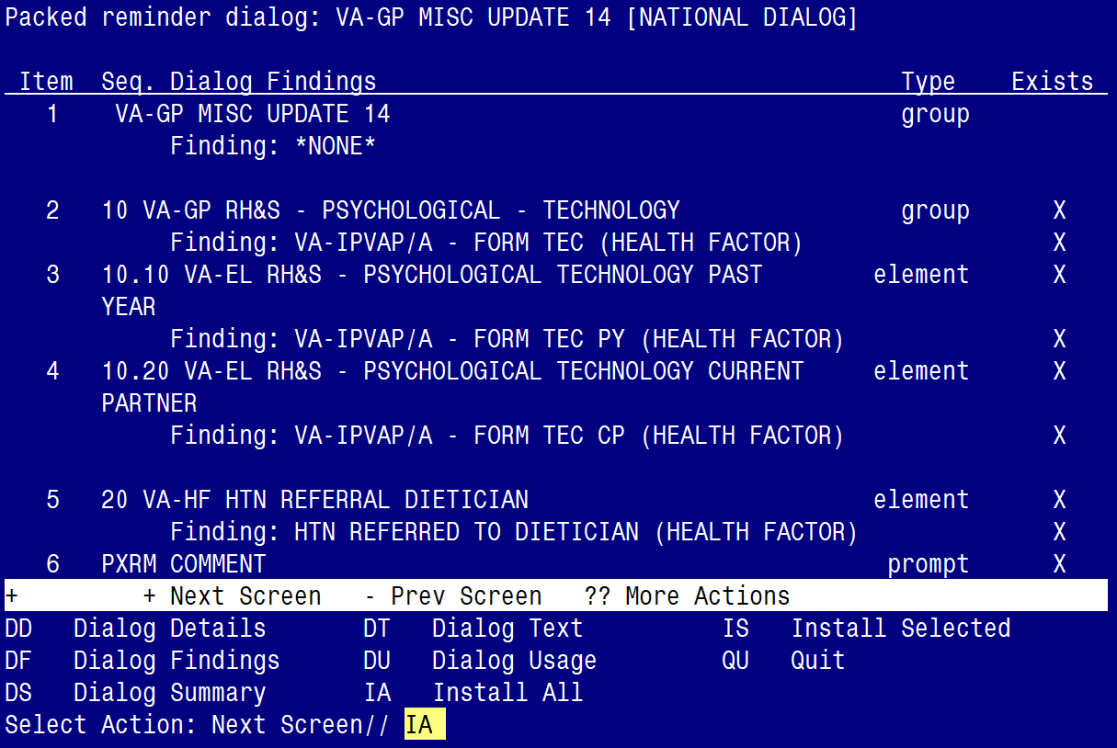

At the Select Action prompt, type IA to install the dialog – VA-GP MISC UPDATE 14
Select Action: Next Screen// IA Install All
Install reminder dialog and all components with no further changes: Y// ES

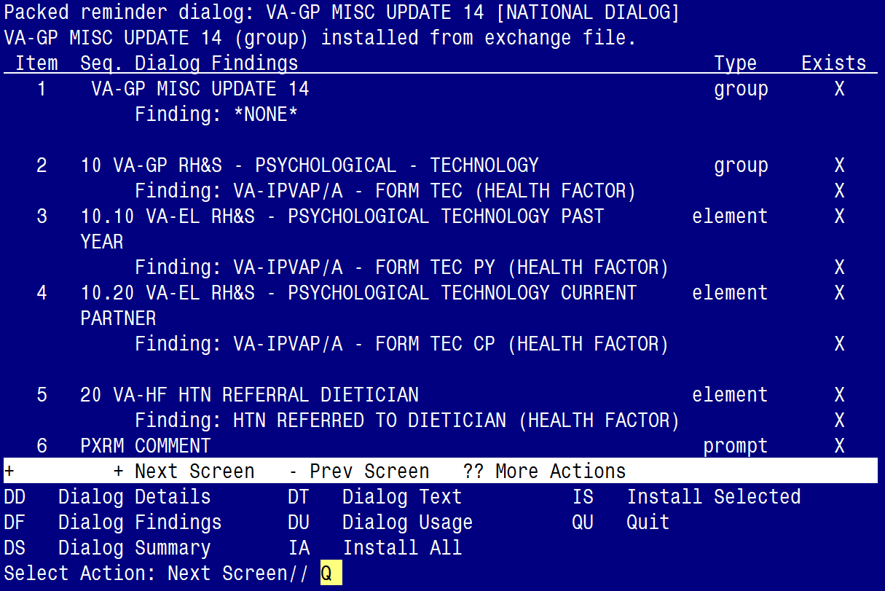

When the dialog has completed installation, you will then be returned to this screen. At the Select Action prompt, type Q.

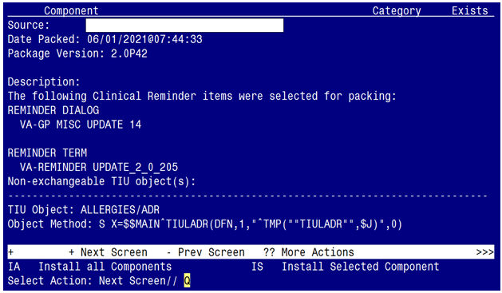

You will be returned to this screen. Type Q to quit.
Install Completed

Post Installation

- Refer to the Inquire/Print (INQ) you saved during the Pre-Installation steps and edit the following ELEMENTS to add objects back into each ELEMENT.

- VAL-TELE URGENT PROBLEM LIST
- VAL-TELE URGENT ALLERGIES
- VAL-TELE URGENT ACTIVE MEDS
- VAL-TELE URGENT DEMOGRAPHICS

- Refer to the Inquire/Print (INQ) you saved during the Pre-Installation steps and edit the following ELEMENTS to re-map orders back to the Finding Items within each ELEMENT.

  - VA-WH OR PAP SMEAR REPEAT - OUTPATIENT
  - VA-WH OR COLPOSCOPY – OUTPATIENT
  - VA-HBV OI IMMUNIZATION
  - VA-HBV OI SEROLOGIC PANEL
  - VA-HF HTN REFERRAL DIETICIAN

- Edit the Health Summary Type titled “PERSONAL HEALTH INVENTORY OBJ”.
  - Add the SPN component
  - With MAX occurrence limit of 1
  - Add the selection item PERSONAL HEALTH INVENTORY NOTE
  - (see below for step by steps).

Step 1 - In VistA, go to the HEALTH SUMMARY MAINTENANCE Menu and select Option 6 – Create/Modify Health Summary Type: (see screenshot below)

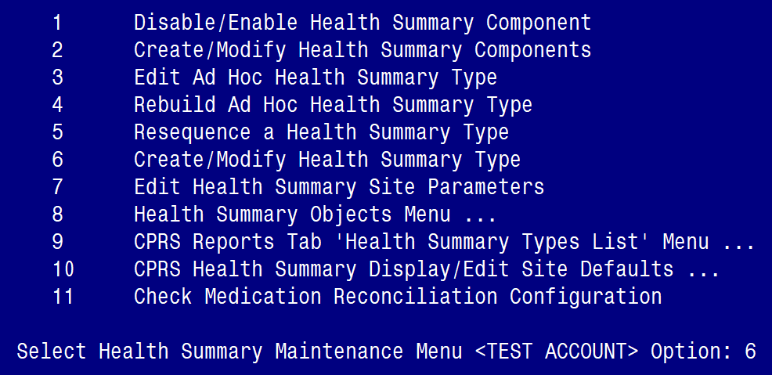

Step 2 – Enter PERSONAL HEALTH INVENTORY OBJ at the “Select Health Summary Type” prompt: (see screenshot below)

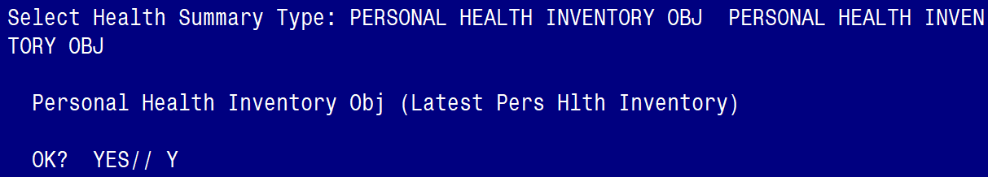

Step 3 – Type Y for yes to continue: (see screenshot below)

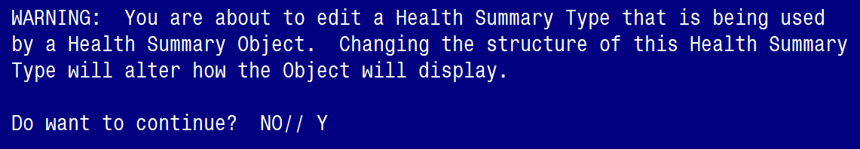

Step 4 – Press N for no at the question “Do you wish to copy COMPONENTS from an existing Health Summary Type?: (see screenshot below)

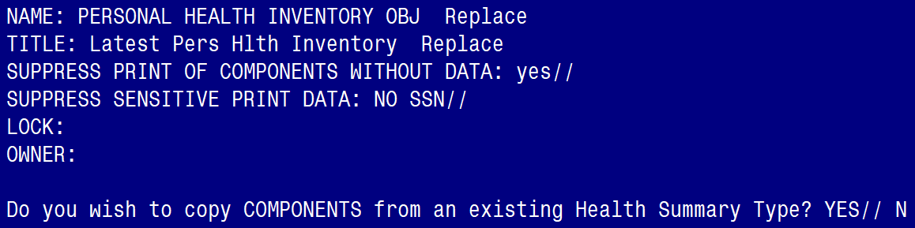

Step 5 – Type “SPN” at the Select COMPONENT prompt: (see screenshot below)

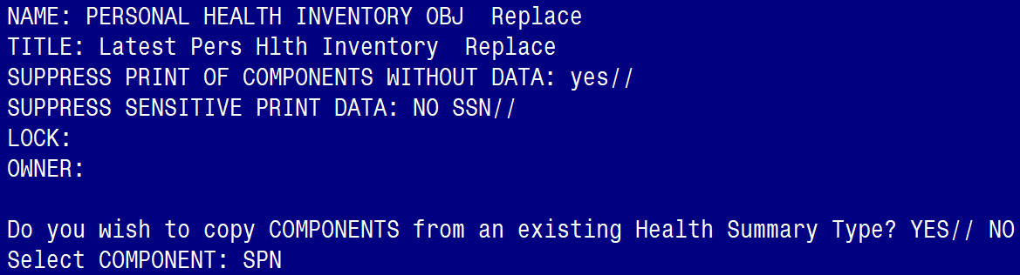

Step 6– Enter a “1” at the OCCURRENCE LIMIT prompt and type PERSONAL HEALTH INVENTORY NOTE at the “Select SELECTION ITEM” prompt (see screenshot below)

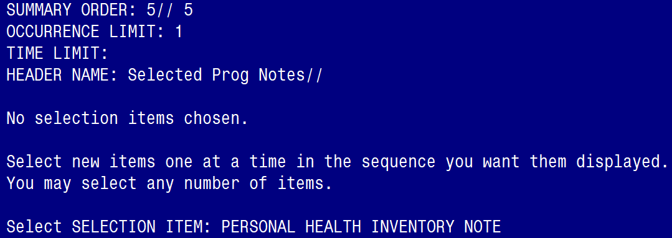

Step 7– Hit ENTER on your keyboard when you see “YES//”: (see screenshot below)



Step 8– Hit ENTER on your keyboard when you see the “Select SELECTION ITEM” prompt, and ENTER again at the “Select COMPONENT” prompt, then type “Y” for yes at the “Do you wish to review the Summary Type structure before continuing?” prompt: (see screenshot below)

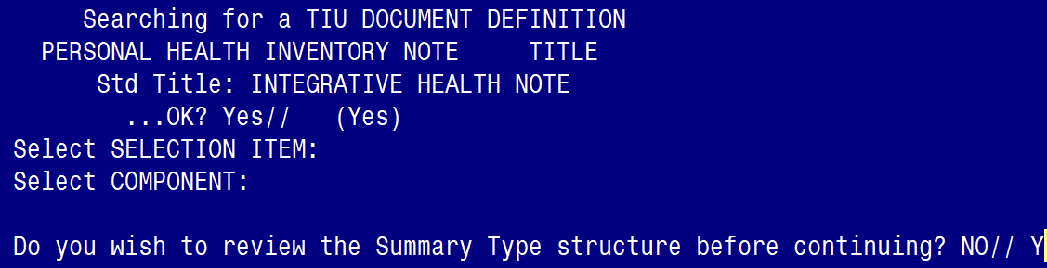

Step 9– Confirm the Health Summary Type appears as you see below: (see screenshot below)

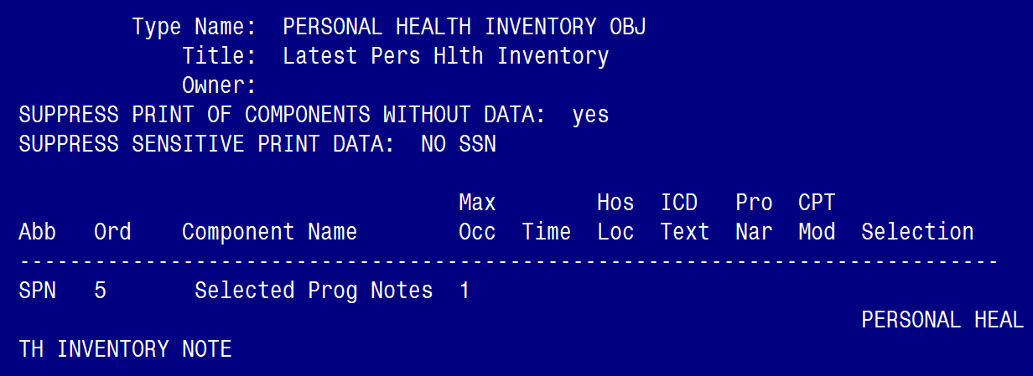

Step 10– Hit ENTER on your keyboard at the “Select COMPONENT” prompt and ENTER at the “Do you wish to review the Summary Type structure before continuing?”: (see screenshot below)

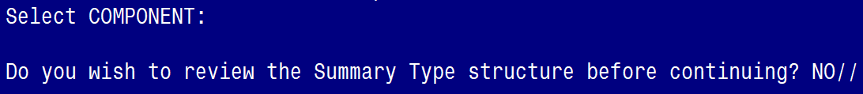

Step 11 – Finished.

