

**Update_2_0_207**

Clinical Reminders

VA-COVID-19 UPDATE

Install Guide

**May 2021**

Product Development

Office of Information Technology

Department of Veterans Affairs

Table of Contents

Introduction 1

Pre-Install 5

Install Details 5

Install Example 6

Post Installation 10

# Introduction

DESCRIPTION:

The following updates/improvements are being made to VA-COVID-19 CPRS templates and banner.

1. VA-COVID-19 PREVENTIVE HEALTH INVENTORY update to include verbal consent clarification

Before:

Before screen shot shows "Patient verbal consent obtained.

After:



1. VA-COVID-19 PREVENTIVE HEALTH INVENTORY update to include COVID-19 VACCINE ACTIONS if no vaccine has been recorded

New section will display below scheduled appointments:

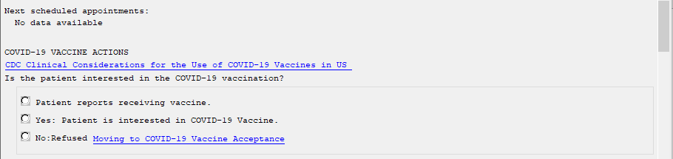

If the patient has had the vaccine, it is available for display, the note will indicate the patient had a prior vaccination without the details:

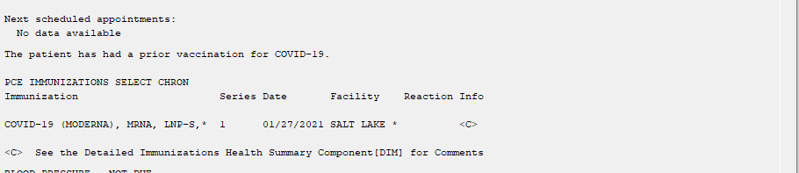

1. VA-SCREEN COVID update to include “Unable to Answer” option

Before:

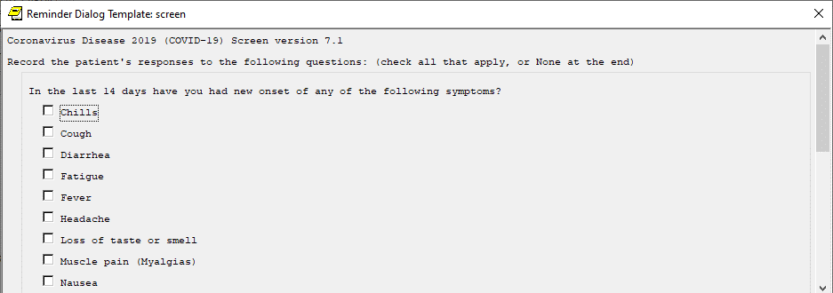

After:

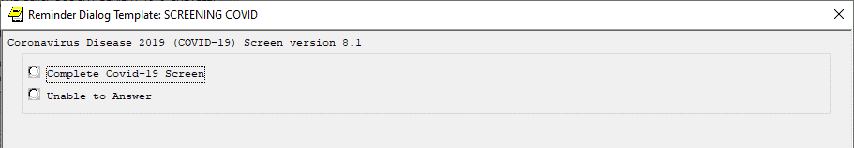

1. Banner logic – update FF119 to allow comparison between lab PCR and outside negative PCR tests

Before:

FI(2)&(FI(16)!FI(19))&'((MRD(2)<MRD(4,5,6,7,9,10,11,14)))&(MRD(16,19)>MRD(2))

After:

FI(2)&(FI(16)!FI(19))&'((MRD(2)<MRD(1,4,5,6,7,9,10,11,14)))&(MRD(16,19)>MRD(2))

UPDATE_2_0_207 contains 1 Reminder Exchange entry:

**UPDATE_2_0_207 VA-COVID-19 UPDATE**

**The exchange file contains the following components:**

**TIU TEMPLATE FIELD**

VA-COVID ACCEPT

IM SARS COV-2 OUTSIDE WARNING2

VA-COVID CDC

**HEALTH FACTORS**

VA-REMINDER UPDATES

VA-UPDATE_2_0_207

IMMUNIZATION

VA-SARS-COV-2 VACCINE REFUSAL

VA-SARS-COV-2 VACCINE INTEREST

COVID-19 VERBAL REPORT COVID VACCINE

VA-TRAVEL SCREEN [C]

VA-COVID SCREEN NEGATIVE

VA-COVID SCREEN POSITIVE

VA-COVID-19 PRIOR DIAGNOSIS

VA-COVID-19

VA-COVID WAITING TEST RESULTS

VA-EXPOSURE TO COVID NO

VA-EXPOSURE TO COVID YES

VA-EXPOSURE TO FEVER/RESP ILL 14D

VA-COVID-19 NO SYMPTOMS

VA-SYMPTOM VOMITING

VA-SYMPTOM SORE THROAT

VA-SYMPTOM SHORTNESS OF BREATH

VA-SYMPTOM RUNNY NOSE

VA-SYMPTOM NAUSEA

VA-SYMPTOM MUSCLE PAIN

VA-SYMPTOM LOSS OF TASTE OR SMELL

VA-SYMPTOM HEADACHE

VA-SYMPTOM FEVER

VA-SYMPTOM FATIGUE

VA-SYMPTOM DIARRHEA

VA-SYMPTOM COUGH

VA-SYMPTOM CHILLS

VA-COVID-19 UNABLE TO ANSWER SCREEN

VA-COVID-19 UNK OUTSIDE LAB TEST POS

VA-COVID-19 NON PCR AG LAB OUTSIDE POS

VA-COVID-19 NO LONGER SUSPECTED

VA-COVID-19 INCORRECT PRIOR POSITIVE PCR

VA-COVID-19 RESOLVED

VA-COVID-19 SUSPECTED

VA-COVID-19 UNK OUTSIDE LAB TEST NEG

VA-COVID-19 NON PCR AG LAB OUTSIDE NEG

VA-COVID-19 OUTSIDE PCR SPEC COLLECTED

VA-COVID-19 PCR LAB OUTSIDE NEGATIVE

VA-COVID-19 PCR LAB OUTSIDE POSITIVE

VA-COVID-19 LAB OUTSIDE POSITIVE

**REMINDER SPONSOR**

NATIONAL CENTER FOR HEALTH PROMOTION AND DISEASE PREVENTION (NCP)

**REMINDER TAXONOMY**

VA-COVID-19 SNOMED CODES

**REMINDER TERM**

VA-REMINDER UPDATE_2_0_207

VA-COVID-19 IMMUNIZATION BL

VA-COVID-19 AG LAB RESULTS POSITIVE HF

VA-COVID-19 AG LAB RESULTS POSITIVE

VA-COVID-19 RELATED ORDERABLE ITEMS FOR BANNER

DISPLAY

VA-SARS-COV-2 VACCINES

VA-COVID-19 PROB LIST DX

VA-COVID-19 PCR LAB ORDERS

VA-COVID-19 CLINICAL INFO

VA-COVID-19 OUTSIDE RESULTS

VA-COVID-19 PRESUMED

VA-COVID-19 ANTIBODY LAB TEST

VA-COVID-19 PCR/AG LAB RESULTS

VA-COVID-19 NO LONGER PRESUMED

VA-COVID-19 INCORRECT PRIOR POSITIVE PCR RESULT

VA-COVID-19 PCR LAB RESULTS POSITIVE

VA-COVID-19 OUTSIDE PCR LAB POSITIVE

VA-COVID-19 OUTSIDE PCR SPECIMEN COLLECTED

VA-COVID-19 RECOVERED

VA-COVID-19 OUTSIDE PCR LAB NEGATIVE

VA-COVID-19 PCR LAB RESULTS NEGATIVE

**REMINDER DEFINITION**

VA-COVID-19 CPRS STATUS

**HEALTH SUMMARY TYPE**

SARS-COV-2 IMMUNIZATION

FUTURE CLINIC VISITS (ALL)

**HEALTH SUMMARY OBJECTS**

SARS-COV-2 IMMUNIZATION (TIU)

FUTURE CLINIC VISITS (TIU)

**TIU DOCUMENT DEFINITION**

SARS-COV-2 IMMUNIZATION

FUTURE CLINIC VISITS

**REMINDER DIALOG**

VA-GP COVID-19 UPDATE MAY 2021

VA-SCREEN COVID

# Pre-Install

1. Using the Vista menu Reminder Dialog Manager, Reminder Dialog, change your view to GROUP and choose inquire/print for the reminder dialog group, VAL-COVID LOCAL GROUP.

Using the Vista menu Reminder Dialog Manager, Reminder Dialog, change your view to ELEMENT and choose inquire/print for the reminder dialog element VAL-COVID-19 PHI NEXT APPOINTMENT. Review the dialog text as you may have to add your local data object back post install.

Save this info for the post install, it will make adding information back post -install easier if your site has made local edits. Not all sites will have made local edits to these dialog groups.

1. Using the Vista menu, Reminder Term management, Term Inquiry, inquire and save the following reminder terms for reference post install. If you follow the install guide closely and skip the items if prompted to overwrite, your mapping should be preserved.
   1. VA-COVID-19 PCR LAB RESULTS NEGATIVE
   2. VA-COVID-19 PCR LAB RESULTS POSITIVE
   3. VA-COVID-19 PCR LAB ORDERS
   4. VA-COVID-19 PCR/AG LAB RESULTS
   5. VA-COVID-19 ANTIBODY LAB TEST
   6. VA-COVID-19 AG LAB RESULTS POSITIVE
   7. VA-COVID-19 RELATED ORDERABLE ITEMS FOR BANNER DISPLAY

# Install Details

Installation:

=============

This update can be loaded with users on the system. Installation will take less than 5 minutes. You will need to allow additional time for the pre and post install steps.

This update is being distributed as a web host file. The address for the host file is:

https://vaww.va.gov/reminders/docs/UPDATE_2_0_207.PRD

The file will be installed using Reminder Exchange, programmer access is not required.

# Install Example

To Load the Web Host File. Navigate to Reminder exchange in Vista

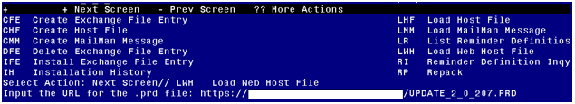

At the **Select Action:** prompt, enter **LWH** for Load Web Host File

At the **Input the url for the .prd file:** prompt, type the following web address:

https://REDACTED/UPDATE_2_0_207.PRD

You should see a message at the top of your screen that the file loaded successfully

Terminal window screen shot of the message displaying the URL of the file that was successfully loaded.  Part of the URL has been redacted as it is a VA only internal web site URL.

Search and locate an entry titled **UPDATE_2_0_207 VA-COVID-19 UPDATE** in reminder exchange.

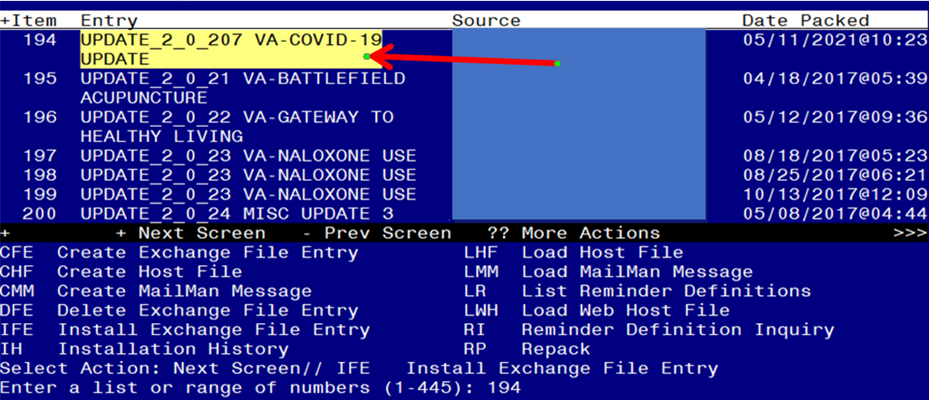

At the **Select Action** prompt, enter **IFE** for Install Exchange File Entry

Enter the number that corresponds with your entry **UPDATE_2_0_207 VA-COVID-19 UPDATE** *(in this example it is entry 194 it will vary by site).* The date of the exchange file should be 05/11/2021.

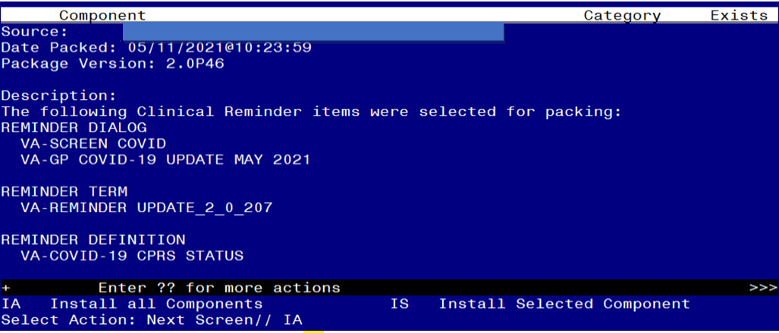

At the **Select Action** prompt, type **IA** for Install all Components and hit enter.

Select Action: Next Screen// IA Install all Components

You will see several prompts, for all new entries you will choose **I to Install**

*For components that already exists but the packed component is different (except the reminder definition), you will choose* ***S to Skip***

There is one exception, for the reminder definition VA-COVID-19 CPRS STATUS you should overwrite

REMINDER DEFINITION entry named **VA-COVID-19 CPRS STATUS** already exists but the packed component is different, what do you

want to do?

Select one of the following:

C Create a new entry by copying to a new name

O Overwrite the current entry

U Update

Q Quit the install

S Skip, do not install this entry

Enter response: O// verwrite the current entry

Are you sure you want to overwrite? N// Y

**You will be prompted to install the FIRST reminder dialog component – You will choose to install all even though some components may have an X to indicate that they exist.**

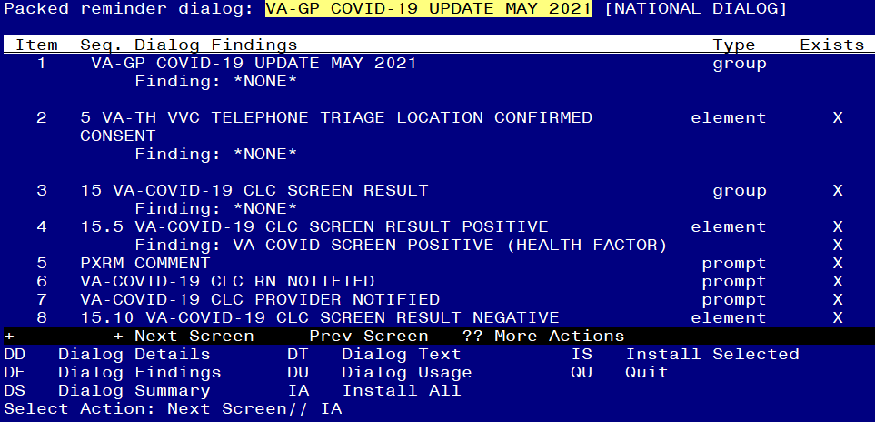

At the **Select Action** prompt, type **IA** to install the dialog – **VA-GP COVID-19 UPDATE MAY 2021**

Select Action: Next Screen// IA Install All

Install reminder dialog and all components with no further changes: Y// Yes

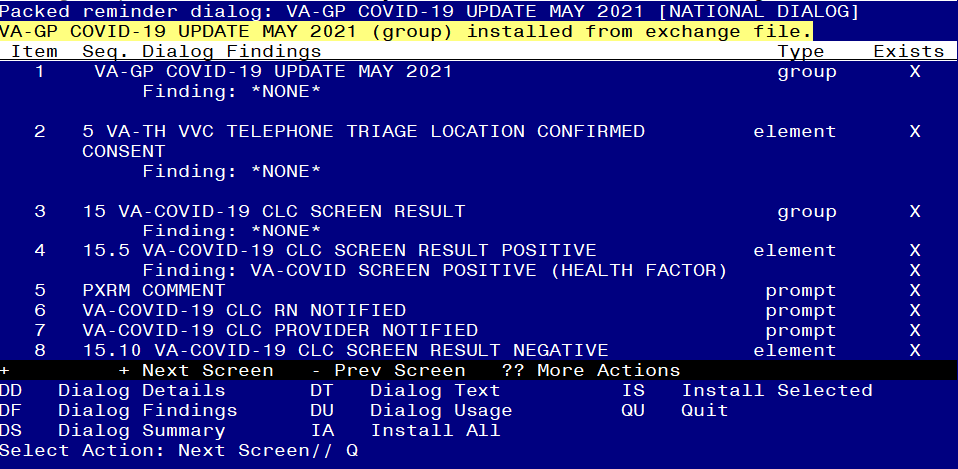

After completing this dialog install, you will type Q.

**You will be prompted to install the next reminder dialog component – You will choose to install all even though some components may have an X to indicate that they exist.**

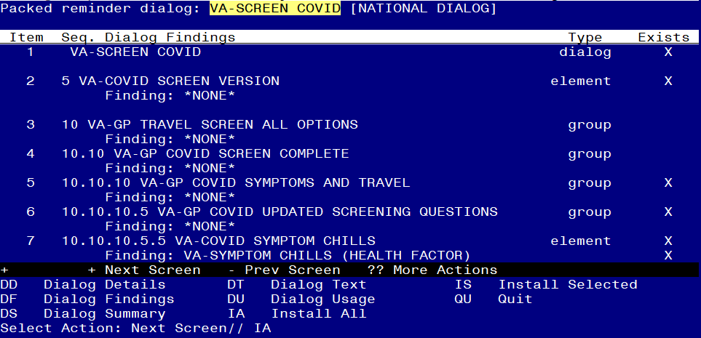

At the **Select Action** prompt, type **IA** to install the dialog – **VA-SCREEN COVID**

Select Action: Next Screen// IA Install All

Install reminder dialog and all components with no further changes: Y// Yes

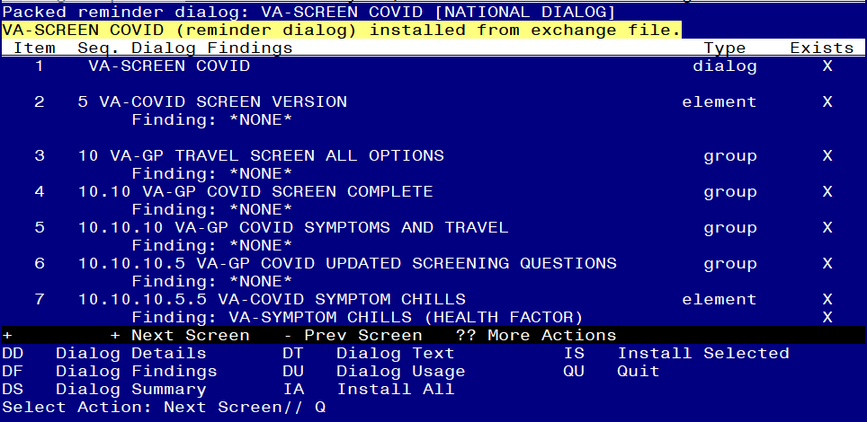

After completing this dialog install, you will type Q.

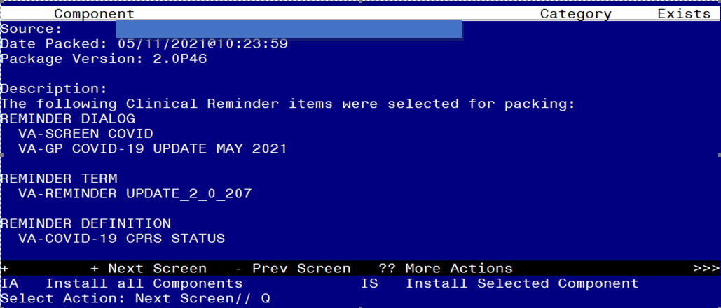

You will then be returned to this screen. At the **Select Action** prompt, type **Q.**

At the end of installation, you may see one or more messages similar to the one below, no action is needed:

Changing pointers to category health factor IMMUNIZATION

to point to IMMUNIZATION [C] and deleting IMMUNIZATION

Install complete.

# Post Installation

1. **Open/review the COVID-19 Screen Template (VA-SCREEN COVID) and confirm the version is 8.1 and that you see the unable to screen option.**
2. **Open/review the VA-COVID-19 PREVENTIVE HEALTH INVENTORY and confirm the new immunization section displays after the scheduled appointment.**
3. **Add local content to reminder dialog groups and elements if needed. (Optional)**

Review the pre-install for the reminder dialog group, VAL-COVID LOCAL GROUP and make any changes that are appropriate for your site

Review the pre-install dialog text in group VAL-COVID-19 PHI NEXT APPOINTMENT as you may have to add your local data object back to the dialog text.

1. **Review the following terms from the pre-install** and edit to add your local items if needed, if you followed the install guide closely during the installation and skipped the terms, no changes should be needed:
2. **VA-COVID-19 PCR LAB RESULTS NEGATIVE**

This term should only contain lab test (LT) findings for COVID-19 PCR lab tests

1. **VA-COVID-19 PCR LAB RESULTS POSITIVE**

This term should only contain lab test (LT) findings for COVID-19 PCR lab tests

1. **VA-COVID-19 PCR LAB ORDERS**

This term should only contain orderable items (OI) findings for COVID-19 PCR lab test orderable items

1. **VA-COVID-19 PCR/AG LAB RESULTS**

This term should only contain lab test (LT) findings for COVID-19 PCR and COVID-19 Antigen lab tests

1. **VA-COVID-19 ANTIBODY LAB TEST**

This term should only contain lab test (LT) findings for COVID-19 ANTIBODY Tests

1. **VA-COVID-19 AG LAB RESULTS POSITIVE**

This term should only contain local lab test (LT) findings for COVID-19 antigen tests

1. **VA-COVID-19 RELATED ORDERABLE ITEMS FOR BANNER DISPLAY**

This term is optional for use and should contain only orderable Items (OI) findings.