

**Update_2_0_209**

Clinical Reminders

VA-OSP SUICIDE RISK MANAGEMENT FOLLOW-UP Install Guide

**August 2021**

Product Development

Office of Information Technology

Department of Veterans Affairs

Table of Contents

Introduction 1

Install Details 3

Install Example 3

Post Installation 6

# Introduction

DESCRIPTION:

The Office of Mental Health and Suicide Prevention is making updates to this existing template based on user feedback and to improve data capture. Additional fields have been added to reflect clinical circumstances the field wants to be able to document. They have added health factors to support the development of metrics for various suicide prevention initiatives.

UPDATE_2_0_209 contains 1 Reminder Exchange entry:

**UPDATE_2_0_209 VA-OSP SUICIDE RISK MANAGEMENT FOLLOW-UP UPDATE**

**The exchange file contains the following components:**

**TIU TEMPLATE FIELD**

TEXT (1-50 CHAR)R

VA-OSP ENTER NOTE

TEXT (1-30 CHAR) REQ

VA-WORDR

VA-WORD

OTHER NON-VA

OTHER TEXT

VA SP 3 LINES

VA-OSP RISK TABLE

**HEALTH FACTORS**

VA-REMINDER UPDATES [C]

VA-UPDATE_2_0_209

VA-SUICIDE RISK MANAGEMENT [C]

VA-SRM FU COVID19

VA-SRM FU OTHER REASON

VA-SRM FU VCL

VA-SRM FU HRF

VA-SRM FU PDE

VA-SRM FU SPED

VA-SRM UNABLE ATTEMPT OTHER

VA-SRM FU UNABLE RCS LETTER

VA-SRM LETTER SENT

VA-SRM FU AD REC

VA-SRM INELIG BY CHART REV

VA-SRM INELIG BY CONSULT

VA-SRM INELIGIBLE FOR CARE

VA-SRM FU CHART LETTER SENT

VA-SRM FU SP CONTINUED

VA-SRM FU VET DECLINED

VA-SRM FU DISCONTINUED OTHER

VA-SRM FU DISCONTINUED ENGAGED

VA-SRM FU DISCONTINUED

VA-SRM FU ENGAGED RES INPT

VA-SRM FU ENGAGED OUTPT

VA-SRM FU VA COMM PROV

VA-SRM FU NONVA COMM PROVIDER

VA-SRM FU VET CENTER

VA-SRM FU VA CARE

VA-SRM FU TX ENGAGEMENT

VA-SRM FU CHART REVIEW

VA-SRM FU UNABLE WELL CHECK

VA-SRM FU YES WELL CHECK

VA-SRM FU NO WELL CHECK

VA-SRM FU NO LETTER

VA-SRM FU LETTER

VA-SRM FU NO VM

VA-SRM FU VM

VA-SRM FU MISSED CALL FIRST

VA-SRM FU UNABLE CONTACT

VA-SRM FU TELEPHONE

VA-SRM FU F2F

VA-SRM FU CVT NON-VVC

VA-SRM FU CVT VVC

VA-SRM FU CVT NON-VA CONSENT NO

VA-SRM FU CVT NON-VA CONSENT YES

VA-SRM FU CVT NON-VA OR HOME-BASED

VA-SRM FU CVT VA CLINIC-BASED

VA-SRM FU CVT

VA-SRM FU SUICIDE RISK MITIGATION

VA-SRM FU LOW CHRONIC RISK

VA-SRM FU INTERMEDIATE CHRONIC RISK

VA-SRM FU HIGH CHRONIC RISK

VA-SRM FU LOW ACUTE RISK

VA-SRM FU INTERMEDIATE ACUTE RISK

VA-SRM FU HIGH ACUTE RISK

VA-SRM FU ADDL DETAILS

VA-SRM FU MH TX DISCUSSED

VA-SRM FU SUPPORT SYS

VA-SRM FU SP YES BARRIERS

VA-SRM FU NO BARRIERS

VA-SRM FU PROVIDE ROI

VA-SRM FU SP DECLINED

VA-SRM FU SP NOT CHANGED

VA-SRM FU SP CHANGED

VA-SRM FU SP REVIEW

VA-SRM FU SP NEW

VA-SRM FU RISK FACTORS

VA-SRM FU PROTECTIVE FACTORS

VA-SRM FU WARNING SIGNS

VA-SRM FU BEHAVIOR

VA-SRM FU IDEATION

VA-SRM FU RISK ASSESSMENT

VA-SRM FU CONTACT MADE

**REMINDER SPONSOR**

OFFICE OF MH AND SUICIDE PREVENTION

MENTAL HEALTH SERVICES

**REMINDER TERM**

VA-REMINDER UPDATE_2_0_209

**REMINDER DIALOG**

VA-OSP SUICIDE RISK MANAGEMENT FOLLOW-UP

# Install Details

Installation:

=============

This update can be loaded with users on the system. Installation will take less than 5 minutes. This update is being distributed as a web host file. The address for the host file is:

https://REDACTED /UPDATE_2_0_209.PRD

The file will be installed using Reminder Exchange, programmer access is not required.

# Install Example

To Load the Web Host File. Navigate to Reminder exchange in VistA

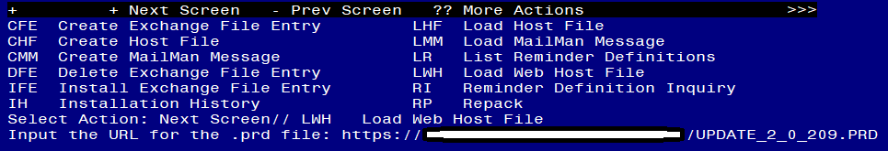

At the **Select Action:** prompt, enter **LWH** for Load Web Host File

At the **Input the url for the .prd file:** prompt, type the following web address:

https://REDACTEDhttps /UPDATE_2_0_209.PRD

You should see a message at the top of your screen that the file loaded successfully

Search and locate an entry titled **UPDATE_2_0_209 VA-OSP SUICIDE RISK MANAGEMENT FOLLOW-UP UPDATE** in reminder exchange.

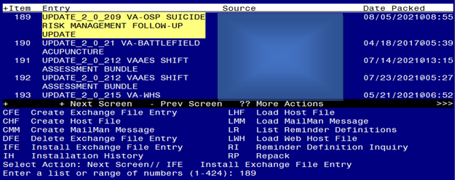

At the **Select Action** prompt, enter **IFE** for Install Exchange File Entry

Enter the number that corresponds with your entry **UPDATE_2_0_209 VA-OSP SUICIDE RISK MANAGEMENT FOLLOW-UP UPDATE** *(in this example it is entry 189 it will vary by site).* The date of the exchange file should be 08/05/2021.

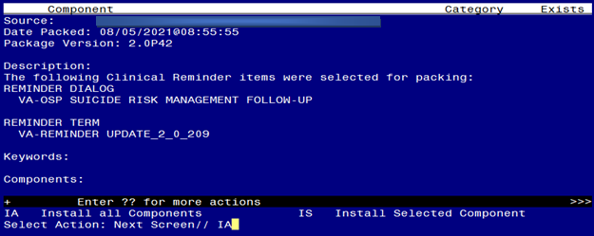

At the **Select Action** prompt, type **IA** for Install all Components and hit enter.

Select Action: Next Screen// IA Install all Components

You will see several prompts, for all new entries you will choose **I to Install**

*For components that already exists but the packed component is different, you will choose* ***O to Overwrite.***

**You will be prompted to install the reminder dialog component – You will choose to install all even though some components may have an X to indicate that they exist.**

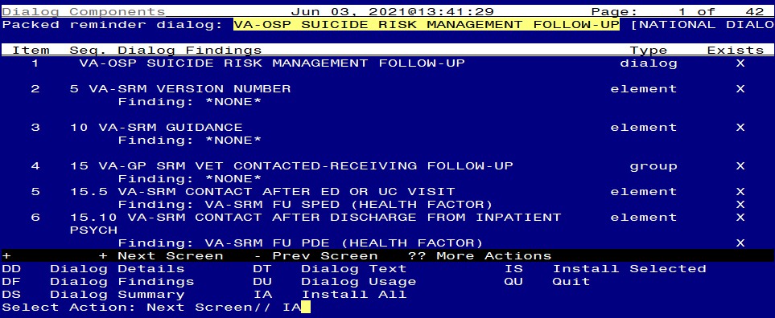

At the **Select Action** prompt, type **IA** to install the dialog – **VA-OSP SUICIDE RISK MANAGEMENT FOLLOW-UP**

Select Action: Next Screen// IA Install All

Install reminder dialog and all components with no further changes: Y// Yes

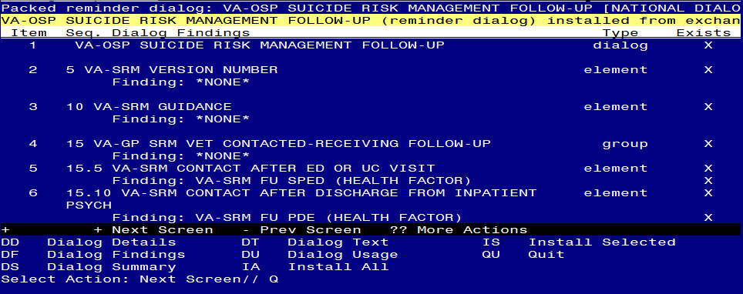

After completing this dialog install, you will type Q.

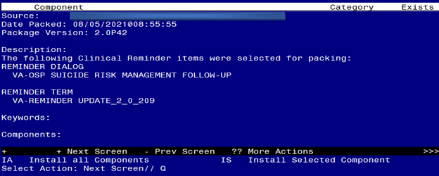

You will then be returned to this screen. At the **Select Action** prompt, type **Q.**

Install complete.

# Post Installation

1. **You should already have a note titled SUICIDE RISK MANAGEMENT FOLLOW-UP attached to the reminder dialog VA-OSP SUICIDE RISK MANAGEMENT FOLLOW-UP. Open/review and confirm the version is 2.****3.**
2. **Insert local data objects.**

Using reminder dialog manager, change view to element view, locate and update the following elements to add your local data objects:

* 1. VAL-TH VVC TELEPHONE TRIAGE CONTACT PHONE OBJECT – replace the dialog text *PHONE OBJECT HERE* with your local object for patient phone number
  2. VAL-TH VVC TELEPHONE TRIAGE PATIENT LOCATION HOME– replace the dialog text *PATIENT ADDRESS OBJECT HERE* with your local object for patient address.