

**Update _2_0_211**

Clinical Reminders

INFLUENZA REMINDER UPDATE 2021

Install Guide

**July 2021**

Product Development

Office of Information Technology

Department of Veterans Affairs

Table of Contents

Introduction 1

Pre-Install 1

Install Details 3

Install Example 3

Post Installation 8

# Introduction

UPDATE Summer 2021 for 2021-22 influenza season.

   1. Update start date to 7/30/21

   2. Update stop date to 5/8/22

   3. Update formulations in the dialog.  (also update the prompts for manuf and lot#/exp)

   4. Update FI(6) and FI(8) to set the begin date of the finding to the

       start date of the flu season - FIEVAL(2,"DATE").

   5. Update the dialog with scribe option and remove the option to enter

       that the vaccine was administered by someone other than the author.

   6. Update to version 2.

**With this install, you should follow the install guide closely to ensure you don’t overwrite your local changes made to the influenza dialog. The steps are outlined below in the Install Details section and are highlighted in yellow.**

UPDATE_2_0_211 contains 1 Reminder Exchange entry:

**UPDATE_2_0_211 FLU REMINDER 2021-2022**

**The exchange file contains the following components:**

TIU TEMPLATE FIELD

1 BLANK TEXT FIELD FOR DIALOGS

2 IM INFLUENZA VACCINE POST SEASON MESSAGE

3 IM INFLUENZA VACCINE REMINDER DIALOG HEADER

4 IM VIS INFLUENZA URL

5 IM VIS INFLUENZA DT

6 IM INFLUENZA COUNSELING

7 IM INFLUENZA FLUZONE HD LOT# EXP DATE

8 IM INFLUENZA CREDENTIALS EG

9 IM INFLUENZA OTHER USER CREDENTIALS

10 EDIT 20+ REQ

11 IM COMMENT COMPLICATONS

12 IM INFLUENZA FLUZONE MANUF

13 IM INJECTION RIGHT/LEFT

14 IM INFLUENZA FLUZONE LOT# EXP DATE

15 IM INFLUENZA FLUARIX LOT# EXP DATE

16 IM INFLUENZA FLUARIX MANUF

17 IM INFLUENZA VACCINE CONTRA WARNING

18 IM INFLUENZA CONTRAINDICATIONS

19 NCP INFLUENZA IMMUNIZATION GUIDANCE

IMMUNIZATION

INFLUENZA, UNSPECIFIED FORMULATION

INFLUENZA, HIGH-DOSE, QUADRIVALENT

INFLUENZA, INJECTABLE, QUADRIVALENT

INFLUENZA, INJECTABLE, QUADRIVALENT, PRESERVATIVE

FREE

INFLUENZA, HIGH DOSE SEASONAL

INFLUENZA, INJECTABLE, MDCK, QUADRIVALENT

INFLUENZA, RECOMBINANT, QUADRIVALENT,INJECTABLE,

PRESERVATIVE FREE

INFLUENZA, INJECTABLE, MDCK, PRESERVATIVE FREE,

QUADRIVALENT

INFLUENZA, TRIVALENT, ADJUVANTED

INFLUENZA, INTRADERMAL, QUADRIVALENT,

PRESERVATIVE FREE

INFLUENZA, RECOMBINANT, INJECTABLE, PRESERVATIVE

FREE

INFLUENZA, INJECTABLE, MDCK, PRESERVATIVE FREE

INFLUENZA NASAL, UNSPECIFIED FORMULATION

INFLUENZA, LIVE, INTRANASAL, QUADRIVALENT

INFLUENZA, SEASONAL, INTRADERMAL, PRESERVATIVE

FREE

INFLUENZA, SEASONAL, INJECTABLE

INFLUENZA, SEASONAL, INJECTABLE, PRESERVATIVE FREE

INFLUENZA, LIVE, INTRANASAL

HEALTH FACTORS

20 VA-REMINDER UPDATES

21 VA-UPDATE_2_0_211

22 IMMUNIZATION

23 VA-INFLUENZA IMM NONE CURRENT SEASON

24 VA-FLU EDUCATION VIRTUAL/TELEHEALTH VST

25 VA-INFLUENZA IMM PRECAUTION

26 VA-INFLUENZA IMM CONTRAINDICATION

27 VA-INFLUENZA IMM REFUSED

REMINDER SPONSOR

28 VA National Center for Health Promotion and

Disease Prevention (NCP)

REMINDER COMPUTED FINDINGS

VA-FILEMAN DATE

VA-ASU USER CLASS

VA-AGE

REMINDER TAXONOMY

29 VA-IMMUNIZATION ICD10 CODE

30 VA-IMMUNIZATION INJECTION 90471

REMINDER TERM

31 VA-REMINDER UPDATE_2_0_211

32 VA-INFLUENZA IMM SEASON STOP DATE

33 VA-INFLUENZA ADMIN SUPPRESSION

34 VA-INFLUENZA HIGH DOSE SUPPRESS OPTION

35 VA-INFLUENZA ORDER SUPPRESSION

36 VA-INFLUENZA IMM REFUSED (END OF SEASON)

37 VA-INFLUENZA IMM NOT DONE THIS SEASON

38 VA-INFLUENZA IMM REFUSED

39 VA-INFLUENZA IMM CONTRAINDICATION

40 VA-INFLUENZA IMM SEASON START DATE

41 VA-INFLUENZA IMM SEASONAL VACCINE FORMULATIONS

REMINDER DEFINITION

42 VA-INFLUENZA SEASONAL IMMUNIZATION

REMINDER DIALOG

43 VA-INFLUENZA IMMUNIZATION

# Pre-Install

None

# Install Details

This update is being distributed as a web host file. The address for the host file is: https://REDACTED/UPDATE_2_0_211.PRD

The file will be installed using Reminder Exchange, programmer access is not required.

Installation:

=============

This update can be loaded with users on the system. Installation will take less than 30 minutes.

# Install Example

To Load the exchange file, use LWH. The URL is <https://REDACTED/UPDATE_2_0_211.PRD>

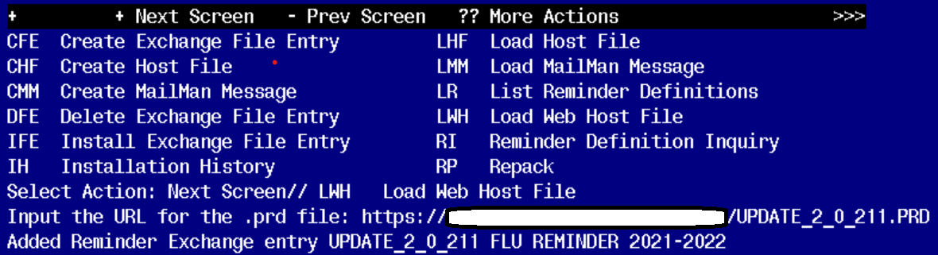

If you use LWH and it works, you will see something like this message. Make sure the file was loaded successfully.

Terminal window screen shot of the message displaying the URL of the file that was successfully loaded.  Part of the URL has been redacted as it is a VA only internal web site URL.

Most components will be the same and will be skipped. Here are general rules for prompts to which you will have to respond.

If a component is new, use **INSTALL** action

Search and locate an entry titled UPDATE_2_0_211 FLU REMINDER 2021-2022 in reminder exchange. If you were a test site, you may have more than 1 entry with this name. Be sure and choose the entry with date of 07/27/2021

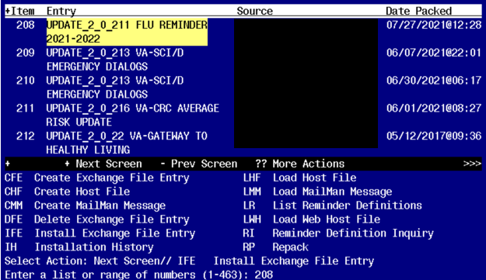

At the **Select Action** prompt, enter **IFE** for Install Exchange File Entry

Enter the number that corresponds with your entry titled UPDATE_2_0_211 FLU REMINDER 2021-2022 *(in this example it is entry 208, it will vary by site)* that is dated 07/27/2021

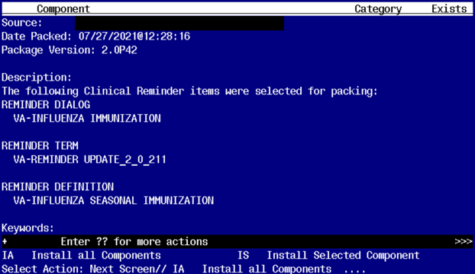

At the **Select Action** prompt, type **IA** for Install all Components and hit enter.

**For all new entries you will choose I to Install**

**For any Reminder Terms that exist but are different, use MERGE action EXCEPT FOR THE FOLLOWING 2 TERMS. FOR THESE TERMS USE OVERWRITE ACTION**

VA-INFLUENZA IMM SEASON START DATE

VA-INFLUENZA IMM SEASON STOP DATE

**For any Template Fields that exist but are different, use OVERWRITE action**

**For existing reminder definition that is different, use OVERWRITE action**

**For Health Factors that exist but are different use OVERWRITE action**

**There is one item that may appear in your test account only. If you see this when merging reminder term** VA-INFLUENZA IMM SEASONAL VACCINE FORMULATIONS, follow the example below. This is due to the fact that Immunization INFLUNZA, HIGH-DOSE, QUADRAVALENT may not exist in your test system, but it will exist in your production system.

REMINDER TERM entry named VA-INFLUENZA IMM SEASONAL VACCINE

FORMULATIONS already exists but the packed component is different,

what do you want to do?

Select one of the following:

C Create a new entry by copying to a new name

M Merge findings

O Overwrite the current entry

U Update

Q Quit the install

S Skip, do not install this entry

Enter response: O// Merge findings

Finding IM.INFLUENZA, HIGH-DOSE, QUADRIVALENT does not exist, what do you want t

o do?

Select one of the following:

D Delete

P Replace with an existing entry

Q Quit the install

Enter response: Delete

**You will be promped to install the reminder dialog component: Many sites have made local edits to the influenza dialog and this will install will override all your local modifications**

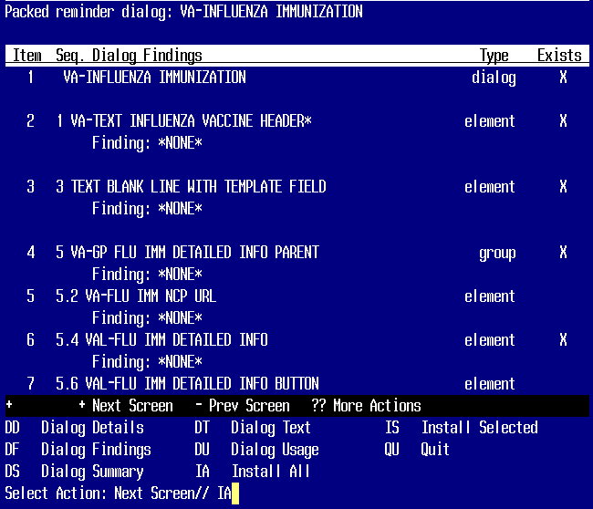

At the **Select Action** prompt, type **IA** to install all items.. If you have made local changes, this will overwrite all your changes!!

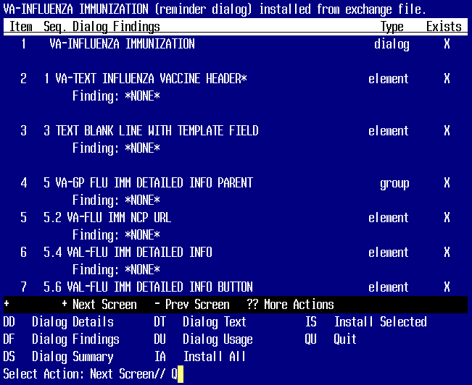

When the dialog has completed installation, you will then be returned to this screen. At the **Select Action** prompt, type **Q.**

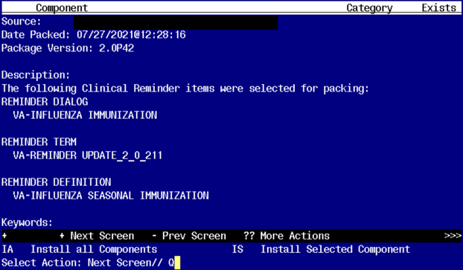

**Type Q to exit the dialog installation**

# Post Installation

1. Add the appropriate immunization quick orders as a FINDING ITEM on the following groups using the reminder dialog manager, reminder dialog menu and change view to groups. If you are not sure what order to map, please work with your pharmacy Ad Pac.
   1. Group - VAL-OI IM INFLUENZA OUTPT

The finding item should be your local order or ordering menu for seasonal influenza.

1. Review the term VA-INFLUENZA IMM SEASONAL VACCINE FORMULATIONS. All the current season’s formulations are included in the term. You should not have to map any local entries. If you find that a vaccine type that you are recording is not included in this term, then please check your reminder dialogs because you could be recording an incorrect formulation or one that should no longer be in use.
2. If you want to suppress the ordering option in the dialog or the administration option in the INFLUENZA dialog, then follow the instructions in the following reminder terms.
   1. VA-INFLUENZA ORDER SUPPRESSION
   2. VA-INFLUENZA ADMIN SUPPRESSION

To suppress the dialog element for specific user classes: VA-ASU USER CLASS Enter the user class that should NOT see the dialog element. If more than one user class is needed, add additional findings of the CF VA-ASU USER CLASS for each one as needed.

To suppress the dialog element for all users: VA-AGE change the < sign to a > sign in the CF for patient age.

To suppress for specific user classes, in the above Terms configure the VA-ASU USER CLASS computed finding and DELETE the VA-AGE finding. NOTE: If the Age finding is not deleted, the user class settings will not work.

Other Local Options

1. Season Start Date: There is a reminder term for the season start date. This is the date before which any vaccination will be ignored for this current season. The reminder is exported with a date of 7/30/2021. You should not need to change this date for the 2021-2022 flu season. In future years, you may be asked to update this date.

VA-INFLUENZA IMM SEASON START DATE

--------------------------------------

Class: NATIONAL

Sponsor: VA National Center for Health Promotion and Disease Prevention (NCP)

Date Created:

Review Date:

Description:

Record the date that the first influenza vaccine for a season should be considered

valid.

E.g. If any vaccine given in August 2021 should be considered valid, then

use 7/31/2021 as the start date since a vaccine recorded with only a

month/year for Aug 2030 will have a date of 08/00/2021.

Enter the date for the start of the valid immunization period as a FileMan

date - enter this in the COMPUTED FINDING PARAMETER field.

Format for FileMan date 3yymmdd

7/30/21 ==> 3210730

Findings:

Finding Item: VA-FILEMAN DATE (FI(1)=CF(69))

Finding Type: REMINDER COMPUTED FINDING

Computed Finding Parameter: 3210530

1. Season Stop Date: There is a reminder term to indicate the date that a facility chooses to stop giving vaccine. Each spring, when flu season is over based on community incidence, the facility chooses to stop giving vaccine. After this date has passed as defined in this reminder term, the reminder logic changes to turn off if the vaccine was refused during the season or if someone records that the patient did not get vaccine during the season. The dialog also changes to a post-season version once this date has passed.  
   The term is exported with a default of 5//2022 which will need to be updated by each site in the spring of 2022 when a decision is made to stop giving vaccine.  
     
   VA-INFLUENZA IMM SEASON STOP DATE

----------------------------------

Class: NATIONAL

Sponsor: VA National Center for Health Promotion and Disease Prevention (NCP)

Description:

Record the date that the site decides to stop giving the influenza vaccine

for a season.

E.g. If influenza activity in the community has dropped off to very low

levels and the site will no longer give vaccine after May 8, 2022, then

enter that date.

Enter the date that the last vaccine will be administered by a site.

FileMan date - enter this in the COMPUTED FINDING PARAMETER field.

Format for FileMan date 3yymmdd

05/08/22 ==> 3220508

Findings:

Finding Item: VA-FILEMAN DATE (FI(1)=CF(69))

Finding Type: REMINDER COMPUTED FINDING

Computed Finding Parameter: 3220508

1. Refusals: The reminder currently is resolved if the patient has 2 refusals in the past 30 days or if the season is over, then any refusal during the season will resolve the reminder. Sites may shorten the time period that the 2 refusals resolve the reminder during the season. To do this, edit the reminder definition and edit the finding in the term  
   3 VA-INFLUENZA IMM REFUSED  
   Change the date range on the finding HF VA-INFLUENZA IMM REFUSED  
   by giving it a different BEGIN date such as T-7
2. Dialog Text: much of the informational text and all of the administration options in the reminder dialog are local. You can edit the information text to add flu clinic hours or other local information. You can add or remove any of the flu vaccination options – the 3 formulary vaccine formulations are included by default but the group that contains them is local.
3. High dose suppression: if you want to completely suppress the option to document high dose vaccine on some group of patients, you can do that by making the condition in the reminder term shown below true for those patients. The reminder dialog is exported with a default age of 18 - for patients under the age of 18, the option to document high dose is suppressed.   
     
   PLEASE be careful with this option -if a nurse administers high dose vaccine and then opens the dialog and the option is not there, they are likely to record the vaccine incorrectly.

VA-INFLUENZA HIGH DOSE SUPPRESS OPTION

-------------------------------------------

Class: NATIONAL

Sponsor: VA National Center for Health Promotion and Disease Prevention (NCP)

Description:

Enter any condition or reminder definition that defines a population for

whom the option to see the High Dose flu vaccine administration option will

be suppressed.

If this term is true, then that option will be suppressed.

Findings:

Finding Item: VA-AGE (FI(1)=CF(27))

Finding Type: REMINDER COMPUTED FINDING

Condition: I V<18

1. Adding non-formulary formulations: The group for administering vaccine is local. You can copy one of the existing options and add it to the group. Be sure to make separate template fields for the manufacturer and lot #s if you have those set by default.
2. Lot#s: You may edit the template fields and make them drop down lists of available lot #s at your site to make it easier for the nurses. These template fields are exported as Edit Boxes but you can change them to a Combo Box with a list of selectable Lot #s and expiration dates.

IM INFLUENZA AFLURIA SYRINGES LOT# EXP DATE

IM INFLUENZA AFLURIA MD VIALS LOT# EXP DATE

IM INFLUENZA FLUZONE HD LOT# EXP DATE

1. Z code: the Z code for immunizations is included in a group that allows primary diagnosis or entry of the ICD10 code as a secondary diagnosis. The word ‘OPTIONAL’ above that group is local and can be edited or removed.

Install complete.