

**Update _2_0_215**

Clinical Reminders

VA-WHS WELL-BEING SIGNS

Install Guide

**August 2021**

Product Development

Office of Information Technology

Department of Veterans Affairs

Table of Contents

Introduction 1

Install Details 2

Install Example 2

Post Installation 6

# Introduction

VA Office of Patient Centered Care and Cultural Transformation program has created a new reminder dialog template for vitality and well-being signs.

This template will apply to all patients, to be completed when any provider type completes review of well-being signs in any clinic.  They are collecting national health factors to track percentage rated over time and track utilization. Well-being signs are measure of overall well-being and finalizing validation process.

Workflow: Within encounter with Veteran, provider can incorporate assessment of well-being signs and utilize this template to capture/document veteran self reported rating.

UPDATE_2_0_215 contains 1 Reminder Exchange entry:

**UPDATE_2_0_215 VA-WHS WELL-BEING SIGNS**

**The exchange file contains the following components:**

**HEALTH FACTORS**

VA-REMINDER UPDATES

VA-UPDATE_2_0_215

VA-HEALTH AND WELL BEING [C]

VA-WHS SCORE OF 20% OR LESS

VA-WHS VITALITY/WELL BEING SCORE

VA-WHS SATISFACTION DECLINED

VA-WHS SATISFACTION 100%

VA-WHS SATISFACTION 90%

VA-WHS SATISFACTION 80%

VA-WHS SATISFACTION 70%

VA-WHS SATISFACTION 60%

VA-WHS SATISFACTION 50%

VA-WHS SATISFACTION 40%

VA-WHS SATISFACTION 30%

VA-WHS SATISFACTION 20%

VA-WHS SATISFACTION 10%

VA-WHS SATISFACTION 0%

VA-WHS FUNCTION DECLINED

VA-WHS FUNCTION 100%

VA-WHS FUNCTION 90%

VA-WHS FUNCTION 80%

VA-WHS FUNCTION 70%

VA-WHS FUNCTION 60%

VA-WHS FUNCTION 50%

VA-WHS FUNCTION 40%

VA-WHS FUNCTION 30%

VA-WHS FUNCTION 20%

VA-WHS FUNCTION 10%

VA-WHS FUNCTION 0%

VA-WHS PARTICIPATE DECLINED

VA-WHS PARTICIPATE 100%

VA-WHS PARTICIPATE 90%

VA-WHS PARTICIPATE 80%

VA-WHS PARTICIPATE 70%

VA-WHS PARTICIPATE 60%

VA-WHS PARTICIPATE 50%

VA-WHS PARTICIPATE 40%

VA-WHS PARTICIPATE 30%

VA-WHS PARTICIPATE 20%

VA-WHS PARTICIPATE 10%

VA-WHS PARTICIPATE 0%

VA-WHS VITALITY/WELL-BEING NOTE

**REMINDER TERM**

VA-REMINDER UPDATE_2_0_215

**REMINDER DIALOG**

VA-WHS WELL-BEING SIGNS

# Install Details

This update is being distributed as a web host file. The address for the host file is: **https://Redacted /UPDATE_2_0_215.PRD**

The file will be installed using Reminder Exchange, programmer access is not required.

Installation:

=============

This update can be loaded with users on the system. Installation will take less than 5 minutes.

# Install Example

To Load the Web Host File. Navigate to Reminder exchange in Vista

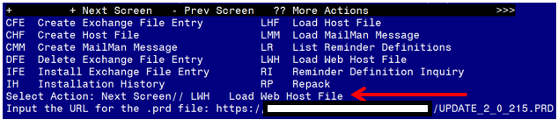

At the **Select Action:** prompt, enter **LWH** for Load Web Host File

At the **Input the url for the .prd file:** prompt, type the following web address:

**https://Redacted /UPDATE_2_0_215.PRD**

You should see a message at the top of your screen that the file successfully loaded.

Search and locate an entry titled **UPDATE_2_0_215 VA-WHS WELL-BEING SIGNS** in reminder exchange.

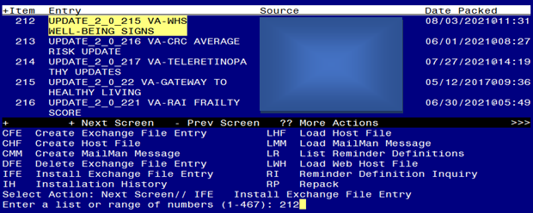

At the **Select Action** prompt, enter **IFE** for Install Exchange File Entry

Enter the number that corresponds with your entry UPDATE_2_0_215 VA-WHS WELL-BEING SIGNS *(in this example it is entry 293. It will vary by site).* The date of the exchange file should be 08/03/2021.

THIS NEXT STEP IS NEW – PLEASE PAY CLOSE ATTENTION BEFORE YOU INSTALL ALL COMPONENTS, YOU NEED TO **INSTALL SELECT** THE NEW REMINDER SPONSOR ENTRY ONLY (ITEM 43):

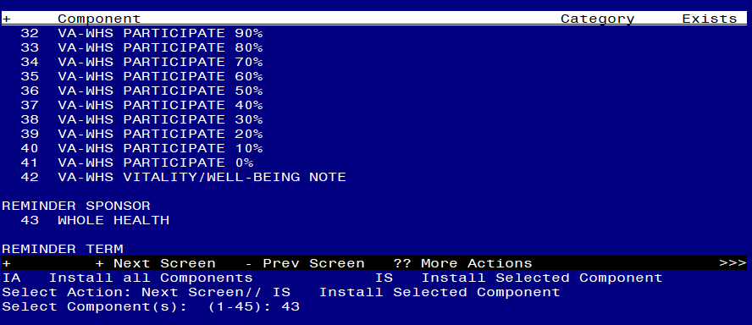

Select Action: Quit// is Install Selected Component

Select Component(s): (1-42): 43

REMINDER SPONSOR entry WHOLE HEALTH is NEW,

what do you want to do?

Select one of the following:

C Create a new entry by copying to a new name

I Install

Q Quit the install

S Skip, do not install this entry

Enter response: I// nstall

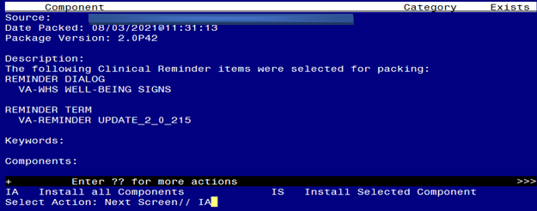

At the **Select Action** prompt, type **IA** for Install all Components and hit enter.

Select Action: Next Screen// IA Install all Components

You will see several prompts, for all new entries you will choose **I to Install**

For components that already exists but the packed component is different, choose **S to Skip.**

**You will be promped to install the reminder dialog component (VA-WHS WELL-BEING SIGNS).** You will choose to install all even though some components may have an X to indicate that they exist.

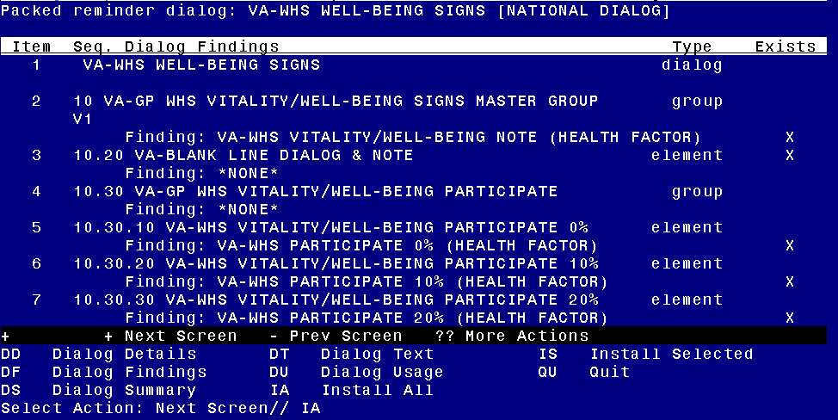

At the **Select Action** prompt, type **IA** to install the dialog: **VA-WHS WELL-BEING SIGNS**

Select Action: Next Screen// IA Install All

Install reminder dialog and all components with no further changes: Y// Yes

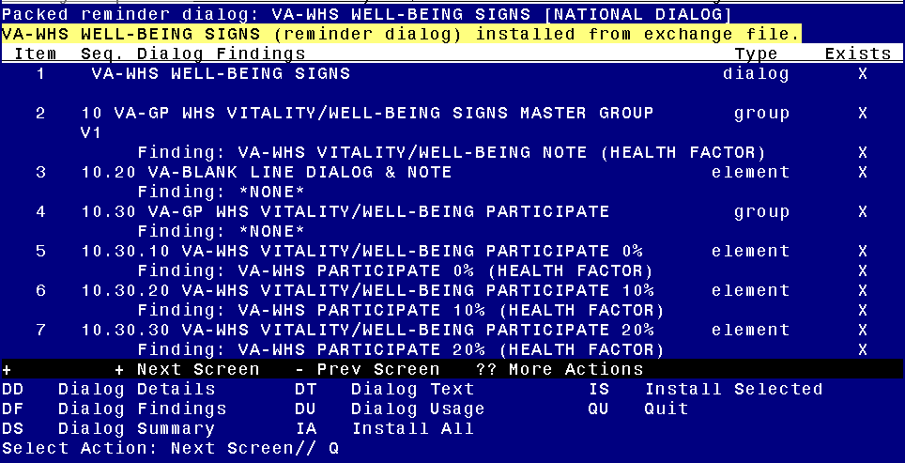

After completing this dialog install, you will type Q.

Screen shot of the terminal window showing that after all of the groups, elements and dialogs have been installed, the reminder that was installed with Q entered for quit to finish. The name of the VA employee at the Source line label has been redacted.



You will then be returned to this screen. At the **Select Action** prompt, type **Q.**

Install complete.

# Post Installation

1. **Make the Dialog template available to be attached to a Personal or Shared template or to be able to attach the dialog to a progress note title.**

Select Reminder Managers Menu <TEST ACCOUNT> Option: **CP** CPRS Reminder Configuration

CA Add/Edit Reminder Categories

CL CPRS Lookup Categories

CS CPRS Cover Sheet Reminder List

MH Mental Health Dialogs Active

PN Progress Note Headers

RA Reminder GUI Resolution Active

TIU TIU Template Reminder Dialog Parameter

DEVL Evaluate Coversheet List on Dialog Finish

DL Default Outside Location

PT Position Reminder Text at Cursor

LINK Link Reminder Dialog to Template

TEST CPRS Coversheet Time Test

NP New Reminder Parameters

GEC GEC Status Check Active

WH WH Print Now Active

Select CPRS Reminder Configuration <TEST ACCOUNT> Option: **TIU** TIU Template Reminder Dialog Parameter

Reminder Dialogs allowed as Templates may be set for the following:

1 User USR [choose from NEW PERSON]

3 Service SRV [choose from SERVICE/SECTION]

4 Division DIV [SALT LAKE CITY]

5 System SYS [NATREM.FO-SLC.MED.VA.GOV]

Enter selection: **5** *Choose the appropriate number for your site. Your site may do this by System or other levels. The example below uses SYSTEM level.*

Setting Reminder Dialogs allowed as Templates for System: NATREM.FO-SLC.MED.VA.GOV

Select Display Sequence: **?**

388 VA-COVID-19 TELEPHONE FOLLOW-UP

389 VA-SRA-CONSULT RESPONSE (D)

*When you type a question mark above, you will see the list of #’s (with dialogs) that are already taken. Choose a number* ***NOT*** *on this list. For this example, 390 is not present so I will use 390.*

Select Display Sequence: **390**

Are you adding 390 as a new Display Sequence? Yes// **YES**

Display Sequence: 390// <Enter> 390

Clinical Reminder Dialog: **VA-WHS WELL-BEING SIGNS** reminder dialog NATIONAL

...OK? Yes// <Enter> (Yes)

1. **Setup of Note Title.**

The note title to create to associate with this template is: WELL-BEING SIGNS

VHA Enterprise Standard Title: **INTEGRATIVE HEALTH NOTE**

You can add this to your document class where whole health notes are located.

***Note:*** *Comprehensive information on Creating new Document Classes and Titles can be found beginning on page 54 of the TIU/ASU Implementation Guide at the following link:* [*http://www.va.gov/vdl/documents/Clinical/CPRS-Text_Integration_Utility_(TIU)/tiuim.pdf*](http://www.va.gov/vdl/documents/Clinical/CPRS-Text_Integration_Utility_(TIU)/tiuim.pdf)

1. **Associate the reminder dialog with the note title in CPRS**

In CPRS, open the Template Editor, expand Document Titles, select the appropriate folder (if applicable), then click New Template (top right-hand corner).

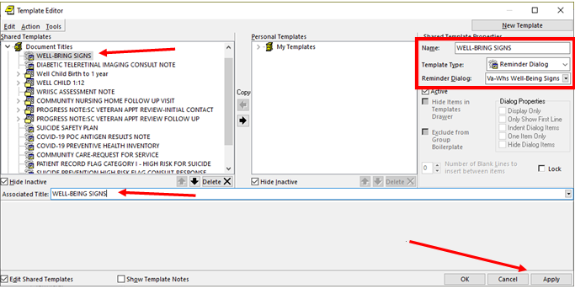

Type in the following information:

Name: **WELL-BEING SIGNS**

Template Type: **Reminder Dialog**

Reminder Dialog: **VA-WHS WELL-BEING SIGNS**

Next, type in the Associated Title name – **WELL-BEING SIGNS** – then click Apply.