

**Update_2_0_216**

Clinical Reminders

**VA-COLORECTAL CANCER SCREENING UPDATE**

Install Guide

**July 2021**

Product Development

Office of Information Technology

Department of Veterans Affairs

**Table of Contents**

Introduction 1

Pre-Install 5

Install Details 5

Install Example 6

Post Installation 17

# Introduction

**The four colorectal screening reminders were released in 2017 as Clinical reminder Update_2_0_9 and updated with Update_2_0_94. This reminder update includes updates/additions to the VA-CRC Average Risk reminder definition.**

**The following changes are in this update:**

1. The VA-CRC AVERAGE RISK baseline frequency changed to 45yo to meet new guidelines to begin CRC screening at age 45.

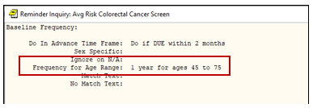

1. All reminder dialog options with branching logic based on age have been updated to the new guidelines. The options below will now display for patients 35yo and older, instead of beginning at age 40. These options are in the VA-CRC COLONOSCOPY AVG RISK, VA-CRC WAITING FOR RECOMMEND GAP, VA-CRC COLONOSCOPY FOLLOW UP REMINDER, VA-CRC COLON SCREENING DOCUMENTATION reminder dialogs.

Note: The age range has changed in the following terms, however, the reminder term name has not changed. Changing the name to match the new age range would have installed new terms, which would have required remapping throughout the dialogs. The decision was made to keep the existing names to reduce the amount of remapping at local sites.

VA-AGE <50

VA-AGE <40!>74

VA-AGE <40!>65

VA-AGE <40!>66

VA-AGE <40!>67

VA-AGE <40!>68

VA-AGE <40!>69

VA-AGE <40!>70

VA-AGE <40!>71

VA-AGE <40!>72

VA-AGE <40!>73

VA-AGE <40

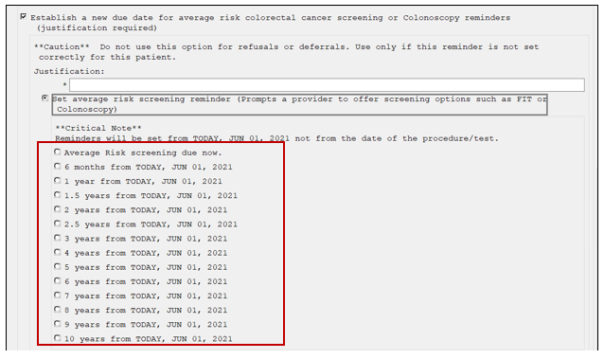

1. In this reminder dialog option to set the average risk screening reminder, the option has been changed from “currently 50 yo” to “currently 45 yo.” This option will only display for patients less than 35 yo. This option is in the VA-CRC COLONOSCOPY AVG RISK, VA-CRC WAITING FOR RECOMMEND GAP, VA-CRC COLONOSCOPY FOLLOW UP REMINDER, VA-CRC COLON SCREENING DOCUMENTATION.

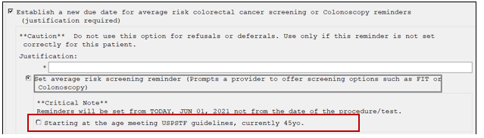

1. In this reminder dialog option to set the colonoscopy reminder, the option has been changed from “currently 50 yo” to “currently 45 yo.” This option will only display for patients less than 35 yo. This option is in the VA-CRC COLONOSCOPY AVG RISK, VA-CRC WAITING FOR RECOMMEND GAP, VA-CRC COLONOSCOPY FOLLOW UP REMINDER, VA-CRC COLON SCREENING DOCUMENTATION.

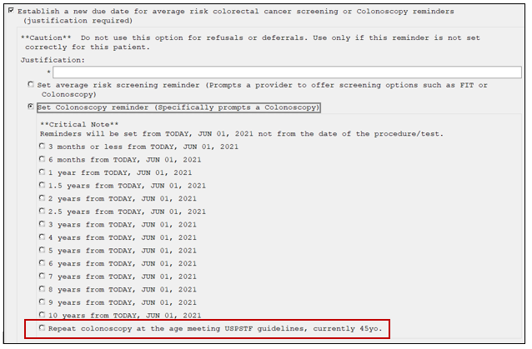

1. In the reminder dialog option below, the option in the patient letter portion of the VA-CRC COLON SCREENING DOCUMENTATION has been changed from “age 50” to “age 45.” This option will only display for patients less than 45 yo.

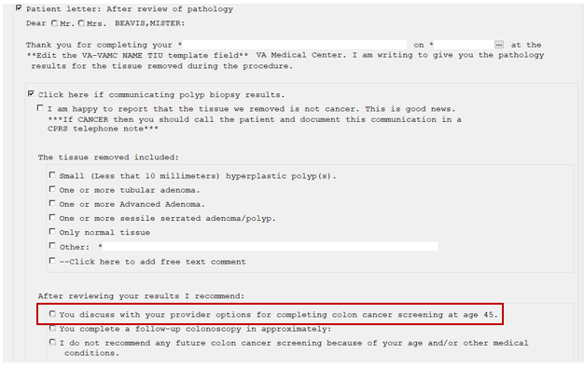

**It will be very important that you follow the install guide carefully during the install.**

**The exchange file contains the following components:**

**REMINDER DIALOGS**

VA-CRC AVG RISK UPDATE JUNE 2021

**REMINDER DEFINITIONS**

VA-CRC AVERAGE RISK

**REMINDER TERMS**

VA-REMINDER UPDATE_2_0_216

VA-AGE <50

VA-AGE <40!>74

VA-AGE <40!>65

VA-AGE <40!>66

VA-AGE <40!>67

VA-AGE <40!>68

VA-AGE <40!>69

VA-AGE <40!>70

VA-AGE <40!>71

VA-AGE <40!>72

VA-AGE <40!>73

VA-AGE <40

# Pre-Install

1. Using the Vista menu, Reminder Managers Menu, inquire about Reminder Definition, run an inquire/print on the following reminder. **Remapping should not be required if the appropriate items are selected for installation.** However, if inappropriate terms are accidentally overwritten, a copy of the definition will be helpful.
   1. VA-CRC AVERAGE RISK
2. Using the Vista menu, Reminder Dialog Management, Reminder Dialogs, change your view to dialog view and run an inquire/print on the following reminder dialogs. **Remapping should not be required if the appropriate items are selected for installation.** However, if inappropriate groups or elements are accidentally overwritten, a copy of the dialog will be helpful.
   1. VA-CRC COLONOSCOPY AVG RISK

# Install Details

This update is being distributed as a web host file. The address for the host file is:

<https://REDACTED/UPDATE_2_0_216.PRD>

This update can be loaded with users on the system. Installation should take less than 5 minutes.

# Install Example

**Follow the instructions below carefully. Only a few items in the exchange file will be installed.**

**DO NOT INSTALL ALL.**

At the **Select Action:** prompt, enter **LWH** for Load Web Host File

At the **Input the url for the .prd file:** prompt, type the following web address:

[**https://REDACTED/UPDATE_2_0_216.PRD**](https://REDACTED/UPDATE_2_0_216.PRD)

Search and locate an entry titled **UPDATE_2_0_216 VA-CRC AVERAGE RISK UPDATE**

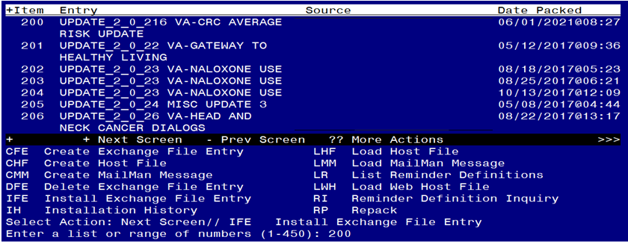

At the **Select Action** prompt, enter **IFE** for Install Exchange File Entry

Enter the number that corresponds with your entry **UPDATE_2_0_216 VA-CRC AVERAGE RISK UPDATE.**  *(in this example it is entry 200 it will vary by site).* The date of the exchange file should be 06/01/2021.

Follow the screenshots below to install selected items. **Do not select Install All.**

**Follow the instructions below carefully. Only a few items in the exchange file will be installed. DO NOT INSTALL ALL.**

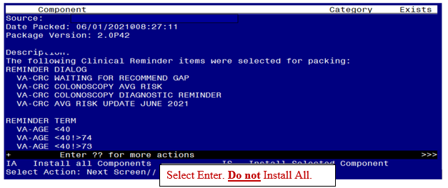

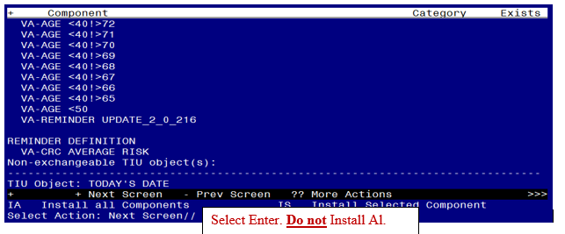

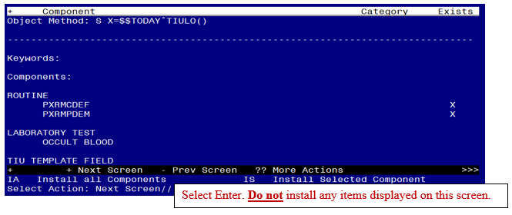

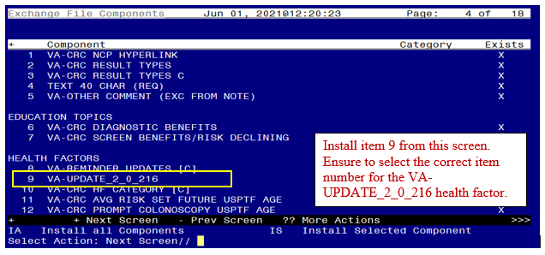

At the HEALTH FACTORS section, select **IS**, then choose the item number 9 from the screenshot above.

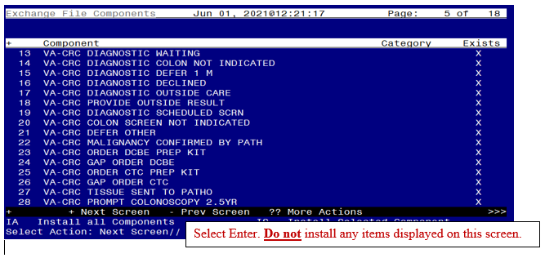

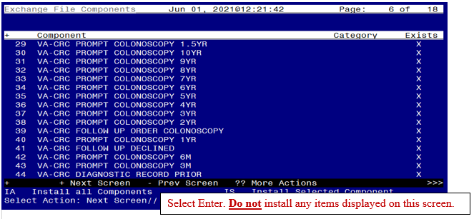

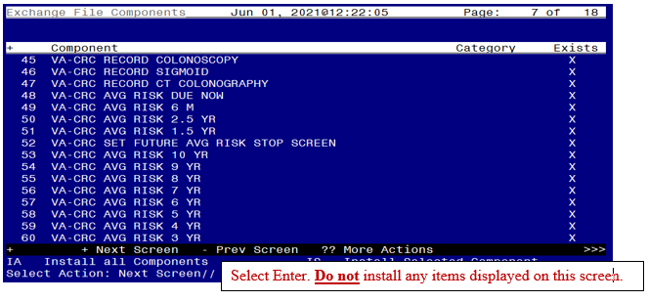

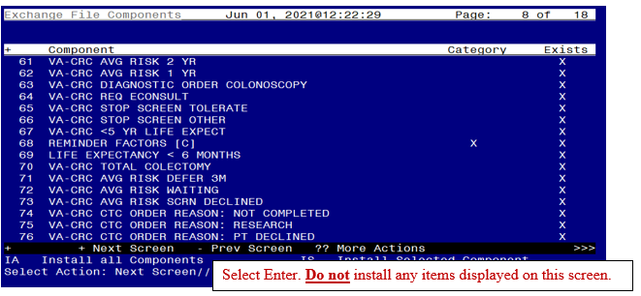

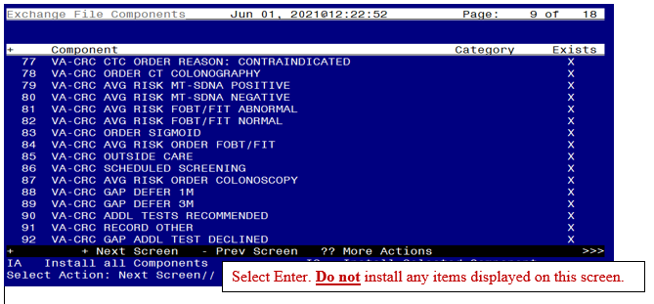

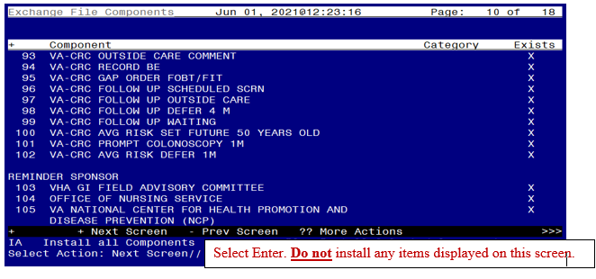

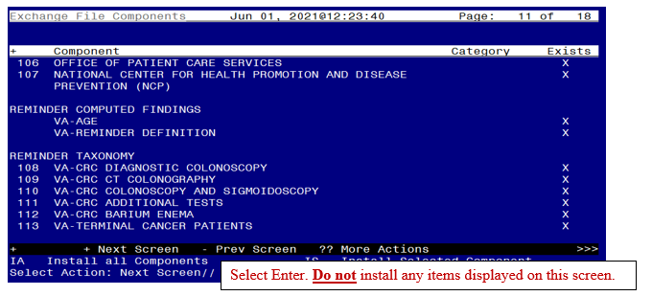

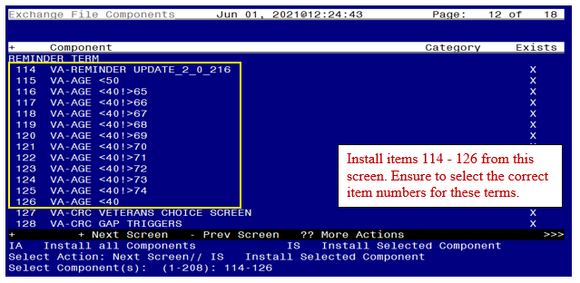

At the REMINDER TERM section, select **IS**, then choose the item numbers 114-126 from the screenshot above.

**Overwrite** the terms.

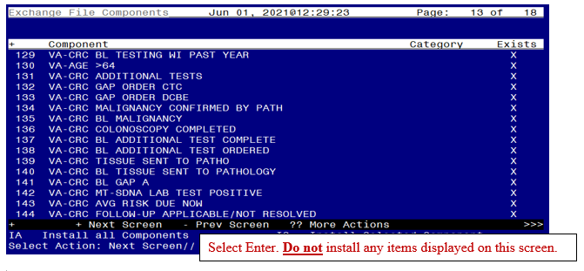

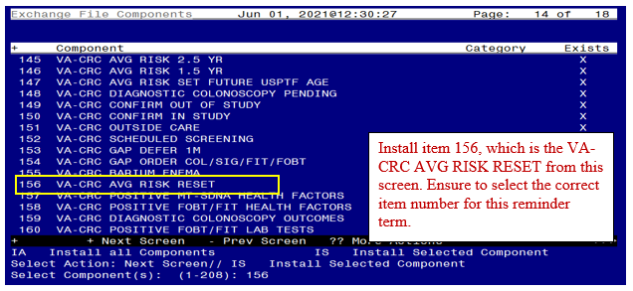

At the REMINDER TERM section, select **IS**, then choose the item number 156 from the screenshot above.

**Merge the term.**

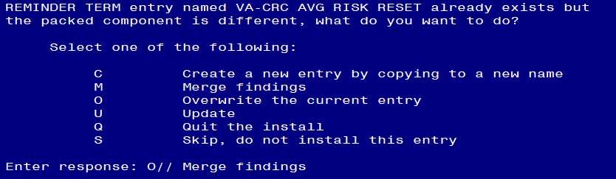

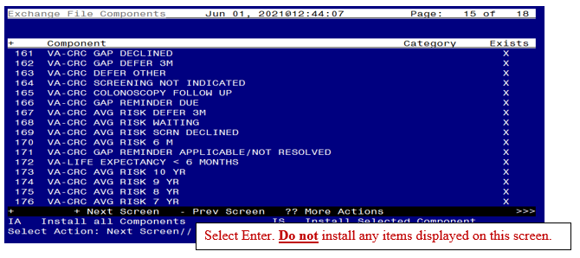

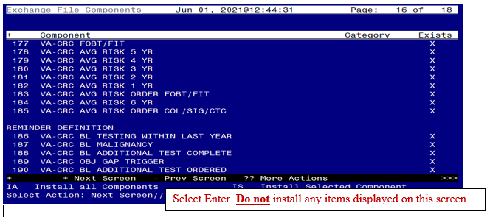

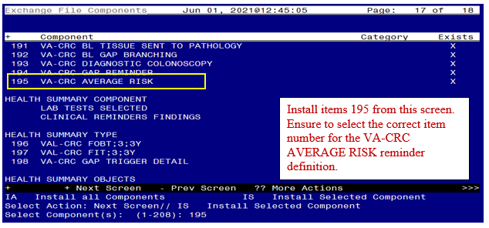

Select **IS**, then the item number for the **VA-CRC AVERAGE RISK** reminder.

**Overwrite the reminder definition.**

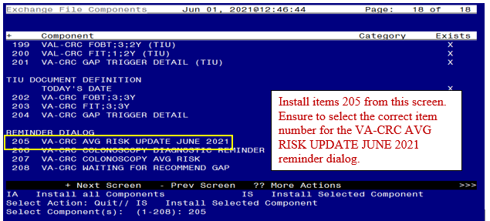

Select **IS**, then the item number for the **VA-CRC AVG RISK UPDATE JUNE 2021** reminder dialog.

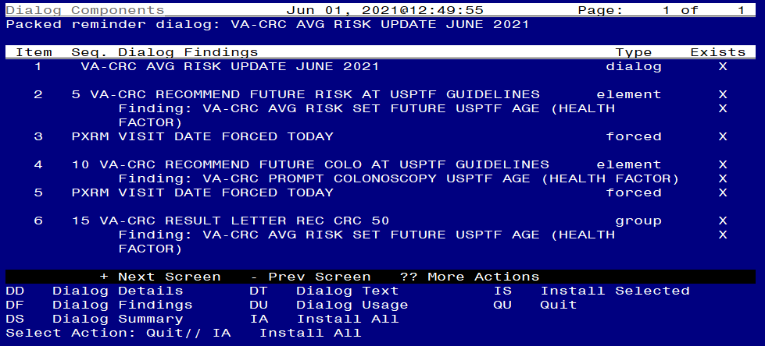

The **VA-CRC AVG RISK UPDATE JUNE 2021** dialog will display.

Select **IA** for Install All. At the Install reminder dialog and all components with no further changes, enter **Yes**.

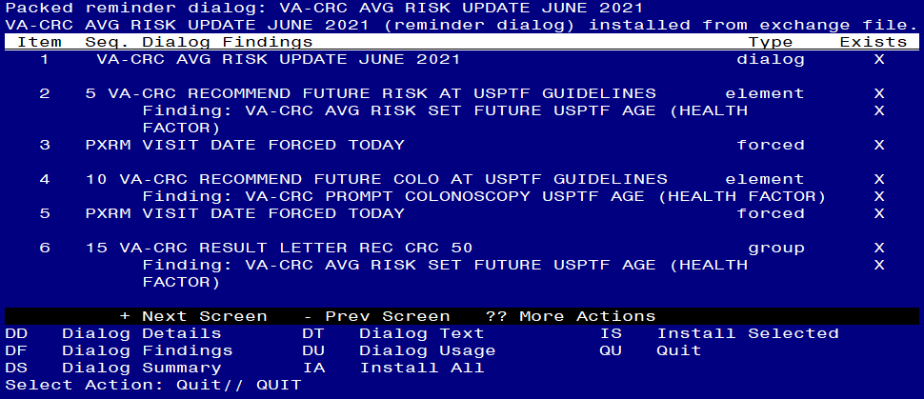

After the dialog installs, you will then be returned to this screen. At the **Select Action** prompt, type **Q.**

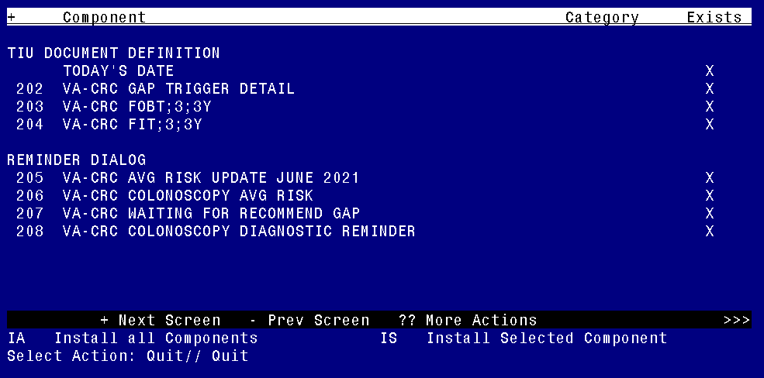

After the dialog installs, you will then be returned to this screen. At the **Select Action** prompt, type **Q.**

Install Complete

# Post Install

1. Confirm the changes in the reminder dialogs and the VA-CRC AVERAGE RISK reminder definition as described in the installation description.
2. Confirm the appropriate text changed in the VA-CRC DOCUMENTATION dialog if local modifications were made to this dialog.