

**Update _2_0_218**

Clinical Reminders

VA-CSP PHP AND WHOLE HEALTH COACHING

Install Guide

**September 2021**

Product Development

Office of Information Technology

Department of Veterans Affairs

Table of Contents

Introduction 1

Install Details 5

Install Example 5

Post Installation 9

# Introduction

In October 2020 the Caregiver Support Program (CSP) implemented changes to the Program of Comprehensive Assistance for Family Caregivers Program that were required under the MISSION Act.  In an effort to meet the needs of the expanded population, CSP continues to add additional programs and services for caregivers.  CSP is currently implementing Personal Health Planning and Whole Health Coaching with caregivers. Health factors built into the templates will assist with evaluating the program moving forward.

UPDATE_2_0_218 contains 1 Reminder Exchange entry:

**UPDATE_2_0_218 VA-CSP PHP AND WELLNESS**

**The exchange file contains the following components:**

**TIU TEMPLATE FIELD**

VA-TEXT (1-30 CHAR)R

VA-TEXT (3 CHAR)R

VA-PHP WHOLE HEALTH LIBRARY URL

VA-WORDR

**HEALTH FACTORS**

VA-REMINDER UPDATES [C]

VA-UPDATE_2_0_218

VA-CSP CAREGIVER SELF-EFFICACY [C]

VA-CSP PGCSS CG SELF EFF SCORE MISS

VA-CSP PGCSS CG SELF EFF SCORE 20

VA-CSP PGCSS CG SELF EFF SCORE 19

VA-CSP PGCSS CG SELF EFF SCORE 18

VA-CSP PGCSS CG SELF EFF SCORE 17

VA-CSP PGCSS CG SELF EFF SCORE 16

VA-CSP PGCSS CG SELF EFF SCORE 15

VA-CSP PGCSS CG SELF EFF SCORE 14

VA-CSP PGCSS CG SELF EFF SCORE 13

VA-CSP PGCSS CG SELF EFF SCORE 12

VA-CSP PGCSS CG SELF EFF SCORE 11

VA-CSP PGCSS CG SELF EFF SCORE 10

VA-CSP PGCSS CG SELF EFF SCORE 9

VA-CSP PGCSS CG SELF EFF SCORE 8

VA-CSP PGCSS CG SELF EFF SCORE 7

VA-CSP PGCSS CG SELF EFF SCORE 6

VA-CSP PGCSS CG SELF EFF SCORE 5

VA-CSP PGCSS CG SELF EFF SCORE 4

VA-CSP PGCSS CG SELF EFF Q4 MISS

VA-CSP PGCSS CG SELF EFF Q4 5 VERY

VA-CSP PGCSS CG SELF EFF Q4 4 QUITE

VA-CSP PGCSS CG SELF EFF Q4 3 SOME

VA-CSP PGCSS CG SELF EFF Q4 2 LITTLE

VA-CSP PGCSS CG SELF EFF Q4 1 NOT

VA-CSP PGCSS CG SELF EFF Q3 MISS

VA-CSP PGCSS CG SELF EFF Q3 5 VERY

VA-CSP PGCSS CG SELF EFF Q3 4 QUITE

VA-CSP PGCSS CG SELF EFF Q3 3 SOME

VA-CSP PGCSS CG SELF EFF Q3 2 LITTLE

VA-CSP PGCSS CG SELF EFF Q3 1 NOT

VA-CSP PGCSS CG SELF EFF Q2 MISS

VA-CSP PGCSS CG SELF EFF Q2 5 VERY

VA-CSP PGCSS CG SELF EFF Q2 4 QUITE

VA-CSP PGCSS CG SELF EFF Q2 3 SOME

VA-CSP PGCSS CG SELF EFF Q2 2 LITTLE

VA-CSP PGCSS CG SELF EFF Q2 1 NOT

VA-CSP PGCSS CG SELF EFF Q1 MISS

VA-CSP PGCSS CG SELF EFF Q1 5 VERY

VA-CSP PGCSS CG SELF EFF Q1 4 QUITE

VA-CSP PGCSS CG SELF EFF Q1 3 SOME

VA-CSP PGCSS CG SELF EFF Q1 2 LITTLE

VA-CSP PGCSS CG SELF EFF Q1 1 NOT

VA-PHP [C]

VA-PHP CHALLENGES

VA-PHP SUPPORT CAREGIVER TEAM

VA-PHP SUPPORT WHOLE HEALTH COACH

VA-PHP SUPPORT WELL BEING TEAM

VA-PHP SUPPORT CLINICAL TEAM

VA-PHP SUPPORT WHOLE HEALTH PARTNER

VA-PHP SUPPORT FRIENDS

VA-PHP SUPPORT FAMILY

VA-PHP NEXT STEPS

VA-PHP SUPPORT TEAM

VA-PHP RESOURCES

VA-PHP COMMUNITY

VA-PHP REFERRAL/CONSULT

VA-PHP TREATMENT

VA-PHP PREV/SCREENING

VA-PHP SHARED GOALS

VA-PHP HEALTH CONCERNS

VA-PHP POWER/MIND

VA-PHP SPIRIT AND SOUL

VA-PHP FAMILY/FRIENDS

VA-PHP RECHARGE

VA-PHP FOOD/DRINK

VA-PHP PERSONAL DEVELOPMENT

VA-PHP SURROUNDINGS

VA-PHP MOVING THE BODY

VA-PHP MINDFUL AWARENESS

VA-PHP STRENGTHS

VA-PHP MY GOAL

VA-PHP MAP

VA-PHP GOAL UPDATE [C]

VA-PHP MOVING THE BODY UPDATE

VA-PHP POWER/MIND UPDATE

VA-PHP SPIRIT AND SOUL UPDATE

VA-PHP FAMILY/FRIENDS UPDATE

VA-PHP RECHARGE UPDATE

VA-PHP FOOD/DRINK UPDATE

VA-PHP PERSONAL DEVELOPMENT UPDATE

VA-PHP SURROUNDINGS UPDATE

VA-PHP MY GOAL UPDATE

VA-CAREGIVER PROGRAM [C]

VA-CSP CLIENT EXPCTD GOAL TIME

VA-CSP SESSION PURPOSE-POWER OF MIND

VA-CSP SESSION PURPOSE-SPIRIT SOUL

VA-CSP SESSION PURPOSE-FAM FRIEND COWORK

VA-CSP SESSION PURPOSE-RECHARGE

VA-CSP SESSION PURPOSE-FOOD AND DRINK

VA-CSP SESSION PURPOSE-PERSONAL DEVELOP

VA-CSP SESSION PURPOSE-SURROUNDINGS

VA-CSP SESSION PURPOSE-WORK THE BODY

VA-CSP COACH SESSION DURATION IN MINUTES

VA-CSP COACH SESSION NUMBER

**REMINDER SPONSOR**

OFFICE OF MENTAL HEALTH SERVICES

MENTAL HEALTH SERVICES

OFFICE OF PATIENT CENTERED CARE AND CULTURAL TRANSFORMATION

**REMINDER TERM**

VA-REMINDER UPDATE_2_0_218

**HEALTH SUMMARY TYPE**

VA-PHP CHALLENGES

VA-PHP HFS

VA-PHP GOAL UPDATE

VA-PHP NEXT STEPS

VA-PHP SUPPORT TEAM

VA-PHP RESOURCES

VA-PHP COMMUNITY

VA-PHP POWER/MIND

VA-PHP SPIRIT

VA-PHP FAMILY/FRIENDS

VA-PHP RECHARGE

VA-PHP FOOD/DRINK

VA-PHP PERS DEVELOPMENT

VA-PHP SURROUNDINGS

VA-PHP MOVING THE BODY

VA-PHP MINDFUL AWARENESS

VA-PHP STRENGTHS

VA-PHP MY GOAL LAST ONE

VA-PHP MY GOALS

VA-PHP MAP

**HEALTH SUMMARY OBJECTS**

VA-PHP CHALLENGES2 (TIU)

VA-PHP HFS (TIU)

VA-PHP GOAL UPDATE (TIU)

VA-PHP NEXT STEPS (TIU)

VA-PHP SUPPORT TEAM (TIU)

VA-PHP RESOURCES (TIU)

VA-PHP COMMUNITY (TIU)

VA-PHP POWER/MIND (TIU)

VA-PHP SPIRIT (TIU)

VA-PHP FAMILY/FRIENDS (TIU)

VA-PHP RECHARGE (TIU)

VA-PHP FOOD/DRINK (TIU)

VA-PHP PERS DEVELOPMENT (TIU)

VA-PHP SURROUNDINGS (TIU)

VA-PHP WORKING BODY (TIU)

VA-PHP MINDFUL AWARENESS (TIU)

VA-PHP STRENGTHS (TIU)

VA-PHP MY GOAL LAST ONE (TIU)

VA-PHP MY GOALS (TIU)

VA-PHP MAP (TIU)

**TIU DOCUMENT DEFINITION**

VA-PHP CHALLENGES2

VA-PHP HFS

VA-PHP GOAL UPDATE

VA-PHP NEXT STEPS

VA-PHP SUPPORT TEAM

VA-PHP RESOURCES

VA-PHP COMMUNITY

VA-PHP POWER/MIND

VA-PHP SPIRIT

VA-PHP FAMILY/FRIENDS

VA-PHP RECHARGE

VA-PHP FOOD/DRINK

VA-PHP PERS DEVELOPMENT

VA-PHP SURROUNDINGS

VA-PHP WORKING BODY

VA-PHP MINDFUL AWARENESS

VA-PHP STRENGTHS

VA-PHP MY GOAL LAST ONE

VA-PHP MY GOALS

VA-PHP MAP

**REMINDER DIALOG**

VA-CSP PHP PERSONAL HEALTH PLAN

VA-CSP WHOLE HEALTH COACHING NOTE

# Install Details

This update is being distributed as a web host file. The address for the host file is: **https://REDACTED/UPDATE_2_0_218.PRD**

The file will be installed using Reminder Exchange, programmer access is not required.

Installation:

=============

This update can be loaded with users on the system. Installation will take less than 5 minutes.

# Install Example

To Load the Web Host File. Navigate to Reminder exchange in Vista

Screen shot of the Reminder Exchange terminal window from the terminal window with LWH for "Load Web Host File" entered and a URL for PRD file downloads filled in (that is only active from inside the VA firewall and some of the URL has been redacted for use outside of the VA.)


At the **Select Action:** prompt, enter **LWH** for Load Web Host File

At the **Input the url for the .prd file:** prompt, type the following web address:

**https://Redacted/UPDATE_2_0_218.PRD**

You should see a message at the top of your screen that the file successfully loaded.

Terminal window screen shot of the message displaying the URL of the file that was successfully loaded.  Part of the URL has been redacted as it is a VA only internal web site URL.

Search and locate an entry titled **UPDATE_2_0_218 VA-CSP PHP AND WELLNESS** in reminder exchange.

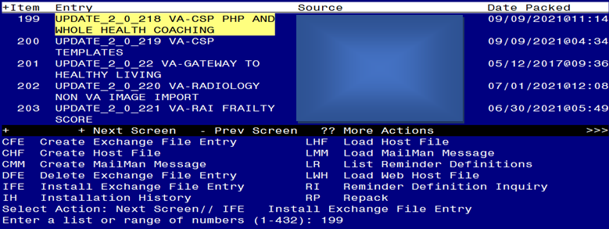

At the **Select Action** prompt, enter **IFE** for Install Exchange File Entry

Enter the number that corresponds with your entry UPDATE_2_0_218 VA-CSP PHP AND WELLNESS *(in this example it is entry 199. It will vary by site).* The date of the exchange file should be 09/09/2021.

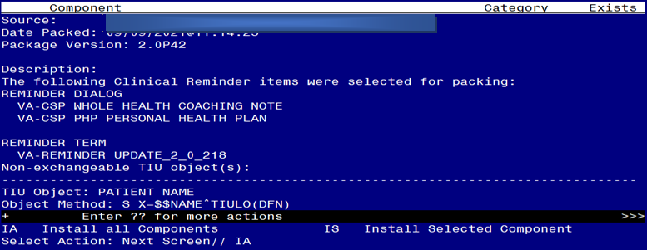

At the **Select Action** prompt, type **IA** for Install all Components and hit enter.

Select Action: Next Screen// IA Install all Components

You will see several prompts, for all new entries you will choose **I to Install**

For components that already exists but the packed component is different, choose **S to Skip with one exception. For this health factor only, VA-PHP MAP, choose OVERWRITE:**

HEALTH FACTORS entry named VA-PHP MAP already exists but the packed

component is different, what do you want to do?

Select one of the following:

C Create a new entry by copying to a new name

O Overwrite the current entry

U Update

Q Quit the install

S Skip, do not install this entry

Enter response: O// verwrite the current entry

Are you sure you want to overwrite? N// YES**.**

**You will be promped to install the FIRST reminder dialog component (VA-CSP PHP PERSONAL HEALTH PLAN).** You will choose to install all even though some components may have an X to indicate that they exist.

Regarding VA-CSP PHP PERSONAL HEALTH PLAN
Terminal screen shot of the first terminal window in Reminder Exchange listing the Clinical Reminder Items that were selected for packing.  It shows IA for "Install All" entered at the prompt.

At the **Select Action** prompt, type **IA** to install the dialog: **VA-CSP PHP PERSONAL HEALTH PLAN**

Select Action: Next Screen// IA Install All

Install reminder dialog and all components with no further changes: Y// Yes

Regarding VA-CSP PHP PERSONAL HEALTH PLAN
Screen shot of the last of the list of elements, groups and dialogs that needed to be installed with a Q for quit entered at the "Select Action:" prompt because they now all exist.  

After completing this dialog install, you will type Q.

**You will be promped to install the next reminder dialog component (VA-CSP WHOLE HEALTH COACHING NOTE).** You will choose to install all even though some components may have an X to indicate that they exist.

Regarding VA-CSP WHOLE HEALTH COACHING NOTE
Terminal screen shot of the first terminal window in Reminder Exchange listing the Clinical Reminder Items that were selected for packing.  It shows IA for "Install All" entered at the prompt.

At the **Select Action** prompt, type **IA** to install the dialog: **VA-CSP WHOLE HEALTH COACHING NOTE**

Select Action: Next Screen// IA Install All

Install reminder dialog and all components with no further changes: Y// Yes

RegardingVA-CSP WHOLE HEALTH COACHING NOTE
 Screen shot of the last of the list of elements, groups and dialogs that needed to be installed with a Q for quit entered at the "Select Action:" prompt because they now all exist.  

After completing this dialog install, you will type Q.

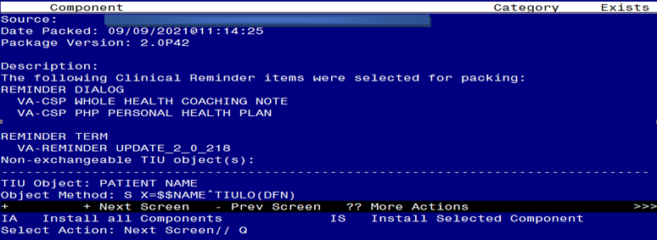 You will then be returned to this screen. At the **Select Action** prompt, type **Q.**

Install complete.

# Post Installation

1. **Make the Dialog template available to be attached to a Personal or Shared template or to be able to attach the dialog to a progress note title.**

Select Reminder Managers Menu <TEST ACCOUNT> Option: **CP** CPRS Reminder Configuration

CA Add/Edit Reminder Categories

CL CPRS Lookup Categories

CS CPRS Cover Sheet Reminder List

MH Mental Health Dialogs Active

PN Progress Note Headers

RA Reminder GUI Resolution Active

TIU TIU Template Reminder Dialog Parameter

DEVL Evaluate Coversheet List on Dialog Finish

DL Default Outside Location

PT Position Reminder Text at Cursor

LINK Link Reminder Dialog to Template

TEST CPRS Coversheet Time Test

NP New Reminder Parameters

GEC GEC Status Check Active

WH WH Print Now Active

Select CPRS Reminder Configuration <TEST ACCOUNT> Option: **TIU** TIU Template Reminder Dialog Parameter

Reminder Dialogs allowed as Templates may be set for the following:

1 User USR [choose from NEW PERSON]

3 Service SRV [choose from SERVICE/SECTION]

4 Division DIV [SALT LAKE CITY]

5 System SYS [NATREM.FO-SLC.MED.VA.GOV]

Enter selection: **5** *Choose the appropriate number for your site. Your site may do this by System or other levels. The example below uses SYSTEM level.*

Setting Reminder Dialogs allowed as Templates for System: NATREM.FO-SLC.MED.VA.GOV

Select Display Sequence: **?**

388 VA-COVID-19 TELEPHONE FOLLOW-UP

389 VA-SRA-CONSULT RESPONSE (D)

*When you type a question mark above, you will see the list of #’s (with dialogs) that are already taken. Choose a number* ***NOT*** *on this list. For this example, 390 is not present so I will use 390.*

Select Display Sequence: **390**

Are you adding 390 as a new Display Sequence? Yes// **YES**

Display Sequence: 390// <Enter> 390

Clinical Reminder Dialog: **VA-CSP WHOLE HEALTH COACHING NOTE** reminder dialog NATIONAL

...OK? Yes// <Enter> (Yes)

Select Display Sequence: **391**

Are you adding 391 as a new Display Sequence? Yes// **YES**

Display Sequence: 391// <Enter> 391

Clinical Reminder Dialog: **VA-CSP PHP PERSONAL HEALTH PLAN**

reminder dialog NATIONAL

...OK? Yes// <Enter> (Yes)

1. **Setup of Note Titles.**

The note titles to create to associate with this template are:

CAREGIVER PERSONAL HEALTH PLAN

CAREGIVER HEALTH AND WELLBEING COACHING

VHA Enterprise Standard Title: CAREGIVER CERTIFICATE

You can add these to your document class where caregiver notes are located.

***Note:*** *Comprehensive information on Creating new Document Classes and Titles can be found beginning on page 54 of the TIU/ASU Implementation Guide at the following link:* [*http://www.va.gov/vdl/documents/Clinical/CPRS-Text_Integration_Utility_(TIU)/tiuim.pdf*](http://www.va.gov/vdl/documents/Clinical/CPRS-Text_Integration_Utility_(TIU)/tiuim.pdf)

1. **Associate the reminder dialogs with the note title in CPRS**
2. In CPRS, open the Template Editor, expand Document Titles, select the appropriate folder (if applicable), then click New Template (top right-hand corner).

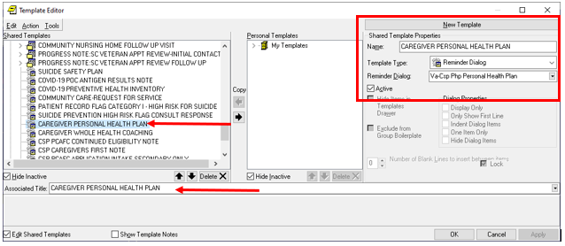

Type in the following information:

Name: **Caregiver Personal Health Plan**

Template Type: **Reminder Dialog**

Reminder Dialog: **VA-CSP PHP PERSONAL HEALTH PLAN**

Next, type in the Associated Title name – **CAREGIVER PERSONAL HEALTH PLAN** – then click Apply.

1. In CPRS, open the Template Editor, expand Document Titles, select the appropriate folder (if applicable), then click New Template (top right-hand corner).

CPRS Template Editor Screen shot showing:
Shared Template list with CAREGIVER HEALTH AND WELLNESS COACHING selected and the same entered in the Associated Title
Under New Template, CAREGIVER HEALTH AND WELLNESS COACHING is entered, Template Type is Reminder Dialog and the Reminder Dialog is Va-CSP Whole Health Coaching Note

Type in the following information:

**Name: Caregiver Health and Wellbeing Coaching**

Template Type: **Reminder Dialog**

Reminder Dialog: **VA-CSP WHOLE HEALTH COACHING NOTE**

Next, type in the Associated Title name – **CAREGIVER HEALTH AND WELLBEING COACHING**– then click Apply.

4. Add Local Patient Data Objects

1. The reminder dialog group VA-CSP PHP WHAT REALLY MATTERS contains the patient data object PATIENT NAME. If you do not have this patient data object in your Vista system, using the Vista Menu, Reminder Dialog manager, Reminder Dialogs, Change view to Group, search for and find the reminder dialog group VA-CSP PHP WHAT REALLY MATTERS and edit the dialog text, replace the dialog text |PATIENT NAME| with text that represents your local patient data object that will display the patient name.
2. The reminder dialog element VAL-CSP VETERAN WELLNESS ID FULL NAME contains the patient data object PATIENT NAME. If you do not have this patient data object in your Vista system, using the Vista Menu, Reminder Dialog manager, Reminder Dialogs, Change view to Element, search for and find the reminder dialog element VAL-CSP VETERAN WELLNESS ID FULL NAME and edit the dialog text, replace the dialog text |PATIENT NAME| with text that represents your local patient data object that will display the patient name.
3. The reminder dialog element VAL-CSP VETERAN WELLNESS ID FULL SSN contains the patient data object PATIENT SSN. If you do not have this patient data object in your Vista system, using the Vista Menu, Reminder Dialog manager, Reminder Dialogs, Change view to Element, search for and find the reminder dialog element VAL-CSP VETERAN WELLNESS ID FULL SSN and edit the dialog text, replace the dialog text |PATIENT SSN| with text that represents your local patient data object that will display the patient social security number.
4. The reminder dialog element VAL-CSP VETERAN WELLNESS ID DATE OF BIRTH contains the patient data object PATIENT DATE OF BIRTH. If you do not have this patient data object in your Vista system, using the Vista Menu, Reminder Dialog manager, Reminder Dialogs, Change view to Element, search for and find the reminder dialog element VAL-CSP VETERAN WELLNESS ID DATE OF BIRTH and edit the dialog text, replace the dialog text |PATIENT DATE OF BIRTH| with text that represents your local patient data object that will display the patient date of birth.
5. The reminder dialog element VAL-TH VVC TELEPHONE TRIAGE CONTACT PHONE OBJECT should contain a patient data object representing the patient telephone number. Using the Vista Menu, Reminder Dialog manager, Reminder Dialogs, Change view to Element, search for and find the reminder dialog element VAL-TH VVC TELEPHONE TRIAGE CONTACT PHONE OBJECT and edit the dialog text, replace the dialog text *PHONE OBJECT HERE* with text that represents your local patient data object that will display the patient phone number.
6. The reminder dialog element VAL-TH VVC TELEPHONE TRIAGE PATIENT LOCATION HOME should contain a patient data object representing the patient telephone number. Using the Vista Menu, Reminder Dialog manager, Reminder Dialogs, Change view to Element, search for and find the reminder dialog element VAL-TH VVC TELEPHONE TRIAGE PATIENT LOCATION HOME and edit the dialog text, replace the dialog text *PATIENT ADDRESS OBJECT HERE* with text that represents your local patient data object that will display the patient address.
7. The reminder dialog group VAL-GP CSP VETERAN WELLNESS VETERAN ADDRESS should contain a patient data object representing the patient address. Using the Vista Menu, Reminder Dialog manager, Reminder Dialogs, Change view to group, search for and find the reminder dialog group VAL-GP CSP VETERAN WELLNESS VETERAN ADDRESS and edit the dialog text, replace the dialog text **PATIENT ADDRESS OBJECT HERE** with text that represents your local patient data object that will display the patient address.
8. The reminder dialog group VAL-GP CSP VETERAN WELLNESS VETERAN PHONE should contain a patient data object representing the patient telephone number. Using the Vista Menu, Reminder Dialog manager, Reminder Dialogs, Change view to group, search for and find the reminder dialog group VAL-GP CSP VETERAN WELLNESS VETERAN PHONE and edit the dialog text, replace the dialog text **insert local object here** with text that represents your local patient data object that will display the patient phone number.