

**Update _2_0_222**

Clinical Reminders

VA-OEND REMINDER

Install Guide

**November 2021**

Product Development

Office of Information Technology

Department of Veterans Affairs

Table of Contents

Introduction 1

Pre-Install 10

Install Details 11

Install Example 11

Post Installation 18

# Introduction

This update contains several components to support standardized Opioid Overdose Education and Naloxone Distribution (OEND), including OEND to a highly vulnerable patient population, patients with Opioid Use Disorder (OUD). The new VA-NALOXONE PRESCRIBING reminder dialog was developed in response to field requests for a streamlined note that included health factors to identify patients who declined naloxone or obtained it outside of VA. The VA-NALOXONE OFFER PRESCRIPTION cover sheet reminder and two Clinical Reminder Order Checks (see below) were developed to support implementation of a February 24, 2021 VA memorandum to increase naloxone distribution to Veterans with OUD, including documentation and tracking of whether a patient declines naloxone or obtains it outside of VA.

1. **A new cover sheet reminder VA-NALOXONE OFFER PRESCRIPTION to provide education and offer naloxone to patients with Opioid Use Disorder (OUD) and no naloxone in the past 335 days.**

This reminder will come due to indicate that a naloxone prescription is needed

This reminder will come due for any patient that has had:

One or more outpatient OUD encounter diagnosis in the past two years

-OR-

one or more inpatient diagnosis in the past year.

-AND-

No naloxone ordered in the past 335 days

It will be resolved by:

a released outpatient prescription for naloxone

or

documentation of a NON-VA prescription started within the past year for naloxone.

A VA outpatient naloxone order will resolve for 14 days.

Two separate documentation of “patient declined naloxone prescription” will resolve for 3 months.

Documentation that the patient “Has current naloxone prescription” will resolve for 6 months.

Documentation of “Other” will resolve for 6 months.

Documentation of “Provider notified of request for naloxone prescription will resolve for 14 days.

1. **A new reminder dialog template VA-NALOXONE PRESCRIBING -** that can be linked to a note title or a shared template and used to document education and offer of a naloxone prescription to a patient.

This national note is meant to support standardized Opioid Overdose Education and Naloxone Distribution (OEND). Naloxone prescribing should include critical education on opioid overdose prevention, recognition, and response.

1. **Two new order checks.**
   1. PATIENT HAS DIAGNOSIS within the past year of OUD, no active naloxone prescription within the last year and an order is placed for a medication that is used to treat OUD (like Buprenorphine)

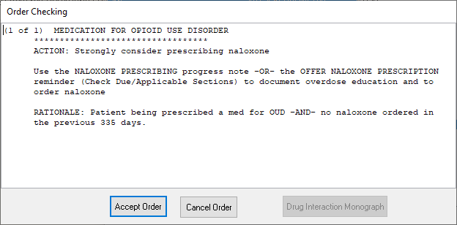

* 1. Patient has a diagnosis within the past year of OUD and no active naloxone prescription within the last year and an order is placed for an opioid:

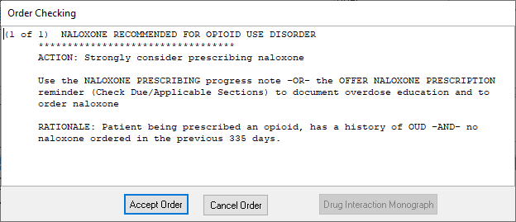

1. An update to the education and naloxone ordering options in the existing reminder dialogs, VA-NALOXONE USE, VA-NALOXONE TREATMENT PROVIDER, VA-OSP SUICIDE SAFETY PLAN and VA-OSP SBOR NOTE.
   1. The specific changes that have been made to the existing templates are:

* The education section has been updated to be consistent with the new options.
* Additional Risk Factors were added
* Additional resources and hyperlinks were added to the existing risk factors

UPDATE_2_0_222 contains 1 Reminder Exchange entry:

UPDATE_2_0_222 VA-OEND REMINDER

**The exchange file contains the following components:**

**TIU TEMPLATE FIELD**

VA-OPIOID TAPER

VA-OSP SAFETY PLANNING RESOURCES

VA-OSP STOP BENZO

VA-OSP BENZO RISK

VA-OSP FIN ASSIST

VA-OSP FAMILY SUPPORT

VA-OSP PTSD COACH

VA-OSP ANGER MANAGE

VA-OSP MH MOBILE

VA-OSP CG SUPPORT

VA-OSP HOMELESS VA PROG

VA-OSP HOMELESS CALL

VA-OSP HOMELESS RESOURCE

VA-OSP HIV RESOURCE

VA-OSP HIV KIT

VA-OSP HIV INFO

VA-OSP PAIN INFO

VA-OSP OPIOID RISK TOOL

VA-OSP SAFE OPIOID USE

VA-OSP STOP OPIOIDS

VA-OSP FENT INFO

VA-OSP INSOMNIA

VA-OSP DEPRESSION

VA-OSP BENZO

VA-OSP ADR

VA-OSP EBP

VA-OSP PTSD GUIDE

VA-OSP MDD GUIDE

VA-OSP SUICIDE GUIDE

VA-OSP VA MH GUIDE

VA-OSP INJ RESOURCE

VA-OSP CLIN GUIDE

VA-OSP OUD QRG

VA-OSP TOPIRAMATE

VA-OSP NALTREXONE

VA-OSP GABAPENTIN

VA-OSP DISULFIRAM

VA-OSP ACAMPROSATE

VA-OSP AUD MED

VA-OSP BRIEF HANDOUT

VA-OSP AUD PROV GUIDE

VA-OSP AUD REF GUIDE

VA-OSP MARIJUANA USE

VA-OSP VA SUD GUIDE

VA-OSP STAB POCKET CARD

VA-OSP TOBACCO RESOURCES

VA-OSP SUD POCKET CARD

VA-NALOXONE OTRR LINK

VA-NALOXONE STORM LINK

VA-OPIOID NALOXONE AUTO

VA-OPIOID NALOXONE NASAL

VA-OPIOID INTRO TO NALOXONE DISORDER

VA-OPIOID INTRO TO NALOXONE PRESCRIBE

VA-NALOXONE PATIENT GUIDE

VA-OSP OEND SHAREPOINT

VA-WORDR

VA-OSP LEGAL INFO

VA-OSP PAIN GUIDE

**HEALTH FACTORS**

VA-REMINDER UPDATES [C]

VA-UPDATE_2_0_222

VA-NALOXONE [C]

VA-OVERDOSE ABSTINENCE RF-DISCUSS RISK

VA-OVERDOSE RISK FACTOR PRIOR ABSTINENCE

VA-OVERDOSE OPIOID TAPER RF-DISCUSS RISK

VA-OVERDOSE RISK FACTOR OPIOID TAPERING

VA-OVERDOSE PREV OD RF-COMPLETE SAFETY PLANNING

VA-OVERDOSE PREV OD RF-DISCUSS PT SAFETY

VA-OVERDOSE RISK FACTOR PRIOR OVERDOSE

VA-OVERDOSE SEDATIVE RF-DISCUSS TAPER

VA-OVERDOSE SEDATIVE RF-DISCUSS ALT TX

VA-OVERDOSE SEDATIVE RF-DISCUSS RISKS

VA-OVERDOSE RISK FACTOR SEDATIVES

VA-OVERDOSE RISK FACTOR OTHER

VA-OVERDOSE FINANCE RF - PROVIDE FIN ASSIST INFO

VA-OVERDOSE RISK FACTOR FINANCE

VA-OVERDOSE FAMILY RF - PROVIDE CG INFO

VA-OVERDOSE FAMILY RF - ASSESS FOR STRESSORS

VA-OVERDOSE RISK FACTOR FAMILY

VA-OVERDOSE HOMELESS RF - PROVIDED INFO

VA-OVERDOSE RISK FACTOR HOMELESS

VA-OVERDOSE HIV RF - PATIENT DECLINES REFERRAL

VA-OVERDOSE HIV RF-REFERRAL

VA-OVERDOSE HIV RF-PROVIDED INFO

VA-OVERDOSE HIV RF-ADDRESSED IN TREATMENT PLAN

VA-OVERDOSE RISK FACTOR HIV

VA-OVERDOSE MEDICAL RF-REFERRAL PLACED

VA-OVERDOSE RISK FACTOR ED

VA-OVERDOSE RISK FACTOR FALLS

VA-OVERDOSE MEDICAL RF-ADDRESSED IN TREATMENT PLAN

VA-OVERDOSE RISK FACTOR MEDICAL

VA-OVERDOSE DUAL OPI RX RF-OTHER

VA-OVERDOSE DUAL OPI RX RF-SLOW TAPER

VA-OVERDOSE DUAL OPI RX RF-CHANGE RX TX

VA-OVERDOSE DUAL OPI RX RF-REVIEWCONSENT

VA-OVERDOSE DUAL OPI RX RF-NO TX CHANGE

VA-OVERDOSE DUAL OPI RX RF-NONOPIOID TX

VA-OVERDOSE DUAL OPI RX RF-CARE COORD

VA-OVERDOSE DUAL OPI RX RF-ALT STRATEGY

VA-OVERDOSE DUAL OPI RX RF-DISCUSS RISK

VA-OPIOID SOURCE VA AND NON VA

VA-OVERDOSE NONVA OPI RX RF-NONOPIOID TX

VA-OVERDOSE NONVA OPI RX RF-CARE COORD

VA-OVERDOSE NONVA OPI RX RF-ALT STRATEGY

VA-OVERDOSE NONVA OPI RX RF-DISCUSS RISK

VA-OPIOID SOURCE NON VA

VA-OVERDOSE VA OPIOID RX RF-ALT STRATEGY

VA-OVERDOSE VA OPIOID RX RF-REVIEW CONSENT

VA-OVERDOSE VA OPIOID RX RF-OTHER

VA-OVERDOSE VA OPIOID RX RF-SLOW TAPER

VA-OVERDOSE VA OPIOID RX RF-CHANGE RX TX

VA-OVERDOSE VA OPIOID RX RF-NO TX CHANGE

VA-OVERDOSE VA OPIOID RX RF-NONOPIOID TX

VA-OVERDOSE VA OPIOID RX RF-DISCUSS RISK

VA-OPIOID SOURCE VA

VA-OVERDOSE RISK FACTOR PRE OPIOIDS

VA-OVERDOSE SUD RF-PROVIDE MED INFO

VA-OVERDOSE NONRX OPIOID RF-DISCUSS RISK

VA-OVERDOSE RISK FACTOR NON PRE OPIOIDS

VA-OVERDOSE MH RF-PT DECLINES MH TX

VA-OVERDOSE MH RF-MH TX REFERRAL

VA-OVERDOSE MH RF-MH ADDRESSED

VA-OVERDOSE RISK FACTOR MENTAL HEALTH

VA-OVERDOSE SUD RF-OFFER SUD TREATMENT

VA-OVERDOSE SUD RF-INJECTION DRUG USE

VA-OVERDOSE SUD RF-ASSESS FOR SUD

VA-OVERDOSE SUD RF-ILLICIT SUBSTANCE USE

VA-OVERDOSE SUD RF-OFFER AUD TREATMENT

VA-OVERDOSE SUD RF-ALCOHOL USE

VA-OVERDOSE PATIENT DECLINES SUD TREAT

VA-OVERDOSE SUD RF-SUD TX REFERRAL

VA-OVERDOSE SUD RF-SUD ADDRESSED

VA-OVERDOSE RISK FACTOR SUD

VA-NALOXONE RISK FACTORS

VA-NALOXONE ED-TEACH BACK

VA-NALOXONE RESOURCES-OTHER

VA-NALOXONE VIDEO-AUTO-INJECTOR

VA-NALOXONE VIDEO-SPRAY

VA-NALOXONE VIDEO-OUD

VA-NALOXONE VIDEO-RX OPIOIDS

VA-NALOXONE ED TO CAREGIVER OR OTHER

VA-NALOXONE ED TO PATIENT

VA-SUICIDE SAFETY PLAN [C]

VA-SP OPIOID DISCUSSION YES

VA-SP OPIOID DISCUSSION NO

VA-NALOXONE RX OTHER

VA-HAS NALOXONE RX

VA-PATIENT DECLINED NALOXONE

VA-NALOXONE RX REQUEST PROVIDER NOTIFIED

VA-NALOXONE RX ORDERED

VA-SP OPIOID ACCESS YES

VA-SUICIDE BEHAVIOR AND OVERDOSE REPORT [C]

VA-NALOXONE NEED UNKNOWN

VA-NALOXONE NOT INDICATED

VA-OVERDOSE REFERRAL INFECTIOUS DISEASE

VA-OVERDOSE REFERRAL SOCIAL WORK

VA-SBOR OD REFERRAL DECLINED

VA-SBOR OD REFERRAL NONE

VA-SBOR OD REFERRAL OTHER

VA-SBOR OD REFERRAL PAIN

VA-SBOR OD REFERRAL SUD

VA-SBOR OD REFERRAL PCMHI/MH

VA-SBOR OD REFERRAL PCP

VA-SBOR OD IMMEDIATE CARE NEED NO

VA-SBOR OD IMMEDIATE CARE NEED OTHER

VA-SBOR OD IMMEDIATE CARE NEED ED

VA-SBOR OD IMMEDIATE CARE NEED PCMHI

VA-SBOR OD IMMEDIATE CARE NEED YES

VA-SBOR OVERDOSE TREATMENT PLAN

VA-OVERDOSE JUSTICE RF - CONSULT WITH VJO SPECIALIST

VA-OVERDOSE JUSTICE RF - PROVIDE LEGAL INFO

VA-OVERDOSE JUSTICE RF - DISCUSS STRESSORS

VA-OVERDOSE UNMET PAIN RF-PROVIDE PAIN INFO GUIDE

VA-SBOR OD RF-PAIN DECLINED FOLLOW UP

VA-SBOR OD RF-PAIN FOLLOW UP

VA-SBOR OD RISK FACTOR PAIN

VA-SBOR OD ABSTINENCE RF-DISCUSS RISK

VA-SBOR OD RISK FACTOR PRIOR ABSTINENCE

VA-SBOR OD OPIOID TAPER RF-DISCUSS RISK

VA-SBOR OD RISK FACTOR OPIOID TAPERING

VA-SBOR OD PREV OD RF-DISCUSS PT SAFETY

VA-SBOR OD RISK FACTOR PRIOR OVERDOSE

VA-SBOR OD SEDATIVE RF-DISCUSS TAPER

VA-SBOR OD SEDATIVE RF-DISCUSS ALT TX

VA-SBOR OD SEDATIVE RF-DISCUSS RISKS

VA-SBOR OD RISK FACTOR SEDATIVES

VA-SBOR OD RISK FACTOR OTHER

VA-SBOR OD RISK FACTOR FINANCE

VA-SBOR OD RISK FACTOR FAMILY

VA-SBOR OD RISK FACTOR HOMELESS

VA-SBOR OD RISK FACTOR HIV

VA-SBOR OD RISK FACTOR ED

VA-SBOR OD RISK FACTOR FALLS

VA-SBOR OD RISK FACTOR MEDICAL

VA-SBOR OD DUAL OPI RX RF-OTHER

VA-SBOR OD DUAL OPI RX RF-SLOW TAPER

VA-SBOR OD DUAL OPI RX RF-CHANGE RX TX

VA-SBOR OD DUAL OPI RX RF-REVIEWCONSENT

VA-SBOR OD DUAL OPI RX RF-NO TX CHANGE

VA-SBOR OD DUAL OPI RX RF-NONOPIOID TX

VA-SBOR OD DUAL OPI RX RF-CARE COORD

VA-SBOR OD DUAL OPI RX RF-ALT STRATEGY

VA-SBOR OD DUAL OPI RX RF-DISCUSS RISK

VA-SBOR OPIOID SOURCE VA AND NON VA

VA-SBOR OD NONVA OPI RX RF-NONOPIOID TX

VA-SBOR OD NONVA OPI RX RF-CARE COORD

VA-SBOR OD NONVA OPI RX RF-ALT STRATEGY

VA-SBOR OD NONVA OPI RX RF-DISCUSS RISK

VA-SBOR OPIOID SOURCE NON VA

VA-SBOR OD VA OPIOID RX RF-ALT STRATEGY

VA-SBOR OD VA OPIOID RX RF-OTHER

VA-SBOR OD VA OPIOID RX RF-SLOW TAPER

VA-SBOR OD VA OPIOID RX RF-CHANGE RX TX

VA-SBOR OD VA OPIOID RX RF-NO TX CHANGE

VA-SBOR OD VA OPIOID RX RF-NONOPIOID TX

VA-SBOR OD VA OPIOID RX RF-DISCUSS RISK

VA-SBOR OPIOID SOURCE VA

VA-SBOR OD RISK FACTOR PRE OPIOIDS

VA-SBOR OD NONRX OPIOID RF-DISCUSS RISK

VA-SBOR OD RISK FACTOR NON PRE OPIOIDS

VA-SBOR OD MH RF-PT DECLINES MH TX

VA-SBOR OD MH RF-MH TX REFERRAL

VA-SBOR OD MH RF-MH ADDRESSED

VA-SBOR OD RISK FACTOR MENTAL HEALTH

VA-SBOR OD SUD INITIATED MAT

VA-SBOR OD PT DECLINES SUD TREAT

VA-SBOR OD SUD RF-SUD TX REFERRAL

VA-SBOR OD SUD RF-SUD ADDRESSED

VA-SBOR OD RISK FACTOR SUD

VA-SBOR OVERDOSE RISK FACTORS

VA-SBOR OD ED TEACH BACK

VA-SBOR OD RESOURCES OTHER

VA-SBOR OD EDUCATION TO CAREGIVER/OTHER

VA-SBOR OD EDUCATION TO PATIENT

VA-SBOR OD EDUCATION NOT PROVIDED

VA-NALOXONE RX FOR STIMULANT USE DISORDER

VA-NALOXONE RX FOR OTHER REASON

VA-NALOXONE RX FOR OTHER SUD

VA-NALOXONE RX FOR OUD

VA-NALOXONE RX FOR OPIOID DISCONT

VA-NALOXONE RX FOR OPIOID RX

VA-OVERDOSE REFERRAL DECLINED

VA-OVERDOSE REFERRAL NONE

VA-OVERDOSE REFERRAL OTHER

VA-OVERDOSE REFERRAL PAIN

VA-OVERDOSE REFERRAL SUD

VA-OVERDOSE REFERRAL PCMHI/MH

VA-OVERDOSE REFERRAL PCP

VA-NALOXONE IMMEDIATE CARE NEEDED-NO

VA-OVERDOSE IMMEDIATE CARE NEEDED OTHER

VA-OVERDOSE IMMEDIATE CARE NEEDED ED

VA-OVERDOSE IMMEDIATE CARE NEEDED PCMHI

VA-NALOXONE IMMEDIATE CARE NEEDED-YES

VA-NALOXONE REFERRALS

VA-NALOXONE TREATMENT PLAN

VA-OVERDOSE RISK FACTOR JUSTICE INVOLVEMENT

VA-OVERDOSE UNMET PAIN RF- PT DECLINES PAIN REFER

VA-OVERDOSE UNMET PAIN RF-FOLLOW UP SCHEDULED

VA-OVERDOSE RISK FACTOR UNMET PAIN NEEDS

VA-SBOR METHOD TYPE OVERDOSE

VA-NALOXONE IMPACT OR TX CHANGE

VA-NALOXONE USED

**REMINDER SPONSOR**

MENTAL HEALTH SERVICES

OFFICE OF MENTAL HEALTH SERVICES

**REMINDER TAXONOMY**

VA-OUD ALL SOURCES

VA-OUD DIAGNOSIS IP

VA-OUD DIAGNOSIS OP

**REMINDER TERM**

VA-NALOXONE PRESCRIPTION ON FILE

VA-OUD REMINDER TERM

VA-NALOXONE PRESCRIPTION

VA-REMINDER UPDATE_2_0_222

VA-NALOXONE USE

VA-NALOXONE DECLINED

VA-NALOXONE PROVIDER NOTIFIED

VA-NALOXONE OUD DIAGNOSIS INPATIENT

VA-NALOXONE NOT NEEDED

VA-NALOXONE ORDER

VA-NALOXONE OUD DIAGNOSIS OUTPATIENT

**REMINDER DEFINITION**

VA-NALOXONE ORDER CHECK

VA-NALOXONE OBJECT

VA-NALOXONE TREATING PROVIDER

VA-NALOXONE OFFER PRESCRIPTION

**HEALTH SUMMARY TYPE**

VA-NALOXONE

**HEALTH SUMMARY OBJECTS**

VA-NALOXONE (TIU)

**TIU DOCUMENT DEFINITION**

VA-NALOXONE

**REMINDER ORDER CHECK RULES**

VA-MEDICATION FOR OPIOID USE DISORDER

VA-NALOXONE FOR OPIOID USE DISORDER

**REMINDER ORDER CHECK ITEMS GROUP**

VA-MEDICATION FOR OPIOID USE DISORDER

VA-OPIOID MEDICATION NON MOUD

**REMINDER DIALOG**

VA-GP SBOR UPDATE 2021

VA-NALOXONE PRESCRIBING

VA-NALOXONE TREATMENT PROVIDER

VA-NALOXONE OFFER PRESCRIPTION

# Pre-Install

1. Check your Reminder Exchange Install History (IH) and ensure you have installed the previously released **UPDATE_2_0_182 VA-OSP SUICIDE SAFETY PLAN UPDATE**
2. **Find Naloxone order currently in use.**

* Using the Vista Menu, Reminder Dialog Manager, DI- Reminder Dialog, change view to element view and Inq/Print the reminder dialog element VAL-NALOXONE REQUEST. You will need to identify the local order or menu used as a finding item and add this order back post install.

1. **Identify existing referral orders currently in use.**

* Using the Vista Menu, Reminder Dialog Manager, DI- Reminder Dialog, change view to Element view and Inq/Print the reminder dialog elements listed below. You will need to identify the local order or menu used as a finding or additional finding item and add this order back post install. You may also have updated the dialog text for these elements. It is possible that your site made no local changes to these items but you should verify post install that these items match the pre-install state:

VAL-OVERDOSE REFERRAL SUD SBOR

VAL-OVERDOSE REFERRAL SUD RISK

VAL-OVERDOSE INITIATE MED SUD SBOR

VAL-OVERDOSE MH REFERRAL SBOR

VAL-OVERDOSE MH REFERRAL

VAL-EL PAIN MGMT SCH FU TO ADDRESS SBOR

VAL-OVERDOSE IMM CARE NEEDED WARM HANDOFF SBOR

VAL-OVERDOSE IMM CARE NEEDED WARM HANDOFF

VAL-OVERDOSE IMM CARE NEEDED ED SBOR

VAL-OVERDOSE IMM CARE NEEDED ED

VAL-OVERDOSE IMM CARE NEEDED OTHER SBOR

VAL-OVERDOSE IMM CARE NEEDED OTHER

VAL-OVERDOSE REFERRAL PCP SBOR

VAL-OVERDOSE REFERRAL PCP

VAL-OVERDOSE REFERRAL MH SBOR

VAL-OVERDOSE REFERRAL MH

VAL-OVERDOSE REFERRAL SUD PROVIDER SBOR

VAL-OVERDOSE REFERRAL SUD

VAL-OVERDOSE REFERRAL PAIN SBOR

VAL-OVERDOSE REFERRAL PAIN

VAL-OVERDOSE OTHER REFERRAL SBOR

# Install Details

This update is being distributed as a web host file. The address for the host file is: https://REDACTED/UPDATE_2_0_222.PRD

The file will be installed using Reminder Exchange, programmer access is not required.

Installation:

=============

This update can be loaded with users on the system. Installation will take less than 10 minutes.

# Install Example

To Load the exchange file, use LWH. The URL is https://REDACTED/UPDATE_2_0_222.PRD

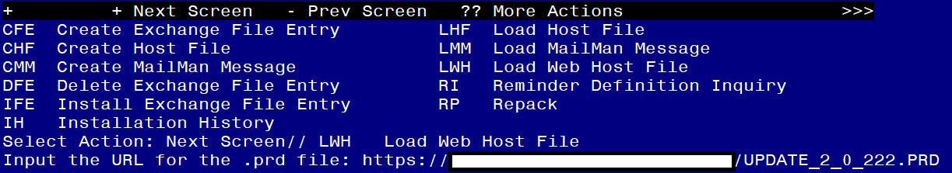

You should see a message that the file was loaded successfully.

Terminal window screen shot of the message displaying the URL of the file that was successfully loaded.  Part of the URL has been redacted as it is a VA only internal web site URL.

Search and locate an entry titled UPDATE_2_0_222 VA-OEND REMINDER in reminder exchange.

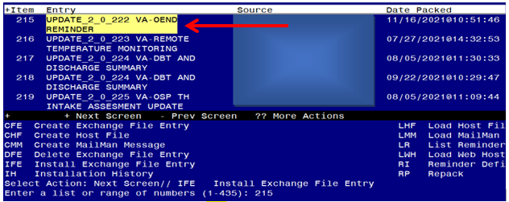

At the **Select Action** prompt, enter **IFE** for Install Exchange File Entry

Enter the number that corresponds with your entry titled UPDATE_2_0_222 VA-OEND REMINDER *(in this example it is entry 215, it will vary by site)* that is dated 11/16/2021.

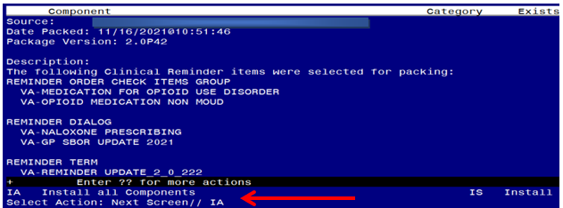

At the **Select Action** prompt, type **IA** for Install all Components and hit enter.

**For all new entries in any category you will choose I to Install**

**Skip any items in any category you are prompted to overwrite with two exceptions listed below, all other items if prompted to overwrite choose SKIP**

1. **For the TIU template field VA-NALOXONE STORM LINK, if you are prompted, you can overwrite it:**

TIU TEMPLATE FIELD entry named VA-NALOXONE STORM LINK already exists

but the packed component is different, what do you want to do?

Select one of the following:

C Create a new entry by copying to a new name

O Overwrite the current entry

U Update

Q Quit the install

S Skip, do not install this entry

Enter response: O// verwrite the current entry

Are you sure you want to overwrite? N// YES

1. **For the reminder definition VA-NALOXONE TREATING PROVIDER, the print name changed so you will need to overwrite the definition:**

REMINDER DEFINITION entry named VA-NALOXONE TREATING PROVIDER already

exists but the packed component is different, what do you want to do?

Select one of the following:

C Create a new entry by copying to a new name

O Overwrite the current entry

U Update

Q Quit the install

S Skip, do not install this entry

Enter response: O// verwrite the current entry

Are you sure you want to overwrite? N// YES

You will then be prompted to install the first dialog component. You will choose IA to install all even though some items will already have an X to indicate they exist.

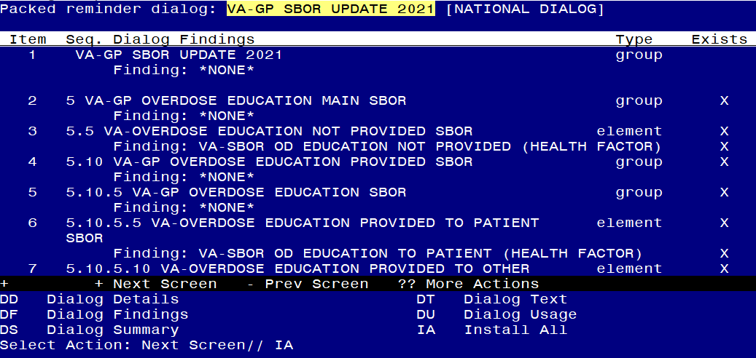

At the **Select Action** prompt, type **IA** to install the dialog – **VA-GP SBOR UPDATE 2021**

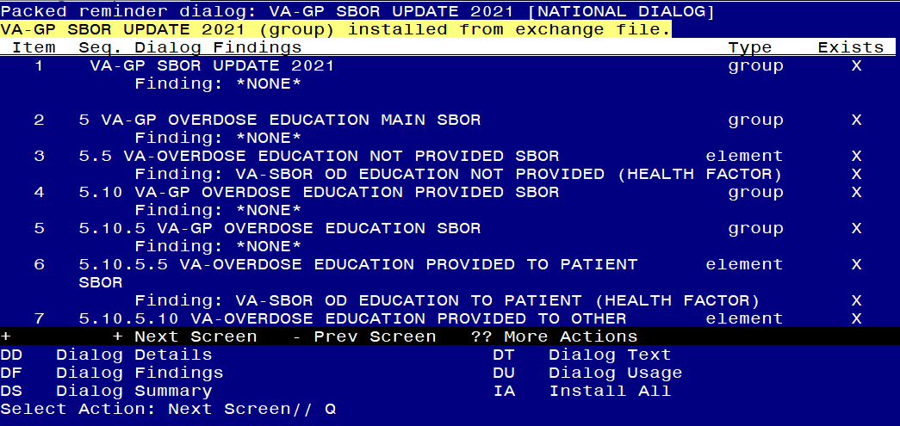

When the dialog has completed installation, you will then be returned to this screen. At the **Select Action** prompt, type **Q.**

You will then be prompted to install the NEXT dialog component. You will choose IA to install all even though some items will already have an X to indicate they exist.

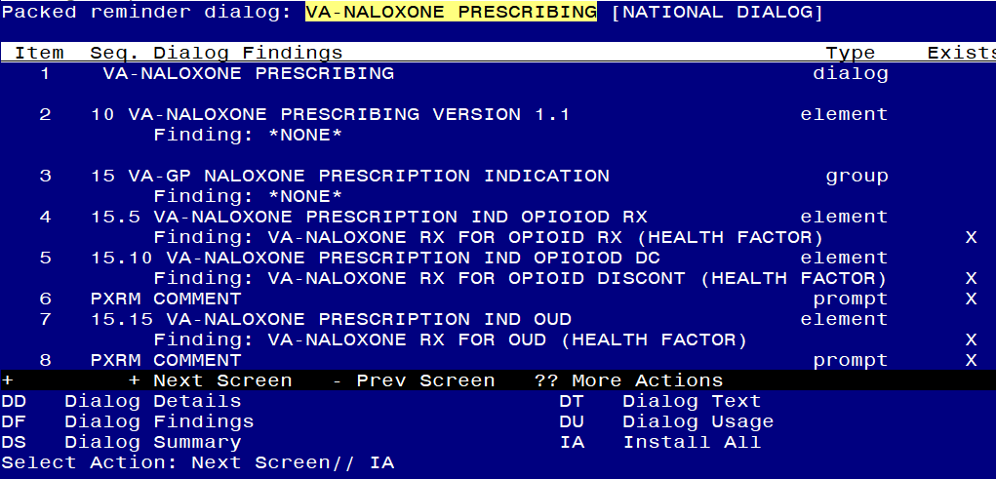

At the **Select Action** prompt, type **IA** to install the dialog – **VA-NALOXONE PRESCRIBING**

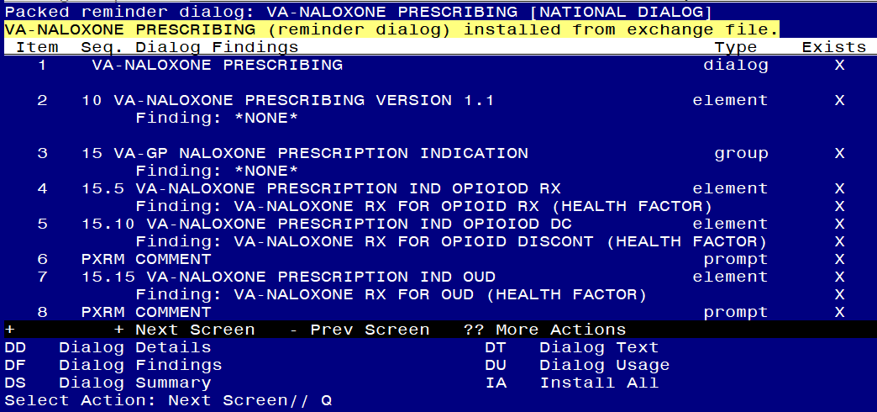

When the dialog has completed installation, you will then be returned to this screen. At the **Select Action** prompt, type **Q.**

You will then be prompted to install the NEXT dialog component. You will choose IA to install all even though some items will already have an X to indicate they exist.

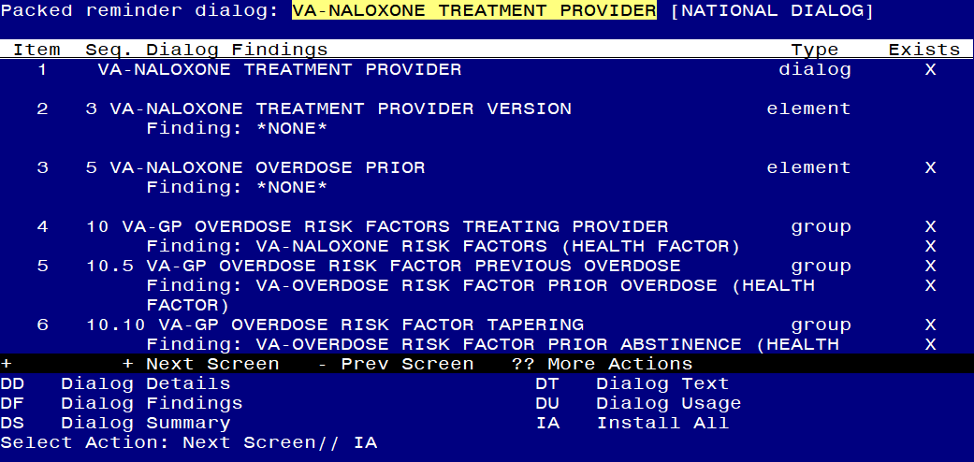

At the **Select Action** prompt, type **IA** to install the dialog – **VA-NALOXONE TREATMENT PROVIDER**

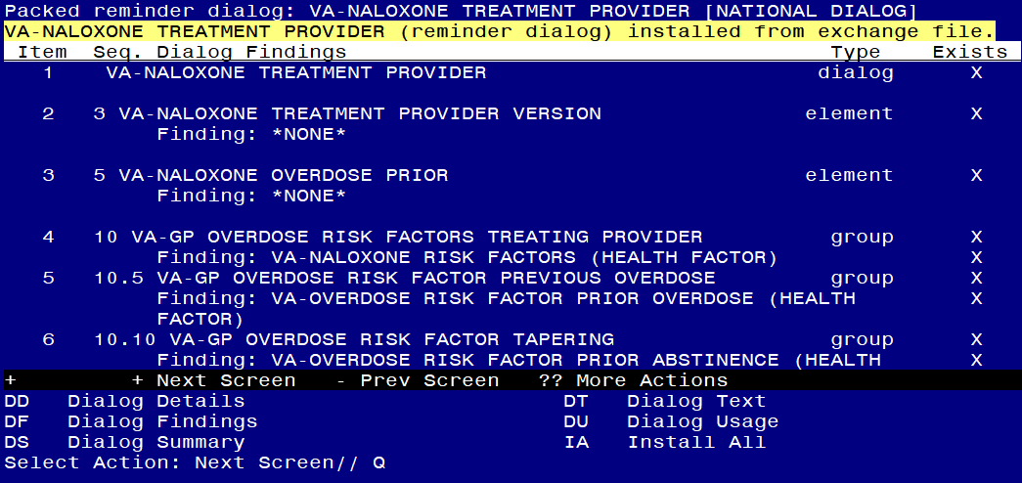

When the dialog has completed installation, you will then be returned to this screen. At the **Select Action** prompt, type **Q.**

You will then be prompted to install the NEXT dialog component. You will choose IA to install all even though some items will already have an X to indicate they exist.

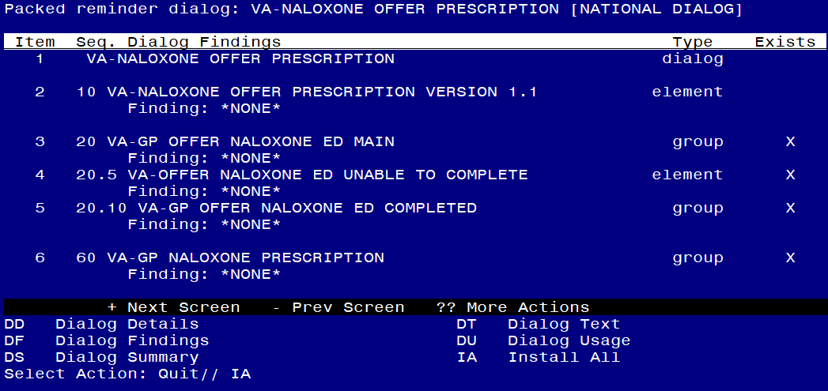

At the **Select Action** prompt, type **IA** to install the dialog – **VA-NALOXONE OFFER PRESCRIPTION**

**Hit enter when prompted to link to the definition:**

Install reminder dialog and all components with no further changes: Y// ES....

Reminder Dialog VA-NALOXONE OFFER PRESCRIPTION is not linked to a reminder.

Select Reminder to Link: VA-NALOXONE OFFER PRESCRIPTION//

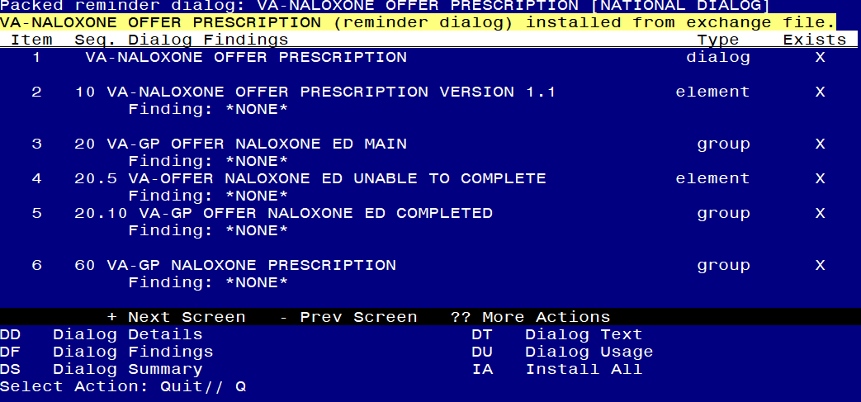

When the dialog has completed installation, you will then be returned to this screen. At the **Select Action** prompt, type **Q.**

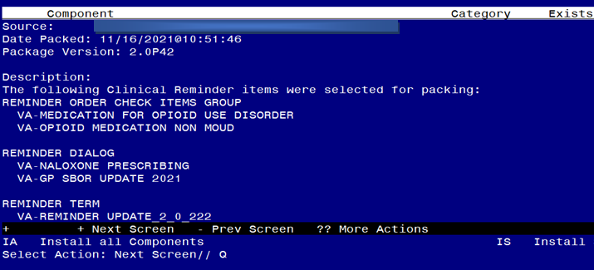

You will then be returned to this screen. At the **Select Action** prompt, type **Q.**

Install complete.

# Post Installation

1. **Setup of Note Title.**

The note title to create to associate with the new template is:

**NALOXONE PRESCRIBING**

VHA Enterprise Standard Title: **MEDICATION MGT NOTE**

**You can add these to your document class where progress notes are located.**

***Note:*** *Comprehensive information on Creating new Document Classes and Titles can be found beginning on page 54 of the TIU/ASU Implementation Guide at the following link:* [*http://www.va.gov/vdl/documents/Clinical/CPRS-Text_Integration_Utility_(TIU)/tiuim.pdf*](http://www.va.gov/vdl/documents/Clinical/CPRS-Text_Integration_Utility_(TIU)/tiuim.pdf)

1. Add the new reminder to the cover sheet for the appropriate users. The print name is **Offer Naloxone Prescription**. Your site should determine who they would like to use this new reminder.
2. **Make the Dialog templates available to be attached to a Personal or Shared templates or to be able to attach the dialog to a progress note title.**

Select Reminder Managers Menu <TEST ACCOUNT> Option: **CP** CPRS Reminder Configuration

CA Add/Edit Reminder Categories

CL CPRS Lookup Categories

CS CPRS Cover Sheet Reminder List

MH Mental Health Dialogs Active

PN Progress Note Headers

RA Reminder GUI Resolution Active

TIU TIU Template Reminder Dialog Parameter

DEVL Evaluate Coversheet List on Dialog Finish

DL Default Outside Location

PT Position Reminder Text at Cursor

LINK Link Reminder Dialog to Template

TEST CPRS Coversheet Time Test

NP New Reminder Parameters

GEC GEC Status Check Active

WH WH Print Now Active

Select CPRS Reminder Configuration <TEST ACCOUNT> Option: **TIU** TIU Template Reminder Dialog Parameter

Reminder Dialogs allowed as Templates may be set for the following:

1 User USR [choose from NEW PERSON]

3 Service SRV [choose from SERVICE/SECTION]

4 Division DIV [SALT LAKE CITY]

5 System SYS [NATREM.FO-SLC.MED.VA.GOV]

Enter selection: **5** *Choose the appropriate number for your site. Your site may do this by System or other levels. The example below uses SYSTEM level.*

Setting Reminder Dialogs allowed as Templates for System: NATREM.FO-SLC.MED.VA.GOV

Select Display Sequence: **?**

388 VA-COVID-19 TELEPHONE FOLLOW-UP

389 VA-SRA-CONSULT RESPONSE (D)

*When you type a question mark above, you will see the list of #’s (with dialogs) that are already taken. Choose a number* ***NOT*** *on this list. For this example, 390 is not present so I will use 390.*

Select Display Sequence: **490**

Are you adding 490 as a new Display Sequence? Yes// **YES**

Display Sequence: 490// <Enter> 390

Clinical Reminder Dialog: **VA-NALOXONE PRESCRIBING** reminder dialog NATIONAL

...OK? Yes// <Enter> (Yes)

1. **Associate the reminder dialogs with the note title in CPRS**
2. In CPRS, open the Template Editor, expand Document Titles, select the appropriate folder (if applicable), then click New Template (top right-hand corner).

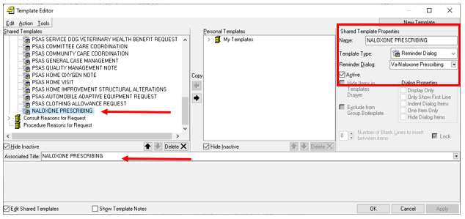

Type in the following information:

Name: **NALOXONE PRESCRIBING**

Template Type: **Reminder Dialog**

Reminder Dialog: **VA-NALOXONE PRESCRIBING**

Next, type in the Associated Title name – **NALOXONE PRESCRIBING** – then click Apply.

1. **Add local orderable items that represent an order for naloxone to the reminder term VA-NALOXONE ORDER.** The findings that you add should be OI type findings. Ex: OI.NALOXONE. You do not need to add a status or info in any other field.
2. **Add naloxone order identified in pre-install to reminder dialog.** Using the Vista Menu, Reminder Dialog Manager, DI- Reminder Dialog, change view to GROUP view edit the reminder dialog GROUP VAL-NALOXONE REQUEST, add the quick order identified in the pre-install as a finding item.
3. **Add referral orders identified in pre-install to reminder dialog.** Using the Vista Menu, Reminder Dialog Manager, DI- Reminder Dialog, change view to Element view and edit the reminder dialog elements. You will need to make any text changes or add the referral orders identified in pre-install.

VAL-OVERDOSE REFERRAL SUD SBOR

VAL-OVERDOSE REFERRAL SUD RISK

VAL-OVERDOSE INITIATE MED SUD SBOR

VAL-OVERDOSE MH REFERRAL SBOR

VAL-OVERDOSE MH REFERRAL

VAL-EL PAIN MGMT SCH FU TO ADDRESS SBOR

VAL-OVERDOSE IMM CARE NEEDED WARM HANDOFF SBOR

VAL-OVERDOSE IMM CARE NEEDED WARM HANDOFF

VAL-OVERDOSE IMM CARE NEEDED ED SBOR

VAL-OVERDOSE IMM CARE NEEDED ED

VAL-OVERDOSE IMM CARE NEEDED OTHER SBOR

VAL-OVERDOSE IMM CARE NEEDED OTHER

VAL-OVERDOSE REFERRAL PCP SBOR

VAL-OVERDOSE REFERRAL PCP

VAL-OVERDOSE REFERRAL MH SBOR

VAL-OVERDOSE REFERRAL MH

VAL-OVERDOSE REFERRAL SUD PROVIDER SBOR

VAL-OVERDOSE REFERRAL SUD

VAL-OVERDOSE REFERRAL PAIN SBOR

VAL-OVERDOSE REFERRAL PAIN

VAL-OVERDOSE OTHER REFERRAL SBOR

1. **Add referral orders for a referral for HIV treatment (Infectious disease) to the reminder dialog element VAL-OVERDOSE RISK FACTOR HIV REFERRAL as an additional finding.**
2. **Add referral orders for a referral for social work to the reminder dialog element VAL-OVERDOSE REFERRAL SOCIAL WORK as an additional finding.**
3. **Add referral orders for a referral for medical issues to the reminder dialog element VAL-OVERDOSE RISK FACTOR COMORBIDITY REFERRAL as an additional finding**. You will map this element only if your site utilizes a referral or consult ordering process for medical issues.
4. **Add referral orders for a referral for infectious disease to the reminder dialog element VAL-OVERDOSE REFERRAL ID as an additional finding.**

1. **Disable reminder dialog element that instructs users to complete a local fall clinical reminder (Optional).** If your site **does not** have a local clinical reminder for falls, you can disable this element VAL-OVERDOSE RISK FACTOR FALLS REMINDER by editing the reminder dialog element and adding 2 DISABLE AND DO NOT SEND MESSAGE in the disable field.
2. **ADD two items to the reminder order check group VA-OPIOID MEDICATION NON MOUD –** the following VA Products need to be added to the reminder order check group VA-OPIOID MEDICATION NON MOUD:

OXYCODONE HCL 5MG/ACETAMINOPHEN 325MG TAB

HYDROMORPHONE HCL 10MG/ML INJ

The option represented here is Add/Edit Reminder Order Check Items Group **[PXRM ORDER CHECK GROUP EDIT].**

Select Reminder Order Check Items Group by: (N/C/D/G/I/O/P/R/Q): N// ORDER CHECK ITEM GROUP NAME

Reminder Order Check Item Group: **VA-OPIOID MEDICATION NON MOUD**

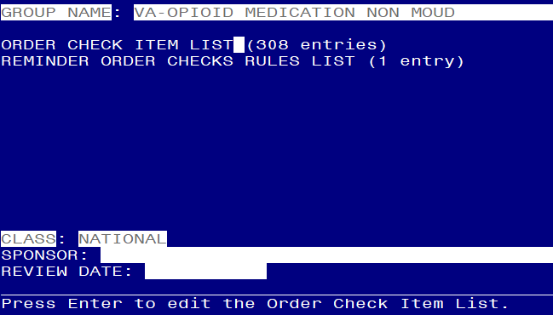

**Hit Enter to enter the order check items list:**

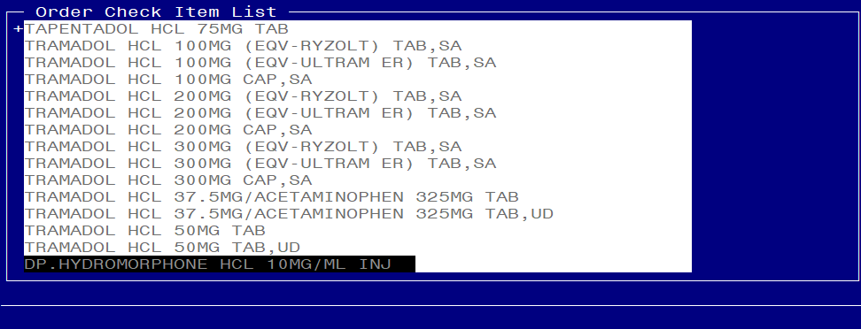 **Add the first entry using a prefix DP. :**

**DP.** **HYDROMORPHONE HCL 10MG/ML INJ**

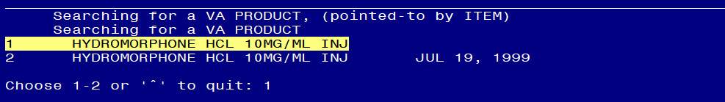

**Choose the first entry that does not show the inactive date**



**Yes to add**

**Repeat these steps for the VA Product:**

**OXYCODONE HCL 5MG/ACETAMINOPHEN 325MG TAB**

**Save and Exit**

1. **Activate the Reminder Order Check Rules (optional)**

The installation of CLINICAL REMINDER UPDATE_2_0_222 will require the STATUS of the Reminder Order Check Rules, VA-NALOXONE FOR OPIOID USE DISORDER and VA-MEDICATION FOR OPIOID USE DISORDER to be changed to PROD.   Shown below are the steps to make this change, which should be done for both rules if your site decides to use the national version of these order checks.

The option represented here is **Add/Edit Reminder Order Check Rule [PXRM ORDER CHECK RULE EDIT].**

Select Reminder Order Check Menu Option: **RE**  Add/Edit Reminder Order Check Rule

Select Reminder Order Check Rule by:  (N/R/T/Q): N// **N**  ORDER CHECK RULE NAME

Select Reminder Order Check Rule: VA-NALOXONE FOR OPIOID USE DISORDER

RULE NAME: VA-NALOXONE FOR OPIOID USE DISORDER

DISPLAY NAME: **NALOXONE RECOMMENDED FOR OPIOID USE DISORDER**

STATUS: **PROD**

**^ *change to PROD to activate Production Mode***

CLASS: **NATIONAL**

SPONSOR:

REVIEW DATE:

_______________________________________________________

I=INACTIVE, P=PRODUCTION, T=TESTING

Save and Exit

**Repeat for the Reminder Order Check Rule** VA-MEDICATION FOR OPIOID USE DISORDER.

**NOTE**: the STATUS property is for a specific Clinical Reminder Order Check (CROC). This is separate from the setting of Enabled/Disabled for ALL CROCs which is shown below as ‘Clinical Reminder Live’ on the Order Checks Tab of the CPRS Options screen. Individual providers cannot enable or disable individual CROCs separately.

It is therefore recommended that these order checks are enabled for all users and set to ‘mandatory’ by the Clinical Application Coordinator (CAC) using the option ‘Set Order Checks to be Uneditable By Users [ORK EDITABLE BY USER]’. If there are users with the Clinical Reminder Live order check set to disabled when the setting is made mandatory/uneditable, the CAC can manually enable it for those users with option ‘Enable/Disable an Order Check [ORK PROCESSING FLAG]’.

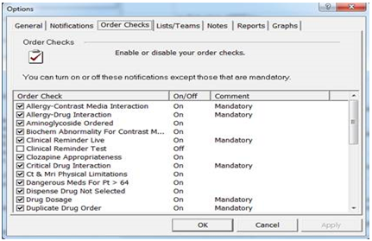

1. **Test reminder order checks (optional)**

If you would like to test the reminder order checks, here is a way you can test them after you have turned them on.

On a test patient that does not have a naloxone prescription

1. Add a diagnosis of F11.20 to an encounter within the past year
2. Using the Non VA Meds Order option, attempt to document a NON VA Morphine Tab, SA prescription
   1. Choose a dosage, schedule and explanation
   2. Choose Accept Order

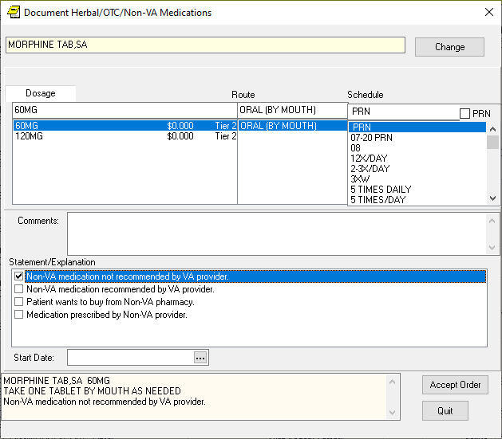

1. You should see the new order check, NALOXONE RECOMMENDED FOR OPIOID USE DISORDER. (you may or not see the other ones listed here, we are testing only the new one that is number 3 of 3 in the illustration below)

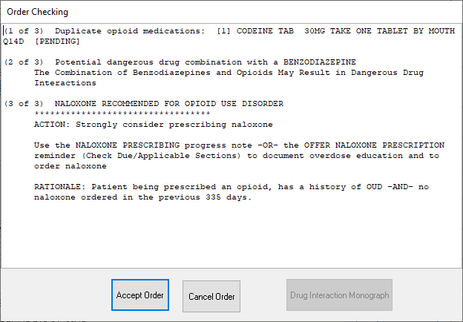

1. Choose Cancel order
2. Change drug name to BUPRENORPHINE/NALOXONE FILM,SUBLINGUAL NF
   1. Choose a dosage, schedule and explanation
   2. Choose Accept Order

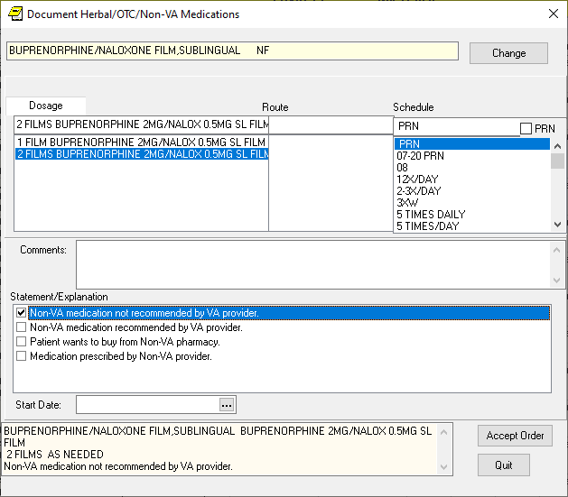

1. You should see the new order check - MEDICATION FOR OPIOID USE DISORDER (you may or not see the other ones listed here, we are testing only the new one that is number 6 of 6 in the illustration below)

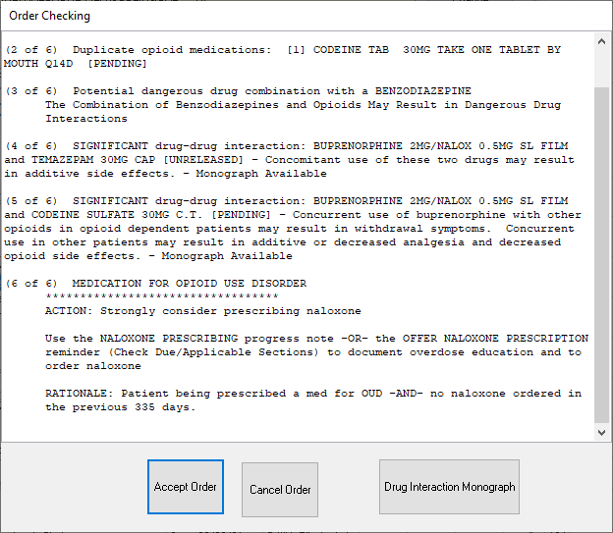

1. Cancel order.
2. Testing is complete after you have confirmed the two order checks will appear as indicated.