

**Update _2_0_223**

Clinical Reminders

VA-REMOTE TEMPERATURE MONITORING

Install Guide

**September 2021**

Product Development

Office of Information Technology

Department of Veterans Affairs

Table of Contents

Introduction 1

Install Details 1

Install Example 2

Post Installation 5

# Introduction

The Remote Temperature Monitoring Template should be used at any site with patients enrolled in Remote Temperature Monitoring. Separate enrollment notes should be entered for any patient that is enrolled in the program. Escalation alert notes should be entered when escalation alerts are received from the vendor via email. Disenrollment notes should be entered when a patient is disenrolled from the program for any reason. These notes will include health factors which will make it much easier to track who has been issued a smart mat nationally as well as track outcomes for this program.

Any sites using this program should create a REMOTE TEMPERATURE MONITORING CLINIC with the primary stop code of the service (example podiatry, PT, etc) and the secondary stop code of 698 for Remote Monitoring. Each of these notes will be entered into this clinic to capture workload. Coding is explained in the above flowchart.

UPDATE_2_0_223 contains 1 Reminder Exchange entry:

**UPDATE_2_0_223 VA-REMOTE TEMPERATURE MONITORING**

**The exchange file contains the following components:**

**TIU TEMPLATE FIELD**

TEXT (1-10 CHAR) REQ

WP FREE TEXT (74X4)

TEXT (1-60 CHAR)R

**HEALTH FACTORS**

VA-REMINDER UPDATES [C]

VA-REMOTE TEMPERATURE MONITORING [C]

VA-UPDATE_2_0_223

VA-REMOTE TEMPERATURE MONITORING-ALERT

VA-REMOTE TEMPERATURE MONITORING-DISENROLL

VA-REMOTE TEMPERATURE MONITORING-ENROLL

**REMINDER TERM**

VA-REMINDER UPDATE_2_0_223

**REMINDER DIALOG**

VA-REMOTE TEMPERATURE MONITORING

**REMINDER SPONSOR**

OFFICE OF REHABILITATION SERVICES IN VACO

# Install Details

This update is being distributed as a web host file. The address for the host file is: **https://REDACTED /UPDATE_2_0_223.PRD**

The file will be installed using Reminder Exchange, programmer access is not required.

Installation:

=============

This update can be loaded with users on the system. Installation will take less than 5 minutes.

# Install Example

To Load the Web Host File. Navigate to Reminder exchange in Vista

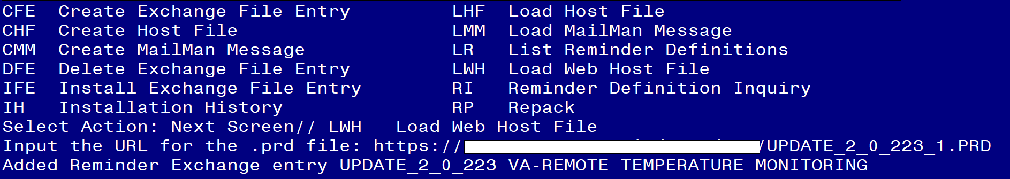

At the **Select Action:** prompt, enter **LWH** for Load Web Host File

At the **Input the url for the .prd file:** prompt, type the following web address:

[**https://Redacted/UPDATE_2_0_223.PRD**](https://Redacted/UPDATE_2_0_223.PRD)

You should see a message at the top of your screen that the file successfully loaded.

Search and locate an entry titled **UPDATE_2_0_223 VA-REMOTE TEMPERATURE MONITORING** in reminder exchange.

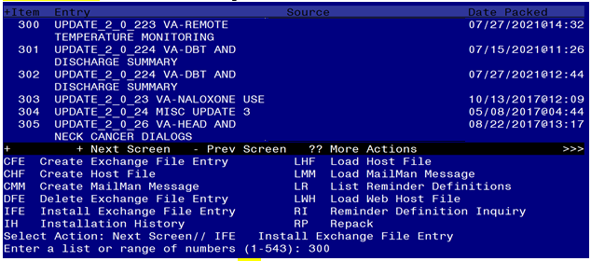

At the **Select Action** prompt, enter **IFE** for Install Exchange File Entry

Enter the number that corresponds with your entry UPDATE_2_0_223 VA-REMOTE TEMPERATURE MONITORING *(in this example it is entry 300. It will vary by site).* The date of the exchange file should be 07/27/2021.

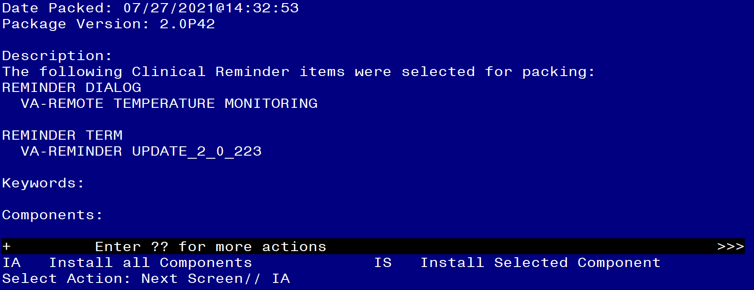

At the **Select Action** prompt, type **IA** for Install all Components and hit enter.

Select Action: Next Screen// IA Install all Components

You will see several prompts, for all new entries you will choose **I to Install**

**Install** all new items.

**You will be promped to install the reminder dialog component (VA-REMOTE TEMPERATURE MONITORING).** You will choose to install all even though some components may have an X to indicate that they exist.

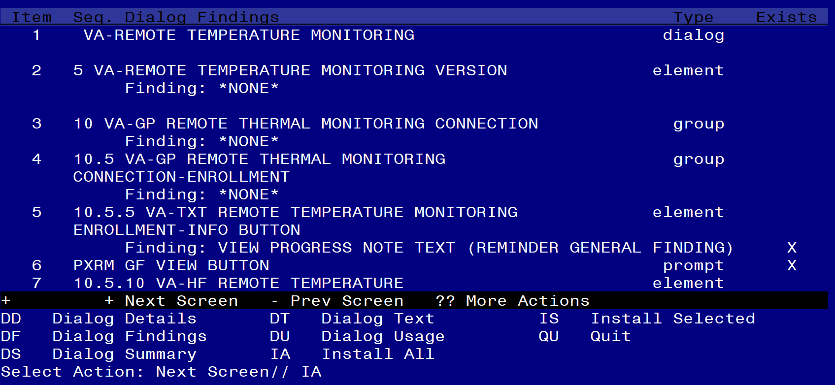

At the **Select Action** prompt, type **IA** to install the dialog: **VA-REMOTE TEMPERATURE MONITORING**

Select Action: Next Screen// IA Install All

Install reminder dialog and all components with no further changes: Y// Yes

After completing this dialog install, you will type Q.

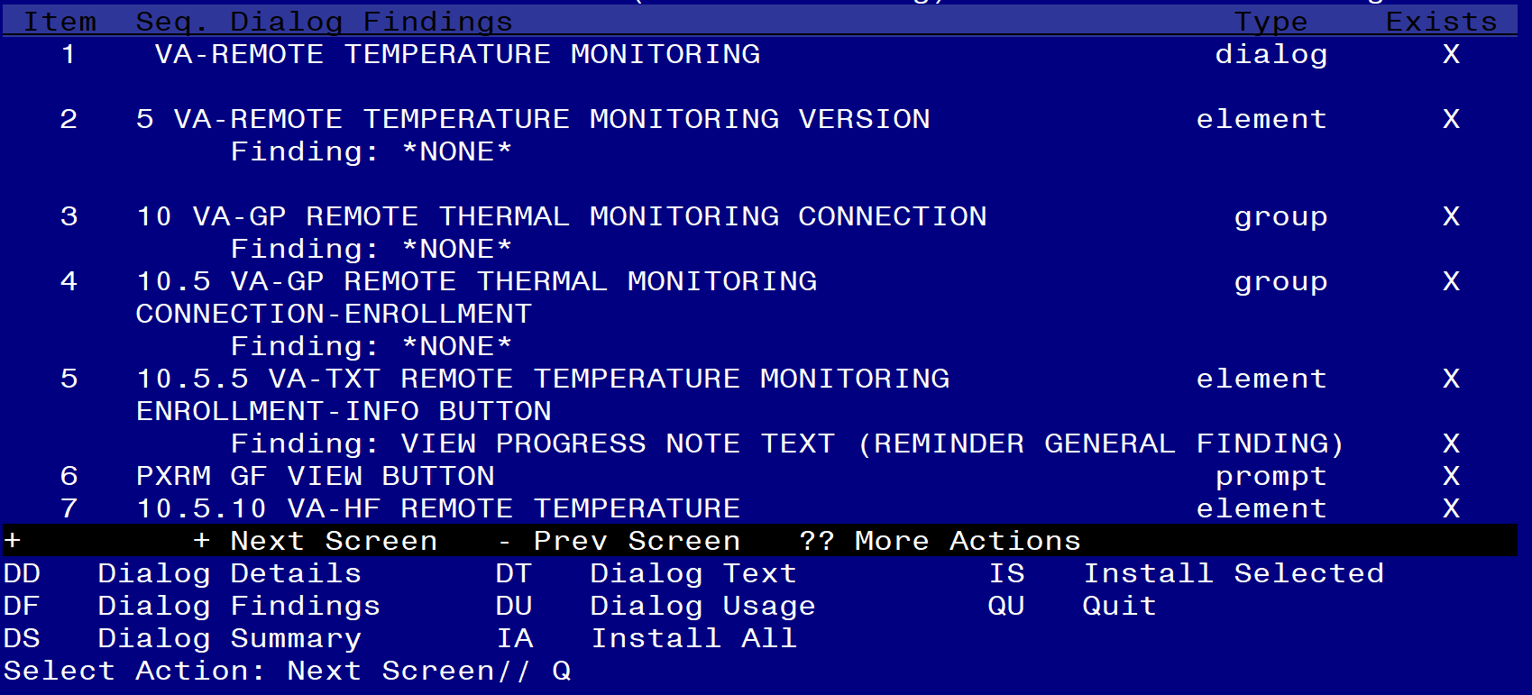

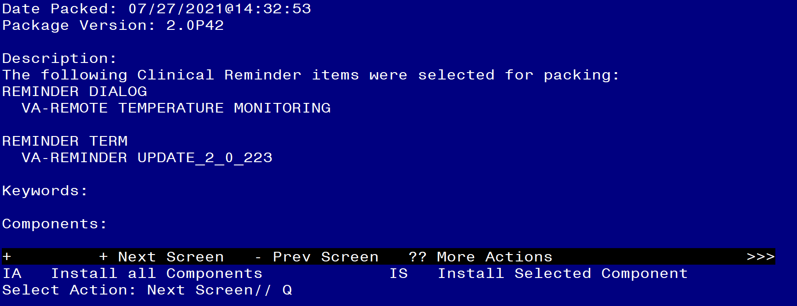

You will then be returned to this screen. At the **Select Action** prompt, type **Q.**

Install complete.

# Post Installation

1. **Make the Dialog template available to be attached to a Personal or Shared template or to be able to attach the dialog to a progress note title.**

Select Reminder Managers Menu <TEST ACCOUNT> Option: **CP** CPRS Reminder Configuration

CA Add/Edit Reminder Categories

CL CPRS Lookup Categories

CS CPRS Cover Sheet Reminder List

MH Mental Health Dialogs Active

PN Progress Note Headers

RA Reminder GUI Resolution Active

TIU TIU Template Reminder Dialog Parameter

DEVL Evaluate Coversheet List on Dialog Finish

DL Default Outside Location

PT Position Reminder Text at Cursor

LINK Link Reminder Dialog to Template

TEST CPRS Coversheet Time Test

NP New Reminder Parameters

GEC GEC Status Check Active

WH WH Print Now Active

Select CPRS Reminder Configuration <TEST ACCOUNT> Option: **TIU** TIU Template Reminder Dialog Parameter

Reminder Dialogs allowed as Templates may be set for the following:

1 User USR [choose from NEW PERSON]

3 Service SRV [choose from SERVICE/SECTION]

4 Division DIV [SALT LAKE CITY]

5 System SYS [NATREM.FO-SLC.MED.VA.GOV]

Enter selection: **5** Choose the appropriate number for your site. Your site may do this by System or other levels. The example below uses SYSTEM level.

Select Display Sequence: **?**

388 VA-COVID-19 TELEPHONE FOLLOW-UP

389 VA-SRA-CONSULT RESPONSE (D)

When you type a question mark above, you will see the list of #’s (with dialogs) that are already taken. Choose a number **NOT** on this list. For this example, 390 is not present so I will use 390.

Select Display Sequence: **390**

Are you adding 390 as a new Display Sequence? Yes// **YES**

Display Sequence: 390// <Enter>

Clinical Reminder Dialog: **VA-REMOTE TEMPERATURE MONITORING** reminder dialog NATIONAL

...OK? Yes// <Enter> (Yes)

1. **Setup of Note Title.**

The note title to create to associate with this template is: **REMOTE TEMPERATURE MONITORING**

VHA Enterprise Standard Title: **TELEHEALTH NOTE**

***Note:*** *Comprehensive information on Creating new Document Classes and Titles can be found beginning on page 54 of the TIU/ASU Implementation Guide at the following link:* [*http://www.va.gov/vdl/documents/Clinical/CPRS-Text_Integration_Utility_(TIU)/tiuim.pdf*](http://www.va.gov/vdl/documents/Clinical/CPRS-Text_Integration_Utility_(TIU)/tiuim.pdf)

1. **Associate the reminder dialog with the note title in CPRS**

In CPRS, open the Template Editor, expand Document Titles, select the appropriate folder (if applicable), then click New Template (top right-hand corner).

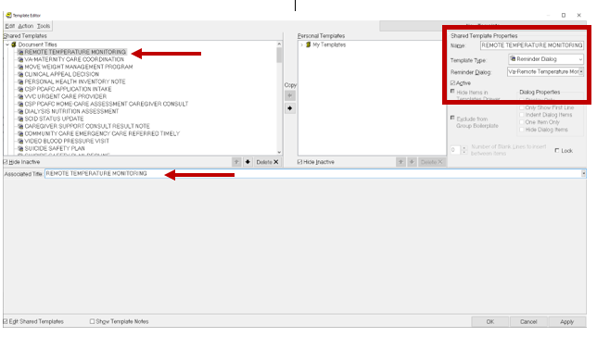

Type in the following information:

Name: **REMOTE TEMPERATURE MONITORING**

Template Type: **Reminder Dialog**

Reminder Dialog: **VA-REMOTE TEMPERATURE MONITORING**

Next, type in the Associated Title name – **REMOTE TEMPERATURE MONITORING** – then click Apply.