

**Update _2_0_224**

Clinical Reminders

VA-DBT AND DISCHARGE SUMMARY

Install Guide

**September 2021**

Product Development

Office of Information Technology

Department of Veterans Affairs

Table of Contents

Introduction 1

Pre-Installation 4

Install Details 4

Install Example 5

Post Installation 11

# Introduction

The Suicide Prevention Telehealth program will utilize note templates for Dialectical Behavior Therapy (DBT).  These note templates were developed by the Veterans Health Administration Office of Mental Health and Suicide Prevention (OMHSP) in collaboration with DBT subject matter experts within the SP 2.0 Clinical Telehealth Workgroup. These notes were designed to create a documentation system within the Veterans Integrated Service Network (VISN) Clinical Resource Hubs (CRH) for Veterans with a history of suicidal self-directed violence to receive suicide-prevention specific psychotherapy interventions via telehealth.

Suicide Prevention Telehealth psychiatrists, psychologists, social workers, and licensed counselors in the Clinical Resource Hubs who have been trained in the DBT intervention will utilize the DBT note templates. The Discharge Summary, developed by the OMHSP in collaboration with Evidence Based Psychotherapy subject matter experts within the SP 2.0 Clinical Telehealth Workgroup, will be utilized by therapists providing all SP 2.0 interventions including DBT, Cognitive Behavioral Therapy for Suicide Prevention (CBT-SP) and Problem Solving Therapy for Suicide Prevention (PST-SP).

The purpose of the templates is to accurately document Suicide Prevention EBP interventions in the health record, in addition to the use of health factors to capture data, collect and track Veteran process and outcome measures.

UPDATE_2_0_224 contains 1 Reminder Exchange entry:

**UPDATE_2_0_224 VA-DBT AND DISCHARGE SUMMARY**

**The exchange file contains the following components:**

**REMINDER GENERAL FINDINGS**

VIEW PROGRESS NOTE TEXT

**TIU TEMPLATE FIELD**

WP 2/50

DATE

VA-OSP SP RISK MGMT

VA-OSP SRM CONSULT EMAIL

EB 20/240

DISPLAY TEXT SP OPTIONAL

WP 2/50 NOT REQ

WP 3/70

EB 20/240 REQ

DATE (REQ)

ED BLANK 3

EB 5/240 REQ

**HEALTH FACTORS**

VA-REMINDER UPDATES [C]

VA-UPDATE_2_0_224

VA-REMINDER UPDATES [C]

VA-UPDATE_2_0_224

VA-OSP TH DISCHARGE [C]

VA-OSP TH DC REFERRED TO DBT

VA-OSP TH DC REFERRED TO PST-SP

VA-OSP TH DC REFERRED TO CBT-SP

VA-OSP TH DC DATE MOST RECENT SUICIDE RISK ASSESSMENT

VA-OSP TH CHRONIC RISK LOW

VA-OSP TH CHRONIC RISK INTERMEDIATE

VA-OSP TH CHRONIC RISK HIGH

VA-OSP TH ACUTE RISK LOW

VA-OSP TH ACUTE RISK INTERMEDIATE

VA-OSP TH ACUTE RISK HIGH

VA-SUICIDE RISK MANAGEMENT [C]

VA-SRM FU LOW ACUTE RISK

VA-SRM FU INTERMEDIATE ACUTE RISK

VA-SRM FU HIGH ACUTE RISK

VA-SUICIDE RISK ASSESSMENT [C]

VA-SUICIDE RISK ACUTE LOW

VA-SUICIDE RISK ACUTE INTERMEDIATE

VA-SUICIDE RISK ACUTE HIGH

VA-OSP TH DC REASON OTHER

VA-OSP TH DC REASON CRISIS

VA-OSP TH DC REASON UNABLE TO REACH

VA-OSP TH DC REASON NOT GOOD FIT OTHER

VA-OSP TH DC REASON INTERFERING SYMPTOMS NEED ADDRESSING

VA-OSP TH DC REASON NOT GOOD FIT AT THIS TIME

VA-OSP TH DC REASON REQUESTED TO END OTHER

VA-OSP TH DC REASON UNABLE TO ATTEND OTHER PRIORITIES

VA-OSP TH DC REASON FEELS NO LONGER NEED TREATMENT

VA-OSP TH DC REASON UNCOMFORTABLE DISCUSSING SUICIDE

VA-OSP TH DC REASON REQUESTED TO END TREATMENT

VA-OSP TH DC DBT NUMBER MONTHS

VA-OSP TH DC DBT NUMBER IND SESSIONS

VA-OSP TH DC DBT PARTIAL PROTOCOL

VA-OSP TH DC DBT FULL PROTOCOL

VA-OSP TH DC DBT UNPLANNED

VA-OSP TH DC PST-SP NUMBER SESSIONS

VA-OSP TH DC PST-SP PARTIAL PROTOCOL

VA-OSP TH DC PST-SP FULL PROTOCOL

VA-OSP TH DC PST-SP UNPLANNED

VA-OSP TH DC CBT-SP NUMBER SESSIONS

VA-OSP TH DC CBT-SP PARTIAL PROTOCOL COMPLETED

VA-OSP TH DC CBT-SP FULL PROTOCOL COMPLETED

VA-OSP TH DC CBT-SP UNPLANNED

VA-OSP TH DC DBT AGREED EARLY TERMINATION

VA-OSP TH DC DBT PLANNED

VA-OSP TH DC PST-SP AGREED EARLY TERMINATION

VA-OSP TH DC PST-SP PLANNED

VA-OSP TH DC CBT-SP AGREED EARLY TERMINATION

VA-OSP TH DC CBT-SP PLANNED

VA-OSP TH DC NOTE

VA-OSP DBT PHONE [C]

VA-OSP DBT PHONE TARGET OTHER

VA-OSP DBT PHONE RELATIONSHIP REPAIR

VA-OSP DBT PHONE OTHER TARGET BEHAVIORS

VA-OSP DBT PHONE OTHER BEHAVIOR URGES

VA-OSP DBT PHONE NON-SUIC SELF INJ BEHAV

VA-OSP DBT PHONE NON-SUIC SELF INJ URGES

VA-OSP DBT PHONE SUICIDAL BEHAVIORS

VA-OSP DBT PHONE SUICIDAL URGES

MH EVIDENCED BASED PSYCHOTHER TEMPLATES [C]

MH EBP TEMPLATE

VA-OSP DBT PHONE NOTE

VA-OSP DBT IND [C]

VA-OSP DBT SELF EFFICACY 6 MONTHS

VA-OSP DBT SELF EFFICACY 1 WEEK

VA-OSP DBT HOPELESSNESS INTENSITY

VA-OSP DBT IND OTHER BEHAVIORS

VA-OSP DBT IND WORK SCHOOL MISSED

VA-OSP DBT IND MH APPTS MISSED

VA-OSP DBT IND CRISIS SERVICES

VA-OSP DBT IND URGE SUICIDE

VA-OSP DBT IND NON-SUIC SELF INJ BEHAV

VA-OSP DBT IND SUICIDE PREP BEHAVIORS

VA-OSP DBT IND SUICIDE ATTEMPTS

VA-OSP DBT PART TELEPHONE

VA-OSP DBT VTH OTHER LOCATION

VA-OSP DBT FACE TO FACE

VA-OSP DBT TELEPHONE CONSENT

VA-OSP DBT ENTIRELY TELEPHONE

VA-OSP DBT VIDEO ATLAS

VA-OSP DBT VTC

VA-OSP DBT VTH RESIDENCE

VA-OSP DBT IND REG VISIT

VA-OSP DBT IND REGULAR NOTE

VA-OSP DBT IND EARLY VISIT

VA-OSP DBT IND EARLY NOTE

VA-OSP DBT GRP [C]

VA-OSP DBT GRP DISTRESS TOLERANCE

VA-OSP DBT GRP INTERPERSONAL EFFECTIVENESS

VA-OSP DBT GRP EMOTION REGULATION

VA-OSP DBT GRP MINDFULNESS

VA-OSP DBT GRP NOTE

**REMINDER SPONSOR**

VHA OFFICE OF MENTAL HEALTH AND SUICIDE PREVENTION

MENTAL HEALTH SERVICES

**REMINDER TERM**

VA-REMINDER UPDATE_2_0_224

VA-OSP DBT TELEPHONE CONSENT

**HEALTH SUMMARY COMPONENT**

PCE HEALTH FACTORS SELECTED

**HEALTH SUMMARY TYPE**

VA-OSP TH ACUTE RISK LEVELS 6M

**HEALTH SUMMARY OBJECTS**

VA-OSP TH ACUTE RISK LEVELS 6M

**TIU DOCUMENT DEFINITION**

VA-OSP TH ACUTE RISK LEVELS 6M

**REMINDER DIALOG**

VA-OSP TH DISCHARGE

VA-OSP DBT PHONE

VA-OSP DBT IND

VA-OSP DBT GRP

# Pre-Installation

Prior to installing this Update, check your Reminder Exchange Install History (IH) and ensure you have installed the following (previously released) Update:

* UPDATE_2_0_193 VA-OSP TH INTAKE ASSESSMENT

# Install Details

This update is being distributed as a web host file. The address for the host file is: **https://Redacted /UPDATE_2_0_224.PRD**

The file will be installed using Reminder Exchange, programmer access is not required.

Installation:

=============

This update can be loaded with users on the system. Installation will take less than 20 minutes.

# Install Example

To Load the Web Host File. Navigate to Reminder exchange in Vista

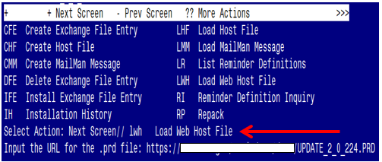

At the **Select Action:** prompt, enter **LWH** for Load Web Host File

At the **Input the url for the .prd file:** prompt, type the following web address:

**https://Redacted/UPDATE_2_0_224.PRD**

You should see a message at the top of your screen that the file successfully loaded.

Terminal window screen shot of the message displaying the URL of the file that was successfully loaded.  Part of the URL has been redacted as it is a VA only internal web site URL.

Search and locate an entry titled **UPDATE_2_0_224 VA-DBT AND DISCHARGE SUMMARY** in reminder exchange.

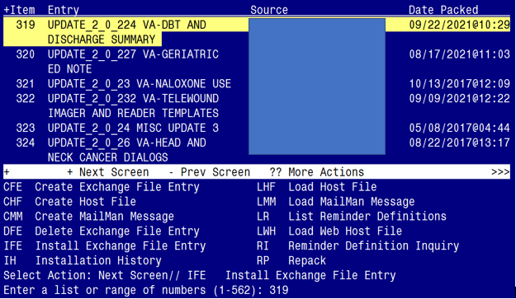

At the **Select Action** prompt, enter **IFE** for Install Exchange File Entry

Enter the number that corresponds with your entry **UPDATE_2_0_224 VA-DBT AND DISCHARGE SUMMARY** *(in this example it is entry 319. It will vary by site).* The date of the exchange file should be 09/22/2021@10:29.

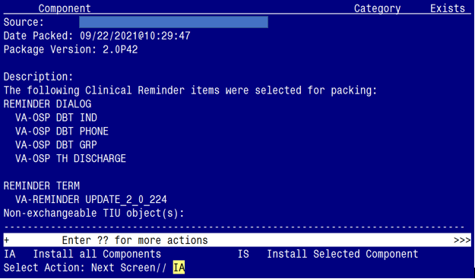

At the **Select Action** prompt, type **IA** for Install all Components and hit enter.

Select Action: Next Screen// IA Install all Components

You will see several prompts, for all new entries you will choose **I to Install**

For **HEALTH SUMMARY TYPE** entry named **VA-CSRE MOST RECENT**, choose **S to Skip**

For **HEALTH SUMMARY OBJECT** entry named **VA-CSRE MOST RECENT**, choose **S to Skip**

For other components that already exists but the packed component is different, choose **O to Overwrite.**

**You will be promped to install the 1st reminder dialog component (VA-OSP TH DISCHARGE).** You will choose to install all even though some components may have an X to indicate that they exist.

For VA-OSP TH DISCHARGE
Screen shot of the terminal window showing a list of elements, groups and dialogs with the text with IA for "Install All" entered at the "Select Action:" Prompt.  The correct entry is described in the text.

At the **Select Action** prompt, type **IA** to install the dialog: **VA-OSP TH DISCHARGE**

Select Action: Next Screen// IA Install All

Install reminder dialog and all components with no further changes: Y// Yes

For VA-OSP TH DISCHARGE
Screen shot of the last of the list of elements, groups and dialogs that needed to be installed with a Q for quit entered at the "Select Action:" prompt because they now all exist.  

After completing this dialog install, you will type Q.

**You will be promped to install the 2nd reminder dialog component (VA-OSP DBT PHONE).** You will choose to install all even though some components may have an X to indicate that they exist.

For VA-OSP DBT PHONE
Screen shot of the terminal window showing a list of elements, groups and dialogs with the text with IA for "Install All" entered at the "Select Action:" Prompt.  The correct entry is described in the text.

At the **Select Action** prompt, type **IA** to install the dialog: **VA-OSP DBT PHONE**

Select Action: Next Screen// IA Install All

Install reminder dialog and all components with no further changes: Y// Yes

For : VA-OSP DBT PHONE
Screen shot of the last of the list of elements, groups and dialogs that needed to be installed with a Q for quit entered at the "Select Action:" prompt because they now all exist.  

After completing this dialog install, you will type Q.

**You will be promped to install the 3rd reminder dialog component (VA-OSP DBT IND).** You will choose to install all even though some components may have an X to indicate that they exist.

For VA-OSP DBT IND
Screen shot of the terminal window showing a list of elements, groups and dialogs with the text with IA for "Install All" entered at the "Select Action:" Prompt.  The correct entry is described in the text.


At the **Select Action** prompt, type **IA** to install the dialog: **VA-OSP DBT IND**

Select Action: Next Screen// IA Install All

Install reminder dialog and all components with no further changes: Y// Yes

For VA-OSP DBT IND
Screen shot of the last of the list of elements, groups and dialogs that needed to be installed with a Q for quit entered at the "Select Action:" prompt because they now all exist.  

After completing this dialog install, you will type Q.

**You will be promped to install the 4th reminder dialog component (VA-OSP DBT GRP).** You will choose to install all even though some components may have an X to indicate that they exist.

For VA-OSP DBT GRP
Screen shot of the terminal window showing a list of elements, groups and dialogs with the text with IA for "Install All" entered at the "Select Action:" Prompt.  The correct entry is described in the text.


At the **Select Action** prompt, type **IA** to install the dialog: **VA-OSP DBT GRP**

Select Action: Next Screen// IA Install All

Install reminder dialog and all components with no further changes: Y// Yes

For VA-OSP DBT GRP
Screen shot of the last of the list of elements, groups and dialogs that needed to be installed with a Q for quit entered at the "Select Action:" prompt because they now all exist.  



After completing this dialog install, you will type Q.

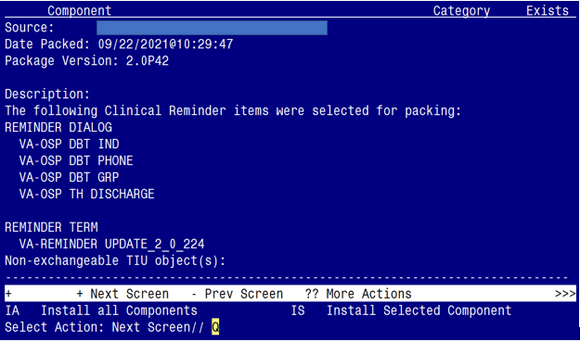

You will then be returned to this screen. At the **Select Action** prompt, type **Q.**

Install complete.

# Post Installation

1. **Make the Dialog template available to be attached to a Personal or Shared template or to be able to attach the dialog to a progress note title.**

Select Reminder Managers Menu <TEST ACCOUNT> Option: **CP** CPRS Reminder Configuration

CA Add/Edit Reminder Categories

CL CPRS Lookup Categories

CS CPRS Cover Sheet Reminder List

MH Mental Health Dialogs Active

PN Progress Note Headers

RA Reminder GUI Resolution Active

TIU TIU Template Reminder Dialog Parameter

DEVL Evaluate Coversheet List on Dialog Finish

DL Default Outside Location

PT Position Reminder Text at Cursor

LINK Link Reminder Dialog to Template

TEST CPRS Coversheet Time Test

NP New Reminder Parameters

GEC GEC Status Check Active

WH WH Print Now Active

Select CPRS Reminder Configuration <TEST ACCOUNT> Option: **TIU** TIU Template Reminder Dialog Parameter

Reminder Dialogs allowed as Templates may be set for the following:

1 User USR [choose from NEW PERSON]

3 Service SRV [choose from SERVICE/SECTION]

4 Division DIV [SALT LAKE CITY]

5 System SYS [NATREM.FO-SLC.MED.VA.GOV]

Enter selection: **5** *Choose the appropriate number for your site. Your site may do this by System or other levels. The example below uses SYSTEM level.*

Setting Reminder Dialogs allowed as Templates for System: NATREM.FO-SLC.MED.VA.GOV

Select Display Sequence: **?**

245 VA-OSP DBT PHONE

246 VA-TELESTROKE RN TRIAGE-ACUTE STROKE

*When you type a question mark above, you will see the list of #’s (with dialogs) that are already taken. Choose a number* ***NOT*** *on this list. For this example, 247 is not present so I will use 247.*

Select Display Sequence: **247**

Are you adding 247 as a new Display Sequence? Yes// **YES**

Display Sequence: 247// <Enter> 247

Clinical Reminder Dialog: **VA-OSP DBT GRP** reminder dialog NATIONAL

...OK? Yes// <Enter> (Yes)

**Repeat the above actions to add the following three additional reminder dialogs**:

* **VA-OSP DBT IND**
* **VA-OSP DBT PHONE**
* **VA-OSP TH DISCHARGE**

1. **Setup of Note Titles.**

Create the following note titles to associate with the reminder dialogs:

* **DIALECTICAL BEHAVIOR THERAPY SKILLS GROUP**
* **DIALECTICAL BEHAVIOR THERAPY INDIVIDUAL SESSION**
* **DIALECTICAL BEHAVIOR THERAPY PHONE COACHING**

VHA Enterprise Standard Title: **PSYCHOLOGY NOTE**

* **SUICIDE PREVENTION TELEHEALTH DISCHARGE SUMMARY**

VHA Enterprise Standard Title: **MENTAL HEALTH TELEHEALTH NOTE**

You can add these to the document class containing your psychology note titles.

***Note:*** *Comprehensive information on Creating new Document Classes and Titles can be found beginning on page 54 of the TIU/ASU Implementation Guide at the following link:* [*http://www.va.gov/vdl/documents/Clinical/CPRS-Text_Integration_Utility_(TIU)/tiuim.pdf*](http://www.va.gov/vdl/documents/Clinical/CPRS-Text_Integration_Utility_(TIU)/tiuim.pdf)

1. **Associate the four reminder dialogs with the four note titles in CPRS**

In CPRS, open the Template Editor, expand Document Titles, select the appropriate folder (if applicable), then click New Template (top right-hand corner).

1. For Reminder Dialog **VA-OSP DBT GRP**

Type in the following information:

Name: **DIALECTICAL BEHAVIOR THERAPY SKILLS GROUP**

Template Type: **Reminder Dialog**

Reminder Dialog: **VA-OSP DBT GRP**

Next, type in the Associated Title name – **DIALECTICAL BEHAVIOR THERAPY SKILLS GROUP** – then click Apply.

Screen shot showing the Template Editor entries for Reminder Dialog VA-OSP DBT GRP.
Under Document Titles, DIALECTICAL BEHAVIOR THERAPY SKILLS GROUP is chosen
Under Associated Title Name, DIALECTICAL BEHAVIOR THERAPY SKILLS GROUP is entered
Under New Template, Name, DIALECTICAL BEHAVIOR THERAPY SKILLS GROUP  is entered
Under Template Type, Reminder Dialog is selected
Under Reminder Dialog - VA-OSP DBT IND
All of the entries are described in the text of this document.

1. For Reminder Dialog **VA-OSP DBT IND**

Type in the following information:

Name: **DIALECTICAL BEHAVIOR THERAPY INDIVIDUAL SESSION**

Template Type: **Reminder Dialog**

Reminder Dialog: **VA-OSP DBT IND**

Next, type in the Associated Title name – **DIALECTICAL BEHAVIOR THERAPY INDIVIDUAL SESSION –** thenclick Apply.

Screen shot from the Template Editor -
Under Document Titles, DIALECTICAL BEHAVIOR THERAPY INDIVIDUAL SESSION is selected
Under Associated TitleDIALECTICAL BEHAVIOR THERAPY INDIVIDUAL SESSION is entered
Under New Template, the name is DIALECTICAL BEHAVIOR THERAPY INDIVIDUAL SESSION  The template Type is Reminder Dialog and the Reminder Dialog entry is  VA-OSP DBT IND

1. For Reminder Dialog **VA-OSP DBT PHONE**

Type in the following information:

Name: **DIALECTICAL BEHAVIOR THERAPY PHONE COACHING**

Template Type: **Reminder Dialog**

Reminder Dialog: **VA-OSP DBT PHONE**

Next, type in the Associated Title name – **DIALECTICAL BEHAVIOR THERAPY PHONE COACHING –** thenclick Apply.

For DIALECTICAL BEHAVIOR THERAPY PHONE COACHING template editor entries
Under Document Titles, DIALECTICAL BEHAVIOR THERAPY PHONE COACHING is chosen
Under Associated Title, DIALECTICAL BEHAVIOR THERAPY PHONE COACHING is entered.
Under New Template, the Name isDIALECTICAL BEHAVIOR THERAPY PHONE COACHING, The type is Reminder Dialog and the Reminder Dialog Title is VA-Osp Dbt Phone

1. For Reminder Dialog **VA-OSP TH DISCHARGE**

Type in the following information:

Name: **SUICIDE PREVENTION TELEHEALTH DISCHARGE SUMMARY**

Template Type: **Reminder Dialog**

Reminder Dialog: **VA-OSP TH DISCHARGE**

Next, type in the Associated Title name – **SUICIDE PREVENTION TELEHEALTH DISCHARGE SUMMARY** – then click Apply.

For the Template Editor Entries for – SUICIDE PREVENTION TELEHEALTH DISCHARGE SUMMARY 
The Document Title chosen is – SUICIDE PREVENTION TELEHEALTH DISCHARGE SUMMARY and this is also the Associated Title entry.  
Under New Template, Name is – SUICIDE PREVENTION TELEHEALTH DISCHARGE SUMMARY 
Template Type is Reminder Dialog
Reminder Dialog entry is Va-Osp Th Discharge

1. **Add Data Objects to Elements**
2. Element - VAL-OSP DBT HOME ADDRESS

* Add your facility’s local data object for PATIENT ADDRESS into the DIALOG/PROGRESS note text field.

NAME: VAL-OSP DBT HOME ADDRESS

DISABLE:

CLASS: LOCAL//

SPONSOR: VHA OFFICE OF MENTAL HEALTH AND SUICIDE PREVENTION

//

REVIEW DATE:

RESOLUTION TYPE:

ORDERABLE ITEM:

FINDING ITEM:

Additional findings: none

Select ADDITIONAL FINDING:

DIALOG/PROGRESS NOTE TEXT:

Home: **INSERT PATIENT ADDRESS OBJECT**

1. Element - VAL-OSP DBT PHONE

* Add your facility’s local data object for PATIENT PHONE into the DIALOG/PROGRESS note text field.

NAME: VAL-OSP DBT PHONE

DISABLE:

CLASS: LOCAL//

SPONSOR: VHA OFFICE OF MENTAL HEALTH AND SUICIDE PREVENTION

//

REVIEW DATE:

RESOLUTION TYPE:

ORDERABLE ITEM:

FINDING ITEM:

Additional findings: none

Select ADDITIONAL FINDING:

DIALOG/PROGRESS NOTE TEXT:

Phone: **INSERT PATIENT PHONE OBJECT**