

**Update _2_0_227**

Clinical Reminders

VA-GERIATRIC ED NOTE TEMPLATE

Install Guide

**September 2021**

Product Development

Office of Information Technology

Department of Veterans Affairs

Table of Contents

Introduction 1

Install Details 3

Install Example 3

Post Installation 7

# Introduction

The Geriatric Emergency Department (Geri-ED) Note Template is for clinical staff who are using geriatric-specific assessments to screen older Veterans being seen in the emergency department. These standardized screens identify common geriatric issues in order to offer high-quality care to older Veterans. This note includes metrics that align with the requirements for national Geri-ED accreditation. This template has been designed so that data can be abstracted for a national Geri-ED dashboard and quality reports. All assessments included in the note align with what currently exists or is being built in the new Federal Electronic Health Record.

For questions, contact Redacted ([Redacted@va.gov](mailto:Redacted@va.gov)).

**Below is a list of the available screens. These can be added to additional local reminder dialog templates, but the content should not be changed.**

Geri-Ed Screens that can be added but should not be changes are:

Identification of Seniors at Risk (ISAR)
Delirium Triage Screen (DTS)
Delirium - Brief Confusion Assessment Method (BCAM)
Cognitive Impairment Screen (Mini-Cog)
KATZ Activities of Daily Living (ADLs)
Falls - Stopping Elderly Accidents, Deaths & Injuries (STEADI)
Caregive Burden - Modified Zarit Burden Interview short-form 4 (ZBI-4)

UPDATE_2_0_227 contains 1 Reminder Exchange entry:

**UPDATE_2_0_227 VA-GERIATRIC ED NOTE TEMPLATE**

**The exchange file contains the following components:**

**TIU TEMPLATE FIELD**

WP LONG

BLANK SPACE1

TEXT (1-10 CHAR) REQ

**HEALTH FACTORS**

VA-REMINDER UPDATES [C]

VA-UPDATE_2_0_227

VA-GERI ED COG IMP SCREEN [C]

VA-GERI ED CIS DEFER

VA-GERI ED CIS NEGATIVE

VA-GERI ED CIS POSITIVE

VA-GERI ED CIS CLOCK-2

VA-GERI ED CIS CLOCK-0

VA-GERI ED CIS RECALL-3

VA-GERI ED CIS RECALL-2

VA-GERI ED CIS RECALL-1

VA-GERI ED CIS RECALL-0

VA-GERI ED SCREENING TIME [C]

VA-GERI ED SCREENING TIME > 20

VA-GERI ED SCREENING TIME 16-20

VA-GERI ED SCREENING TIME 10-15

VA-GERI ED SCREENING TIME < 10

VA-GERI ED ISAR SCORE [C]

VA-GERI ED ISAR DEFER

VA-GERI ED ISAR SCORE-6

VA-GERI ED ISAR SCORE-5

VA-GERI ED ISAR SCORE-4

VA-GERI ED ISAR SCORE-3

VA-GERI ED ISAR SCORE-2

VA-GERI ED ISAR SCORE-1

VA-GERI ED ISAR SCORE-0

VA-GERI ED ISAR REPORTS MORE THAN 3 MEDS DAILY

VA-GERI ED ISAR REPORTS MEMORY PROBLEM

VA-GERI ED ISAR REPORTS VISION PROBLEM

VA-GERI ED ISAR HOSP

VA-GERI ED ISAR HELP MORE

VA-GERI ED ISAR HELP REG

VA-GERI ED DELIRIUM SCREEN [C]

VA-GERI ED BCAM DEFER

VA-GERI ED BCAM FEATURE 1-NO

VA-GERI ED BCAM FEATURE 3-YES

VA-GERI ED BCAM FEATURE 4-NO

VA-GERI ED BCAM FEATURE 4-YES

VA-GERI ED BCAM FEATURE 3-NO

VA-GERI ED BCAM FEATURE 2-YES

VA-GERI ED BCAM FEATURE 2-NO

VA-GERI ED BCAM FEATURE 1-YES

VA-GERI ED DTS DEFER

VA-GERI ED DTS POSITIVE

VA-GERI ED DTS NEGATIVE

VA-GERI ED STEADI FALL SCREEN [C]

VA-GERI ED STEADI FALL SCREEN DEFER

VA-GERI ED STEADI FALL SCREEN NEG

VA-GERI ED STEADI FALL SCREEN POS

VA-GERI ED STEADI WORRIES ABOUT FALLING

VA-GERI ED STEADI FEELS UNSTEADY STAND OR WALK

VA-GERI ED STEADI FALL PAST YEAR

VA-GERI ED CGB SCORE [C]

VA-GERI ED CGB DEFER

VA-GERI ED CGB SCORE 13-16

VA-GERI ED CGB SCORE 9-12

VA-GERI ED CGB SCORE 5-8

VA-GERI ED CGB SCORE 0-4

VA-GERI ED KATZ ADLS [C]

VA-GERI ED KATZ ADLS FEEDING INDEP

VA-GERI ED KATZ ADLS CONTINENCE COMPLETE SELF

CONTROL

VA-GERI ED KATZ ADLS TRANSFERRING INDEP

VA-GERI ED KATZ ADLS TOILETING INDEP

VA-GERI ED KATZ ADLS DRESSING INDEP

VA-GERI ED KATZ ADLS BATHING INDEP

VA-GERI ED KATZ ADLS DEFER

VA-GERI ED KATZ ADLS 6 INDEP

VA-GERI ED KATZ ADLS 5 INDEP

VA-GERI ED KATZ ADLS 4 INDEP

VA-GERI ED KATZ ADLS 3 INDEP

VA-GERI ED KATZ ADLS 2 INDEP

VA-GERI ED KATZ ADLS 1 INDEP

VA-GERI ED KATZ ADLS ZERO INDEP

**REMINDER SPONSOR**

CAREGIVER SUPPORT PROGRAM

**REMINDER TERM**

VA-REMINDER UPDATE_2_0_227

**REMINDER DIALOG**

VA-GERIATRIC ED NOTE

# Install Details

This update is being distributed as a web host file. The address for the host file is: **https://Redacted /docs/UPDATE_2_0_227.PRD**

The file will be installed using Reminder Exchange, programmer access is not required.

Installation:

=============

This update can be loaded with users on the system. Installation will take less than 5 minutes.

# Install Example

To Load the Web Host File. Navigate to Reminder exchange in Vista

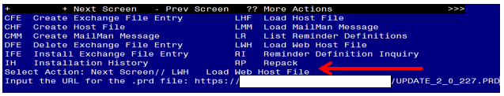

At the **Select Action:** prompt, enter **LWH** for Load Web Host File

At the **Input the url for the .prd file:** prompt, type the following web address:

[**https://REDACTED/UPDATE_2_0_227.PRD**](https://REDACTED/UPDATE_2_0_227.PRD)

You should see a message at the top of your screen that the file successfully loaded.

Terminal window screen shot of the message displaying the URL of the file that was successfully loaded.  Part of the URL has been redacted as it is a VA only internal web site URL.

Search and locate an entry titled **UPDATE_2_0_227 VA-GERIATRIC ED NOTE TEMPLATE** in reminder exchange.

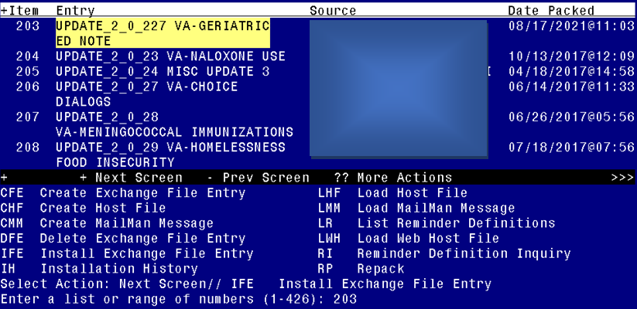

At the **Select Action** prompt, enter **IFE** for Install Exchange File Entry

Enter the number that corresponds with your entry UPDATE_2_0_227 VA-GERIATRIC ED NOTE TEMPLATE *(in this example it is entry 203. It will vary by site).* The date of the exchange file should be 08/17/2021.

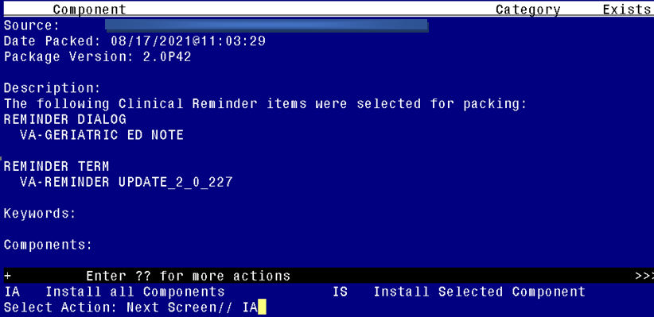

At the **Select Action** prompt, type **IA** for Install all Components and hit enter.

Select Action: Next Screen// IA Install all Components

You will see several prompts:

For all new entries you will choose **I to Install**

If you are prompted to overwrite any components, choose **S to Skip.**

**You will be promped to install the reminder dialog component (VA-GERIATRIC ED NOTE).** You will choose to install all even though some components may have an X to indicate that they exist.

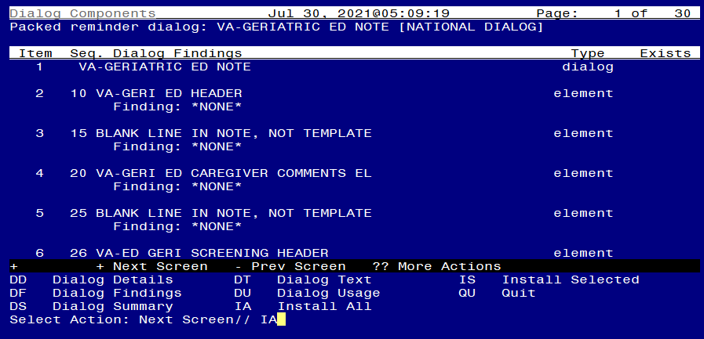

At the **Select Action** prompt, type **IA** to install the dialog: **VA-GERIATRIC ED NOTE**

Select Action: Next Screen// IA Install All

Install reminder dialog and all components with no further changes: Y// Yes

After completing this dialog install, you will type Q.

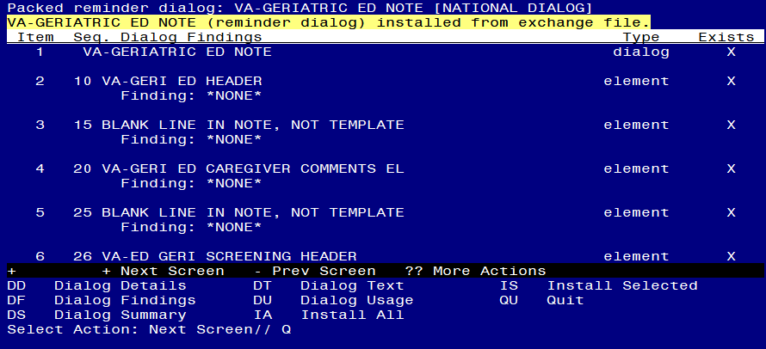

Select Action: Next Screen// Q

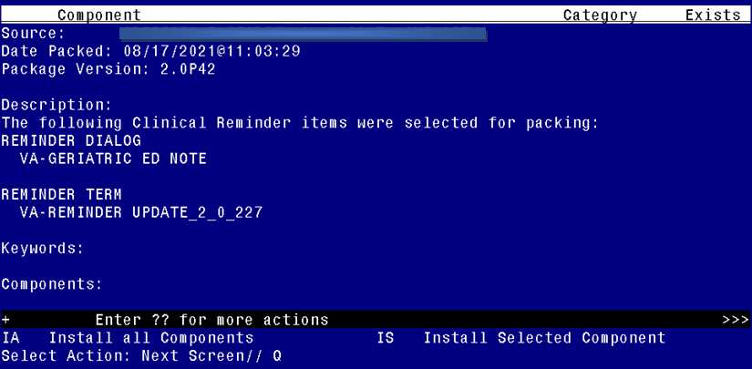

You will then be returned to this screen. At the **Select Action** prompt, type **Q.**

Install complete.

# Post Installation

The post install ONLY needs to be completed at facilities participating in the GERI_ED program. If your site IS NOT one of the listed sites, no post install setup is needed. For the sites listed below, please complete the post install set-up:

**VA ACEP Accredited Geriatric ED or Applicant City,State Facility**

**Number**

|  |  |  |
| --- | --- | --- |
| Ann Arbor VA Medical Center | Ann Arbor, MI | 506 |
| Baltimore VA Medical Center | Baltimore, MD | 512 |
| Biloxi VA Medical Center | Biloxi, MS | 520 |
| Buffalo VA Medical Center | Buffalo, NY | 528 |
| Fresno VA Medical Center | Central California | 570 |
| Ralph H Johnson VA Medical Center | Charleston, SC | 534 |
| Jesse Brown VA Medical Center | Chicago, IL | 537 |
| Cincinnati VA Medical Center | Cincinnati, OH | 539 |
| Louis Stokes Cleveland VA Medical Center | Cleveland, OH | 541 |
| Wm. Jennings Bryan Dorn VA Medical Center | Columbia, SC | 544 |
| Dallas VA Medical Center | Dallas, TX | 549 |
| Atlanta VA Medical Center | Decatur, GA | 508 |
| Rocky Mountain Regional VA Medical Center | Denver, CO | 554 |
| Des Moines VA Medical Center | Des Moines, IA | 636A6 |
| John D. Dingell VA Medical Center | Detroit, MI | 553 |
| Durham VA Health Care System | Durham, NC | 558 |
| Fayetteville VA Medical Center (Veterans HCS of the Ozarks) | Fayetteville, AR | 564 |
| Fayetteville VA Medical Center (VA Coastal HCS) | Fayetteville, NC | 565 |
| Grand Junction VA Medical Center | Grand Junction, CO | 575 |
| Michael E. DeBakey VA Medical Center | Houston, TX | 580 |
| Richard L Roudebush VA Medical Center | Indianapolis, IN | 583 |
| GV Sonny Montgomery VA Medical Center | Jackson, MS | 586 |
| Kansas City VA Medical Center | Kansas City, MO | 589 |
| John L. McClellan Memorial Veterans Hospital | Little Rock, AR | 598 |
| Tibor Rubin VA Medical Center | Long Beach, CA | 600 |
| West Los Angeles VA Medical Center | Los Angeles, CA | 691 |
| Robley Rex VA Medical Center | Louisville, KY | 603 |
| William S. Middleton Memorial Veterans Hospital | Madison, WI | 607 |
| Memphis VA Medical Center | Memphis, TN | 614 |
| New Orleans VA Medical Center | New Orleans, LA | 629 |
| Omaha VA Medical Center | Omaha, NE | 636 |
| Palo Alto VA Medical Center | Palo Alto, CA | 640 |
| Carl T. Hayden VA Medical Center | Phoenix, AZ | 644 |
| Alexandria VA Medical Center | Pineville, LA | 502 |
| Pittsburgh VA Medical Center | Pittsburg, PA | 646 |
| Northern Arizona VA Health Care System | Prescott, AZ | 649 |
| Reno VA Medical Center | Reno, NV | 654 |
| Hunter Holmes McGuire VA Medical Center | Richmond, VA | 652 |
| VA Boston HCS | Roxbury, MA | 523 |
| George E Whalen Veterans Affairs Medical Center | Salt Lake City, UT | 660 |
| Audie L Murphy Veteran's Hospital San Antonio TX | San Antonio, TX | 671 |
| San Diego VA Medical Center | San Diego, CA | 664 |
| San Francisco VA Medical Center | San Francisco, CA | 662 |
| Seattle VA Medical Center | Seattle, WA | 663 |
| Overton Brooks VA Medical Center | Shreveport, LA | 667 |
| John Cochran Veterans Hospital - St Louis | St. Louis, MO | 657 |
| Syracuse VA Medical Center | Syracuse, NY | 528A7 |
| Togus VA Medical Center | Togus, ME | 402 |
| Topeka VA Medical Center | Topeka, KS | 677 |
| Tucson VA Medical Center | Tucson, AZ | 678 |
| West Haven VA Medical Center | West Haven, CT | 689 |
| West Palm Beach VA Medical Center | West Palm Beach, FL | 548 |
| White River Junction VA Medical Center | White River Junction, VT | 405 |
|  |  |  |

1. **Make the Dialog template available to be attached to a Personal or Shared template or to be able to attach the dialog to a progress note title.**

Select Reminder Managers Menu <TEST ACCOUNT> Option: **CP** CPRS Reminder Configuration

CA Add/Edit Reminder Categories

CL CPRS Lookup Categories

CS CPRS Cover Sheet Reminder List

MH Mental Health Dialogs Active

PN Progress Note Headers

RA Reminder GUI Resolution Active

TIU TIU Template Reminder Dialog Parameter

DEVL Evaluate Coversheet List on Dialog Finish

DL Default Outside Location

PT Position Reminder Text at Cursor

LINK Link Reminder Dialog to Template

TEST CPRS Coversheet Time Test

NP New Reminder Parameters

GEC GEC Status Check Active

WH WH Print Now Active

Select CPRS Reminder Configuration <TEST ACCOUNT> Option: **TIU** TIU Template Reminder Dialog Parameter

Reminder Dialogs allowed as Templates may be set for the following:

1 User USR [choose from NEW PERSON]

3 Service SRV [choose from SERVICE/SECTION]

4 Division DIV [SALT LAKE CITY]

5 System SYS [NATREM.FO-SLC.MED.VA.GOV]

Enter selection: **5** *Choose the appropriate number for your site. Your site may do this by System or other levels. The example below uses SYSTEM level.*

Setting Reminder Dialogs allowed as Templates for System: NATREM.FO-SLC.MED.VA.GOV

Select Display Sequence: **?**

388 VA-COVID-19 TELEPHONE FOLLOW-UP

389 VA-SRA-CONSULT RESPONSE (D)

*When you type a question mark above, you will see the list of #’s (with dialogs) that are already taken. Choose a number* ***NOT*** *on this list. For this example, 390 is not present so I will use 390.*

Select Display Sequence: **390**

Are you adding 390 as a new Display Sequence? Yes// **YES**

Display Sequence: 390// <Enter> 390

Clinical Reminder Dialog: **VA-GERIATRIC ED NOTE** reminder dialog NATIONAL

...OK? Yes// <Enter> (Yes)

1. **Setup of Note Title.**

The note title to create to associate with this template is: **GERIATRIC EMERGENCY DEPARTMENT NOTE**

VHA Enterprise Standard Title: **GERIATRIC MEDICINE NOTE**

You can add this to your document class where emergency progress notes are located.

***Note:*** *Comprehensive information on Creating new Document Classes and Titles can be found beginning on page 54 of the TIU/ASU Implementation Guide at the following link:* [*http://www.va.gov/vdl/documents/Clinical/CPRS-Text_Integration_Utility_(TIU)/tiuim.pdf*](http://www.va.gov/vdl/documents/Clinical/CPRS-Text_Integration_Utility_(TIU)/tiuim.pdf)

1. **Associate the reminder dialog with the note title in CPRS**

In CPRS, open the Template Editor, expand Document Titles, select the appropriate folder (if applicable), then click New Template (top right-hand corner).

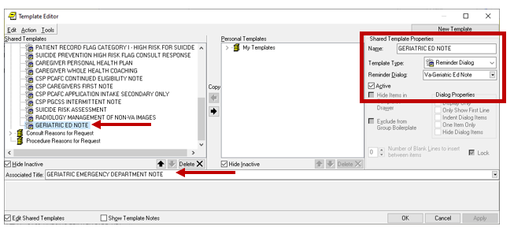

Type in the following information:

Name: **GERIATRIC ED NOTE**

Template Type: **Reminder Dialog**

Reminder Dialog: **VA-GERIATRIC ED NOTE**

Next, type in the Associated Title name – **GERIATRIC EMERGENCY DEPARTMENT NOTE** – then click Apply.

1. Add local orders/enable reminder dialog groups for referrals – OPTIONAL

Each screening tool has the option to add local orders for referrals if needed. There is a reminder dialog group located at the end of each screen. The purpose of these reminder dialog groups is to allow local editing and addition of consults or other orderable items in response to the screen result. Your site should determine what if any referral options should be offered based on positive screens.

The reminder dialog VAL-GP ISAR ORDERS is currently not disabled to provide an example of what the group currently looks like. The other reminder dialog groups are disabled. The dialog text can be modified as needed.

VAL-GP ISAR ORDERS

VAL-GP DTS ORDERS

VAL-GP BCAM ORDERS

VAL-GP MINI ORDERS

VAL-GP KATZ ORDERS

VAL-GP STEADI ORDERS

VAL-GP CAREGIVER ORDERS

1. Update local templates (optional). Components of this dialog can be incorporated into your local emergency department (ED) reminder dialog templates. If you have a local reminder dialog used for emergency nursing or for emergency provider documentation, please review this new GERI-ED dialog with your Geriatric ED physician champion and determine if any sections should be included in existing local dialogs to improve workflow. This is not required.